Asymmetric Atlantic-Pacific interactions on decadal timescales underrepresented in climate models

Yan Xia^{1*}, Yong-Fu Lin², Jin-Yi Yu¹, Yunfan Chen³, Mike Pritchard¹*

¹Department of Earth System Science, University of California, Irvine, California, USA
²Department of Earth Sciences, National Taiwan Normal University, Taipei, Taiwan
³Earth and Environmental Sciences, University of Michigan, Ann Arbor, Ann Arbor, MI, USA.
Corresponding author: Yan Xia (yxia24@uci.edu), Mike Pritchard (mspritch@uci.edu)

Supplementary Table 1 | Observational and reanalysis datasets used in this study for model evaluation.
Dataset | Type | Variables | Resolution | Period | Reference
Sea Surface Temperature (SST)
HadISST | SST | SST | 1° × 1° | 1891–2014 | Rayner et al. (2003)
ERSSTv5 | SST | SST | 1° × 1°ᵃ | 1891–2014 | Huang et al. (2017)
COBE SST | SST | SST | 1° × 1° | 1891–2014 | Ishii et al. (2005)
Atmospheric Reanalysis
ERA5 | Atmospheric reanalysis | ω (vertical pressure velocity), precipitation, 850 hPa wind (ua, va) | 0.25° × 0.25° | 1958–2014 | Hersbach et al. (2020)
Ocean Reanalysis
ORAS5 | Ocean reanalysis | thermocline depth (D20), Zonal wind stress (τx) | 1° × 1° | 1958–2014 | Zuo et al. (2019)
ᵃNative resolution is 2° × 2°; bilinearly interpolated to 1° × 1°. ω, vertical pressure velocity; ua, eastward wind; va, northward wind; θ, potential temperature; D20, depth of the 20°C isotherm (thermocline depth proxy); τx, zonal wind stress. All fields were interpolated to a common 1° × 1° grid.

Supplementary Table 2 | Overview of the 27 CMIP6 models used in this study, showing the availability of monthly variables from historical simulations (1850–2014, r1i1p1f1 realization). All model fields were bilinearly interpolated to a common 1° × 1° grid.
Model | ua | va | wap | ts | pr | tauu | thetao | Available
ACCESS-CM2 | ✓ | ✓ | ✓ | ✓ | ✓ | ✓ | ✓ | 7/7
AWI-ESM-1-1-LR | ✓ | ✓ | ✓ | ✓ | ✓ | ✓ | ✓ | 7/7
BCC-CSM2-MR | ✓ | ✓ | ✓ | ✓ | ✓ | ✓ | ✓ | 7/7
BCC-ESM1 | ✓ | ✓ | ✓ | ✓ | ✓ | ✓ | ✓ | 7/7
CAMS-CSM1-0 | ✓ | ✓ | ✓ | ✓ | ✓ | — | ✓ | 6/7
CESM2 | ✓ | ✓ | ✓ | ✓ | ✓ | ✓ | ✓ | 7/7
CESM2-FV2 | ✓ | ✓ | ✓ | ✓ | ✓ | ✓ | ✓ | 7/7
CESM2-WACCM | ✓ | ✓ | ✓ | ✓ | ✓ | ✓ | ✓ | 7/7
CESM2-WACCM-FV2 | ✓ | ✓ | ✓ | ✓ | ✓ | ✓ | ✓ | 7/7
CMCC-CM2-HR4 | ✓ | ✓ | ✓ | ✓ | ✓ | ✓ | ✓ | 6/7
CMCC-CM2-SR5 | ✓ | ✓ | ✓ | ✓ | ✓ | ✓ | ✓ | 7/7
CMCC-ESM2 | ✓ | ✓ | ✓ | ✓ | ✓ | ✓ | ✓ | 7/7
CanESM5 | ✓ | ✓ | ✓ | ✓ | ✓ | ✓ | ✓ | 7/7
FGOALS-g3 | ✓ | ✓ | ✓ | ✓ | ✓ | ✓ | ✓ | 7/7
GISS-E2-1-G | ✓ | ✓ | ✓ | ✓ | ✓ | ✓ | ✓ | 7/7
GISS-E2-1-G-CC | ✓ | ✓ | ✓ | ✓ | ✓ | ✓ | ✓ | 7/7
GISS-E2-1-H | ✓ | ✓ | ✓ | ✓ | ✓ | ✓ | — | 6/7
IITM-ESM | ✓ | ✓ | ✓ | ✓ | ✓ | — | — | 5/7
MIROC6 | ✓ | ✓ | ✓ | ✓ | ✓ | ✓ | ✓ | 7/7
MPI-ESM-1-2-HAM | ✓ | ✓ | ✓ | ✓ | ✓ | ✓ | ✓ | 7/7
MPI-ESM1-2-HR | ✓ | ✓ | ✓ | ✓ | ✓ | ✓ | ✓ | 7/7
MPI-ESM1-2-LR | ✓ | ✓ | ✓ | ✓ | ✓ | ✓ | ✓ | 7/7
MRI-ESM2-0 | ✓ | ✓ | ✓ | ✓ | ✓ | ✓ | ✓ | 7/7
NESM3 | ✓ | ✓ | ✓ | ✓ | ✓ | ✓ | ✓ | 7/7
NorESM2-MM | ✓ | ✓ | ✓ | ✓ | ✓ | ✓ | — | 6/7
SAM0-UNICON | ✓ | ✓ | ✓ | ✓ | ✓ | ✓ | ✓ | 7/7
TaiESM1 | ✓ | ✓ | ✓ | ✓ | ✓ | ✓ | ✓ | 7/7
✓, variable available; —, variable not available. ua, eastward wind; va, northward wind; wap, vertical pressure velocity; ts, surface temperature; pr, precipitation; tauu, eastward wind stress; thetao, sea water potential temperature. The number of models contributing to each diagnostic varies according to variable availability.

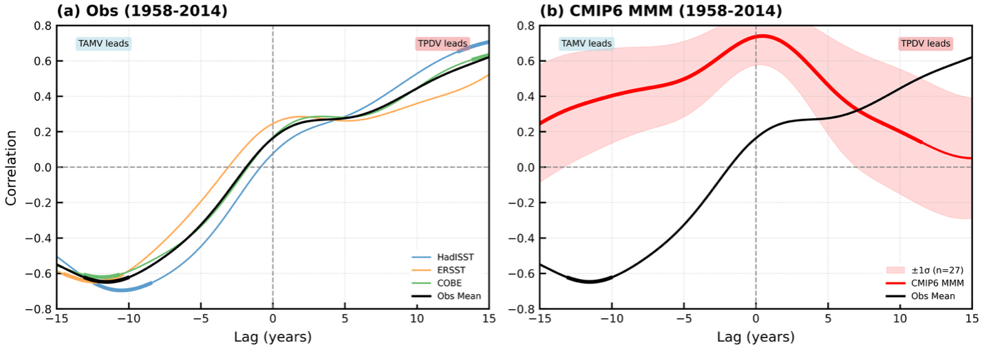
Supplementary Figure 1 | Lead–lag correlations between TPDV and TAMV for 1958–2014. (a) Observational estimates from HadISST (blue), ERSSTv5 (orange), and COBE SST (green), with the observational mean in black. (b) CMIP6 multi-model mean (red) with ±1 standard deviation across 27 models (shading), and the observational mean (black) reproduced for comparison. Positive lags indicate TPDV leads; negative lags indicate TAMV leads. All indices are computed from the full 1891–2014 SST record and truncated to 1958–2014 for the correlation calculation. The asymmetric correlation structures and model deficiency identified over the full 1891–2014 period (Fig. 1a, b) are robust in the shorter window, supporting the use of 1958–2014 for mechanism diagnostics.

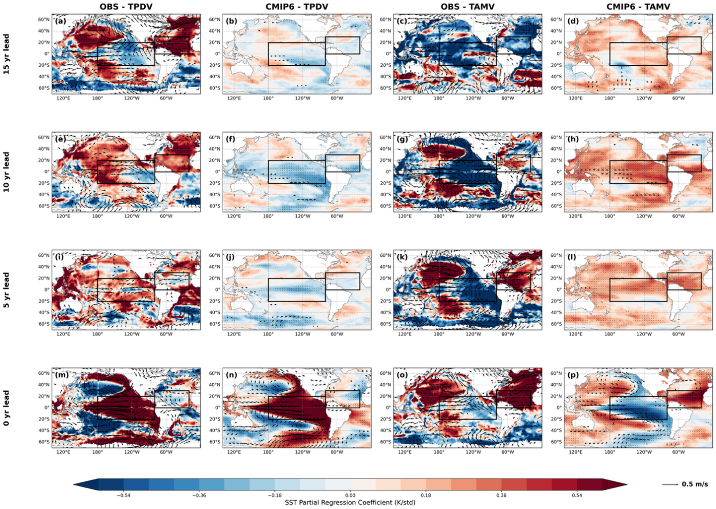
Supplementary Figure 2 | Partial regression of SST and 850 hPa wind anomalies onto the TPDV and TAMV indices at multiple lead times (1958–2014). Shading shows the partial regression coefficient of linearly detrended, 11-year Lanczos low-pass filtered SST anomalies (K std⁻¹) onto the TPDV (first and second columns) and TAMV (third and fourth columns) indices. Arrows show the corresponding 850 hPa wind regression (m s⁻¹ std⁻¹; reference vector at bottom right). For each index, the left column shows observations (HadISST for SST, ERA5 for winds) and the right column shows the CMIP6 MMM. Rows correspond to indexes lead times of 15 years (a–d), 10 years (e–h), 5 years (i–l), and 0 years (m–p), where positive lead indicates that the index leads the response field. Black boxes denote the TPDV domain (180°–280°E, 20°S–20°N) and TAMV domain (280°–340°E, 0°–30°N). Stippling denotes significance at the 90% confidence level (two-tailed Student's t-test with effective degrees of freedom corrected for serial autocorrelation; one-sample t-test across models for the CMIP6 mean). SST patterns are consistent with the 1891–2014 results shown in Fig. 2.
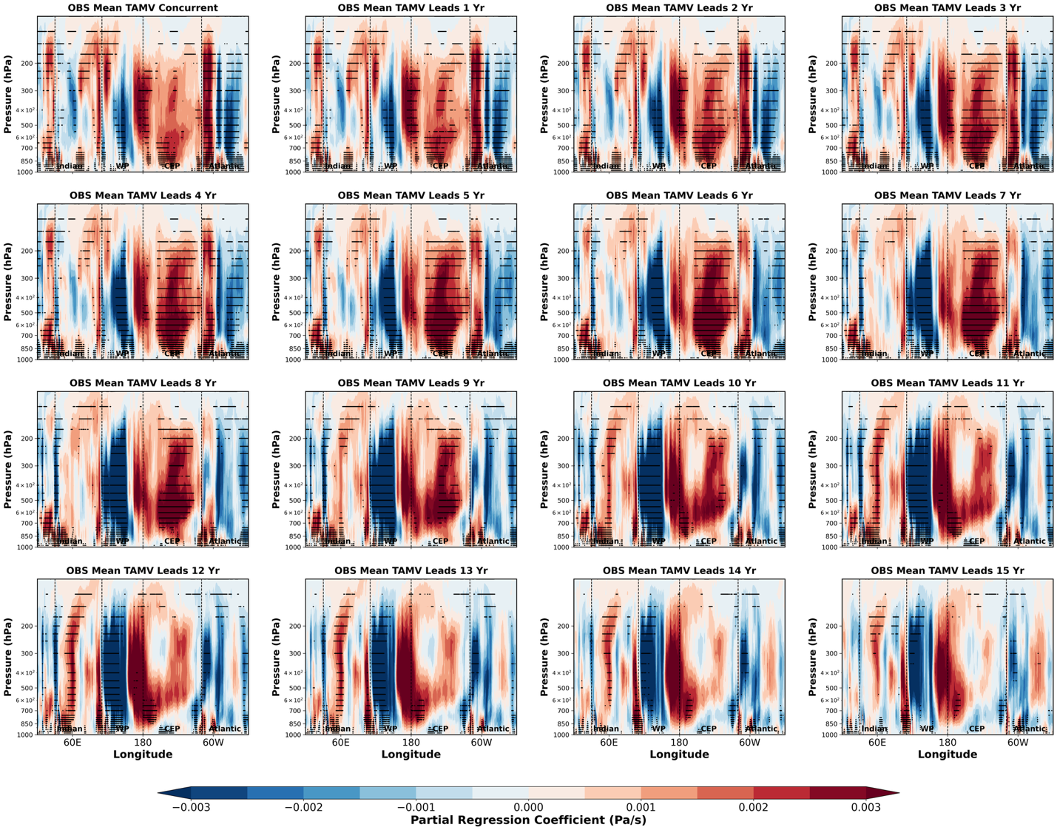
Supplementary Figure 3 | Longitude–pressure cross-sections of partial regression of observed tropical mean vertical pressure velocity (ω) onto the TAMV index at progressive lead intervals (1958-2014). Shading shows the partial regression coefficient of linearly detrended, 11-year Lanczos low-pass filtered ω anomalies (Pa s⁻¹) onto the TAMV index, averaged meridionally over 20°S–20°N, from concurrent to TAMV leading by 15 years in one-year increments. Vertical dashed lines denote the boundaries of the Indian Ocean (Indian), West Pacific (WP), Central-East Pacific (CEP), and Atlantic Ocean (Atlantic) basins. All regression coefficients are expressed per standard deviation of the TAMV index. Stippling denotes regions significant at the 90% confidence level (two-tailed Student's t-test; effective degrees of freedom corrected for serial autocorrelation).
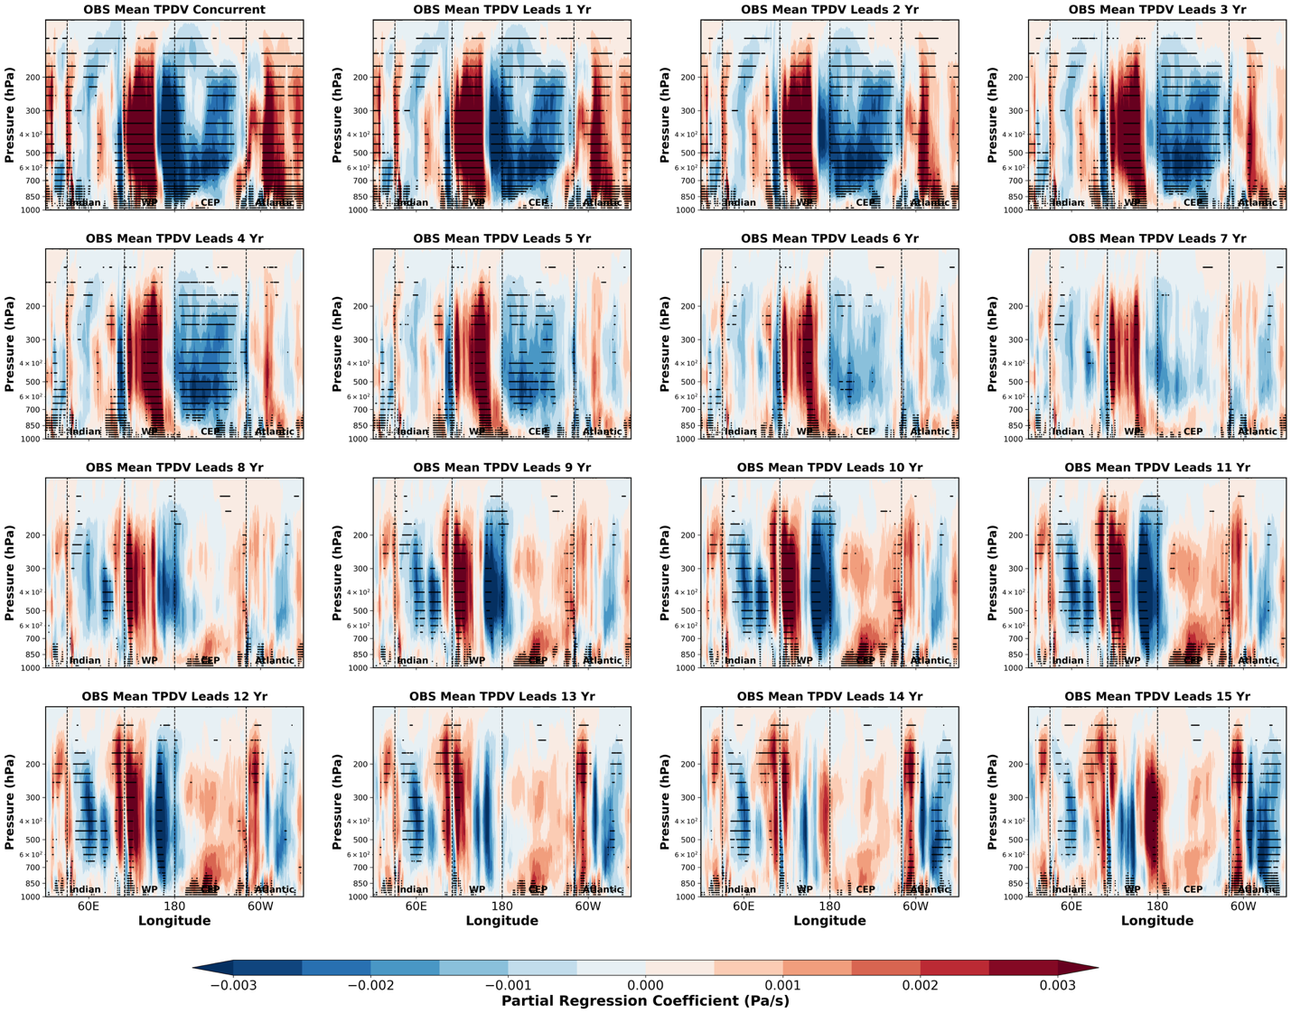
Supplementary Figure 4 | As Supplementary Figure 3, but for the OBS Mean TPDV index (1958-2014). Longitude–pressure cross-sections of partial regression of observed tropical mean ω anomalies (Pa s⁻¹) onto the TPDV index, from concurrent to TPDV leading by 15 years in one-year increments.
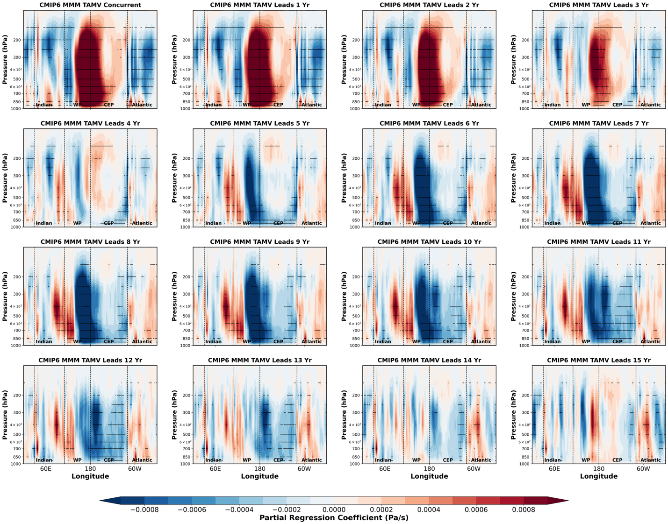
Supplementary Figure 5 | As Supplementary Figure 3, but for the CMIP6 MMM TAMV index (1958-2014). Longitude–pressure cross-sections of partial regression of CMIP6 MMM tropical mean ω anomalies (Pa s⁻¹) onto the TAMV index, from concurrent to TAMV leading by 15 years in one-year increments. Stippling denotes regions where the ensemble mean response is significantly different from zero at the 90% confidence level (one-sample t-test across the 27 models).

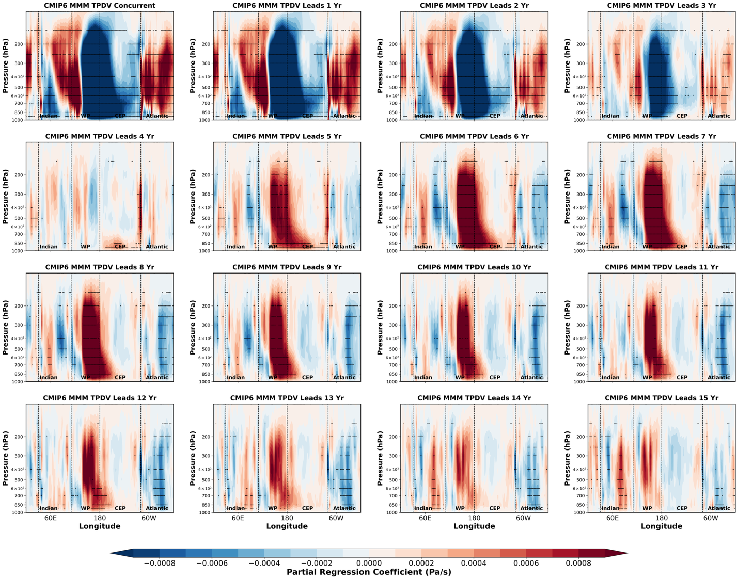
Supplementary Figure 6 | As Supplementary Figure 3, but for the CMIP6 MMM TPDV index (1958-2014). Longitude–pressure cross-sections of partial regression of CMIP6 MMM tropical mean ω anomalies (Pa s⁻¹) onto the TPDV index, from concurrent to TPDV leading by 15 years in one-year increments. Stippling denotes regions where the ensemble mean response is significantly different from zero at the 90% confidence level (one-sample t-test across the 27 models).

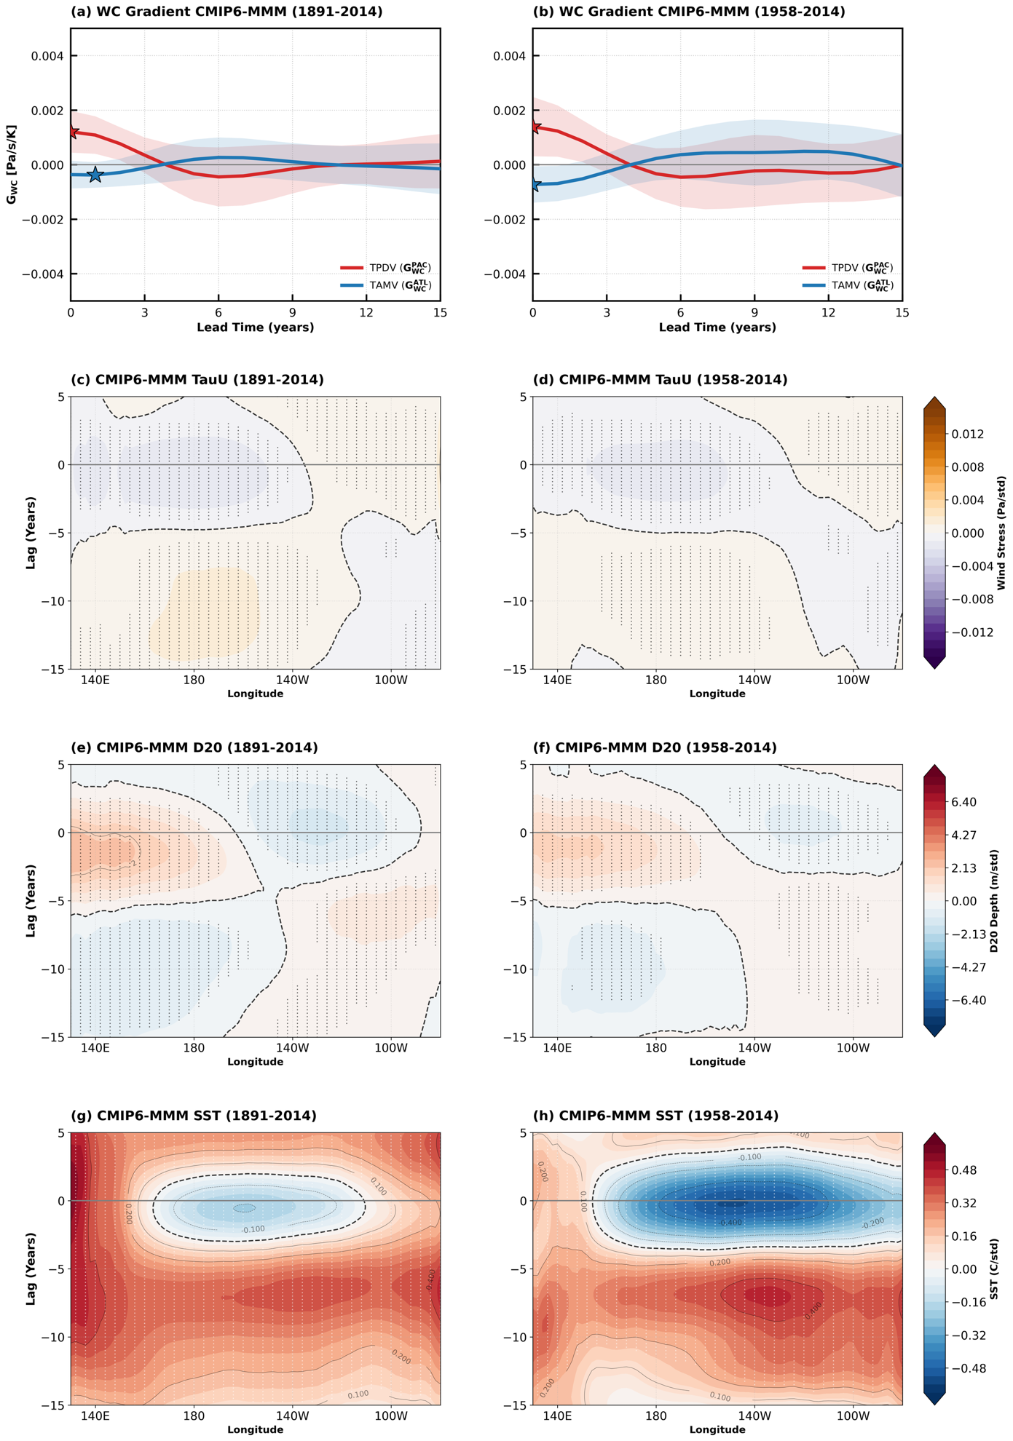
Supplementary Figure 8 | CMIP6 mechanism diagnostics: comparison of 1891–2014 and 1958–2014 analysis periods. (a, b) Trans-Basin Walker Circulation Gradient under TPDV forcing ($G_{WC}^{PAC}$, red) and TAMV forcing ($G_{WC}^{ATL}$, blue) for (a) 1891–2014 and (b) 1958–2014. Solid lines show the CMIP6 multi-model mean; shading indicates ±1 standard deviation across models; stars mark the observed values at zero lag. (c, d) Equatorial zonal wind stress (τ_x; Pa std⁻¹) regressed onto TAMV along 5°S–5°N for (c) 1891–2014 and (d) 1958–2014. (e, f) 20°C isotherm depth (D20; m std⁻¹) regressed onto TAMV along 5°S–5°N for (e) 1891–2014 and (f) 1958–2014. (g, h) SST (K std⁻¹) regressed onto TAMV along 5°S–5°N for (g) 1891–2014 and (h) 1958–2014. In all Hovmöller panels, the y-axis shows lead time in years, with negative values indicating TAMV leads. Dashed contours denote the zero line. The consistency between the two periods confirms that model biases in the atmospheric and oceanic pathways are persistent features of the CMIP6 ensemble and not sensitive to the choice of analysis period.

