Supplementary files
Title: Exploring Antibiotic Prescription Practices & Perceptions About Antibiotic Use in Dental care- A Mixed-Method study

Table of Contents
Appendix 1: COREQ (COnsolidated criteria for REporting Qualitative research) Checklist 1
Appendix 2. Copy Of ERC Approval Letter 4
Appendix 3. Interview Guide for Dental Practitioners 5
Appendix 4: Interview Guide for Policy Experts & Stakeholders 7

Appendix 1: COREQ (COnsolidated criteria for REporting Qualitative research) Checklist

A checklist of items that should be included in reports of qualitative research. You must report the page number in your manuscript where you consider each of the items listed in this checklist. If you have not included this information, either revise your manuscript accordingly before submitting or note N/A.
Qualitative component of the mixed-methods study
Manuscript: Exploring Antibiotic Prescription Practices & Perceptions About Antibiotic Use in Dental care- A Mixed-Method study

Topic | Item No. | Guide Questions/Description | Reported on Page No.
Domain 1: Research team and reflexivity
Personal characteristics
Interviewer/facilitator | 1 | Which author/s conducted the interview or focus group? | Title page
Credentials | 2 | What were the researcher’s credentials? E.g. PhD, MD | Title page
Occupation | 3 | What was their occupation at the time of the study? | Title page
Gender | 4 | Was the researcher male or female? | Title page
Experience and training | 5 | What experience or training did the researcher have? | Title page
Relationship with participants
Relationship established | 6 | Was a relationship established prior to study commencement? | 9
Participant knowledge of the interviewer | 7 | What did the participants know about the researcher? e.g. personal goals, reasons for doing the research | 9
Interviewer characteristics | 8 | What characteristics were reported about the inter viewer/facilitator? e.g. Bias, assumptions, reasons and interests in the research topic | 9
Domain 2: Study design
Theoretical framework
Methodological orientation and Theory | 9 | What methodological orientation was stated to underpin the study? e.g.  grounded theory, discourse analysis, ethnography, phenomenology, content analysis | 6
Participant selection
Sampling | 10 | How were participants selected? e.g. purposive, convenience, consecutive, snowball | 6
Method of approach | 11 | How were participants approached? e.g. face-to-face, telephone, mail, email | 7
Sample size | 12 | How many participants were in the study? | 7
Non-participation | 13 | How many people refused to participate or dropped out? Reasons? | 7
Setting
Setting of data collection | 14 | Where was the data collected? e.g. home, clinic, workplace | 7
Presence of nonparticipants | 15 | Was anyone else present besides the participants and researchers? | 7
Description of sample | 16 | What are the important characteristics of the sample? e.g. demographic data, date | 6
Data collection
Interview guide | 17 | Were questions, prompts, guides provided by the authors? Was it pilot tested? | 7
Repeat interviews | 18 | Were repeat inter views carried out? If yes, how many? | 7
Audio/visual recording | 19 | Did the research use audio or visual recording to collect the data? | 7
Field notes | 20 | Were field notes made during and/or after the inter view or focus group? | 7
Duration | 21 | What was the duration of the inter views or focus group? | 7
Data saturation | 22 | Was data saturation discussed? | 7
Transcripts returned | 23 | Were transcripts returned to participants for comment and/or | 7
Topic | Item No. | Guide Questions/Description | Reported on Page No.
 |  | correction?
Domain 3: analysis and findings
Data analysis
Number of data coders | 24 | How many data coders coded the data? | 8
Description of the coding tree | 25 | Did authors provide a description of the coding tree? | 10
Derivation of themes | 26 | Were themes identified in advance or derived from the data? | 8
Software | 27 | What software, if applicable, was used to manage the data? | 9-10
Participant checking | 28 | Did participants provide feedback on the findings? | 9
Reporting
Quotations presented | 29 | Were participant quotations presented to illustrate the themes/findings?  Was each quotation identified? e.g. participant number | 10-13
Data and findings consistent | 30 | Was there consistency between the data presented and the findings? | 18-19
Clarity of major themes | 31 | Were major themes clearly presented in the findings? | 10-13, 18-19
Clarity of minor themes | 32 | Is there a description of diverse cases or discussion of minor themes? | -

Developed from: Tong A, Sainsbury P, Craig J. Consolidated criteria for reporting qualitative research (COREQ): a 32-item checklist for interviews and focus groups. International Journal for Quality in Health Care. 2007. Volume 19, Number 6: pp. 349 – 357

Once you have completed this checklist, please save a copy and upload it as part of your submission. DO NOT include this checklist as part of the main manuscript document. It must be uploaded as a separate file.

Appendix 2. Copy Of ERC Approval Letter
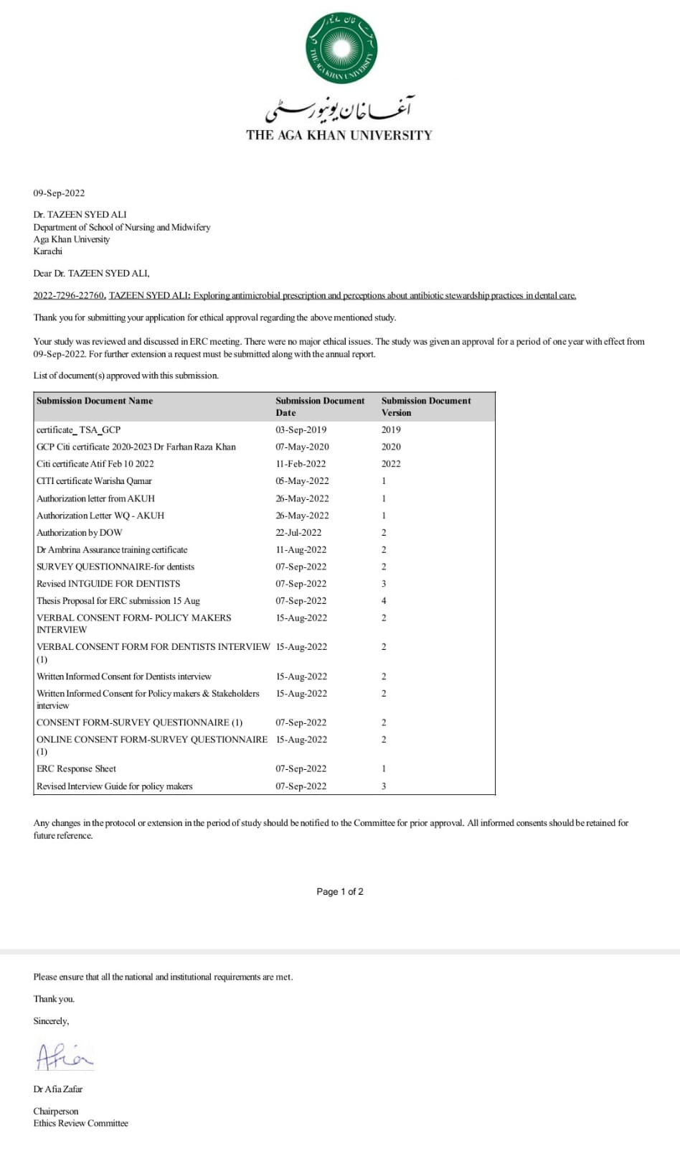

Appendix 3. Interview Guide for Dental Practitioners

Q1. How effective are antibiotics in controlling localized infection? (Rarely helpful)
Q2. What are your thoughts about rational antibiotic prescription?
  - Probe: your selection criteria is according to
- clinical conditions- like abscess, pulpitis etc.,
- antibiotic selection based on causative agents’
Q3. How much rationalized use of antibiotic prescription is practiced in your hospital, from your perspective?
Q4. Do you document the rationale of antibiotic prescribed in the patient’s diagnostic sheet?
Q5. What are other factors which influence you while prescribing antibiotics?
Probe: - Is it factors? like
- clinical uncertainty
- time constraints
- workflow pressure/ high patient load
- patient demand/satisfaction
- when pain is not resolved with operative mediation?
Q6. Are antibiotics sometimes prescribed instead of definitive operative treatment (e.g., root canal treatment, extraction, incision and drainage)? If yes, why?
Q6. Have you ever followed any antibiotic prescription guidelines in your practice?
  - Probe: - Does your institution have any guidelines available? Does anyone review or question your antibiotic prescriptions in this institution?
Q7. What are your thoughts about antimicrobial resistance?
Q8. What do you know about antimicrobial stewardship?
Q9. Do you educate your patients about taking antibiotics as prescribed? And the repercussion of misuse (harm) caused by resistant organisms?
Q10. Have you ever attended any awareness workshop or webinar regarding improving antibiotic prescription – adopting antimicrobial stewardship practices? Yes/ no?
  - Probe: - Will education programmes for continuum of dental professional on antibiotic resistance, prescribing & stewardship are needed for improving your prescription practices?

Appendix 4: Interview Guide for Policy Experts & Stakeholders

Q1: How often is a focused needs assessment or situational analysis of antibiotic use conducted at your facility for the dental department?
Q2: Kindly give us an overview of existing guidelines, plans, or policies regarding antimicrobial stewardship practices for dental care available at your organization.
- Probe: How accessible are these documents at your level and the dental healthcare providers’ level? Please explain
Q3: What strategies exist in enforcing the code of conduct (Guidelines) for appropriate prescribing practices & policies regarding AMS in your institution?
- Probe: Is there any team that optimizes dental antibiotic prescription, if in line with best practices or not?
Q4: Are existing dental antibiotic guidelines locally adapted or mainly based on international guidance?
Q5: In your opinion, does the overuse of antibiotics in dental care affect the effectiveness of antibiotics in resolving dental infections over time?
Q6: Is dentistry represented in the antimicrobial stewardship committee? If not, why?
Q7: Is outpatient dental antibiotic prescribing electronically captured or retrievable in your system?
Q8: What are the factors contributing to the reduced uptake or implementation of antimicrobial stewardship in dentistry?
- Institutional level factors- what is the lack of awareness? workload? other systems factors- system readiness/openness to change? (Including management capacity/human resources, supervision systems, supply systems, role of professional associations, job satisfaction, de-motivation, and burnout including perceptions of organizational justice?
- Personal level factors- patients satisfaction, attitude, stigma, motivation?
- Governance level issues (leadership, deployment, accountability)
- Community level factors (ignorance, culture, religion)
Q9: How can existing interventions be improved to deal with improper prescription practices in dentistry?
- Probe: If none of the interventions exist, what are the potential & effective ways by which ASP can be introduced in our dental healthcare facilities?
Q10: Is there any policy for quarterly or yearly dental clinical audit to optimize antimicrobial prescription by dentists?
- Probe: Do you think clinical audit will help optimize and monitor antibacterial usage?

