Supplementary Materials

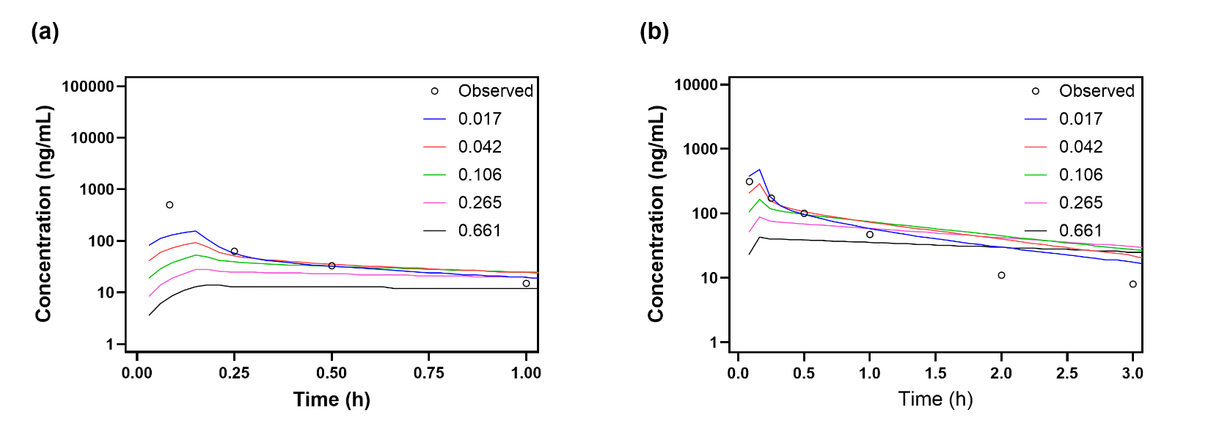
Fig. S1. Sensitivity analysis of BPR on MTMSA-Trp monkey PBPK model prediction at (a) 1.34 µg/kg and (b) 4.19 µg/kg following 10-minute IV infusion. Solid lines and circles are the PBPK predictions and observations, respectively.

Table S1. Predictive performance of the MTM PBPK model for human plasma PK using three clearance prediction methods.
CL prediction method | AUC |  |  | Concentration
CL prediction method | AUC_{Obs} (ng/mL.h) | AUC_{Pred} (ng/mL.h) | AUC_{Pred/Obs} Ratio | AFE | RMSE
Additional clearance | 136 | 143 | 1.05 | 0.52 | 0.61
Allometric scaling | 136 | 1482 | 10.9 | 10.66 | 1.06
Single species scaling | 136 | 856 | 6.29 | 6.51 | 0.84
Note: AUCs were calculated using extracted or predicted concentrations for 24 hours following the first dose. AFE and RMSE were calculated using extracted or predicted concentration-time points across the 7-day dosing period.

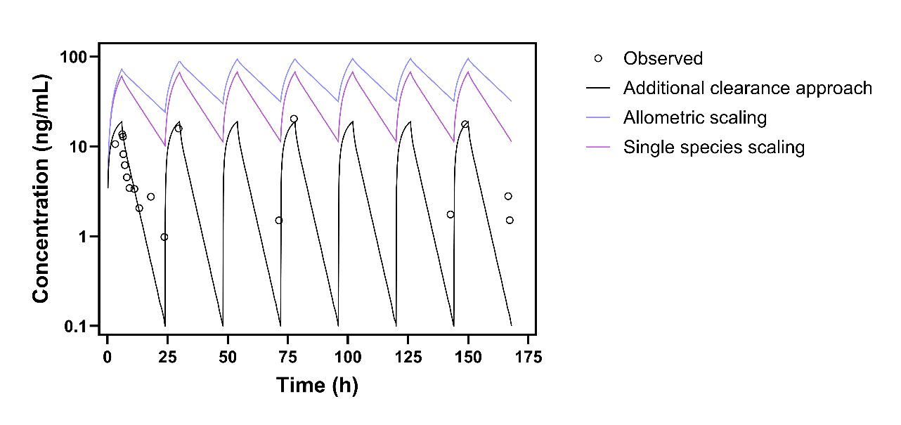
Fig. S2. Human MTM plasma PK predictions using three clearance prediction methods (solid lines) compared with observed clinical plasma PK (open circles).

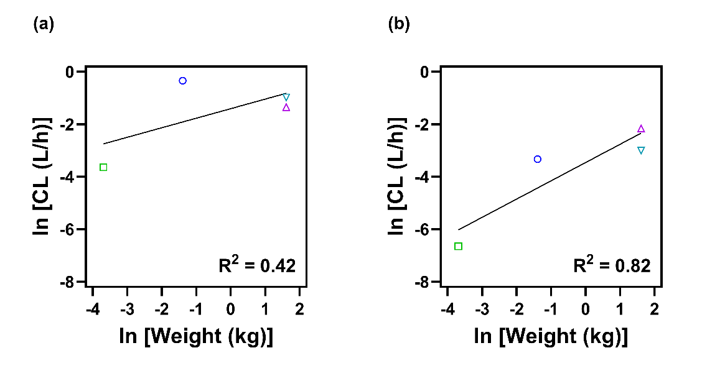
Fig. S3. Human clearance projections of (a) MTM and (b) MTMSA-Trp using allometric scaling. Symbols represent species body weights and solid lines represent linear regression fit.

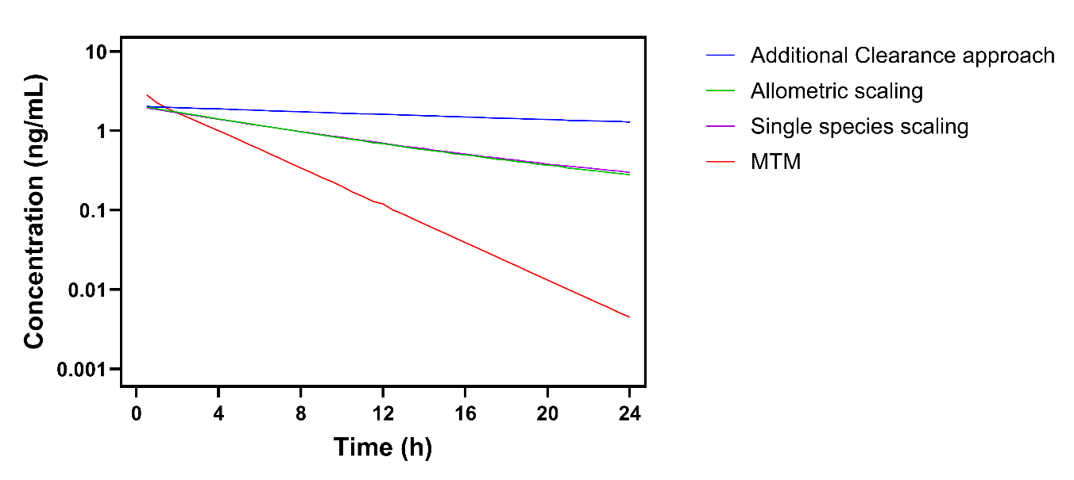
Fig. S4. Exploratory human liver concentration-time profiles of MTMSA-Trp and MTM generated by PBPK modeling. MTMSA-Trp liver profiles were projected using three human clearance prediction methods and compared with the MTM liver profile generated with the additional clearance approach. PBPK simulations were conducted at a single 13 µg/kg IV bolus dose in a 13-year-old, 50-kg male.

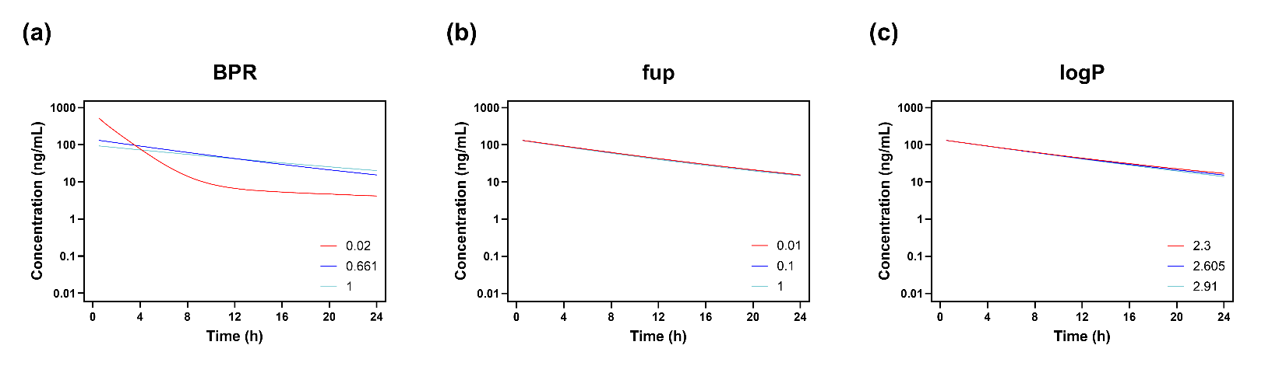
Fig. S5. Parameter sensitivity analysis of projected human plasma PK for MTMSA-Trp for (a) blood-to-plasma ratio (BPR), (b) fraction unbound in plasma (fup), and (c) lipophilicity (logP). PBPK simulations were conducted at a single 13 µg/kg IV bolus dose in a 13-year-old, 50-kg male using human clearance predicted by allometric scaling (Method 2).

