FDM Printing of Aluminum Feedstocks with focus on the debinding process
Differential scanning calorimetry (DSC) analysis
DSC measurements were performed to further elucidate the thermal reactions occurring during debinding. For the Al-EnCeram feedstock, the non-solvent-debound sample exhibits a pronounced exothermic region between 120 and 200 °C. Deconvolution of this region reveals two overlapping exothermic peaks, indicating multiple thermally activated processes occurring within this temperature range. The peak intensities are significantly higher compared to those of the solvent-debound sample, confirming that the presence of the soluble binder components contributes to a stronger exothermic response. This observation supports the kinetic analysis, where a reduced apparent activation energy was associated with the additional heat release in the non-solvent-debound specimens.
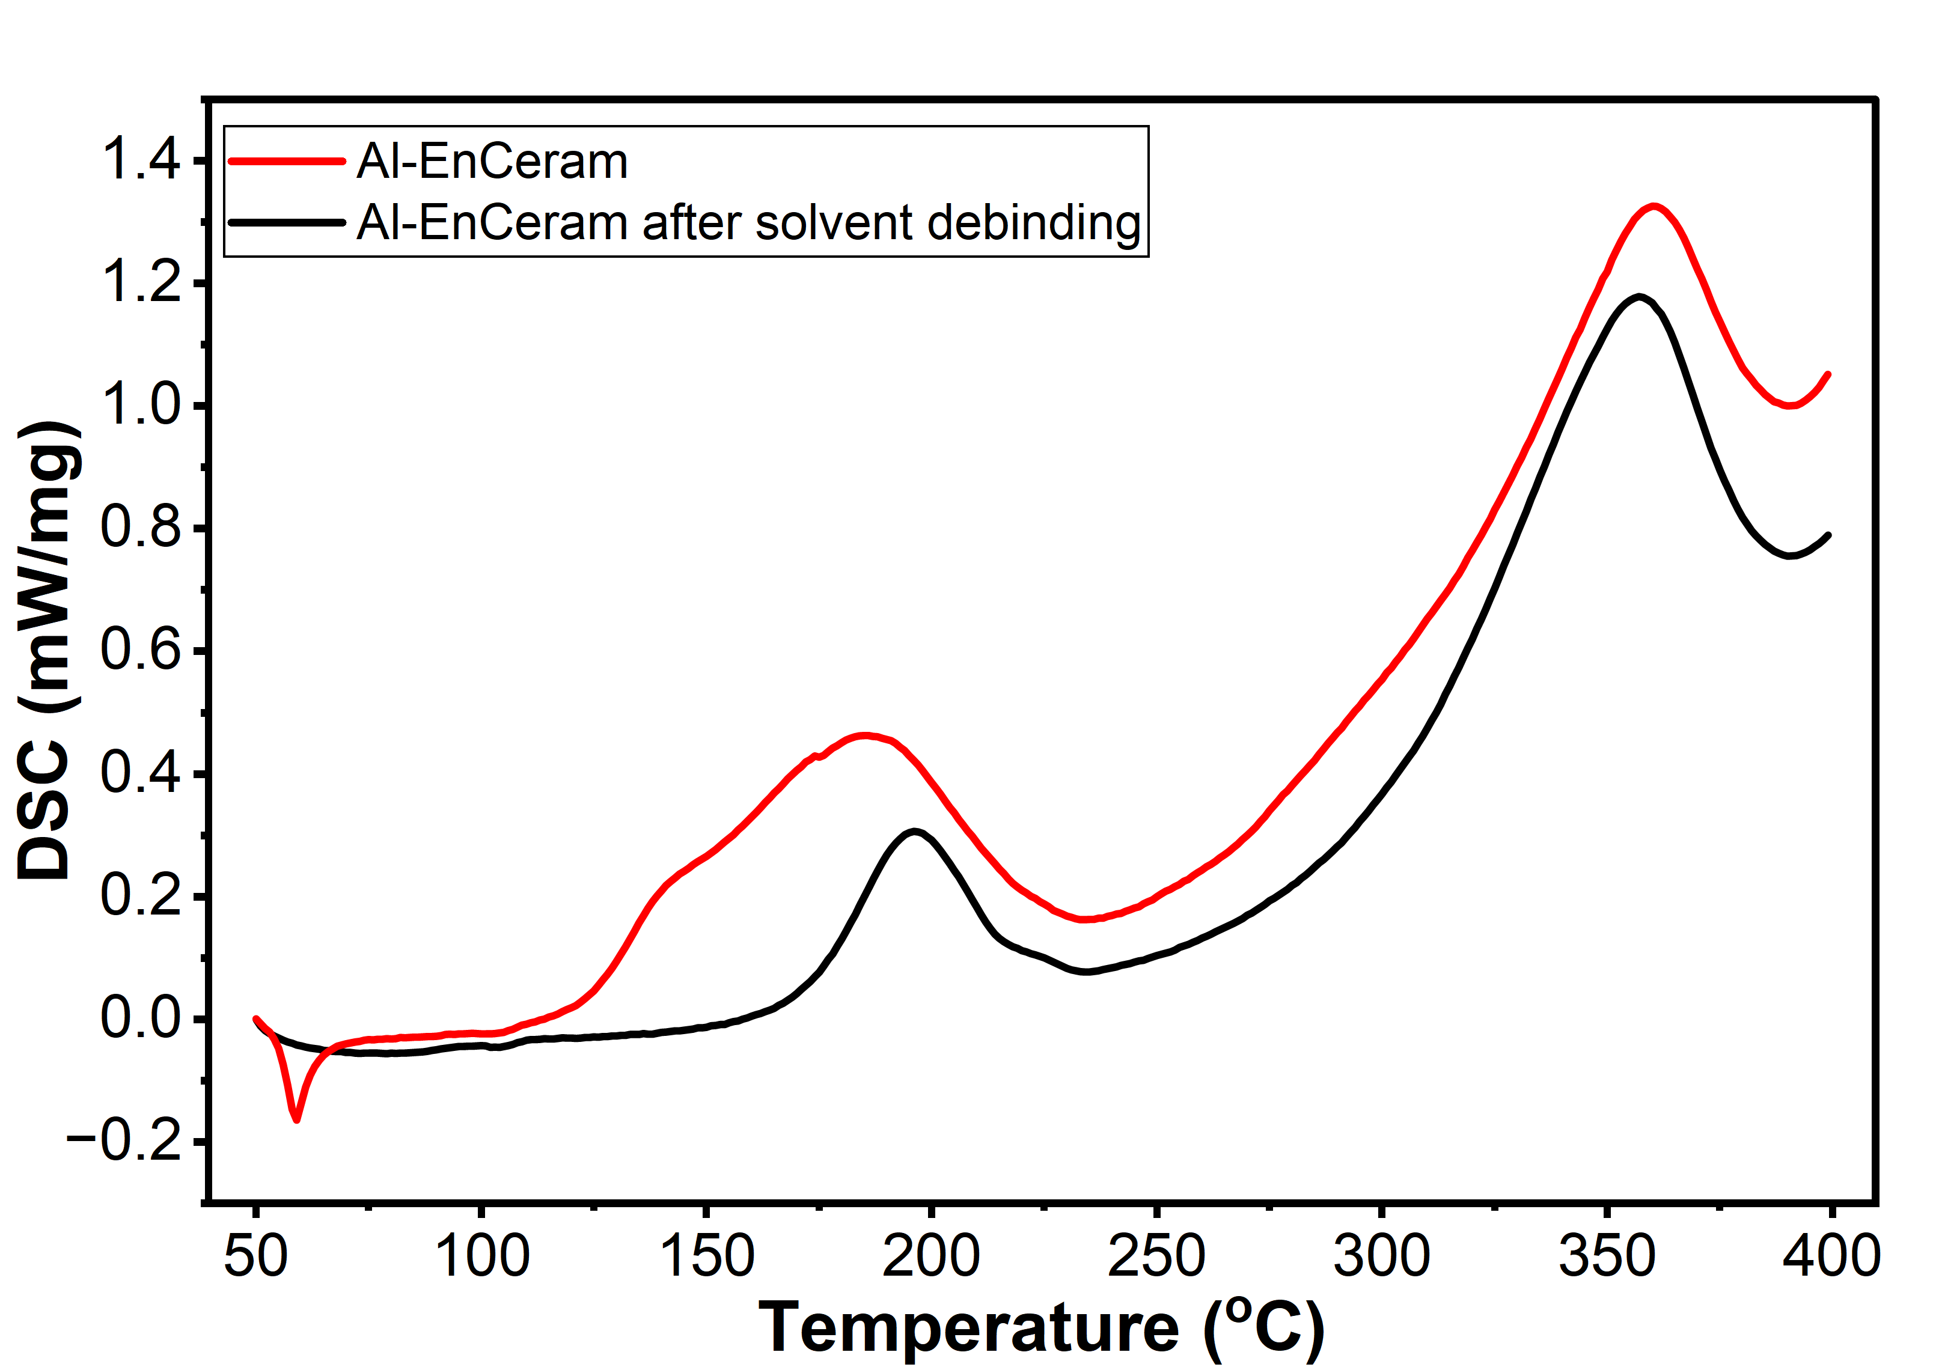
Fig S1 DSC curves of Al-EnCeram printed parts with and without prior solvent debinding.
For the Al-Kcmix system, a more pronounced exothermic signal is observed at temperatures above 300 °C for the sample without prior solvent debinding. The higher heat flow in this temperature range further confirms the occurrence of exothermic reactions during binder decomposition, consistent with the conversion rate peaks identified in the kinetic analysis.

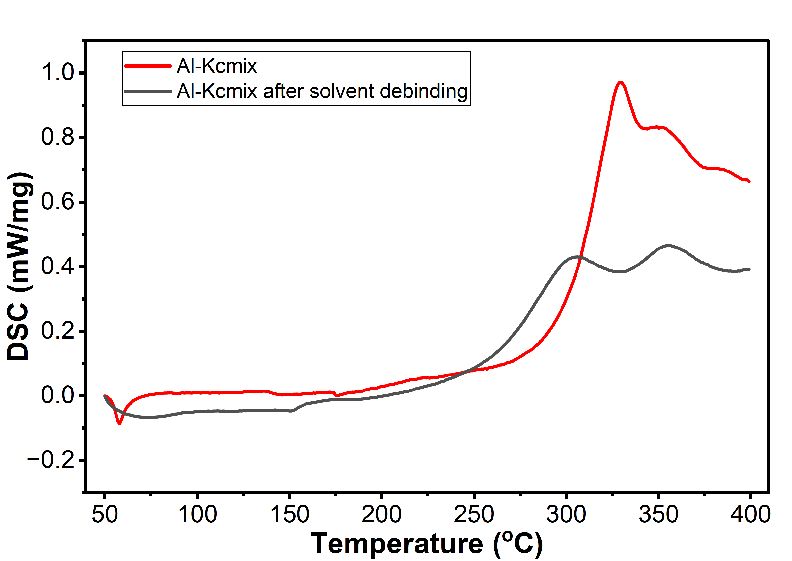
Fig S2 DSC curves of Al-Kcmix printed parts with and without prior solvent debinding.

