Complex non-falciparum transmission and widespread insecticide resistance in Penka-Michel, a hyperendemic malaria focus of the Cameroon highlands.
Belinda Claire Kiam^{1,2}, Ibrahima Ibrahima^{1,2}, Aline Gaëlle Bouopda-Tuedom², Jean Arthur Mbida Mbida¹, Luc Abate³, Samuel J. White⁴, Charlène Tina Nanssong V.^{1,2}, Brigitte Fotso Tumamo², Isabelle Morlais³, Lawrence Ayong², Jessica T. Lin^{4‡}, Innocent Mbulli Ali^{5‡}, Jonathan J. Juliano^{4‡}, Rhoel R. Dinglasan^{6‡*}, Sandrine Eveline Nsango^{2,7*‡}

Supplemental Table S1……………………………………………………………………….. 2
Supplemental Table S2……………………………………………………………………….. 4
Supplemental Table S3……………………………………………………………………….. 5
Supplemental Table S4……………………………………………………………………….. 6
Supplemental Table S5……………………………………………………………………….. 7
Supplemental Table S6……………………………………………………………………….. 8
Supplemental Table S7……………………………………………………………………….. 9
Supplemental Table S8……………………………………………………………………….. 10
Supplemental Figure S1……………………………………………………………………… 11
Supplemental Figure S2……………………………………………………………………… 11
Supplemental Figure S3……………………………………………………………………… 12
Supplemental Figure S4……………………………………………………………………… 13
Supplemental Figure S5……………………………………………………………………… 14
Supplemental Figure S6……………………………………………………………………… 15

Supplemental tables

Table S1: Malaria qPCR methods.
Plasmodium species (18S)
Adapted from | Mangold et al., 2005
PL1473 Forward 18S | 5’-TAA CGA ACG AGA TCT TAA-3’
PL1679 Reverse 18S | 5’-GTT CCT CTA AGA AGC TTT-3’
Cycling conditions | 1 cycle | 1 cycle | 45 cycles
Temperature (°C) | 95 | 72 | 95 | 50
Time | 10 min | 20 s | 10 s | 5 s
Reaction conditions | HOT FIREPol® Evagreen® qPCR Mix Plus (ROX), 5x
 | PL1473F18 | 300 nM
 | PL1679R18 | 300 nM
 | Template DNA | 1 µL
 | Total volume | 10 µL
Plasmodium ovale (18S)
Adapted from | Mitchell et al., 2011
Forward primer | 5’-CCRACTAGGTTTTGGATGAAAVRTTTTT-3’
Reverse primer | 5'-AACCCAAAGACTTTGATTTCTCATAA-3’
Probe (VIC) | 5’-VIC/CRA AAGGAATTYTCTTATT /MGB-3’
Cycling conditions | 1 cycle | 1 cycle | 45 cycles
Temperature (°C) | 95 | 50 | 95 | 52
Time | 10 min | 2 min | 15 s | 1 min
Reaction conditions | 2X TaqMan Master mix
 | Fwd primer | 400 nM
 | Rev primer | 400 nM
 | Probe | 200 nM
 | gDNA | 2 µL
 | Total volume | 10 µL
Plasmodium vivax (18S)
Adapted from | Brazeau et al., 2021
Forward primer | 5’-ACGCTTCTAGCTTAATCCACATAACT-3’
Reverse primer | 5’-ATTTACTCAAAGTAACAAGGACTTCCAAGC-3’
Probe (FAM) | 5'-/56-FAM/TTCGTATCG/ZEN/ACTTTGTGCGCATTTTGC/3IABkFQ/-3’
Cycling conditions | 1 cycle | 1 cycle | 45 cycles
Temperature (°C) | 95 | 50 | 95 | 60
Time | 10 min | 2 min | 15 s | 1 min
Reaction conditions | 2X TaqMan Master mix
 | Fwd primer | 400 nM
 | Rev primer | 400 nM
 | Probe | 200 nM
 | gDNA | 2 µL
 | Total volume | 10 µL
Plasmodium ovale subspecies (18S)
Adapted from | Potlapalli et al., 2023
Forward primer (Poc) | 5’TTTTGAAGAATACATTAGGATACAATTAATG-3’
Reverse primer (Poc) | 5’-CATCGTTCCTCTAAGAAGCTTTACAAT-3’
Probe Poc (VIC) | 5’-CCTTTTCCCTATTCTACTTAATTCGCAATTCATG-3’
Forward primer (Pow) | 5’-TTTTGAAGAATATATTAGGATACATTATAG-3’
Reverse primer (Pow) | 5’-CATCGTTCCTCTAAGAAGCTTTACAAT-3’
Probe Pow (FAM) | 5’-CCTTTTCCCTTTTCTACTTAATTCGCTATTATG -3’
Cycling conditions | 1 cycle | 1 cycle | 50 cycles
Temperature (°C) | 95 | 60 | 95 | 52.8
Time | 10 min | 1 min | 15 s | 30 s
Reaction conditions | 2X TaqMan Master mix
 | Fwd primer | 300 nM
 | Rev primer | 300 nM
 | Probe | 200 nM
 | gDNA | 2 µL
 | Total volume | 10 µL

Table S2: Resistance PCR primers, probes, and reaction conditions.
Genes | Primers and probes (concentrations) | 5′ modifications | Sequences | Reaction condition
L1014F-kdr | Agd1 | - | ATAGATTCCCCGACCATG | 1 cycle: 94 °C for 3 min  35 cycles: 94 °C for 30 s,  55 °C for 30 s, 72 °C for  10 s  1 cycle: 72 °C for 5 min
L1014F-kdr | Agd2 | - | AGACAAGGATGATGAACC
L1014F-kdr | Agd3 | - | AATTTGCATTACTTACGACA
L1014F-kdr | Agd4 | - | CTGTAGTGATAGGAAATTTA
N1575Y | Forward (1 µM) | - | TGGATCGCTAGAAATGTTCATGACA | 1 cycle: 15 min at 95 °C  40 cycles: 15 s at 94 °C,  1 min at 60 °C
N1575Y | Reverse (1 µM) | - | CGAGGAATTGCCTTTAGAGGTTTCT
N1575Y | Probe WT (0.5 µM) | HEX | ATTTTTTTCATTGCATTATAGTAC
N1575Y | Probe MUT (0.5 µM) | FAM | TTTTTCATTGCATAATAGTAC
G119S-Ace 1 | Forward |  | GGCCGTCATGCTGTGGAT | 95°C | 95°C 60°C |  10’ | 10” 35” |  X40 cycles
G119S-Ace 1 | Reverse |  | GCGGTGCCGGAGTAGA | 95°C | 95°C 60°C |  10’ | 10” 35” |  X40 cycles
G119S-Ace 1 | Probe WT | HEX | TTCGGCGGC/ZEN/GGCT/3IABKFQ | 95°C | 95°C 60°C |  10’ | 10” 35” |  X40 cycles
G119S-Ace 1 | Probe MUT | FAM | TTCGGCGGC/ZEN/AGCT/3IABKFQ | 95°C | 95°C 60°C |  10’ | 10” 35” |  X40 cycles
CYP6P3 | Forward |  | AATACACTTAAGACGACCGACTC | 95°C | 95°C 60°C |  10’ | 10” 45” |  X40 cycles
CYP6P3 | Reverse |  | GCGAGGAAGGTCTTCATCAT | 95°C | 95°C 60°C |  10’ | 10” 45” |  X40 cycles
CYP6P3 | Probe MUT | FAM | AC+TTGCG+GA+A+G+TC/3IABKFQ | 95°C | 95°C 60°C |  10’ | 10” 45” |  X40 cycles
CYP6P3 | Probe -WT | HEX | ACTTG+CG+GA+A+C+TC/3IABKFQ | 95°C | 95°C 60°C |  10’ | 10” 45” |  X40 cycles
L119F-GSTe2 | Forward (1 µM) | - | AACAATTTTTCATTTCTTATTCTCATTTAC | 1 cycle: 10 min at 95 °C  40 cycles: 15 s at 92 °C  and 1 min at 60 °C
L119F-GSTe2 | Reverse (1 µM) | - | CGACTCGATCTTCGGGAATGTC
L119F-GSTe2 | Probe MUT (0.5 µM) | FAM | AGGAGCGTATTCTTTTCTAC
L119F-GSTe2 | Probe WT (0.5 µM) | HEX | AGGAGCGTATTTTTTTCTA
CYP6P9a | Forward (1 µM) | - | TCCCGAAATACAGCCTTTCAG | 1 cycle: 95 °C for 3 min  40 cycles: 94 °C for 30 s,  55 °C for 30 s, 72 °C for  1 min  1 cycle: 72 °C for 10 min
CYP6P9a | Reverse (1 µM) | - | ATTGGTGCCATCGCTAGAAG
CYP6P9b | Forward (1 µM) | - | CCCCCACAGGTGGTAACTATCTGAA | 1 cycle: 95 °C for 3 min  40 cycles: 94 °C for 30 s,  58 °C for 30 s, 72 °C for  1 min  1 cycle: 72 °C for 10 min
CYP6P9b | Reverse (1 µM) | - | TTATCCGTAACTCAATAGCGATG

Table S3: Monthly collected mosquito composition.
Months | Anopheles | Aedes | Culex | Mansonia | Coquillettidia | Total | Percentage
Sept-23 | 1008 | 11 | 3 | - | 1 | 1023 | 16.06
Oct-23 | 972 | 37 | 16 | - | 1 | 1026 | 16.10
Nov-23 | 781 | 2 | 8 | 2 | - | 793 | 12.45
Dec-23 | 153 | 1 | 1 | - | - | 155 | 2.43
Jan-24 | 45 | - | - | - | - | 45 | 0.71
Feb-24 | 46 | 1 | 2 | 2 | - | 51 | 0.80
Mar-24 | 166 | 11 | 4 | - | - | 181 | 2.84
Apr-24 | 524 | 10 | 16 | - | - | 550 | 8.63
May-24 | 841 | 34 | 17 | 1 | - | 893 | 14.02
Jun-24 | 785 | 6 | 15 | - | - | 806 | 12.65
Jul-24 | 458 | 1 | 9 | - | - | 468 | 7.35
Aug-24 | 373 | 2 | 5 | - | - | 380 | 5.96
Total | 6152 | 116 | 96 | 5 | 2 | 6371 | 100.00

Table S4: Monthly variation in the abundance of Anopheles species collected.
Months | An. gambiae s.l. |  | An. funestus s.l. |  | An. ziemanni |  | Total  (n) | Density  (D) | Percentage  (%)
 | Ind | Out | Ind | Out | Ind | Out
Sept-23 | 318 | 368 | 127 | 149 | 14 | 32 | 1008 | 100.8 | 16.4
Oct-23 | 170 | 233 | 117 | 139 | 140 | 173 | 972 | 162 | 15.8
Nov-23 | 184 | 144 | 77 | 68 | 115 | 193 | 781 | 130.17 | 12.7
Dec-23 | 17 | 6 | 9 | 10 | 42 | 69 | 153 | 25.5 | 2.5
Jan-24 | 6 | 10 | 12 | 9 | - | 8 | 45 | 7.5 | 0.7
Feb-24 | 6 | 13 | 12 | 15 | - | - | 46 | 7.67 | 0.7
Mar-24 | 45 | 33 | 34 | 54 | - | - | 166 | 27.67 | 2.7
Apr-24 | 140 | 166 | 93 | 124 | - | 1 | 524 | 87.33 | 8.5
May-24 | 146 | 140 | 245 | 309 | - | 1 | 841 | 140.17 | 13.7
Jun-24 | 124 | 63 | 317 | 273 | 4 | 4 | 785 | 130.84 | 12.8
Jul-24 | 114 | 80 | 132 | 118 | 8 | 6 | 458 | 76.33 | 7.4
Aug-24 | 59 | 51 | 132 | 112 | 10 | 9 | 373 | 62.17 | 6.1
Total | 2636 |  | 2687 |  | 829 |  | 6152 | 958.15 | 100.00
Ind: Indoor; Out: Outdoor; F=4.61, df=11, p<0.001

Table S5: Entomological indices of collected Anopheles between seasons during the study period.
Species | Biting place | N° captured | N° tested | IR % (N° Infected) | HBR (b/h/n) | EIR (ib/h/n)
(a) Rainy season
An. funestus s.l. | Indoor | 1240 | 400 | 8.5 (34) | 15.5 | 1.3
An. funestus s.l. | Outdoor | 1292 | 400 | 9.3 (37) | 16.2 | 1.5
An. funestus s.l. | Total | 2532 | 800 | 8.9 (71) | 15.8 | 1.4
An. gambiae s.l. | Indoor | 1255 | 400 | 4.5 (18) | 15.7 | 0.7
An. gambiae s.l. | Outdoor | 1245 | 400 | 7.0 (28) | 15.6 | 1.0
An. gambiae s.l. | Total | 2500 | 800 | 5.8 (46) | 15.6 | 0.9
An. ziemanni | Indoor | 291 | 138 | 0.7 (1) | 3.6 | 0.03
An. ziemanni | Outdoor | 419 | 153 | 2.0 (3) | 5.2 | 0.1
An. ziemanni | Total | 710 | 291 | 1.4 (4) | 4.4 | 0.06
Species |  | N° captured | N° tested | IR (N° Infected) | HBR (ib/h/n) | EIR (ib/h/n)
(b) Dry season
An. funestus s.l. | Indoor | 67 | 67 | 1.5 (1) | 1.7 | 0.03
An. funestus s.l. | Outdoor | 88 | 88 | 2.3 (2) | 2.2 | 0.05
An. funestus s.l. | Total | 155 | 155 | 1.9 (3) | 1.9 | 0.04
An. gambiae s.l. | Indoor | 74 | 74 | 4.1 (3) | 1.8 | 0.08
An. gambiae s.l. | Outdoor | 62 | 62 | 3.2 (2) | 1.6 | 0.05
An. gambiae s.l. | Total | 136 | 136 | 3.7 (5) | 1.7 | 0.06
An. ziemanni | Indoor | 42 | 42 | 2.4 (1) | 1.1 | 0.03
An. ziemanni | Outdoor | 77 | 66 | 1.5 (1) | 1.9 | 0.03
An. ziemanni | Total | 119 | 108 | 1.9 (2) | 1.5 | 0.03
IR=Infection Rate, HBR= Human Biting Rate, EIR= Entomological Inoculation Rate, b/h/n= bites/human/night, ib/h/n= infected bites/human/night, N°=Number

Table S6: Seasonal variation in observed and expected heterozygosity, fixation index, and Hardy-Weinberg equilibrium.
Species | Mutation | Ho (%) | He (%) | Fis  (W & C) | HWE  p-value | Interpretation of Panmixia
An. gambiae s.l. | L1014F | 16.75 | 18.32 | +0.085 | 0.03 | Rejected: Slight deficit of heterozygotes (F>0). Indicates inbreeding or population structure.
An. gambiae s.l. | N1575Y | 11.63 | 11.46 | -0.015 | 0.9 | Not Rejected: Close to panmictic equilibrium.
An. gambiae s.l. | G119S-Ace1 | 48.99 | 49.98 | +0.020 | <2.2e-16 | Rejected: Very slight deviation (F close toˆ0), but the HWE test is statistically significant.
An. gambiae s.l. | CYP6P3 | 27.85 | 32.08 | +0.132 | <0.001 | Rejected: Moderate deficit of heterozygotes (F>0). Indicates inbreeding/structure.
An. funestus s.l. | L119F-GSTe2 | 25.58 | 49.37 | +0.482 | <2.2e-16 | Strongly Rejected: Very strong deficit (F close to 0.5). Indicates severe Wahlund effect or high inbreeding.
An. funestus s.l. | CYP6P9a | - | - | - | - | Equilibrium: Allele fixed for susceptibility.
An. funestus s.l. | CYP6P9b | - | - | - | - | Equilibrium: Allele fixed for susceptibility.
An. ziemanni | L1014F | 8.52 | 20.83 | +0.591 | <2.2e-16 | Strongly Rejected: Very strong deficit (F close to 0.6). Severe Wahlund effect or high inbreeding.
FIS: fixation index; Ho: observed heterozygosity; He: expected heterozygosity; HWE: Hardy-Weinberg equilibrium

Table S7: Poisson binomial GLM showing associations between climatic factors and Anopheles species abundance.
Term | IRR | P_value | Species | LCI_95 | UCI_95
(Intercept) | 66.3063290 | 0.0000000 | An.funestus s.l. | 54.3121846 | 80.9492253
scale(as.numeric(Temp)) | 1.0261596 | 0.8780003 | An.funestus s.l. | 0.7379414 | 1.4269473
scale(as.numeric(Rain)) | 1.2997715 | 0.0468370 | An.funestus s.l. | 1.0036745 | 1.6832211
scale(as.numeric(Humidity)) | 2.5934785 | 0.0004953 | An.funestus s.l. | 1.8989549 | 3.5420171
scale(as.numeric(Wind)) | 0.8274142 | 0.1787978 | An.funestus s.l. | 0.6277395 | 1.0906026
Locationoutdoor | 1.0668151 | 0.2995082 | An.funestus s.l. | 0.9441147 | 1.2054620
(Intercept) | 66.3369222 | 0.0000000 | An.gambiae s.l. | 51.3441478 | 85.7076696
scale(as.numeric(Temp)) | 0.7838779 | 0.2451473 | An.gambiae s.l. | 0.5198869 | 1.1819197
scale(as.numeric(Rain)) | 0.8594780 | 0.3664637 | An.gambiae s.l. | 0.6187420 | 1.1938778
scale(as.numeric(Humidity)) | 3.1597298 | 0.0008105 | An.gambiae s.l. | 2.1492322 | 4.6453298
scale(as.numeric(Wind)) | 0.5824614 | 0.0023265 | An.gambiae s.l. | 0.4113194 | 0.8248122
Locationoutdoor | 0.9216790 | 0.4185564 | An.gambiae s.l. | 0.7564135 | 1.1230526
(Intercept) | 2.3831481 | 0.1701052 | An.ziemanni | 0.6891615 | 8.2410218
scale(as.numeric(Temp)) | 0.0130476 | 0.0030513 | An.ziemanni | 0.0007393 | 0.2302868
scale(as.numeric(Rain)) | 0.3026961 | 0.0577610 | An.ziemanni | 0.0880909 | 1.0401184
scale(as.numeric(Humidity)) | 1.2129152 | 0.7821017 | An.ziemanni | 0.3088694 | 4.7630595
scale(as.numeric(Wind)) | 0.0820281 | 0.0144118 | An.ziemanni | 0.0110668 | 0.6079971
Locationoutdoor | 1.5098430 | 0.0000088 | An.ziemanni | 1.2590550 | 1.8105848

Table S8: Poisson binomial GLM showing associations between resistance markers and specific infection (Plasmodium spp.).
Term | IRR | P_value | Species | Plasmodium | LCI_95 | UCI_95
(Intercept) | 0.0278710 | 0.0000000 | An.funestus s.l. | Pf | 0.0152634 | 0.0508925
scale(L119F.Gste2) | 1.6269024 | 0.1414694 | An.funestus s.l. | Pf | 0.8503872 | 3.1124780
(Intercept) | 0.0056690 | 0.0000000 | An.funestus s.l. | Pm | 0.0018965 | 0.0169458
scale(L119F.Gste2) | 1.8195371 | 0.3439622 | An.funestus s.l. | Pm | 0.5267088 | 6.2856654
(Intercept) | 0.0026362 | 0.0000000 | An.funestus s.l. | Po | 0.0003326 | 0.0208913
scale(L119F.Gste2) | 1.1545224 | 0.0329162 | An.funestus s.l. | Po | 1.01015553 | 1.3184439
(Intercept) | 0.0255691 | 0.0000000 | An.gambiae s.l. | Pf | 0.0168322 | 0.0388410
scale(CYP6P3) | 1.3793478 | 0.3383139 | An.gambiae s.l. | Pf | 0.7141144 | 2.6642793
scale(G119S.Ace1) | 0.9942650 | 0.9802539 | An.gambiae s.l. | Pf | 0.6305208 | 1.5678513
scale(L1014F) | 1.0019496 | 0.9956919 | An.gambiae s.l. | Pf | 0.4940808 | 2.0318599
scale(N1575Y) | 0.8285983 | 0.6008641 | An.gambiae s.l. | Pf | 0.4096639 | 1.6759477
(Intercept) | 0.0100223 | 0.0000000 | An.gambiae s.l. | Pm | 0.0049322 | 0.0203654
scale(CYP6P3) | 0.5446662 | 0.2871372 | An.gambiae s.l. | Pm | 0.1779332 | 1.6672623
scale(G119S.Ace1) | 1.1325883 | 0.7478528 | An.gambiae s.l. | Pm | 0.5301553 | 2.4195859
scale(L1014F) | 2.8083089 | 0.0421506 | An.gambiae s.l. | Pm | 1.0372994 | 7.6030114
scale(N1575Y) | 2.2052842 | 0.1418203 | An.gambiae s.l. | Pm | 0.7677554 | 6.3344108
(Intercept) | 0.0053118 | 0.0000000 | An.gambiae s.l. | Po | 0.0018810 | 0.0149996
scale(CYP6P3) | 1.7925199 | 0.3308177 | An.gambiae s.l. | Po | 0.5528651 | 5.8117751
scale(G119S.Ace1) | 1.1501514 | 0.7970330 | An.gambiae s.l. | Po | 0.3960574 | 3.3400418
scale(L1014F) | 1.4973818 | 0.5933249 | An.gambiae s.l. | Po | 0.3402755 | 6.5892270
scale(N1575Y) | 1.7880593 | 0.3975532 | An.gambiae s.l. | Po | 0.4652405 | 6.8720508
(Intercept) | 0.0093061 | 0.0000000 | An.ziemanni | Pf | 0.0029865 | 0.0289983
scale(L1014F) | 0.6987142 | 0.7558440 | An.ziemanni | Pf | 0.0729246 | 6.6946047
(Intercept) | 0.0011488 | NaN | An.ziemanni | Pm | NaN | NaN
scale(L1014F) | 0.0961698 | NaN | An.ziemanni | Pm | NaN | NaN
(Intercept) | 1.3913780 | NaN | An.ziemanni | Po | NaN | NaN
scale(L1014F) | 2.4796394 | NaN | An.ziemanni | Po | NaN | NaN
NaN = Not a Number; Pf= Plasmodium falciparum; Pm= Plasmodium malariae; Po= Plasmodium ovale

Supplemental Figures

Figure S1: Anopheles species composition. The inner ring represents the proportional distribution of the total number of mosquitoes collected. The outer ring displays the species-specific breakdown determined by molecular identification from a representative subsample within the An. gambiae complex and An. funestus group.
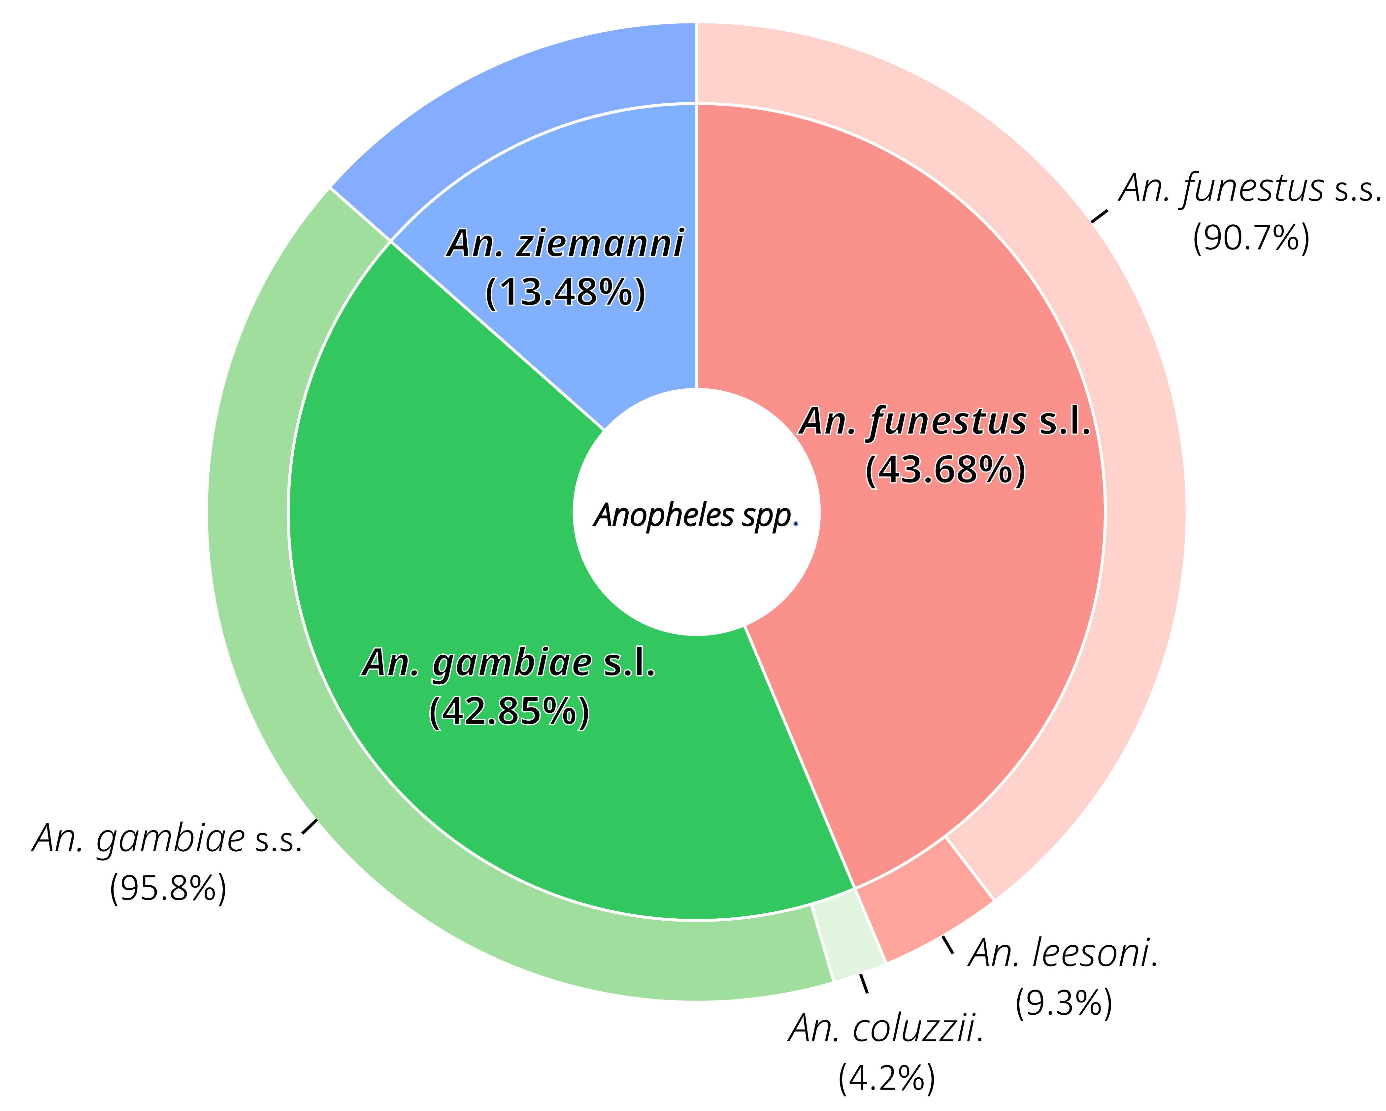
Figure S2: Hourly variations of the human biting rates of Anopheles mosquitoes.
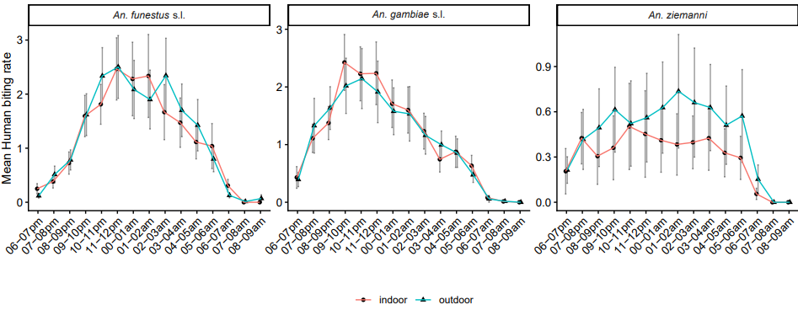
Figure S3: Seasonal variation in the parity of anopheline species during the study period.
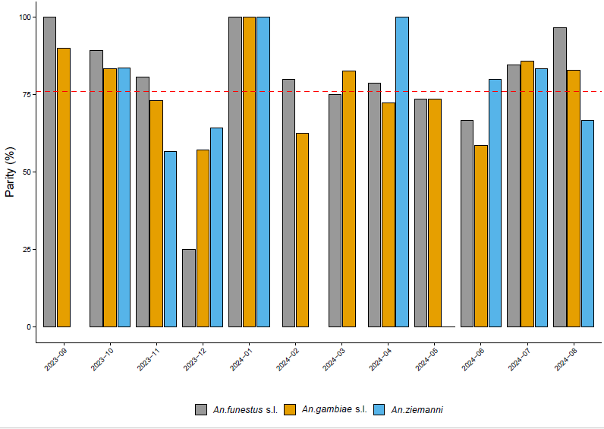

Figure S4: Monthly variation of infection rate (IR) and human biting rates of anopheline species during the study period.
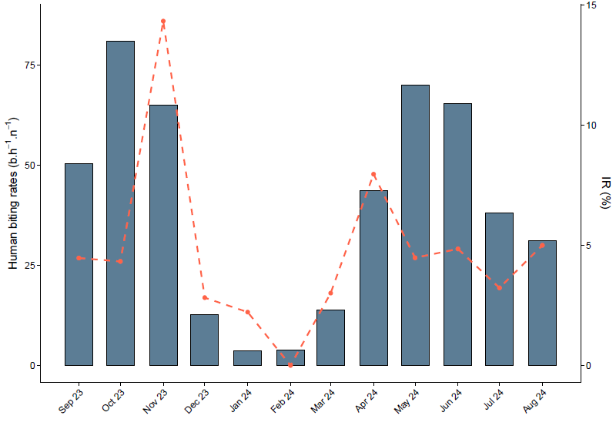

Figure S5: Monthly genotype variation of insecticide resistance in Anopheles species. Stacked area plots illustrate genotypic seasonal fluctuations in vector resistance to insecticide (resistant homozygous (RR) in orange, sensitive homozygous (SS) in blue, and heterozygous (RS) in green).
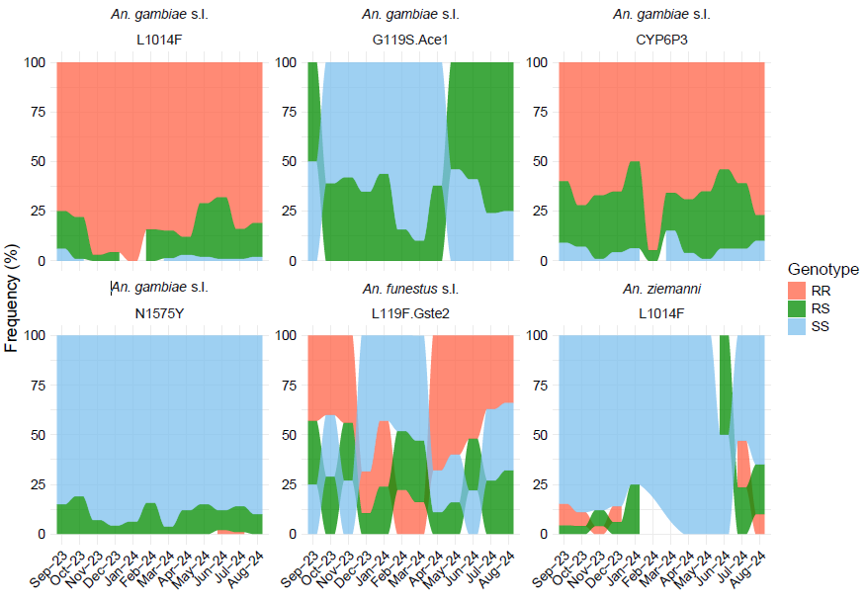

Figure S6: Allelic resistance frequency variation between seasons in anopheline species. The bar plots illustrate the frequency (%) of susceptible (S, blue) versus resistant (R, red) alleles during the dry and rainy seasons.
