Supplementary Table 1. Standardized mean difference of covariates before and after propensity score matching

Covariate | before propensity score matching |  |  |  |  |  |  |  |  | after propensity score matching
 | ACA normal anatomy  N = 300 |  | ACA variant anatomy  N = 64 |  | SMD |  |  |  |  | ACA normal anatomy  N = 64 |  | ACA variant anatomy  N = 64 |  |  | SMD
Age in years (mean) | 59.7 |  | 60.9 |  | 0.1 |  |  |  |  | 62.2 |  | 60.9 |  |  | -0.1
unruptured aneurysm (%) | 59.3 |  | 54.7 |  | - 0.09 |  |  |  |  | 48.4 |  | 54.7 |  |  | 0.12
dome-to-neck ratio | 1.52 |  | 1.65 |  | - 0.23 |  |  |  |  | 1.57 |  | 1.65 |  |  | 0.15
branch artery origin (%)
sac | 11.0 |  | 18.7 |  | 0.19 |  |  |  |  | 20.3 |  | 18.7 |  |  | - 0.04
neck | 53.4 |  | 46.9 |  | - 0.06 |  |  |  |  | 48.4 |  | 46.9 |  |  | - 0.03
artery | 38.7 |  | 34.3 |  | - 0.09 |  |  |  |  | 31.2 |  | 34.3 |  |  | 0.07
type of treatment, (%)
coiling | 41.3 |  | 42.2 |  | 0.02 |  |  |  |  | 46.9 |  | 42.2 |  |  | -0.09
balloon-assisted coiling | 7.7 |  | 11 |  | 0.10 |  |  |  |  | 11.0 |  | 11.0 |  |  | 0.0
stent-assisted coiling | 13.0 |  | 7.8 |  | - 0.19 |  |  |  |  | 0.6 |  | 7.8 |  |  | 0.06
flow diverter | 29.7 |  | 28.1 |  | - 0.03 |  |  |  |  | 25.0 |  | 28.1 |  |  | 0.07
flow diverter + coiling | 2.7 |  | 3.1 |  | 0.03 |  |  |  |  | 3.1 |  | 3.1 |  |  | 0.0
intrasaccular device | 5.0 |  | 7.8 |  | - 0.10 |  |  |  |  | 7.8 |  | 7.8 |  |  | 0.0
parent artery occlusion | 0.06 |  | 0 |  | - 0.09 |  |  |  |  | 0.0 |  | 0.0 |  |  | 0.0

ACA, anterior cerebral artery; SMD, standardized mean difference.

Supplementary Table 2. Sensitivity analysis for rates of Raymond-Roy class I and class II under different scenarios

scenario | ACA normal  anatomy | ACA variant anatomy | OR (95% CI) # | p*
pro-ACA variant anatomy | 76.5% | 82.4% | 0.7 (0.2 - 2.2) | 0.7
pro-ACA normal anatomy | 91.2% | 67.6% | 3.3 (0.9 - 11.1) | 0.06
observed | 89.7% | 79.3% | 1.5 (0.4 - 6.0) | 0.7

ACA, anterior cerebral artery; OR, odds ratio; CI, confidence interval; #, OR was calculated with ACA variant anatomy serving as the reference; *, significance set at p < 0.05.

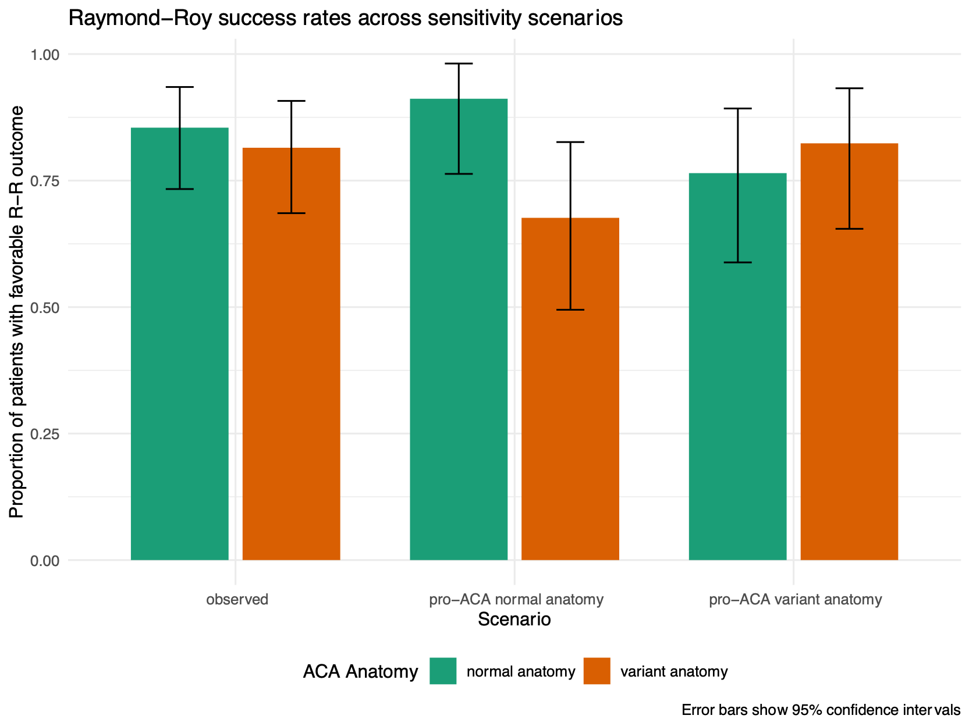

Supplementary Figure 1. Graphic of the sensitivity analysis for rates of Raymond-Roy class I and class II under different scenarios

Supplementary Table 3. Angiographic outcome of the covered vessel by the Flow-Diverter stent in the two subgroups ACA normal anatomy and ACA variant anatomy.

 | Total | Normal | Slow Flow | Occlusion | Symptomatic Ischemic complication | Missing
ACA Normal anatomy | 97 | 72 | 9 | 11 | 0* | 5
ACA variant anatomy | 20 | 11 | 2 | 4 | 0 | 3

*2 cases of asymptomatic thromboembolic complications were recorded.

