Supplementary Figure A1: European clean energy transition manufacturing investments by technology since 2016
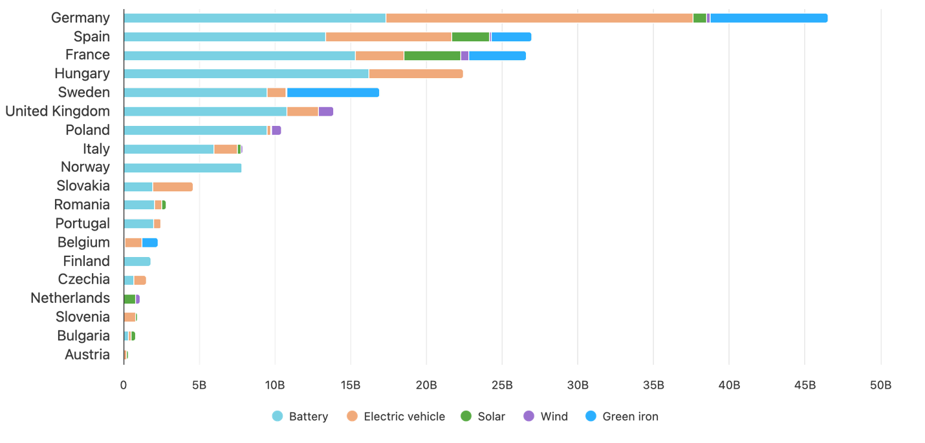
Supplementary Figure A2: European clean energy transition manufacturing investments by country headquarter origin and technology since 2016
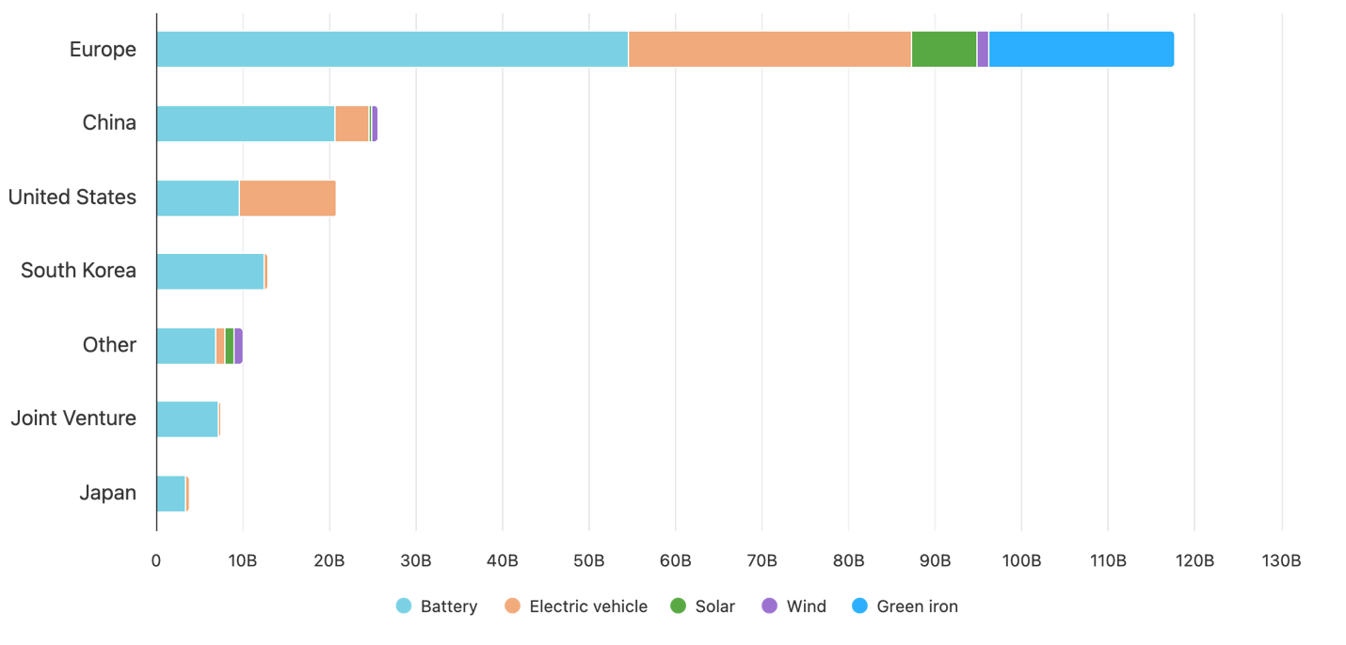
Table A1: Technology and product mapping
Technology | Product | Definition
battery | eam | Electrode active materials including anodes, cathodes, electrolytes and separators
battery | cell | Cell fabrication
battery | module_pack | Assembly of cells to form battery modules and packs
green iron | DRI | The direct chemical reduction of iron ore
solar | ingot_wafer | Polysilicon ingot pulling and wafer slicing
solar | cell | Cell fabrication
solar | module | Assembly of cells to form solar modules
vehicle | electric | Battery electric vehicle assembly, including plug-in hybrid
wind | blade | Rotor blade manufacture
wind | tower | Fabrication and assembly
wind | nacelle | Nacelle housing assembly

Figure A1: Full Knowledge Graph of the European Database
