Table 1. Baseline characteristic.
Feature Name | ALL | Train | Test | P
Age | 50.33±14.62 | 49.41±14.55 | 52.46±14.63 | 0.091
CD3 | 787.30±648.55 | 803.27±644.56 | 750.43±659.64 | 0.226
CD4 | 200.64±239.52 | 196.70±215.08 | 209.73±289.27 | 0.454
CD8 | 556.95±493.74 | 576.04±525.16 | 512.89±411.40 | 0.296
CD4/CD8 | 0.83±6.92 | 0.44±0.59 | 1.71±12.55 | 0.768
WBC | 7.65±26.55 | 6.20±3.54 | 10.99±48.01 | 0.882
RBC | 4.92±18.99 | 5.40±22.64 | 3.80±3.20 | 0.319
Hemoglobin | 98.87±30.28 | 101.14±30.16 | 93.62±30.08 | 0.075
Platelet | 223.72±110.12 | 228.69±108.26 | 212.27±114.08 | 0.327
Neutrophil | 4.56±3.46 | 4.60±3.36 | 4.46±3.71 | 0.61
lymphocyte | 1.07±0.76 | 1.06±0.68 | 1.11±0.93 | 0.783
Monocyte | 0.42±0.24 | 0.42±0.23 | 0.41±0.25 | 0.742
Eosinophils | 0.14±0.20 | 0.14±0.20 | 0.16±0.20 | 0.478
Basophilia | 0.02±0.02 | 0.03±0.02 | 0.02±0.02 | 0.611
CRP | 37.66±48.21 | 36.83±47.48 | 39.58±50.08 | 0.673
Gender |  |  |  | 0.687
Female | 69(22.19) | 50(23.04) | 19(20.21)
Male | 242(77.81) | 167(76.96) | 75(79.79)
Hepatitis B |  |  |  | 0.888
No | 248(79.74) | 174(80.18) | 74(78.72)
Yes | 63(20.26) | 43(19.82) | 20(21.28)
Hypertension |  |  |  | 0.458
No | 279(89.71) | 197(90.78) | 82(87.23)
Yes | 32(10.29) | 20(9.22) | 12(12.77)
Heart Disease |  |  |  | 0.812
No | 281(90.35) | 195(89.86) | 86(91.49)
Yes | 30(9.65) | 22(10.14) | 8(8.51)
Diabetes |  |  |  | 0.032
No | 288(92.60) | 206(94.93) | 82(87.23)
Yes | 23(7.40) | 11(5.07) | 12(12.77)
Smoke |  |  |  | 0.23
No | 229(73.63) | 155(71.43) | 74(78.72)
Yes | 82(26.37) | 62(28.57) | 20(21.28)
Drink |  |  |  | 0.41
No | 251(80.71) | 172(79.26) | 79(84.04)
Yes | 60(19.29) | 45(20.74) | 15(15.96)
Fever |  |  |  | 0.135
No | 194(62.38) | 129(59.45) | 65(69.15)
Yes | 117(37.62) | 88(40.55) | 29(30.85)

Table 2. Univariable and multivariable analysis of clinical features.
Feature Name | OR_UNI | 95% CI_UNI | P | OR_MULTI | 95% CI_MULTI | P
basophilia | <0.05 | 0.0030-0.3480 | <0.05 | <0.05 | 0.0010-0.1240 | <0.05
fever | 0.851 | 0.7600-0.9530 | <0.05 | 0.965 | 0.8620-1.0800 | 0.604
eosinophils | 0.929 | 0.7040-1.2250 | 0.661
Neutrophil | 0.967 | 0.9510-0.9830 | <0.05 | 0.929 | 0.8340-1.0350 | 0.26
WBC | 0.976 | 0.9610-0.9920 | <0.05 | 1.048 | 0.9440-1.1640 | 0.458
CRP | 0.998 | 0.9970-0.9990 | <0.05 | 0.999 | 0.9980-1.0010 | 0.391
platelet | 1.0 | 1.0000-1.0010 | 0.266
CD3 | 1.0 | 1.0000-1.0000 | 0.119
CD8 | 1.0 | 1.0000-1.0000 | 0.762
CD4 | 1.001 | 1.0000-1.0010 | <0.05 | 1.001 | 1.0000-1.0010 | <0.05
Age | 1.001 | 0.9980-1.0050 | 0.551
RBC | 1.002 | 0.9990-1.0040 | 0.281
Hemoglobin | 1.002 | 1.0000-1.0040 | 0.065
Gender | 1.076 | 0.9410-1.2290 | 0.368
Smoke | 1.095 | 0.9670-1.2400 | 0.231
Monocyte | 1.096 | 0.8600-1.3980 | 0.533
Lymphocyte | 1.125 | 1.0360-1.2210 | <0.05 | 0.963 | 0.8260-1.1220 | 0.682
Diabetes | 1.135 | 0.8780-1.4670 | 0.415
heart disease | 1.143 | 0.9490-1.3770 | 0.236
Drink | 1.143 | 0.9960-1.3130 | 0.111
Hepatitis B | 1.15 | 0.9990-1.3230 | 0.102
CD4/CD8 | 1.19 | 1.0830-1.3070 | <0.05 | 0.964 | 0.8390-1.1100 | 0.668
Hypertension | 1.294 | 1.0670-1.5680 | <0.05 | 1.098 | 0.9120-1.3220 | 0.406

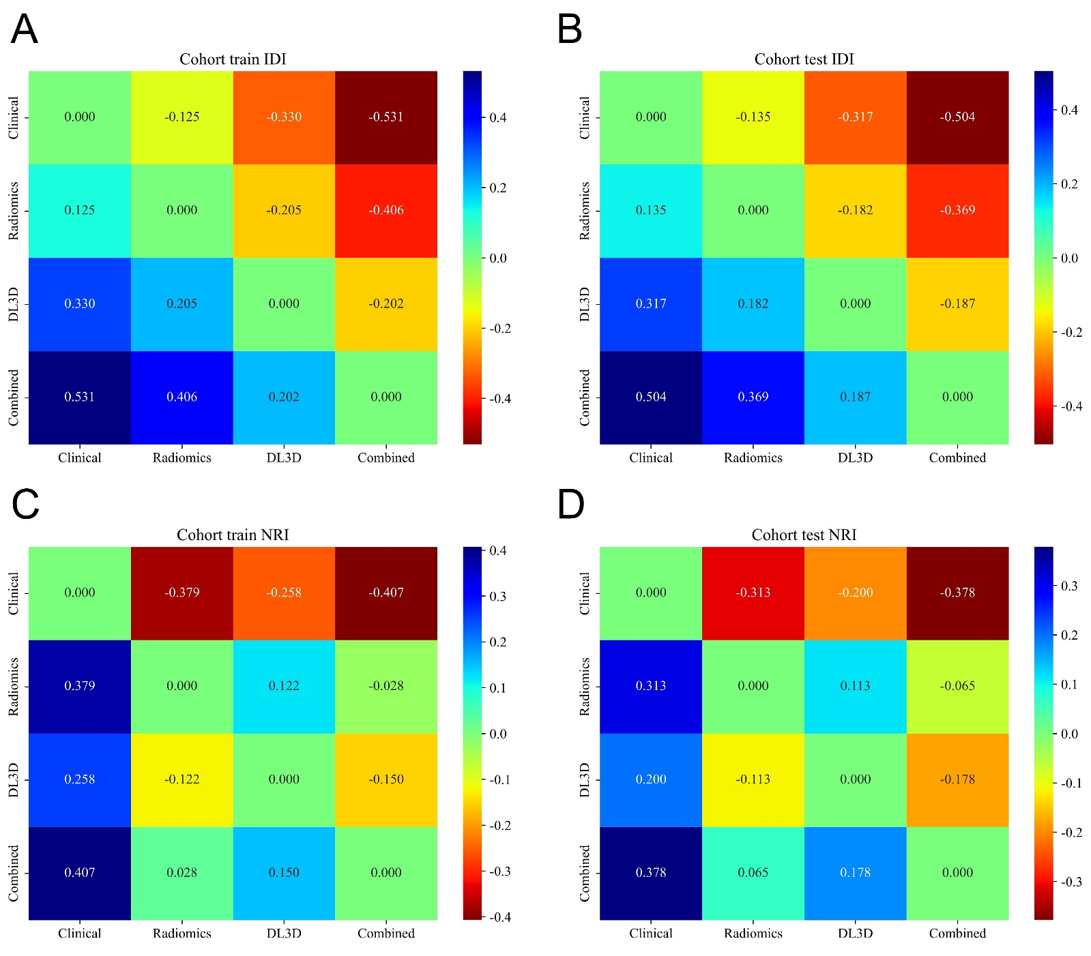
Supplementary Figure 1. IDI and NRI of different models. (A. IDI in Training cohort; B. IDI in Testing cohort; C. NRI in Training cohort; D. NRI in Testing cohort)

