Learning complex stimuli with a honey bee brain: contrasting consequences on performance and flight behaviour from degrading configural versus featural information

Marie-Genevieve Guiraud^{1,2*}, Adam D. Hines^{1,3}, Mengjie Jin^{1,4}, Andrew B. Barron¹

¹ School of Natural Sciences, Macquarie University, Sydney, NSW, Australia. marie-genevieve.guiraud@mq.edu.au.
² Institut des Sciences et du Mouvement, Aix-Marseille University, CNRS, Marseille, France
³ QUT Centre for Robotics, Queensland University of Technology, Brisbane, QLD, Australia
⁴ Department of Biomedical Engineering, Southern University of Science and Technology (Shenzhen), China

*Corresponding author: marie-genevieve.guiraud@univ-amu.fr

Supplementary information

Tables S1. A. Results of the Generalised Linear Mixed Model (GLMM) testing the effects of training block and rewarded stimulus category on bees’ performance during training. The response variable was the number of correct choices within each block of 10 trials (binomial: successes vs. failures). Bee identity was included as a random factor to account for individual differences in learning performance.

Term | Estimate | Std. Error | z value | P-value
(Intercept) | 0.329 | 0.084 | 3.89 | <0.001
Block | 0.0168 | 0.00368 | 4.55 | 5.34×10⁻⁶
Group (A) | −0.0572 | 0.107 | −0.54 | 0.593
Random effect
Random effect | Group | Variance | Std. Dev.
Intercept | Bee_ID | 0.071 | 0.266

Tables S1 B. Summary deviance table for the minimal generalised linear mixed model (GLMM) analysing training performance. Likelihood ratio tests were used to compare nested binomial GLMMs fitted to the number of correct choices per block of 10 trials. The null model included only bee identity as a random intercept. Adding training block significantly improved model fit, confirming that bees increased their likelihood of selecting the rewarded stimulus across consecutive blocks. Adding training group (A vs. B) as a category did not improve model fit, and the Block × Group interaction did not reach significance, indicating comparable learning rates between groups.

Table S1 B a. Effect of training block (learning across trials)
Model comparison | Δdf | ΔDeviance (χ²) | P-value
Null model vs. Block | 1 | 20.89 | 4.85 × 10⁻⁶*

Table S1 B b. Effect of training group
Model comparison | Δdf | ΔDeviance (χ²) | P-value
Block vs. Block + Group | 1 | 0.29 | 0.59

Table S1 B c. Difference in learning rates between groups
Model comparison | Δdf | ΔDeviance (χ²) | P-value
Block + Group vs. Block × Group | 1 | 3.10 | 0.078

Table S2. Results of the Generalised Linear Mixed Model (GLMM) testing whether bees trained with male- versus female-rewarded faces differed in learning rate. The dependent variable was the number of correct choices per block of 10 trials (binomial: successes vs. failures). Bee identity was included as a random intercept.
Term | Estimate | Std. Error | z value | P-value
(Intercept) | 0.400 | 0.094 | 4.27 | 1.93×10⁻⁵
Block | 0.0102 | 0.00523 | 1.95 | 0.0508
Group (B) | −0.197 | 0.133 | −1.48 | 0.1386
Block × Group B | 0.0129 | 0.00733 | 1.76 | 0.0782
Random effect
Random effect | Group | Variance | Std. Dev.
Intercept | Bee_ID | 0.0706 | 0.266
Model fit: AIC = 2684.3, BIC = 2706.9, LogLik = −1337.2, Deviance = 2674.3, N = 671; groups = 33.

Table S3. Performance in the unrewarded learning test (LT)
Test | Comparison | Statistic | P-value | Interpretation
LT vs. chance | Wilcoxon signed-rank | V = 325 | 6.36×10⁻⁶ | Bees learned (performance > 0.5)
F vs. M | Wilcoxon rank-sum | W = 60.5 | 0.435 | No difference between groups

Table S4. Results of the unrewarded inverted face test (Test 2). Bees were presented with the same faces used during training but rotated by 180°. Performance was compared to chance (0.5) using a Wilcoxon signed-rank test. Differences between groups (F vs M) were assessed using a Kruskal–Wallis H test.
Test comparison | Statistic | P-value | N | Interpretation
LT-inverted vs. chance (0.5) | V = 101 | 0.405 | 14 | No preference for the trained stimulus
F vs. M (Kruskal–Wallis test) | H = 0.161 | 0.688 | 14 | No performance difference between groups

Table S5. Results of the unrewarded generalisation test (Test 3).
In this test, bees were presented with two novel stimuli that differed from the trained faces but retained similar structural features. Performance was compared against chance (0.5) using a Wilcoxon signed-rank test. Differences between bees trained on male- versus female-rewarded faces were assessed using a Kruskal–Wallis H test. Bees showed significant generalisation to the stimulus most similar to the trained face, with no difference between groups.
Test comparison | Statistic | P-value | N | Interpretation
Generalisation vs. chance (0.5) | V = 98 | 0.015 | 12 | Bees generalize to similar faces
F vs. M (Kruskal–Wallis test) | H = 0.0017 | 0.967 | 12 | No difference between groups

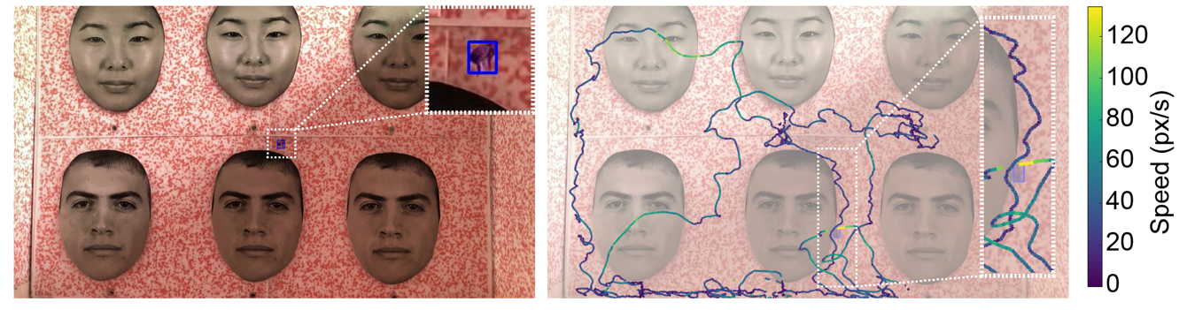
b
a
Supplementary Figure 1. Flight trajectories and scanning dynamics across naïve, learning, inversion, and generalisation conditions. (a) Visual stimuli used during the tests, consisting of greyscale human faces from the Chicago Face Dataset (three female, three male). Dotted frames illustrate the region of interest (ROI) with the bee.
(b) Example flight trajectories from tracked bees overlaid on the stimulus wall. Line colour represents instantaneous flight speed (px/s), from low (purple) to high (yellow). Insets show detailed zooms on portions of the flight path where scanning occurred close to facial features.

Table S6. Pearson correlations between training length (total number of training trials) and performance in each of the three non-rewarded tests. Only generalisation performance was significantly correlated with training length.
Test | r | df | P-value | Interpretation
Learning Test (LT) | –0.325 | 14 | 0.113 | No correlation
Inverted Test (IT) | 0.183 | 12 | 0.415 | No correlation
Generalisation Test (GT) | 0.562 | 10 | 0.012 | Bees with longer training generalised better

Supplementary Figure 2. Correlation between training length (total number of trials completed during the learning phase) and performance in the three non-rewarded tests. Regression lines and 95% confidence intervals are shown. See Table S6. Asterisks denote significance levels (*P < 0.05; n.s. = not significant). Only generalisation performance correlated positively with training length.
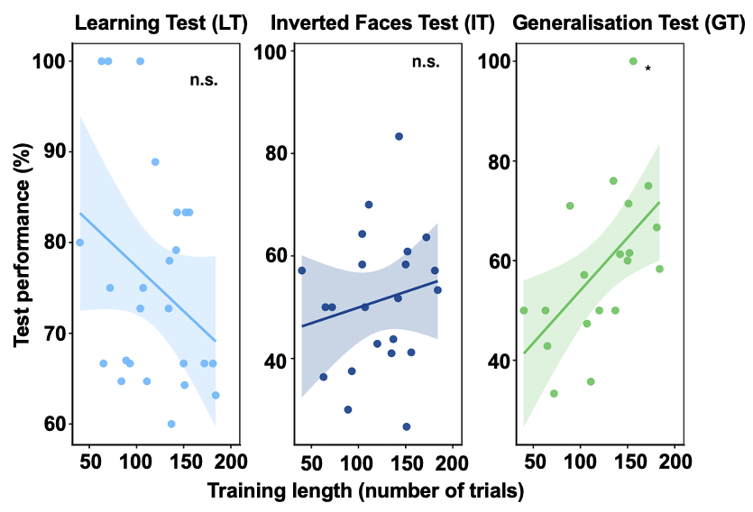

Table S7. Individual differences among bees. Summary of performance metrics for all individually tested bees across the different phases of the experiment. For each bee, we report the total number of training trials completed (n_trials), learning test performance (LT, % correct choices in the non-rewarded learning test), inverted test performance (IT, % correct choices with the same faces presented upside-down), and generalisation performance (GT, % correct choices when tested with new images of the learned identity). “NA” indicates that the bee did not reach the learning criterion or was not available for subsequent tests. Notes highlight exceptional individuals (e.g. perfect learners, high generalisers, high inverted-face performers, or bees with unusually high endurance).
Bee ID | n_trials | LT (%) | Inverted (%) | Generalisation (%) | Notes
Bee_1 | 150 | 64.7 | NA | 50 | –
Bee_10 | 100 | 100 | 36.4 | 50 | Perfect LT performer
Bee_11 | 180 | 75 | 50 | 47.4 | –
Bee_12 | 240 | 79.2 | 51.7 | 61.3 | –
Bee_13 | 100 | 75 | 50 | 33.3 | Low generaliser
Bee_14 | 110 | 66.7 | 50 | 42.9 | Low generaliser
Bee_15 | 240 | 78 | 41 | 66.7 | –
Bee_16 | 140 | 67 | 30 | 40 | Low generaliser
Bee_17 | 220 | 66.7 | 58.3 | 58.3 | –
Bee_18 | 60 | 80 | 57.1 | 61.5 | Very short training; good performance
Bee_19 | 280 | 64.3 | 26.7 | 70 | Low inverted test; borderline high generalisation
Bee_2 | 210 | 72.7 | NA | 61.5 | –
Bee_20 | 240 | 88.9 | 42.9 | 50 | –
Bee_21 | 140 | 100 | NA | 61.5 | Perfect LT performer
Bee_22 | 300 | NA | NA | NA | Very high endurance
Bee_23 | 130 | NA | NA | NA | –
Bee_24 | 240 | 60 | 43.8 | 75 | High generaliser
Bee_25 | 190 | 100 | 58.3 | 50 | Perfect LT performer
Bee_26 | 260 | NA | NA | NA | –
Bee_27 | 150 | NA | NA | NA | –
Bee_28 | 210 | NA | NA | NA | –
Bee_29 | 300 | NA | NA | NA | Very high endurance
Bee_3 | 300 | 83.3 | 41.2 | 100 | Exceptional generaliser (100%)
Bee_30 | 150 | 72.7 | 64.3 | 57.1 | –
Bee_31 | 250 | NA | NA | NA | –
Bee_32 | 300 | 63.2 | 53.3 | 58.3 | –
Bee_33 | 170 | 64.7 | 70 | 35.7 | Highest inverted performance
Bee_4 | 260 | 66.7 | 63.6 | 75 | High generaliser
Bee_5 | 270 | 66.7 | 57.1 | 63.6 | –
Bee_6 | 190 | 83.3 | 60.9 | 80 | High generaliser
Bee_7 | 290 | NA | NA | NA | –
Bee_8 | 210 | 83.3 | 83.3 | 57.1 | Exceptional inverted performance
Bee_9 | 130 | 66.7 | 37.5 | 33.3 | Low generaliser

