Supplementary Material I ROBINS-1 traffic light plot
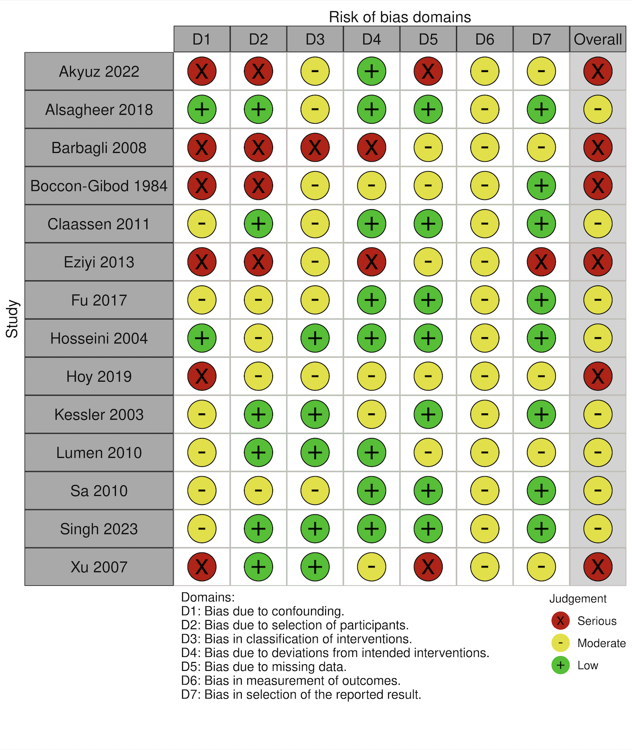

Supplementary Material II RoB2 traffic light plot
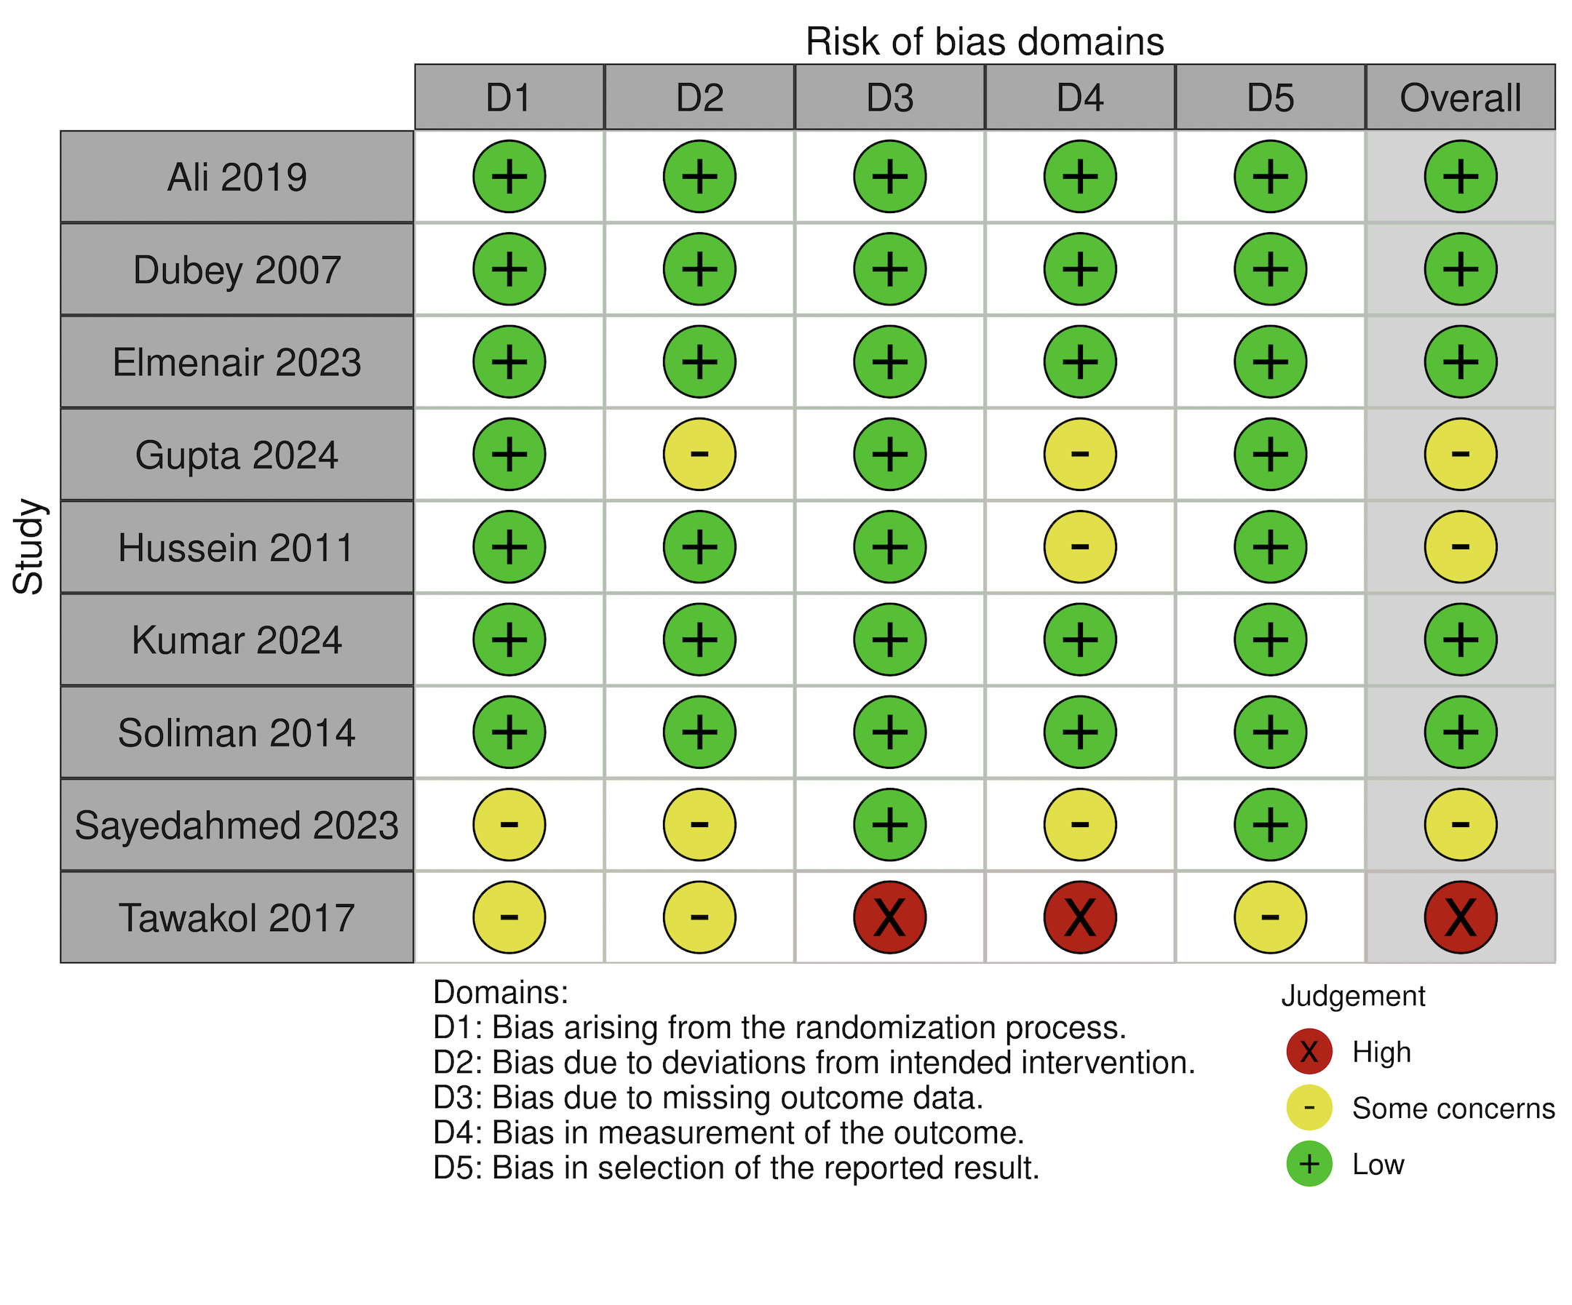

Supplementary Material III operative time forest plot
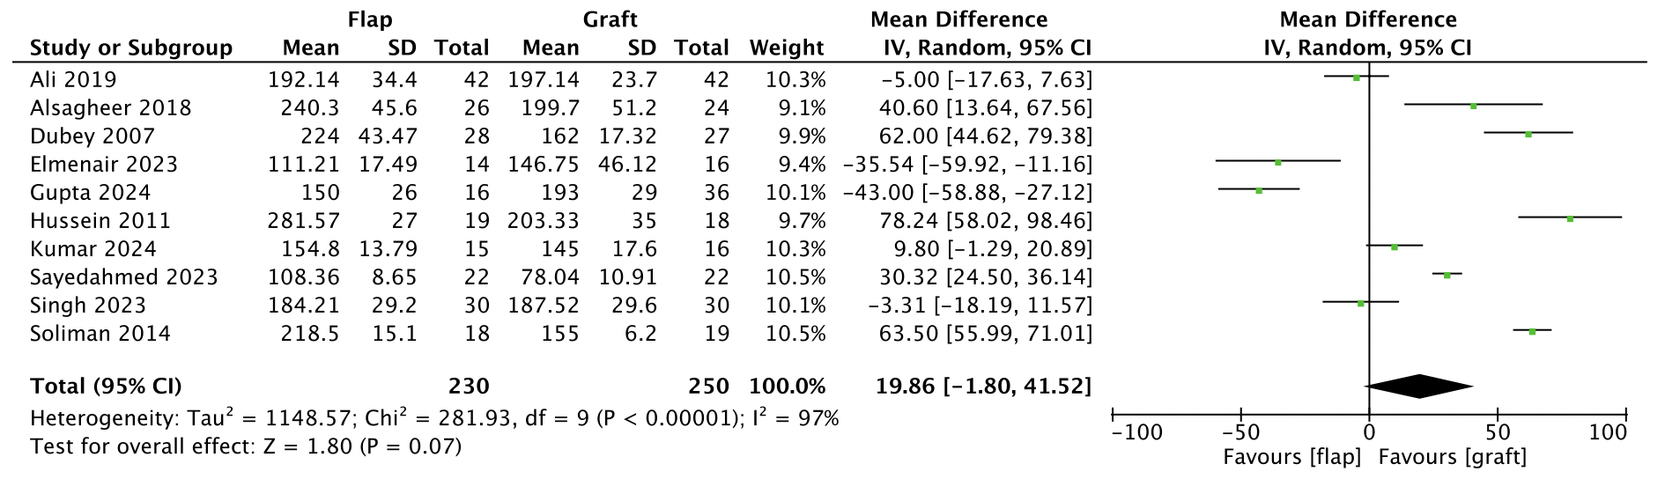

Supplementary Material IV Qmax forest plot
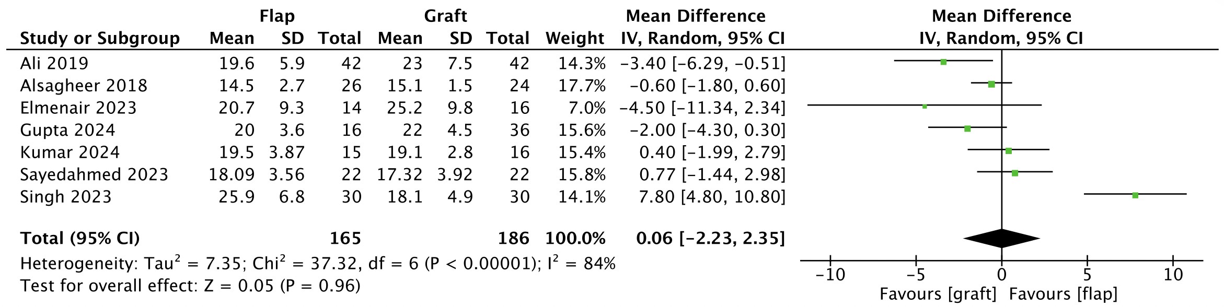

Supplementary Material V Qmax <15mL/sec forest plot
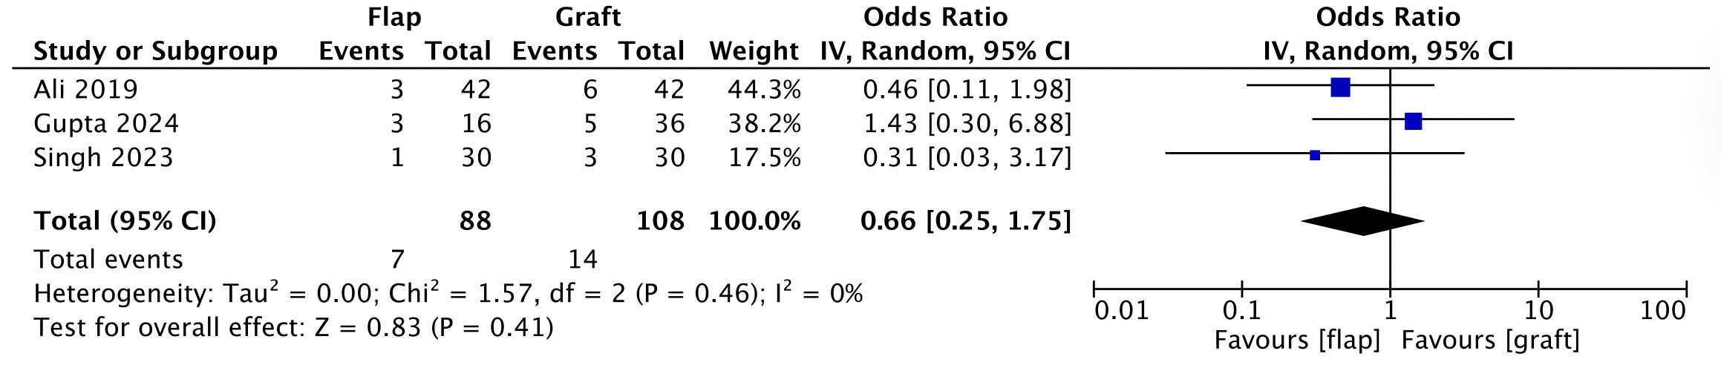

Supplementary Material VI LOS
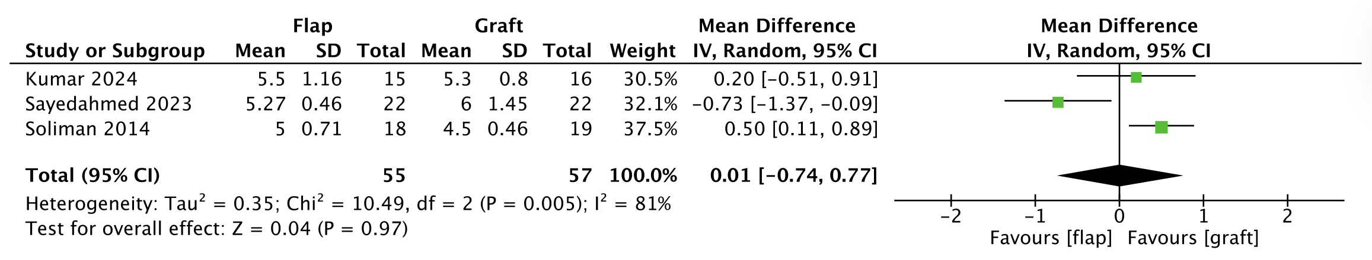

Supplementary Material VII Early Complications
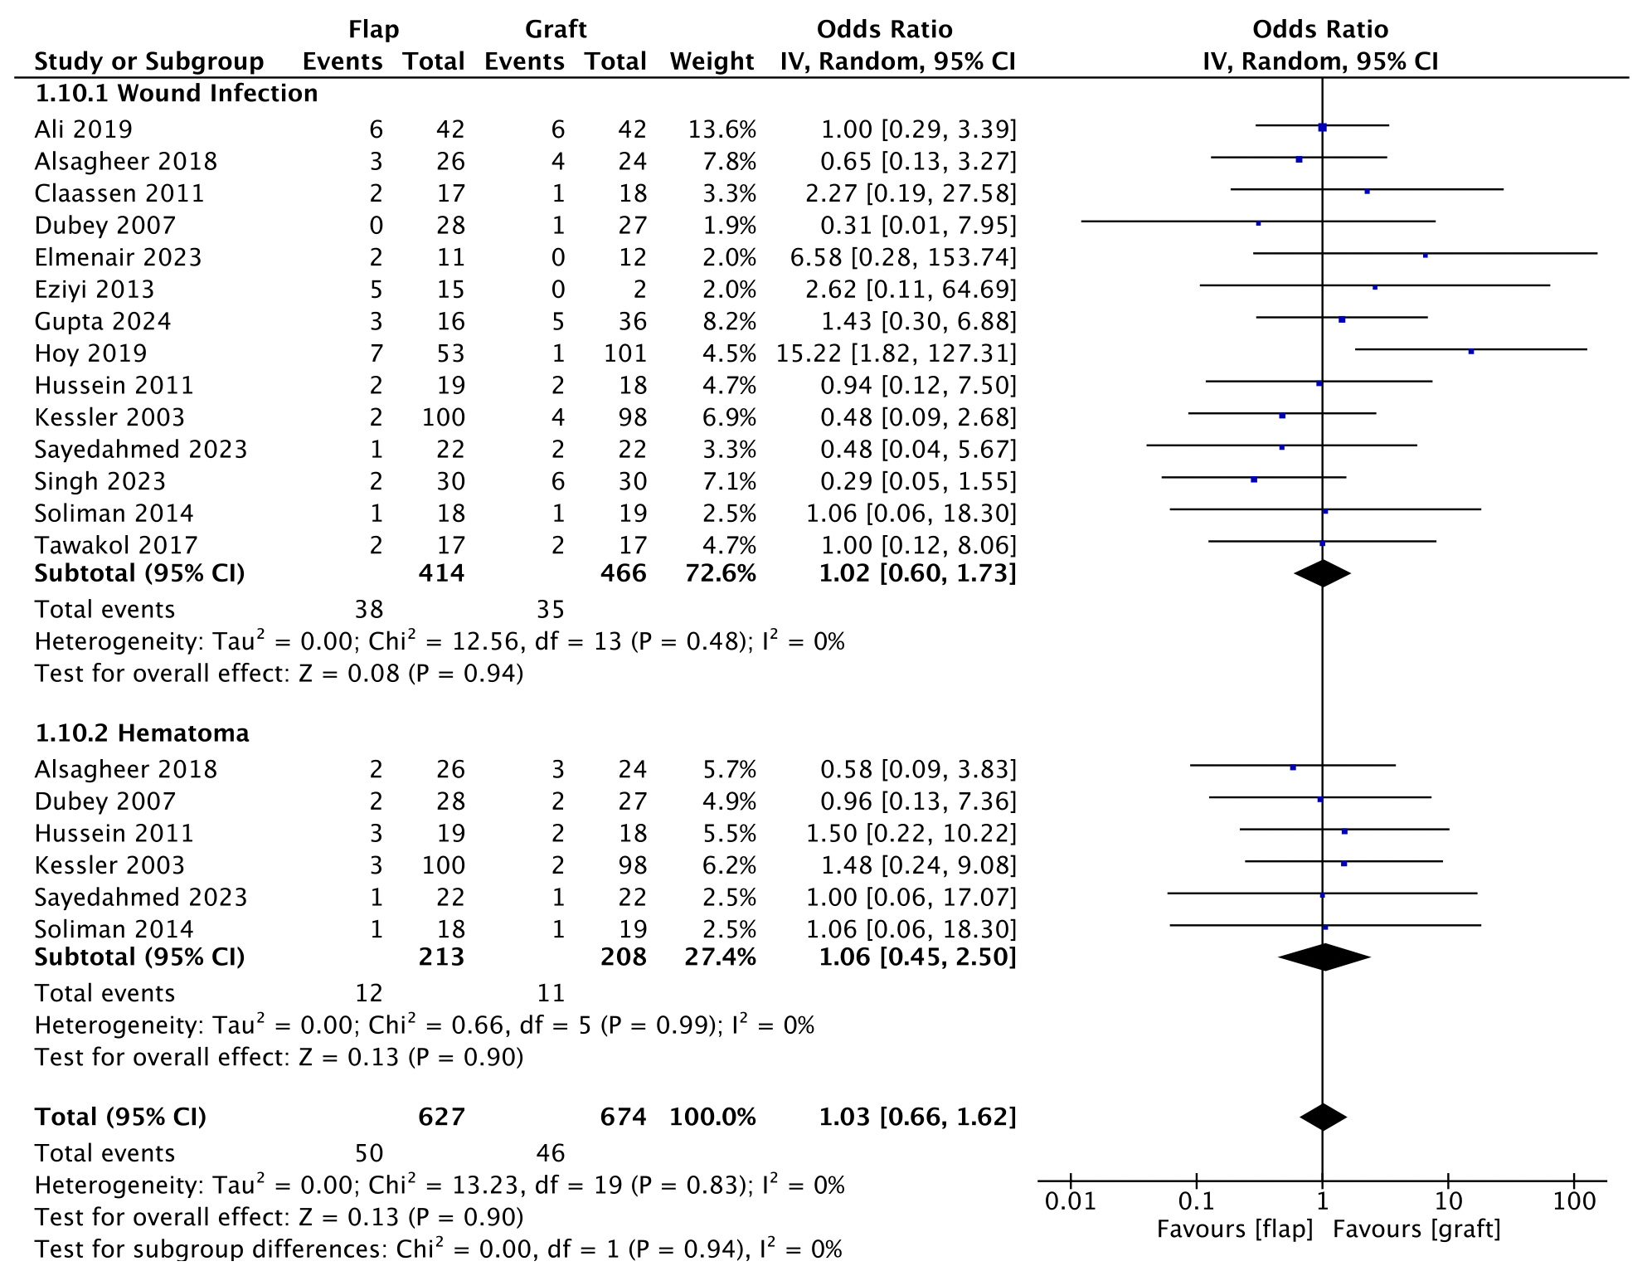

Supplementary Material VIII Funnel Plot for Publication Bias
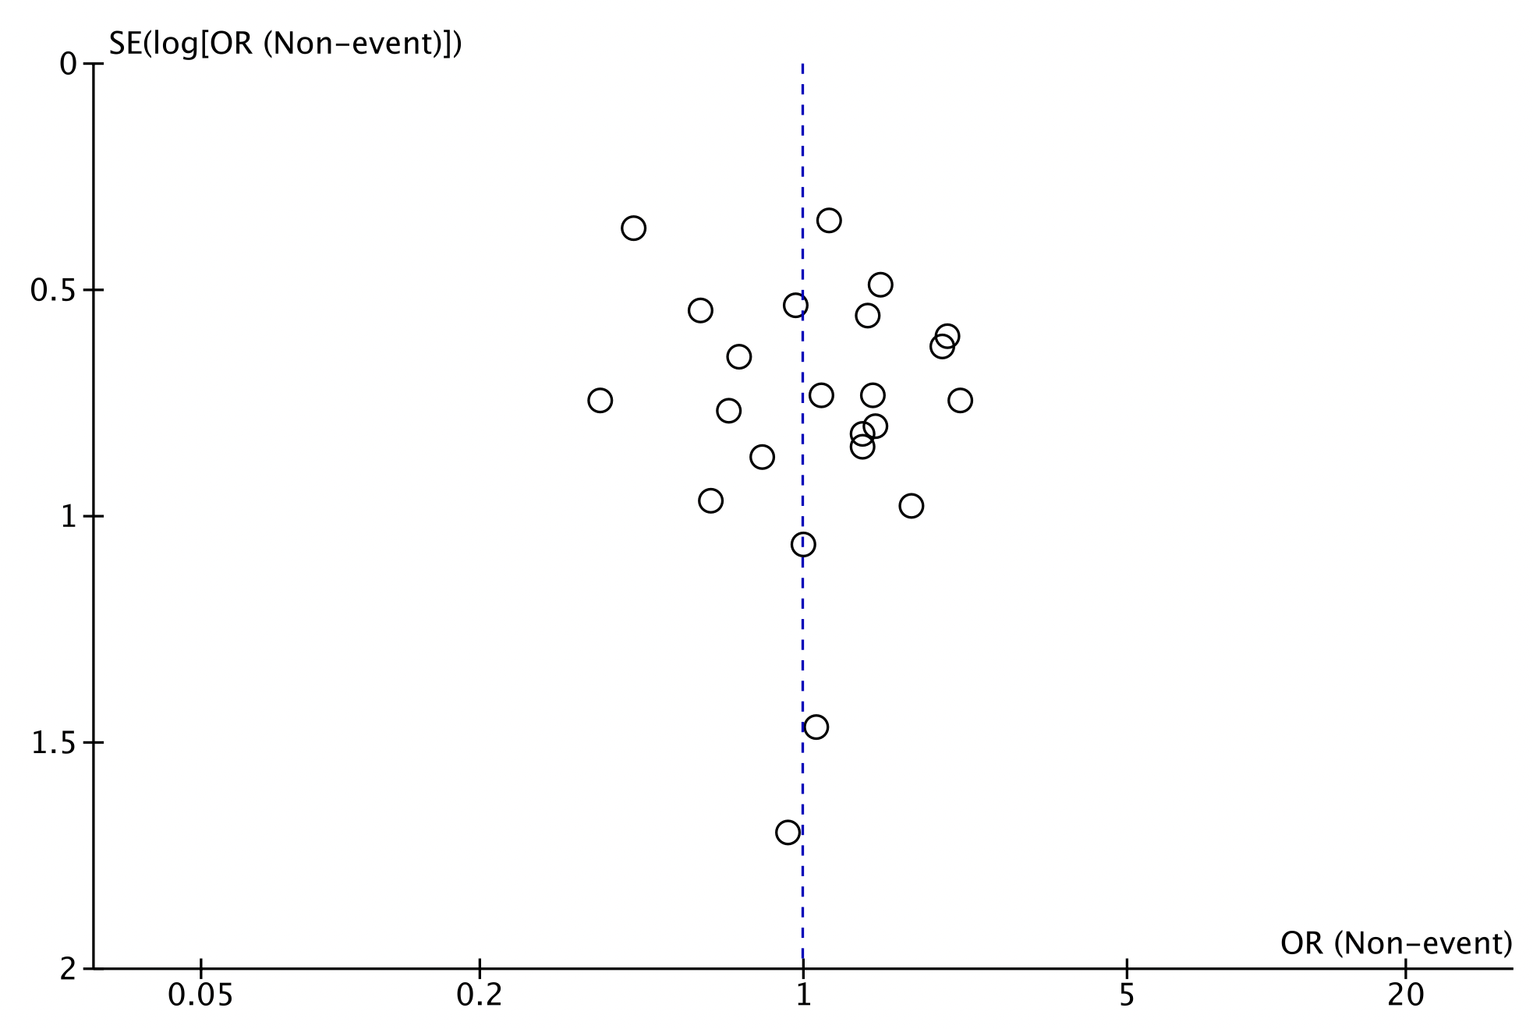

SUPPLEMENTARY MATERIAL CAPTIONS
Supplementary Material I ROBINS-1 traffic light plot for non-randomized studies
Supplementary Material II RoB2 traffic light plot for randomized studies
Supplementary Material III Forest plot of comparison: Operative Time

Supplementary Material IV Forest plot of comparison: Qmax
Supplementary Material V Forest plot of comparison: Qmax <15mL/sec
Supplementary Material VI Forest plot of comparison: Length of Hospital Stay
Supplementary Material VII Forest plot of comparison: Early Complications
Supplementary Material VIII Funnel plot of comparison for Publication Bias

