Supplementary information

Hybrid PEO–hydrothermal–silane coating with synergistic Ce–8HQ inhibitor sealing for durable corrosion protection of AZ31 magnesium alloy
Majid Shahsanaei ^{a, c}, Nastaran Farahbakhsh ª, Masoud Atapour ^{b}, Morteza Shamanian ^{b}, Benjamin Butz ^{c}, Christian Pritzel ª, and Manuela S. Killian ª*
a) Chemistry and Structure of novel Materials, Department of Chemistry and Biology, University of Siegen, Paul-Bonatz-Str. 9-11, 57076 Siegen, Germany
b) Department of Materials Engineering, Isfahan University of Technology, Isfahan 84156-83111, Iran
c) Micro- and Nano Analytics Group, University of Siegen, Adolf-Reichwein-Straße 28, 57076 Siegen, Germany
* Corresponding author, Email: Manuela Killian, manuela.killian@uni-siegen.de

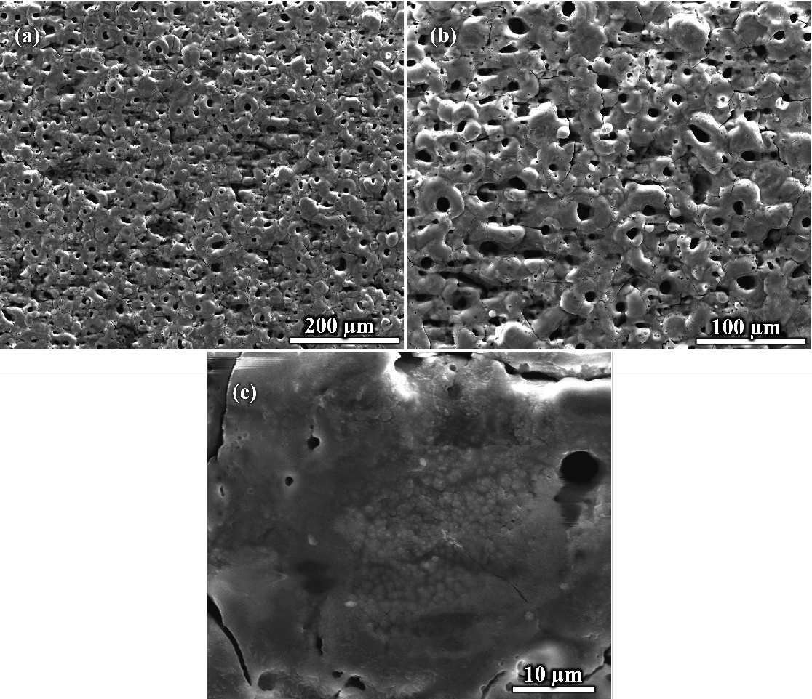
Figure S 1: SEM images of PEO coatings at different magnifications. The images clearly show cracks and pores formed during plasma electrolytic oxidation.
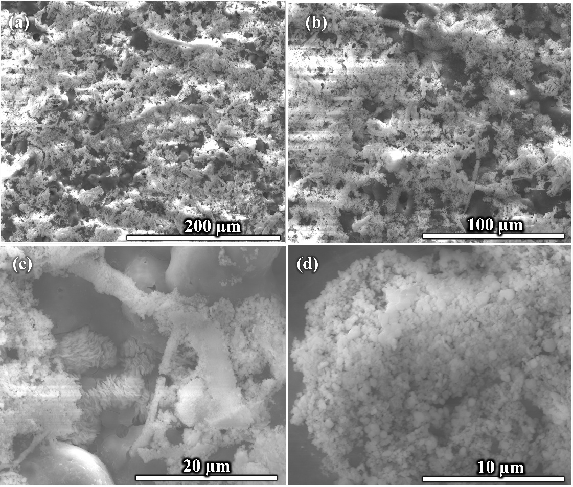
Figure S 2: SEM images of PEO/HT coatings at different magnifications, showing that cracks and pores are effectively sealed by Ce-based components.

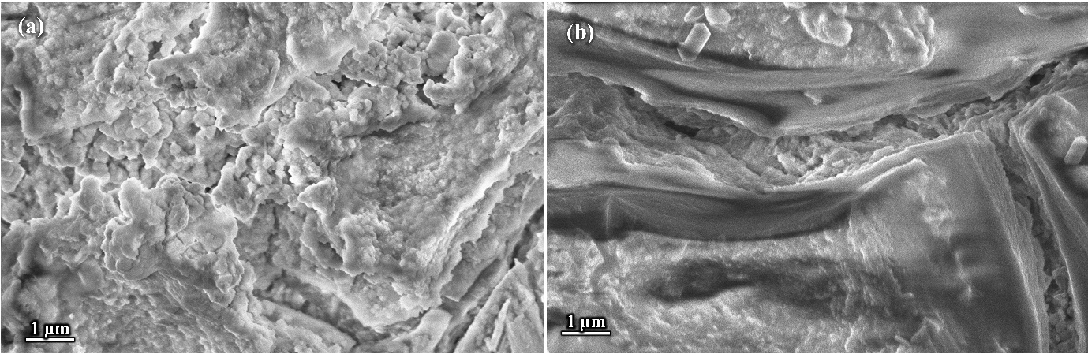
Figure S 3: SEM images of (a) PEO/HT/Silane and (b) PEO/HT/Silane+8HQ show that the surface is covered with a silane layer.

Figure S 4: Water contact angle measurements of various samples: (a) AZ31 magnesium, (b) PEO, (c) PEO/HT, (d) PEO/HT/Silane, and (e) PEO/HT/Silane+8HQ.

Figure S 5: Parameters calculated using the Young’s equation and Neumann equation, including work of adhesion, surface free energy, and water contact angle for different samples.

Figure S 6: Positive ToF-SIMS signals of molecular fragments: (a) Mg⁺, (b) C₂H₅NO⁺, (c) C₉H₉NO⁺/ SiC₅H₁₃NO₂⁺, and (d) SiO₂C₉H₉NO⁺ for PEO/HT and PEO/HT/silane+8HQ samples.

Table S 1: Peak list applied for PCA of positive-ion ToF-SIMS spectra from PEO/HT and PEO/HT/silane+8HQ samples. Fragment assignments were obtained from the corresponding loading plot shown in Figure 5e.
m/z | Ion
15.02 | CH₃⁺
23.98 | Mg⁺
27.97 | Si⁺
40.99 | MgOH⁺
41.03 | C₃H₅⁺
44.02 | C₂H₄O⁺
45.03 | CH₃NO⁺
58.03 | C₂H₄NO⁺
59.03 | C₂H₅NO⁺
73.04 | SiC₂H₅O⁺
87.04 | SiC₂H₅NO⁺
91.02 | NaC₅H₈⁺
139.91 | Ce⁺
140.91 | Na₂PO₄⁺
147.09 | C₉H₉NO⁺/SiC₅H₁₃NO₂⁺
155.91 | CeO⁺
156.92 | CeOH⁺
207.03 | SiO₂C₉H₉NO⁺

