Table 2 Binding energy for the formation of complex between the compounds and the protease of SARS-CoV-2, against COVID-19
Name of the compound | Docked pose | Π Interactions |  | Hydrogen Bond Interactions |  | Binding affinity (kcal/mol)
Name of the compound | Docked pose | Amino acids | Distance (Å) | Amino acids | Distance (Å) | Binding affinity (kcal/mol)
Acyclovir, CMPD1 | 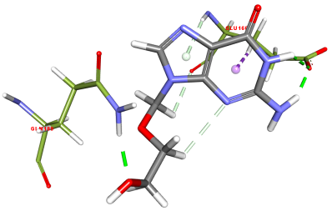 | GLU_166 | 3.93 | GLU_166  GLN_189 | 5.07, 4.27, 3.90, 3.77,  3.58 | -3.92
Ganciclovir, CMPD2 | 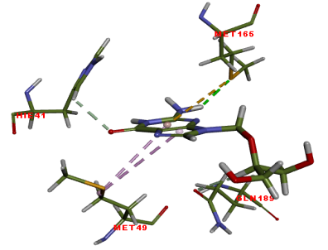 | MET_165  MET_49 | 7.03  5.78, 4.36 | MET_165  GLN_189  HIE_41 | 3.77,  4.38,  3.53, | -3.74
CMPD3 | 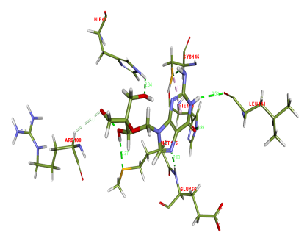 | CYS_145 | 5.63 | CYS_145  LEU_141  GLU_166  HIE_163  MET_165  ARG_188  HIE_41 | 3.93,  6.36,  4.29,  5.44,  3.41,  5.93,  4.94 | -4.34

