Supplementary Information for “Ozone promotes aerosol formation from polycyclic aromatic hydrocarbons”
Avinash Kumar^{1*}, Mojtaba Bezaatpour¹, Aliisa Ojala¹, Prasenjit Seal¹, Shawon Barua¹, Petteri Marjanen¹, Olga Garmash², Topi Rönkkö¹, Siddharth Iyer¹ and Matti Rissanen^{1,3*}
¹Aerosol Physics Laboratory, Physics Unit, Faculty of Engineering and Natural Sciences,
Tampere University, 33720 Tampere, Finland.
²Department of Chemistry, University of Copenhagen, DK-2100, Copenhagen, Denmark.
³Department of Chemistry, University of Helsinki, 00560, Helsinki, Finland.
* Corresponding author. Email: avinashkumar@tuni.fi and matti.rissanen@tuni.fi

S1. Experiment Methodology
All experiments were conducted in a quartz laminar flow reactor operated at 1 atm using dry, purified zero air as the carrier gas. The reactor was 50 cm in length with an outer diameter of 25 mm. The system was maintained at a constant temperature of 295 ± 2 K. All gases and reagents were introduced via 6 mm outer-diameter PTFE tubing through a series of Swagelok cross fittings positioned upstream of the flow reactor.
Zero air was generated using a zero air generator (AADCO Instruments, 737 Series) supplied with clean in-house synthetic air. This air was further dried using a mist separator (SMC AMG150C-F01C) and an air membrane dryer (SMC IDG100LA-F04B-P) prior to introduction into the reactor.
Hydroxyl radicals (OH) were generated via two independent methods: (i) photolysis of hydrogen peroxide (H₂O₂) using a germicidal lamp emitting at 254 nm (Osram HNS 15W G13), and (ii) ozonolysis of tetramethylethylene. Ozone (O₃) was produced by an ozone generator (Analytik Jena UVP), equipped with a mercury pen-ray lamp emitting at 184.9 nm. Ozone was measured by an ozone analyzer in every experiment (2B Technologies. Inc). The photolysis lamp during the production of OH radicals by H₂O₂ photolysis was placed inside an aluminum cabinet and exposure light was controlled by the shield in between the lamp and the quartz tube. The amount of OH radicals formed during the photolysis of H₂O₂ was estimated by measuring the concentration of sulfuric acid and the details are given in the section S11.
For short residence time experiments, a 6 mm stainless steel injector was introduced into the flow reactor, and residence time was controlled by adjusting the distance between the injector outlet and the sampling orifice of the mass spectrometer.
The flows of the gases were set by means of calibrated mass flow controllers (Alicat Scientific Inc.), which were further utilized to calculate the concentration of a chemical species in the reaction mixture.
S1.1. Detection of products by Mass spectrometry
A chemical ionization atmospheric pressure interface time-of-flight mass spectrometer (CI-APi-TOF; Tofwerk/Aerodyne Research Inc.) was used to detect oxidation products, employing an Eisele-type inlet (1–3). Nitric acid vapors were generated by passing ultra-high purity (UHP) N₂ through concentrated HNO₃ and introduced into the ion–molecule region, where soft X-ray radiation (<9.5 keV, Hamamatsu L9490) ionized the HNO₃ to produce nitrate ions (NO₃⁻). The total inlet flow rate through the flow reactor was maintained at 8.4–8.8 standard liters per minute (slpm). The sheath air flow in the CI -inlet carries the charged nitrate clusters and the ions into the sample gas flow by an applied electric field.
Ionization of sample molecules (X) occurred through adduct formation (X·NO₃⁻), which only proceeds efficiently if the binding enthalpy of X with NO₃⁻ exceeds that of the HNO₃·NO₃⁻ cluster ⁴.
All data processing, including averaging, mass axis calibration, and peak integration, was performed using the tofTools software package for MATLAB. The signal intensity of all the mentioned species (X) was normalized using the following expression:
$S= \frac{\left[X^{*}{NO}_{3}^{-}\right]}{\left[{NO}_{3}^{-}\right]+\left[{{HNO}_{3}}^{*}{NO}_{3}^{-}\right]+\left[{{\left({HNO}_{3}\right)}_{2}}^{*}{NO}_{3}^{-}\right] }$ (I)
S1.2. Chemicals
Reactants used in the experiments had the following purity: naphthalene (Sigma Aldrich, ≥ 99 %), 1-naphthol (Sigma Aldrich, ≥ 99 %), 2-naphthol (Sigma Aldrich, 99 %), biphenyl (Sigma Aldrich, 99.5 %), anthracene (Sigma Aldrich, 99 %), mesitylene (Sigma Aldrich, 98 %) and H₂O₂ (Sigma Aldrich, 50 % wt in H₂O). The gas cylinder containing toluene and p-xylene was prepared with respective concentrations of 88 ppm and 13.4 ppm in UHP nitrogen. The gas used in the experiments had the following purity: N₂ (Woikoski and Linde Oy, 99.999 %), NO (Air products, 100 ppm in N₂), NO₂ (Air products, 100 ppm in N₂) and SO₂ (Air Products, 100 ppm in N₂). The gas cylinder for tetramethyl ethylene was also prepared with a concentration of 283 ppm in UHP nitrogen.
¹⁸O₂ (97 % ¹⁸O) gas cylinder was obtained from CortecNet, France. Deuterium oxide (99.9 atom % D) was obtained from Sigma Aldrich.
Table S1. Concentration of the VOCs used in the experiments.
Reagent | Concentration  (molecule cm⁻³)
Naphthalene | (6.40 – 64.0) × 10¹²
1-naphthol | (1.01 – 3.70) × 10¹¹
2-naphthol | (1.17 – 5.87) × 10¹¹
Biphenyl | (3.27 – 21.82) × 10¹²
Anthracene | (3.31 – 11.60) × 10¹⁰
Toluene | (9.38 – 28.15) × 10¹¹
para-xylene | (6.15 – 18.45) × 10¹²
1,3,5-trimethylbenzene | (2.23 – 35.72) × 10¹²

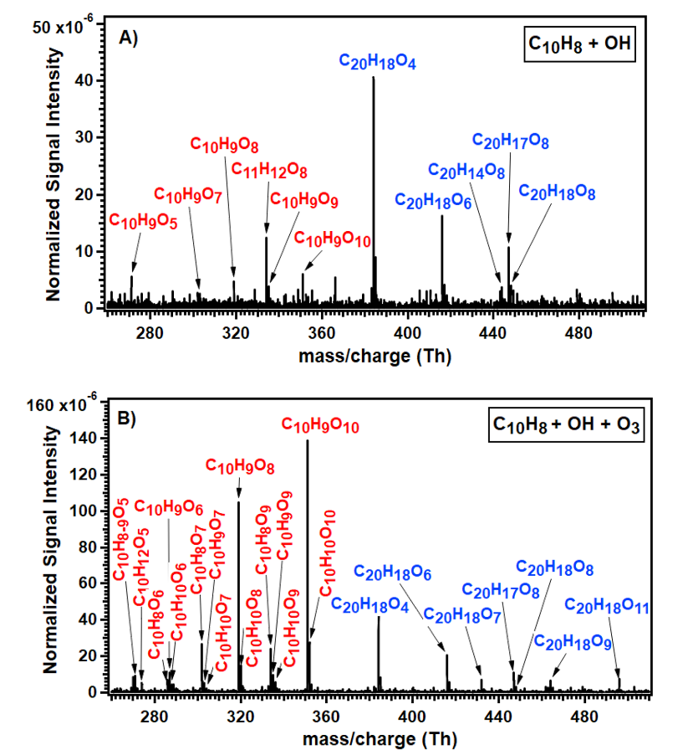
Figure S1. Enhancement of HOM formation by ozone during naphthalene oxidation
Normalized mass spectra obtained during the naphthalene oxidation with OH radicals a) in the absence of ozone and b) in presence of 1.87 x 10¹² molecules cm⁻³ of O₃. The formulas are only given for the identified peaks. All products in the spectra are detected as clusters with NO₃-. Background signals have been subtracted from both spectra. The experimental conditions are [naphthalene] = 3.08 × 10¹³ molecules cm⁻³, [OH] = 3.90 × 10⁶ molecules cm⁻³. The reaction time was 1.8 s.

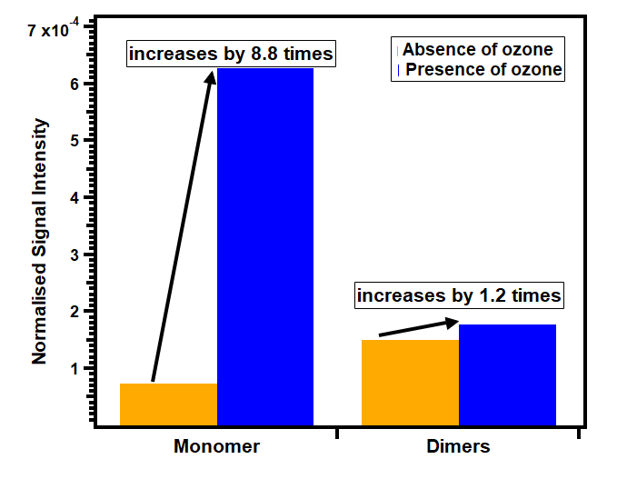
Figure S2: Relative changes in normalized signal intensities of monomers and dimers formed in the reaction of naphthalene with OH radicals in the absence and presence of ozone. The reaction time was 1.8 seconds. The concentrations of naphthalene and ozone were maintained at 3.08 × 10¹³ molecules cm⁻³ and 1.88 × 10¹² molecules cm⁻³, respectively.

S2. Sub-seconds time scale experiments for naphthalene oxidation.
The oxidation of naphthalene was investigated at residence times of 620 ms and 890 ms. The residence time control was achieved by inserting an injector constructed from a 6 mm silcoinert -coated stainless steel tube into the flow reactor. The injector was positioned downstream of the main flow, at a fixed distance from the pinhole, to introduce the organic precursors. Figures S4 and S5 present the mass spectra obtained from the reaction of naphthalene with OH radicals in the absence and presence of ozone at 890 and 620 ms respectively.
At 890 ms reaction time, the signal intensity of the monomers was observed to be increased by nearly ten times in the presence of ozone. The signal intensity of dimers were almost linear and showed a negligible increase in the intensity. The bar plot showing the increase in the signal intensities of monomers and dimers are shown in Figure S3.
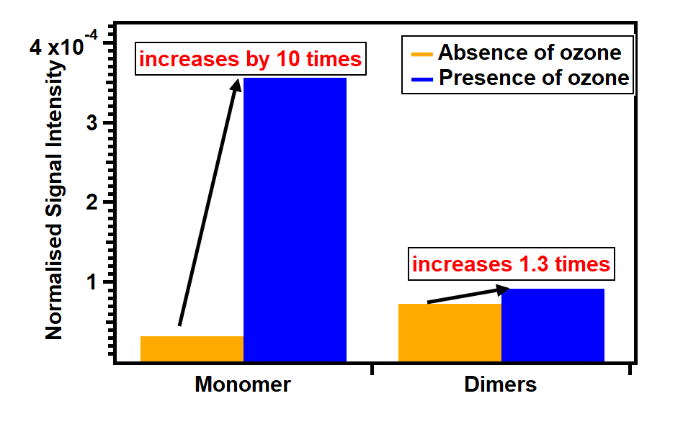
Figure S3: Relative changes in normalized signal intensities of monomers and dimers formed in the reaction of naphthalene with OH radicals in the absence and presence of ozone. The reaction time was 890 milliseconds. The concentrations of naphthalene and ozone were maintained at 6.22 × 10¹³ molecules cm⁻³ and 1.90 × 10¹² molecules cm⁻³, respectively.

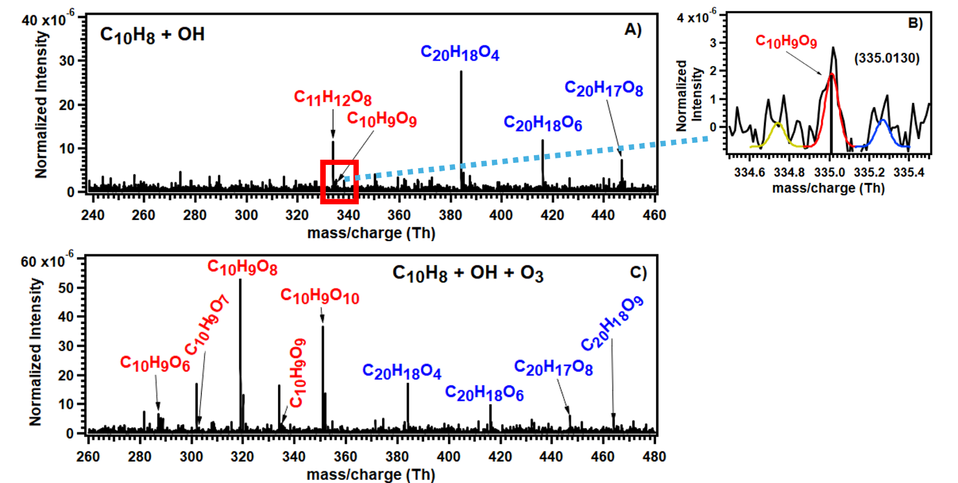
Figure S4. Normalized mass spectra obtained from the OH-initiated oxidation of naphthalene (C₁₀H₈) (A) in the absence of ozone and (C) in the presence of 1.82 × 10¹² molecules cm⁻³ O₃ at a residence time of 890 ms. Panel (B) shows a magnified view of the normalized signal at m/z corresponding to C₁₀H₉O₉ observed in the absence of ozone. These spectra were obtained at a naphthalene concentration of 6.4 × 10¹³ molecules cm⁻³. All products were detected as nitrate (NO₃⁻) cluster ions. Background signals were subtracted from both spectra.
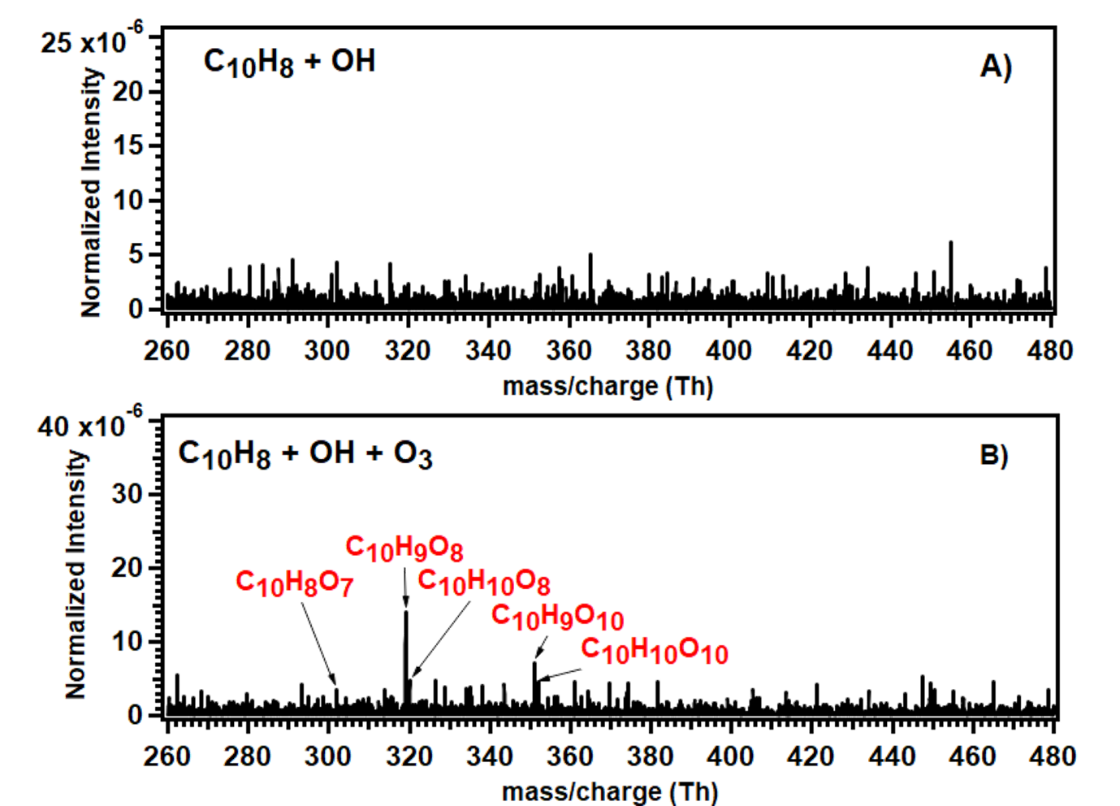
Figure S5. Normalized mass spectra obtained from the OH-initiated oxidation of naphthalene (C₁₀H₈) (A) in the absence of ozone and (B) in the presence of 1.82 × 10¹² molecules cm⁻³ O₃ at a residence time of 620 ms. These spectra were obtained at a naphthalene concentration of 9.70 × 10¹³ molecules cm⁻³. All products were detected as nitrate (NO₃⁻) cluster ions. Background signals were subtracted from both spectra.

S3. Oxidation of 1 and 2-naphthol
The mass spectra obtained in the reaction of 1 and 2- naphthol with OH radicals in the absence and presence of ozone are shown in figures S6 and S7, respectively. For clarity, only peroxy radical peaks, few closed shell species and dimers are labeled in the figures; all other identified peaks, together with their exact mass-to-charge ratios, are summarized in Section S13. For all other spectra presented in this work, only peroxy radicals are labeled in the figures, while the complete list of fitted peaks is provided in Section S13.

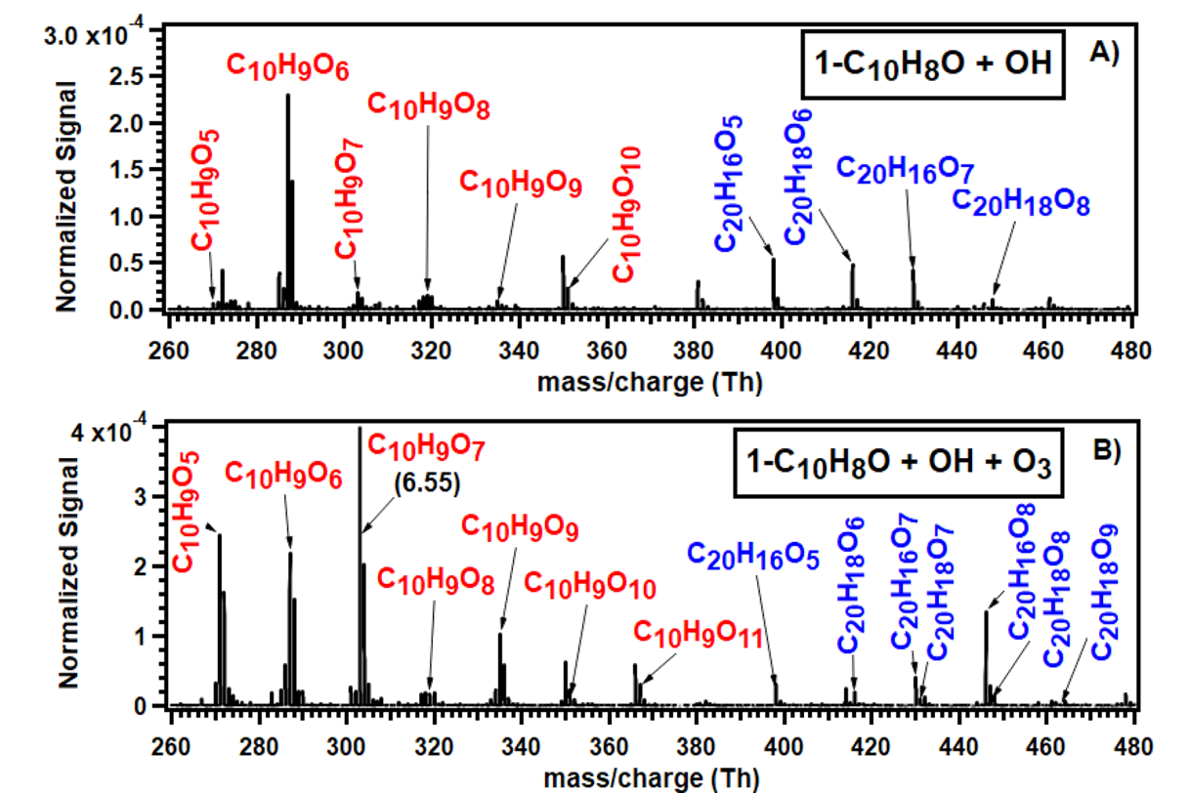
Figure S6. Normalized mass spectra obtained from the OH-initiated oxidation of 1-naphthol (1-C₁₀H₈O) (A) in the absence of ozone and (B) in the presence of 1.77 × 10¹² molecules cm⁻³ O₃ at a residence time of 1.8 s. These spectra were obtained at a 1-C₁₀H₈O concentration of 3.70 × 10¹¹ molecules cm⁻³. All products were detected as nitrate (NO₃⁻) cluster ions. Background signals were subtracted from both spectra.
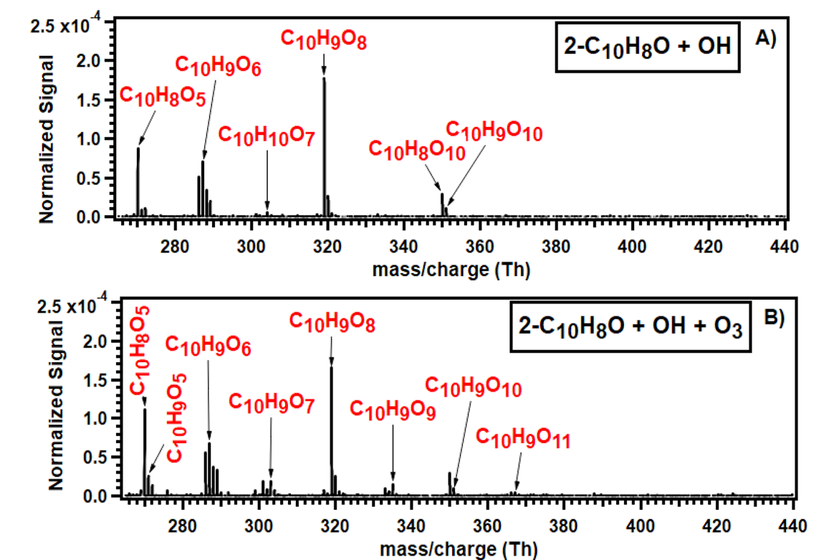
Figure S7. Normalized mass spectra obtained from the OH-initiated oxidation of 2-naphthol (2-C₁₀H₈O) (A) in the absence of ozone and (B) in the presence of 1.77 × 10¹² molecules cm⁻³ O₃ at a residence time of 1.8 s. These spectra were obtained at a 2-C₁₀H₈O concentration of 5.87 × 10¹¹ molecules cm⁻³. All products were detected as nitrate (NO₃⁻) cluster ions. Background signals were subtracted from both spectra.
S4. Experiments in the presence of isotopically labelled compounds
¹⁸O₃ experiments Commercially available isotopically labelled oxygen gas (¹⁸O₂, CortecNet, 97% 18O) was used to generate ¹⁸O₃. These experiments were performed only for the OH-initiated oxidation of naphthalene at a residence time of 1.8 s. The experimental setup was identical to that used for the ¹⁶O₃ experiments, with the only change being the use of ¹⁸O₃ instead of ¹⁶O₃, to assess the direct influence of ozone on the observed oxidation products.
In the presence of ¹⁸O₃, an increase in monomer signal intensities was observed, similar to the enhancement seen with ¹⁶O₃. A mass shift of +2 mass units was detected for monomers ranging from C₁₀H₉O₆ to C₁₀H₉O₁₀, while no mass shift was observed for C₁₀H₉O₅. The peak corresponding to C₁₀H₈O₅, which appears only upon addition of ozone, also shifted by +2 mass units, confirming incorporation of only one oxygen atom from the ozone molecule.
For dimeric products, a +2 mass units shift was observed for C₂₀H₁₈O₅, C₂₀H₁₈O₇, C₂₀H₁₈O₉, and C₂₀H₁₈O₁₁, indicating incorporation of one oxygen atom from ozone. In contrast, C₂₀H₁₈O₈ displayed two distinct features - one shifted by +4 mass units and another without any shift, suggesting the presence of two structural isomers with different ozone-involvement pathways. No mass shift was observed for the dimeric products C₂₀H₁₈O₄, C₂₀H₁₈O₆, and the dimer radical C₂₀H₁₇O₈.
A key pattern emerges from these experiments is that the dimeric species that were already present in the absence of ozone do not shift upon introduction of ¹⁸O₃, indicating that ozone does not affect the pre-existing products formed in the naphthalene + OH reaction. Conversely, dimer peaks that appear only in the presence of ozone exhibit the mass shifts. A similar trend holds for monomers is that for the species whose intensities increase or newly appeared peak upon ozone addition show a +2 mass units shift, confirming the direct incorporation of one oxygen atom from ozone molecule.
Overall, these results provide clear evidence for the direct involvement of ozone in the formation of specific monomeric and dimeric oxidation products in the naphthalene + OH reaction system. The mass spectra for naphthalene oxidation in the absence of ozone, in the presence of ¹⁶O₃, and in the presence of ¹⁸O₃ are shown in Figure S8. The shift in the mass units of some important species are tabulated in Table S2.
Figure S8. Mass spectrum showing the shift in the mass units of the products formed in the OH initiated oxidation of naphthalene in the presence of ¹⁸O₃.
Table S2. Composition, exact mass-charge ratio and shift in the unit mass of the peroxy radicals and dimers formed in the OH-initiated oxidation of naphthalene in the presence of ¹⁸O₃.
Composition in the presence of ¹⁶O₃ª | Exact mass-charge ratio | Composition in the presence of ¹⁸O₃ª | Exact mass-charge ratio | Shift in the unit mass
C₁₀H₉O₆ | 287.0283 | C₁₀H₉O₅(¹⁸O) | 289.0324 | +2
C₁₀H₉O₇ | 303.0232 | C₁₀H₉O₆(¹⁸O) | 305.0274 | +2
C₁₀H₉O₈ | 319.0181 | C₁₀H₉O₇(¹⁸O) | 321.0224 | +2
C₁₀H₉O₉ | 335.0130 | C₁₀H₉O₈(¹⁸O) | 337.0173 | +2
C₁₀H₉O₁₀ | 351.0079 | C₁₀H₉O₉(¹⁸O) | 353.0122 | +2
C₂₀H₁₈O₅ | 400.1038 | C₂₀H₁₈O₄(¹⁸O) | 402.1080 | +2
C₂₀H₁₈O₇ | 432.0936 | C₂₀H₁₈O₆(¹⁸O) | 434.0979 | +2
C₂₀H₁₈O₈ | 448.0885 | C₂₀H₁₈O₆(¹⁸O)₂ | 452.0970 | +4
C₂₀H₁₈O₉ | 464.0834 | C₂₀H₁₈O₈(¹⁸O) | 466.0877 | +2
C₂₀H₁₈O₁₁ | 496.0733 | C₂₀H₁₈O₁₀(¹⁸O) | 498.0775 | +2
a – All the species are detected as NO₃- cluster. The exact mass-charge ratio includes the mass NO₃-
D₂O experiment Hydrogen–deuterium exchange (H/D) experiments were performed by introducing D₂O vapor into the main carrier gas stream of the flow reactor. This experiment is a way to quantify the number of exchangeable hydrogen atoms (i.e., –OH or –OOH functional groups) present in the oxidation products formed during the OH-initiated oxidation of naphthalene. Table S3 summarizes the observed mass shifts for the monomer peroxy radical species, and Figure S9 shows the mass spectra comparing experiments conducted with and without the addition of D₂O.
Figure S9. Mass spectrum showing mass shifts of peroxy radicals formed in the reaction of naphthalene with OH radicals in the presence of ozone upon addition of D₂O.

For C₁₀H₉O₅, we observed a +1 mass unit shift upon addition of D₂O, indicating that this species contains one exchangeable hydrogen atom, confirming the presence of one –OH or –OOH group.
For C₁₀H₉O₆ and C₁₀H₉O₇, the peaks shifted by +2 mass units suggest that these molecules contain two exchangeable hydrogen atoms. In C₁₀H₉O₆, the peak also shifted by +1 mass unit which suggests that it may have two isomers.
For C₁₀H₉O₈ and C₁₀H₉O₉, two distinct shifted peaks were present for each species i.e, +2 and +3 mass units. These two different shifts in these species strongly suggest that the presence of to at least two distinct structural isomers, one containing two exchangeable hydrogens and another containing three.
For C₁₀H₉O₁₀, only a +3 mass units shift was observed, indicating the presence of three exchangeable hydrogen atoms in this product.
Table S3. Composition, exact mass-charge ratio and shift in the unit mass of the peroxy radicals formed in the OH-initiated oxidation of naphthalene in the presence of D₂O.
Composition in the presence of ¹⁶O₃ª | Exact mass-charge ratio | Composition in the presence of D₂Oª | Exact mass-charge ratio | Shift in the unit mass
C₁₀H₉O₅ | 271.0334 | C₁₀H₈DO₅ | 272.0396 | +1
C₁₀H₉O₆ | 287.0283 | C₁₀H₈DO₆  C₁₀H₇D₂O₆ | 288.0346  289.0408 | +1  +2
C₁₀H₉O₇ | 303.0232 | C₁₀H₇D₂O₇ | 305.0357 | +2
C₁₀H₉O₈ | 319.0181 | C₁₀H₇D₂O₈  C₁₀H₆D₃O₈ | 321.0307  322.0369 | +2  +3
C₁₀H₉O₉ | 335.0130 | C₁₀H₇D₂O₉  C₁₀H₆D₃O₉ | 337.0256  338.0319 | +2  +3
C₁₀H₉O₁₀ | 351.0079 | C₁₀H₆D₃O₁₀ | 354.0268 | +3

S5. Experiments in the presence of carbon monoxide (CO)
The experiments were conducted under varying concentrations of CO to examine the influence of the HO₂-related bimolecular reactions on the product distribution arising from the oxidation of naphthalene by OH radicals. While the concentrations of naphthalene and H₂O₂ were held constant, the CO concentration was systematically varied to modulate the HO₂/OH ratio. Figure S10 compares the mass spectra of the naphthalene + OH system obtained with and without CO. A pronounced decrease in product signal intensities is observed in the presence of CO, consistent with the conversion of OH radicals to HO₂ radicals and the consequent suppression of oxidation pathways involving OH.

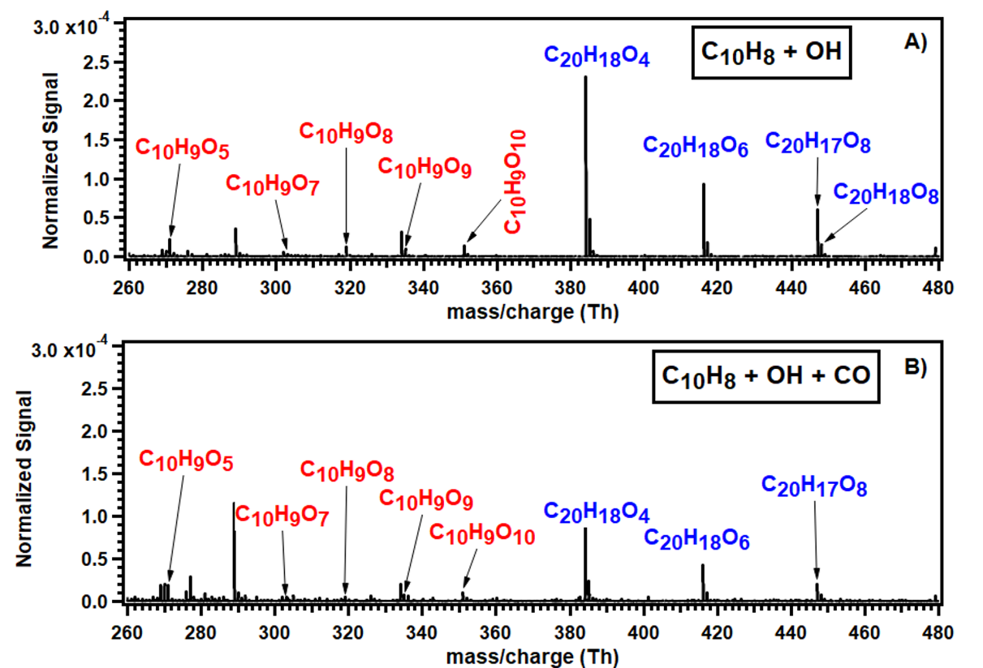
Figure S10. Normalized mass spectra obtained from the OH-initiated oxidation of naphthalene (C₁₀H₈) (A) in the absence of CO and (B) in the presence of 1.12 × 10¹⁵ molecules cm⁻³ of CO at a residence time of 1.8 s. These spectra were obtained at a C₁₀H₈ concentration of 3.08 × 10¹³ molecules cm⁻³. All products were detected as nitrate (NO₃⁻) cluster ions. Background signals were subtracted from both spectra.
$$OH+CO →HOCO$$
$$HOCO+O_{2} →{HO}_{2}+{CO}_{2}$$

The overall product distribution remained unchanged upon the addition of CO. When ozone was introduced into the reaction system, an increase in the intensities of monomeric oxidation products was observed, while the dimer signals remained nearly constant. The CO concentration was varied following the same procedure as in the ozone-free experiments. Figure S11 presents the mass spectra of the naphthalene + OH + O₃ reaction system with and without CO. Similar to the experiments without ozone, no new product peaks appeared, and the relative distribution of oxidation products remained invariant, apart from an overall decrease in signal intensity consistent with the reduced availability of OH radicals. Interestingly, even at high CO concentrations (2.79 × 10¹³ molecules cm⁻³), no enhancement in the signal intensities of hydroperoxide (ROOH) products even from early-generation peroxy radicals (C₁₀H₁₀O₅) was observed. This behavior is attributed to rapid intramolecular H-shift reactions followed by sequential O₂ addition, which outcompete bimolecular RO₂ + HO₂ termination under the present experimental conditions. These results demonstrate that under the studied conditions, HO₂-mediated chemistry exerts a negligible influence on the product composition, suggesting that the formation of highly oxidized monomers and dimers proceeds primarily through OH as well as O₃-driven autoxidation pathways rather than HO₂-involved reaction channels.
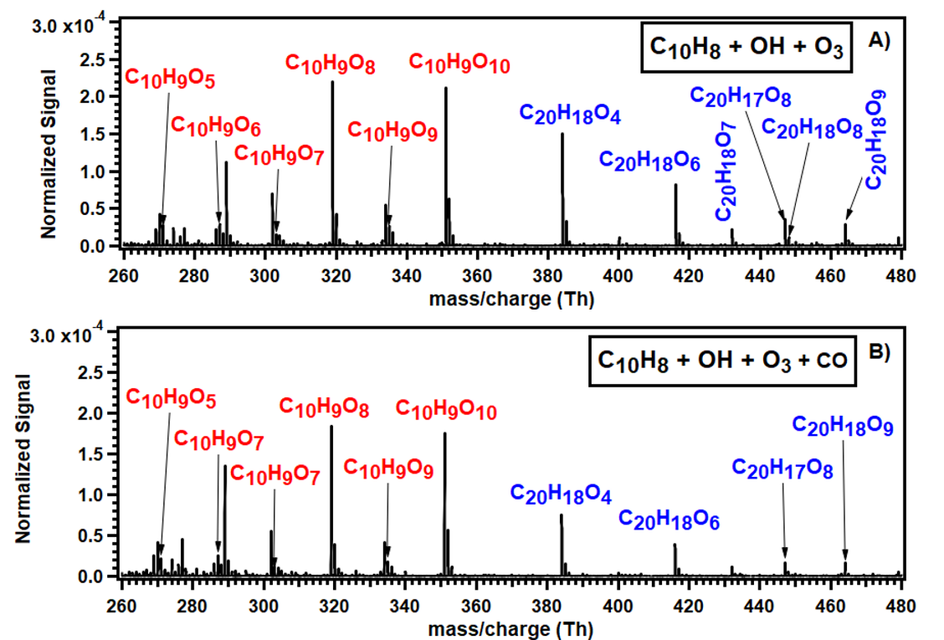
Figure S11. Normalized mass spectra obtained from the OH-initiated oxidation of naphthalene (C₁₀H₈) in the presence of 1.77 × 10¹² molecules cm⁻³ of O₃ and (A) absence of CO and (B) in the presence of 1.12 × 10¹⁵ molecules cm⁻³ of CO at a residence time of 1.8 s. These spectra were obtained at a C₁₀H₈ concentration of 3.08 × 10¹³ molecules cm⁻³. All products were detected as nitrate (NO₃⁻) cluster ions. Background signals were subtracted from both spectra.

S6. Effect of NO addition on the oxidation of naphthalene in the presence and absence of ozone
Nitric oxide (NO) was introduced into the reaction system to verify the peroxy radical nature of the observed C₁₀H₉O_{x} species via formation of organonitrates through the reaction RO₂ + NO → RONO₂. The formation of organonitrates during the OH-initiated oxidation of naphthalene, in both the absence and presence of ozone, is shown in Figure S12. The NO concentration was varied between (2.46 ̶ 49.2) × 10¹¹ molecules cm⁻³. The detection of the expected organonitrate products provides strong evidence that the assigned C₁₀H₉O_{x} species are peroxy radicals.
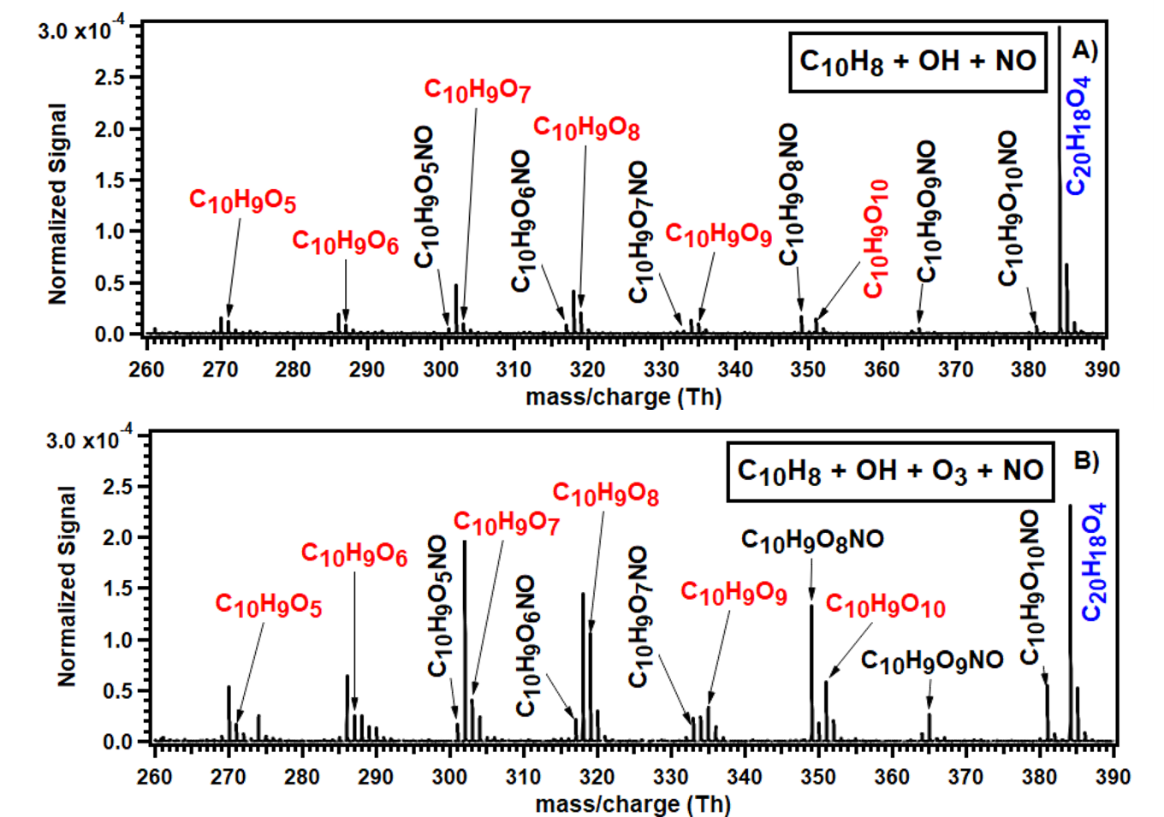
Figure S12. Normalized mass spectra showing the formation of organonitrates from the OH-initiated oxidation of naphthalene (C₁₀H₈) due to the addition of NO (A) in the absence of ozone and (B) in the presence of 1.77 × 10¹² molecules cm⁻³ O₃ at a residence time of 1.8 s. These spectra were obtained at a naphthalene concentration of 3.07 × 10¹³ molecules cm⁻³. The concentration of NO used in the absence of O₃ (spectrum A) and presence of O₃ (spectrum B) were 2.46 × 10¹² and 2.46 × 10¹¹ molecules cm⁻³ respectively. All products were detected as nitrate (NO₃⁻) cluster ions. Background signals were subtracted from both spectra.

S7. Effect of NO₂ addition on the oxidation products of naphthalene with OH radicals
In the absence of externally added ozone, an increase in the signal intensities of two monomeric products, C₁₀H₉O₆ and C₁₀H₉O₈, was observed when naphthalene (C₁₀H₈) was oxidized by OH radicals in the presence of NO. This enhancement is likely associated with the formation of NO₂ through reactions of NO with RO₂ or HO₂ radicals. The resulting NO₂ can undergo photolysis which is expected under our experimental conditions, to produce O(³P), which subsequently reacts with O₂ to form ozone, thereby indirectly influencing the oxidation chemistry.
The other explanation to this increase might be also due to the higher reactivity of NO₂ than O₂ addition to the aromatic alkyl radical formed due to OH initiated oxidation. NO₂ could have a similar effect on naphthalene as O₃, i.e. form an epoxide that continues autoxidation.

It can further eliminate NO molecule to form an epoxide ring that continues autoxidation showing a similar effect as that of ozone. In the presence of ozone, NO₂ is formed even at the lower concentration of NO (20 ppb) and showed a combined effect in enhancing the HOM monomers. The signal intensity of the C₁₀H₉O₈ peak first decreases and then remained flat, likely due to its simultaneous formation through combined NO₂ and O₃ effects, while also being consumed via reaction with NO to form organonitrates. There was an increase in the intensity of peroxy radicals with odd numbers of oxygen atoms, possibly indicating the involvement of alkoxy-mediated pathways regenerating peroxy radicals.
To isolate and verify the influence of NO₂ on the oxidation product distribution, controlled experiments were conducted by directly introducing NO₂ into the reaction system. Naphthalene (3.07 x 10¹³ molecules cm⁻³) was oxidized by OH radicals generated in situ via H₂O₂ photolysis, while the NO₂ concentration varied between (2.46 – 73.8) x 10¹¹ molecules cm⁻³. These experiments were performed in the same flow reactor (50 cm length, 1-inch outer diameter quartz tube) at a residence time of 1.8 s, and the products were detected using nitrate CIMS. A systematic increase in the signals of C₁₀H₉O₆ and C₁₀H₉O₈ with increasing NO₂ concentration is shown in Figure S13, confirming the direct role of NO₂ in enhancing HOM monomer formation.
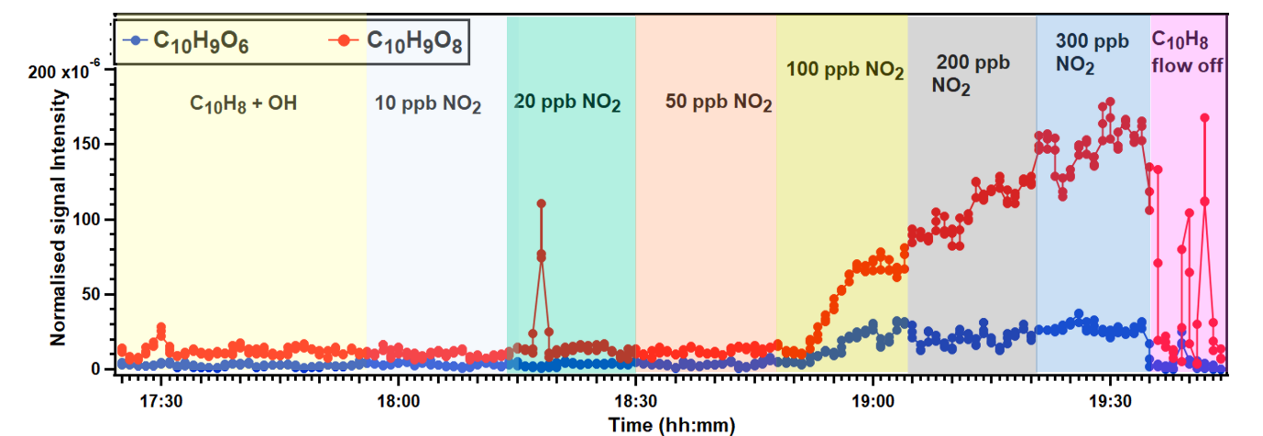
Figure S13. Normalized time series of peroxy radicals (C₁₀H₉O₈ and C₁₀H₉O₁₀) formed in the OH-initiated oxidation of naphthalene (C₁₀H₈) due to the addition of NO₂ at a residence time of 1.8 s. The concentration of naphthalene was maintained at 3.07 × 10¹³ molecules cm⁻³. The red and blue color traces represent the time series of C₁₀H₉O₆ and C₁₀H₉O₈ respectively.

S8. Reaction of other polyaromatic compounds with OH radicals
S8.1. Biphenyl + OH A similar set of experiments was performed to examine the influence of ozone on the oxidation products formed during the reaction of biphenyl with OH radicals. At a residence time of 1.8 s, the mass spectra showed a distribution of monomeric products along with one dimeric species (C₂₄H₂₂O₈). The mass spectrum for biphenyl + OH in the absence of ozone is shown in Figure S14A. Upon introducing ozone into the reaction system, a slight increase in product signal intensities and extent of autoxidation was observed but no change in the composition of the most intense signal as shown in Figure S14B.
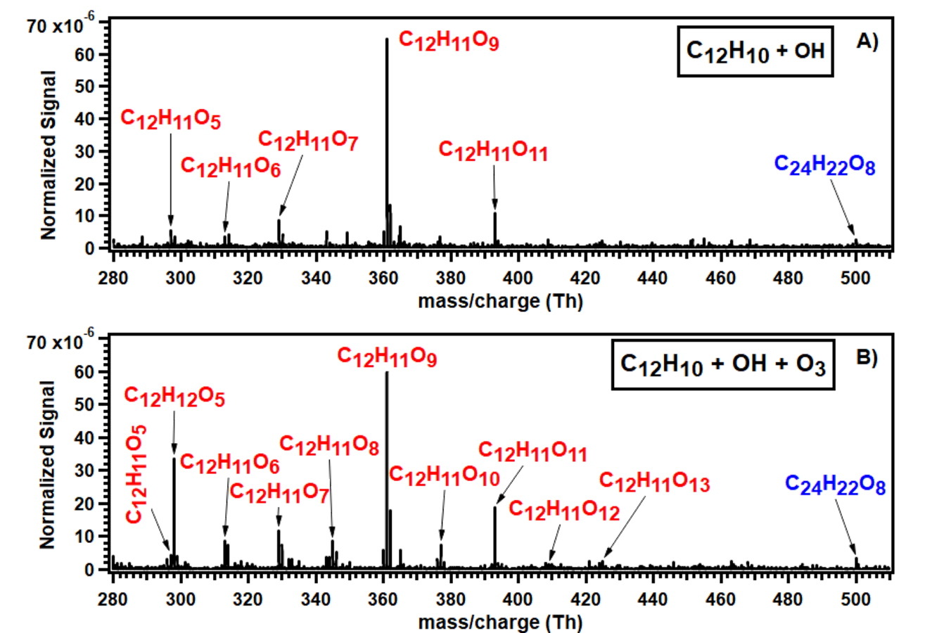
Figure S14. Normalized mass spectra obtained from the OH-initiated oxidation of biphenyl (C₁₂H₁₀) (A) in the absence of ozone and (B) in the presence of 1.77 x 10¹² molecules cm⁻³ O₃ at a residence time of 1.8 s. These spectra were obtained at a biphenyl concentration of 8.73 × 10¹² molecules cm⁻³. All products were detected as nitrate (NO₃⁻) cluster ions. Background signals were subtracted from both spectra.

Sub-second residence-time experiments (890 ms) were also conducted to evaluate the effect of ozone under shorter reaction times. At this residence time, the product distribution in both the absence and presence of ozone was similar to that observed at 1.8 s, though with lower overall signal intensities. The corresponding mass spectra for the 890 ms experiments are shown in Figure S15.
Figure S15. Normalized mass spectra obtained from the OH-initiated oxidation of biphenyl (C₁₂H₁₀) (A) in the absence of ozone and (B) in the presence of 1.89 × 10¹² molecules cm⁻³ O₃ at a residence time of 890 ms. These spectra were obtained at a biphenyl concentration of 1.40 × 10¹³ molecules cm⁻³. All products were detected as nitrate (NO₃⁻) cluster ions. Background signals were subtracted from both spectra.

S8.2. Anthracene + OH Experiments on the oxidation of anthracene with OH radicals were conducted using the same experimental setup at a residence time of 1.8 s. The monomer-to-dimer distribution in the absence of ozone was similar to that observed for naphthalene. Notably, the dimer signals were more intense than the monomeric signals, with the most intense monomeric peak corresponding to C₁₄H₁₁O₈. A dimer radical, C₂₈H₂₁O₈, was also detected, consistent with the behavior observed for naphthalene but shifted by 100 mass units as expected from the structural difference.
In the presence of ozone, the overall monomer signal intensities increased and exceeded the intensities of the overall dimer signals, while the dimer peaks themselves remained almost unchanged relative to the ozone-free experiments. The mass spectra obtained in the reaction of anthracene with OH radicals in both absence and presence of ozone is shown in Figure S16.
Extending the reaction system from naphthalene to anthracene shows that ozone significantly influences the OH-initiated oxidation product distribution in these non-functionalized polycyclic aromatic hydrocarbons. The magnitude and nature of the ozone effect on anthracene closely resembles those observed for naphthalene. In contrast, for biphenyl, the influence of ozone was minimal. Negligible changes in biphenyl oxidation product distribution were detected, and only a modest increase in overall signal intensities and oxidation extent was observed at 1.8s.
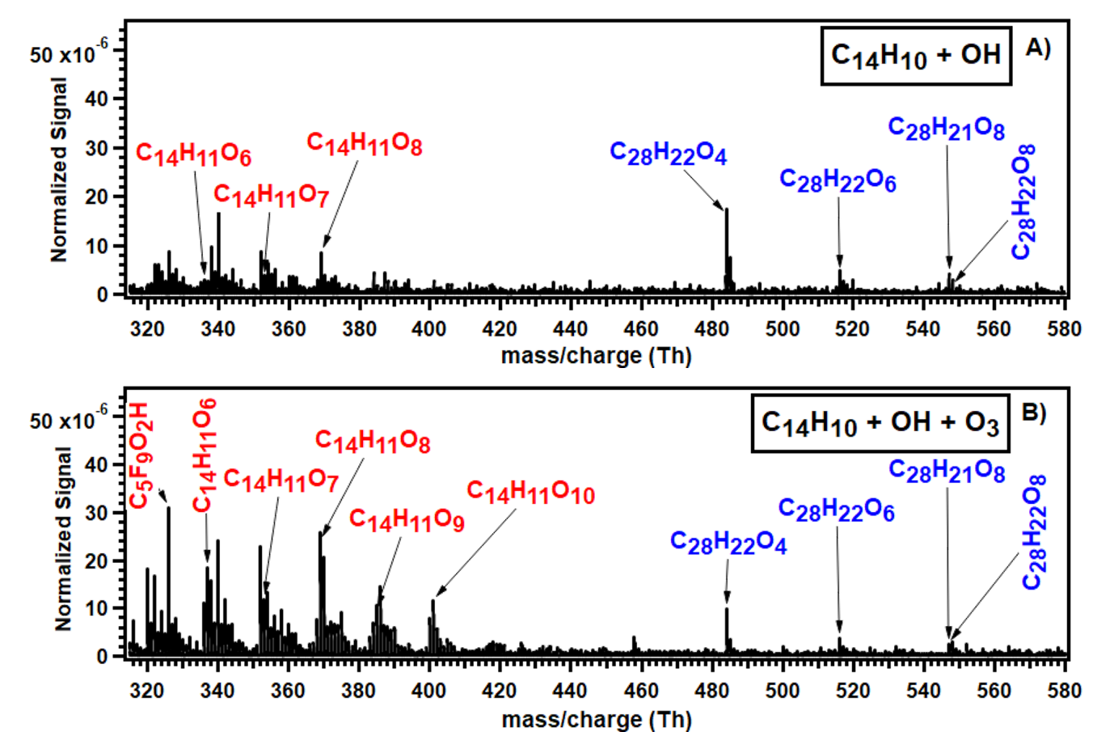
Figure S16. Normalized mass spectra obtained from the OH-initiated oxidation of anthracene (C₁₄H₁₀) (A) in the absence of ozone and (B) in the presence of 1.77 × 10¹² molecules cm⁻³ O₃ at a residence time of 1.8 s. These spectra were obtained at an anthracene concentration of 8.28 × 10¹⁰ molecules cm⁻³. All products were detected as nitrate (NO₃⁻) cluster ions. Background signals were subtracted from both spectra.

S9. Monoaromatic oxidation
The effect of ozone on the oxidation product formed in the reaction of OH radicals with monoaromatic compounds such as toluene, p-xylene and mesitylene was tested. The experiments were performed in a similar experimental set up and the products were observed using nitrate-CIMS.
S9.1. Toluene + OH The OH-initiated oxidation of toluene was investigated using the same flow-tube experimental configuration described for naphthalene and the other polyaromatic systems. In the absence of ozone, the resulting mass spectrum (Figure S17 A) displayed a distribution of both monomeric and dimeric products. Consistent with previous study ⁵, the most intense monomeric signal corresponded to the C₇H₉O₉ peroxy radical, indicating the formation of toluene derived HOM species under our experimental conditions.
Upon the addition of ozone into the reaction system, no new oxidation products emerged, and the overall product distribution remained unchanged (Figure S17B). The only observable effect of ozone was a moderate enhancement in the signal intensities of the existing monomer and dimer peaks. This behavior contrasts with the strong ozone-induced modifications observed for naphthalene and anthracene, and indicates that, for toluene, ozone does not participate directly in the formation of new OH-initiated oxidation products under the present experimental conditions.
These observations confirm that the ozone influence is compound-specific and shows no effect for alkyl-substituted monocyclic aromatics like toluene than for non-functionalized polycyclic aromatic hydrocarbons.
Figure S17. Normalized mass spectra obtained from the OH-initiated oxidation of toluene (C₇H₈) (A) in the absence of ozone and (B) in the presence of 1.77 × 10¹² molecules cm⁻³ O₃ at a residence time of 1.8 s. These spectra were obtained at a toluene concentration of 1.88 × 10¹² molecules cm⁻³. All products were detected as nitrate (NO₃⁻) cluster ions. Background signals were subtracted from both spectra.

S9.2. Para-xylene/1,3,5-Trimethylbenzene + OH To further verify the negligible effect of ozone on the mono-aromatic compounds, the experiments were performed for the reaction of p-xylene and 1,3,5-trimethylbenzene with OH radicals. In the case of p-xylene oxidation, the most intense peak was observed for C₈H₁₁O₉ monomer, and the extent of autoxidation ranged up to the formation of C₈H₁₁O₁₁. The mass spectra are shown in Figure S18.
Figure S18. Normalized mass spectra obtained from the OH-initiated oxidation of para-xylene (p-C₈H₀) (A) in the absence of ozone and (B) in the presence of 1.77 × 10¹² molecules cm⁻³ O₃ at a residence time of 1.8 s. These spectra were obtained at a para-xylene concentration of 1.84 × 10¹³ molecules cm⁻³. All products were detected as nitrate (NO₃⁻) cluster ions. Background signals were subtracted from all spectra.

In the case of 1,3,5-trimethylbenzene reaction with OH radicals, the most intense signal was observed for C₉H₁₃O₇ along with formation of dimers (C₁₈H₂₆O_{8/10/12}). The mass spectra are shown in Figure S19. The most oxygenated monomer species was observed to have up to 11 oxygen atoms.
In the presence of ozone, there were no significant changes in the intensity or the formation of new products. This suggests that at the present experimental conditions, the ozone does not have any considerable influence on the formation of products initiated by the OH radicals.
Figure S19. Normalized mass spectra obtained from the OH-initiated oxidation of 1,3,5-trimethyl benzene (C₉H₁₂) (A) in the absence of ozone and (B) in the presence of 1.77 × 10¹² molecules cm⁻³ O₃ at a residence time of 1.8 s. These spectra were obtained at a 1,3,5-trimethylbenzene concentration of 3.57 × 10¹³ molecules cm⁻³. All products were detected as nitrate (NO₃⁻) cluster ions. Background signals were subtracted from all spectra.

S10. Reaction of OH radicals produced by ozonolysis of tetramethylethylene (TME)
Naphthalene + OH The oxidation of naphthalene by OH radicals, produced via the ozonolysis of tetramethylethylene (TME), was carried out in a quartz flow reactor and the reaction products were detected using nitrate CIMS. Experiments were performed at residence times of 1.8 s and 630 ms and the concentration of naphthalene was varied from (6.44 – 32.21) x 10¹² molecules cm⁻³. At 1.8 s, the mass spectra (Figure S20A) showed a wide range of oxidation products, including both monomers and dimers. The most intense monomer peak corresponded to C₁₀H₉O₈, and the most highly oxygenated monomer detected was C₁₀H₉O₁₀. Dimeric products were observed at C₂₀H₁₈O₄, C₂₀H₁₈O₆ and C₂₀H₁₈O₇.
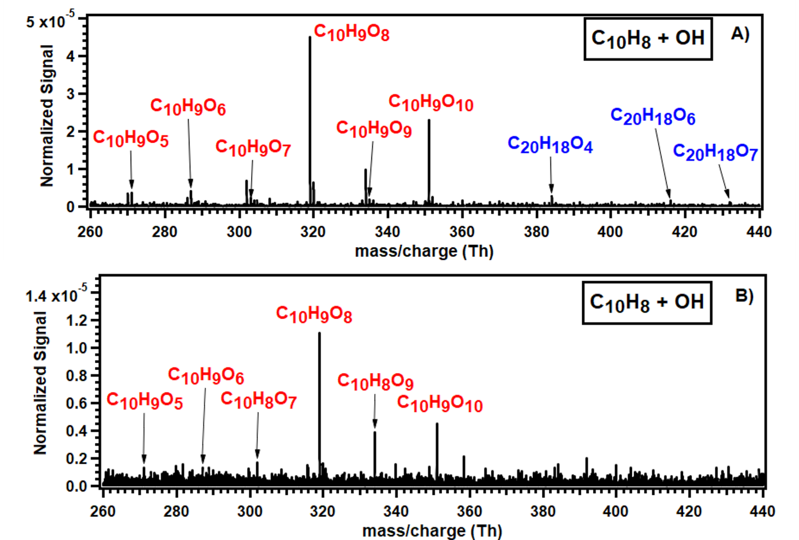
Figure S20. Normalized mass spectra obtained from the OH-initiated oxidation of naphthalene (C₁₀H₈) at a residence time of (A) 1.84 s. and (B) 630 ms. OH radicals were produced from the reaction of tetramethyl ethylene (TME) with ozone. Experimental conditions at 1.84 s residence time: [C₁₀H₈] = 9.23 × 10¹² molecules cm⁻³, [TME] = 1.56 × 10¹² molecules cm⁻³, [O₃] = 3.90 x 10¹² molecules cm⁻³; Experimental conditions at 630 ms residence time: [C₁₀H₈] = 6.44 × 10¹³ molecules cm⁻³, [TME] = 1.65 × 10¹² molecules cm⁻³, [O₃] = 4.13 × 10¹² molecules cm⁻³. All products were detected as nitrate (NO₃⁻) cluster ions. Background signals were subtracted from all spectra.

At the shorter residence time of 630 ms, only monomeric products were detected, with C₁₀H₉O₈ again being the dominant signal (fig. S20B). The naphthalene concentration was varied from (3.22 – 64.42) × 10¹² molecules cm⁻³. According to the general unimolecular autoxidation mechanism scheme, oxidation of naphthalene by OH followed by O₂ addition is expected to produce peroxy radicals with odd numbers of oxygen atoms (C₁₀H₉O_{x}, x = odd). Since secondary bimolecular reactions are almost completely suppressed at such short timescales, chemistry should be primarily dominated by unimolecular processes. The observation of peroxy radicals with even numbers of oxygen atoms at 630 ms suggests that rapid formation and subsequent autoxidation of early phenolic products (e.g., 1- or 2-naphthol) may occur; however, such pathways occurring significantly through second generation OH oxidation at sub-second timescales is highly unlikely.
1- and 2-naphthol + OH The same experimental setup was used to investigate the oxidation products formed from the reactions of 1-naphthol and 2-naphthol with OH radicals. For 1-naphthol, only monomeric products were detected at a residence time of 630 ms (fig. S21A). The most oxygenated peroxy radical observed was C₁₀H₉O₉, while the most intense signal appeared at C₁₀H₉O₇. According to the general unimolecular autoxidation mechanism, the peroxy radical formed from OH-initiated oxidation of 1-naphthol should contain an even number of oxygen atoms. However, the most intense signal in this case corresponds to a peroxy radical with an odd number of oxygen atoms. As discussed in the previous section, bimolecular reactions between two free radical species at sub-second timescales are expected to be minimal, making the formation of alkoxy-derived peroxy radicals an unlikely explanation for this observation.
For 2-naphthol, only monomeric oxidation products were detected, with the dominant signal at C₁₀H₉O₆ and the most oxygenated peroxy radical observed at C₁₀H₉O₁₀ (fig.S21B). Here, the most intense peroxy radical contains an even number of oxygen atoms, consistent with the expected peroxy radical formation mechanism.
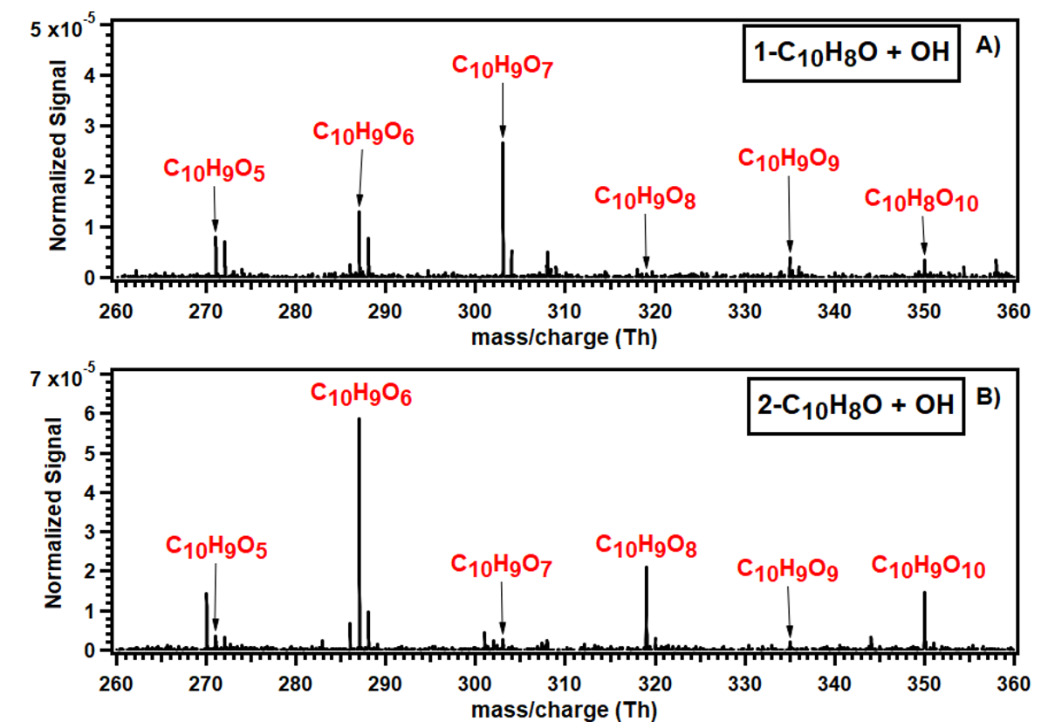
Figure S21. Normalized mass spectra obtained from the OH-initiated oxidation of (A) 1-naphthol (1-C₁₀H₈O) and (B) 2-naphthol (2-C₁₀H₈O) at a residence time of 630 ms. OH radicals were produced from the reaction of tetramethyl ethylene (TME) with ozone. Experimental conditions: [1-C₁₀H₈O] = 6.34 × 10¹¹ molecules cm⁻³, 1-C₁₀H₈O] = 9.84 × 10¹¹ molecules cm⁻³, [TME] = 1.65 × 10¹² molecules cm⁻³, [O₃] = 4.13 × 10¹² molecules cm⁻³. All products were detected as nitrate (NO₃⁻) cluster ions. Background signals were subtracted from both spectra.

Comparing the mass spectra obtained in the oxidation of naphthalene with 1 and 2-naphthol at the same residence time (630 ms), the most intense monomer signal in the case of naphthalene was C₁₀H₉O₈, which contains an even number of oxygen atoms. At this timescale, the most intense signals from 1-naphthol and 2-naphthol correspond to odd (C₁₀H₉O₇) and even (C₁₀H₉O₆) oxygen numbers, respectively. Since OH addition to naphthalene predominantly occurs at the 1-position, forming 1-naphthol, and since the most intense peroxy radical from 1-naphthol contains an odd number of oxygen atoms, therefore the interference from 1-naphthol–derived products can be ruled out. In the case of 2-naphthol, although the most intense peroxy radical has an even number of oxygen atoms, its dominant signal (C₁₀H₉O₆) differs from the most intense monomer observed in naphthalene oxidation (C₁₀H₉O₈). Moreover, OH addition at the 2nd -position is a minor reaction channel, and the yield of 2-naphthol should be correspondingly low under our experimental conditions. Taken together, these differences in dominant product signals indicate that contributions from secondary chemistry involving 1- or 2-naphthol are minimal and can be effectively excluded.
S11. Estimation of OH radicals
OH radical concentrations generated via photolysis of H₂O₂ were estimated indirectly from sulfuric acid (H₂SO₄) formation. Direct determination of OH radical was not possible due to the lack of an absolute photon flux measurement for the non-coherent UV light source used to photolyze H₂O₂. Instead, OH concentrations were inferred using the well-established SO₂ + OH reaction, with sulfuric acid selected as the tracer due to its exclusive formation via OH chemistry and its high sensitivity to detection by nitrate CIMS.
SO₂ was introduced into the same quartz flow reactor used for all oxidation experiments, and OH radicals were generated by photolysis of H₂O₂ using the same germicidal lamp. The residence time was maintained at 1.8 s. The estimation was performed at two SO₂ concentrations (1.23 × 10¹³ and 2.46 × 10¹³ molecules cm⁻³), while all other experimental conditions were the same.
Quantification of sulfur-containing products was achieved by first calibrating the nitrate CIMS following the procedure described by Kürten et al. ⁶. Calibration was performed by increasing water vapor concentrations at constant flow of SO₂ and tracking the corresponding sulfuric acid signal. The resulting calibration factor, corrected for the dimensions and flow conditions of the present reactor, was determined to be 3.10 × 10⁹ molecules cm⁻³ ncps⁻¹.
Given that SO₂ concentrations exceeded OH concentrations by more than few orders of magnitude, SO₂ consumption during the reaction was assumed to be negligible ([SO₂]₀ =[SO₂]_{1.8s}). The OH concentration was calculated using the rate-determining step for sulfuric acid formation:
${SO}_{2}+OH \underset{→}{k} {HOSO}_{2} \underset{→}{+O_{2} / {-HO}_{2}} {SO}_{3} \underset{→}{{2 H}_{2}O}H_{2}{SO}_{4}+ H_{2}$O
with a rate coefficient k = 2.0 × 10⁻¹² cm³ molecule⁻¹ s⁻¹ ⁷
The reaction rate was expressed as:
$rate = \frac{d [P]}{dt} =k \left[{SO}_{2}\right]\left[OH\right]$ (II)
where d[P] represents the total concentration of products formed during the residence time. We have included the concentration of SO₃ in addition to H₂SO₄ concentration because we have carried out the experiments at a nearly dry condition and the SO₃ is not fully converted to H₂SO₄ ⁸. The only source of water to form sulfuric acid was from the gas flows and H₂O₂ bubbling. Therefore, the total product concentration was estimated as the sum of H₂SO₄ and SO₃ concentrations. The value of d[P] was calculated by multiplying the sum of the normalized signal counts of HSO₄⁻, HNO₃HSO₄⁻, H₂HSO₄HSO₄⁻ and SO₃NO₃⁻ with the estimated corrected calibration factor.
The OH concentration was calculated as:
[OH] = (d[P]/dt) / (k × [SO₂]), (III)
and the average OH concentration derived from the two SO₂ levels was estimated to be 3.90 × 10⁶ molecules cm⁻³.
The uncertainty in the estimated OH radical concentration arises from uncertainties in the sulfuric acid calibration factor, SO₂ concentration, residence time, and the rate coefficient for the SO₂ + OH reaction. The systematic uncertainty in the nitrate CIMS calibration factor is estimated to be approximately ±30%, while uncertainties in SO₂ concentration and residence time, dominated by mass flow controller accuracy, contribute an additional ±10%. The uncertainty in the rate coefficient (k = 2.0 × 10⁻¹² cm³ molecule⁻¹ s⁻¹) is estimated to be within the factor of 1.5. Combining these contributions, the overall uncertainty in the derived OH concentration is estimated to be within a factor of 2.
S12. Experimental uncertainties and reproducibility
Uncertainties in the present measurements arise from instrumental transmission efficiency, flow control, residence-time determination, and wall losses within the flow reactor. The transmission efficiency of the APi-TOF can introduce uncertainty in the relative signal intensities of HOM. However, the mass resolving power of the instrument (≈3500 m/Δm), combined with high-resolution peak fitting, enables unambiguous molecular formula assignment for the detected species.
Uncertainties in gas flow rates, originating from mass flow controllers, propagate into uncertainties in reactant concentrations and calculated residence times. Based on the routine calibration, the maximum uncertainty in residence time is estimated to be approximately ±10%. Wall losses of reactant gases and oxidation products are unavoidable in flow reactors of this size and primarily affect absolute signal intensities rather than product identity or relative trends. Quantitative estimation of wall losses for individual condensable products is challenging due to compound-dependent diffusivities and uptake coefficients. As a reference case, the transmission efficiency of the flow reactor was estimated assuming diffusion-limited wall loss with a diffusion coefficient of 0.08 cm² s⁻¹ (typical for sulfuric acid), yielding an estimated transmission efficiency of 64.76%.
Product detection was performed using an APi-TOF nitrate CIMS equipped with an Eisele-type inlet, which minimizes sampling losses and wall interactions for low-volatility and highly oxygenated species. Consequently, the analysis presented in this work emphasizes relative changes in signal intensities, product distributions, mass shifts due to isotopes, and systematic responses to the changes in the experimental conditions (e.g., addition of O₃, NO₂, and D₂O), all of which are robust against the uncertainties described above.
All experiments were repeated two to three times to assess reproducibility. Figure S22 compares the OH-initiated oxidation of naphthalene in the absence and presence of ozone measured on two different experimental days. The experimental conditions were kept nearly the same. The overall spectral features and product distributions are consistent between the two experiments, with differences primarily limited to absolute signal intensities. The comparative experimental uncertainty between the two datasets was 22.7% for monomer signal intensities and 16.6% for dimer signal intensities. Based on the variability observed across repeated experiments, we estimate an upper limit of random uncertainty of approximately ±50% for individual product signal intensities.
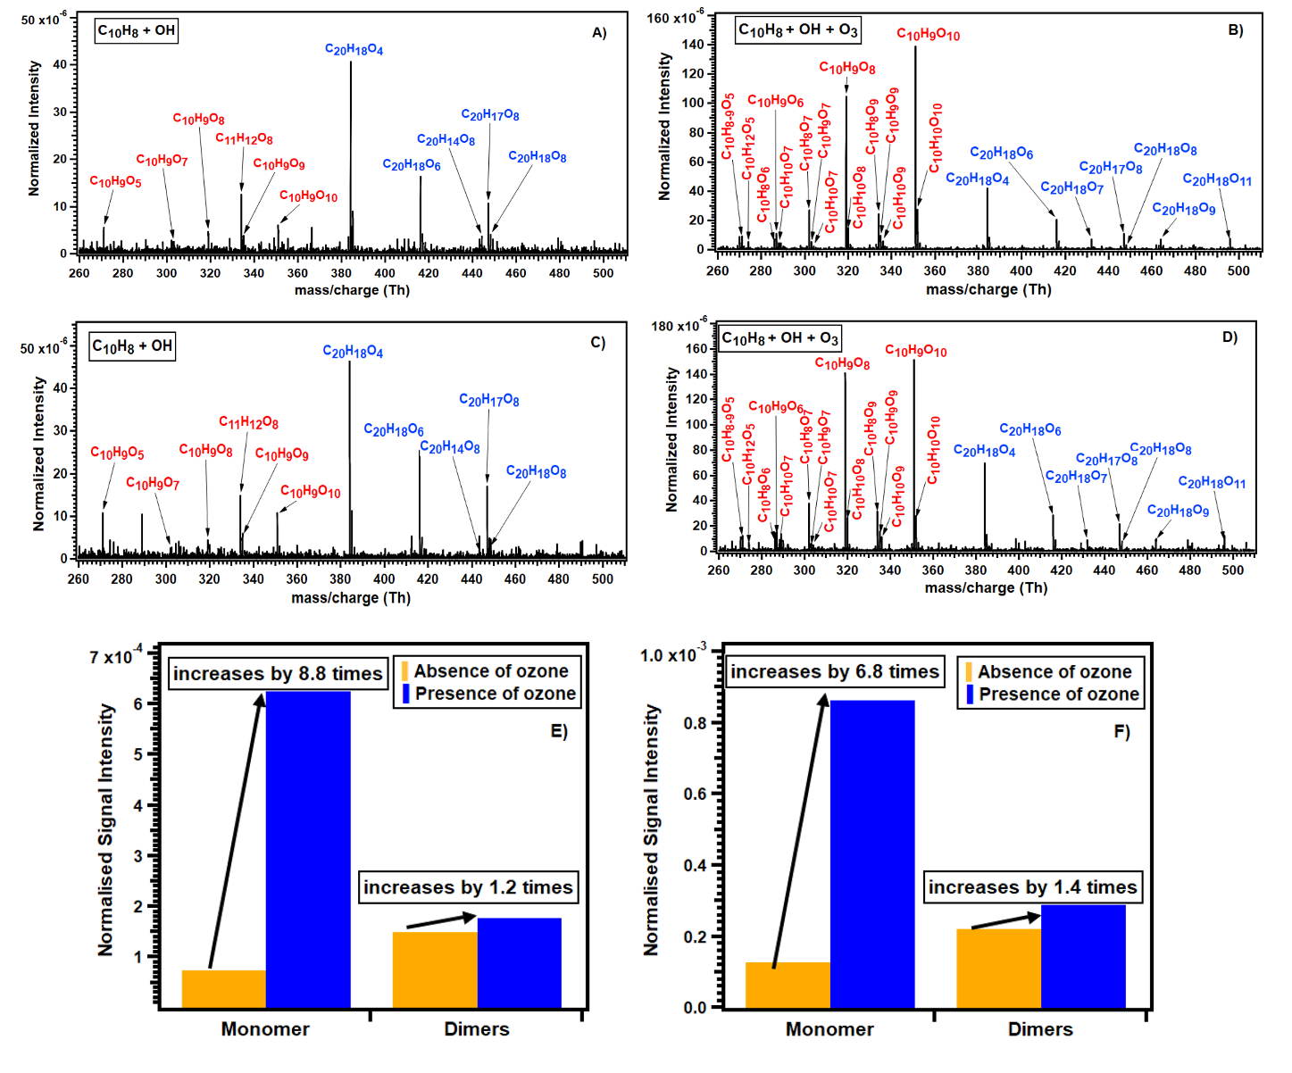
Figure S22. Normalized mass spectra and relative changes in the signal intensities of monomer and dimer products formed during the OH-initiated oxidation of naphthalene on two different days. Figures A, B and E are obtained from the experiments of Day 1. Figures C, D and F are obtained from the experiments of day 2. The experimental conditions for both days are the same: [C₁₀H₈] = 3.08 × 10¹³ molecules cm⁻³, [O₃] = 1.86 × 10¹² molecules cm⁻³ and residence time: 1.8 seconds. Figures A and C are the normalized mass spectra obtained in the absence of ozone on days 1 and 2 respectively. Figures B and D are the normalized mass spectra of OH-initiated oxidation of naphthalene obtained in the presence of ozone on day 1 and 2 respectively. Figures E and F show the relative change in the intensities of monomer and dimer products obtained in the OH-initiated oxidation of naphthalene in the absence and presence of ozone days 1 and 2 respectively.

S13. Peak list of the observed oxidation products formed during the reaction
1-naphthol + OH
C10H8O4NO3-  254.0306 | C10H10O4NO3-  256.0463 | C10H8O5NO3-  270.0255 | C10H9O5NO3-  271.0334 | C10H10O5NO3-  272.0412
C10H8O6NO3-  286.0205 | C10H9O6NO3-  287.0283 | C10H10O6NO3-  288.0361 | C10H9O5NONO3-  301.0314 | C10H8O7NO3-  302.0154
C10H9O7NO3-  303.0232 | C10H10O7NO3-  304.031 | C10H9O6NONO3-  317.0263 | C10H8O8NO3-  318.0103 | C10H9O8NO3-  319.0181
C10H10O8NO3-  320.0259 | C10H8O9NO3-  334.0052 | C10H9O9NO3-  335.013 | C10H10O9NO3-  336.0208 | C10H8O10NO3-  350.0001
C10H9O10NO3-  351.0079 | C10H10O10NO3-  352.0158 | C20H16O5NO3-  398.0881 | C20H18O5NO3-  400.1038 | C20H18O6NO3-  416.0987
C20H16O7NO3-  430.078 | C20H18O8NO3-  448.0885 | C20H15O9NO3-  461.06

1-naphthol+OH + O₃
C10H8O4NO3-  254.0306 | C10H10O4NO3-  256.0463 | C10H8O5NO3-  270.0255 | C10H9O5NO3-  271.0334 | C10H10O5NO3-  272.0412
C10H8O6NO3-  286.0205 | C10H9O6NO3-  287.0283 | C10H10O6NO3-  288.0361 | C10H12O6NO3-  290.0518 | C10H9O5NONO3-  301.0314
C10H8O7NO3-  302.0154 | C10H9O7NO3-  303.0232 | C10H10O7NO3-  304.031 | C10H9O6NONO3-  317.0263 | C10H8O8NO3-  318.0103
C10H9O8NO3-  319.0181 | C10H10O8NO3-  320.0259 | C10H9O7NONO3-  333.0212 | C10H8O9NO3-  334.0052 | C10H9O9NO3-  335.013
C10H10O9NO3-  336.0208 | C10H9O8NONO3-  349.0161 | C10H8O10NO3-  350.0001 | C10H9O10NO3-  351.0079 | C10H10O10NO3-  352.0158
C10H9O9NONO3-  365.011 | C10H8O11NO3-  365.995 | C10H9O11NO3-  367.0029 | C20H16O5NO3-  398.0881 | C20H16O6NO3-  414.0831
C20H18O6NO3-  416.0987 | C20H16O7NO3-  430.078 | C20H18O7NO3-  432.0936 | C20H16O8NO3-  446.0729 | C20H18O8NO3-  448.0885
C20H18O9NO3-  464.0834 | C20H16O10NO3  478.0622 | C20H18O10NO3-  480.0784

2-naphthol + OH
C10H8O4NO3-  254.0306 | C10H10O4NO3-  256.0463 | C10H8O5NO3-  270.0255 | C10H10O5NO3-  272.0412 | C10H8O6NO3-  286.0205
C10H9O6NO3-  287.0283 | C10H10O6NO3-  288.0361 | C10H8O7NO3-  302.0154 | C10H10O7NO3-  304.031 | C10H9O8NO3-  319.0181
C10H8O10NO3-  350.0001 | C10H9O10NO3-  351.0079

2-naphthol + OH+ O₃
C10H8O4NO3-  254.0306 | C10H10O4NO3-  256.0463 | C10H8O5NO3-  270.0255 | C10H9O5NO3-  271.0334 | C10H10O5NO3-  272.0412
C10H8O6NO3-  286.0205 | C10H9O6NO3-  287.0283 | C10H10O6NO3-  288.0361 | C10H9O5NONO3-  301.0314 | C10H8O7NO3-  302.0154
C10H9O7NO3-  303.0232 | C10H10O7NO3-  304.031 | C10H9O6NONO3-  317.0263 | C10H9O8NO3-  319.0181 | C10H10O8NO3-  320.0259
C10H9O7NONO3-  333.0212 | C10H8O9NO3-  334.0052 | C10H9O9NO3-  335.013 | C10H10O9NO3-  336.0208 | C10H8O10NO3-  350.0001
C10H9O10NO3-  351.0079 | C10H10O10NO3-  352.0158 | C10H8O11NO3-  365.995 | C10H9O11NO3-  367.0029

Biphenyl + OH
C12H11O5NO3-  297.049 | C12H12O5NO3-  298.0568 | C12H10O6NO3-  312.0361 | C12H11O6NO3-  313.0439 | C12H12O6NO3-  314.0518
C12H11O7NO3-  329.0388 | C12H12O7NO3-  330.0467 | C10H17O9NO3-  343.0756 | C12H12O8NO3-  346.0416 | C12H10O9NO3-  360.0208
C12H11O9NO3-  361.0287 | C12H12O9NO3-  362.0365 | C11H11O10NO3-  365.0236 | C12H10O10NO3-  376.0158 | C12H10O11NO3-  392.0107
C12H11O11NO3-  393.0185 | C16H10O10NO3-  424.0158 | C24H22O8NO3-  500.1198

Biphenyl + OH+ O₃
C12H10O5NO3-  296.0412 | C12H11O5NO3-  297.049 | C12H12O5NO3-  298.0568 | C12H10O6NO3-  312.0361 | C12H11O6NO3-  313.0439
C12H12O6NO3-  314.0518 | C12H10O7NO3-  328.031 | C12H11O7NO3-  329.0388 | C12H12O7NO3-  330.0467 | C7H10O11NO3-  332.0107
C7H11O11NO3-  333.0185 | C12H10O8NO3-  344.0259 | C12H11O8NO3-  345.0338 | C12H12O8NO3-  346.0416 | C12H10O9NO3-  360.0208
C12H11O9NO3-  361.0287 | C12H12O9NO3-  362.0365 | C11H11O10NO3-  365.0236 | C12H10O10NO3-  376.0158 | C12H11O10NO3-  377.0236
C12H12O10NO3-  378.0314 | C12H11O11NO3-  393.0185 | C12H10O12NO3-  408.0056 | C12H11O12NO3-  409.0134 | C12H11O13NO3-  425.0083
C12H12O13NO3-  426.0162 | C24H22O8NO3-  500.1198

Anthracene + OH
C14H12O5NO3- | C14H10O6NO3- | C14H11O6NO3- | C14H12O6NO3- | C14H10O7NO3-
322.0568 | 336.0361 | 337.0439 | 338.0518 | 352.031
C14H11O7NO3- | C14H12O7NO3- | C14H11O8NO3- | C28H22O4NO3- | C28H22O6NO3-
353.0388 | 354.0467 | 369.0338 | 484.1402 | 516.13
C28H21O8NO3- | C28H22O8NO3-
547.112 | 548.1198

Anthracene + OH + O₃
C14H10O5NO3- | C14H11O5NO3- | C14H12O5NO3- | C14H10O6NO3- | C14H11O6NO3-
320.0412 | 321.049 | 322.0568 | 336.0361 | 337.0439
C14H12O6NO3- | C14H10O7NO3- | C14H11O7NO3- | C14H12O7NO3- | C14H10O8NO3-
338.0518 | 352.031 | 353.0388 | 354.0467 | 368.0259
C14H11O8NO3- | C14H12O8NO3- | C14H10O9NO3- | C14H11O9NO3- | C14H12O9NO3-
369.0338 | 370.0416 | 384.0208 | 385.0287 | 386.0365
C14H10O10NO3- | C14H11O10NO3- | C14H12O10NO3- | C28H22O4NO3- | C28H22O5NO3-
400.0158 | 401.0236 | 402.0314 | 484.1402 | 500.1351
C28H22O6NO3- | C28H22O7NO3- | C28H21O8NO3- | C28H22O8NO3-
516.13 | 532.1249 | 547.112 | 548.1198

Toluene +OH (+ O₃)
C7H9O5NO3-  235.0334 | C7H10O5NO3-  236.0412 | C7H8O6NO3-  250.0205 | C7H9O6NO3-  251.0283 | C7H10O6NO3-  252.0361
C7H9O7NO3-  267.0232 | C7H10O7NO3-  268.031 | C7H8O8NO3-  282.0103 | C7H9O8NO3-  283.0181 | C7H10O8NO3-  284.0259
C7H8O9NO3-  298.0052 | C7H9O9NO3-  299.013 | C7H10O9NO3-  300.0208 | C7H8O11NO3-  329.995 | C7H9O11NO3-  331.0029
C7H10O11NO3-  332.0107 | C7H8O13NO3-  361.9849 | C14H18O8NO3-  376.0885 | C14H18O10NO3-  408.0784

para-xylene + OH (+ O₃)
C8H10O5NO3-  248.0412 | C8H11O5NO3-  249.049 | C8H12O5NO3-  250.0568 | C8H10O6NO3-  264.0361 | C8H11O6NO3-  265.0439
C8H12O6NO3-  266.0518 | C8H10O7NO3-  280.031 | C8H11O7NO3-  281.0388 | C8H12O7NO3-  282.0467 | C8H10O8NO3-  296.0259
C8H11O8NO3-  297.0338 | C8H12O8NO3-  298.0416 | C8H10O9NO3-  312.0208 | C8H11O9NO3-  313.0287 | C8H12O9NO3-  314.0365
C8H11O10NO3-  329.0236 | C8H10O11NO3-  344.0107 | C8H11O11NO3-  345.0185 | C8H10O13NO3-  376.0005 | C16H22O8NO3-  404.1198
C16H22O10NO3-
436.1097

1,3,5-Trimethylbenzene + OH (+ O₃)
C9H12O5NO3-  262.0568 | C9H13O5NO3-  263.0647 | C9H14O5NO3-  264.0725 | C9H12O6NO3-  278.0518 | C9H13O6NO3-  279.0596
C9H14O6NO3-  280.0674 | C9H12O7NO3-  294.0467 | C9H13O7NO3-  295.0545 | C9H14O7NO3-  296.0623 | C5F8O2H2NO3-  307.9811
C9H12O8NO3-  310.0416 | C9H13O8NO3-  311.0494 | C9H14O8NO3-  312.0572 | C9H12O9NO3-  326.0365 | C9H13O9NO3-  327.0443
C9H14O9NO3-  328.0521 | C9H12O10NO3-  342.0314 | C9H13O10NO3-  343.0392 | C9H12O11NO3-  358.0263 | C9H13O11NO3-  359.0342
C9H14O11NO3-  360.042 | C18H26O8NO3-  432.1511 | C18H26O10NO3-  464.141 | C18H26O12NO3-  496.1308

S14. Computational Discussions
The experimental results indicate that O₃ adds to the OH-radical activated naphthalene, and that the reaction happens early in the oxidation chain. The reaction times in the experiments necessitate that fast unimolecular pathways leading to HOM formation are available. Quantum chemical methods were used to understand the role of ozone in the reaction and to map out the possible oxidation pathways. Bimolecular rate coefficients were calculated using lowest conformer transition state theory with equation
$k_{bimolec}= \frac{k_{B}T}{hc°}\exp{(\frac{G_{TS}-G_{R}}{k_{B}T})}$, (IV)
where G is the Gibbs energy and c° is the total concentration of molecules in standard condition, 2.46$×{10}^{19}$ molecules $cm^{-3}$, $k_{B}$ is the Boltzmann constant, h is the Planck constant, and T is the temperature set to 298.15 K. Unimolecular rate coefficients were calculated using multi-conformer transition state theory (MC-TST) at ROHF-CCSD(T)-F12a/VDZ-F12/ωB97X-D/aug-cc-pVTZ level-of-theory (henceforth denoted as F12 level-of-theory) following protocol of Møller et al ⁹. The rate coefficients are calculated from equation
$k=κ\frac{k_{B}T}{h}\frac{\sum_{i}{Q_{TS,i}e^{-E_{TS, i}/{(k}_{B}T)}}}{\sum_{j}{Q_{R,j}e^{-E_{R,j}/{(k}_{B}T)}}}e^{-\frac{E_{TS,0}-E_{R,0}}{k_{B}T}}$, (V)
where $E_{x,k}$ and $Q_{x,k}$ refer to the transition state (TS) and reactant (R) conformers with indices i and j respectively. $E_{x,k}$ is the energy difference in relation to the lowest energy conformer and $Q_{x,k}$ is the partition function. The lowest energy conformers (index 0) define the reaction barrier, and the F12-correction is calculated for these. ωB97X-D/aug-cc-pVTZ level of theory (denoted ωB97-level) was used for many of the compounds due to the large molecule sizes, M06-2x/aug-cc-pVTZ level of theory (denoted M062x-level) was used for assessing reliability of ωB97 level-of-theory, and MN15/def2-TZVP (denoted as MN15) was used for some reactions. Reactions calculated using MN15 are clearly marked in the following tables. B3LYP/6-31+G(d) level of theory (denoted as B3LYP level-of-theory) was used to exclude reaction pathways if they show sufficiently high barriers. The rate calculation protocol involves initial conformer sampling in Spartan ‘24 using the MMFF-method, with a cutoff of 5 kcal/mol based on B3LYP-level single points, and a cutoff of 2 kcal/mol for B3LYP-level geometry optimization. F12-correction was used for the reaction barriers. To minimize the number of required computations, tunneling corrections were not computed for reactions with an imaginary frequency lower than 700 $cm^{-1}$ as the effect of tunneling is then small, generally less than 10%.
A novel O₃ addition reaction to the naphthalene + OH adduct was found using computational methods. The subsequent oxidation mechanisms following O₃ addition are mapped out in this section.
Mechanistically HOM formation from monoaromatics has been shown to involve molecular rearrangement reaction of the bicyclic peroxy radicals (BPRs) ⁵ and for this reason molecular rearrangement is of particular interest also in this work. Molecular rearrangement leads to ring-breaking, which facilitates autoxidation and consequently HOM formation by removing the steric hindrance of the aromatic ring. For this reason, the molecular rearrangement and other mechanisms leading to ring-breaking received more attention, while pathways deemed unlikely for HOM formation received less.
O₃ addition
Transition states for reactions of covalently bonded OH-naphthalene adduct with O₃ were found. There are different ways this reaction can take place, both in terms of stereochemistry, as well as depending on where OH adds. OH has branching ratios of 93.8 % and 5.8% for addition to positions 1 and 2 respectively ¹⁰. For position 1 addition (right pathway in Figure S23) O₃ can add either from the syn- or the anti-side relative to the OH group position. Based on DFT values, addition to the syn side is favored, likely due to the favorable OH-O₃ interaction. For the position 2 addition, only syn side addition is considered as for the purposes of HOM formation, their oxidation mechanisms are identical as will become apparent later in this section.
Figure S23. Naphthalene reactions with ozone. O₃ can add to the tertiary position of the naphthalene. This is followed by O₂ loss leading to epoxide formation. See table S4 for rate coefficients.
Table S4. Rate coefficients for naphthalene reactions with ozone ($cm^{3} molecule^{-1} s^{-1}$) along with the values of the spin-squared operator S².
 | ωB97 ($S^{2}$) | M062x ($S^{2}$) | MN15
O₃-add-1 (Syn) | $1.7×{10}^{-11}$ (0.7522) | $1.6×{10}^{-7}$ (0.7501) | -
O₃-add-1 (Anti) | $5.6×{10}^{-16}$ (0.7719) | $1.1×{10}^{-12}$ (0.7767) | -
O₃-add-2 | $1.2×{10}^{-12}$ (0.7523) | $$-$$ | -
O₂-loss-1 | - | - | $$6.0×{10}^{10}$$

Two functionals, ωB97X-D and M06-2x, were used to see if the rate coefficients are independent of the method used. This is because ozone can have multireference character due to the delocalized nature of O₃. For DFT, the spin contaminant is used as a proxy for multireference character. For doublets, the $S^{2}$ value should be 0.75, and deviations from this indicate spin contamination. For the syn-side addition, the transition states do not suffer from spin contamination for either of the methods, whereas for the anti-side addition, $S^{2}$ value is in the range of 0.77-0.78 are seen for both. The $S^{2}$ value for a reaction here is the maximum $S^{2}$ value of any of the reactant and transition state conformers. The rates calculated from the two methods differ consistently by roughly 5 orders of magnitude with M062x showing systematically lower barriers. This causes the reaction rate on the syn side to exceed the collision limit at the M062x level of theory. These discrepancies indicate large uncertainties in the computed barriers for O₃ additions to delocalized OH-naphthalene alkyl radicals.
Despite these complications, the transition state search convergence and the IRC calculations from the O₃ addition transition state seems to be well behaved for the syn side, with clean convergence to react and product wells. From previous experience, IRC calculations for spin contaminated systems using our methods often have difficulty converging to the correct wells, with crashing being a frequent occurrence. The IRC path also shows no spin contamination. This indicates that the reaction itself is reasonably well behaved, but energetics, and therefore the rate coefficients, are not reliable. Despite this, the well behaved nature of the reaction, as well as the strong experimental evidence supporting the role of the tertiary carbon in the reaction supports this O₃-addition reaction as a potential pathway to the experimentally detected HOM.
Subsequent chemistry following O₃ addition
Following O₃ addition, the trioxide radical intermediate that forms as O₃ adds will quickly lose O₂. A transition state for this reaction was found, and it has reaction rate coefficient of $6.0 ×{10}^{10}$ $s^{-1}$ at the MN15 level of theory. The IRC calculation leads to the formation of epoxides shown in Figure S23. This means that O₃ addition effectively leads to the addition of one oxygen atom and this is in agreement with isotopically labelled CIMS experiments in which the addition of only one$^{18}O$ was seen. The resulting epoxide can react with oxygen directly and the subsequent chemistry is shown in Figure S23. O₂ addition to the 2-position leads to a peroxy radical intermediate that can potentially undergo endocyclization to form cyclic peroxy radicals (CPRs). The molecular rearrangement reaction, a key reaction for HOM formation of the analogous BPRs for aromatics ⁵, was found to be slow with rates of $2.7 ×{10}^{-6} s^{-1}$ for C₂ and $3.6×{10}^{-6} s^{-1}$ for C₁ for C₁₀H₉O₆-epox-2-CPR (Figure S24).
For position 1 addition, cyclic compounds can form via 5-membered ring-closure, and O₂ can then add to form a O₆-compound. No ring-breaking reactions or other unimolecular pathways leading to higher oxygenated species were found. It is therefore likely that O₆-compound, as well as C₁₀H₉O₆-epox-2-CPR, accumulate on the experimental time scale contributing to the O₆ compounds with one labile H atom detected in the D₂O-experiments.
a)
b)
Figure S24. Naphthalene oxide chemistry. Both position 1 (a) and 2 (b) addition lead to formation of O₆ compounds and could lead to even higher oxygenated compounds via molecular rearrangement (MR) (See Table S5). However, these rates are too slow to contribute in the experimental timescales.
Table S5. Rate coefficients for naphthalene oxide chemistry ($s^{-1}$) shown in Figure S24.
 | ωB97 | MN15
O2-add-A | - | $$7.5×{10}^{4}$$
Endo-1 | - | 13
O2-add-B | - | 90
Endo-2 | 0.04 | -
MR (C₁) * | $$2.7×{10}^{-6}$$ | -
MR (C₂) * | $$3.6×{10}^{-6}$$ | -
* C₁ refers to the C-C bond breaking as illustrated in Figure S23, where as C₂ refers to the other C-C bond breaking leading to different chemistry
Oxepine chemistry
Due to no apparent pathways leading to compounds with 8 or more oxygens being known from the previous considered pathways, it is likely that the experimentally detected HOMs are a result of oxepine formation, a new reaction found for the epoxide compounds. This reaction is very fast, and based on the computed values, the naphthalene oxide (C₁₀H₉O₂-epox-1 and C₁₀H₉O₂-epox-2) and oxepine exist in an equilibrium that favors the oxepine form. This reaction is analogous to the benzene oxide-oxepine tautomerism for closed shell compounds ¹¹, but here we present that it exists for radicals as well.
a)
b)
Figure S25. Oxide-oxepine tautomerism. The naphthalene oxide and the oxepine form exists in an equilibrium a) Position 1 addition. b) Position 2 addition. For rate coefficients, see Table S6.
Table S6. Rate coefficients for oxide-oxepine tautomerism ${(s}^{-1})$
 | F12 | ωB97
Position 1 (syn) forward | $$2.9×{10}^{8}$$ | $$8.9×{10}^{8}$$
Position 1 (syn) reverse | $$3.5×{10}^{7}$$ | $$1.9×{10}^{8}$$
Position 1 (anti) reverse | - | $$6.0×{10}^{9}$$
Position 2 | - | $$1.3×{10}^{5}$$

For the position 2 addition the resulting oxepine is close to planar. For this reason, the syn- and anti-side O₃ addition lead to identical structures and the complication regarding the O₂ addition chemistry can be side-stepped. However, due to the placement of the initial epoxide group for the position 1 addition, the resulting oxepines are distinct, with the O group exhibiting stereochemistry. The transition state from the O at the syn side to the corresponding anti side has a barrier of 45.0 kcal/mol at the ωB97 level of theory and therefore the interchange is much too slow under ambient conditions. For this reason, the O₃ addition site affects the subsequent chemistry.
The new pathways allowed by oxepine chemistry can potentially lead to facile subsequent autoxidation and ultimately HOM formation. For position 2 addition, endocyclization is possible to yield CPRs. However, the molecular rearrangement rates are slow for similar reasons as was discussed for the C₁₀H₉O₆-epox-2-CPR. Additionally, C₁₀H₉O₄-CAR, the cyclic alkyl radical (CAR) forming from O₃ addition at position 2 is likely quite stable due to the resonance stabilization enabled by the two rings. The most stable peroxy radical is likely the one illustrated in Figure S26 as it allows for the full delocalization over the oxepine moiety, existing in well of -5.1 kcal/mol. This is likely unstable enough to decompose thermally and thus the resonance stabilized alkyl and the peroxy radicals exist in equilibrium with the alkyl radical in which O₂ continually adds and is lost again.
Figure S26. Position 2 oxepine chemistry. Oxepine pathway initiated by position 2 O₃-addition can lead to O₆ compounds in experimental time scales. Endo-L/R refers to the two possible endocyclization reactions and MR refers to molecular rearrangement. C₁ and C₂ refer to the two ways C-C bond breaking can happen, and the prefix a- in aC_{i} refers to the alkyl radical. For rate coefficients, see Table S7.

Table S7. Rate coefficients for position 2 oxepine chemistry $(s^{-1}$)
 | ωB97
Endo-L | $$1.4×10^{3}$$
Endo-R | $$2.3×10^{3}$$
MR (aC₁) | $$1.9×10^{-7}$$
MR (aC₂) | $$2.1×10^{-6}$$
MR (C₁) | $$9.1×10^{-6}$$
MR (C₂) | $$3.2×10^{-6}$$

For the position 1 addition, many autoxidation pathways are possible. Most of the known pathways for HOM formation involve molecular rearrangement. However, these pathways are contingent on the endocyclization taking place. Technically there are multiple ways for endocyclization to take place, but forming a 5-membered ring over the initial location of the OH attack (see Figure S26) is highly favored. However, the endocyclization cannot take place with the epoxide intermediate shown in Figure S27, as this would require one of the carbon atoms to exceed its valency. Following tautomerism of the epoxide, endocylization is possible.
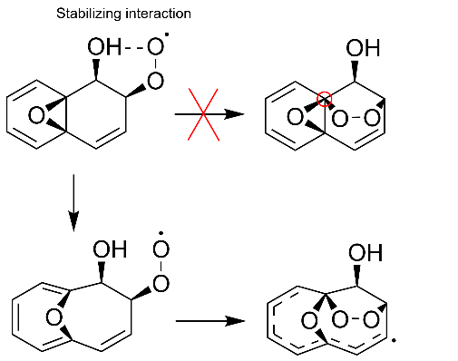
Figure S27. Impossibility of endocyclization without oxide-oxepine tautomerism for O₃ addition at position 1. Oxepine chemistry is required for endocyclization to take place as otherwise the carbon would need to form 5 bonds. No concerted transition state for simultaneous endocyclization and oxepine formation was found.
Endocyclization has two ways of this happening, with O₂ either adding on to the two ortho positions relative to the OH-group, the non-substituted carbon or to the tertiary position. The barrier for the O₂ transition state for the tertiary position exhibits high Gibbs energy barriers of over 20 kcal/mol but suffers from spin contamination (S² ~0.8) and the rate is thus unreliable. The fates of the syn and anti-side O₂ addition sites (relative to -OH) also differ significantly. For the anti-side, both the endocyclization rates are atmospherically competitive, with rates of $1.3 s^{-1}$ and $3.0{ ×{10}^{6} s}^{-1}$. The corresponding rates on the syn-side are much slower, being of the order of ${10}^{-4} s^{-1}$. There is also a competing 1,5 H-shift from the -OH group available for syn-side peroxy radical, with a forward rate of around $1.1×{10}^{-3} s^{-1}$. However, reverse reaction is likely significant as the IRC endpoint is endothermic by 20.6 kcal/mol and further reactions are likely limited by steric effects due to the constrained structure of the molecule.

Figure S28. Position 1 oxepine chemistry. HOM formation could be possible following molecular rearrangement of the different cyclic peroxy radicals given endocyclization takes place. For rate coefficients, see Table S8.

Table S8. Position 1 oxepine chemistry $(s^{-1}$)
 | F12 | ωB97 ($S^{2}$)
O₂-add (syn) | $$3.7×{10}^{-4}$$ | $8.1×{10}^{-8}$ (~0.8)
Endo-R (syn) | $$2.2×{10}^{-4}$$ | 3.1 $×{10}^{-5}$
Endo-L (syn) | - | 43
Endo-R (anti) | $$1.3$$ | $$8.1×{10}^{-3}$$
Endo-L (anti) | - | $$3.0×{10}^{6}$$
H-shift (syn) | - | $$1.1×{10}^{-3}$$
O-O break (anti) | - | $$1.46×{10}^{3}$$

Molecular rearrangement of the cyclic peroxy radical
The previous considerations indicate that that endocyclization happens via O₂ addition to the tertiary position and then follows the Endo-L pathway. Due to the inherent uncertainties in the calculations, the syn side pathway might still also allow endocyclization to take place despite the high barriers at the used computational levels. If endocyclization from the syn side takes place, the resulting CPRs can undergo molecular rearrangement to lead to HOMs (see Figure S28). These HOMs have H-shifts available that are in agreement with our D₂O experiments. This is a nontrivial finding, as many arbitrary combinations of H-shifts and ring-breakings lead to compounds with a different number of labile H-atoms. We note that the reaction for the interchange reaction between the syn and anti CPRs was found to have large barriers, 40.1 kcal/mol for syn to anti and 30.8 kcal/mol for the reverse and so no interchange between these is possible without a catalyst under atmospheric conditions.
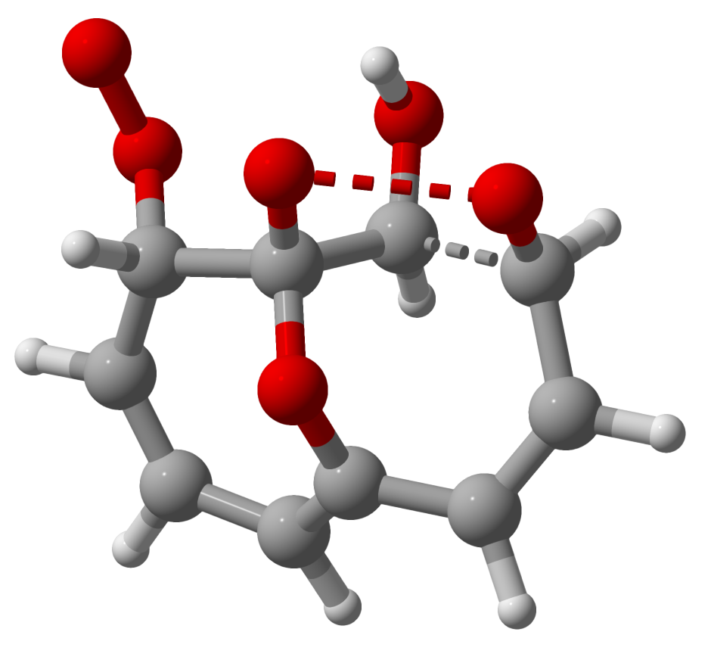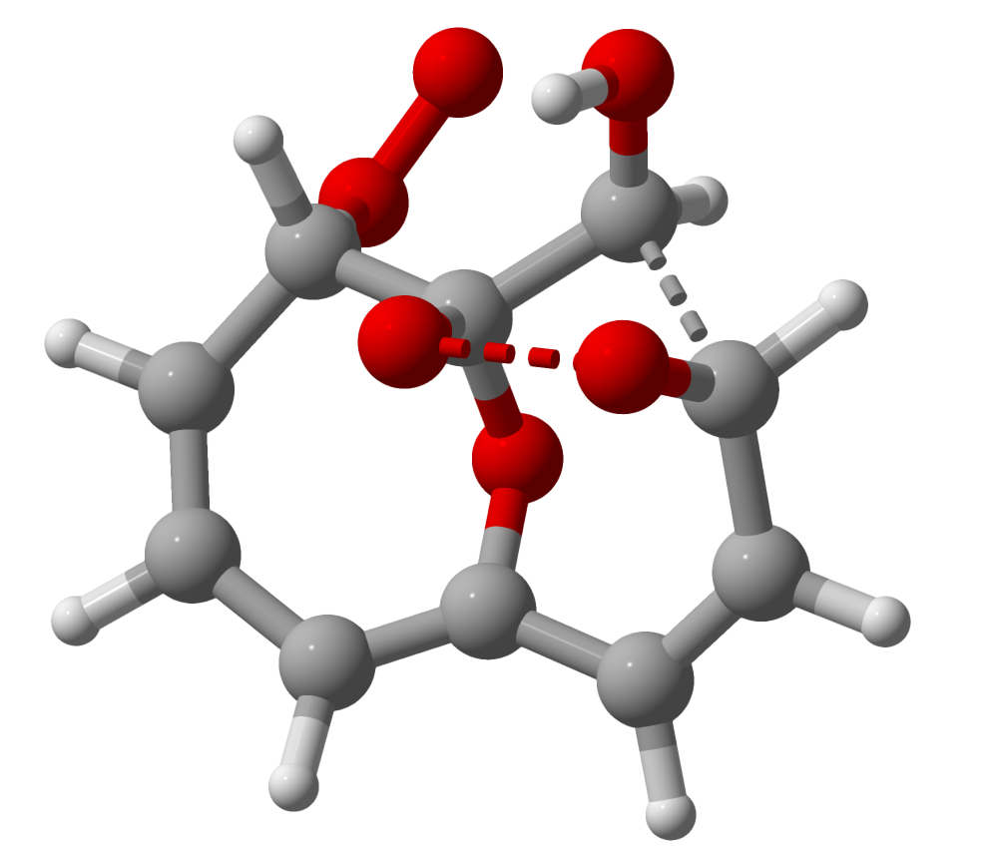
Figure S29. Molecular rearrangement of the CPRs. The breaking bonds are shown as dashed lines. The oxygen bridge of the syn-side CPR causes the structure to be skewed in a way that the OH group is pushed away from the endoperoxide bridge. For the anti-side, the opposite is the case. As the ring-breaking reaction proceeds, this causes the H-shift reaction inherent to molecular rearrangement to happen in a different way. Color code for the atoms: grey – carbon; white: hydrogen; red – oxygen.
Molecular rearrangement usually happens in such a way that a H-shift to the newly formed alkoxy radical takes place. For anti-side O₃ addition molecular rearrangement pathways this is true. However, syn-side addition causes the CPRs to be highly non-planar, increasing the distance of the H of hydroxy group and the O-O bridge. This causes the molecular rearrangement to happen in a way that the H atom from the alkoxy radical containing carbon shifts to the terminal C carbon. This is illustrated in Figure S29 for the L(syn) pathway which forms a terminal hydroxy-group. Following ring-breaking, fast autoxidation pathways via H-shift are very likely due to the excess energy from the ring-breaking and the lifting of the steric hindrance. Proposed autoxidation mechanism is illustrated in Figure S30.
Figure S30. Molecular rearrangement of position 1 CPR. Highly oxygenated ring-opened compounds could form from molecular rearrangement following position 1 O₃ addition. For rate coefficients, see Table S9.
Table S9. Molecular rearrangement rate coefficients and product wells of position 1 CPR ($s^{-1}$)
 | L (syn) [ωB97] ($S^{2}$) | R (syn) [ωB97] ($S^{2}$) | L (anti) [ωB97] ($S^{2}$) | R (anti) [ωB97] ($S^{2}$) | R (anti) [ωB97] | Product well [anti]
1 | 2.96 (0.7689) | x | x | $$3.8×{10}^{-7}$$  (0.75) | -8.0 | -9.7
2 | x | 3.5 (0.75) | $4.5×{10}^{-9}$ (0.75) | x | +26.0 | -2.4
3 | 0.3 (0.75) | x | x | $1.0×{10}^{-7}$ (0.75) | -1.5 | +0.5
4 | 0.07* (0.8277) | 0.4** (0.774) | $9.3× {10}^{-9}$ (0.75) | $4.1×{10}^{-6}$ (0.75) | -3.6 | -7.0
*Lowest conformer fails to converge at $ωb97$, rates at B3LYP LC-TST
**For one of the conformers, the IRC calculation converges to the reactant for both the reverse and forward directions.
It is also possible for the cyclic alkyl radical to undergo direct molecular rearrangement. This is due to the O₂ being very weakly bonded to the alkyl radical, with O₂ loss resulting in recovering the delocalized alkyl radical. This would result in equilibrium between the peroxy radicals and the alkyl radicals. The most stable peroxy radicals are those where O₂ adds to one of the two ends of this delocalized chain. The alkyl radical could undergo molecular rearrangement directly before O₂ addition can take place. This has a rate of $1.46×{10}^{3}$ s⁻¹ for the anti-side at the $ωb97$ level of theory. The transition state at the B3LYP level of theory was found for the syn-side as well, but the optimization of transition state failed at the higher DFT level. For the syn side, the reaction has a barrier of 5.9 kcal/mol, whereas 10.9 kcal/mol for anti side. While both are likely very fast, this indicates that the syn-side is slower. The reaction is fast enough to compete with O₂ addition.
This early molecular rearrangement of the cyclic alkyl radical opens up multiple pathways highlighted in Figure S30. Due to the excess energy from the ring-breaking, around 44.1 and 34.8 kcal/mol for the anti and syn sides respectively, and the lifting of the steric hindrance, even otherwise unfavorable H-shift pathways could be possible beyond this point. The proposed oxidation mechanism is illustrated in Figure S31.
Figure S31. Subsequent chemistry following early ring-breaking. One example of the many pathways available following ring-breaking due to the excess energy and lifting of steric hindrance. See Figure S27 for the formation of the reactant. For rate coefficients, see Table S10.

Table S10. Rate coefficients for the subsequent chemistry following early ring-breaking $(s^{-1}$)
 | ωB97 | B3LYP
O-O break | $$1.46×{10}^{3}$$ | -
1,4 H-shift * | 100.3 | -
Ring-breaking | 2.3 $×{10}^{11}$ | -
Ring-formation | - | 480.3
* tunneling at B3LYP level of theory.
HOM signal
The NO₃-CIMS experiments showed that the dominant O₆ isomer had 2 labile H-atoms, whereas the computations indicate that most of the O₆ compounds that can form following O₃ addition have 1 labile H-atom. The experimental signal intensity, however, likely doesn’t reflect the true relative abundance of the isomers, as compounds with one OH group would likely cluster very weakly with the NO₃⁻ ion leading to much lower sensitivity compared to the isomer with two OH/OOH groups ⁴. O₆ isomer with two labile H-atoms could result from a H-shift, likely the non-OH hydrogen of the OH-substituted carbon to yield a ring retaining enol after O₂ addition along with a hydroperoxyl group.
Figure S32. Proposed scheme for the HOM formation. O₆ compounds form either through position 2 addition (purple pathway), or via the ring-closure before oxepine formation takes place (orange pathway). O₈ and O₁₀ compounds can form via either syn-CPR molecular rearrangement, which potentially involves O₂ addition to the tertiary position (red pathway), or via endoperoxide bridge breaking for either syn- or anti-side (blue pathway). The O₆ compounds have 1 labile H-atom, as illustrated in blue, whereas the O₈ compounds have 1 or 2 and the O₁₀ compounds have 2 or 3.

Based on our calculations, it is likely that the O₈ compounds form as a result of a combination of ring-breaking of the syn- and anti-side O₃ addition following position 1 addition as illustrated in Figure S32. The O₁₀ compounds with three labile H-atoms, as well as the O₈ compounds with 2 labile H-atoms, likely result from molecular rearrangement of the syn-side CPRs.
The previous calculations have assumed that the O₃ addition takes place directly after the OH addition. It is possible that O₃ adds at another point. O₂ can add to the OH-naphthalene adduct followed by endocyclization. Due to the possibility of delocalization over both naphthalene rings, the alkyl radicals are likely relatively stable. This could allow for O₃ to add to the tertiary position of this alkyl radical to continue autoxidation.
The simplified the reaction mechanism for the formation of the O₈ and O₁₀ HOMs is presented in Figure S33.
Figure S33. Proposed simplified scheme for the HOM formation.

S15. Atmospheric modeling
EmChem19rc, a reference chemical mechanism implemented in version 5.0 of the European Monitoring and Evaluation Programme Meteorological Synthesizing Centre — West (EMEP MSC-W) chemistry–transport model, was used to assess the impact of naphthalene oxidation on secondary organic aerosol (SOA) formation ^{12,13}. EmChem19rc is an updated version of the earlier EmChem19a mechanism, incorporating minor revisions described in detail by Bergström et al. ¹⁴.
The mechanism includes 17 primary non-methane volatile organic compound (NMVOC) species, comprising 14 anthropogenic and 3 biogenic compounds, together with a computationally efficient set of surrogate species designed to represent a broader range of VOCs in global modeling applications ¹⁵. For example, n-butane is used not only to represent its own emissions but also to account for the reactivity of higher alkanes (C > 3) and other compounds with comparable photochemical ozone creation potential. Similarly, benzene and toluene are treated explicitly, while o-xylene serves as a surrogate for aromatic VOCs with more than seven carbon atoms, including polycyclic aromatic hydrocarbons (PAHs).
- Ozone-excluded naphthalene chemistry
Naphthalene was treated explicitly by incorporating its oxidation chemistry into the EmChem19rc mechanism. The reaction set describing ozone-excluded naphthalene oxidation was formulated based on the experimentally observed pathways leading to highly oxygenated organic molecule (HOM) formation, as outlined below:
- Napht + OH à Nap1; k₁ = 2.30 × 10⁻¹¹ cm³molecule⁻¹s⁻¹
- Nap1 + O₂ à HOM; k₂ = 2.0 × 10⁻¹⁷ cm³molecule⁻¹s⁻¹
Here, Napht and Nap1 denote naphthalene and the corresponding hydroxy-bicyclohexadienyl radical (OH-C₁₀H₈ •), respectively. HOM refers to highly oxygenated organic molecules formed via subsequent autoxidation steps. These reactions allow the mechanism to capture the first-generation naphthalene oxidation and the formation of low-volatility products that contribute to SOA formation.
UK National Atmospheric Emissions Inventory (NAEI) (https://naei.beis.gov.uk/, last access: 1 October 2025) was used as the primary source of anthropogenic VOC (AVOC) emission profiles to address naphthalene emission. According to the fractions reported for specific emission sectors in the NAEI, 0.0209, 2.4879, 2.0677, 0.6484, and 1.4712 % of overall NMVOC emissions were apportioned to naphthalene from the following gridded aggregated nomenclature for reporting (GNFR) source categories: Industry, Other stationary combustion, Solvents, Aviation, and Agri-other, corresponding to GNFR sectors 2, 3, 5, 8, and 12, respectively, as specified in Matthews and Wankmüller ¹⁶. This approach provides a consistent and traceable representation of naphthalene emissions within the global modeling framework.
Volatility Basis Set (VBS) framework was applied to model SOA formation by distributing the organic aerosol mass across several volatility classes. In the EmChem19rc mechanism used here, the molar SOA yield from naphthalene oxidation was partitioned into volatility bins with log C* = [−2, −1, 0, 1, 2, 3], assuming the same distribution as for OH-initiated toluene oxidation, following Hodzic et al. ¹⁷. Since the oxidation products of naphthalene are generally less volatile than those of monocyclic aromatics such as toluene and benzene, this assumption provides a conservative estimate and avoids overestimating the naphthalene’s contribution to SOA ^{18,19}.
The SOA formation pathway is therefore represented as:
$\text{Napht}+\text{OH }⟶ \sum_{i=-2}^{3}{y_{i}} {\text{SOA}}_{i}$; k = 2.30×10⁻¹¹ cm³ molecule⁻¹ s⁻¹
where $y_{i}$ denotes the organic yield assigned to the i-th VBS class, and ${\text{SOA}}_{i}$ denotes the SOA formed in that volatility bin. This approach ensures consistency with the existing EMEP parameterization for aromatics while enabling explicit modeling of naphthalene-derived SOA.
- Ozone-included naphthalene chemistry
The representation of naphthalene oxidation was further refined by taking into account the role of ozone in the oxidation pathway. Two additional reactions were introduced to replicate the experimentally observed change of HOM formation in the presence of ozone. These reactions extend the OH-initiated oxidation scheme and enable the mechanism to capture ozone-driven secondary autoxidation pathways, as described below:
- Napht + OH à Nap1; k₁ = 2.30 × 10⁻¹¹ cm³molecule⁻¹s⁻¹
- Nap1 + O₂ à HOM; k₂ = 2.0 × 10⁻¹⁷ cm³molecule⁻¹s⁻¹
- Nap1 + O₃ à Nap2; k₃ = 5.0 × 10⁻¹¹ cm³molecule⁻¹s⁻¹
- Nap2 + O₂ à α HOM; k₄ = 2.0 × 10⁻¹⁷ cm³molecule⁻¹s⁻¹
where Nap2 denotes successive oxidation intermediate, and the branching ratio $α$ for reaction (IV) replicates the experimentally determined dependence of HOM formation on ozone concentration parameterized as:
α = (7.0 × 10⁻¹³ × [O₃]) +1
$α$ was determined from a linear fit to the enhancement ratio of HOM signals as a function of ozone concentration for the OH-initiated oxidation of naphthalene at a reaction time of 1.8 s.
Incorporating these reactions enables the model to reproduce the enhanced HOM yields associated with elevated ozone levels and thereby provides a more realistic representation of naphthalene-driven SOA formation under atmospheric conditions.

Choice of the rate coefficients
The rate coefficient for the reaction of naphthalene (Napht) with OH radicals used in the modelling study is 2.30 × 10⁻¹¹ cm³molecule⁻¹s⁻¹ ²⁰. The subsequent addition of O₂ to the covalently bonded naphthalene–OH radical adduct (Nap1) was parameterized using values derived from our quantum chemical calculations. The rate coefficient was calculated using TST at ROHF-CCSD(T)-F12a/VDZ-F12/ωB97X-D/aug-cc-pVTZ level-of-theory to be 1.52 × 10⁻¹⁷ cm³ molecule⁻¹ s⁻¹. Oxygen addition to aromatic radical intermediates is known to proceed slower than for aliphatic radicals due to resonance stabilization of the aromatic system. Previous studies have reported rate coefficients for O₂ addition to the Nap1 to be 2.32×10⁻¹⁸ and 4.21× 10⁻¹⁸ cm³molecule⁻¹s⁻¹, as calculated by Shiroudi et al. ²¹ and Gnanaprakasam et al. ²², respectively. Wu et al. ²³ reported a substantially larger computationally derived rate coefficient for the Nap1 + O₂ reaction of 5.20 × 10⁻¹⁶ cm³molecule⁻¹s⁻¹. Given that the reported values span nearly two orders of magnitude, a representative intermediate value of 2.0 × 10⁻¹⁷ cm³ molecule⁻¹ s⁻¹ adopted for O₂ addition to Nap1 in the atmospheric model, which is also consistent with our own calculated value.
The rate coefficient for ozone addition to the naphthalene–OH adduct (Nap1) was assigned a value of 5 × 10⁻¹¹ cm³ molecule⁻¹ s⁻¹. To our knowledge, no experimental or theoretical rate coefficients have previously been reported for the reaction of O₃ with aromatic OH–adduct radicals such as Nap1. However, experimentally measured rate coefficients for the reactions of ozone with C₁–C₄ straight-chain and branched alkyl radicals are above 10⁻¹¹ cm³ molecule⁻¹ s⁻¹, with the exception of the methyl radical (CH₃), for which a value of 2.53 × 10⁻¹² cm³molecule⁻¹s⁻¹ has been reported ²⁴. Given the higher degree of radical stabilization and delocalization in the naphthalene–OH adduct relative to simple alkyl radicals, and on the basis of reactivity trends, a rate coefficient of 5 × 10⁻¹¹ cm³ molecule⁻¹ s⁻¹ was adopted for ozone addition in the atmospheric modeling framework.
To quantify the influence of ozone on SOA formation through atmospheric oxidation of naphthalene, a factor 𝛽 was introduced to represent the change in SOA yield relative to the ozone-free case:
$Napht+OH⟶β\sum_{i=-2}^{3}{y_{i}} {SOA}_{i}$ ; k = 2.30 × 10⁻¹¹ cm³molecule⁻¹s⁻¹
The introduction of the parameter β in the reaction scheme assumes that SOA mass scales proportionally with HOM formation when ozone participates in naphthalene oxidation, consistent with the VBS-based parameterization used in EmChem19rc. To quantify this proportionality, the following framework was adopted. In the absence of ozone, Nap1 forms one mole HOM with no second competitive loss pathway. In the ozone-enhanced scheme, a second competing pathway is introduced in which Nap1 reacts with O₃ to form another intermediate (Nap2), which subsequently produces α moles of HOM per reacted Nap1. Thus, a fraction of Nap1 yields one mole of HOM via reaction with O₂, while the remaining fraction yields α moles of HOM via reaction with O₃. These fractions are determined by the relative pseudo–first-order loss rates of Nap1 with O₂ and O₃, given by k₂[O₂] and k₃[O₃], respectively. The fraction of Nap1 reacting with O₂ to produce one mole of HOM is therefore:
$$\frac{k_{2}[O_{2}]}{k_{2}[O_{2}]+k_{3}[O_{3}]}$$
and the fraction of Nap1 reacting with O₃ to yield α mole HOM is
$$\frac{k_{3}[O_{3}]}{k_{2}[O_{2}]+k_{3}[O_{3}]}$$
Using these fractions, the expected HOM formed per Nap1 under ozone-influenced conditions can be expressed as the weighted sum of the HOM produced by each pathway:
$${HOM}_{per Nap1}= \frac{k_{2}[O_{2}]}{k_{2}[O_{2}]+k_{3}[O_{3}]}+ α.\frac{k_{2}[O_{2}]}{k_{2}[O_{2}]+k_{3}[O_{3}]}$$
The enhancement factor 𝛽, defined as the ratio of HOM formation with ozone to HOM formation without ozone, is therefore
$$β=\frac{k_{2}[O_{2}]+α k_{3}[O_{3}]}{k_{2}[O_{2}]+k_{3}[O_{3}]}$$
This expression satisfies physically meaningful limits: 𝛽$→1$ when $[O_{3}]→0$, meaning no change in SOA formation in the absence of ozone.
Figure S34 shows the monthly mean surface concentrations of ozone (left panels) and naphthalene (right panels) over the considered domain together with the daily mean variation of surface-averaged ozone and naphthalene concentrations over the year. These two species play a key role in naphthalene-derived anthropogenic SOA formation in the updated mechanism. While an increase in either ozone or naphthalene concentrations can lead to higher anthropogenic SOA production, a contrast is observed in their seasonal behavior. Ozone concentrations rise during warmer months due to higher solar radiation and photochemical activity, reaching their maximum levels in April and falling to minimum values in December. However, naphthalene concentrations peak during winter and decline substantially in summer, reflecting the combined effects of seasonal emission patterns, atmospheric mixing, and chemical removal processes. The contour maps display localized emission of naphthalene in warm months while more dispersed in cold months. Moreover, ozone distribution exhibits higher concentrations over marine areas in the vicinity of continental sources than over continental Europe for most of the year. This behavior is largely attributable to reduced ozone loss associated with lower biogenic emissions and weaker surface deposition over the ocean surface. As a result, inclusion of ozone-enhanced naphthalene oxidation leads to relatively stronger SOA enhancement over marine regions compared to continental areas.
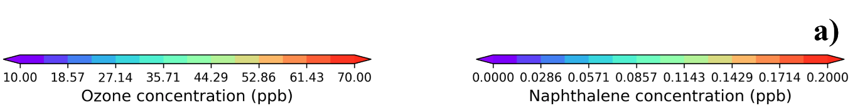
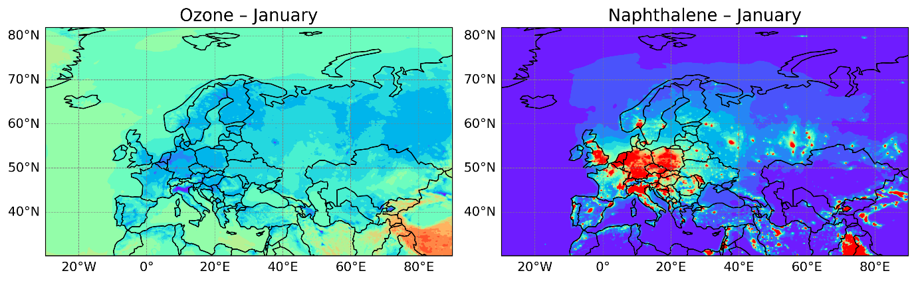
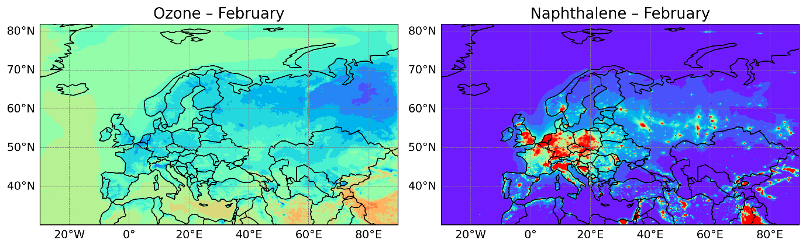
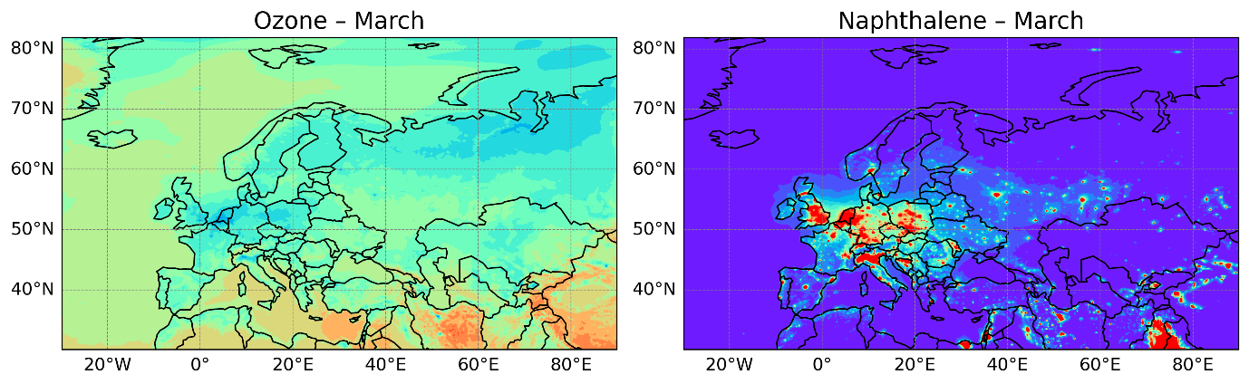
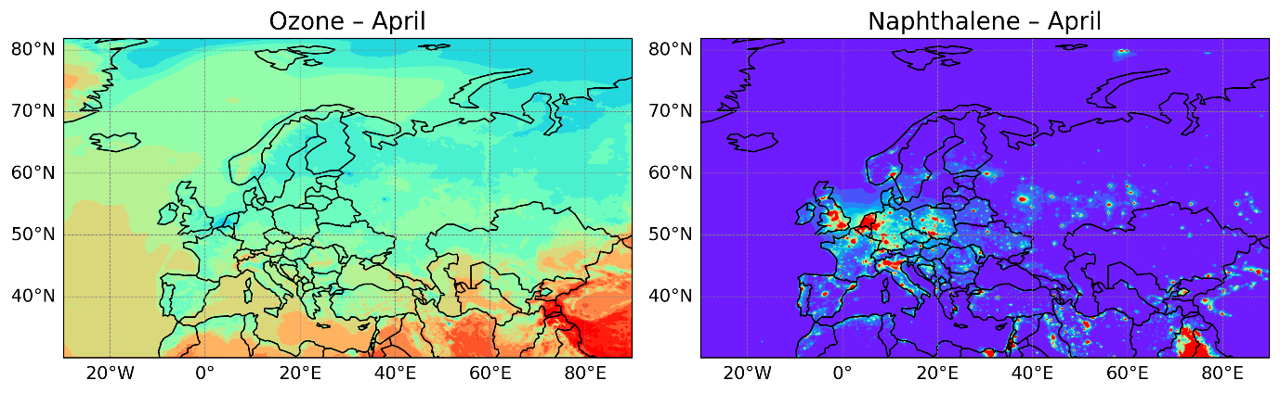
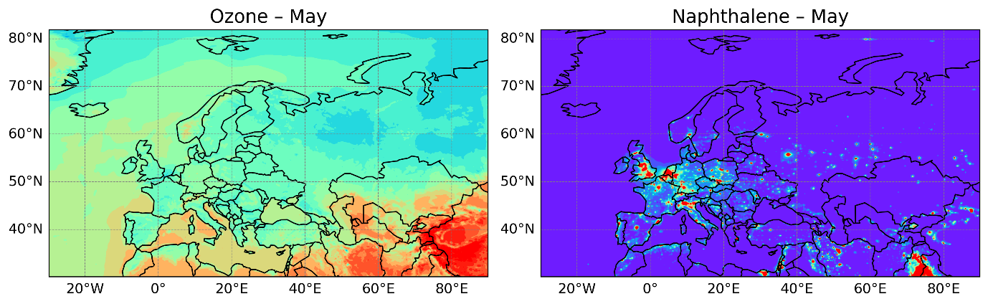
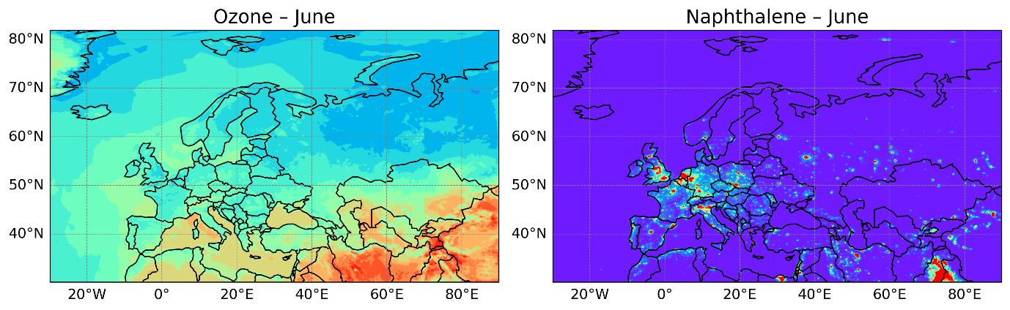
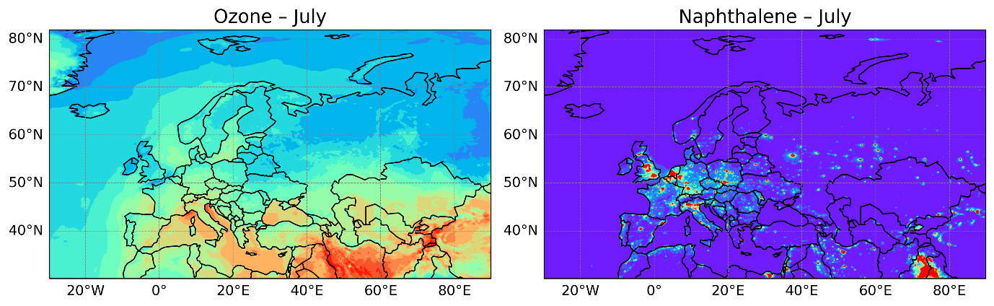
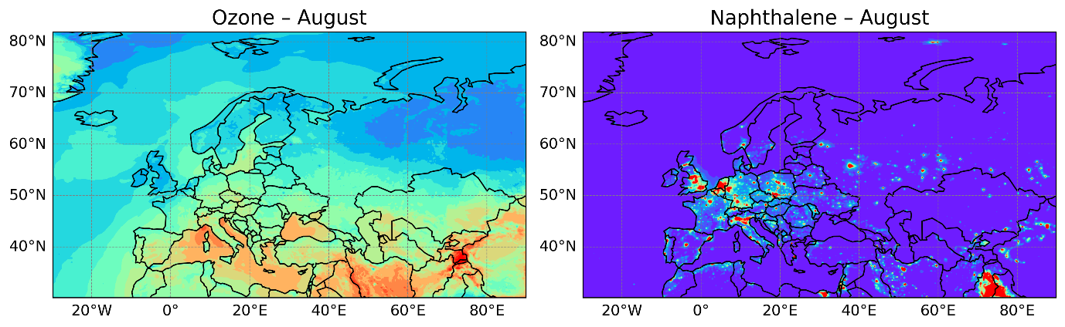
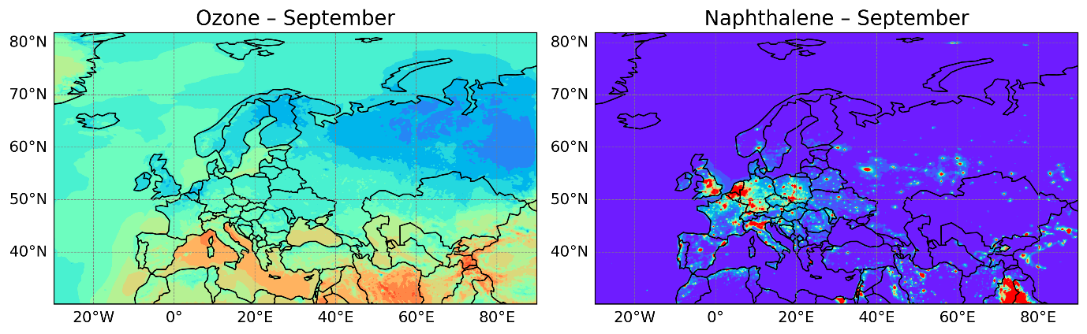
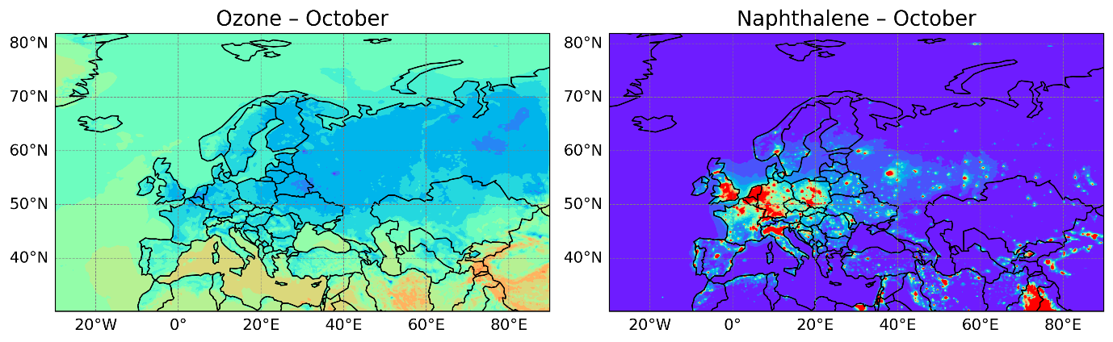
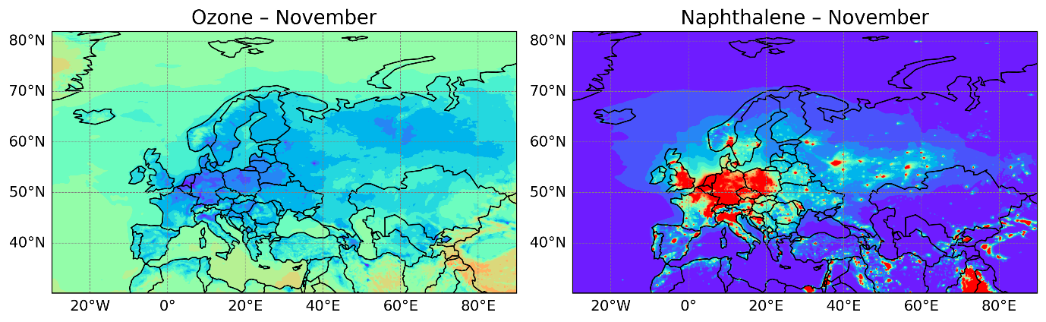
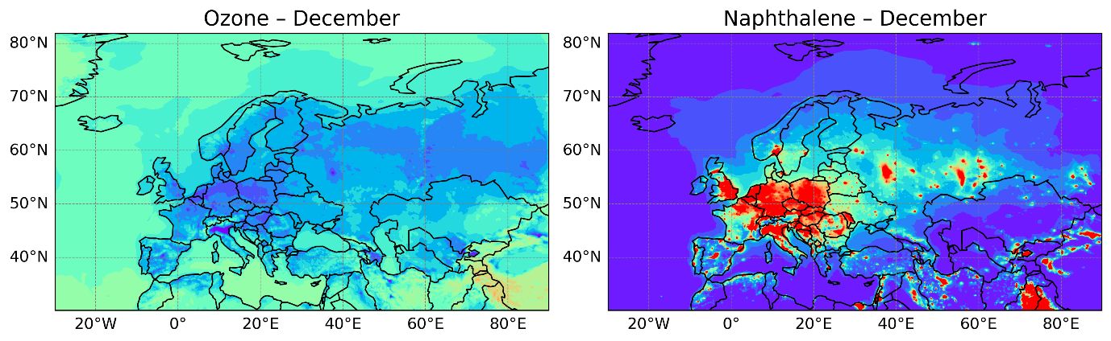
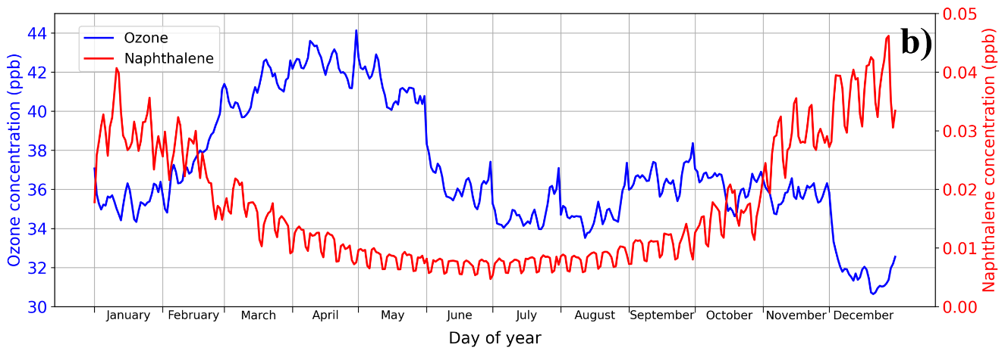Figure S34. Evolution of surface ozone and naphthalene concentrations (in ppb) over the model domain. (a) Monthly mean surface concentrations of ozone (left panels) and naphthalene (right panels) for each month of the year. (b) Daily mean variation of surface-averaged ozone (left y-axis) and naphthalene (right y-axis) concentrations over the annual cycle.
Figure S35 demonstrates the influence of ozone-induced extension of naphthalene oxidation on anthropogenic SOA formation. Figure S35(a) displays the surface anthropogenic SOA concentrations including (left panels) and excluding (middle panels) ozone role in naphthalene atmospheric chemistry together with the corresponding enhancement ratios (with/without the ozone role; right panels) over Europe and parts of Asia for all months of the year. Figure S35(b) shows the daily mean variation of surface-averaged anthropogenic SOA concentrations obtained with and without ozone-driven naphthalene chemistry, together with the associated enhancement ratio.

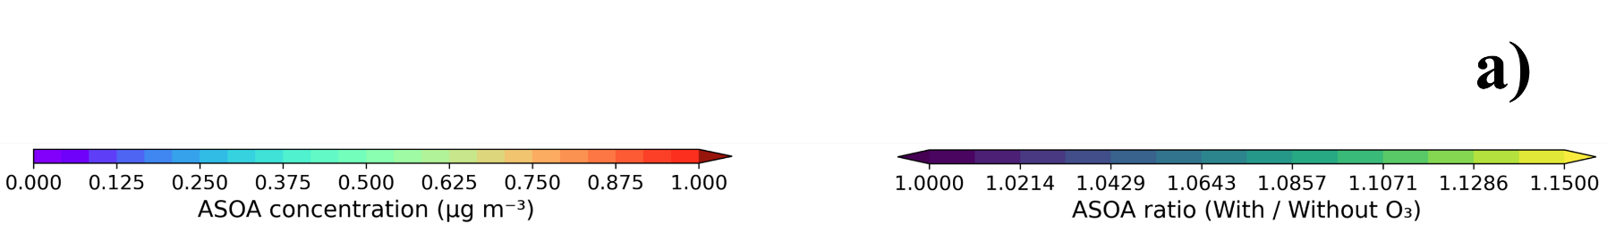
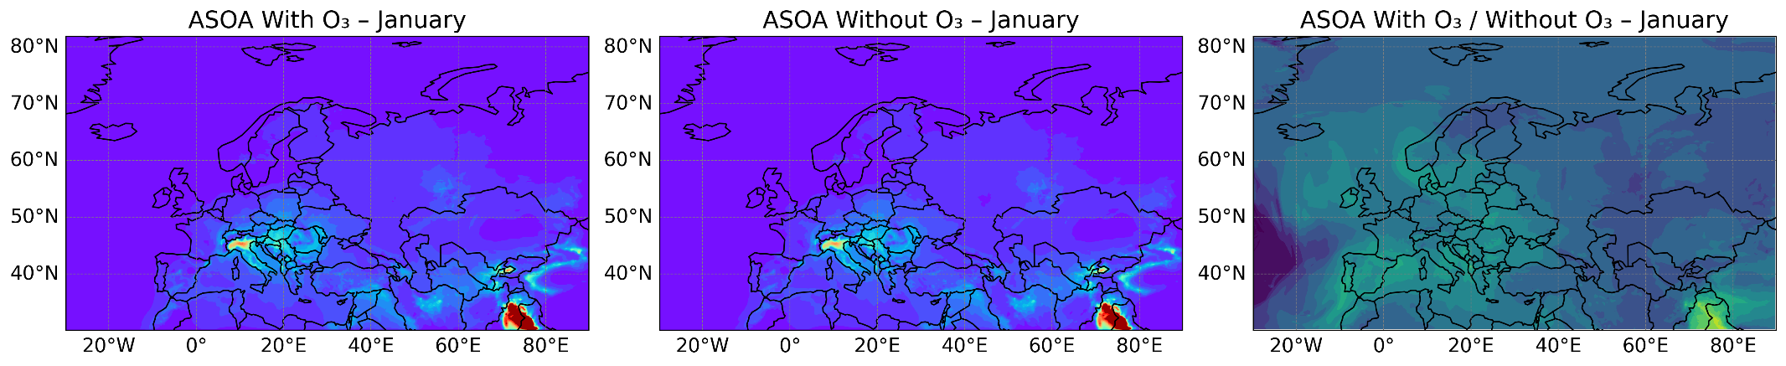
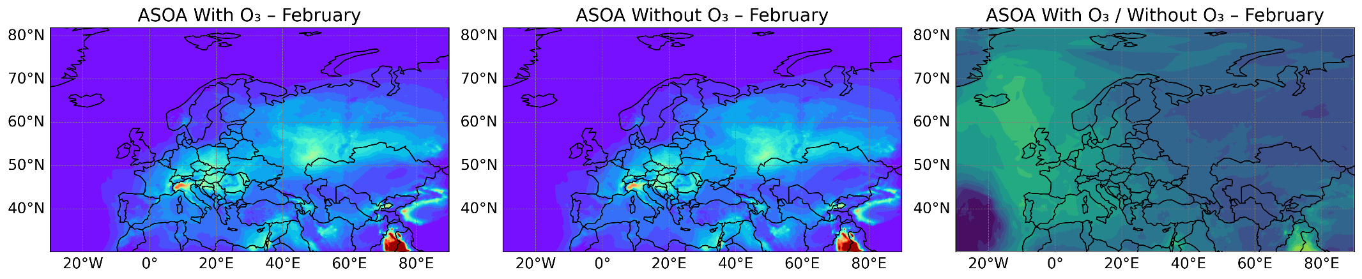

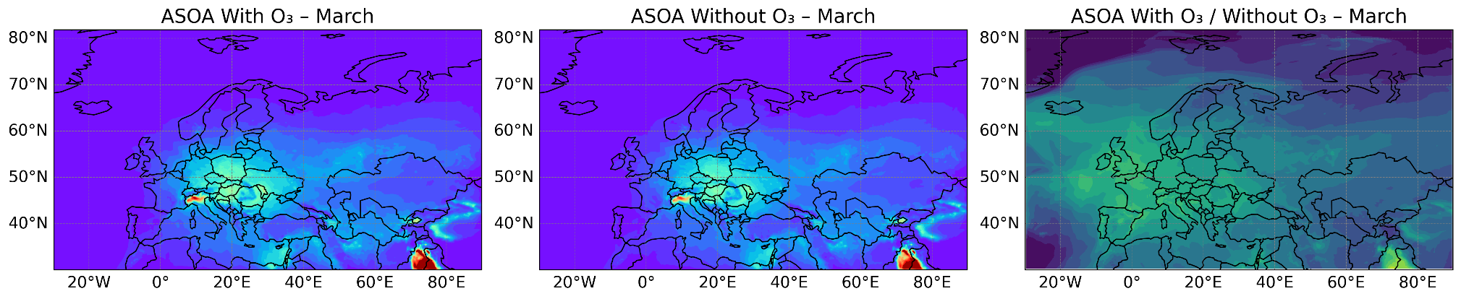
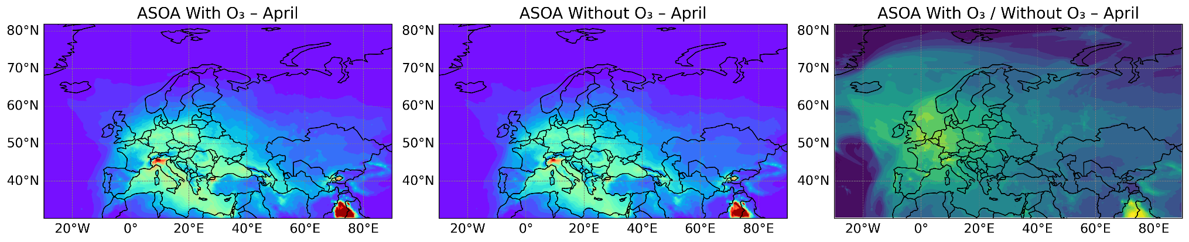
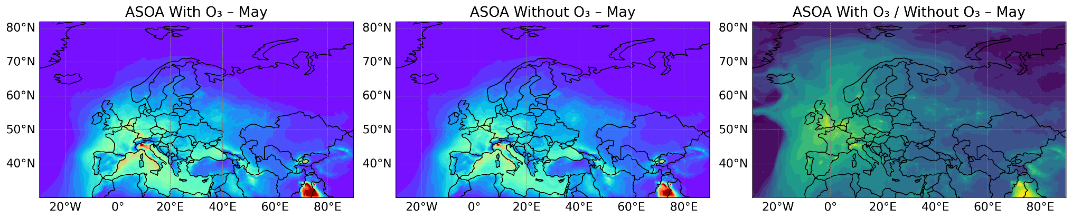
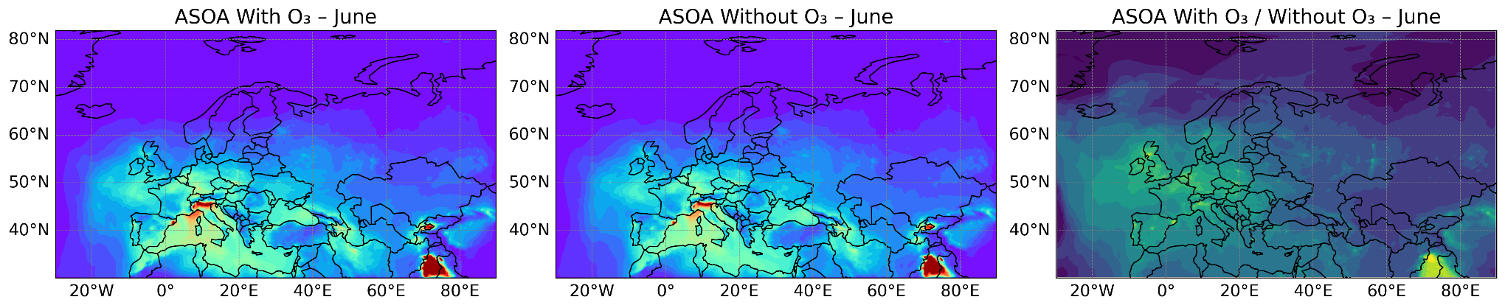
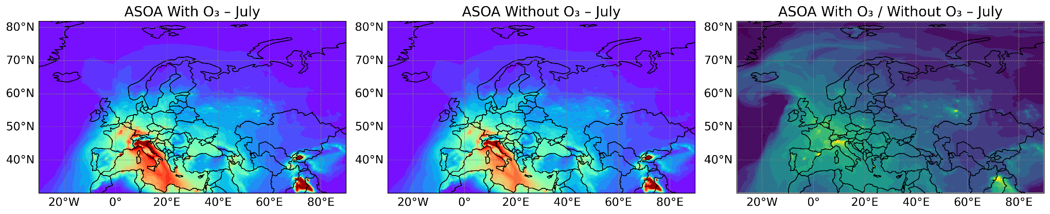
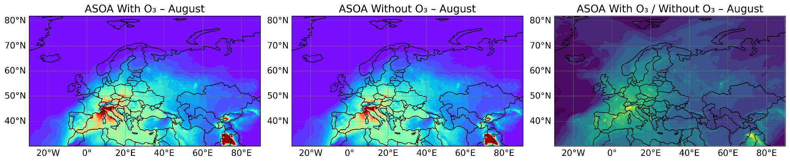
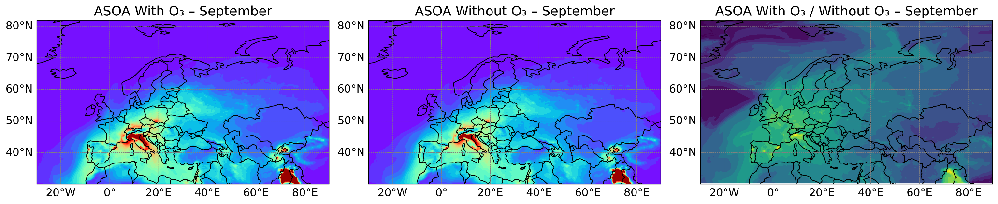
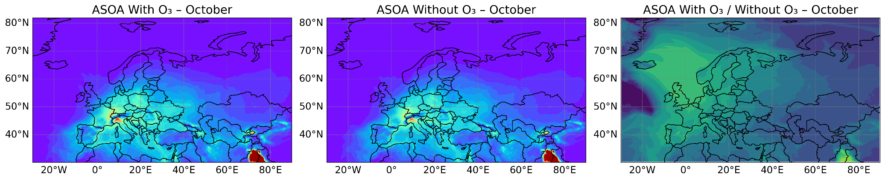
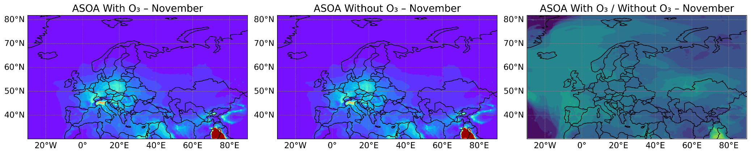
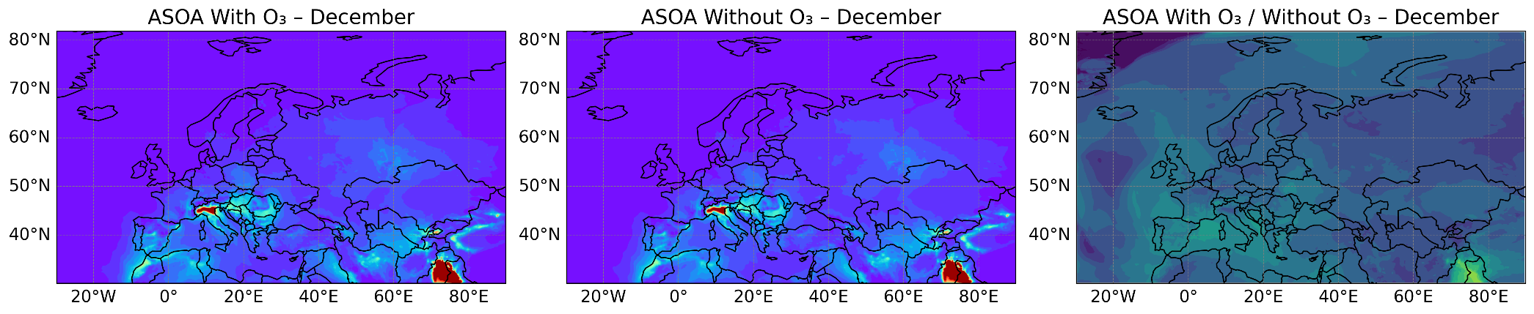
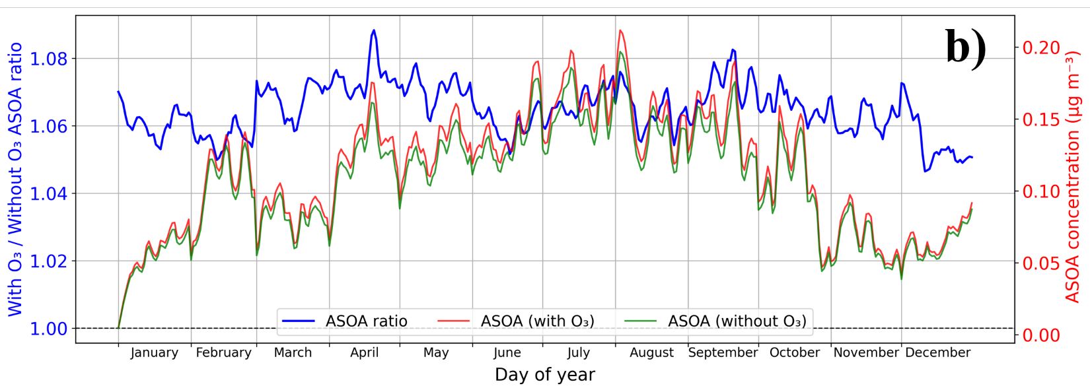
Figure S35. Ozone role in naphthalene oxidation and global anthropogenic SOA formation. (a) Monthly mean surface concentrations of global anthropogenic SOA (in µg/m³) for each month of the year obtained with and without ozone role in naphthalene oxidation, together with the corresponding enhancement ratio (with O₃/ without O₃) shown in three columns from left to right, respectively. (b) Daily mean variation of surface-averaged anthropogenic SOA concentrations (right y-axis in µg/m³) with and without ozone-driven naphthalene chemistry, together with the attributed enhancement ratio (left y-axis).
The results indicate an enhancement of anthropogenic SOA formation when the role of ozone is included in naphthalene oxidation. Although overall anthropogenic SOA concentrations peak in July, the maximum enhancement ratio (i.e., caused by ozone role) occurs in April. This indicates that the anthropogenic SOA yield ratio is more strongly controlled by ozone abundance than by naphthalene concentration. Consequently, high relative enhancement ratios are not necessarily associated in regions or periods with the highest naphthalene concentrations, but rather in areas and periods characterized by elevated ozone levels. For example, northern Italy demonstrates high naphthalene concentrations throughout the year, with December representing the month of highest naphthalene abundance (Figure S34). However, relatively low ozone concentrations during winter lead to lower anthropogenic SOA enhancement ratios compared to other seasons, and significant enhancements in northern Italy occur primarily during months with higher ozone levels, as presented in Figure S35. Similarly, oceanic regions exhibit higher enhancement ratios than many continental European regions because of higher ozone concentrations. These results demonstrate that neglecting ozone role in naphthalene oxidation leads to an underestimation of anthropogenic SOA formation both temporally and spatially.
Figure S36 illustrates total secondary organic aerosol (SOA = anthropogenic + biogenic) formation considering and ignoring ozone role in naphthalene oxidation. Figure S36(a) consists of three columns of monthly surface contour plots, showing from left to right: total SOA concentrations with ozone inclusion in naphthalene chemistry, total SOA concentrations without ozone inclusion, and the corresponding ratio of these two cases (with/without O₃). Figure S36(b) presents the daily evolution of surface-averaged total SOA concentrations with and without ozone effects, together with the associated enhancement ratio.
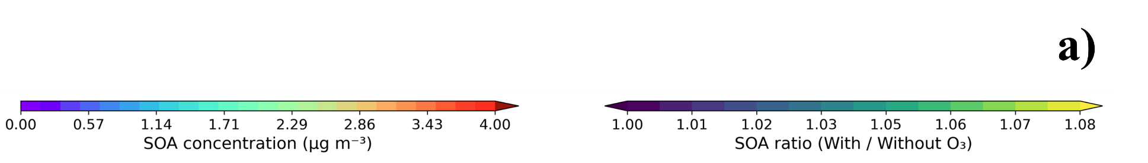
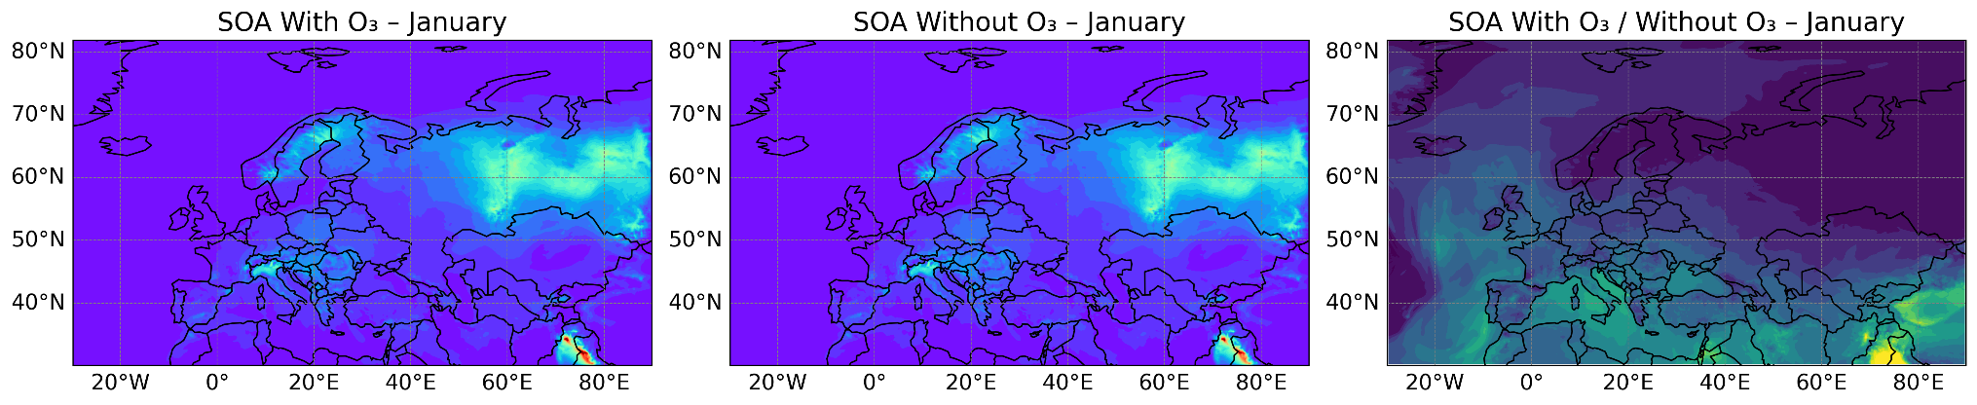
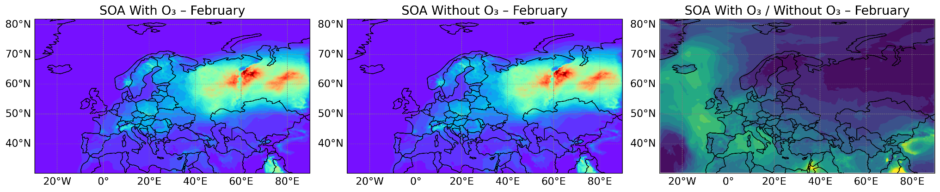
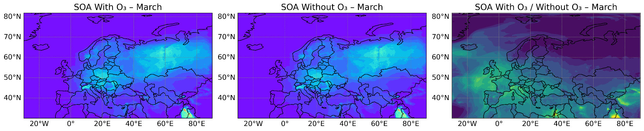
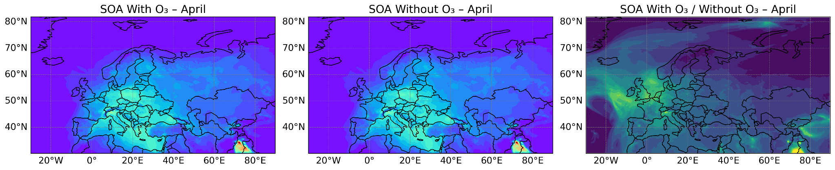
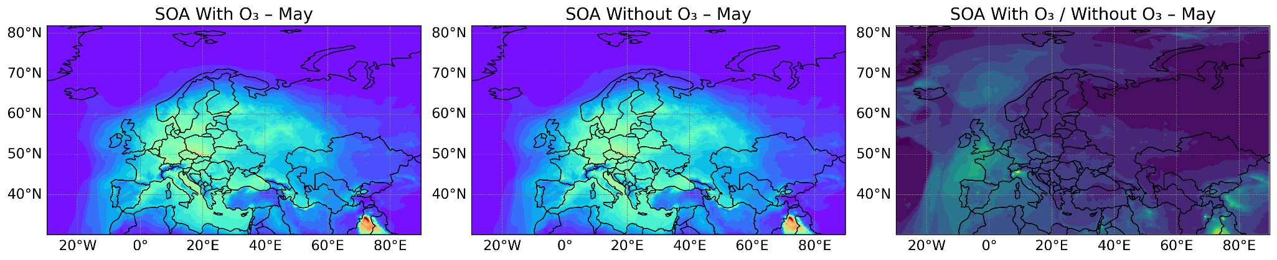
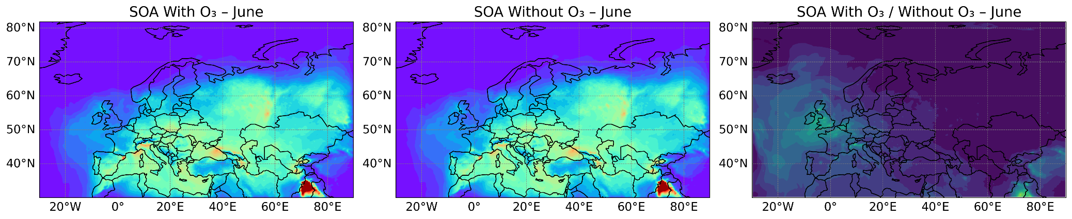
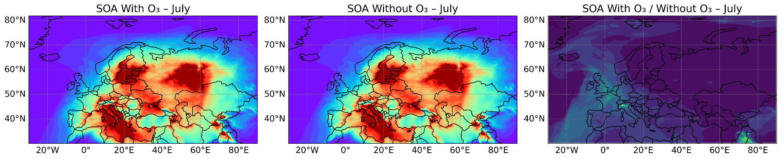
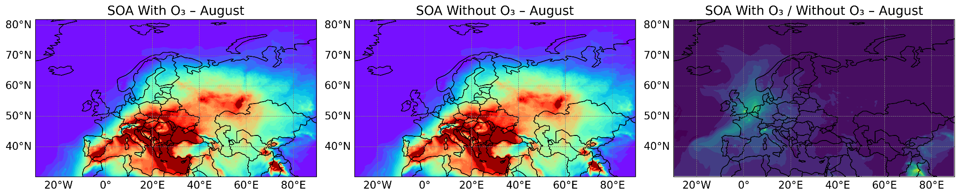
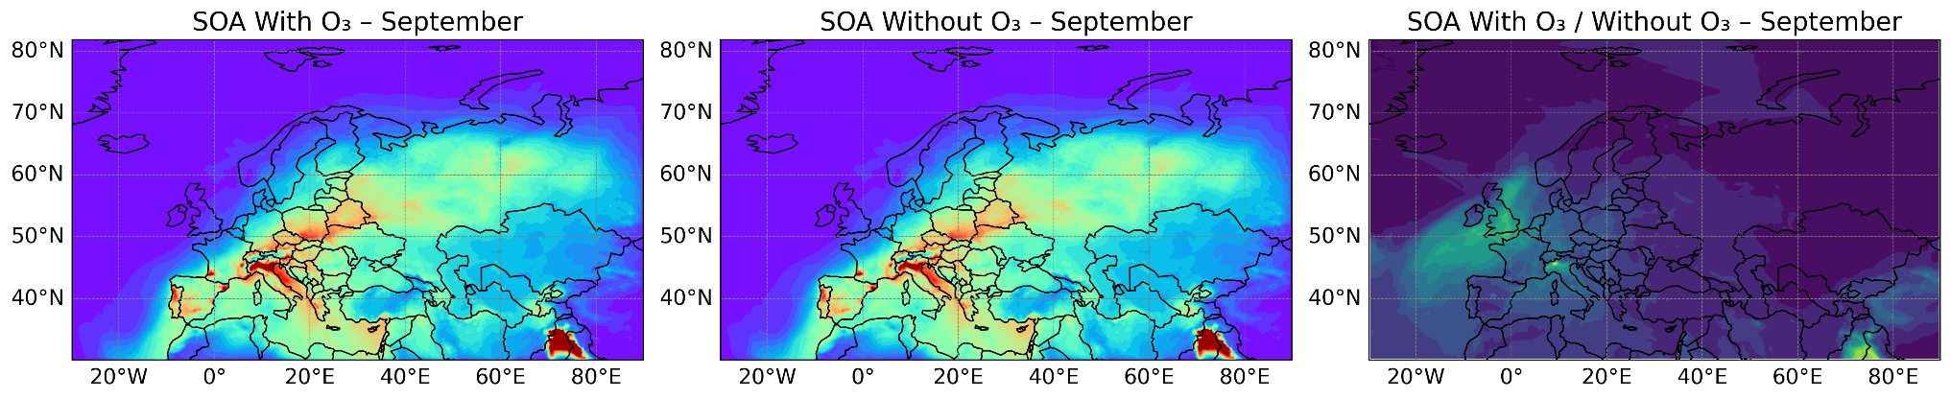
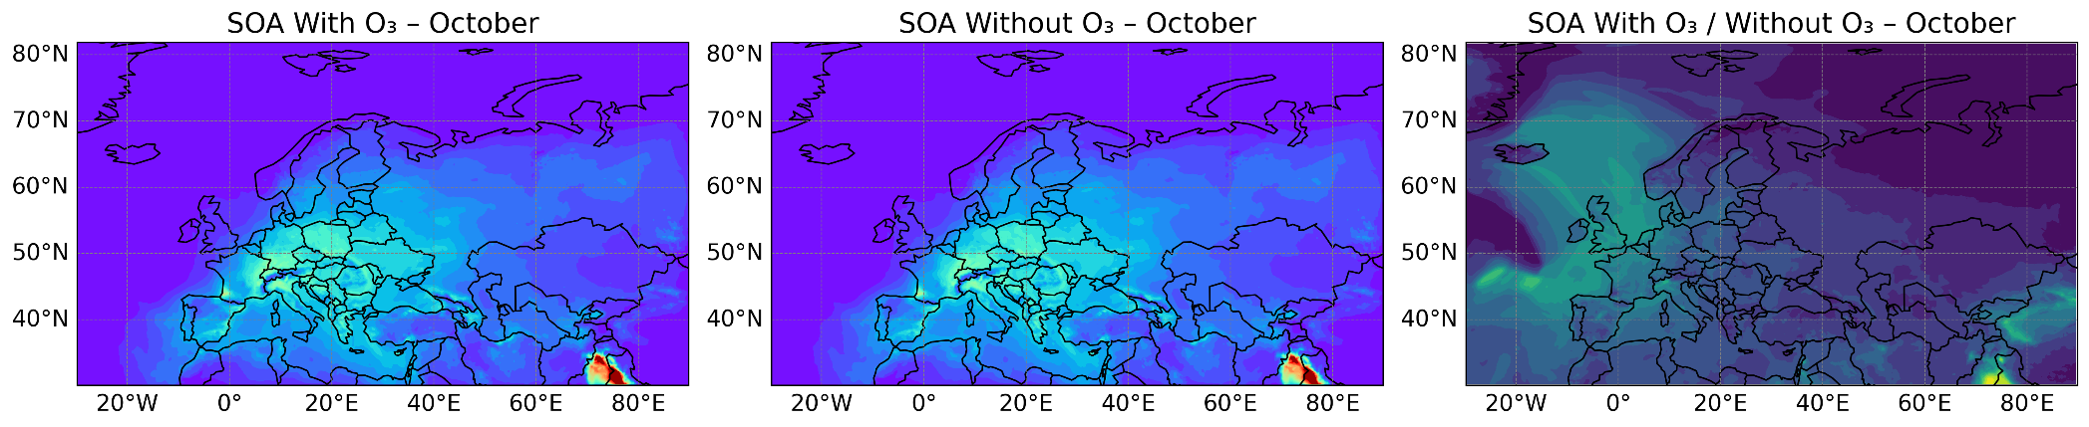
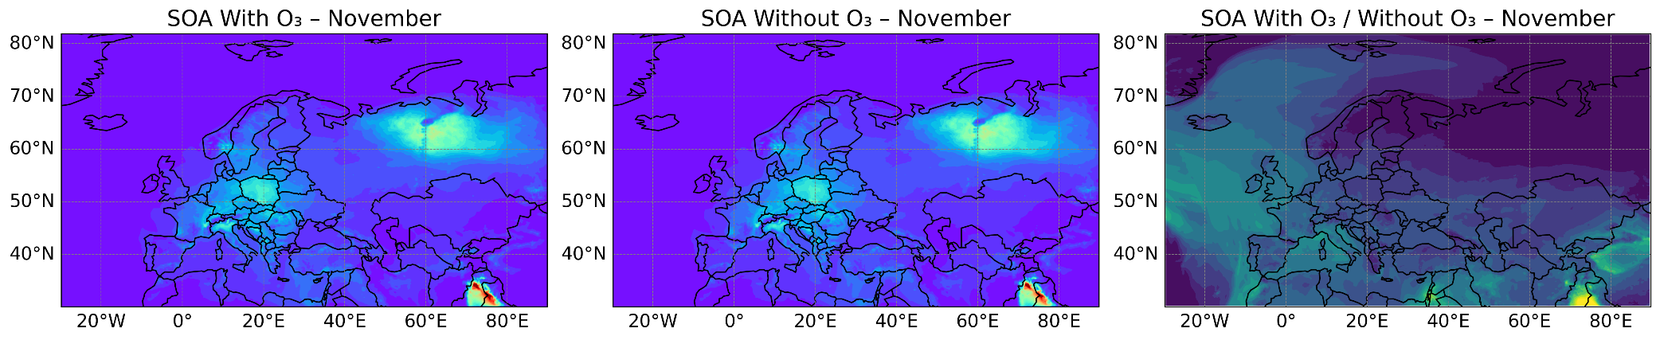
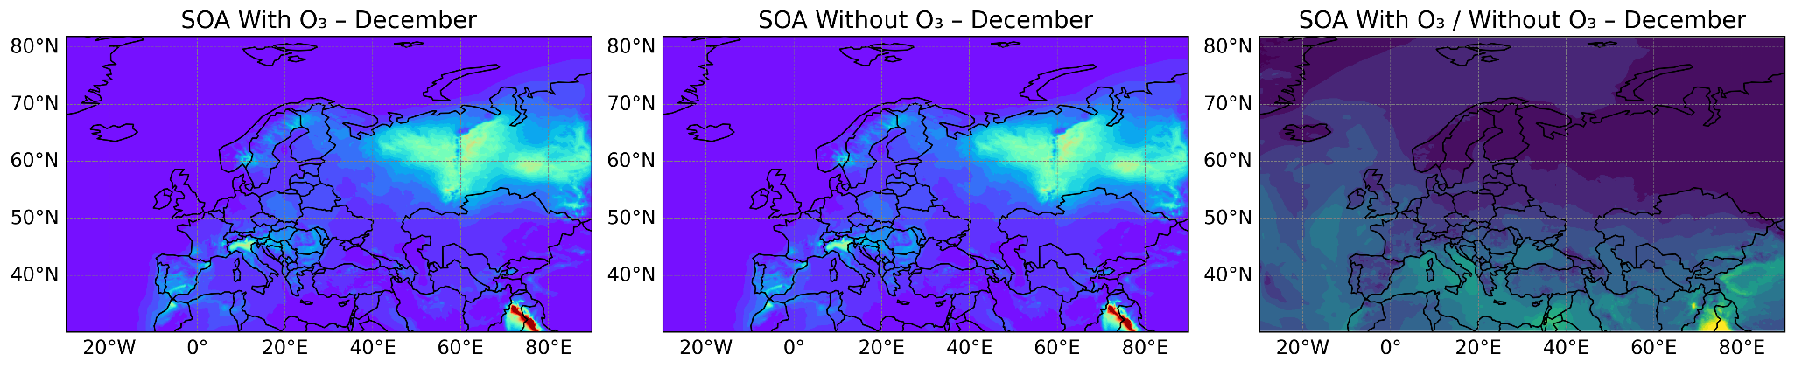
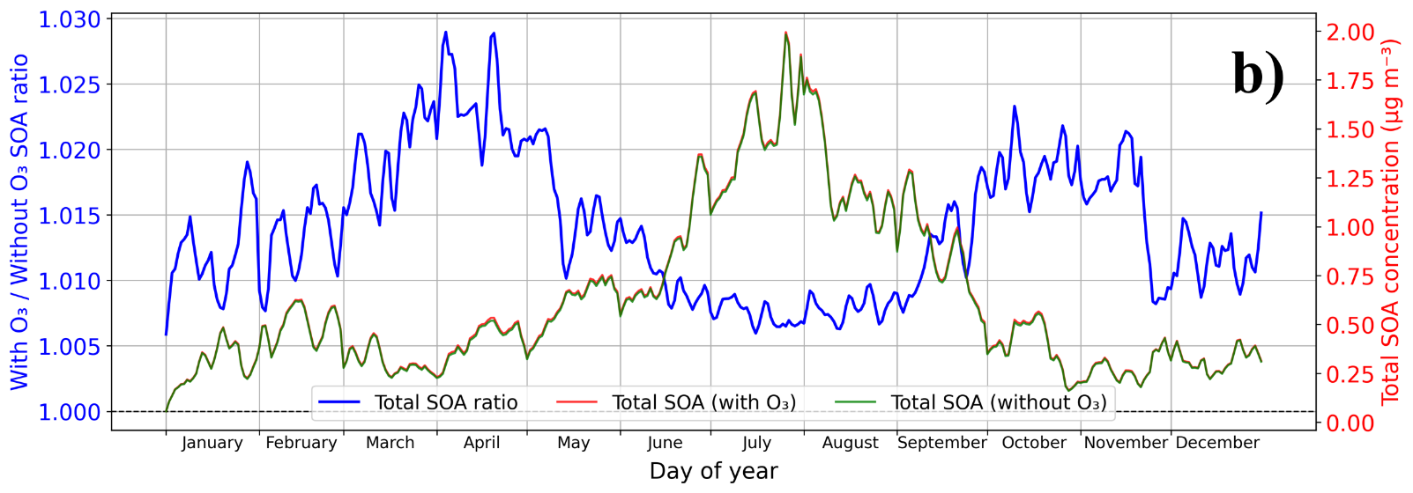
Figure S36. Total secondary organic aerosol (SOA = anthropogenic + biogenic) formation influenced by ozone role inclusion in naphthalene oxidation. (a) Mean surface concentrations of total SOA (in µg/m³) with and without ozone inclusion in naphthalene chemistry (left and middle columns), and the corresponding ratio of the two cases (with/without O₃; right column) in each month of the year. (b) Daily variation of surface-averaged total SOA (in µg/m³; right y-axis) with and without ozone role inclusion in naphthalene oxidation, together with the associated total SOA enhancement ratio (with/without O₃; left y-axis).

The results reveal that total SOA concentrations rise in summer and fall in winter, consistent with enhanced biogenic emissions and photochemical activities. Incorporating ozone role into naphthalene oxidation causes a subtle increase in total SOA compared to the ozone-free mechanism because of dominant contribution of biogenic SOA. This increase, however relatively small, is more sensible during spring and autumn months when there is a balance between ozone production and consumption.
Figure S37 outlines the monthly and annual behavior of the enhancement ratio of anthropogenic and total SOA formation taking into account the role of ozone in naphthalene oxidation. The results depict that the enhancement ratio is larger for anthropogenic SOA than for total SOA throughout the year, implying the significant contribution of naphthalene oxidation to the anthropogenic fraction of SOA. Both anthropogenic and total SOA enhancement ratios show a pronounced seasonal cycle, with higher values during spring, coinciding with elevated ozone levels. The annual mean ratios further emphasize that neglecting ozone-driven naphthalene oxidation leads to a systematic underestimation of SOA formation.

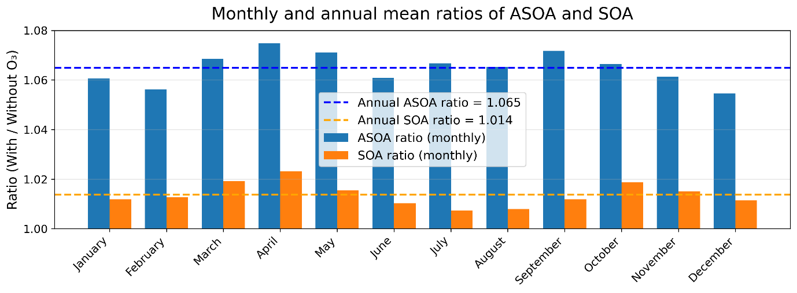
Figure S37. Monthly mean enhancement ratios of anthropogenic (blue bars) and total (orange bars) SOA obtained with and without ozone effects on naphthalene oxidation. Dashed blue and red lines show the corresponding annual mean enhancement ratios for anthropogenic and total SOA, respectively.
A sensitivity analysis was performed by varying the rate coefficients $k_{2}$ and $k_{4}$ in the ozone-included naphthalene oxidation scheme, considering values 10 and 100 times faster, as well as 10 times slower than 2 × 10⁻¹⁷ cm³ molecule⁻¹ s⁻¹. Figure S38 shows that increasing these reaction rates leads to a reduction in daily mean anthropogenic SOA concentrations. This trend can be explained by the competition between chemical pathways, where faster reactions with O₂ promote direct HOM formation from intermediate species Nap1 (reaction II), thereby suppressing the ozone-driven branching that facilitates indirect HOM formation (reaction IV). Consequently, the influence of ozone-enhanced chemistry on anthropogenic SOA formation diminishes, yielding a smaller anthropogenic SOA enhancement compared to the baseline case. With the same logic, reducing the rate coefficients enhances the relative importance of the ozone-mediated pathway, allowing ozone to more effectively promote indirect HOM formation and leading to a substantial increase in anthropogenic SOA concentrations.

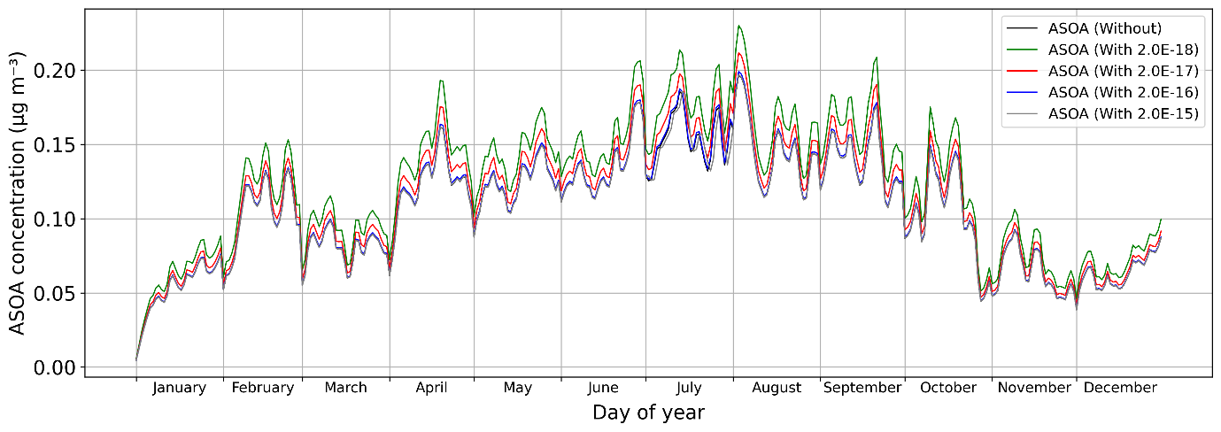
Figure S38. Sensitivity of anthropogenic SOA formation to the oxidation rates in naphthalene chemistry. Daily mean surface-averaged anthropogenic SOA concentrations (in µg/m³) obtained for reaction rates $k_{2}$ and $k_{4}$ increased 10 and 100 times and decreased 10 times relative to the baseline case i.e., 2 × 10⁻¹⁷ cm³molecule⁻¹s⁻¹.
References
1. Junninen, H. et al. A high-resolution mass spectrometer to measure atmospheric ion composition. Atmos. Meas. Tech. 3, 1039–1053 (2010).
2. Jokinen, T. et al. Atmospheric sulphuric acid and neutral cluster measurements using CI-APi-TOF. Atmos. Chem. Phys. 12, 4117–4125 (2012).
3. Eisele, F. L. & Tanner, D. J. Measurement of the gas phase concentration of H₂ SO₄ and methane sulfonic acid and estimates of H₂ SO₄ production and loss in the atmosphere. J. Geophys. Res. 98, 9001–9010 (1993).
4. Hyttinen, N. et al. Modeling the Charging of Highly Oxidized Cyclohexene Ozonolysis Products Using Nitrate-Based Chemical Ionization. J. Phys. Chem. A 119, 6339–6345 (2015).
5. Iyer, S. et al. Molecular rearrangement of bicyclic peroxy radicals is a key route to aerosol from aromatics. Nat Commun 14, 4984 (2023).
6. Kürten, A., Rondo, L., Ehrhart, S. & Curtius, J. Calibration of a Chemical Ionization Mass Spectrometer for the Measurement of Gaseous Sulfuric Acid. J. Phys. Chem. A 116, 6375–6386 (2012).
7. Atkinson, R., Baulch, D. L., Cox, R. A., Crowley, J. N., Hampson, R. F., Hynes, R. G., Jenkin, M. E., Rossi, M. J., and Troe, J.: Atmos. Chem. Phys. 4, 1461, 2004; IUPAC Task Group on Atmospheric Chemical Kinetic Data Evaluation, (https://iupac.aeris-data.fr/).
8. Kumar, A. et al. Direct Measurements of Covalently Bonded Sulfuric Anhydrides from Gas-Phase Reactions of SO₃ with Acids under Ambient Conditions. J. Am. Chem. Soc. 146, 15562–15575 (2024).
9. Møller, K. H., Otkjær, R. V., Hyttinen, N., Kurtén, T. & Kjaergaard, H. G. Cost-Effective Implementation of Multiconformer Transition State Theory for Peroxy Radical Hydrogen Shift Reactions. J. Phys. Chem. A 120, 10072–10087 (2016).
10. Wu, X. et al. Unraveling the atmospheric oxidation mechanism and kinetics of naphthalene: Insights from theoretical exploration. Chemosphere 352, 141356 (2024).
11. Vogel, E. & Günther, H. Benzene Oxide‐Oxepin Valence Tautomerism. Angew. Chem. Int. Ed. Engl. 6, 385–401 (1967).
12. Simpson, D. et al. The EMEP MSC-W chemical transport model – technical description. Atmos. Chem. Phys. 12, 7825–7865 (2012).
13. Fagerli, H. et al. Convention on Long-range Transboundary Air Pollution Co-operative programme for monitoring and evaluation of the lang-range transmission of air pollutants in Europe. Norwegian Meteorological Institute (2024). https://emep.int/publ/reports/2024/EMEP_Status_Report_1_2024.pdf.
14. Bergström, R., Hayman, G. D., Jenkin, M. E. & Simpson, D. Update and Comparison of Atmospheric Chemistry Mechanisms for the EMEP MSC-W Model System-EmChem19a, EmChem19X, CRIv2R5Em, CB6r2Em, and MCMv3.3Em (Norwegian Meteorological Institute, 2022). https://emep.int/publ/reports/2022/MSCW_technical_1_2022.pdf.
15. Ge, Y. et al. Evaluation of modelled versus observed non-methane volatile organic compounds at European Monitoring and Evaluation Programme sites in Europe. Atmos. Chem. Phys. 24, 7699–7729 (2024).
16. Matthews, B. and Wankmüller, R.: Methodologies applied to the CEIP GNFR gap-filling 2021 Part I: Main Pollutants (NOx, NMVOCs, SOx, NH3, CO), Particulate Matter (PM2.5, PM10, PMcoarse) and Black Carbon (BC) for the years 2000 to 2019., EMEP/CEIP Technical Report 2/2021, CEIP Vienna, https://www.ceip.at/fileadmin/inhalte/ceip/00_pdf_other/ 2021/main_pm_bc_gap-filling_documentation_2021_final.pdf (last access: 1 July 2024), 2021.
17. Hodzic, A. et al. Rethinking the global secondary organic aerosol (SOA) budget: stronger production, faster removal, shorter lifetime. Atmos. Chem. Phys. 16, 7917–7941 (2016).
18. Wang, M. et al. Photo-oxidation of Aromatic Hydrocarbons Produces Low-Volatility Organic Compounds. Environ. Sci. Technol. 54, 7911–7921 (2020).
19. Ye, F. et al. The role of naphthalene and its derivatives in the formation of secondary organic aerosol in the Yangtze River Delta region, China. Atmos. Chem. Phys. 24, 7467–7479 (2024).
20. Atkinson, R. & Arey, J. Atmospheric Degradation of Volatile Organic Compounds. Chem. Rev. 103, 4605–4638 (2003).
21. Shiroudi, A., Deleuze, M. S. & Canneaux, S. Theoretical study of the oxidation mechanisms of naphthalene initiated by hydroxyl radicals: the O₂ addition reaction pathways. Phys. Chem. Chem. Phys. 17, 13719–13732 (2015).
22. Gnanaprakasam, M., Sandhiya, L. & Senthilkumar, K. A theoretical investigation on the mechanism and kinetics of the gas-phase reaction of naphthalene with OH radical. Theor Chem Acc 136, 131 (2017).
23. Wu, X. et al. Unraveling the atmospheric oxidation mechanism and kinetics of naphthalene: Insights from theoretical exploration. Chemosphere 352, 141356 (2024).
24. Paltenghi, R., Ogryzlo, E. A. & Bayes, K. D. Rates of reaction of alkyl radicals with ozone. J. Phys. Chem. 88, 2595–2599 (1984).

