Supplementary Figures
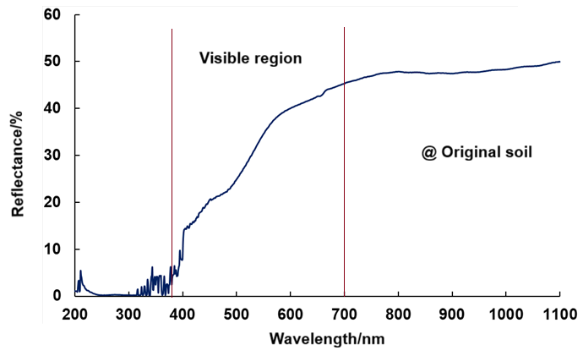
Fig.S1a Reflectance spectrum of the original soil.
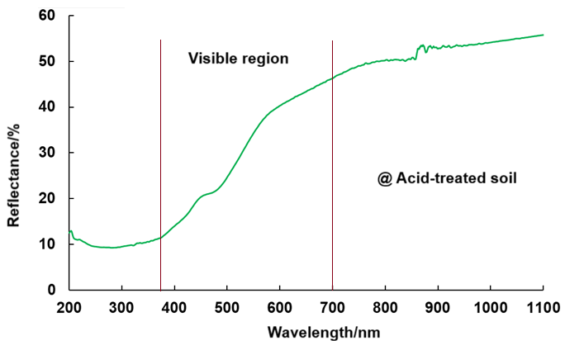
Fig.S1b Reflectance spectrum of acid-treated soil.
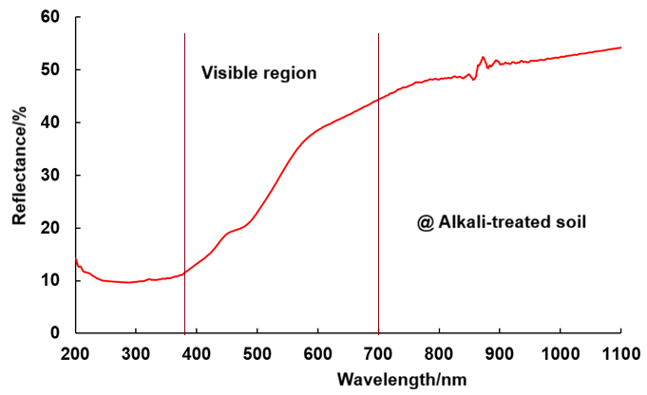
Fig.S1c Reflectance spectrum of alkali-treated soil.
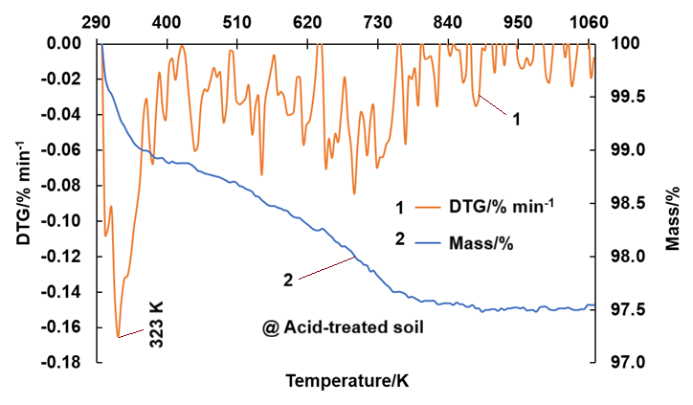
Fig.S2a TG-DTG curve of the acid-treated soil
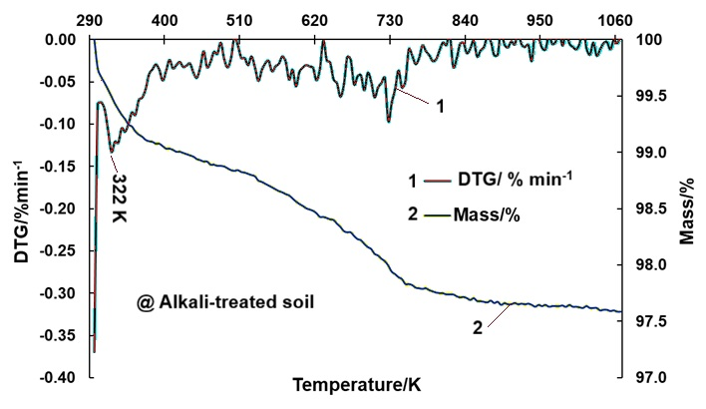
Fig.S2b TG-DTG curve of the alkali-treated soil
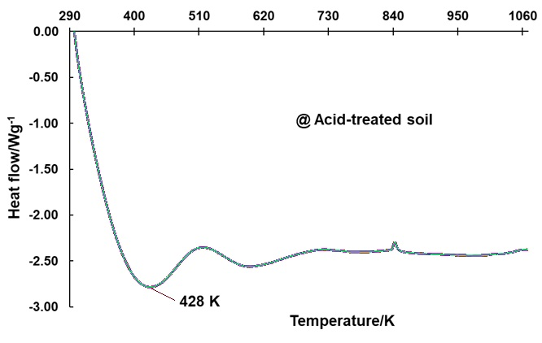
Fig.S2c DSC curve of the acid-treated soil
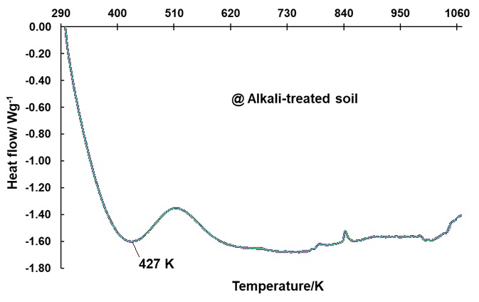
Fig.S2d DSC curve of the alkali-treated soil.
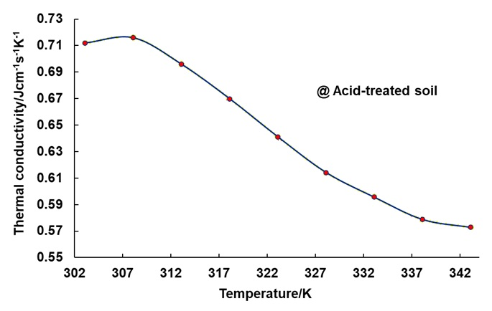
Fig.S2e Thermal conductivity graph of the acid-treated soil
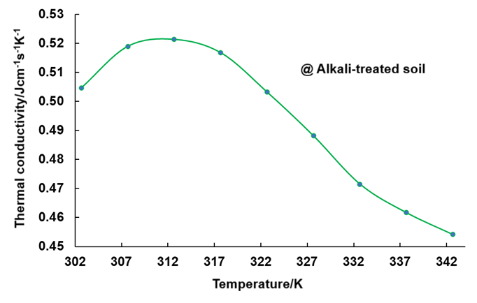
Fig.S2f Thermal conductivity graph of the alkali-treated soil

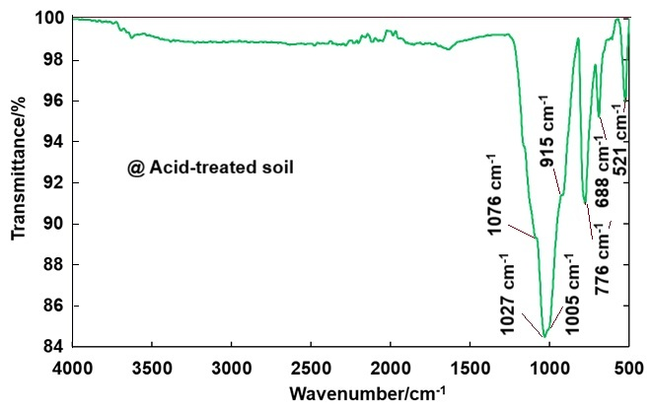
Fig.S3a ATR-IR spectrum of acid-treated soil.
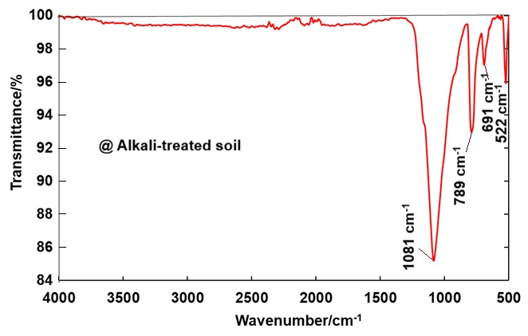
Fig.S3b ATR-IR spectrum of alkali-treated soil.
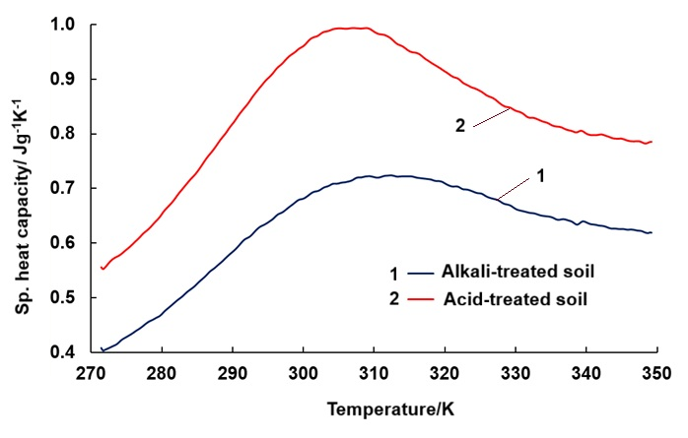
Fig.S4 Specific heat capacity of the chemically treated soil.
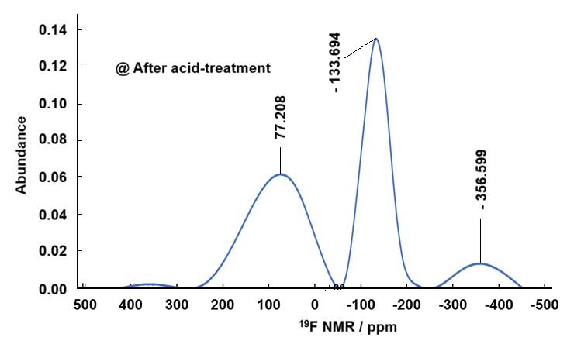
Fig.S5a ¹⁹F NMR of the acid-treated soil.
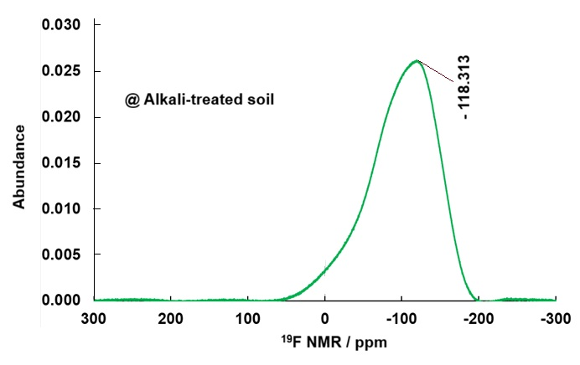
Fig.S5b ¹⁹F NMR of the alkali-treated soil.
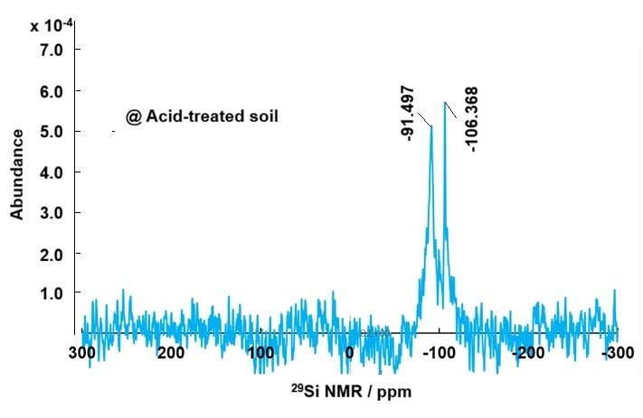
Fig.S5c ²⁹Si NMR of the acid-treated soil.
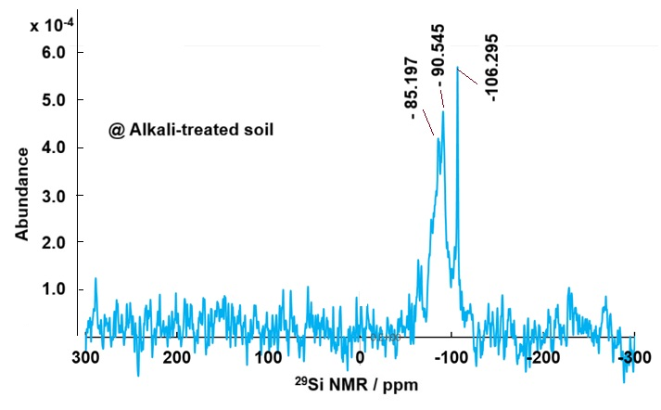
Fig.S5d ²⁹Si NMR of the alkali-treated soil.

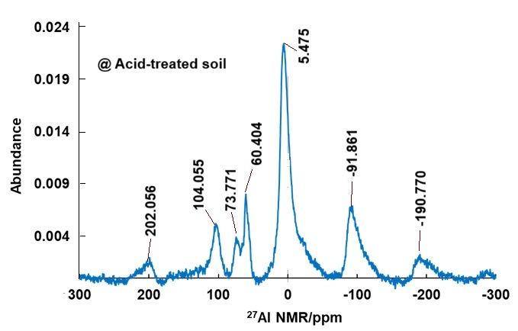
Fig.S5e ²⁷Al NMR of the acid-treated soil.
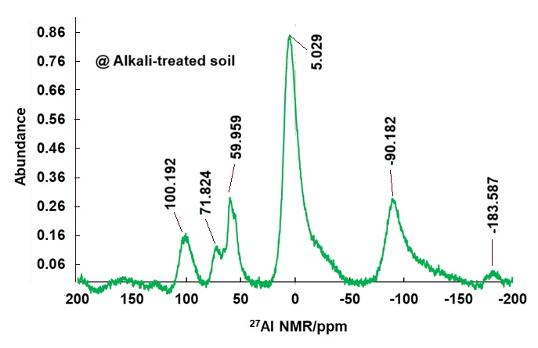
Fig.S5f ²⁷Al NMR of the alkali-treated soil.

