Table S1. Primers used for RT-qPCR analysis of gene expression in this study
Gene | Forward Primer (5′-3′)
Actin | F: GCTTACAGAGGCACCACTCAACC  R: CCGGAATCCAGCACCAATACCAG
PFK-6  (Actinidia32111) | F: TCCACTTCCATTCCGACCAA  R: TGGGTTAGGGTACGTAGGGA
iPGAM  (Actinidia11471) | F: CTGATGGCCGTGATGTCTTG  R:GCATCCCATCCACGTTTCAC
PDH E1β  (Actinidia30609) | F: GAGTTGTTGTATGGTGAGTC  R: CCTTTGCAAGGATCTCAGCT
CCO  (Actinidia25935) | F: GTATCCAAAGTTGCCACGGG  R:GTGGTTGGAAATCTCCAATC
PMA  (Actinidia08949) | F: AGAGATGGCTGGGATGGATG  R: CACGCTCGGCAAACTTATCA
ACLY  (Actinidia15066) | F: ACCTTGGCTCTCATCGGAAA  R: GCATCCTCCCATCTCAACCT

Table S2. Overview of transcriptome sequencing quality for 15 kiwifruit libraries across different treatment groups during the edible window period.
Sample | Clean read number | Clean read radio (%) | Q30 (%)
0d_1 | 45865610 | 98.48 | 95.72
0d_2 | 50014650 | 98.33 | 95.60
0d_3 | 54043696 | 98.52 | 95.66
CK11d_1 | 42776774 | 98.21 | 95.41
CK11d_2 | 46994612 | 98.30 | 95.32
CK11d_3 | 38562010 | 97.63 | 93.96
ASA11d_1 | 49393546 | 98.28 | 95.53
ASA11d_2 | 43795942 | 98.31 | 95.37
ASA11d_3 | 44336078 | 98.28 | 95.39
MT11d_1 | 50093100 | 98.37 | 95.45
MT11d_2 | 43758638 | 97.77 | 94.34
MT11d_3 | 40129144 | 98.44 | 95.47
1-MCP11d_1 | 44006318 | 98.42 | 95.64
1-MCP11d_2 | 41459468 | 98.33 | 95.61
1-MCP11d_3 | 50962486 | 98.30 | 95.65

Fig. S1. Effects of 1-methylcyclopropene (1-MCP) treatment at different concentrations (0.25 and 0.5 μL/L) on the physiological quality of kiwifruit during the edible window period. (A) SSC; (B) Respiration rate; (C) Ethylene production rate; (D) Decay rate; (E) Outer pericarp firmness; (F) Inner pericarp firmness; (G) Core firmness. Data represent the mean ± standard deviation (n = 3). Different lowercase letters indicate significant differences between treatments according to Duncan’s multiple range test (P < 0.05).

Fig. S2. Effects of melatonin (MT) treatment at different concentrations (0.1, 0.5, and 1.0 mmol/L) on the physiological quality of kiwifruit during the edible window period. (A) SSC; (B) Respiration rate; (C) Ethylene production rate; (D) Decay rate; (E) Outer pericarp firmness; (F) Inner pericarp firmness; (G) Core firmness. Data represent the mean ± standard deviation (n = 3). Different lowercase letters indicate significant differences between treatments according to Duncan’s multiple range test (P < 0.05).
Fig. S3. Effects of Acetylsalicylic acid (ASA) treatment at different concentrations (0.5, 1.0 and 2.0 mmol/L) on the physiological quality of kiwifruit during the edible window period. (A) SSC; (B) Respiration rate; (C) Ethylene production rate; (D) Decay rate; (E) Outer pericarp firmness; (F) Inner pericarp firmness; (G) Core firmness. Data represent the mean ± standard deviation (n = 3). Different lowercase letters indicate significant differences between treatments according to Duncan’s multiple range test (P < 0.05).

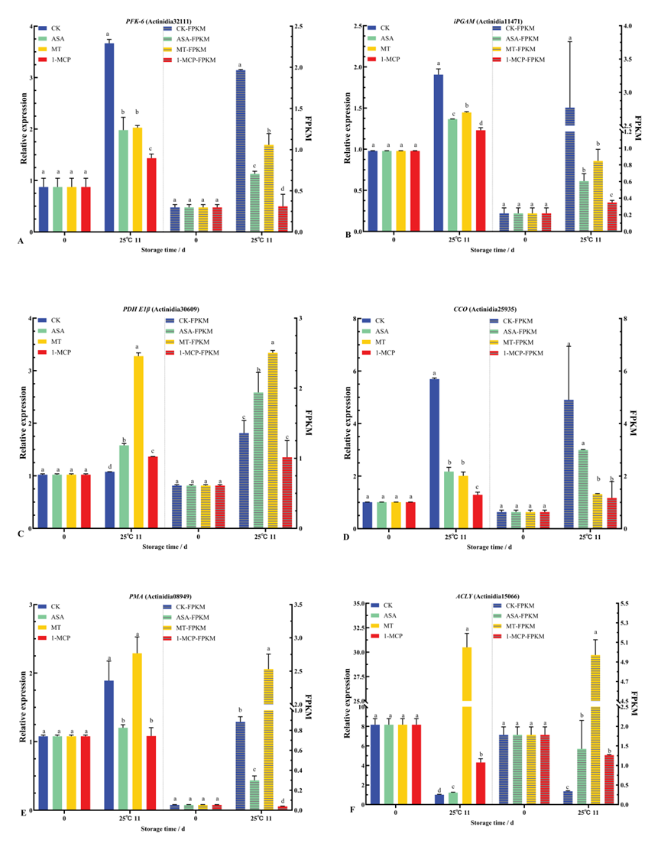
Fig. S4. Comparison of the expression patterns of selected DEGs obtained from RT-qPCR and RNA-Seq analysis. The bars (left y-axis) represent the relative expression levels determined by RT-qPCR, and the hashed bars (right y-axis) represent the FPKM values from RNA-Seq data. Data represent mean ± standard deviation (n = 3). Different lowercase letters indicate significant differences between treatments per Duncan’s test (P < 0.05).

