Supplementary materials
Gaussian Boson Sampling for Efficient Dense Subgraph Identification in Omic-driven Gene Networks During Anthropogenic Methane Emission
Kin Tung Michael Ho¹, Ching-Jui Lai², Giin Yu Amy Tan³, Po-Heng Lee¹
¹ Department of Civil and Environmental Engineering, Imperial College London, London, United Kingdom
² Department of Mathematics, National Cheng Kung University, Tainan, Taiwan
³ Department of Architecture and Civil Engineering, City University of Hong Kong, Hong Kong SAR, China

a | b
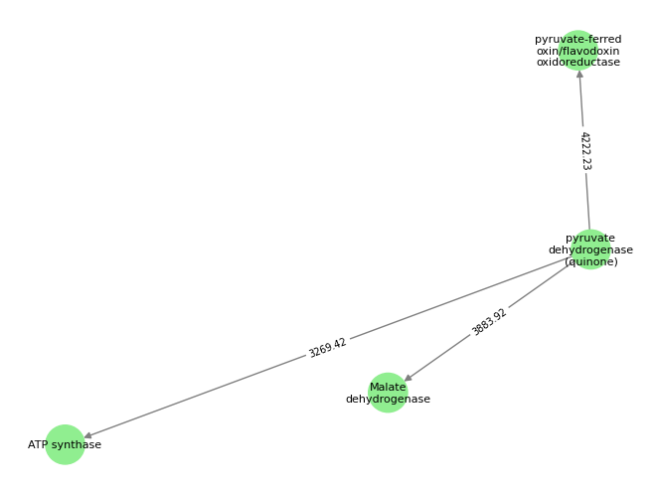 | 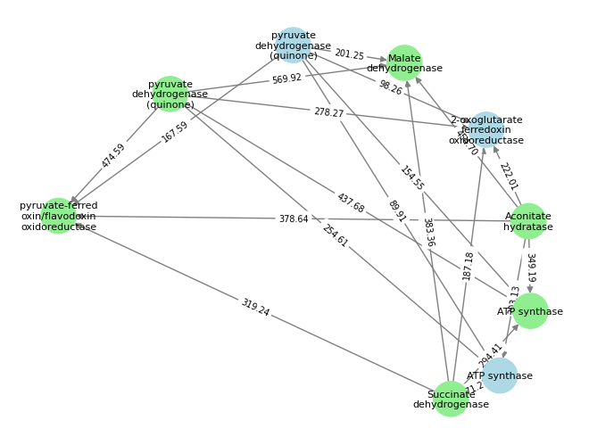
c | d
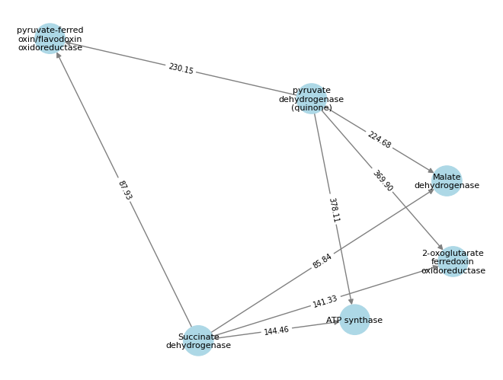 | 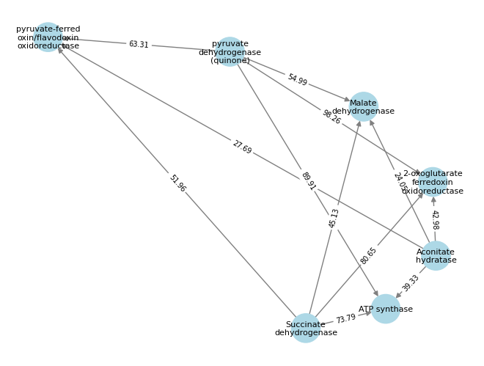
e | f
 | 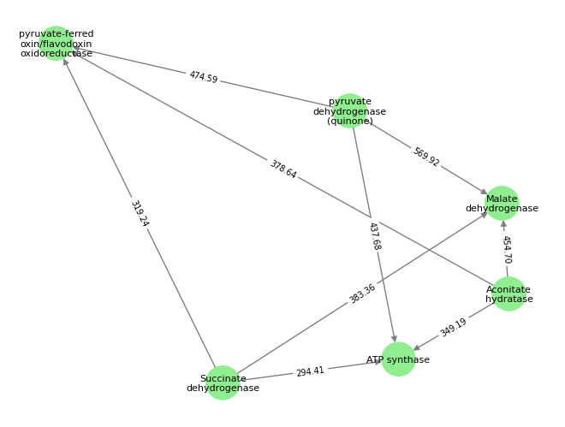
Figure S1 Densest subgraphs identified under low and high methane yield conditions across metagenomic, metatranscriptomic, and multi-omics networks. Subgraphs in (a) and (b) represent the multi-omics networks under low and high methane yield conditions. Blue nodes indicate genes from the metagenomic layer, whereas green nodes indicate genes from the metatranscriptomic layer. Numerical values on the edges represent the corresponding edge weights. Subgraphs in (c) and (d) correspond to the metagenomic networks under low and high methane yield conditions, respectively. Subgraphs in (e) and (f) correspond to the metatranscriptomic networks under low and high methane yield conditions.

Approximation ratio
a | b
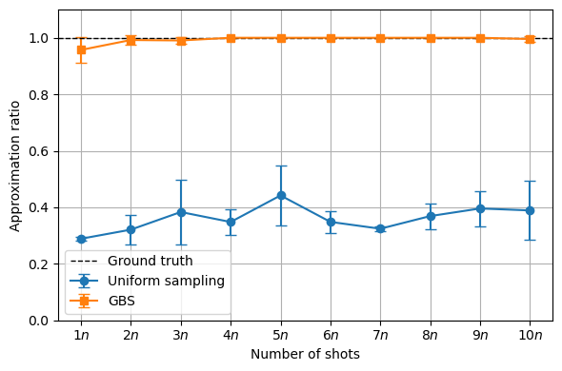 | 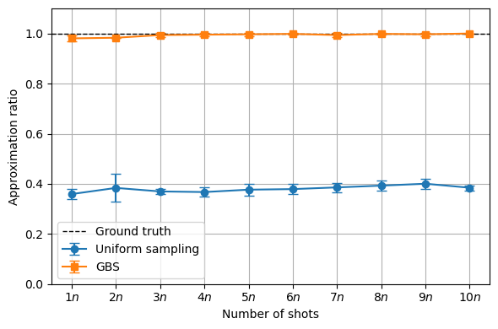
c | d
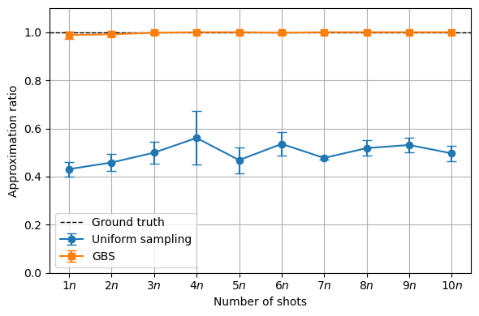 | 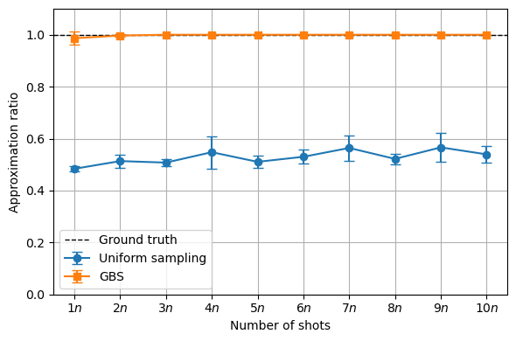
e | f
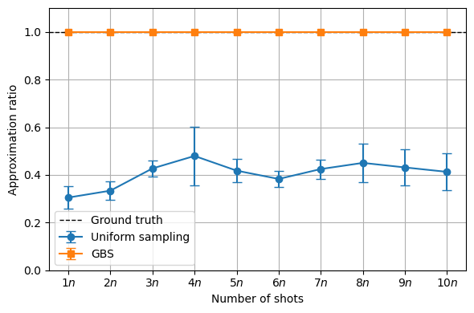 | 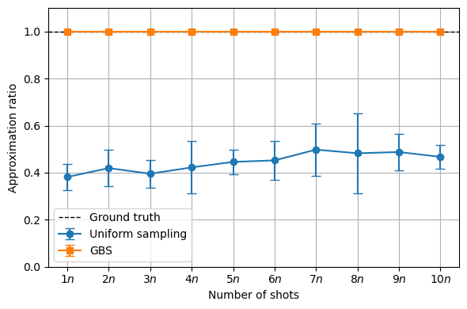
Figures S2 (a)-(f): (a) Combined network at low-methane condition, (b) Combined network at high-methane condition, (c) Metagenomic network at low-methane condition, (d) Metagenomic network at high-methane condition, (e) Metatranscriptomic network at low-methane condition, (f) Metatranscriptomic network at high-methane condition

