Supplementary Material - Figures
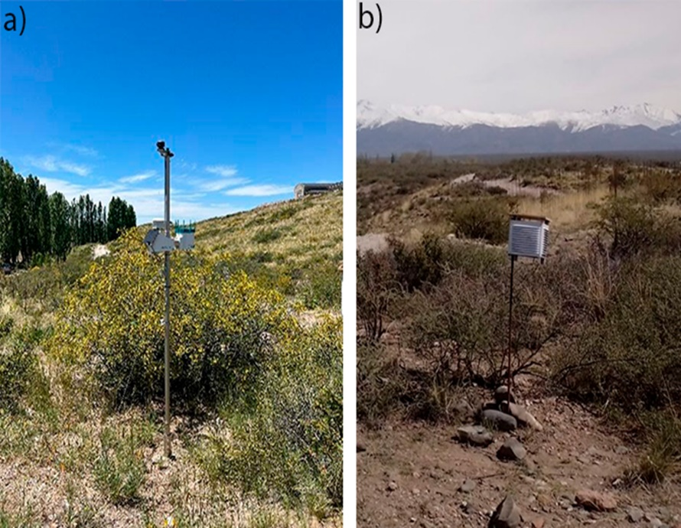
Figure S1. Instrumentation used in the study: a) μMETOS meteorological station 12A; b) HOBO Pendant MX2201 temperature sensor.
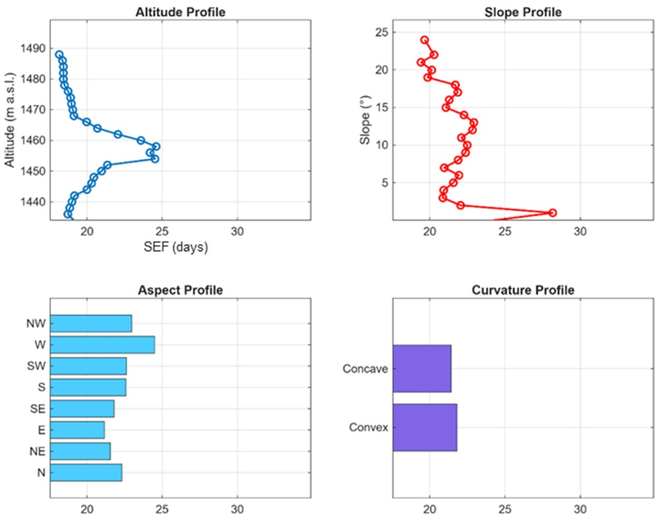
Figure S2. Topographic profile of clusters 2 based on conditional SEF distributions: a) altitude, b) slope (°), c) aspect (cardinal orientation), and d) curvature types).
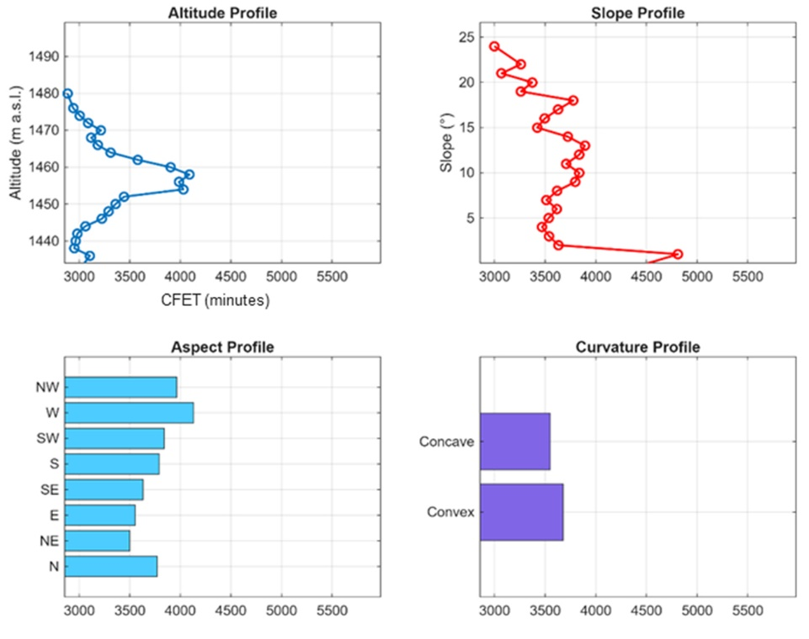
Figure S3. Topographic profile of clusters 2 based on conditional CFET distributions: a) altitude, b) slope (°), c) aspect (cardinal orientation), and d) curvature types).
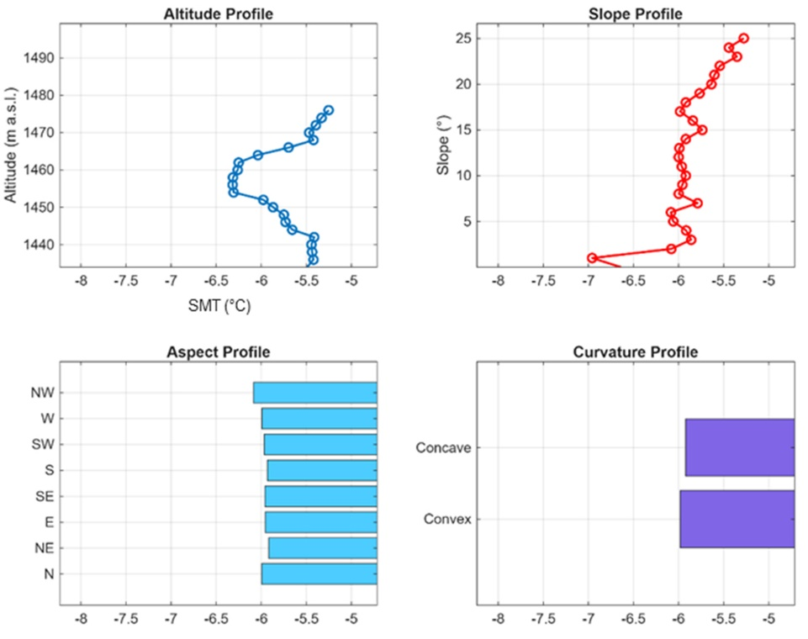
Figure S4. Topographic profile of clusters 3 based on conditional SMT distributions: a) altitude, b) slope (°), c) aspect (cardinal orientation), and d) curvature types).

