Supplementary
Table S1. PBMC donor information
Donor | Age | Smoker | Weight (kg) | Height (cm) | Race
Female-1 | 43 | Yes | 53 | 167 | Caucasian
Female-2 | 29 | No | 91 | 173 | Caucasian
Female-3 | 41 | No | 61 | 168 | Caucasian
Female-4 | 22 | No | 195 | 174 | Caucasian
Male-1 | 42 | Yes | 95 | 183 | African American
Male-2 | 42 | No | 83 | 185 | Hispanic
Male-3 | 32 | Yes | 90 | 182 | Asian
Male-4 | 27 | Yes | 111 | 184 | Caucasian

Table S2. Compound name, acronym, CAS number, and key LC-MS/MS parameters for targeted PFAS and internal standard (IS), including IS choice, RF lens voltage, Selective Reaction Monitoring (SRM) transitions, and collision energy (CE).

Compounds Name | CAS | Acronym | IS | RF (V) | Quantifier |  | Qualifier
 |  |  |  |  | Transition | CE(V) | Transition | CE(V)
Perfluorobutanoic acid | 375-22-4 | PFBA | MPFBA | 31 | 213.0>168.9 | 8.6 | NA | NA
Perfluoropentanoic acid | 2706-90-3 | PFPeA | M5PFPeA | 32 | 263.0>218.9 | 7.8 | NA | NA
Perfluorohexanoic acid | 307-24-4 | PFHxA | M5PFHxA | 37 | 313.9>268.9 | 8.3 | NA | NA
Perfluoroheptanoic acid | 375-85-9 | PFHpA | M4PFHpA | 43 | 363.0>318.9 | 9.1 | 363.0>168.9 | 17.2
Perfluorooctanoic acid | 335-67-1 | PFOA | M8PFOA | 47 | 413.0>368.9 | 9.3 | 413.0>168.9 | 17.8
Perfluorononanoic acid | 375-95-1 | PFNA | M9PFNA | 51 | 463.0>418.9 | 9.6 | 463.0>218.9 | 16.3
Perfluorodecanoic acid | 335-76-2 | PFDA | M6PFDA | 56 | 513.0>468.9 | 10.4 | 513.0>218.9 | 17.9
Perfluoroundecanoic acid | 2058-94-8 | PFUdA | M7PFUdA | 59 | 563.0>518.9 | 10.7 | 563.0>268.9 | 18.6
Perfluorododecanoic acid | 307-55-1 | PFDoA | MPFDoA | 65 | 612.9>568.9 | 11.6 | 612.9>168.9 | 27.0
Perfluorotridecanoic acid | 72629-94-8 | PFTrDA | MPFDoA | 73 | 662.9>618.9 | 12.1 | 662.9>168.9 | 28.2
Perfluorotetradecanoic acid | 376-06-7 | PFTeDA | M2PFTeDA | 71 | 712.9>668.9 | 12.3 | NA | NA
Perfluorobutane sulfonic acid | 375-73-5 | PFBS | M3PFBS | 112 | 298.8>79.8 | 35.0 | 298.8>98.8 | 30.6
Perfluoropentane sulfonic acid | 2706-91-4 | PFPeS | M3PFHxS | 126 | 348.8>79.8 | 40.3 | 348.8>98.8 | 34.7
Perfluorohexane sulfonic acid | 355-46-4 | PFHxS* | M3PFHxS | 111 | 398.8>79.8 | 42.8 | 398.8>98.8 | 37.9
Perfluoroheptane sulfonic acid | 375-92-8 | PFHpS | M3PFHxS | 161 | 448.8>79.8 | 46.1 | 448.8>98.8 | 40.8
Perfluorooctane sulfonic acid | 1763-23-1 | PFOS* | M8PFOS | 120 | 498.8>98.8** | 44.6 | 498.8>79.8 | 51.6
Perfluorononane sulfonic acid | 68259-12-1 | PFNS | M8PFOS | 250 | 548.8>79.8 | 57.1 | 548.8>98.8 | 48.4
Perfluorodecane sulfonic acid | 335-77-3 | PFDS | M8PFOS | 119 | 598.8>79.8 | 57.7 | 598.8>98.8 | 50.8
4:2 Fluorotelomer sulfonate | 757124-72-4 | 4:2-FTS | M2-4:2 FTS | 101 | 327.0>306.9 | 19.7 | 327.0>79.8 | 35.7
6:2 Fluorotelomer sulfonate | 27619-97-2 | 6:2-FTS | M2-6:2 FTS | 124 | 427.0>406.8 | 23.1 | 427.0>80.8 | 34.9
8:2 Fluorotelomer sulfonate | 39108-34-4 | 8:2-FTS | M2-8:2 FTS | 120 | 527.0>506.8 | 26.8 | 527.0>486.8 | 33.0
Perfluoro-n-(13C)butanoic acid | NA | MPFBA | NA | 31 | 217.0>172.0 | 8.6 | NA | NA
Perfluoro-n-(13C)pentanoic acid | NA | M5PFPeA | NA | 32 | 268.0>223.0 | 7.8 | NA | NA
Perfluoro-n-(1,2,3,4,6-13C)hexanoic acid | NA | M5PFHxA | NA | 37 | 318.0>273.0 | 8.3 | NA | NA
Perfluoro-n-(1,2,3,4-13C)heptanoic acid | NA | M4PFHpA | NA | 45 | 366.9>322.0 | 9.1 | NA | NA
Perfluoro-n-(13C)octanoic acid | NA | M8PFOA | NA | 47 | 421.0>376.0 | 9.3 | NA | NA
Perfluoro-n-(13C)nonanoic acid | NA | M9PFNA | NA | 51 | 472.0>427.0 | 9.6 | NA | NA
Perfluoro-n-(1,2,3,4,5,6-13C)decanoic acid | NA | M6PFDA | NA | 56 | 519.0>474.0 | 10.4 | NA | NA
Perfluoro-n-(1,2,3,4,5,6,7-13C)undecanoic acid | NA | M7PFUdA | NA | 59 | 570.0>525.0 | 10.7 | NA | NA
Perfluoro-n-(1,2-13C )dodecanoic acid | NA | MPFDoA | NA | 67 | 614.9>569.9 | 11.5 | NA | NA
Perfluoro-n-(1,2-13C )tetradecanoic acid | NA | M2PFTeDA | NA | 71 | 715.0>670.0 | 12.3 | NA | NA
Sodium perfluoro-1-(2,3,4-13C )butanesulfonate | NA | M3PFBS | NA | 113 | 302.0>80.0 | 31.6 | NA | NA
Sodium perfluoro-1-(1,2,3-13C)hexanesulfonate | NA | M3PFHxS | NA | 111 | 402.0>99.0 | 37.9 | NA | NA
Sodium perfluoro-1-(13C)octanesulfonate | NA | M8PFOS | NA | 121 | 507.0>99.0 | 45.6 | NA | NA
Sodium 1H,1H,2H,2H-perfluoro(1,2-13C) hexanesulfonate | NA | M2-4:2 FTS | NA | 101 | 329.0>309.0 | 19.7 | NA | NA
Sodium 1H,1H,2H,2H-perfluoro(1,2-13C) octanesulfonate | NA | M2-6:2 FTS | NA | 124 | 429.0>409.0 | 23.1 | NA | NA
Sodium 1H,1H,2H,2H-perfluoro(1,2-13C) decanesulfonate | NA | M2-8:2 FTS | NA | 120 | 529.0>509.0 | 26.8 | NA | NA
* PFHxS and PFOS are mixtures that contain linear and a variety of branched isomers.

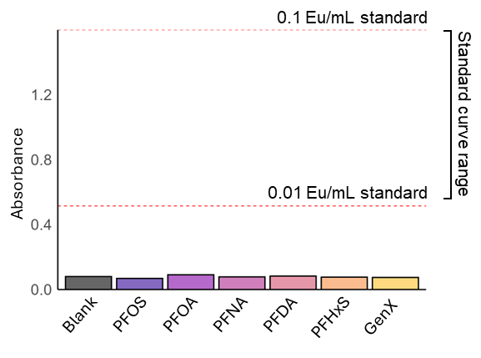
Figure S1. Endotoxin in prepared chemical solutions. Averaged raw absorbance values of technical duplicates measured for endotoxin in prepared PFOS, PFOA, PFNA, PFDA, PFHxS, and GenX solutions. Red dotted lines indicate the highest (0.1 EU/mL) and lowest (0.01 EU/mL) standard curve absorbance values. Abbreviations: PFDA, perfluorodecanoic acid; PFHxS, perfluorohexanesulfonic acid; PFNA, perfluorononanoic acid; PFOA, perfluorooctanoic acid; PFOS, perfluorooctanesulfonic acid.

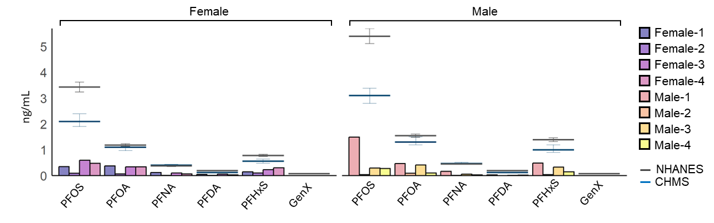
Figure S2. Baseline PFAS concentrations in human donor plasma compared to USA (NHANES) and Canada (CHMS) biomonitoring data. Plasma concentrations of five PFAS of interest (PFOS, PFOA, PFHxS, PFNA, PFDA) in n=8 human donors. Data are coloured by individual. NHANES geometric mean (collection period: 2017-2018) and CHMS geometric mean (collection period: 2018-2019) reference values ± 95% CI. Abbreviations: CHMS, Canadian Health Measures Survey; NHANES, National Health and Nutrition Examination Survey; PFDA, perfluorodecanoic acid; PFHxS, perfluorohexanesulfonic acid; PFNA, perfluorononanoic acid; PFOA, perfluorooctanoic acid; PFOS, perfluorooctanesulfonic acid
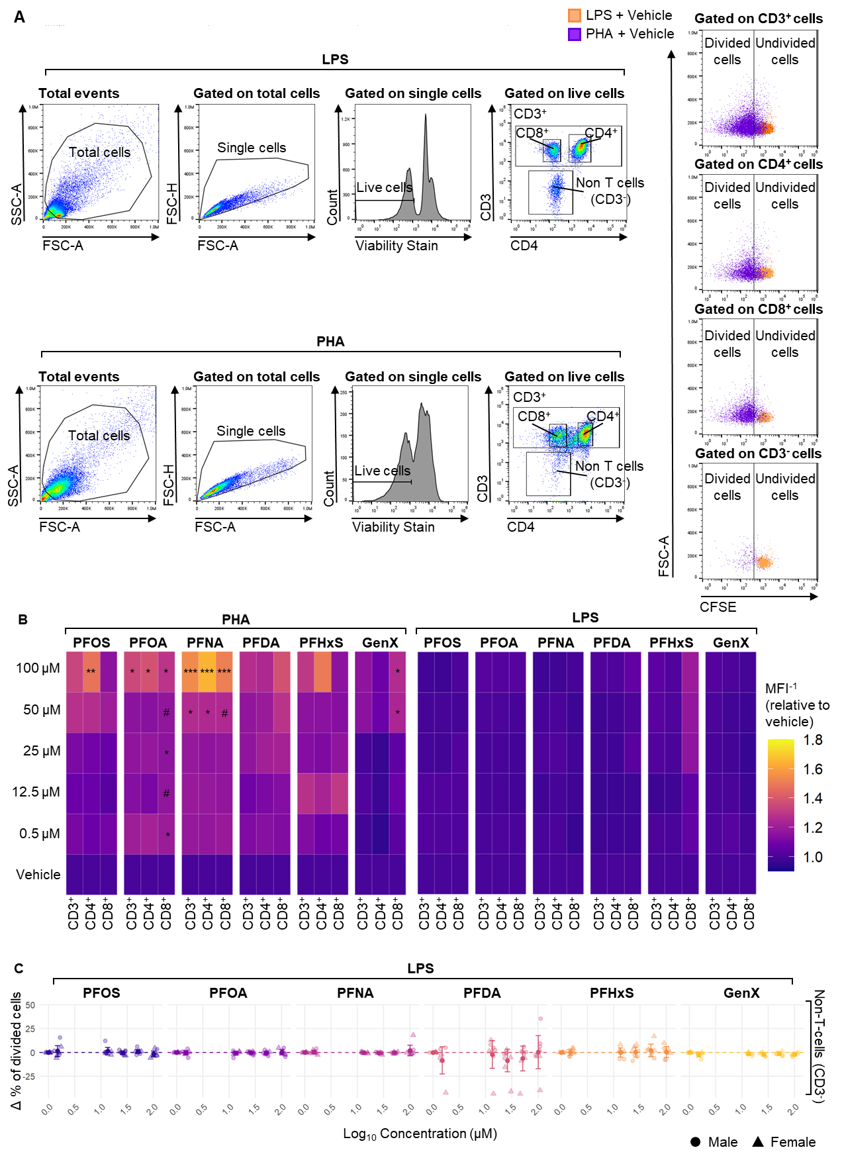
Figure S3. PFAS pre-treatment with PHA increases T-cell proliferation. (A) Flow cytometry gating strategy. (B) MFI⁻¹ of CD3⁺, CD4⁺, and CD8⁺ T-cells following PHA or LPS stimulation was assessed by CFSE in the presence or absence of PFAS. Data is presented as mean MFI⁻¹ fold-change, relative to vehicle. Proliferation of non-T-cells (CD3⁻) following LPS stimulation was assessed by CFSE in the presence or absence of PFAS. Data are presented as Δ (treated − vehicle) ± 95% CI. The dotted line represents the mean of the corresponding vehicle control. Statistical significance was assessed using the repeated measures one-way ANOVA with Tukey’s multiple comparisons (control: vehicle). #p≤0.099; *p≤0.05; **p≤0.01; ***p≤0.001. n=7-8 humans/group. Abbreviations: CFSE, carboxyfluorescein succinimidyl ester; FSC-A, forward scatter area; FSC-H, forward scatter height; LPS, lipopolysaccharide; PFDA, perfluorodecanoic acid; PFHxS, perfluorohexanesulfonic acid; PFNA, perfluorononanoic acid; PFOA, perfluorooctanoic acid; PFOS, perfluorooctanesulfonic acid; PHA, phytohemagglutinin; MFI⁻¹, reciprocal mean fluorescence intensity; SSC-A, side scatter area.

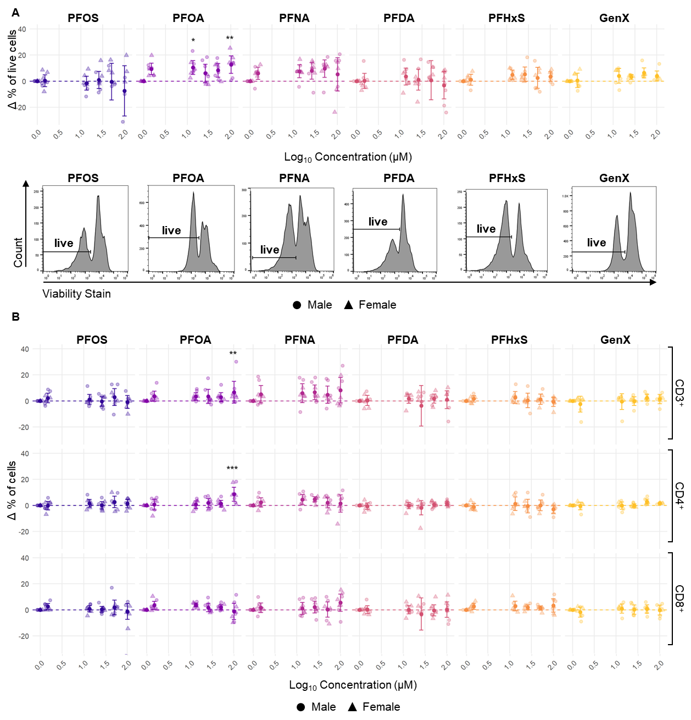

Figure S4. Co-treatment with PFAS and PHA does not decrease cell viability (A) Percentage of live cells following PHA stimulation was assessed by fixable viability stain in the presence or absence of PFAS. Data are presented as Δ (treated − vehicle) ± 95% CI. The dotted line represents the mean of the corresponding vehicle control. Representative histograms for the vehicle group show the distribution of fixable viability stain for each PFAS tested. (B) Percentage of CD3⁺, CD4⁺, and CD8⁺ cells following PHA stimulation in the presence or absence of PFAS. Data are presented as Δ (treated − vehicle) ± 95% CI. The dotted line represents the mean of the corresponding vehicle control. Statistical significance was assessed using the repeated measures one-way ANOVA with Tukey’s multiple comparisons (control: vehicle). n=7-8 humans/group. Abbreviations: PFDA, perfluorodecanoic acid; PFHxS, perfluorohexanesulfonic acid; PFNA, perfluorononanoic acid; PFOA, perfluorooctanoic acid; PFOS, perfluorooctanesulfonic acid; PHA, phytohemagglutinin.

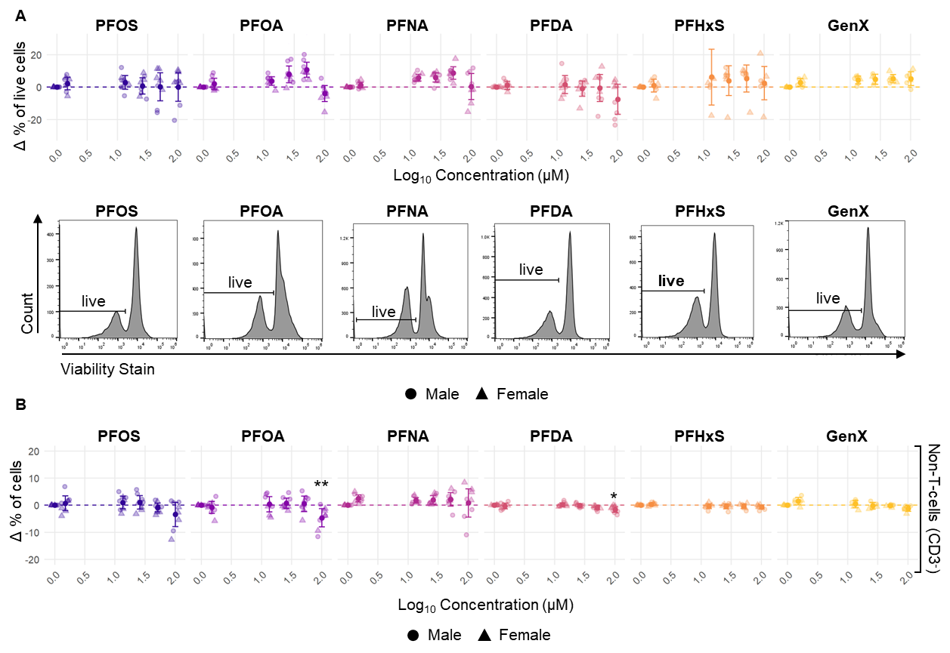
Figure S5. Co-treatment with PFAS and LPS does not decrease viability (A) Percentage of live cells following LPS stimulation was assessed by fixable viability stain in the presence or absence of PFAS. Data are presented as Δ (treated − vehicle) ± 95% CI. The dotted line represents the mean of the corresponding vehicle control. Representative histograms for the vehicle group show the distribution of fixable viability stain for each PFAS tested. (B) Percentage of non-T-cells (CD3⁻) following LPS stimulation in the presence or absence of PFAS. Data are presented as Δ (treated − vehicle) ± 95% CI. The dotted line represents the mean of the corresponding vehicle control. Statistical significance was assessed using the repeated measures one-way ANOVA with Tukey’s multiple comparisons (control: vehicle). *p≤0.05; **p≤0.01. n=7-8 humans/group. Abbreviations: LPS, lipopolysaccharide; PFDA, perfluorodecanoic acid; PFHxS, perfluorohexanesulfonic acid; PFNA, perfluorononanoic acid; PFOA, perfluorooctanoic acid; PFOS, perfluorooctanesulfonic acid.

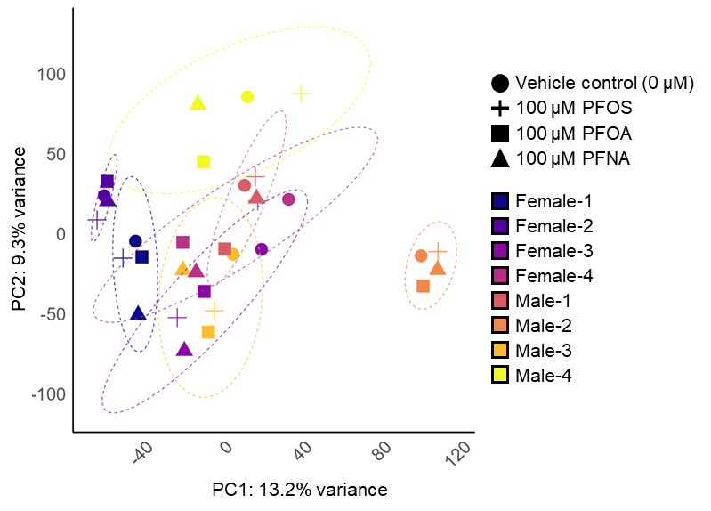
Figure S6. CA shows donor-specific clustering of human PBMC responses. PCA of vehicle control (0 μM), 100 μM PFOS, 100 μM PFOA, and 100 μM PFNA exposed human PBMCs. Data points are coloured by individual donor. Abbreviations: PC, principal component; PFNA, perfluorononanoic acid; PFOA, perfluorooctanoic acid; PFOS, perfluorooctanesulfonic acid.

