Supplementary Material

Contents
Supplemental Tables
Table S1 ………………………………………………………………………………... 2
Table S2 ……………………………………………………………..…………………. 4
Table S3 …………………………………………………………………………….…...5
Table S4 ………………………………………………………………………….……...6
Table S5 ………………………………………………………………………….….….7

Supplementary Figures
Figure S1 ……………………………………………………………………….……… 11
Figure S2 ……………………………………………………………………….……… 12

Supplemental Table S1. ICD diagnostic codes used in the study
Disease | ICD-9 | ICD-10
Hypertension | 401.x-405.x | I10.x-I15.x, N26.2x
Diabetes mellitus | 250.x | E08.x-E13.x
Coronary heart disease | 410.x-414.x | I20.x-I24.x
Hyperlipidemia | 272.x | E77.x, E78.0x-E78.6x, E88.1x, E75.3x, E75.5x, E88.2x, E75.6x, E78.9x, E75.21, E75.22, E75.24, E71.30, E78.79, E78.81, E78.89, E88.89, E78.70
Atrial fibrillation | 427.3x | I48.x
Peripheral arterial disease | 440.x, 441.x, 443.x, 444.0x, 444.8x, 447.8x, 447.9x, 093.0, 437.3, 444.22, 447.1, 557.1, 557.9, V434 | I70.x, I71.x, I73.x, I75.x, I77.1x, I79.0x, I79.1x, I79.2x, I77.3x, I77.9x, I79.8x, K55.1x, K55.8x, K55.9x, Z95.8x, Z95.9x, I74.3x-I74.5x, I74.8x, I74.0x, I77.89x
Chronic obstructive pulmonary disease | 491.x, 492.x, 496.x | J41.x-J44.x
Chronic kidney disease | 580.x-589.x, 403.x-404.x, 016.0x, 095.4x, 236.9x, 250.4x, 274.1x, 442.1x, 447.3x, 440.1x, 572.4x, 642.1x, 646.2x, 753.1x, 283.11, 403.01, 404.02, 446.21 | A18.11x, D59.3x, E10.2x, E11.2x, E13.2x, I12.x, I13.x, K76.7x, M10.3x, M31.0x, N00.x-N08.x, N14.x, N15.0x, N15.8x, N15.9x, N16.x, N17.1x, N17.2x, N18.x, N19.x, N20.0x, N25.x, N26.1x, N26.9x, N27.x, Q61.x
Myocardial infarction | 410.x, 412.x | I21.x-I22.x
Heart failure hospitalization | 428.x | I50.x
Stroke | 430.x-437.x | I60.x-I62.x, I66.x, I65.1x, I65.0x, I65.8x, I65.9x, I63.6x, I63.8x, I63.9x, G45.0x, G45.8x, G45.1x, G45.2x, G46.0x, G46.1x, G46.2x, G45.9x, G45.4x, G46.3x, G46.4x, G46.5x, G46.6x, G46.7x, G46.8x, I67.0x, I67.1x, I67.2x, I67.4x-I67.9x, I68.0x, I68.2x, I68.8x
Distant metastasis | 197.0x-197.8x, 198.0x-198.7x, 198.81, 198.82, 198.89 | C78.x, C79.x, C7B.02x, C7B.03x, C7B.04x
Ischemic stroke | 433.x-437.x | I66.x, I65.1x, I65.0x, I65.8x, I65.9x, I63.6x, I63.8x, I63.9x, G45.0x, G45.8x, G45.1x, G45.2x, G46.0x, G46.1x, G46.2x, G45.9x, G45.4x, G46.3x, G46.4x, G46.5x, G46.6x, G46.7x, G46.8x, I67.0x, I67.1x, I67.2x, I67.4x, I67.5x, I67.6x, I67.7x, I67.9x, I68.0x, I68.2x, I68.8x
Myocardial infarction | 410.x | I21.x
Cardiovascular death | 390.x-459.x | I01.x, I02.0x, I05-I15.x, I20.x-I25.x, I27.x, I30.x, I31.x, I32.x, I33.x-I52.x, I60.x-I71.x
Abbreviation: ICD, International Classification of Diseases.

Supplemental Table S2. Discrimination performance of various machine learning models and traditional Cox model using 15 features in the training cohort
Model (15 features) | Area under the curve, % (95% CI)
Decision tree | 63.7 (59.6 to 67.7)
Linear discriminant analysis | 69.6 (68.5 to 70.7)
eXtreme Gradient Boosting | 75.1 (74.3 to 75.9)
Support vector machine | 59.0 (58.0 to 60.0)
Random forest | 75.6 (74.8 to 76.5)
k-nearest neighbor classification | 62.3 (61.0 to 63.6)
Cox proportional hazard model | 71.9 (71.0 to 72.8)
Fine and Gray subdistribution hazard model | 67.6 (67.1 to 68.1)
Random survival forest | 81.2 (80.5 to 81.9)
CI, confidence interval.

Supplemental Table S3. VIMP and minimal depth of the initial RSF model in the derivation cohort.
Features | VIMP (%) | Rank of VIMP | Minimum depth
- Age | 18.19 | 1 | 1.18
- Coronary heart disease | 10.59 | 2 | 4.03
- Atrial fibrillation | 7.04 | 3 | 4.30
- Heart failure hospitalization | 5.19 | 4 | 2.12
- Myocardial infarction | 5.13 | 5 | 4.09
- Peripheral arterial disease | 4.30 | 6 | 3.82
- ADT type at the index date | 2.60 | 7 | 2.77
- Hypertension | 2.39 | 8 | 4.38
- Diabetes mellitus | 2.26 | 9 | 3.62
- Coronary revascularization | 2.12 | 10 | 4.27
- Stroke | 1.81 | 11 | 2.07
- Chronic kidney disease | 1.23 | 12 | 2.75
- Chronic obstructive pulmonary disease | 0.95 | 13 | 2.48
- Hyperlipidemia | -0.02 | 14 | 2.66
- Distant metastasis | -0.25 | 15 | 1.48
Abbreviation: VIMP, variable importance; RSF, random survival forest; ADT, androgen deprivation therapy

Supplemental Table S4. Performance of RSF models with different numbers of predictors according to the rankings of the initial RSF model
Feature numbers | AUC, % (95% CI)
Top 1 feature | 75.7 (74.9 to 76.4)
Top 2 features | 76.5 (75.8 to 77.2)
Top 3 features | 76.8 (76.1 to 77.5)
Top 4 features | 77.0 (76.3 to 77.7)
Top 5 features | 77.9 (77.1 to 78.6)
Top 6 features | 78.0 (77.3 to 78.7)
Top 7 features | 78.1 (77.4 to 78.8)
Top 8 features* | 78.7 (78.0 to 79.4)
Top 9 features | 78.6 (77.9 to 79.3)
Top 10 features | 79.2 (78.5 to 79.9)
Top 11 features | 79.7 (79.0 to 80.4)
Top 12 features | 79.8 (79.1 to 80.5)
Top 13 features | 80.2 (79.5 to 80.9)
Top 14 features | 80.6 (80.0 to 81.3)
All (15 features) | 81.2 (80.5 to 81.9)
Abbreviations: RSF, random survival forest; AUC, area under curve; CI, confidence interval;
* Finally selected model.

Supplemental Table S5. The baseline characteristics of patients with and without development of MACE at the end of follow up in the derivation and validation cohorts
 | Derivation cohort |  |  |  | Validation cohort
Variable | MACE  (n = 3,982) | Non-MACE  (n = 23,275) | P value |  | MACE  (n = 1,699) | Non-MACE  (n = 9,982) | P value
Urbanization level of the residence |  |  | 0.024 |  |  |  | 0.752
Low | 559 (14.0) | 2,910 (12.5) |  |  | 219 (12.9) | 1,259 (12.6)
Moderate | 1,223 (30.7) | 7,043 (30.3) |  |  | 521 (30.7) | 3,046 (30.5)
High | 1,153 (29.0) | 6,871 (29.5) |  |  | 507 (29.8) | 2,899 (29.0)
Very High | 1,047 (26.3) | 6,451 (27.7) |  |  | 452 (26.6) | 2,778 (27.8)
Region |  |  | 0.938 |  |  |  | 0.007
North | 1,816 (45.6) | 10,595 (45.5) |  |  | 813 (47.9) | 4,481 (44.9)
West | 956 (24.0) | 5,564 (23.9) |  |  | 366 (21.5) | 2,489 (24.9)
South | 1,097 (27.6) | 6,489 (27.9) |  |  | 485 (28.6) | 2,748 (27.5)
East | 113 (2.8) | 627 (2.7) |  |  | 35 (2.1) | 264 (2.6)
Age, year | 78.5 ± 7.8 | 74.3 ± 8.9 | <0.001 |  | 78.5 ± 8.0 | 74.3 ± 8.9 | <0.001
ADT type at the index date |  |  | <0.001 |  |  |  | <0.001
GnRH agonist | 3,633 (91.2) | 21,108 (90.7) |  |  | 1,540 (90.6) | 8,977 (89.9)
GnRH antagonist (Degarelix) | 171 (4.3) | 1,378 (5.9) |  |  | 71 (4.2) | 650 (6.5)
Bilateral orchiectomy | 178 (4.5) | 789 (3.4) |  |  | 88 (5.2) | 355 (3.6)
Comorbidities
Hypertension | 2,939 (73.8) | 13,479 (57.9) | <0.001 |  | 1,219 (71.8) | 5,791 (58.0) | <0.001
Diabetes mellitus | 1,374 (34.5) | 6,142 (26.4) | <0.001 |  | 580 (34.1) | 2,676 (26.8) | <0.001
Coronary heart disease | 846 (21.3) | 2,485 (10.7) | <0.001 |  | 371 (21.8) | 1,069 (10.7) | <0.001
Hyperlipidemia | 1,121 (28.2) | 6,998 (30.1) | 0.015 |  | 486 (28.6) | 3,029 (30.3) | 0.148
Atrial fibrillation | 294 (7.4) | 825 (3.5) | <0.001 |  | 130 (7.7) | 367 (3.7) | <0.001
Peripheral arterial disease | 212 (5.3) | 868 (3.7) | <0.001 |  | 89 (5.2) | 364 (3.7) | 0.002
Chronic obstructive pulmonary disease | 580 (14.6) | 2,535 (10.9) | <0.001 |  | 284 (16.7) | 1,062 (10.6) | <0.001
Chronic kidney disease | 1,084 (27.2) | 4,893 (21.0) | <0.001 |  | 460 (27.1) | 2,102 (21.1) | <0.001
Cardiovascular disease* | 1,693 (42.5) | 5,525 (23.7) | <0.001 |  | 748 (44.0) | 2,393 (24.0) | <0.001
History of event
Myocardial infarction | 293 (7.4) | 682 (2.9) | <0.001 |  | 125 (7.4) | 327 (3.3) | <0.001
Coronary revascularization | 529 (13.3) | 1,479 (6.4) | <0.001 |  | 250 (14.7) | 636 (6.4) | <0.001
Heart failure hospitalization | 426 (10.7) | 791 (3.4) | <0.001 |  | 182 (10.7) | 371 (3.7) | <0.001
Stroke | 741 (18.6) | 2,165 (9.3) | <0.001 |  | 319 (18.8) | 972 (9.7) | <0.001
Duration between PCa diagnosis and ADT, month | 1.63 [0.77, 5.20] | 1.63 [0.77, 5.40] | 0.005 |  | 1.70 [0.77, 7.07] | 1.63 [0.77, 5.20] | <0.001
Disease extent |  |  | <0.001 |  |  |  | 0.226
Loco regional | 2,373 (59.6) | 13,213 (56.8) |  |  | 993 (58.5) | 5,677 (56.9)
Distant metastasis | 1,609 (40.4) | 10,062 (43.2) |  |  | 706 (41.6) | 4,305 (43.1)
Medication
NSAIDs | 2,450 (61.5) | 13,930 (59.9) | 0.046 |  | 1,017 (59.9) | 5,970 (59.8) | 0.968
Cox-2 inhibitor | 652 (16.4) | 3,858 (16.6) | 0.751 |  | 259 (15.2) | 1,671 (16.7) | 0.125
Antiplatelet agents (aspirin/ clopidogrel/ ticagrelor) | 1,605 (40.3) | 5,981 (25.7) | <0.001 |  | 683 (40.2) | 2,662 (26.7) | <0.001
Anticoagulant agents (Warfarin/ DOACs) | 239 (6.0) | 834 (3.6) | <0.001 |  | 100 (5.9) | 359 (3.6) | <0.001
Oral hypoglycemic agents | 1,136 (28.5) | 5,048 (21.7) | <0.001 |  | 488 (28.7) | 2,226 (22.3) | <0.001
Insulin | 200 (5.0) | 583 (2.5) | <0.001 |  | 92 (5.4) | 249 (2.5) | <0.001
ACEI / ARB / ARNI | 1,533 (38.5) | 6,724 (28.9) | <0.001 |  | 649 (38.2) | 2,943 (29.5) | <0.001
Beta-blocker | 1,273 (32.0) | 5,334 (22.9) | <0.001 |  | 496 (29.2) | 2,235 (22.4) | <0.001
Dihydropyridine calcium channel blockers | 1,537 (38.6) | 6,361 (27.3) | <0.001 |  | 664 (39.1) | 2,795 (28.0) | <0.001
MRAs (spironolactone/ eplerenone) | 223 (5.6) | 603 (2.6) | <0.001 |  | 67 (3.9) | 264 (2.6) | 0.003
Loop diuretics | 764 (19.2) | 2,700 (11.6) | <0.001 |  | 336 (19.8) | 1,114 (11.2) | <0.001
Thiazide | 308 (7.7) | 1,150 (4.9) | <0.001 |  | 141 (8.3) | 498 (5.0) | <0.001
Statin | 990 (24.9) | 5,560 (23.9) | 0.184 |  | 457 (26.9) | 2,365 (23.7) | 0.004
Fibrate | 102 (2.6) | 563 (2.4) | 0.590 |  | 52 (3.1) | 270 (2.7) | 0.408
Anti-androgen medication
Flutamide | 302 (7.6) | 1,397 (6.0) | <0.001 |  | 117 (6.9) | 592 (5.9) | 0.127
Bicalutamide | 2,072 (52.0) | 12,469 (53.6) | 0.072 |  | 867 (51.0) | 5,323 (53.3) | 0.080
Cyproterone | 959 (24.1) | 4,835 (20.8) | <0.001 |  | 427 (25.1) | 2,111 (21.2) | <0.001
Novel anti-androgen (enzalutamide/ abiraterone) | 45 (1.1) | 525 (2.3) | <0.001 |  | 16 (0.9) | 225 (2.3) | <0.001
Follow up year | 4.5 ± 3.0 | 4.2 ± 2.9 | <0.001 |  | 4.4 ± 2.9 | 4.2 ± 2.9 | 0.003
Abbreviation: ADT, androgen deprivation therapy; ACEI, angiotensin-converting enzyme inhibitor; ARB, angiotensin receptor blocker; ARNI, angiotensin receptor-neprilysin inhibitor; Cox-2, cyclooxygenase-2; DOACs, direct oral anticoagulants; GnRH, gonadotropin-releasing hormone; NSAIDs, non-steroidal anti-inflammatory drugs; PCa, prostate cancer; STD, standardized difference.
* Anyone of coronary heart disease, peripheral arterial disease, myocardial infarction, and stroke;
Data are presented as frequency (percentage), mean ± standard deviation, or median [25th percentile, 75th percentile].

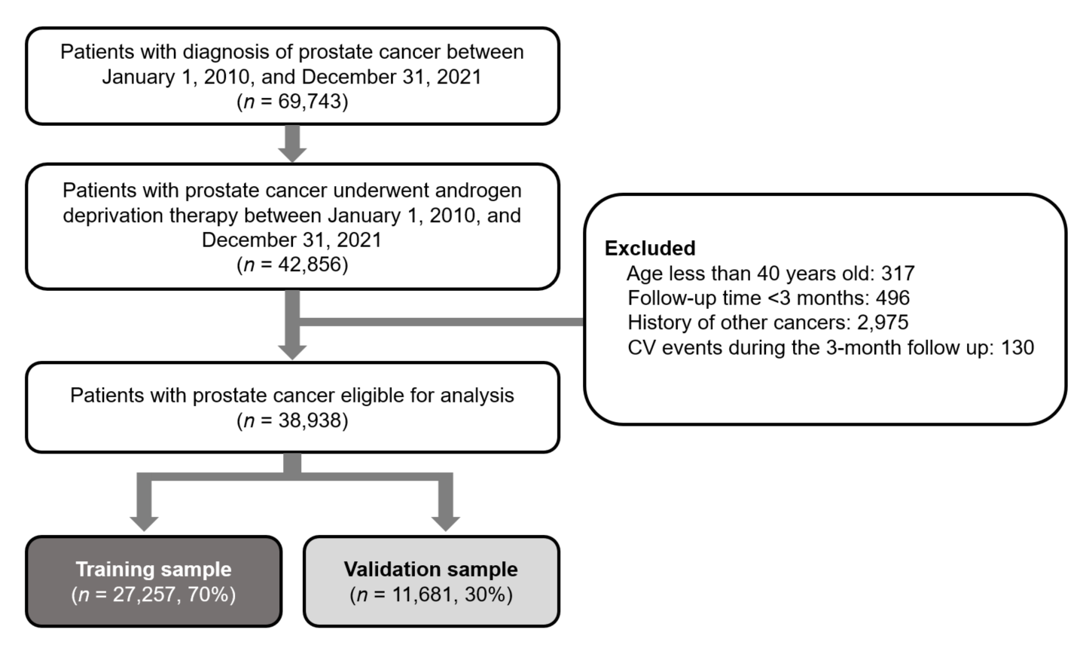
Supplemental Figure S1. The ﬂow chart of this study. CV, cardiovascular

Supplemental Figure S2. Partial dependence plots for selected features in the training sample. ADT, androgen deprivation therapy.

