Supplementary Materials
Adsorption of volatile organic compounds and microwave regeneration on self-prepared high-surface-area beaded activated carbon
Shih-Ying Hsiao ¹, Shu-Wen You ¹, Can Wang ^{2,3}, Ji-Guang Deng ⁴, and Hsing-Cheng Hsi ^{1,}∗
¹ Graduate Institute of Environmental Engineering, National Taiwan University, No. 1, Sec. 4, Roosevelt Rd., Da'an Dist., Taipei 10617, Taiwan
² School of Environmental Science and Engineering, Tianjin University, Tianjin 300072, China
³ Tianjin Key Lab of Indoor Air Environmental Quality Control, Tianjin 300072, China
⁴ College of Environmental and Energy Engineering, Beijing University of Technology, Beijing, 100124, China

- Langmuir, Freundlich, and Dubinin-Radushkevich (D-R) isotherms
The Langmuir isotherm was primarily designed to describe gas-solid phase adsorption. It assumed the adsorption was monolayer and in dynamic equilibrium, the Langmuir equation can be written in the following form:
 | $$\frac{\text{q}}{{\text{q}}_{\text{s}}}\text{=} \frac{\text{b∙P}}{\text{1+bP}}$$ | (S1)
where q (mg g⁻¹) is the adsorption capacity, q_{s} (mg g⁻¹) the saturated adsorption capacity, b (Pa⁻¹) the Langmuir constant representing the strength of the adsorbate-adsorbent interactions, and P (Pa) stands for the partial pressure of the adsorbate in the bulk phase.
The Freundlich isotherm is an empirical equation which is applicable to adsorption processes occurred on heterogeneous interfaces. The form of Freundlich isotherm is as follows:
 | $$q = K_{F}∙P^{1/{n_{F}}}$$ | (S2)
where K_{F} and n_{F} are empirical constants that are generally temperature dependent.
The Dubinin-Radushkevich isotherm is a semi-empirical equation adapted from the earlier Polanyi potential theory and has been widely applied to describe the adsorption in microporous materials (Nguyen and Do, 2001), having the form of:
 | q $=\text{ρ}$W₀ exp$\left[-{\left(\frac{ε}{E_{0}β}\right)}^{2}\right]$ | (S3)
and
 | $ε=$RTln$\frac{{\text{P}}_{\text{0}}}{\text{P}}$ | (S4)
where W₀ is the pore volume filled, β the affinity coefficient (β = 1 for the reference vapor), ε the adsorption potential, E₀ the so-called characteristic energy for a reference vapor (usually benzene), R the universal gas constant (8.314 J mole⁻¹ K⁻¹), T the absolute temperature (K), and P₀ the saturated vapor pressure of the adsorbate.

- Supplementary figures
Figure S1 The scheme diagram of the microwave regeneration system
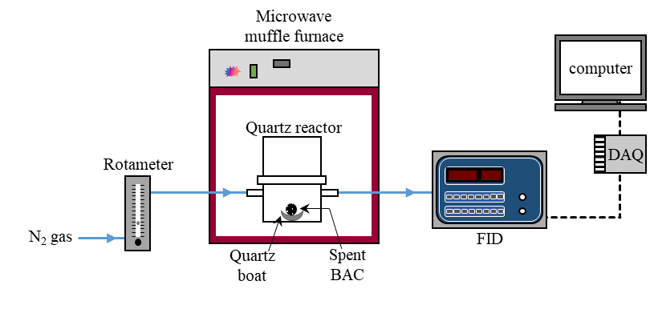

Figure S2 DTG of MEK-SBAC at various heating rates. (a) DTG peaks; (b) linear form providing the heat of desorption.
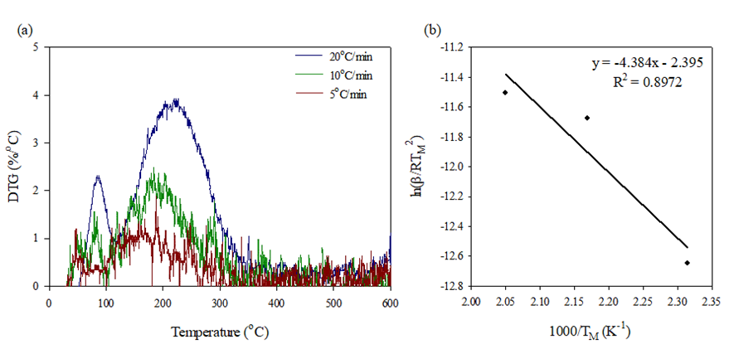

Figure S3 DTG of MEK-KBAC at various heating rates. (a) DTG peaks; (b) linear form providing the heat of desorption.
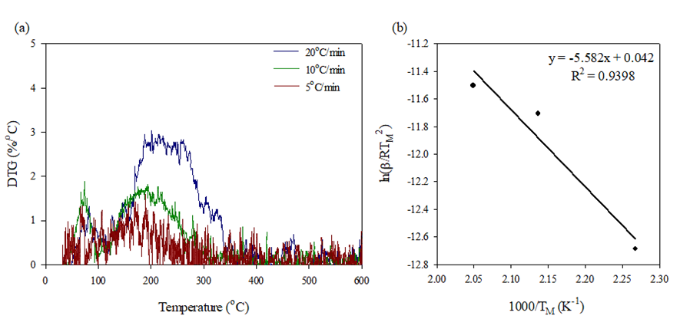

Figure S4 DTG of TOL-SBAC at various heating rates. (a) DTG peaks; (b) linear form providing the heat of desorption.
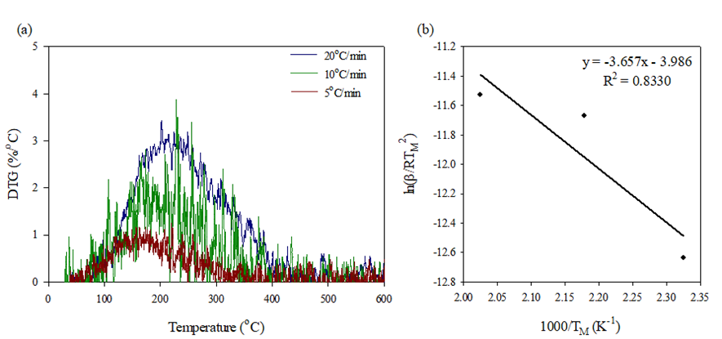

Figure S5 DTG of TOL-KBAC at various heating rates. (a) DTG peaks; (b) linear form providing the heat of desorption
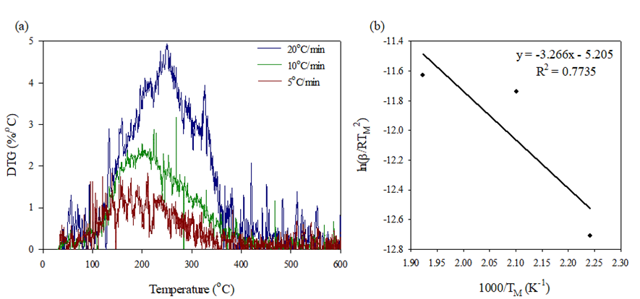
- Supplementary tables
Table S1 Peak desorption temperatures at different heating rates and activation energies for desorption
 | Peak desorption temperatures (K) at different heating rates |  |  | $$E_{d}$$  (kJ mol⁻¹) | ∆H_{vap}  (kJ mol⁻¹)
 | 20 ºC min⁻¹ | 10 ºC min⁻¹ | 5 ºC min⁻¹ | $$E_{d}$$  (kJ mol⁻¹) | ∆H_{vap}  (kJ mol⁻¹)
MEK-SBAC | 488 | 461 | 432 | 36.45 | 31.21
MEK-KBAC | 488 | 468 | 441 | 46.41 | 31.21
TOL-SBAC | 494 | 459 | 430 | 30.40 | 32.80
TOL-KBAC | 520 | 476 | 446 | 27.15 | 32.80

Table S2 Langmuir parameters for different adsorbate-adsorbent systems at different temperatures
Langmuir parameter
Integration method
Adsorbate | Adsorbent | T (°C) | R² | q_{s} (mg g⁻¹) | K_{L}
MEK | SBAC | 30 | 0.9571 | 1956.8 | 40.2
MEK | SBAC | 40 | 0.9559 | 1701.5 | 60.3
MEK | SBAC | 50 | 0.9904 | 2382.2 | 29.9
MEK | KBAC | 30 | 0.9321 | 547.6 | 230.6
MEK | KBAC | 40 | 0.8572 | 538.9 | 419.2
MEK | KBAC | 50 | 0.9730 | 568.3 | 238.8
TOL | SBAC | 30 | 0.8669 | 1686.0 | 64.6
TOL | SBAC | 40 | 0.8551 | 1222.0 | 168.6
TOL | SBAC | 50 | 0.9405 | 1433.7 | 105.4
TOL | KBAC | 30 | 0.9902 | 593.1 | 176.3
TOL | KBAC | 40 | 0.9838 | 557.1 | 218.9
TOL | KBAC | 50 | 0.9866 | 555.6 | 362.9
Gravimetric method
Adsorbate | Adsorbent | T (°C) | R² | q_{s} (mg g⁻¹) | K_{L}
MEK | SBAC | 30 | 0.9683 | 962.7 | 112.5
MEK | SBAC | 40 | 0.9906 | 770.2 | 100.4
MEK | SBAC | 50 | 0.8936 | 610.1 | 211.3
MEK | KBAC | 30 | 0.9924 | 365.1 | 368.0
MEK | KBAC | 40 | 0.9849 | 358.8 | 286.0
MEK | KBAC | 50 | 0.9652 | 377.4 | 255.3
TOL | SBAC | 30 | 0.9612 | 1323.9 | 71.7
TOL | SBAC | 40 | 0.9343 | 997.3 | 147.5
TOL | SBAC | 50 | 0.9456 | 978.2 | 123.7
TOL | KBAC | 30 | 0.9944 | 421.8 | 468.6
TOL | KBAC | 40 | 0.9995 | 413.0 | 491.5
TOL | KBAC | 50 | 0.9912 | 400.9 | 653.6

Table S3 Freundlich parameters for different adsorbate-adsorbent systems at different temperatures
Freundlich parameter
Integration method
Adsorbate | Adsorbent | T (°C) | R² | n | K_{F}
MEK | SBAC | 30 | 0.9657 | 2.302 | 4243.3
MEK | SBAC | 40 | 0.9896 | 2.309 | 4431.1
MEK | SBAC | 50 | 0.9999 | 1.746 | 7927.5
MEK | KBAC | 30 | 0.9822 | 4.778 | 890.8
MEK | KBAC | 40 | 0.9410 | 4.995 | 954.2
MEK | KBAC | 50 | 0.9931 | 3.352 | 1360.9
TOL | SBAC | 30 | 0.9486 | 3.942 | 2426.1
TOL | SBAC | 40 | 0.9825 | 4.496 | 2013.0
TOL | SBAC | 50 | 0.9669 | 3.041 | 3060.9
TOL | KBAC | 30 | 0.9927 | 7.886 | 737.1
TOL | KBAC | 40 | 0.9925 | 6.382 | 783.6
TOL | KBAC | 50 | 0.9967 | 6.662 | 824.7
Gravimetric method
Adsorbate | Adsorbent | T (°C) | R² | n | K_{F}
MEK | SBAC | 30 | 0.9483 | 3.336 | 1793.6
MEK | SBAC | 40 | 0.9769 | 2.531 | 2005.2
MEK | SBAC | 50 | 0.9637 | 3.105 | 1569.8
MEK | KBAC | 30 | 0.9960 | 6.784 | 518.7
MEK | KBAC | 40 | 0.9946 | 4.407 | 656.4
MEK | KBAC | 50 | 0.9947 | 3.386 | 905.4
TOL | SBAC | 30 | 0.9555 | 3.824 | 1988.3
TOL | SBAC | 40 | 0.9900 | 3.902 | 1777.6
TOL | SBAC | 50 | 0.9857 | 3.187 | 2107.6
TOL | KBAC | 30 | 0.9989 | 15.97 | 475.8
TOL | KBAC | 40 | 0.9960 | 12.42 | 494.1
TOL | KBAC | 50 | 0.9890 | 10.67 | 515.3

Table S4 D-R parameters for different adsorbate-adsorbent systems at different temperature
D-R parameter
Integration method
adsorbate | adsorbent |  | T (°C) | R² |  | W₀  (cm³ g⁻¹) |  |  | E₀  (kJ mol⁻¹) | E  (kJ mol⁻¹) |  | x₀  (nm)
MEK |  | SBAC | 30 | 0.9685 |  | 2.711 |  |  | 7.44 | 7.20 |  | 1.747
 |  | SBAC | 40 | 0.9778 |  | 2.536 |  |  | 8.17 | 7.92 |  | 1.592
 |  | SBAC | 50 | 0.9949 |  | 3.367 |  |  | 7.30 | 7.09 |  | 1.780
 |  | KBAC | 30 | 0.9709 |  | 0.787 |  |  | 11.09 | 10.74 |  | 1.172
 |  | KBAC | 40 | 0.9200 |  | 0.808 |  |  | 12.52 | 12.14 |  | 1.039
 |  | KBAC | 50 | 0.9954 |  | 0.927 |  |  | 10.67 | 10.36 |  | 1.218
TOL |  | SBAC | 30 | 0.9020 |  | 2.014 |  |  | 7.45 | 8.88 |  | 1.745
 |  | SBAC | 40 | 0.9559 |  | 1.590 |  |  | 9.12 | 10.88 |  | 1.425
 |  | SBAC | 50 | 0.9636 |  | 1.962 |  |  | 7.84 | 9.36 |  | 1.658
 |  | KBAC | 30 | 0.9956 |  | 0.724 |  |  | 10.19 | 12.15 |  | 1.276
 |  | KBAC | 40 | 0.9935 |  | 0.710 |  |  | 10.21 | 12.18 |  | 1.273
 |  | KBAC | 50 | 0.9974 |  | 0.728 |  |  | 11.45 | 13.66 |  | 1.136
Gravimetric method
adsorbate | adsorbent |  | T (°C) | R² | W₀  (cm³ g⁻¹) |  |  | E₀  (kJ mol⁻¹) |  |  | E  (kJ mol⁻¹) |  | x₀  (nm)
MEK |  | SBAC | 30 | 0.9690 | 1.389 |  |  | 9.22 |  |  | 8.92 |  | 1.410
 |  | SBAC | 40 | 0.9932 | 1.219 |  |  | 8.67 |  |  | 8.41 |  | 1.500
 |  | SBAC | 50 | 0.9477 | 1.008 |  |  | 10.34 |  |  | 10.04 |  | 1.258
 |  | KBAC | 30 | 0.9998 | 0.510 |  |  | 13.14 |  |  | 12.72 |  | 0.989
 |  | KBAC | 40 | 0.9990 | 0.540 |  |  | 11.44 |  |  | 11.10 |  | 1.136
 |  | KBAC | 50 | 0.9936 | 0.618 |  |  | 10.77 |  |  | 10.46 |  | 1.207
TOL |  | SBAC | 30 | 0.9768 | 1.635 |  |  | 7.83 |  |  | 9.34 |  | 1.659
 |  | SBAC | 40 | 0.9834 | 1.342 |  |  | 8.41 |  |  | 10.03 |  | 1.546
 |  | SBAC | 50 | 0.9811 | 1.368 |  |  | 8.13 |  |  | 9.70 |  | 1.599
 |  | KBAC | 30 | 0.9982 | 0.505 |  |  | 14.84 |  |  | 17.68 |  | 0.876
 |  | KBAC | 40 | 0.9982 | 0.505 |  |  | 14.23 |  |  | 16.98 |  | 0.913
 |  | KBAC | 50 | 0.9905 | 0.503 |  |  | 14.53 |  |  | 17.34 |  | 0.895

Table S5 Kinetic parameters of desorption and correlation coefficient R² obtained from PFO and IPD kinetic models
Adsorbate | Adsorbent | Irradiation power (W) | PFO model |  | IPD model
Adsorbate | Adsorbent | Irradiation power (W) | k₁ (min⁻¹) | R² | k_{p} (mg g⁻¹ s^{-1/2}) | I (mg g⁻¹) | R²
MEK | SBAC | 400 | 0.328 ± 0.030 | 0.889 – 0.921 | 9.17 ± 0.49 | -8.23 ± 4.40 | 0.889 – 0.912
MEK | SBAC | 600 | 0.372 ± 0.027 | 0.900 – 0.934 | 9.50 ± 0.20 | -7.67 ± 5.55 | 0.886 – 0.916
MEK | SBAC | 800 | 0.350 ± 0.009 | 0.895 – 0.926 | 8.60 ± 1.65 | -7.97 ± 6.86 | 0.881 – 0.912
MEK | SBAC | 1000 | 0.309 ± 0.030 | 0.875 – 0.904 | 8.75 ± 0.64 | -3.35 ± 6.15 | 0.877 – 0.893
MEK | KBAC | 400 | 0.064 ± 0.017 | 0.953 – 0.975 | 4.03 ± 0.67 | -25.30 ± 6.39 | 0.973 – 0.985
MEK | KBAC | 600 | 0.068 ± 0.007 | 0.842 – 0.987 | 3.87 ± 0.67 | -17.87 ± 8.32 | 0.949 – 0.988
MEK | KBAC | 800 | 0.138 ± 0.036 | 0.902 – 0.973 | 5.83 ± 0.55 | -24.30 ± 21.61 | 0.901 – 0.955
MEK | KBAC | 1000 | 0.204 ± 0.021 | 0.904 – 0.937 | 7.17 ± 0.12 | -23.43 ± 6.95 | 0.907 – 0.940
TOL | SBAC | 400 | 0.158 ± 0.044 | 0.868 – 0.951 | 18.07 ± 1.72 | -20.17 ± 49.80 | 0.896 – 0.944
TOL | SBAC | 600 | 0.230 ± 0.012 | 0.887 – 0.926 | 22.20 ± 0.98 | 7.23 ± 18.65 | 0.874 – 0.905
TOL | SBAC | 800 | 0.212 ± 0.019 | 0.803 – 0.870 | 19.90 ± 0.85 | 54.53 ± 13.78 | 0.799 – 0.850
TOL | SBAC | 1000 | 0.232 ± 0.031 | 0.814 – 0.895 | 20.43 ± 0.32 | 33.70 ± 42.86 | 0.817 – 0.888
TOL | KBAC | 400 | 0.026 ± 0.007 | 0.949 – 0.972 | 4.30 ± 1.18 | -35.50 ± 7.66 | 0.958 – 0.976
TOL | KBAC | 600 | 0.078 ± 0.026 | 0.981 – 0.985 | 9.33 ± 1.62 | -64.70 ± 8.22 | 0.975 – 0.987
TOL | KBAC | 800 | 0.126 ± 0.042 | 0.963 – 0.990 | 11.20 ± 0.70 | -56.93 ± 20.97 | 0.928 – 0.982
TOL | KBAC | 1000 | 0.170 ± 0.009 | 0.899 – 0.947 | 11.33 ± 0.64 | -10.13 ± 17.22 | 0.866 – 0.908

Reference
- Nguyen C, Do DD. The Dubinin–Radushkevich equation and the underlying microscopic adsorption description. Carbon. 2001;39(9):1327-36.

∗ Correspondence: hchsi@ntu.edu.tw

