Supplementary Table 1: Social activity items assessed at ages 65 and 70
Domain | No. | Item | Response options
Community-oriented
Community-oriented | 1 | Participation in community events or festivals | Regularly doing / Occasionally doing / Not doing
Community-oriented | 2 | Participation in neighbourhood associations | Regularly doing / Occasionally doing / Not doing
Community-oriented | 3 | Membership in senior citizen clubs | Regularly doing / Occasionally doing / Not doing
Community-oriented | 4 | Membership in volunteer groups | Regularly doing / Occasionally doing / Not doing
Community-oriented | 5 | Registration at the Silver Human Resources Centre | Regularly doing / Occasionally doing / Not doing
Interest/learning-oriented
Interest/learning-oriented | 6 | Membership in hobby groups | Regularly doing / Occasionally doing / Not doing
Interest/learning-oriented | 7 | Teaching or sharing one's skills and experience | Regularly doing / Occasionally doing / Not doing
Interest/learning-oriented | 8 | Attendance at senior college or schools for older adults | Regularly doing / Occasionally doing / Not doing
Interest/learning-oriented | 9 | Participation in culture centre learning activities | Regularly doing / Occasionally doing / Not doing
Interest/learning-oriented | 10 | Attendance at public lectures or study groups | Regularly doing / Occasionally doing / Not doing

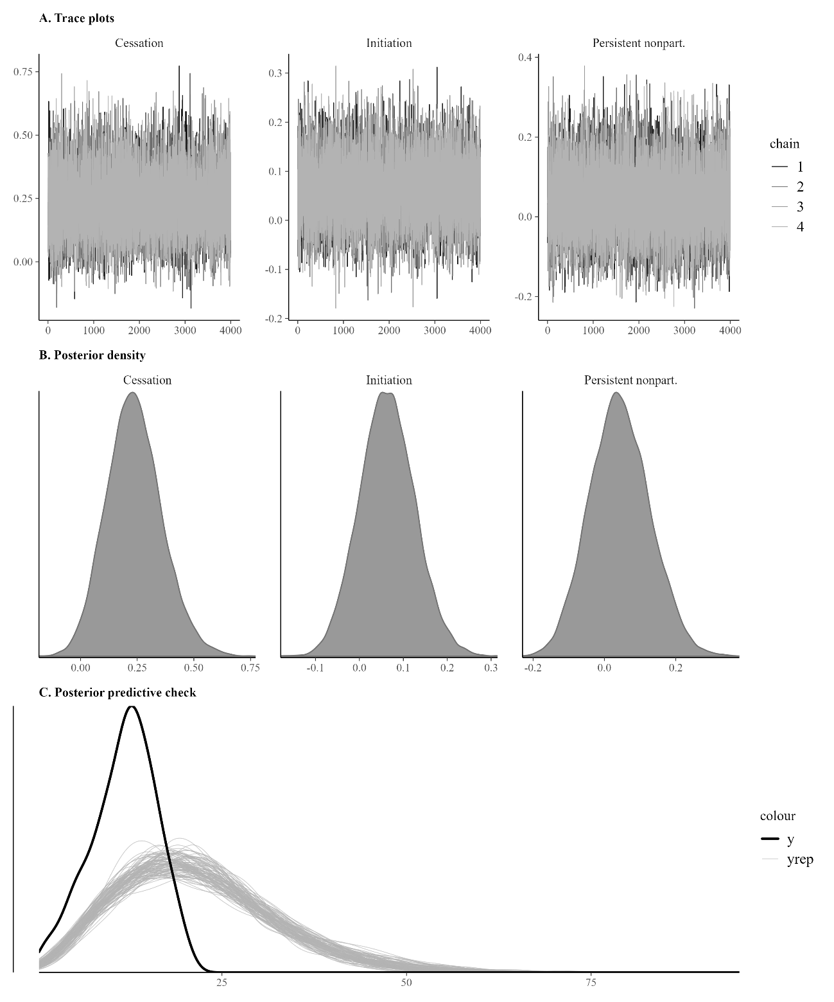
Supplementary Figure 1. Markov chain Monte Carlo diagnostic plots for the Bayesian Weibull cause-specific hazard model (Model 3, imputation 1).
(A) Trace plots for the exposure coefficients (cessation, initiation, and persistent nonparticipation vs. continuation), showing adequate mixing across four chains with 6,000 iterations (2,000 warmup). (B) Posterior density plots for the same coefficients. (C) Posterior predictive check comparing the distribution of observed follow-up times (uncensored observations) with 100 replicated datasets drawn from the posterior predictive distribution. All chains converged satisfactorily (R-hat range: 1.000 to 1.001; minimum effective sample size ratio: 0.363; zero divergent transitions).
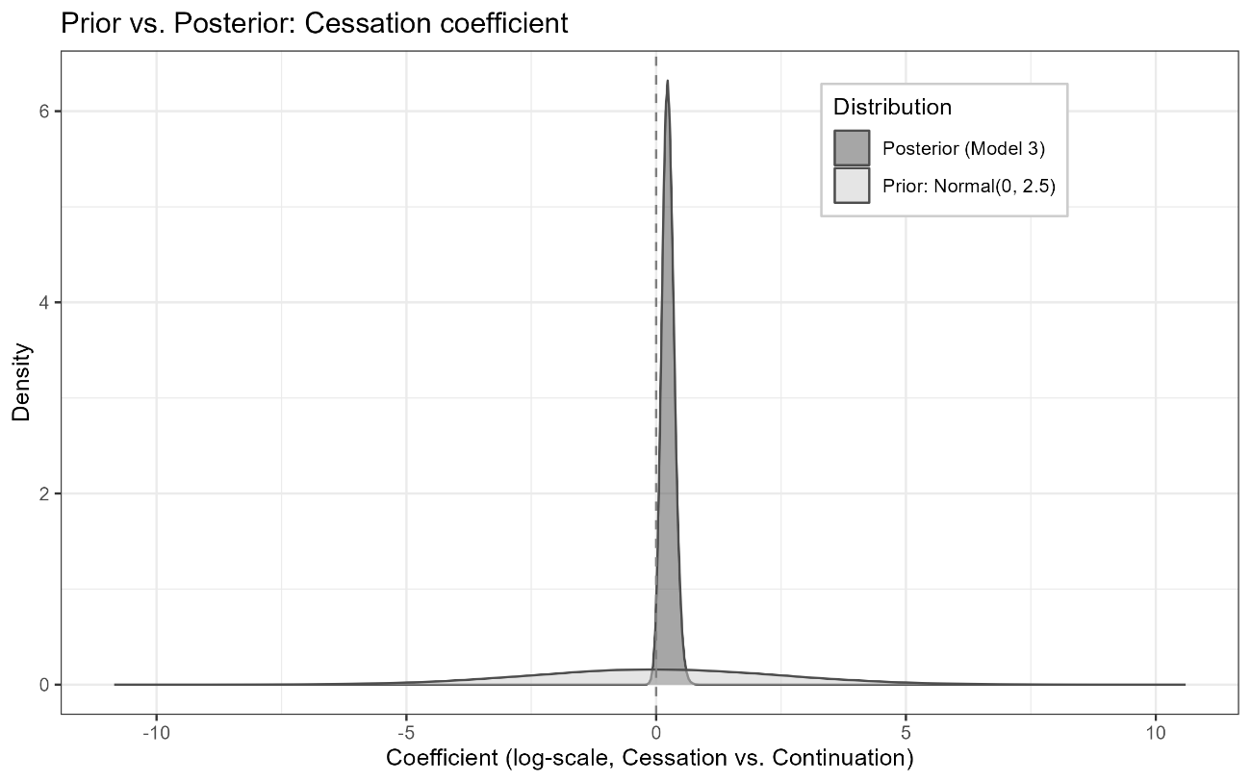
Supplementary Figure 2. Prior and posterior distributions of the regression coefficient for cessation of social activity participation (vs. continuation) in the Bayesian Weibull cause-specific hazard model for incident dementia (Model 3, fully adjusted).
The light-shaded density represents the weakly informative prior distribution (Normal(0, 2.5)), and the dark-shaded density represents the posterior distribution pooled across 20 multiply imputed datasets (320,000 draws). The dashed vertical line indicates the null value of zero (hazard ratio = 1 on the exponentiated scale). The posterior distribution is concentrated to the right of zero, with a posterior probability of 98.3% that the hazard ratio exceeds 1.

