Supporting Information
Biodegradable reduce expenditure bioreactor for augmented sonodynamic therapy via regulating tumor hypoxia and inducing pro-death autophagy
Weijuan Zou^{1,2†}, Junnian Hao^{1†}, Jianrong Wu^{1*} , Xiaojun Cai¹, Bing Hu¹, Zhigang Wang², and Yuanyi Zheng^{1,2,3*}

* Correspondence: wujr_028@126.com, zhengyuanyi@sjtu.edu.cn
† These authors contributed equally to this work.
¹ Department of Ultrasound in Medicine, Shanghai Institute of Ultrasound in Medicine, Shanghai Jiao Tong University Affiliated Sixth People's Hospital, Shanghai, 200233, P. R. China
² Chongqing Key Laboratory of Ultrasound Molecular Imaging, Ultrasound Department of the Second Affiliated Hospital of Chongqing Medical University, Chongqing, 400010, P. R. China
³ State Key Laboratory of Oncogenes and Related Genes, School of Medicine, Shanghai Jiao Tong University, Shanghai, 200233, P. R. China

Additional details on experimental section
Materials
3-bromopyruvic acid (3BP), cetyltrimethylammonium chloride (CTAC) and 3-aminopropyltriethoxysilane (APTES) were purchased from the Aladdin Reagent Co. (Shanghai, China). Hematoporphyrin monomethyl ether (HMME) was provided by Yuanye Biological Technology Co. (Shanghai, China). 1,3-diphenylisobenzofuran (DPBF), N-hydroxy succinimide (NHS) and 1-ethyl-3-(3-dimethylaminopropyl) carbodiimide (EDC) were obtained from Sigma-Aldrichh (MO, USA). Triethanolamine (TEA), tetraethyl orthosilicate (TEOS) and bis(3-triethoxysilylpropyl) disulfide (BTDS) were purchased from Macklin Reagent Co. (Shanghai, China). Glutathione (GSH), fluorescein isothiocyanate (FITC) and MDC staining assay kit were purchased from Solarbio. (Beijing, China). Cell counting kit-8 (CCK-8), 2, 2, 6, 6-tetramethylpiperidine oxide (TEMP), Calcein-AM/PI cell double dyeing kit (Dojindo, C542), mitochondrial membrane potential detection kit JC-1 (JC-1) and DAPGreen-autophgy were obtained from Dojindo Laboratories (Japan). Reactive oxygen species assay kit, ATP luminescence assay kit and Annexin V-FITC apoptosis detection kit were provided by Beyotime Biotechnology Co. (Shanghai, China). hematoxylin and eosin (H&E), Ki67, dUTP nick-end labeling (TUNEL) and dihydroethidium (DHE) were obtained from Servicebio Co. (Hubei, China). LC3 and HIF-1α primary antibody were provided by Abcam Trading Co. (Shanghai, China).
Characterization
The structure and morphology of nanoparticles were characterized by transmission electron microscope (TEM, JEOL JEM 2100F). The fourier transform infrared (FTIR) spectra were measured on a Perkin Elmer Frontier (Perkin Elmer Frontier, USA). Malvern Zetasizer Nanoseries (Malvern, UK) was used to measure the zeta potential and size distributions. The pore size and specific surface area were recorded by the automatic specific surface and porosity analyzer (BET, McASAP2460, USA). UV-vis-NIR absorption spectra were recorded on a UV-vis-NIR spectrophotometer (Perkin Elmer, USA). The HMONs was placed in GSH solution (10 mM) for different time and the changes of structure and morphology were observed by TEM.
Cell lines and cell culture
HUVECs (human umbilical vein endothelial cells), 4T1 cells (murine breast cancer cells), A375 cells (Human malignant melanoma cells), A549 cells (Human adenocarcinoma alveolar basal epithelial cells) were purchased from Cell Resource Center (Institute of Life Sciences, Chinese Academy of Sciences). Cells were cultured in DMEM high glucose medium supplemented with 10% FBS and 0.1% penicillin–streptomycin at 37 °C, in a humidified 5% CO₂ atmosphere.
In vitro cell uptake of HHBP
To obtain FITC-conjugated HHBP, HHBP (60 mg) and FITC (10 mg) was dispersed in 20 mL of ethanol. The mixtures were then stirred overnight at room temperature. The products were obtained by centrifugation, washed with ethanol and redispersed with PBS for further use.
4T1 cells were seeded into 12-well plates (1 × 10⁵ cells per well) and incubated with FITC labeled HHBP (150 µg/mL) for 1, 2, 4 and 8 h. The cells were treated by with or without US irradiation (1.0 W/cm², 1.0 MHz, 50% duty circle, 1 min), respectively. Then, the cells were washed three times with PBS, followed by fixing with 4% paraformaldehyde for 15 min. The cell nucleus was stained by DAPI for 5 min. All the fluorescence images were acquired by laser scanning confocal microscopy (CLSM, Nikon, Japan). Correspondingly, the quantitative analysis of intracellular fluorescence of FITC was further measured by flow cytometry (BD Accuri C6).
In vitro cytotoxicity assay
The biosafety of HMONs-PEG was evaluated through detecting the viability of different cells, including HUVECs, 4T1 cells, A375 cells and A549 cells by a CCK-8 assay. After incubated with different concentrations of HMONs-PEG for 24 h, the cells were washed the cells with PBS for three times, and then added into the medium (100 μL) containing CCK-8 reagent (10 μL) for another 2 h incubation. Finally, the absorbance at 450 nm was detected by a microplate analyzer.
In vitro ROS production at cellular level
DCFH-DA was served as a probe to detect intracellular ROS generation. Briefly, 4T1 cells were incubated into 12-well plates at a density of 1 × 10⁵ cells overnight. Subsequently, the cell medium was replaced and the cells were treated with different formulations including PBS, HMME@HMONs-PEG, HHBP for another 4 h. Then, the cells were further exposed to US irradiation (1.0 W/cm², 1.0 MHz, 50% duty circle, 1 min). Then, the cells were incubated with DCFH-DA (1:1000 dilution) for 30 min according to the provided protocols. The cells were washed three times with PBS and then imaged by fluorescence microscope. Finally, cells were collected and the quantitative analysis of fluorescence intensity was analyzed by flow cytometry.
In vitro nanotherapeutic performance of HHBP
4T1 cells were seeded into 96-well plates at a density of 1 × 10⁴ cells and treated with PBS, HMME@HMONs-PEG or HHBP for 4 h. Then, part of the cells were further exposed to US irradiation (1.0 W/cm², 1.0 MHz, 50% duty circle, 1 min). After incubated for a total time of 12 h, the cells were washed with PBS for three times and the cell viability was measured by the CCK-8 assay. Correspondingly, all the treated cells were digested with trypsin and stained by Calcein-AM/PI Cell Double Dyeing Kit according to the instructions. After incubation for 15 min, the cells were visualized under a fluorescence microscope. Next, cell apoptosis apoptosis detection assay was also carried out to further investigate the cell death mechanism. 4T1 cells were seeded in 6-well plates for 24 h and then treated as the same procedure in the CCK-8 assay. Then, the cells were washed with PBS and collected by centrifugation, and then treated with Annexin V-FITC apoptosis detection kit, and finally quantitated by flow cytometer (FACS-Calibur, BD Biosciences).
Detection of HIF-1α and HK-Ⅱ by western blot assay
The expression of HIK-2 and HIF-α in cells was evaluated by Western blot assay. The BCA protein concentration determination kit was used to measure the protein concentration, and the specific method was referred to the kit instructions. Briefly, the 4T1 cells were inoculated into 6-well plates (2 × 10⁵ cells per well) and incubated with PBS, HMME@HMONs-PEG (100 µg/mL) or HHBP (100 µg/mL) for 4 h. Then, part of the cells were further exposed to US irradiation (1.0 W/cm², 1.0 MHz, 50% duty circle, 1 min). After incubated for a total time of 6 h, cell lysates with protease inhibitor are added to extract the proteins. The proteins were separated by sodium dodecyl sulfate polyacrylamide gel electrophoresis (10%) and then transferred to polyvinylidene fluoride membrane (Millipore, IPVH00010). The membrane was decolorized and sealed with 5% skim milk (0.5%TBST) on a shaker for 1 h. The primary antibodies (HIF-1α (1:2000 dilution, Abcam, ab16066) and HK-Ⅱ (1:5000 dilution, Abcam, ab227198)) was diluted and incubated overnight at 4 ℃, and then the membranes were washed with TBST for three times and hybridized with relevant secondary antibody for 1 h. Finally, the film was observed by chemiluminescence. The protein expression and the band strength was quantified using Image Pro Plus 6.0 software. β-actin is served as a loading control. Each treatment had three parallel samples, and the data were expressed as mean ± standard deviation (n = 3).
Detection of cellular mitochondrial membrane potential
Mitochondrial membrane potential detection kit (JC-1) was used as a probe to detect the changes of intracellular mitochondrial membrane potential. In brief, 4T1 cells with respective treatments (as mentioned in section of “In Vitro Nanotherapeutic Performance of HHBP”) were collected and then stained with JC-1 (1:5000 dilution) for 45 min according to the specification. After that, the cells were washed three times with PBS and the fluorescence images were acquired by fluorescence microscope.
Detection of intracellular autophagy
For the Western blot assay, 4T1 cells with respective treatments were lysed and the protein was extracted. The expression of P62 and LC3 in the cells after different treatments were measured by Western blot assay with the protocols as mentioned in section of “Detection of HK-Ⅱ and HIF-1α by Western Blot Assay”.
For the MDC staining assay, MDC and DAPGreen-Autophgy were used to observe intracellular autophagy. 4T1 cells seeded into confocal petri dish (1 × 10⁵ cells per well) and treated as the procedure as-mentioned in the CCK-8 assay. After that, the cells were stained with MDC or DAPGreen-autophgy according to the specification, and then washed three times with PBS. The fluorescence images indicated the LC3 dots from different treatments were acquired by fluorescence microscope.
Next, TEM was used to observe intracellular autophagosomes. 4T1 cells with respective treatments were scraped off with a cell scraper and centrifuged. Then,the cells were collected and fixed with glutaraldehyde solution (2.5%) for 1 h. After that, the fixed solution was poured out and the sample was rinsed with PBS (pH 7.0) for three times. After fixing with 1% osmium acid solution for another 2h, the autophagosomes in these cell sections were observed by TEM after dehydration, embedding, secting and staining.
Detection of intracellular ATP level
ATP luminescence assay kit was used to determinate the ATP level . 4T1 cells seeded into 6-well plates (2 × 10⁵ cells per well) and cultured overnight. The cells were treated as the procedure as-mentioned in the CCK-8 assay. Then, the cells were harvested and the levels of intracellular ATP were measured using an ATP luminescence assay kit according to the according to the specifications. The luminescent signals were measured by a luminometer.
Animals and tumor model
Healthy female BALB/c nude mice (4-6 weeks) were provided by the Animal Center of Shanghai Sixth People's Hospital. All animal experiments were conducted under the protocols approved by the Institutional Animal Care and Use Committee (IACUC) of Shanghai Jiao Tong University Affiliated Sixth People's Hospital (Animal Welfare Ethics acceptance number No: DWLL2020-0582). The 4T1 cell subcutaneous tumor model was established by subcutaneously injecting 100 μL of 2 × 10⁶ cells suspension into female nude mice. The body weight of the mice was monitored and the tumor volume (V) was calculated as V = 0.5 × L × W², where L and W represented the length and width of the tumor respectively.
In vivo fluorescence imaging
ICG-loaded HHBP nanoparticles were prepared to evaluate the biodistribution of HHBP. 4T1 tumor bearing nude mice were intravenously injected with ICG-loaded HHBP nanoparticles (1.85 mg/kg equivalent ICG, 100 μL). At time points of 0, 0.5, 4, 8, 12, 16, and 24 h post-injection, the fluorescence imaging was conducted at by using a in vivo imaging system (VISQUE, invivo Elite). Then, the mice were sacrificed, and the major organs (e.g., heart, liver, spleen, lung, and kidney) and tumors were collected for ex vivo imaging under the same conditions.
In vivo antitumor assays
When the tumor size reached 150 mm³, the mice were randomly divided into five groups (n = 6): I) PBS, II) HMME@HMONs-PEG, III) HHBP, IV) HMME@HMONs-PEG + US, V) HHBP + US. Mice were intravenously injected with 100 μL HMME@HMONs-PEG (HMME: 8 mg/kg) or HHBP (HMME: 8 mg/kg, 3BP: 3.4 mg/kg), respectively. The parameters of US irradiation are as follows: 1.5 W/cm², 1.0 MHz, 50% duty circle for 5 min. Mice were administrated drugs and irradiated at day 1 and 4. After 12 h of treatments, tumor blocks of mice were taken out and frozen at -20 °C for DHE staining to detect ROS, HIF-1α staining to measure the extent of tumor hypoxia, and LC3 staining to detect autophagy level. After treatments, the tumor-bearing nude mice were sacrificed and the tumor tissues were collected for H&E, Ki67, and TUNEL staining. Additionally, the major tissues were also dissected to make paraffin sections for further H&E staining.
In vivo toxicity evaluation
The healthy ICR mice were euthanized at 3th day, 7th day, and 14th day (six mice at each group) after injected with 100 μL of HHBP (HMME:8 mg/kg, 3BP: 3.4 mg/kg). In addition, untreated ICR mice were served as control group. Blood samples were collected for routine blood analysis and serum biochemical tests.

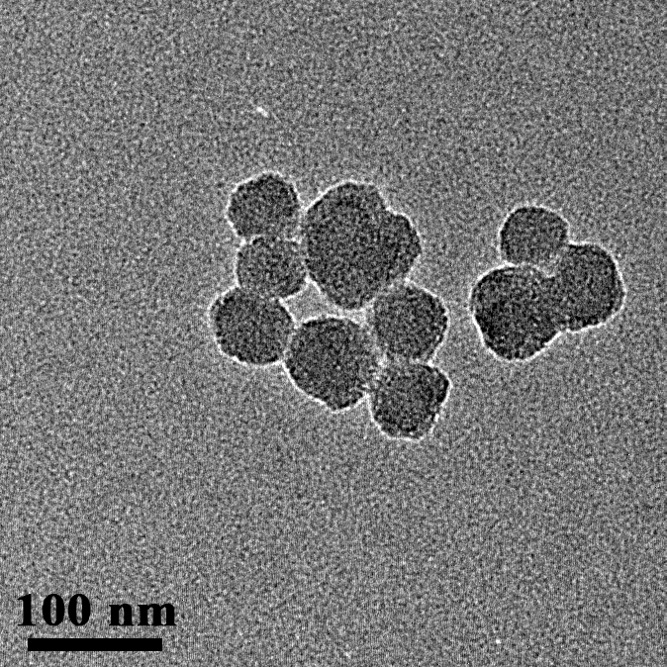
Fig. S1. TEM images of SiO₂@MONs nanoparticles.

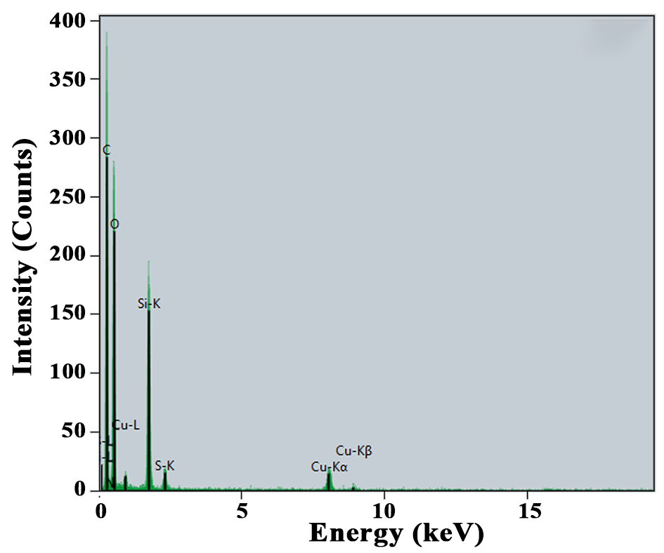
Fig. S2. EDS spectrum of the prepared HMONs.

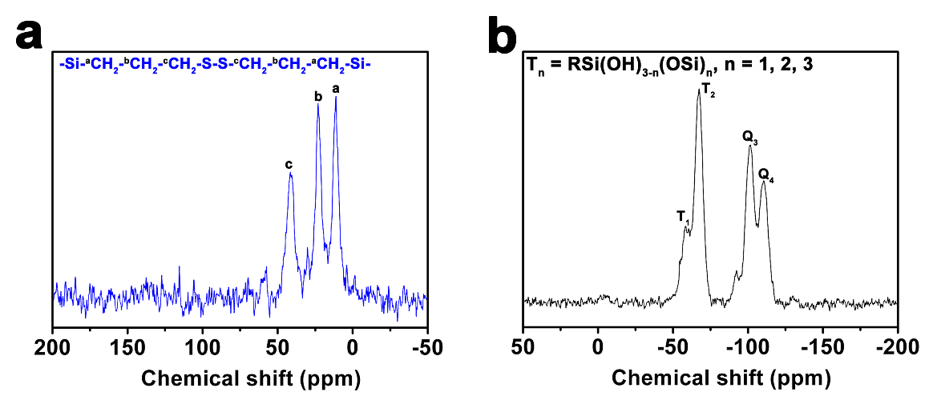
Fig. S3. a ¹³C and b ²⁹Si NMR spectra of HMONs nanoparticles.

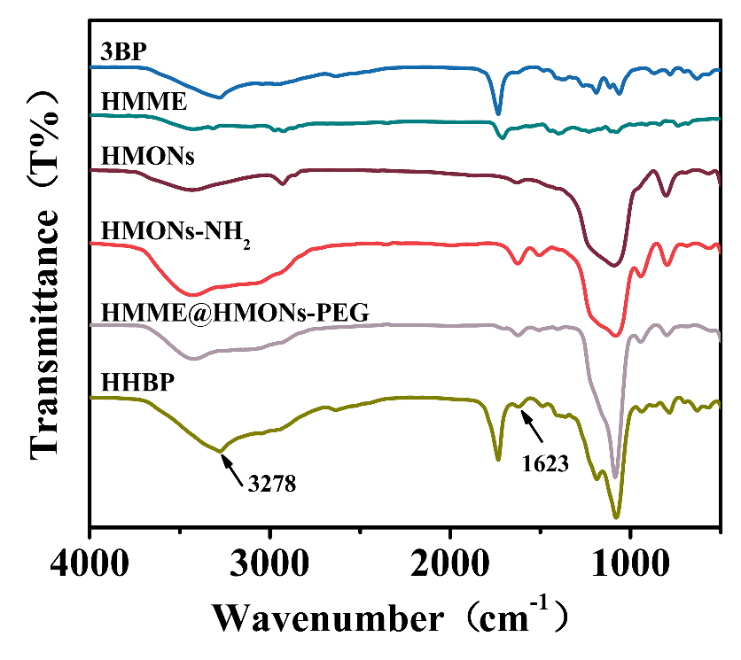
Fig. S4. FT-IR spectra of 3BP, HMME, and different HMONs-based nanoparticles.

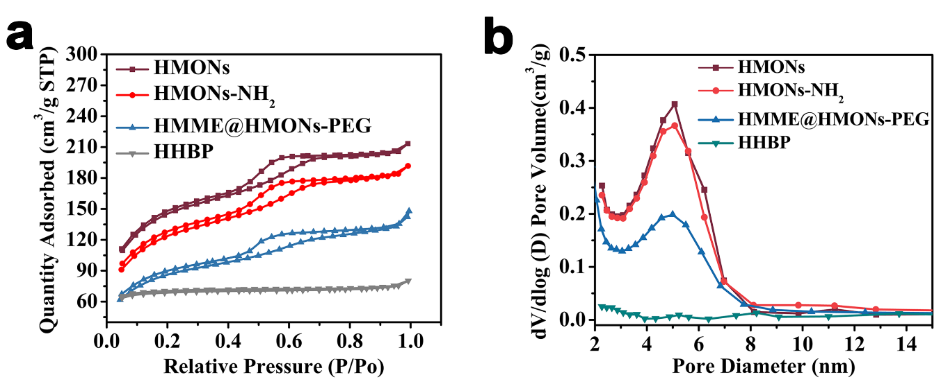
Fig. S5. a N₂ adsorption-desorption isotherm and b pore-size distribution of HMONs, HMONs-NH₂, HMME@HMONs-PEG, and HHBP nanoparticles.

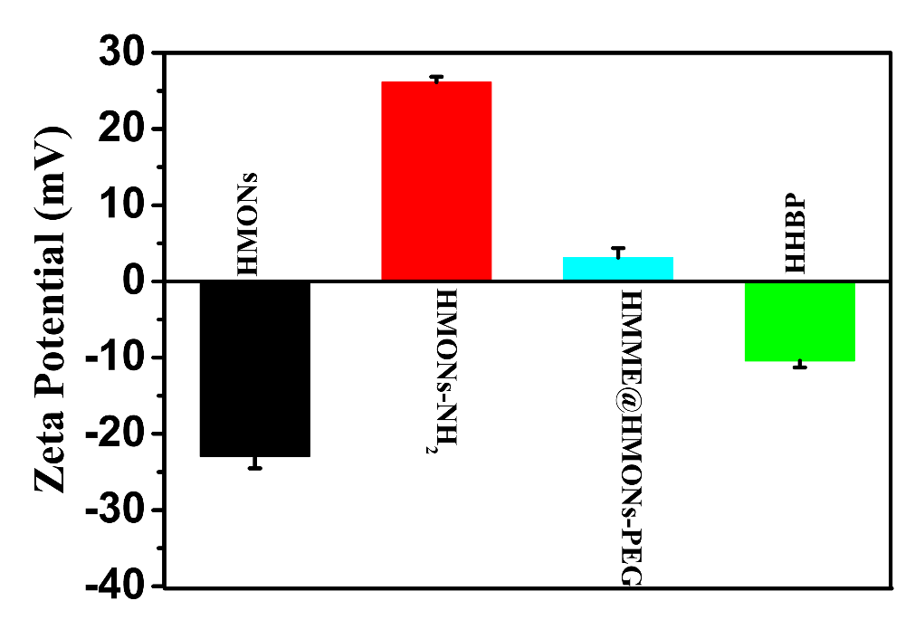
Fig. S6. zeta potentials of HMONs, HMONs-NH₂, HMME@HMONs-PEG, and HHBP aqueous solution after fresh preparation.

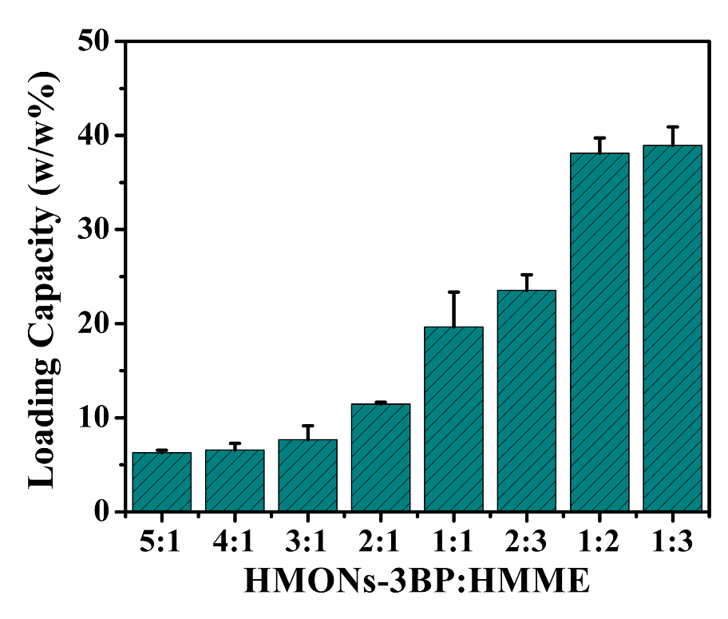
Fig. S7. HMME loading capacities on HMONs-3BP-PEG NPs (w/w%) with diffrent HMONs-3BP/HMME feeding ratios (n = 3).

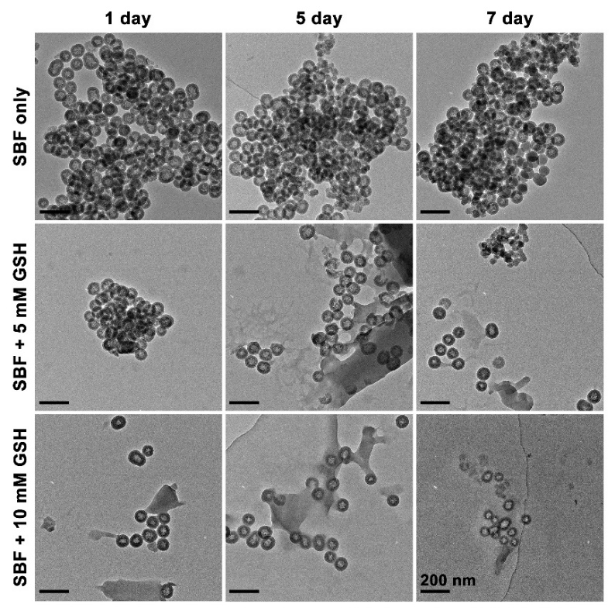
Fig. S8. TEM images of HHBP dispersed in SBF at varied GSH concentrations (0, 5, and 10 mM) for 1, 5, and 7 days.

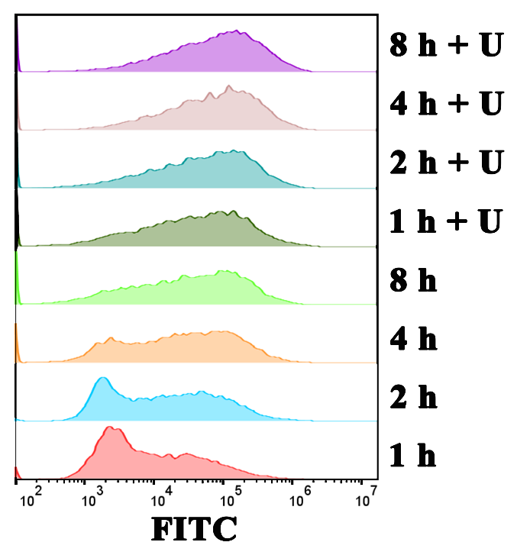
Fig. S9. Flow cytometry analyses of 4T1 cells incubated with FITC-conjugated HHBP for 1, 2, 4, and 8 h without or with US irradiation.

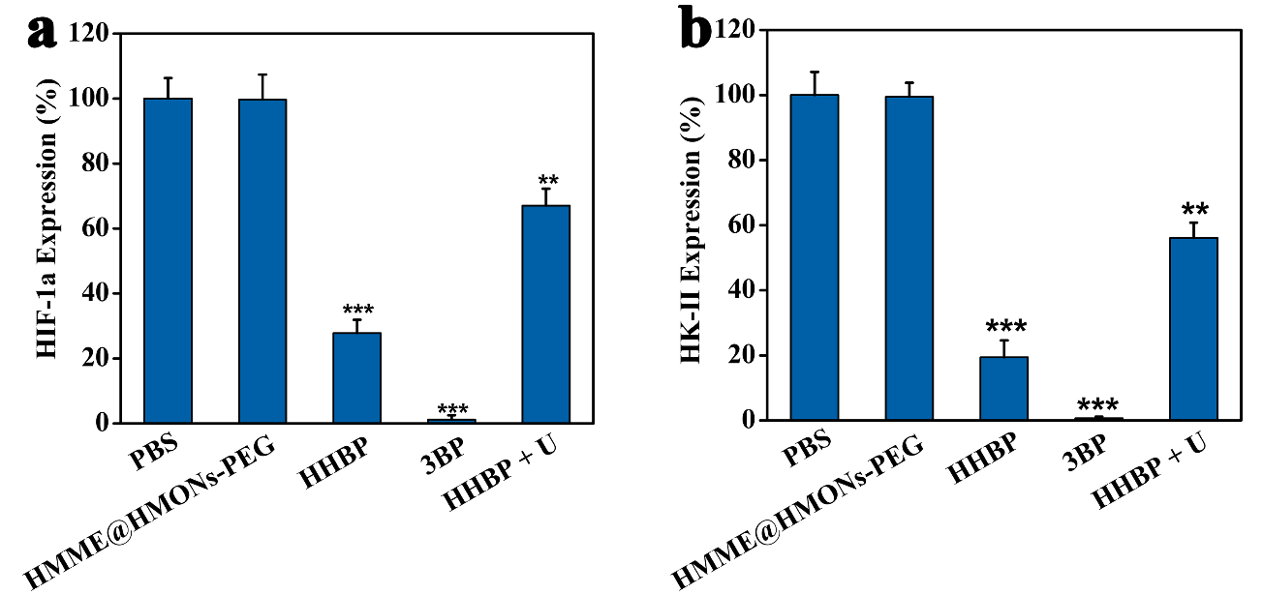
Fig. S10. Quantitative determination of the relative HIF-1α a and HK-Ⅱ b expression from Western blotting results (see Fig. 2c). β-Actin was used as a loading control was used as a loading control. **P < 0.01, ***P < 0.001. Error bars indicate standard deviation (n = 3).

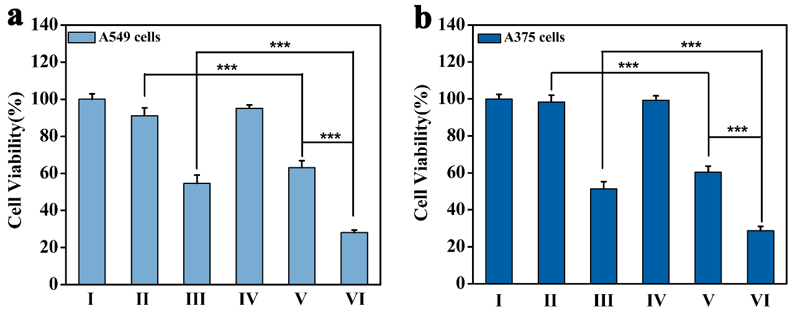
Fig. S11. Relative viabilities of a A549 and b A375 cells after different treatments, quantified by CCK-8 assay (n = 6). ***P < 0.001.

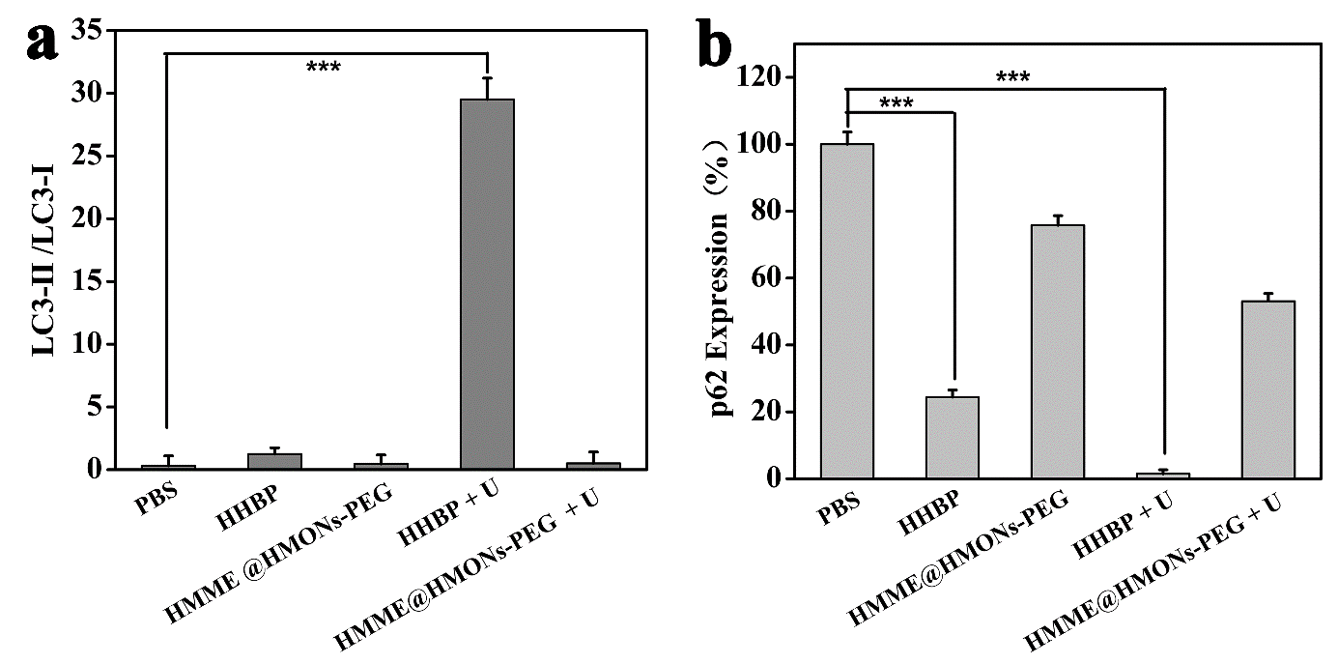
Fig. S12. Quantitative analysis of LC3-II/LC3-I a and relative p62 b expression after different treatments from Western blotting results (see Fig. 3d). ***P < 0.001. Error bars indicate standard deviation (n = 3).

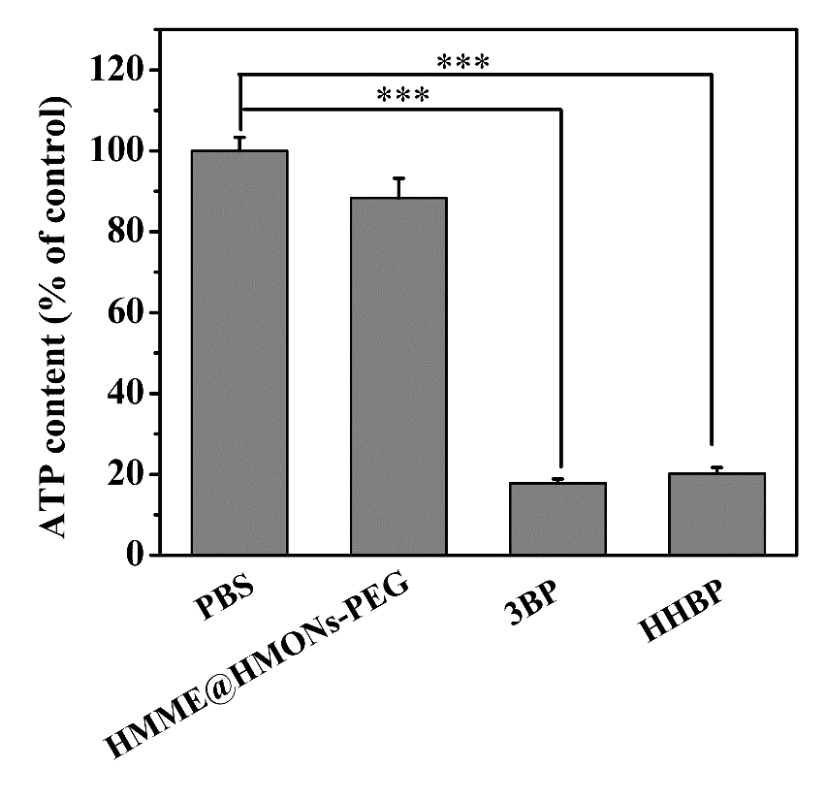
Fig. S13. ATP levels in 4T1 cells after different treatments. The data are shown as mean ± SD (n = 3).

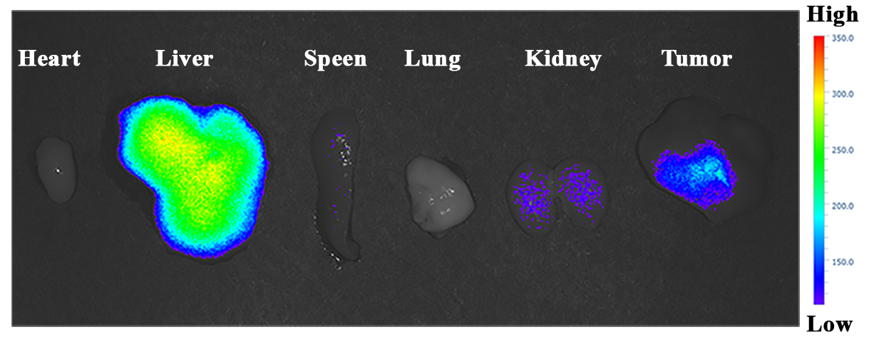
Fig. S14. Ex vivo fluorescence imaging of the tumor and the major organs including liver, spleen, kidney, heart, and lung, collected from the mice at 24 h post-injection.

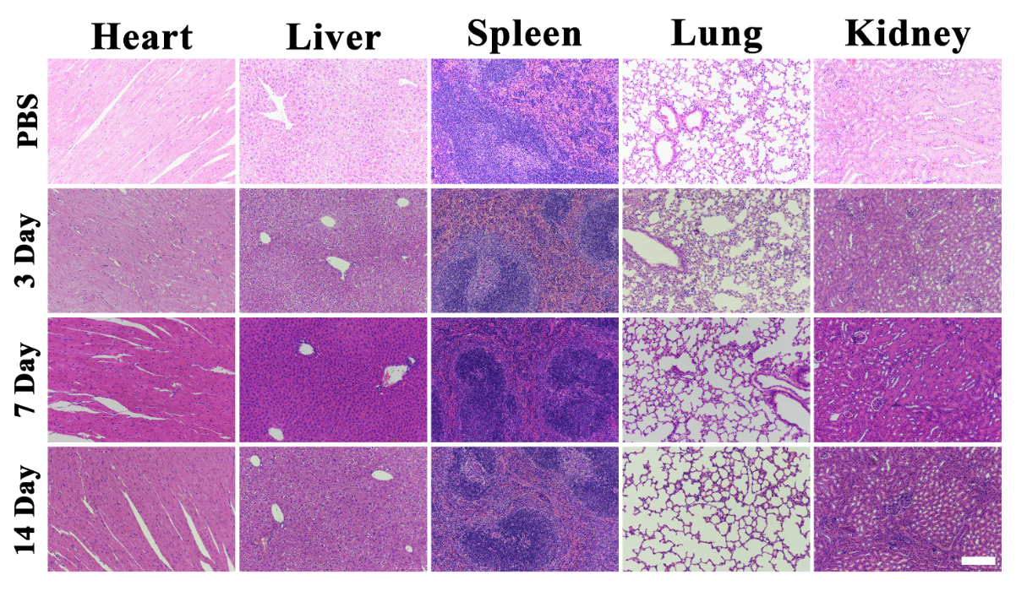
Fig. S15. H&E stained histological images of major organs (heart, liver, spleen, lung, and kidney) from mice treated with PBS versus HHBP. Scale bar: 200 μm.

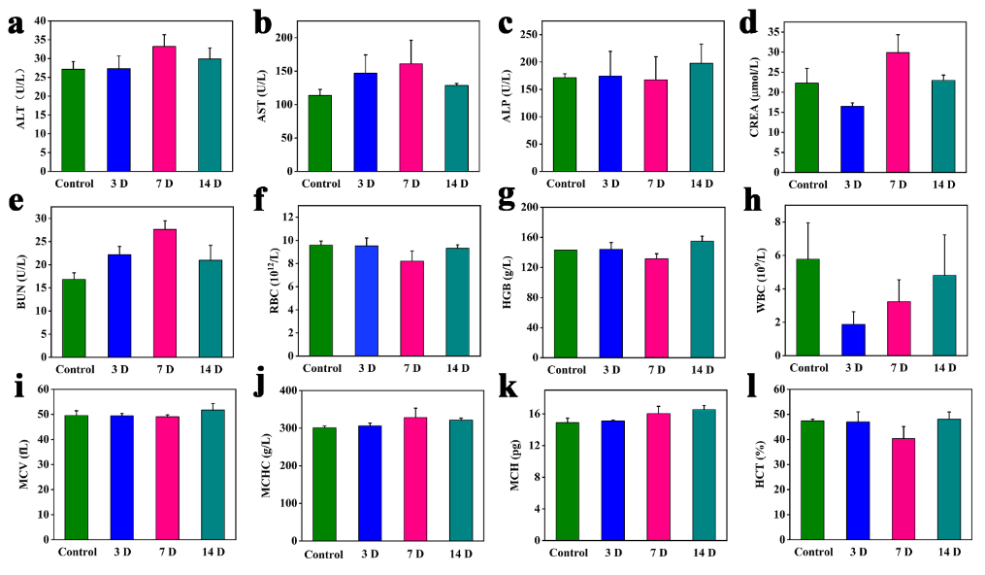
Fig. S16. Blood biochemistry and hematology data of Balb/c mice treated with HHBP at different time point after i.v. injection. a Alanine aminotransferase (ALT), b Aspartate aminotransferase (AST), c Alkaline phosphatase (ALP), d Creatinine (CREA), e Urea nitrogen (BUN), f Red blood cells (RBC), g Hemoglobin (HGB), h White blood cells (WBC), i Mean corpuscular volume (MCV), j Mean corpuscular hemoglobin concentration (MCHC), k Mean corpuscular hemoglobin (MCH), and l hematocrit (HCT).

