Tables
Table 1

Sample | Total reads | Longest read | Average read length | Mapped to human transcriptome | Mapped to Chadox1 nCoV-19 (E1 region in 293) | ChAdOx1 nCoV-19 mapped reads as a percentage of human mapped reads (E1 region in 293)
MRC5 mock | 987,540 | 23,008 | 1,607 | 836,380
MRC5 24hpi | 633,046 | 23,426 | 1,600 | 578,180 | 6,190 | 1.07
MRC5 48hpi | 903,254 | 32,925 | 1,549 | 810,640 | 13,547 | 1.67
MRC5 72hpi | 1,020,009 | 26,592 | 1,552 | 758,197 | 9,723 | 1.28
A549 mock | 1,171,427 | 17,654 | 1,270 | 844,383
A549 24hpi | 1,411,415 | 22,536 | 1,381 | 1,243,531 | 3,255 | 0.26
A549 48hpi | 1,771,635 | 25,111 | 1,287 | 1,356,800 | 3,194 | 0.24
A549 72hpi | 1,790,983 | 19,641 | 1,312 | 1,486,051 | 2,620 | 0.18
293 24hpi | 1,013,425 | 31,829 | 1,482 | 768,842 | 109,197 (+1,014) | 14.20 (+0.13)

Read counts for individual dRNAseq datasets.
The total number of reads, longest read and average read length is noted for each dataset. In addition, the table details how many reads mapped to the human transcriptome list, the ChAdOx1 nCoV-19 genome and (in the case of HEK293 cell dataset) the E1/pIX region from human adenovirus type 5 known to be cloned into the cell line. Also shown is the percent contribution of the mapped reads relative to the total number of reads analysed. In the case of reads mapping to the ChAdOx1 nCoV-19 genome from the HEK293 cell experiment, the figures in brackets refer solely to reads mapping to the adenovirus type 5 sequences.

Table 2

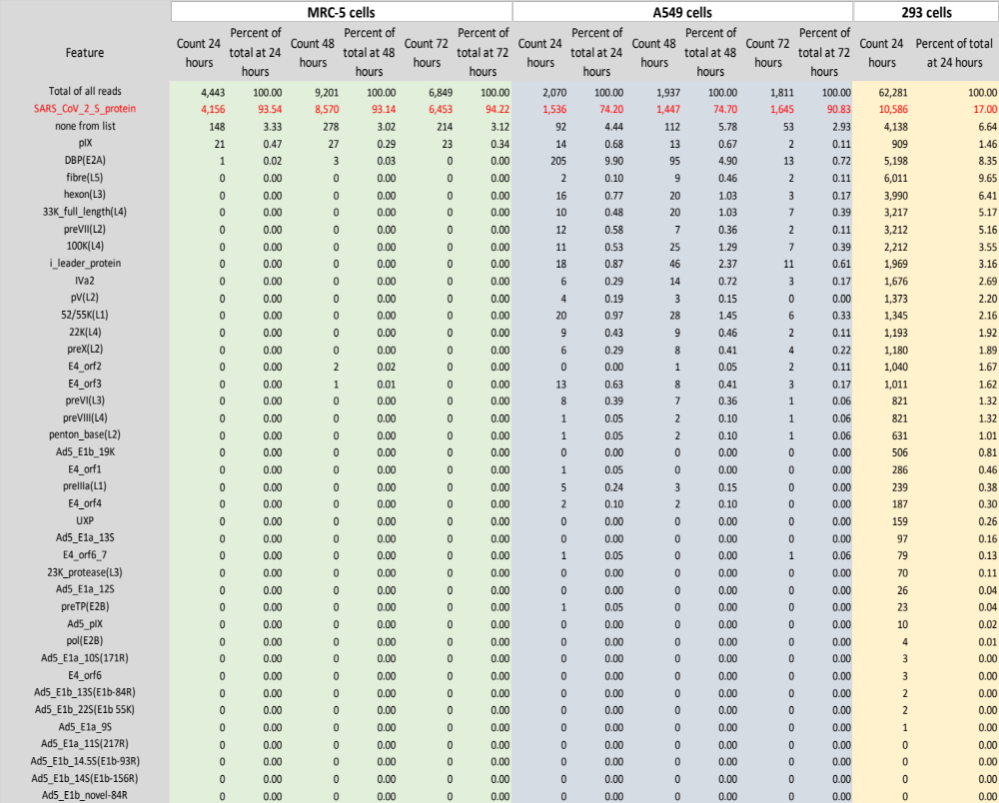

List of ORFs searched for and the transcript frequency for each ORF
This table details how many transcripts would code for each indicated ORF from the ChAdOx1 nCoV-19 genome or ORFs coded by the region of Ad5 integrated into the HEK293 cell line. The “total of all reads” row indicates how many transcripts map to either the ChAdOx nCoV-19 genome or the region of human Ad5 integrated into the HEK 293 genome. The “none from list” row indicates how many transcripts did map but the pipeline was unable to correlate the 5’ most ORF on that transcript with any of the known ORFs form the genomes under consideration.

Table 3

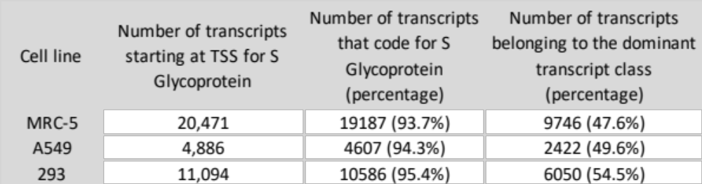

Counts of transcripts arising from the expected transcription start site for S glycoprotein transcripts and their assignment.
This table details numbers of transcripts which map to the expected transcription start site for the major S glycoprotein transcript at 1700nt. For each cell line the counts are the accumulated numbers of transcripts at all the time points examined and the numbers (and percentage) of transcripts that should code for the S glycoprotein as the 5’ most ORF.

Table 4
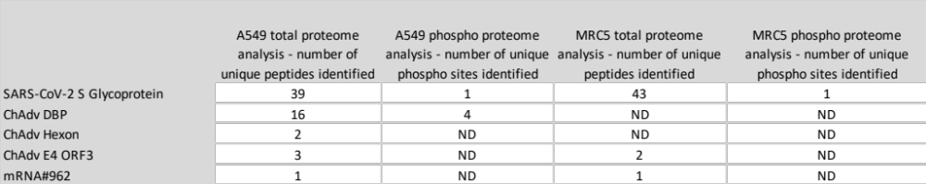

Peptides identified as derived from ChAdOx1 nCoV-19 in each cell line used
The table lists the number of unique peptides identified and unique phosphorylation sites identified for the proteins listed. ND indicates that none were detected in that sample, ChAdv indicates a protein from the ChAdOx1 viral vector backbone and mRNA#962 indicates the truncated S glycoprotein coded by this single transcript.

