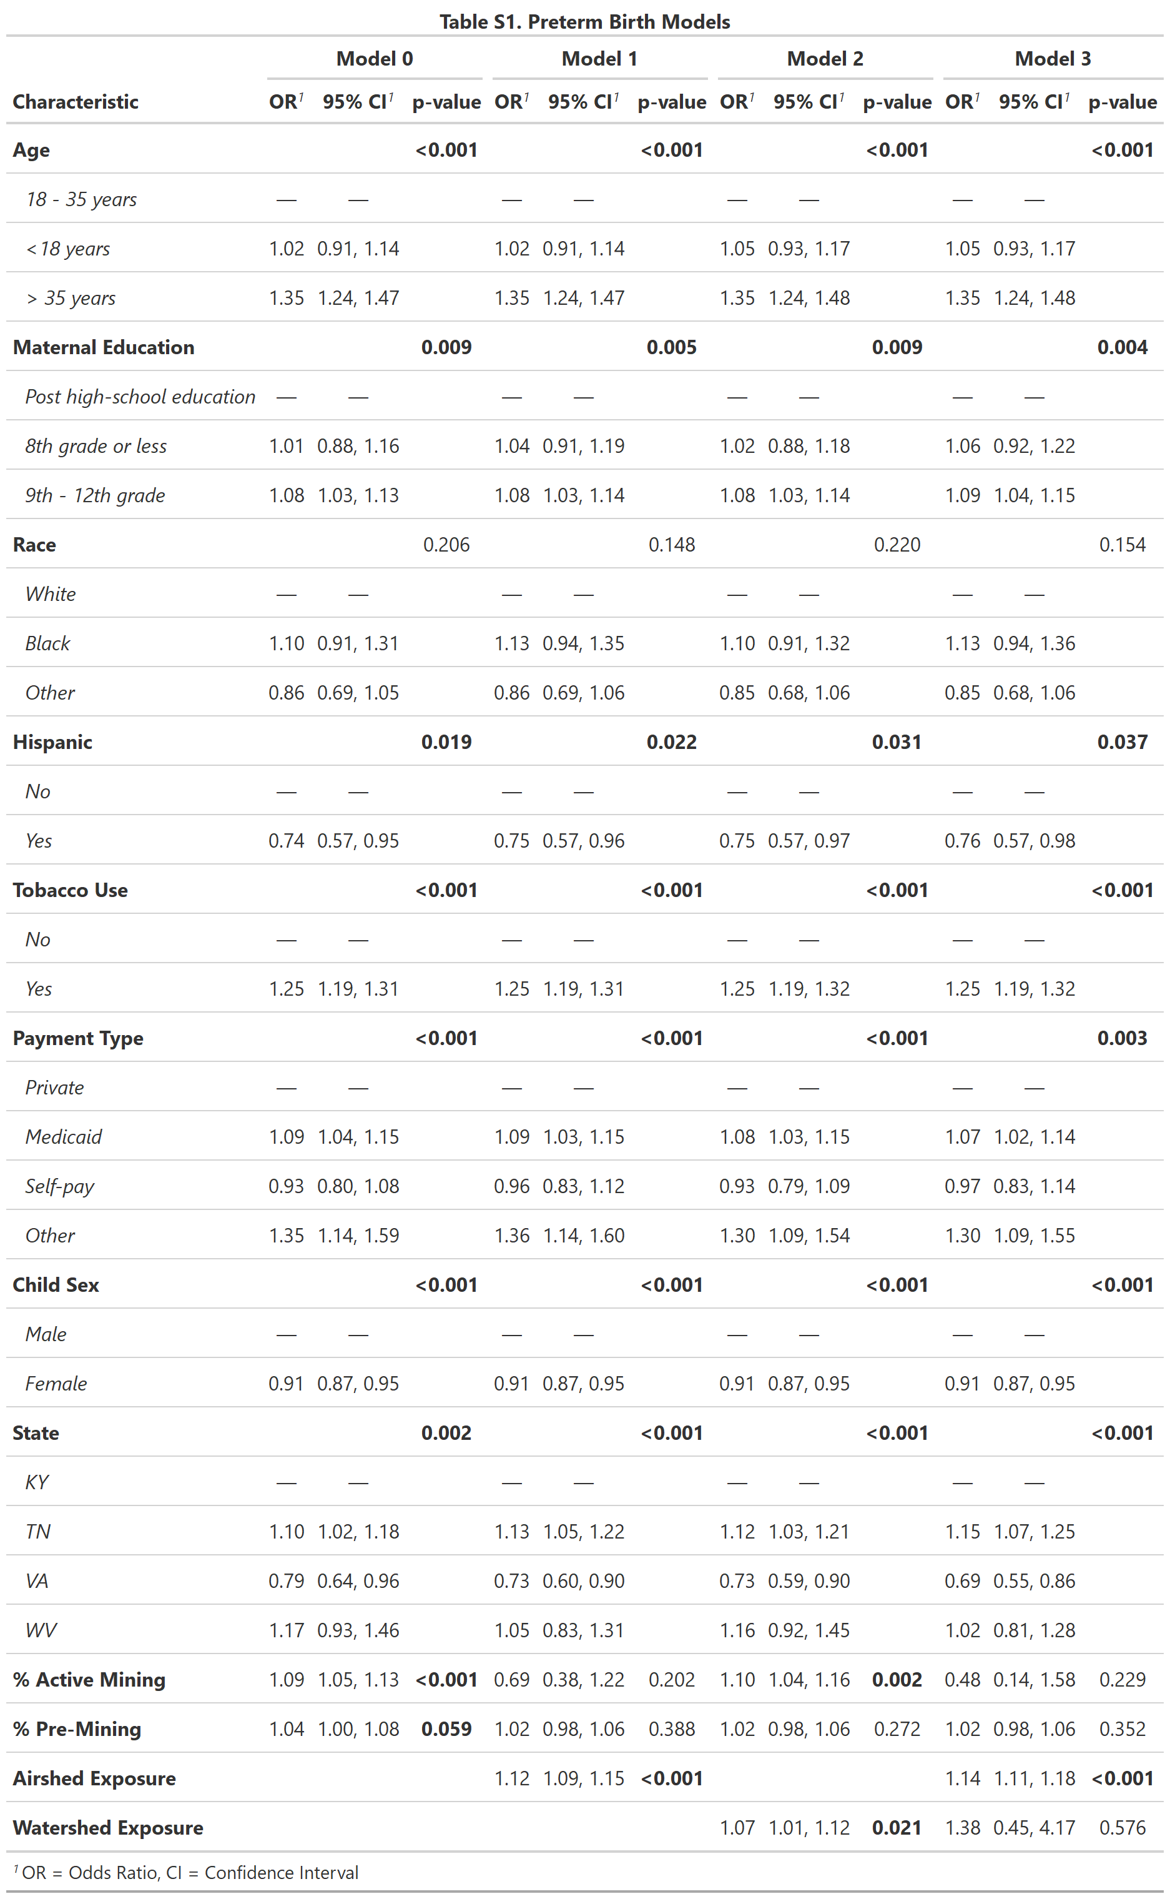
Supplemental Information

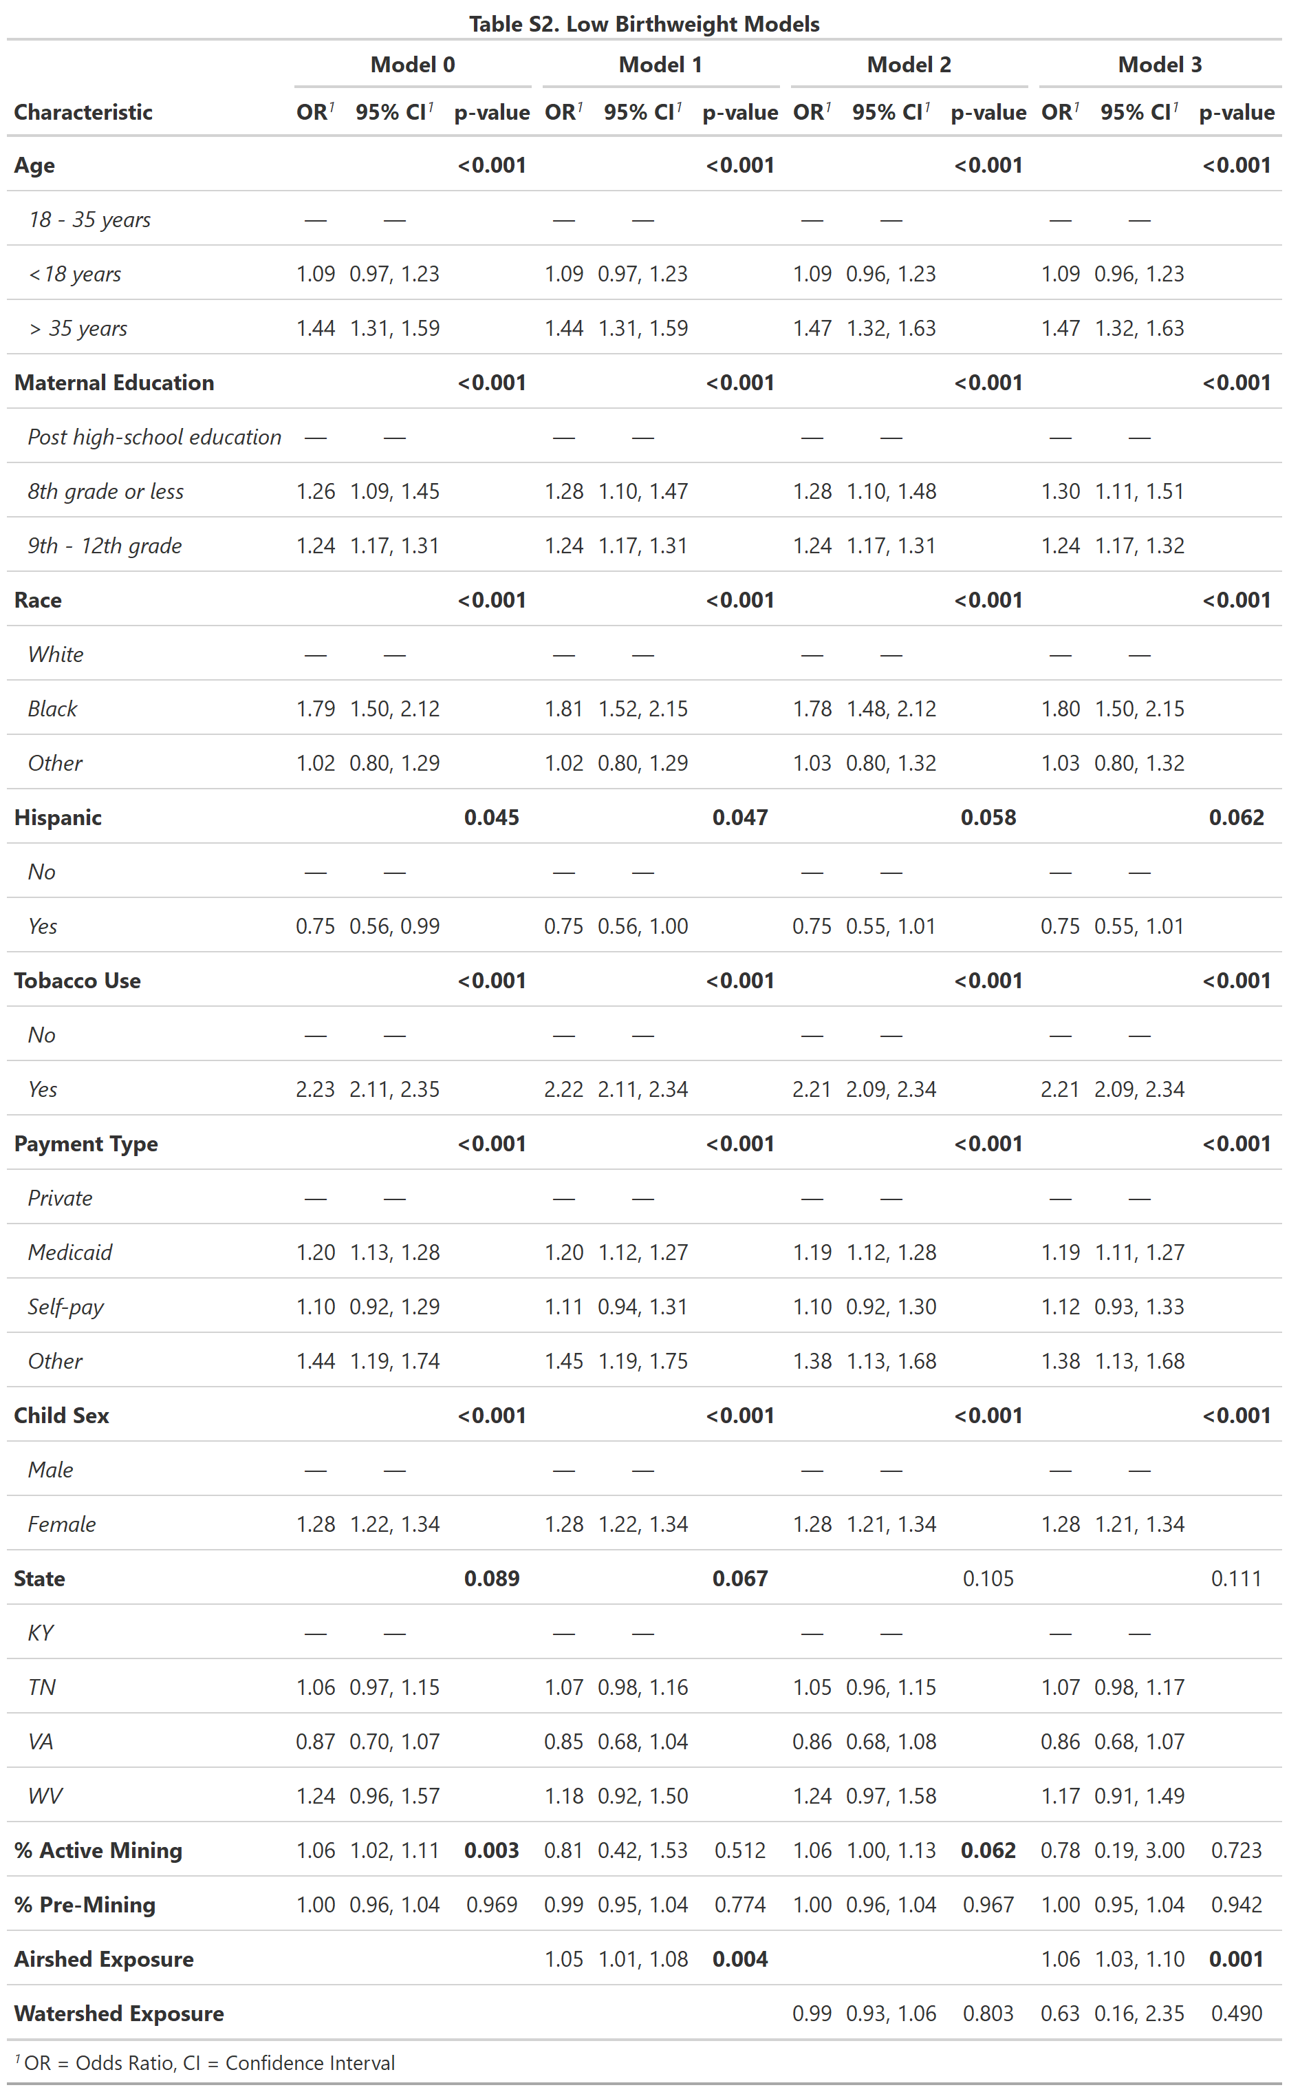
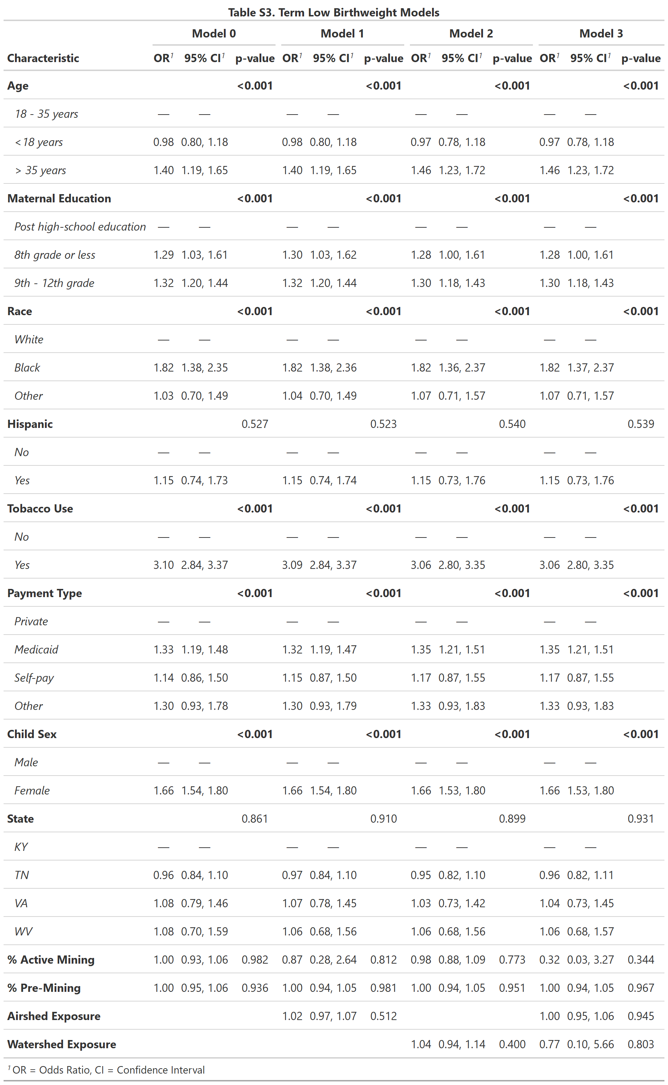

Table S4. Model validation statistics
 | RMSE | MAE | McFadden’s Psuedo-R² | AIC
Preterm birth
Model 0 | 3.38 | 2.0002 | 0.007 | 62347
Model 1 | 3.39 | 2.0001 | 0.008 | 62284
Model 2 | 3.38 | 2.0003 | 0.007 | 56513
Model 3 | 3.39 | 2.0001 | 0.008 | 56456
Low birthweight
Model 0 | 4.08 | 2.0016 | 0.032 | 50959
Model 1 | 4.09 | 2.0018 | 0.033 | 50954
Model 2 | 4.08 | 2.0018 | 0.032 | 46153
Model 3 | 4.09 | 2.002 | 0.032 | 46149
Term low birthweight
Model 0 | 7.37 | 2.0058 | 0.052 | 24109
Model 1 | 7.37 | 2.0059 | 0.052 | 24112
Model 2 | 7.35 | 2.0052 | 0.052 | 21880
Model 3 | 7.35 | 2.0049 | 0.052 | 21887

Table S5. Participant characteristics by exposure status. Obtained from Buttling et al., 2021.²²
 | No Mining Within 5km | Active Mining Within 5km
 | n=170,351 | n=23,733
Mother’s State of Residence
Kentucky | 149,652(87.8%) | 19,711(83.1%)
Tennessee | 10,215(6.0%) | 1,279(5.4%)
Virginia | 3,195(1.9%) | 1,533(6.5%)
West Virginia | 7,289(4.3%) | 1,210(5.1%)
Child’s Sex
Male | 87,776(51.5%) | 12,279(51.7%)
Female | 82,575(48.5%) | 11,454(48.3%)
Mother’s Race
White | 165,163(97.0%) | 23,258(98.0%)
Black | 2,747(1.6%) | 275(1.2%)
Other | 2,441(1.4%) | 200(0.8%)
Mother’s Age (years)
18-35 | 153,784(90.3%) | 21,566(90.9%)
<18 | 7,765(4.6%) | 1,058(4.5%)
>35 | 8,802(5.2%) | 1,109(4.7%)
Previous Births
0 | 74,310(43.6%) | 10,403(43.8%)
1 | 57,750(33.9%) | 8,202(34.6%)
2 | 25552(15.0%) | 3,567(15.0%)
3 | 8,192(4.8%) | 1,066(4.5%)
4 or more | 4,547(2.7%) | 495(2.1%)
Mother’s Education (years)
<9 | 6,458(3.8%) | 607(2.6%)
9-12 | 95,633(56.1%) | 13,729(57.8%)
>12 | 68,260(40.1%) | 9,397(39.6%)
Reported Tobacco Use During Pregnancy
No | 119,868(70.4%) | 15,962(67.3%)
Yes | 50,483(29.6%) | 7,771(32.7%)
Payment
Medicaid | 53,957(31.7%) | 9,320(39.3%)
Private Insurance | 27,801(16.3%) | 4,213(17.8%)
Self-Pay | 2,729(1.6%) | 195(0.8%)
Other | 1,182(0.7%) | 198(0.8%)
NA | 84,682(49.7%) | 9,807(41.3%)
Mother’s Hispanic Origin
Not Hispanic | 157,789(92.6%) | 22,116(93,2%)
Hispanic | 1,913(1.1%) | 100(0.4%)
NA | 10,649(6.3%) | 1,517(6.4%)
Dependent variables
Preterm birth | 15,803(9.3%) | 2,303(9.7%)
Low birthweight | 11,928(7.0%) | 1,747(7.4%)
Term low birthweight | 4,357(2.6%) | 665(2.8%)

