Supplemental Information

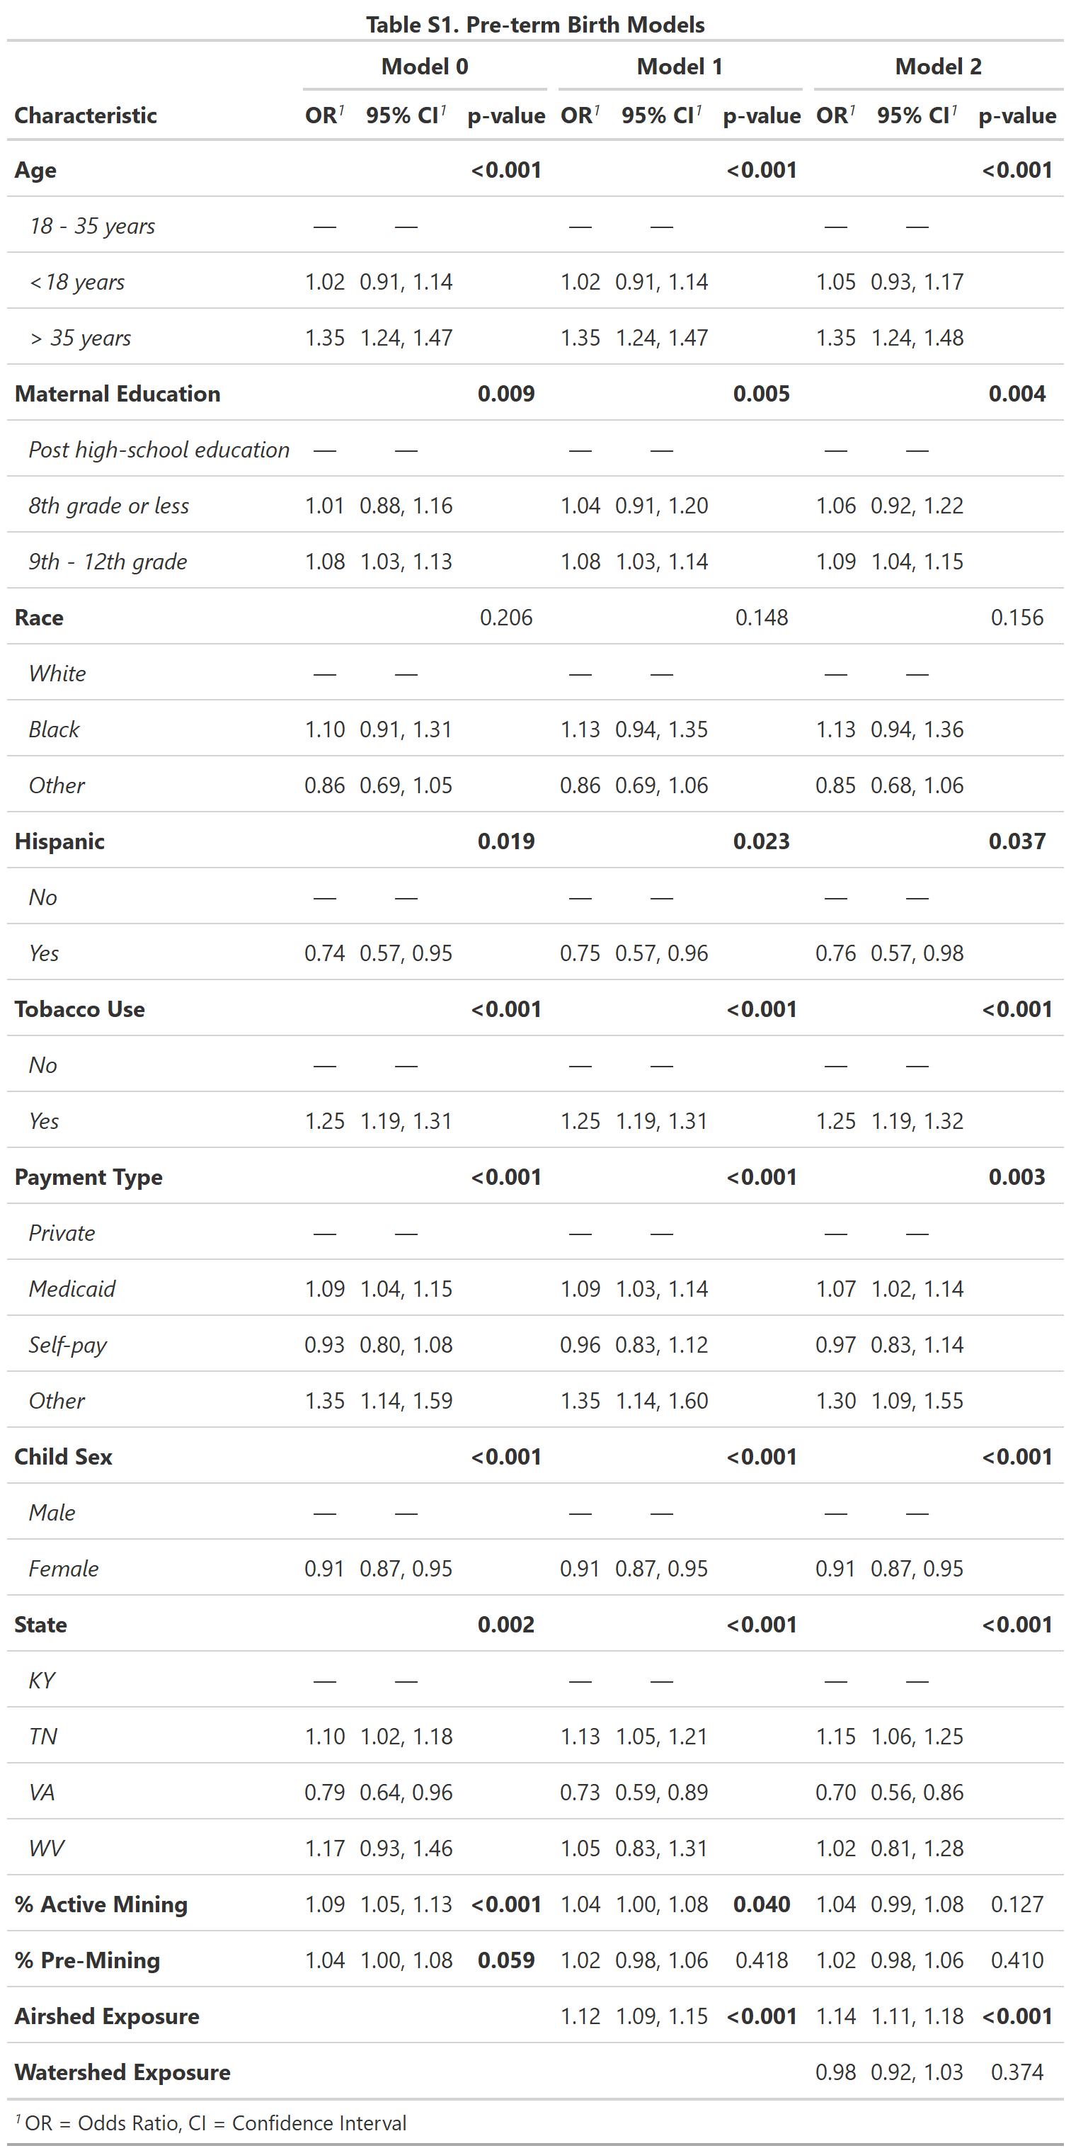
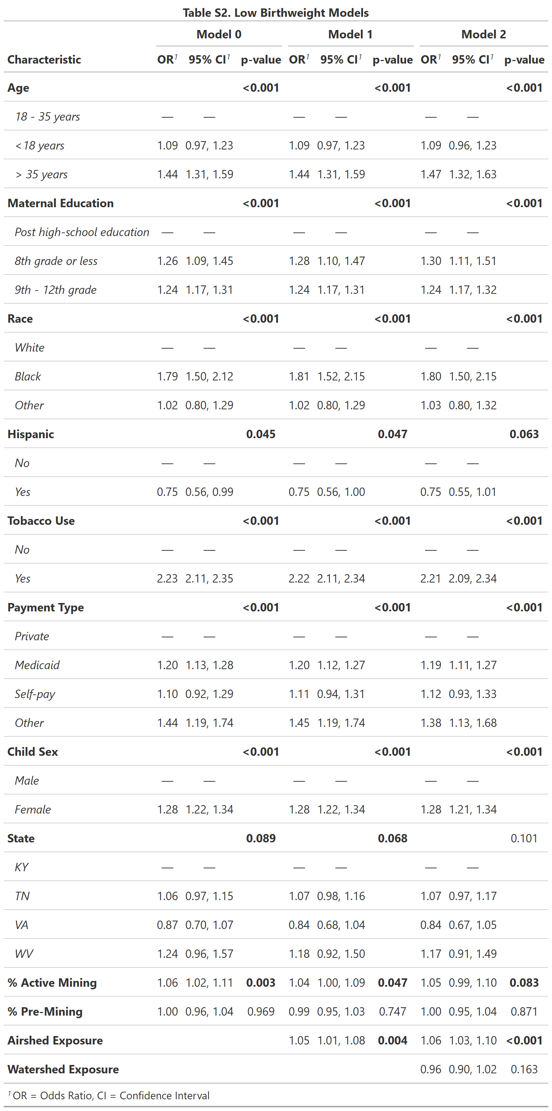

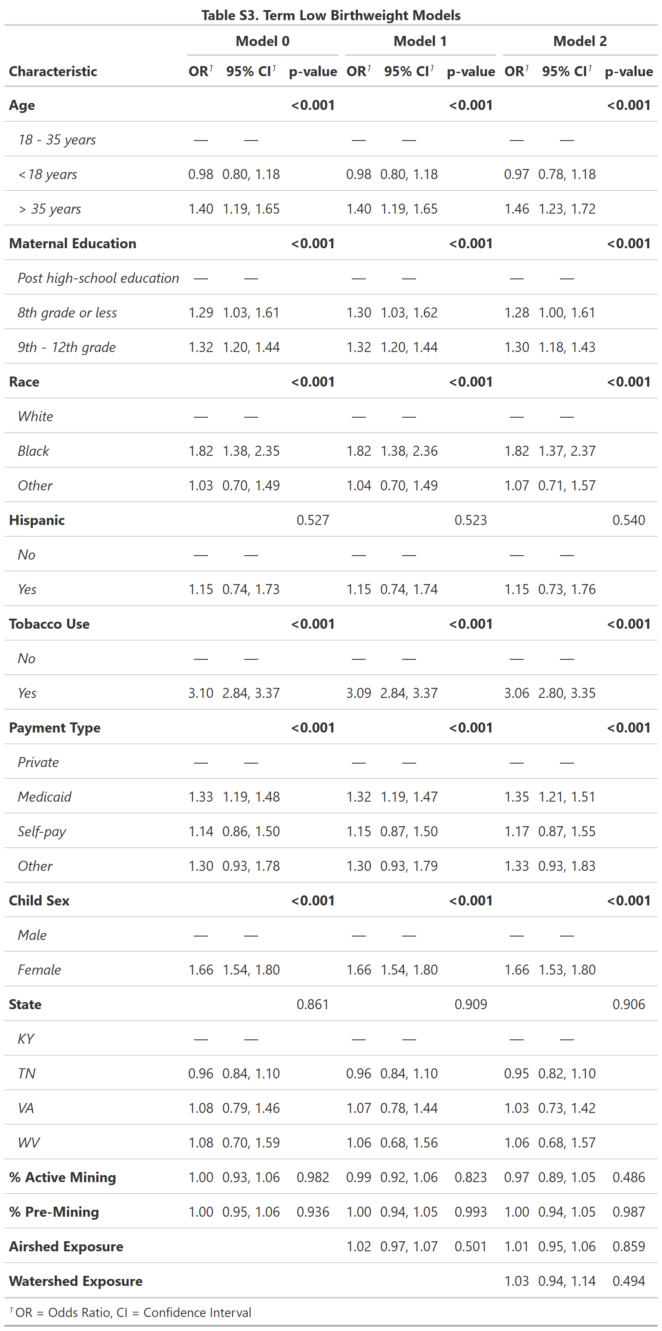
Table S4. Model validation statistics
 | RMSE | MAE | McFadden’s Psuedo-R² | AIC
Preterm birth
Model 0 | 3.382 | 2.0002 | 0.0067 | 62347
Model 1 | 3.390 | 2.0001 | 0.0077 | 62284
Model 2 | 3.392 | 2.0002 | 0.0081 | 56450
Low birthweight
Model 0 | 4.083 | 2.0016 | 0.0325 | 50959
Model 1 | 4.086 | 2.0018 | 0.0326 | 50952
Model 2 | 4.086 | 2.002 | 0.0323 | 46142
Term low birthweight
Model 0 | 7.368 | 2.0058 | 0.0524 | 24109
Model 1 | 7.370 | 2.006 | 0.0524 | 24110
Model 2 | 7.350 | 2.0052 | 0.0517 | 21880

