Supplementary Information

Achieving Paris climate goals calls for increasing ambition of the Kigali Amendment.
S1. History of the hydrochlorofluorocarbon (HCFC) phaseout and amendments under the Montreal Protocol
- 1987 Montreal Protocol – non-Article 5 (non-A5) countries begin phasing out chlorofluorocarbons (CFCs) in 1993 and reduce total Ozone Depleting Substances (ODS) consumption to 50% of 1986 levels by 1998.
- 1990 London Amendment – 100% phaseout of CFCs and other harmful ODS is set at 2000 for non-A5 countries (mostly industrialized countries) and 2010 for Article 5 (A5) countries (mostly developing countries).
- 1992 Copenhagen Amendment - CFCs, halons, carbon tetrachloride, and methyl chloroform be completely phased out in non-A5 countries by 1996. First controls for HCFCs established:
  - Non-A5 - required to freeze consumption of HCFCs in 1996 at 1989 baseline levels (the sum of 1989 HCFC consumption + 3.1% of 1989 CFC consumption for Non-A5 parties); 35% reduction in 2004; 65% reduction in 2010; 90% reduction in 2015; 99.5% reduction in 2020; 100% reduction in 2030¹.
  - A5 - No control measure for A5 Parties were adopted but Parties agree to decide by 1996 on the baseline and control schedule for A5 parties.
- 1995 Vienna Meeting of the Parties²
  - Non-A5 - The non-A5 consumption baseline calculation was adjusted from 3.1% to 2.8% of 1998 CFC consumption for non-A5 parties.
  - A5 - A5 Parties required to freeze HCFC consumption by 2016, with a 2015 baseline, with a one-step 100% phaseout in 2040.
- 1997 Montreal Amendment (MOP-9)– Phaseout of HCFCs is established for A5 countries.
- 1999 Beijing Amendment (MOP-11)- Phaseout of HCFC is accelerated for developed countries to start ten years earlier.
  - Non-A5 - Non-A5 production baseline set as the average of the sum of 1989 HCFC consumption + 2.8% of 1989 CFC consumption and the sum of 1989 HCFC production + 2.8% of 1989 CFC production. Non-A5 countries have a production freeze in 2004 with no reduction steps.
  - A5 - A5 production baseline set as the average of HCFC production and consumption in 2015.
- 2007 Montreal Amendment (MOP- 19) - Accelerated phaseout of HCFCs for A5 and non-A5 countries.
  - Non-A5 – Third phaseout step (65% in 2010) was strengthened to 75% reduction.
  - A5 - A5 baseline was amended to the average of 2009-2010 consumption and freeze in 2013; 10% reduction in 2015; 35% reduction in 2020; 67.5% reduction in 2025; 100% reduction in 2030 with a servicing allowance of 2.5% average per annum until 2040. A5 production baseline was harmonized with the accelerated consumption baseline and phaseout.
S2. HFC phase-down under the Kigali amendment to the Montreal Protocol
The Kigali Amendment (KA) to the Montreal Protocol agreed upon in October 2016 and which entered into force on 1 January 2019 is a global agreement to phase down and almost eliminate the consumption of HFCs by 2050³. So far, 122 signatories have ratified the Kigali Amendment to the Montreal Protocol on phasing down HFCs worldwide, as of 15 august 2021⁴. The KA defines HFC phase-down schedules for four different Party groups. The first group (Group 1) includes 136 primarily developing countries that make up all Article 5 countries as specified under the Montreal Protocol with the exception of Bahrain, India, Iran, Iraq, Kuwait, Oman, Pakistan, Qatar, Saudi Arabia, and the United Arab Emirates (UAE). These ten countries are characterized by high ambient air temperatures and make up a second and separate group (Group 2) of Article 5 countries. Countries specified as non-Article 5 countries under the Montreal Protocol are primarily developed countries and under the KA divided into two separate groups with 45 countries in a first group and with the five countries Belarus, the Russian Federation, Kazakhstan, Tajikistan and Uzbekistan forming a separate second group as shown in Table S1. We will hereafter refer to these four Party groups as Article 5 (Group 1), Article 5 (Group 2), non-Article 5 (earlier start), and non-Article 5 (later start). The HFC phase-down steps for each country group are summarised in Fig. S2.
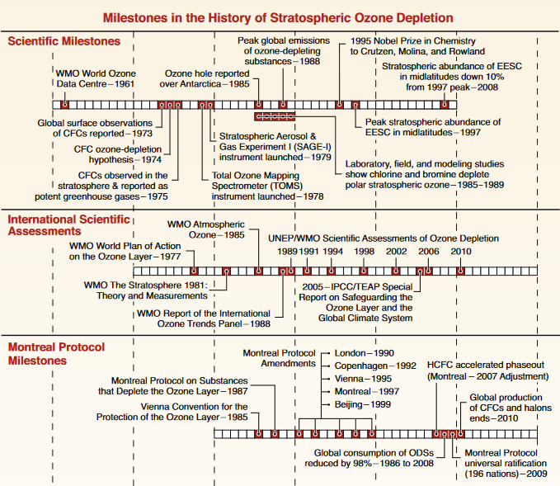
Fig S1. Major milestones in the history of stratospheric ozone depletion^{5,6}
Table S1. Baseline and HFC phase-down schedule of Article-5 and non- Article-5 Parties³
 | Article 5*, Group 1** |  | Article 5, Group 2⁺
Baseline Years | 2020, 2021 & 2022 |  | 2024, 2025 & 2026
Baseline calculation | Average production /consumption of HFCs in 2020, 2021, and 2022  plus 65% of HCFC baseline production/consumption |  | Average production /consumption of HFCs in 2024, 2025, and 2026  plus 65% of HCFC baseline production/consumption
Reduction steps  Freeze | 2024 |  | 2028
Step 1 | 2029 | 10% | 2032 | 10%
Step 2 | 2035 | 30% | 2037 | 20%
Step 3 | 2040 | 50% | 2042 | 30%
Step 4 | 2045 | 80% | 2047 | 85%
 | Non-Article 5, earlier start |  | Non-Article 5, later start ⁺⁺
Baseline Years | 2011, 2012 & 2013 |  | 2011, 2012 & 2013
Baseline calculation | Average production /consumption of HFCs in 2011, 2012 & 2013  plus 15% of HCFC baseline production/consumption |  | Average production /consumption of HFCs in 2011, 2012 & 2013  plus 25% of HCFC baseline production/consumption
Reduction steps  Step 1 | 2019 | 10% | 2020 | 5%
Step 2 | 2024 | 40% | 2025 | 35%
Step 3 | 2029 | 70% | 2029 | 70%
Step 4 | 2034 | 80% | 2034 | 80%
Step 5 | 2036 | 85% | 2036 | 85%
* Article 5 and non-Article 5 parties are defined within the Montreal Protocol based on their annual calculated level of consumption of any controlled substance per capita. Those that exceed this level of annual calculated consumption are classified as non-Article 5 and those that do not exceed it as Article 5 parties.
**Group 1: Article 5 parties not part of Group 2
⁺ Group 2: Bahrain, India, the Islamic Republic of Iran, Iraq, Kuwait, Oman, Pakistan, Qatar, Saudi Arabia and the United Arab Emirates
⁺⁺ For Belarus, Russian Federation, Kazakhstan, Tajikistan, Uzbekistan, 25% HCFC component of baseline and different initial two steps (1) 5% reduction in 2020 and (2) 35% reduction in 2025

Table S2. Cumulative HFC emissions and mitigation potential in different scenarios for the period (2018-2050)

Scenario | Cumulative HFC emissions  (Gt CO₂eq) | Cumulative HFC mitigation potential  (Gt CO₂eq)
Baseline scenario | 92.5
KA scenario | 32.2 | 60.3
A5 harmony scenario | 30.0 | 62.5
95% scenario | 31.0 | 61.4
A5 harmony + 95% scenario | 29.1 | 63.4
Accelerated phase-down scenario | 23.8 | 68.6
MTFR scenario | 15.5 | 76.9

References
- The Montreal Amendment, The amendment to the Montreal Protocol agreed by the Ninth Meeting of the Parties (Montreal, 15-17 September 1997) available at: https://ozone.unep.org/treaties/montreal-protocol/amendments/beijing-amendment-1999-amendment-montreal-protocol-agreed, last access: 17 August 2021.
- The Montreal Protocol – Vienna Amendment 1995, Adjustments agreed in 1995 in Vienna at the Seventh Meeting of the Parties (Vienna, 5-7 December 1995) available at: https://ozone.unep.org/treaties/montreal-protocol/adjustment/adjustments-agreed-1995-vienna-seventh-meeting-parties, last access: 18 August 2021.
- UNEP, Further Amendment of the Montreal Protocol: Submitted by the Contact group on HFCs, Twenty-Eighth Meeting of the Parties to the Montreal Protocol on Substances that Deplete the Ozone Layer (United Nations Environment Programme, Kigali, 2016).
- UN, Chapter XXVII – Environment (2.f Amendment to the Montreal Protocol on Substances that Deplete the Ozone Layer), Treaty Section, Office of Legal Affairs, (United Nations, New York, 2021) available at: https://treaties.un.org/Pages/ViewDetails.aspx?src=IND&mtdsg_no=XXVII-2-f&chapter=27&clang=_en, last access: 20 August 2021.
- Andersen, S.O. et al., Stratospheric ozone, global warming, and the principle of unintended consequences—An ongoing science and policy success story. J Air Waste Manag Assoc, 63, 607-647 (2013).
- Fahey, W.D. & Hegglin, M.I. Twenty Questions and Answers About the Ozone Layer: 2010. Scientific Assessment of Ozone Depletion (World Meteorological Organization, Geneva, 2011).

