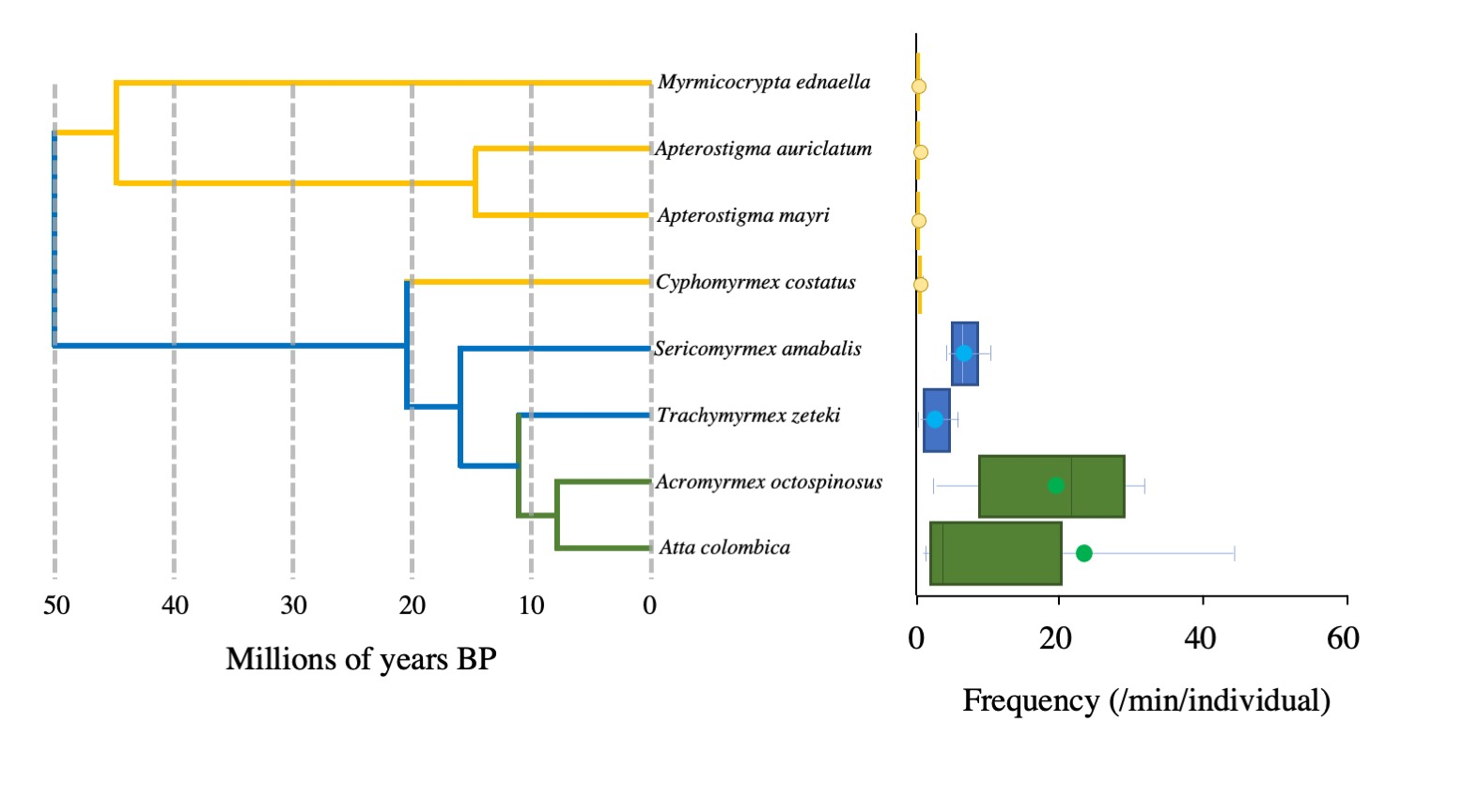
Extended Data 3. Evolutionary traits and sound-production frequency of fungus-growing ants. Using a high-resolution recording device that we designed, acoustic signals of 3–10 workers with fungus garden pieces were captured for 15–30 minutes in seven genera (eight species) of attines. Yellow boxes indicate lower attines, dark blue boxes represent middle-advanced attines, and green boxes represent leaf-cutting ants. The phylogenetic relationships of attine ants were created by referring to Bransetter, M. G. et al. (2017)⁵ with some modifications. A significant correlation between evolutionary traits and sound-production frequencies was observed (Jonckheere–Terpstra test, χ² = 26.28, d.f. = 7, P < 0.001, error bars indicate standard deviations).

