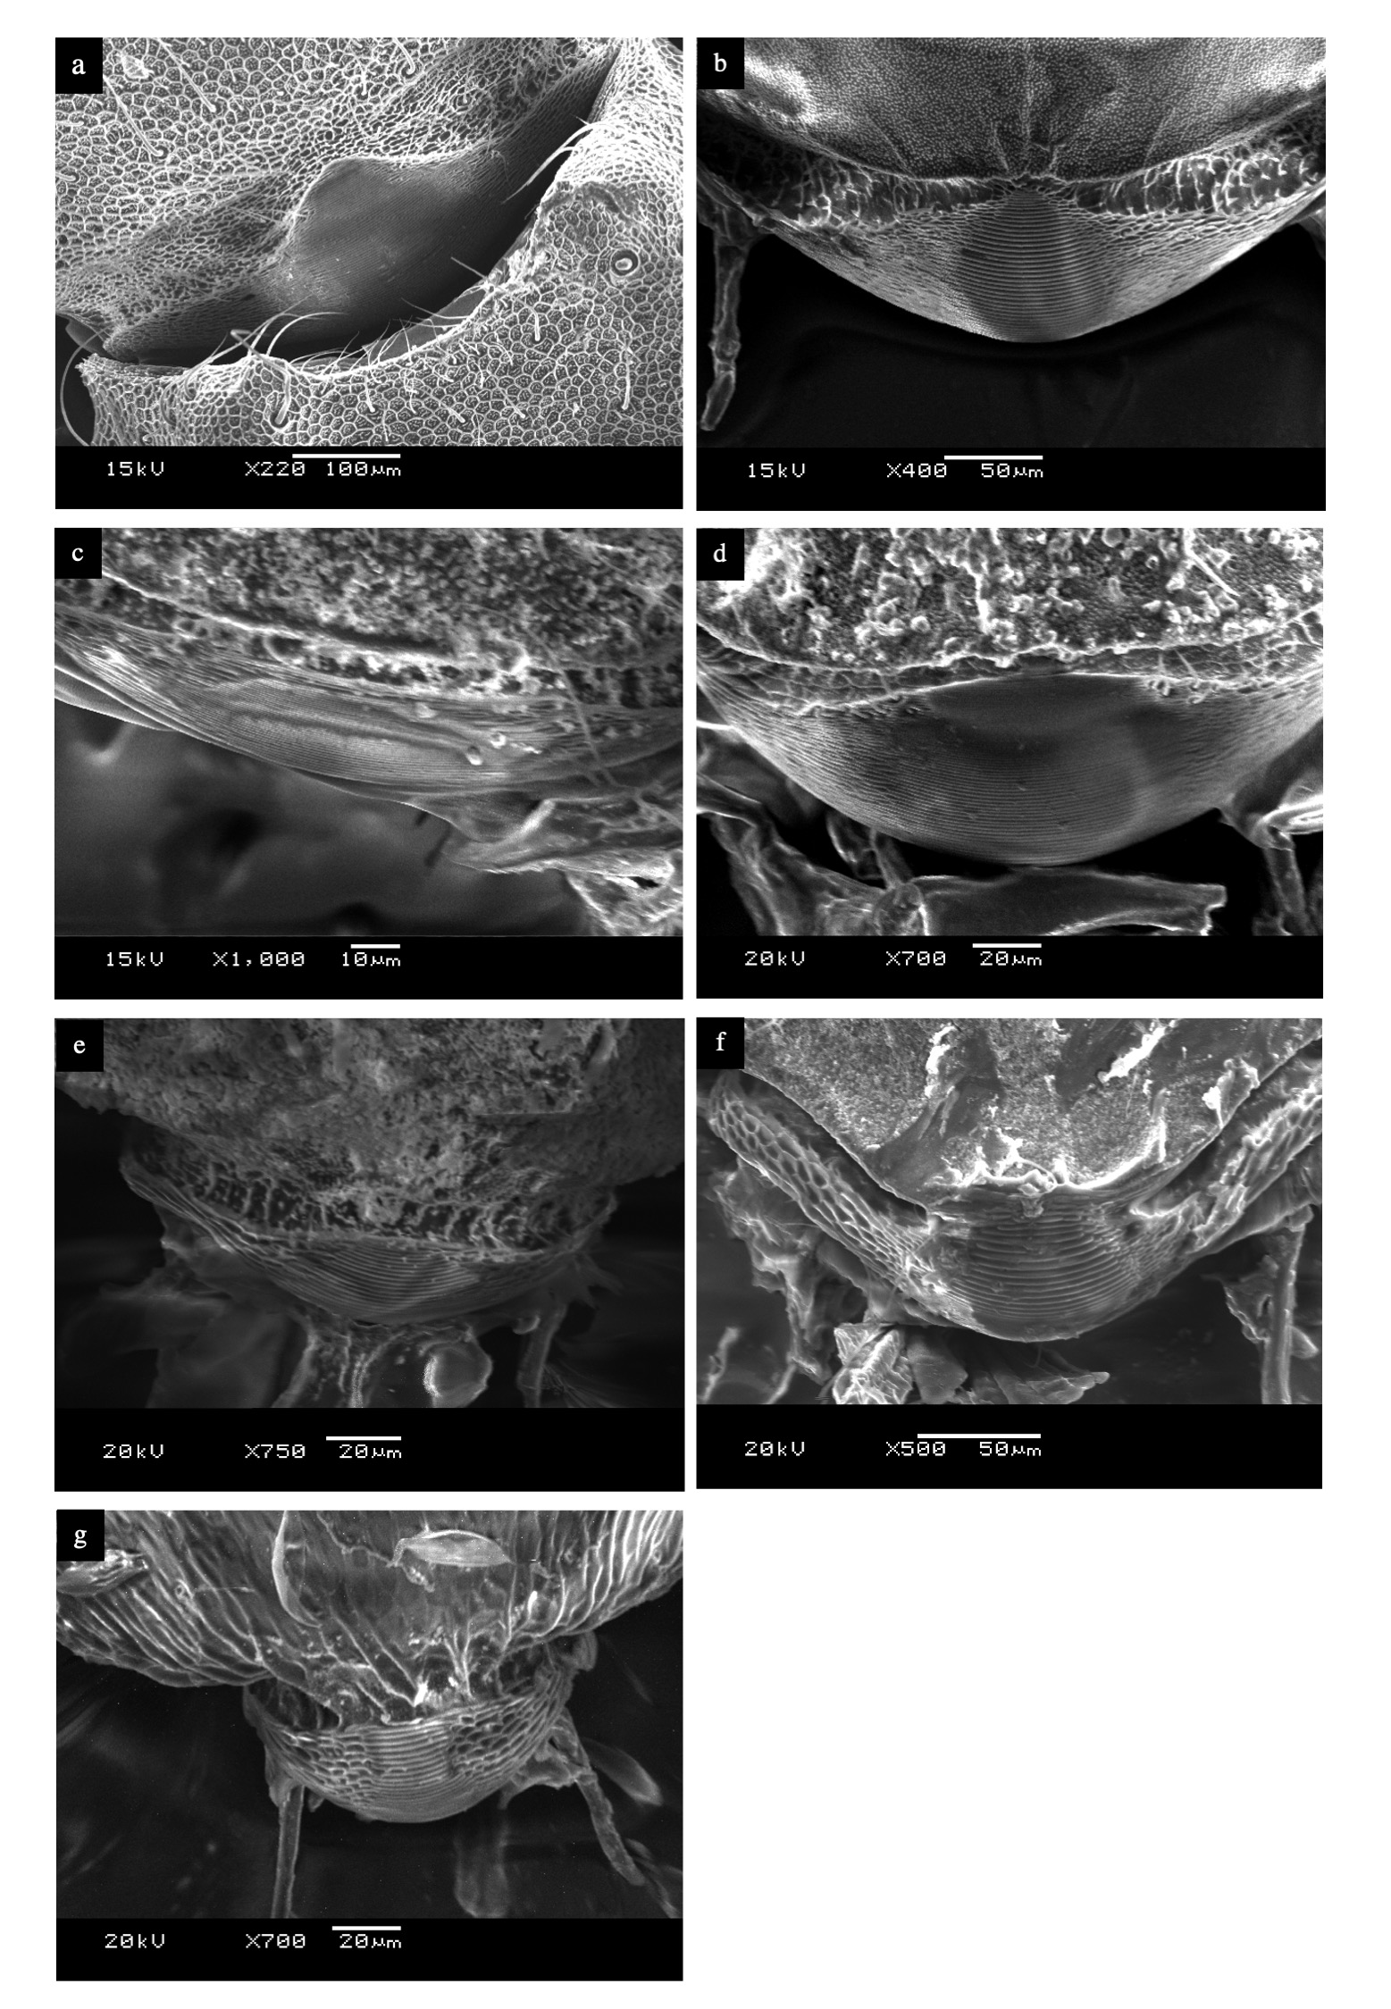
Extended Data 5. SEM images of the stridulatory organs of seven attine ants. a: Atta colombica, b: Acromyrmex octospinosus, c: Sericomyrmex amabilis, d: Trachymyrmex zeteki, e: Cyphomyrmex costatus, f: Apterostigma mayri, g: Myrmicocrypta ednaella

