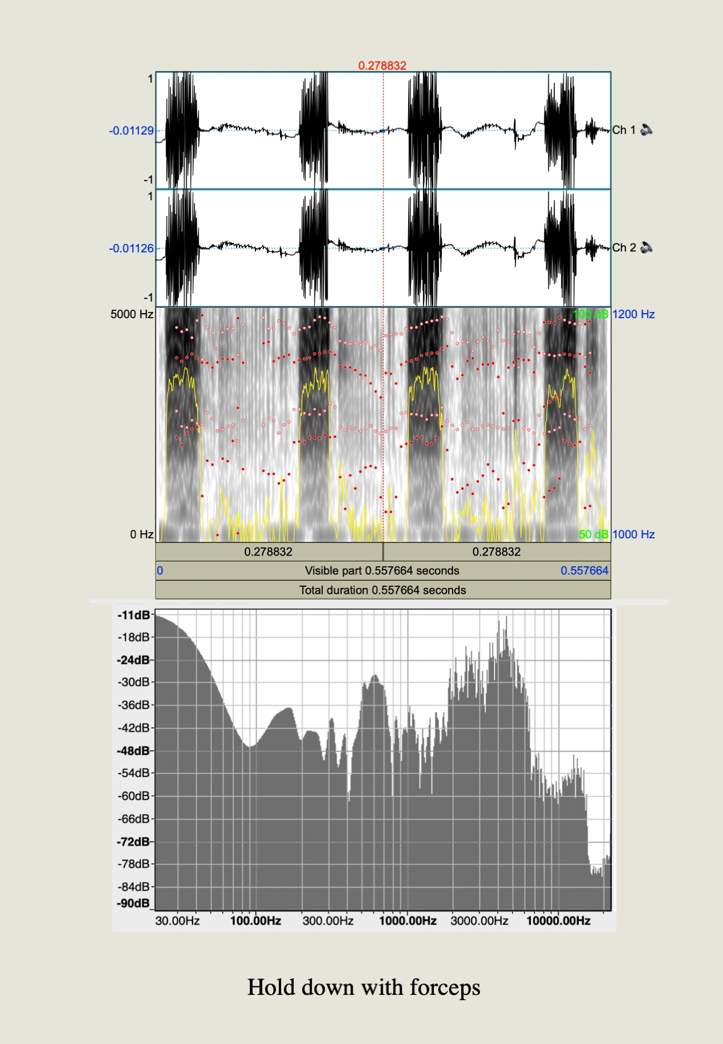
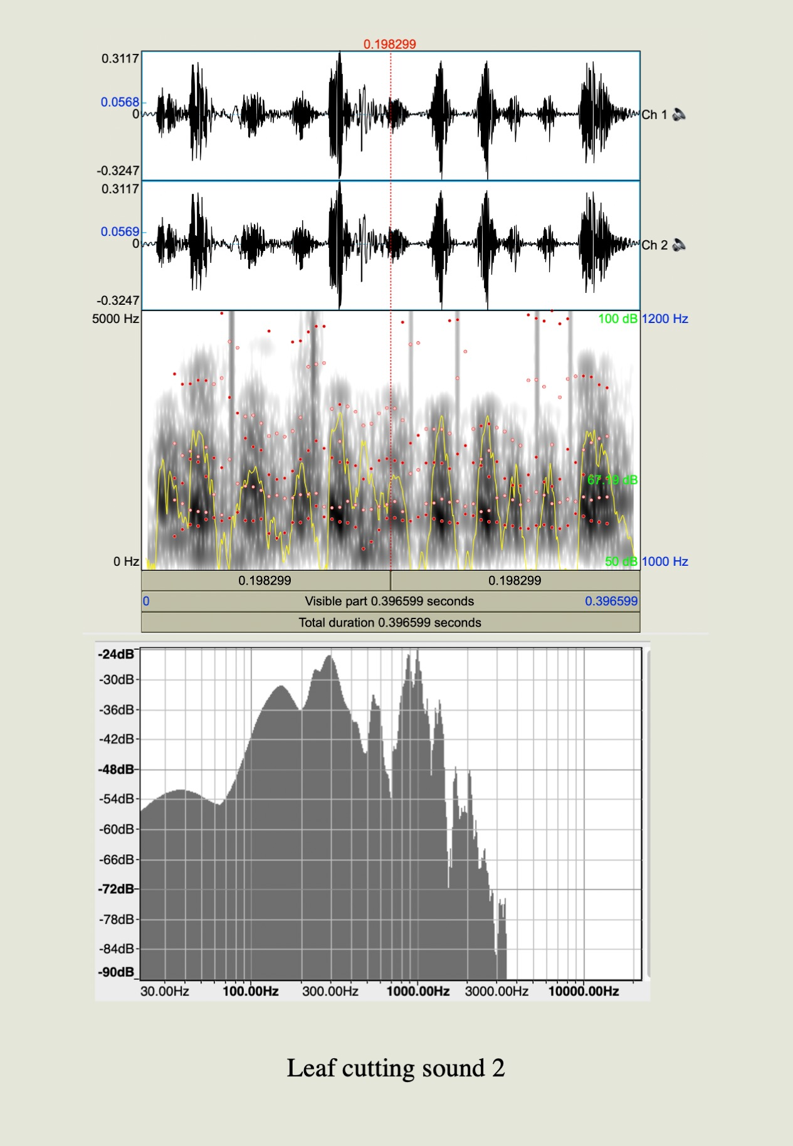
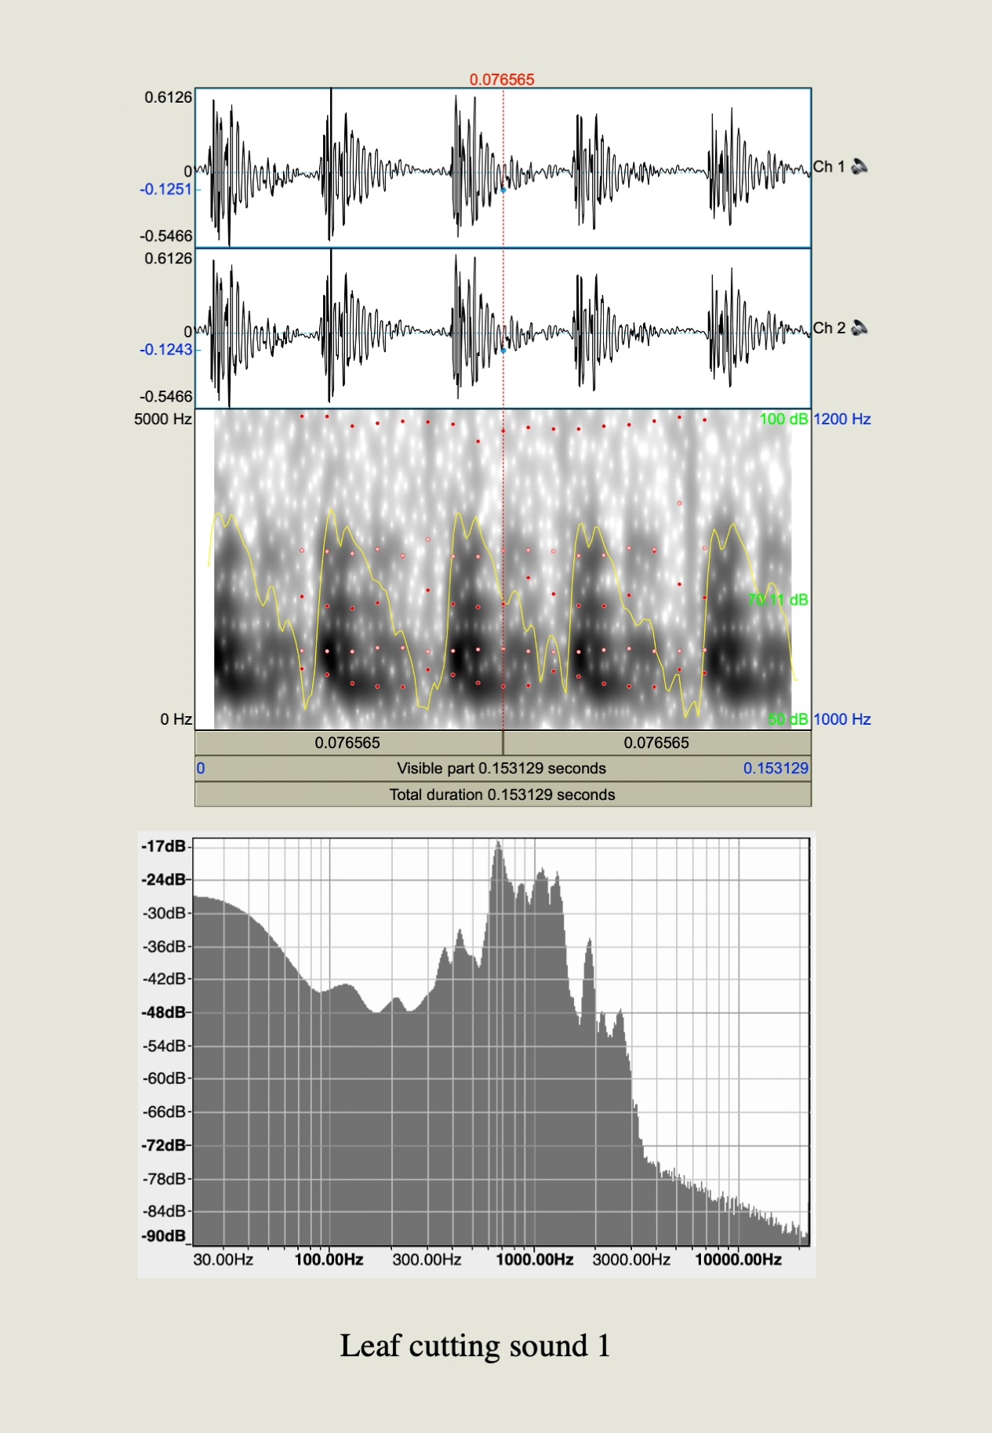
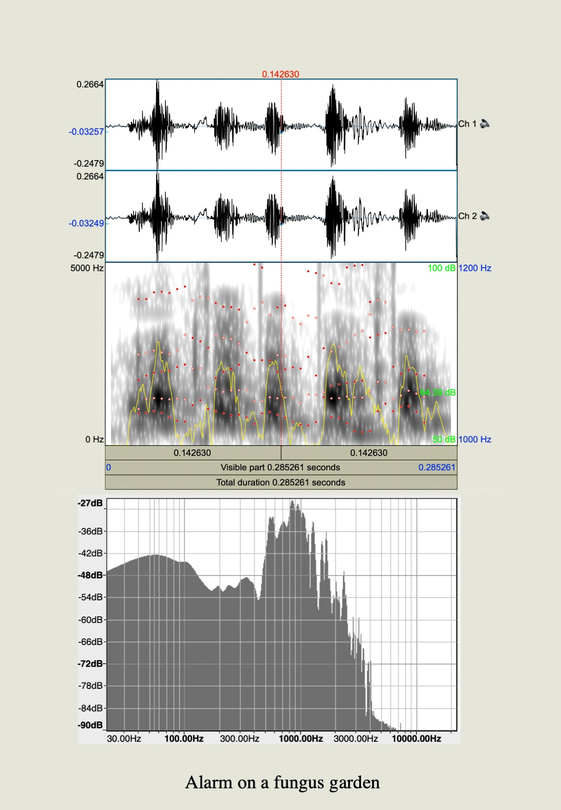
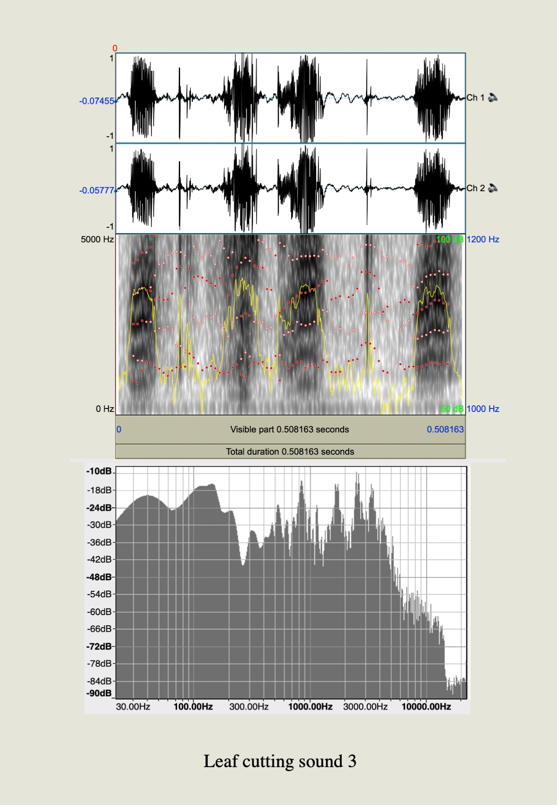
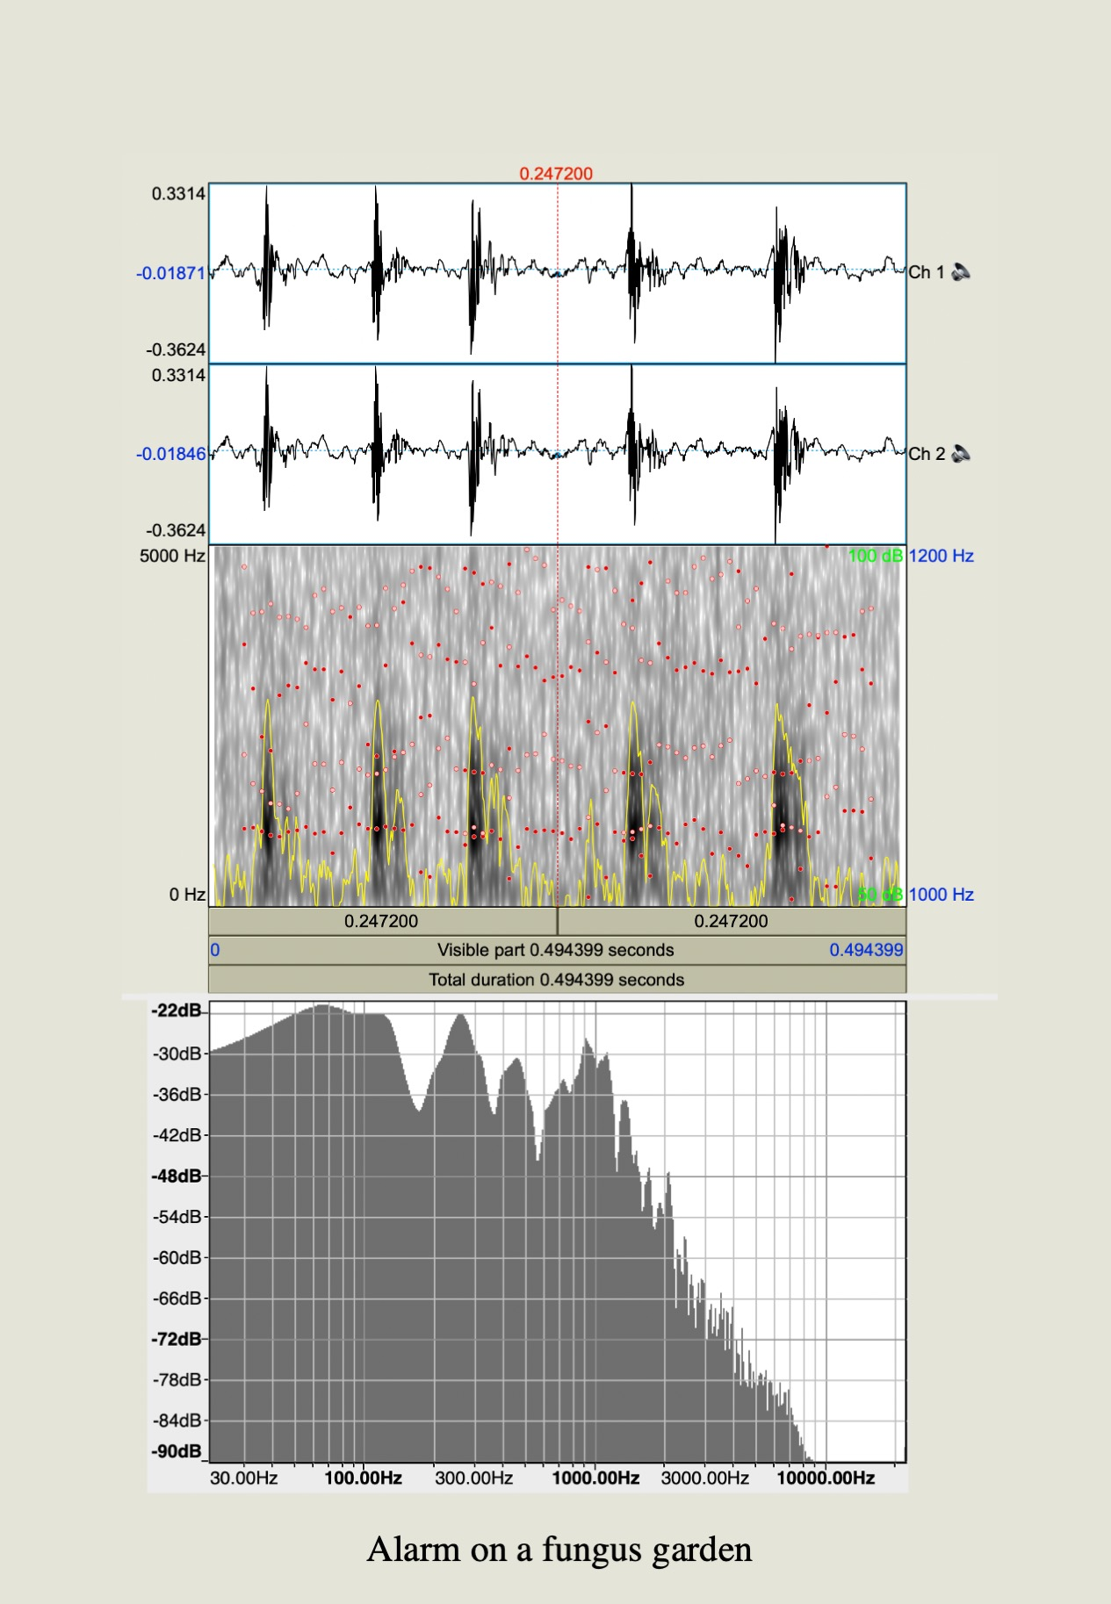
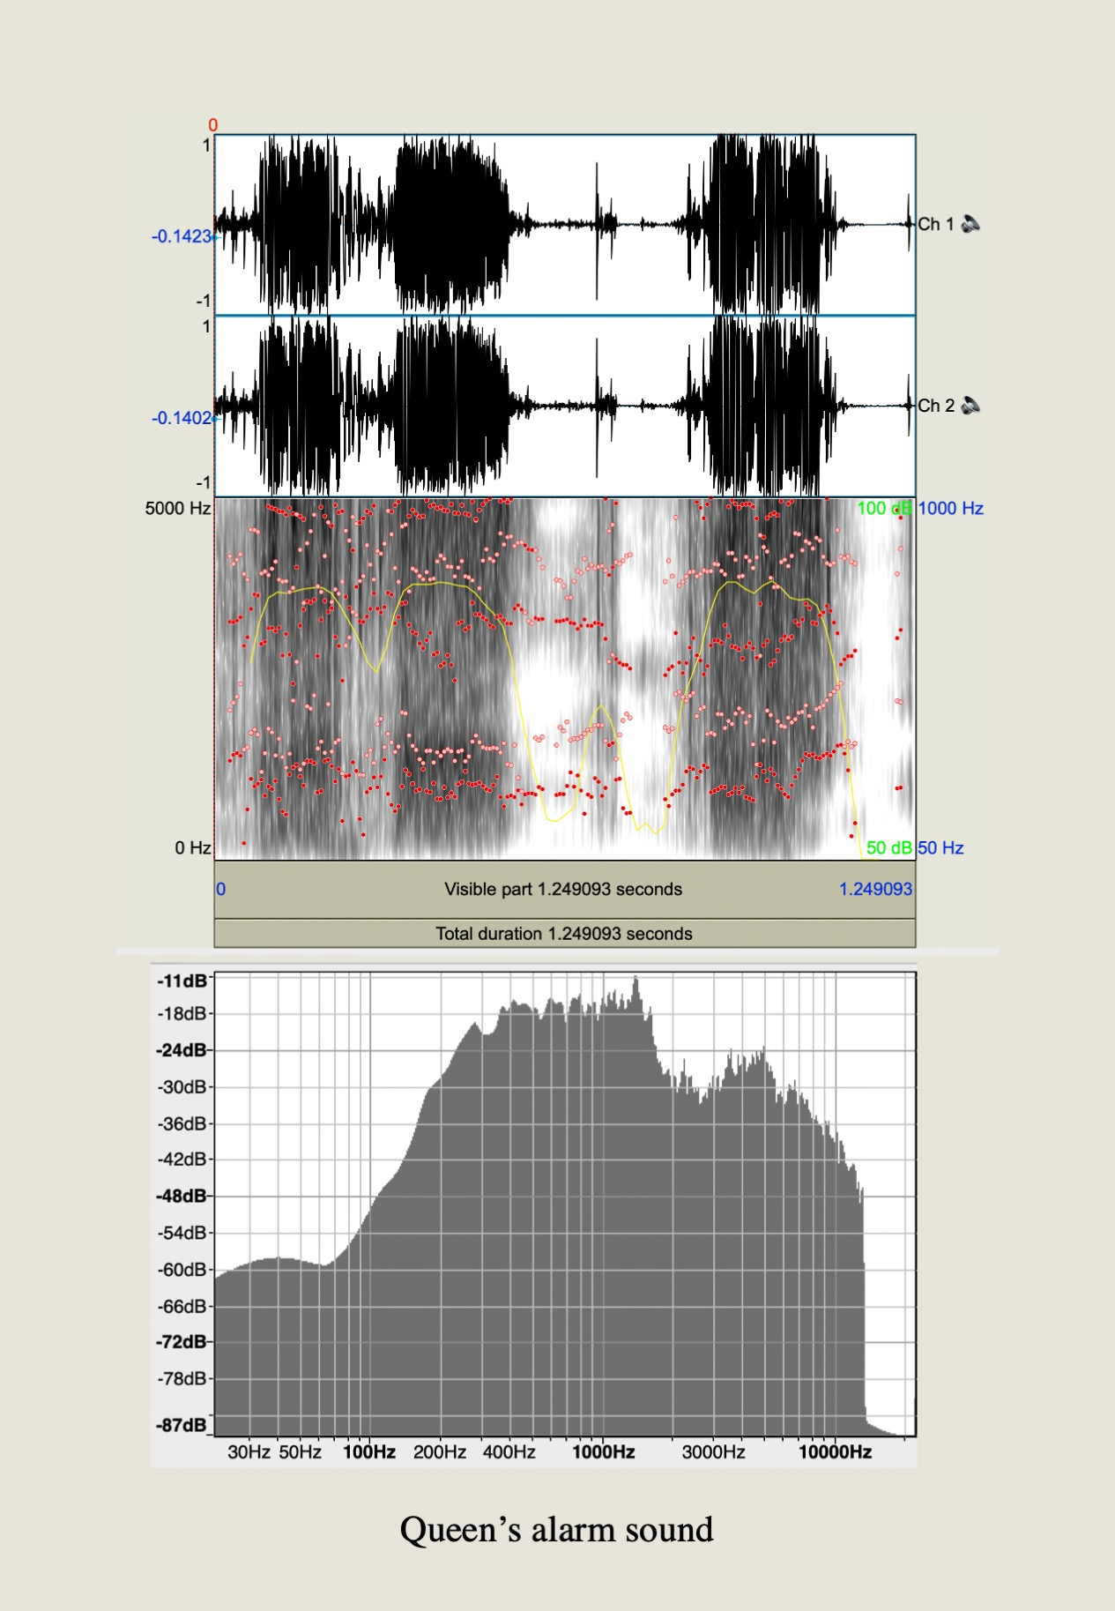
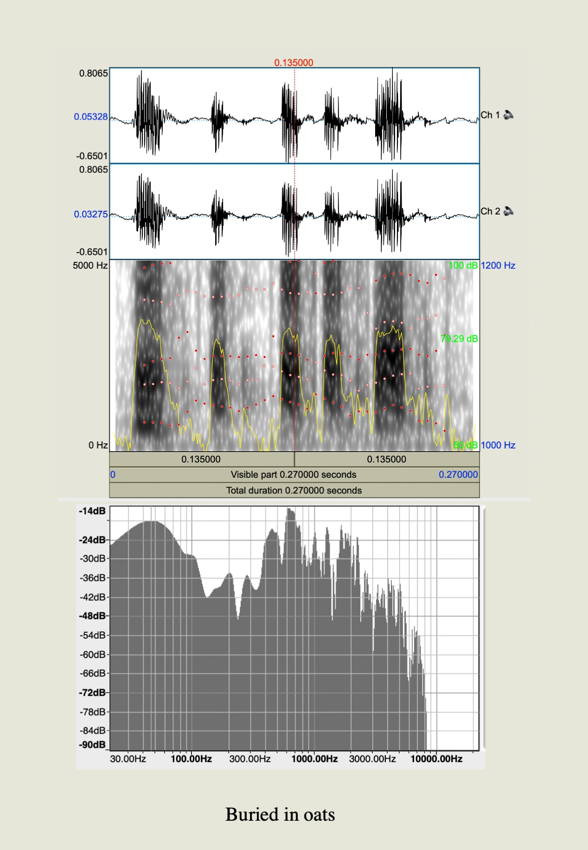
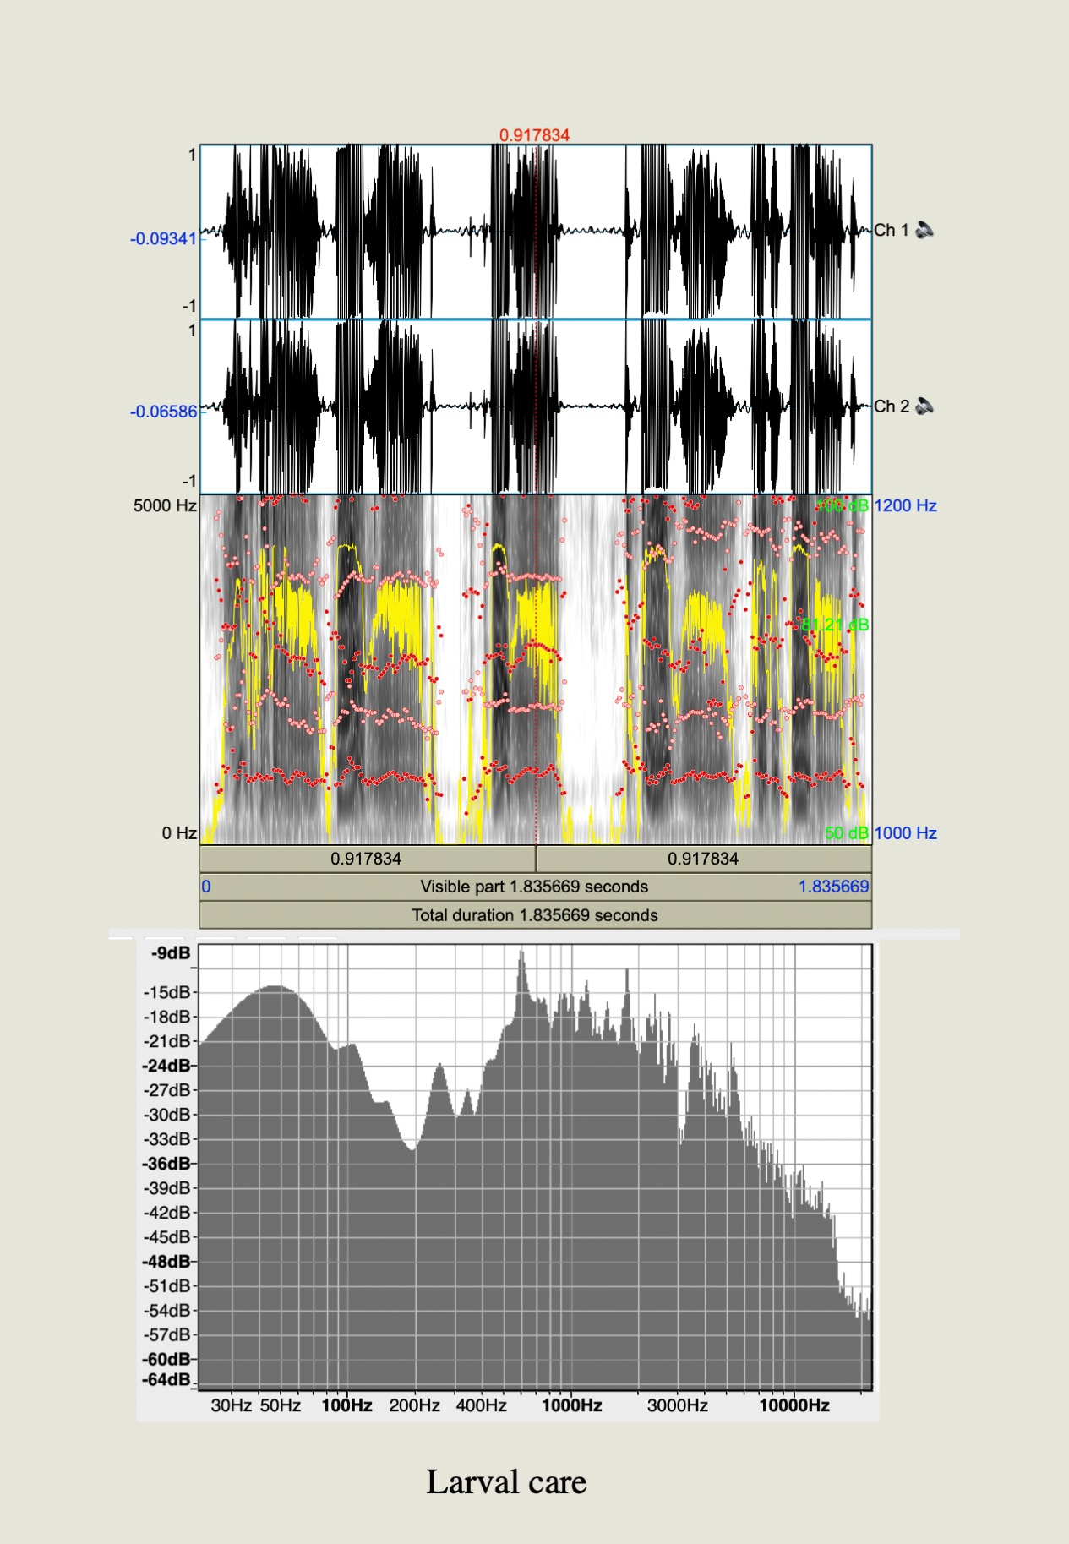
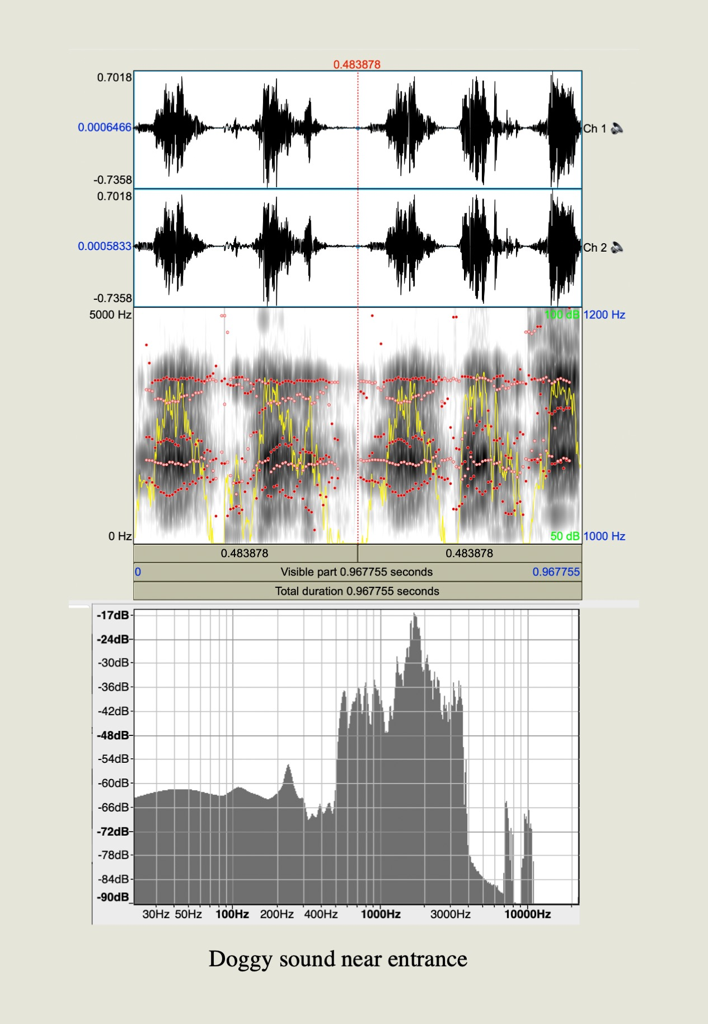
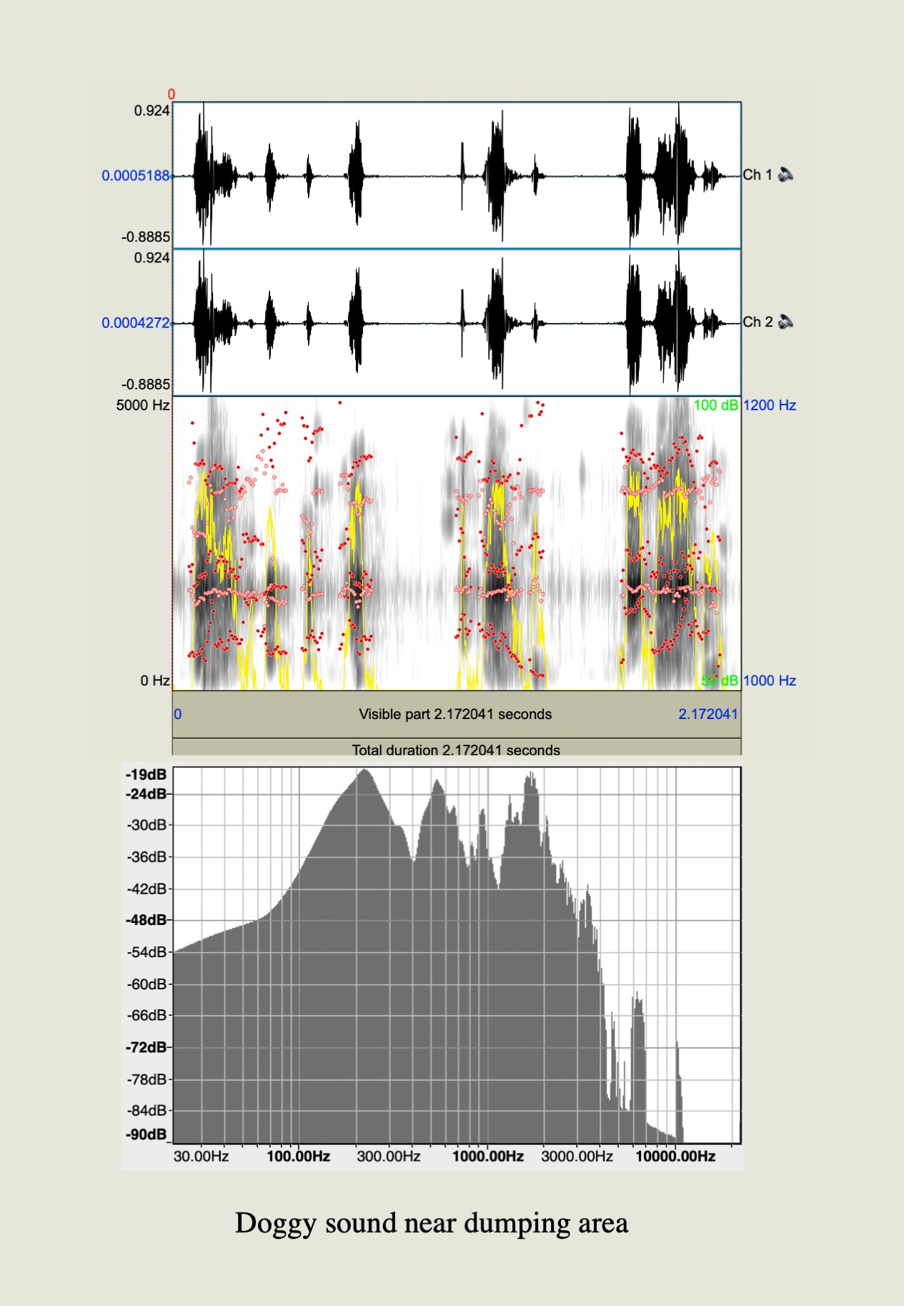
a
b
c
d
e
f
g
h
i
j
k

Extended Data 4. Characteristics of acoustic signals in Atta colombica. In each panel upper column: wave form, middle: spectrogram, bottom: spectrum plot. (a) pinching with forceps, and (b) burying with oats; whereas the recorded signals from independent conditions and locations were: (c) cutting Leguminosae leaves, (d) cutting Clusiaceae leaves, (e) cutting Heliconiaceae flowers, (f) vigilant sound near a fungus garden, (g) bark-like sound near a garbage dump, (h) bark-like sound near an entrance, (i) alarm sound on a trail, (j) larval care, and (k) a queen’s alarm sounds

