Extended Data 1. Sampling information of the fungus-growing ants in Panama. We collected all species of attines in Soberania National Park in Panama (9.12887, -79.71528 to 9.1879, -79.76921). Sampling were conducted on 3 Sep 2012 to 21 Nov 2012, 20 Aug 2013 to 8 Sep 2013, and 20 Feb 2015 to 28 Feb 2015. Samples were kept in Institution of Decision Science, Kyushu University.
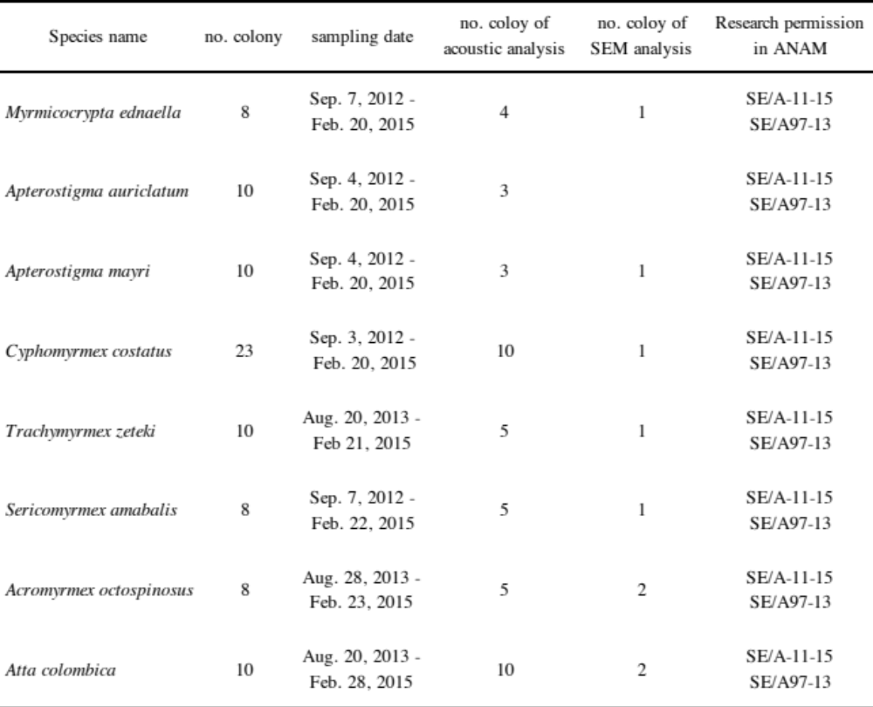

Extended Data 2. Acoustic data of eight species of attines.
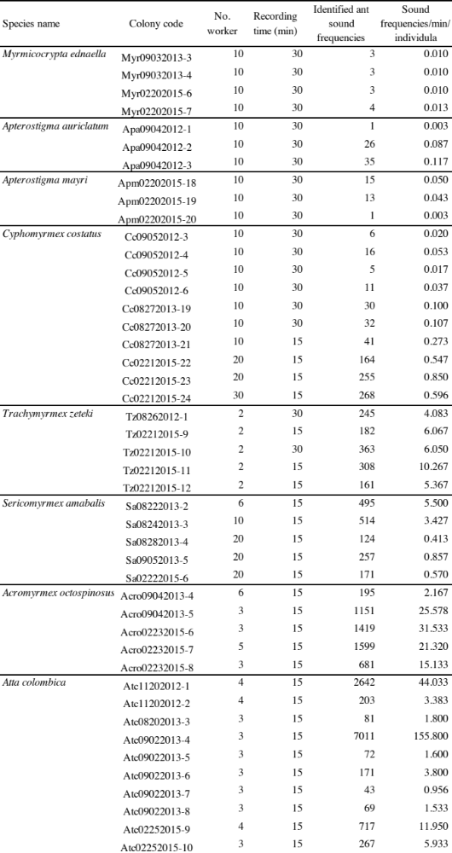
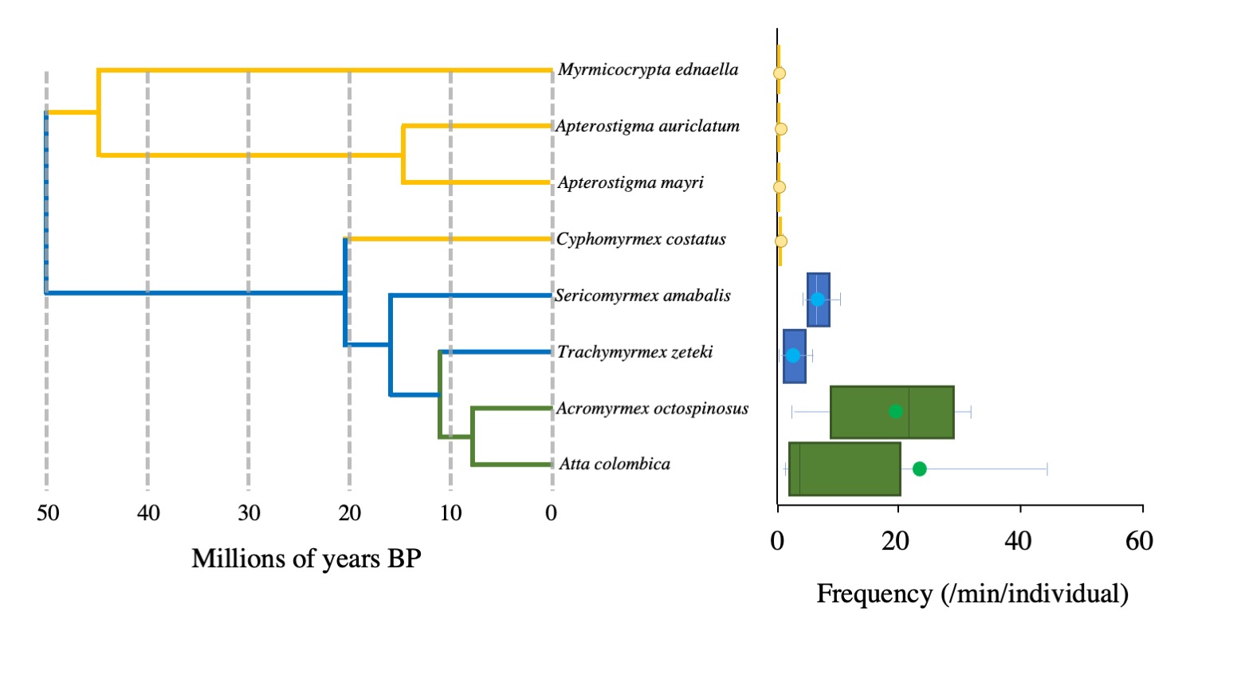
Extended Data 3. Evolutionary traits and sound-production frequency of fungus-growing ants. Using a high-resolution recording device that we designed, acoustic signals of 3–10 workers with fungus garden pieces were captured for 15–30 minutes in seven genera (eight species) of attines. Yellow boxes indicate lower attines, dark blue boxes represent middle-advanced attines, and green boxes represent leaf-cutting ants. The phylogenetic relationships of attine ants were created by referring to Bransetter, M. G. et al. (2017)⁵ with some modifications. A significant correlation between evolutionary traits and sound-production frequencies was observed (Jonckheere–Terpstra test, χ² = 26.28, d.f. = 7, P < 0.001, error bars indicate standard deviations).

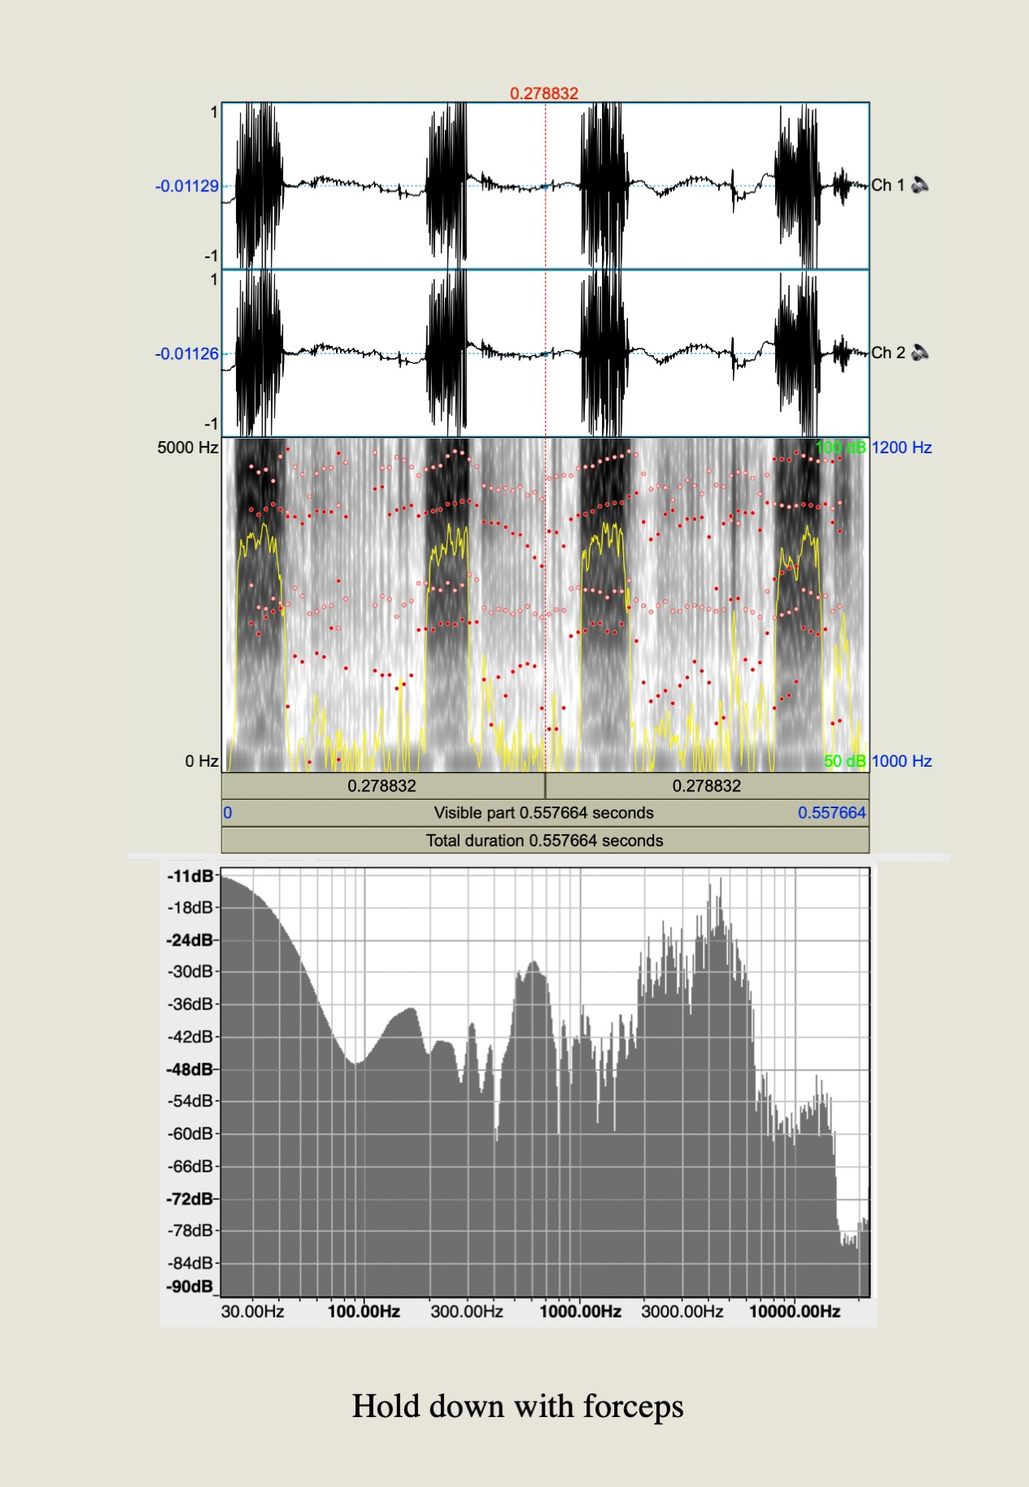
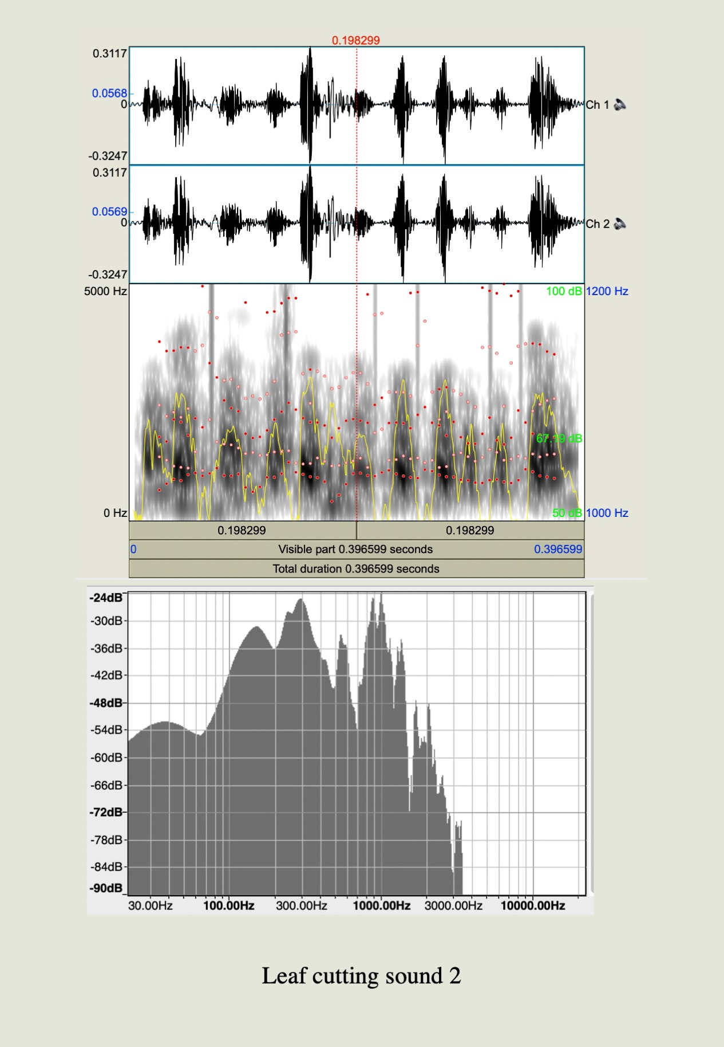
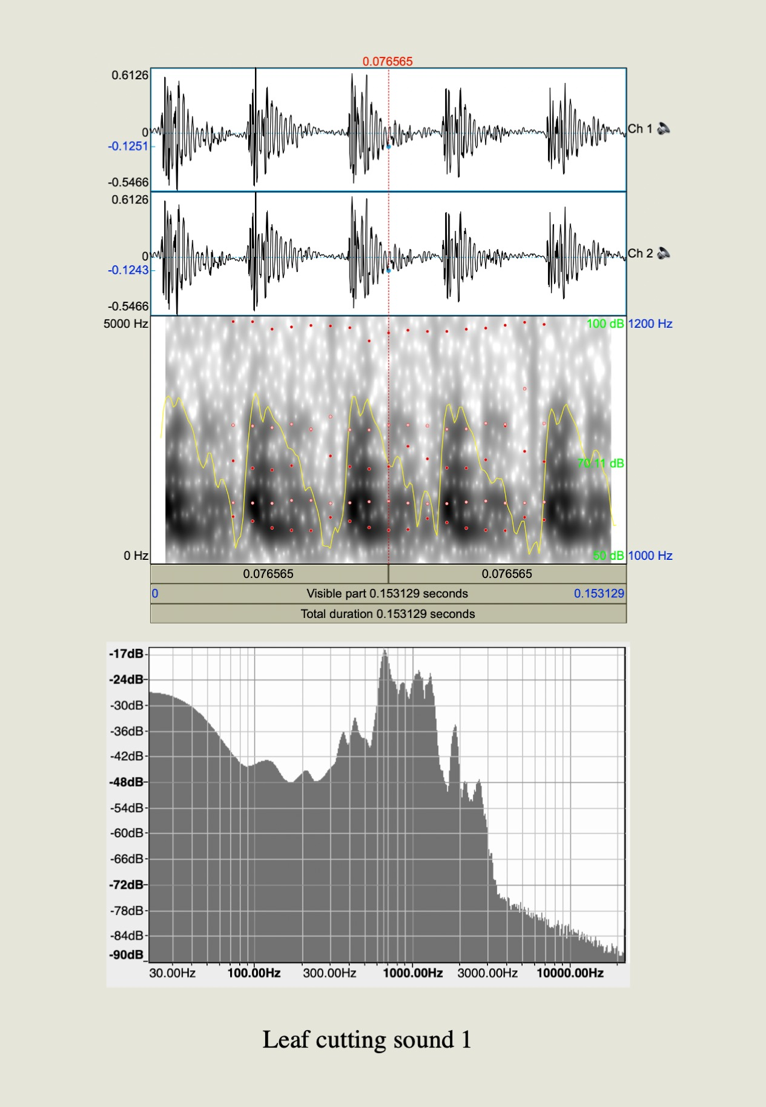
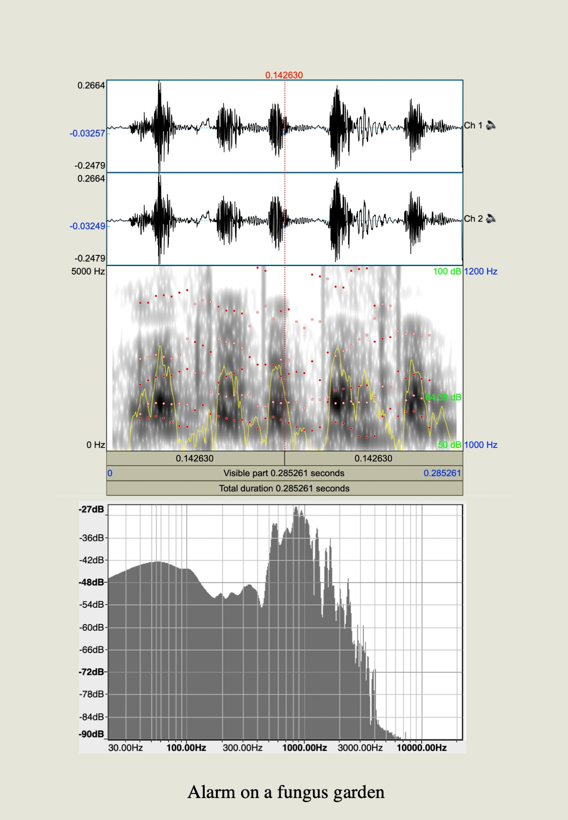
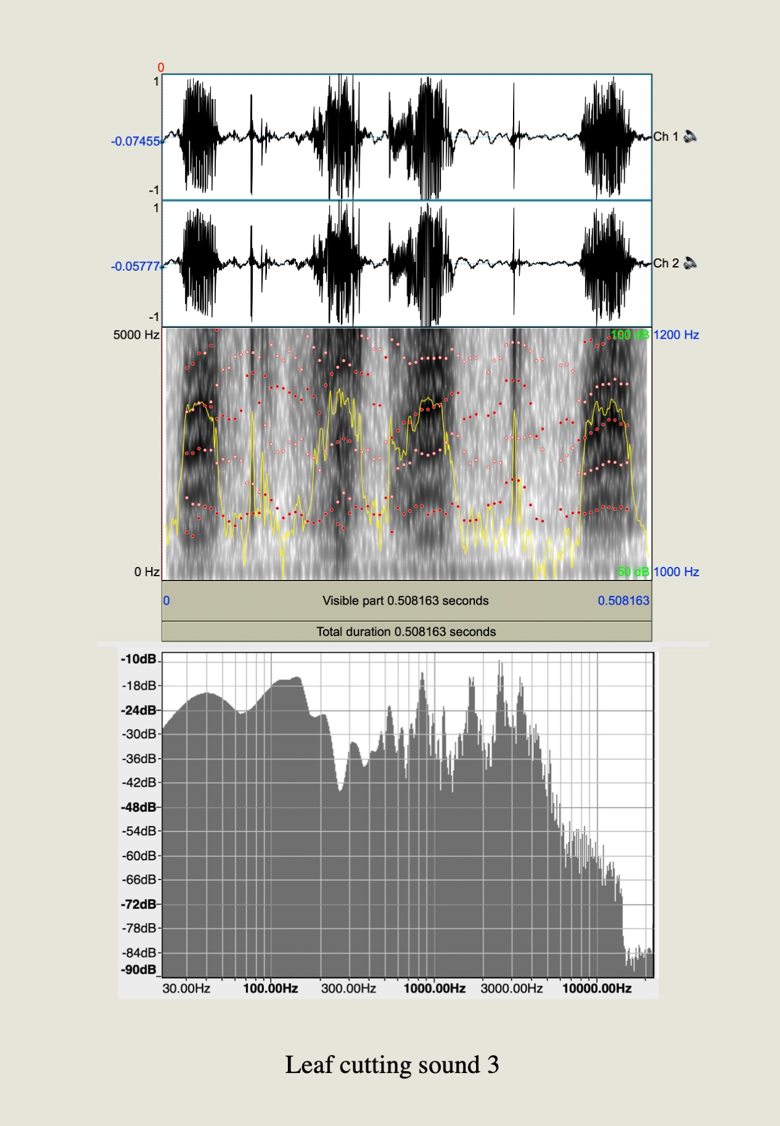
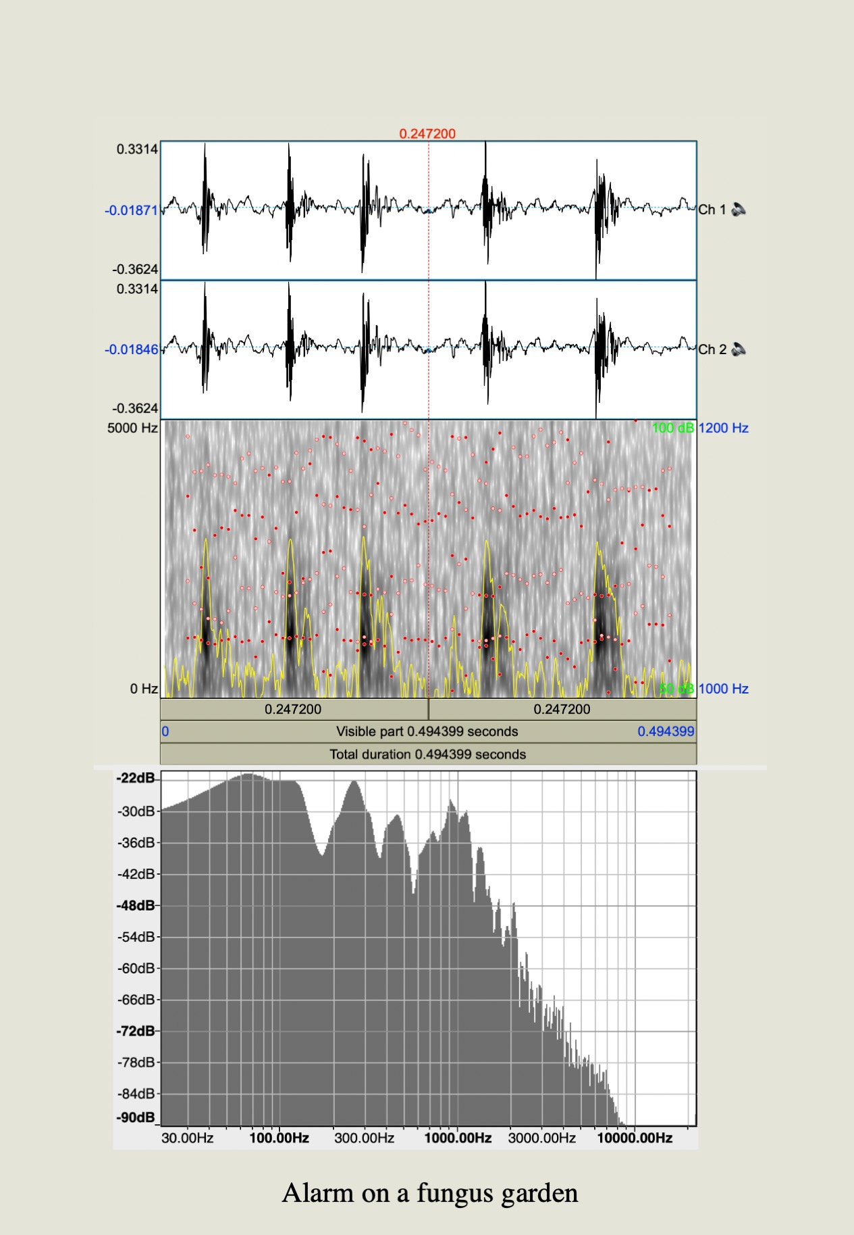
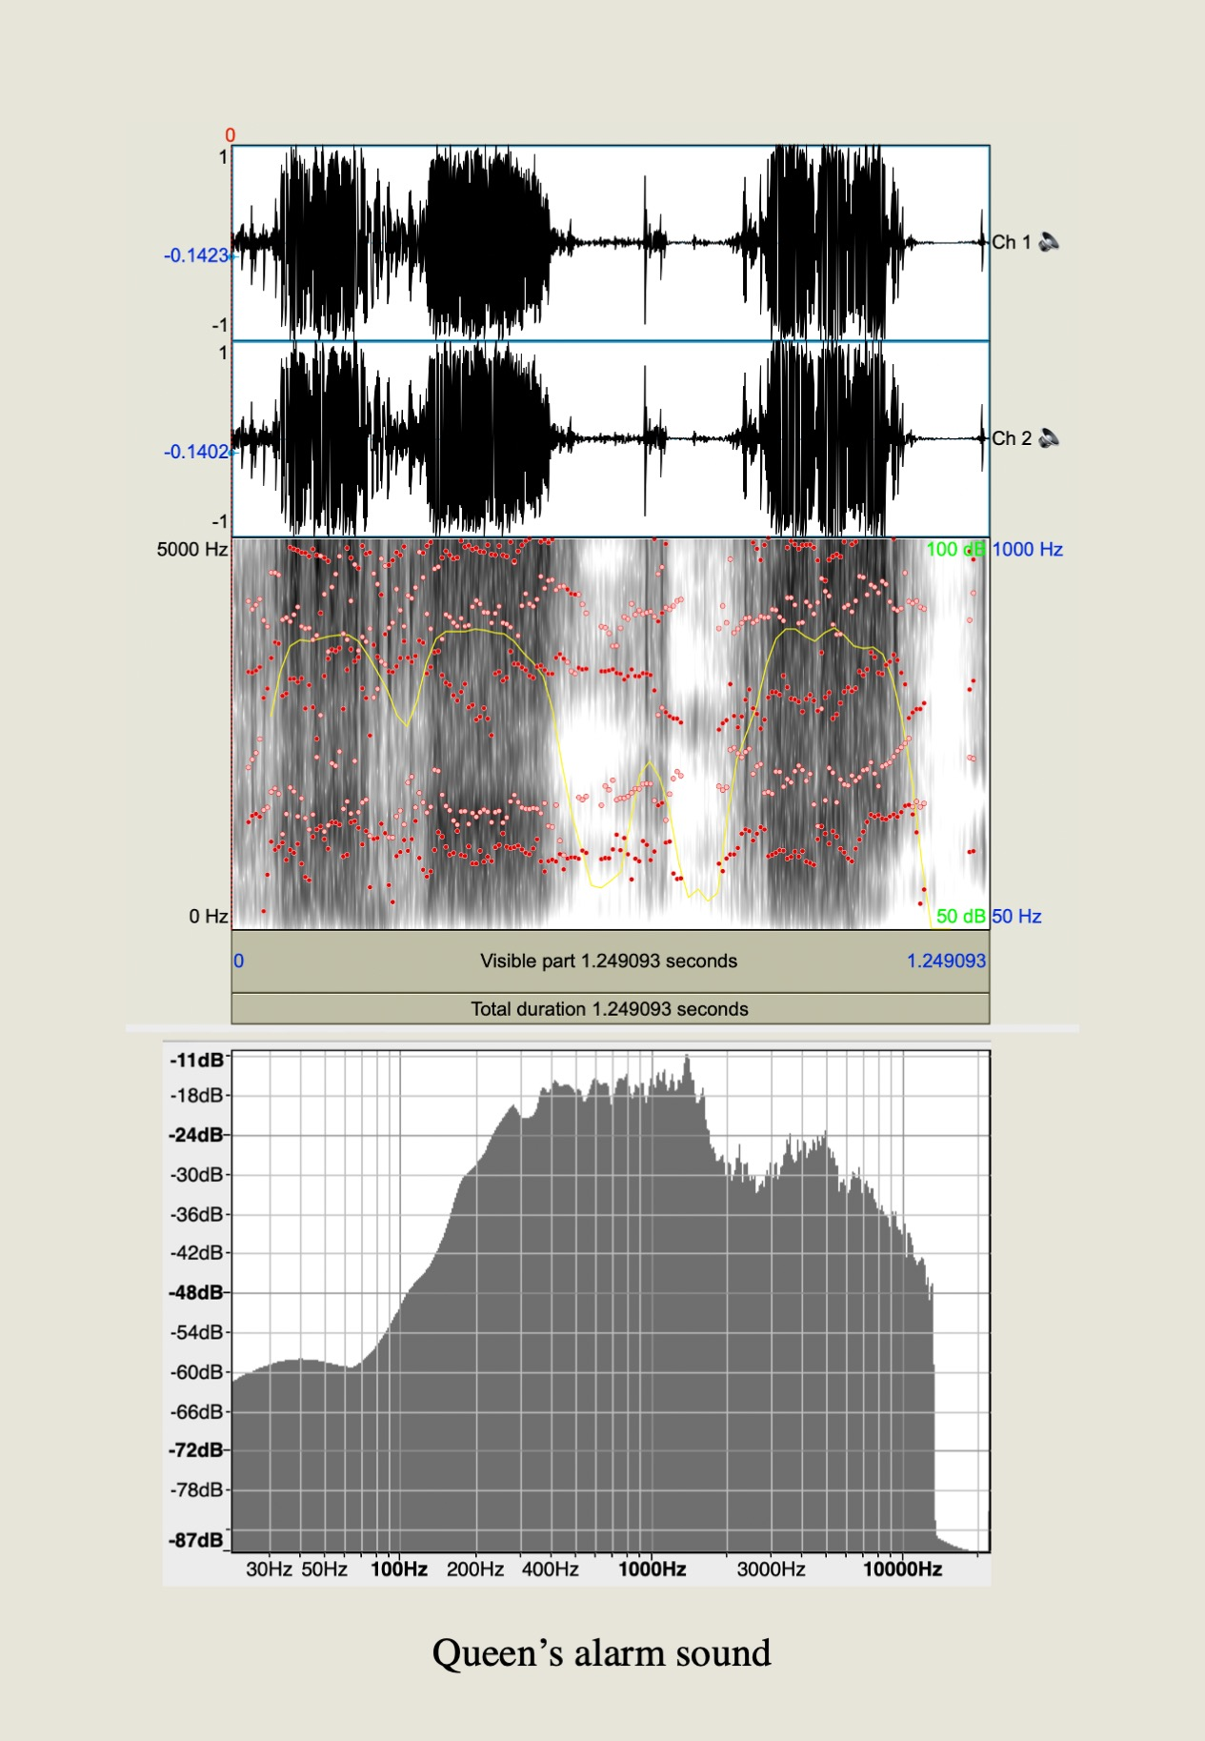
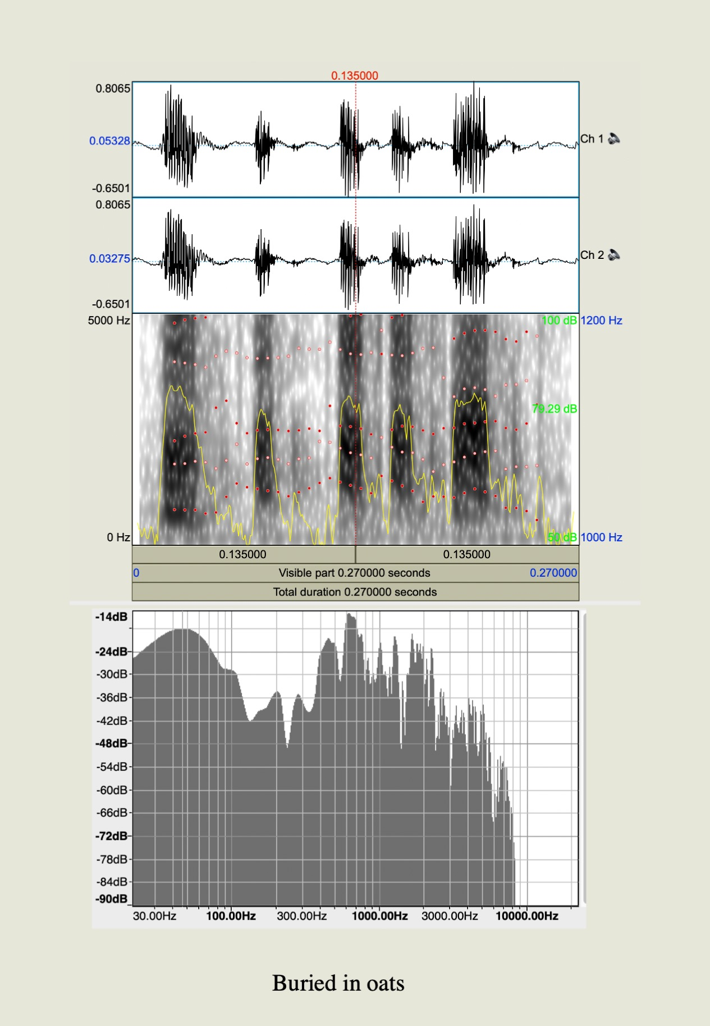
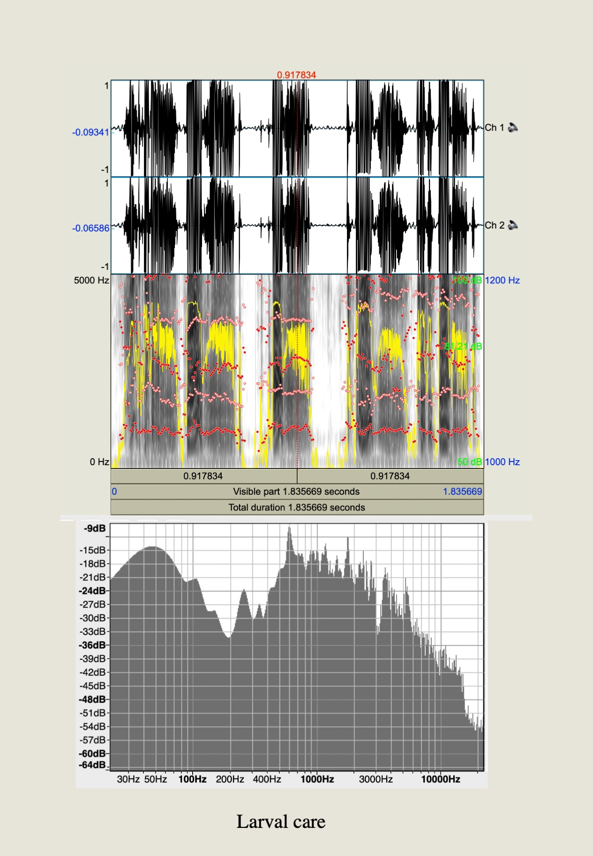
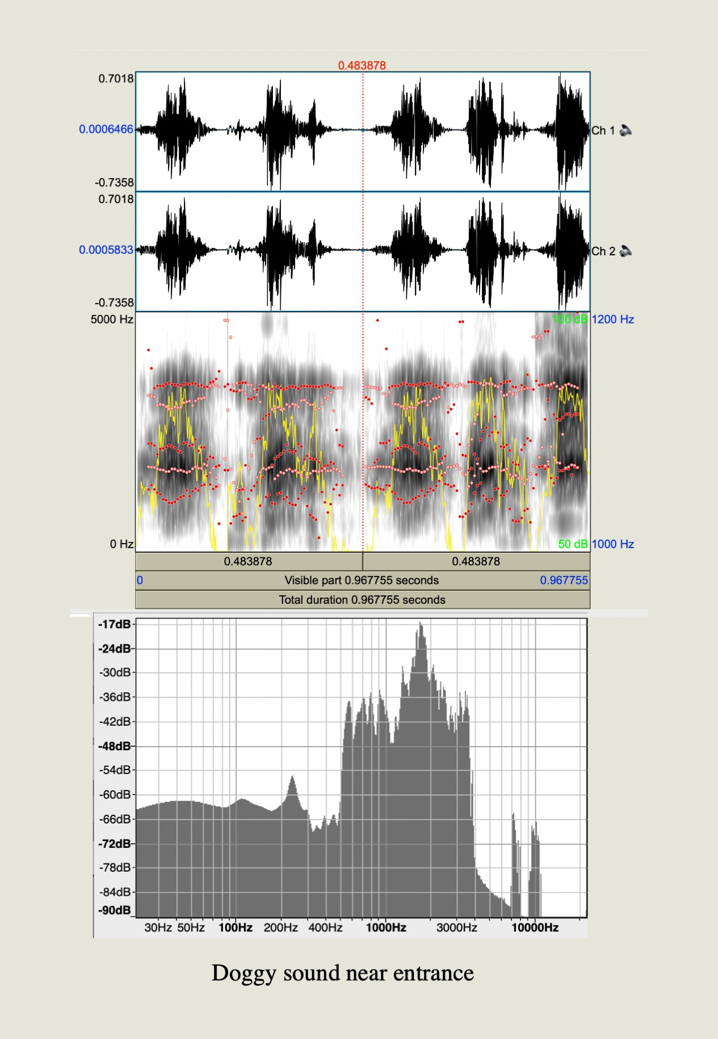
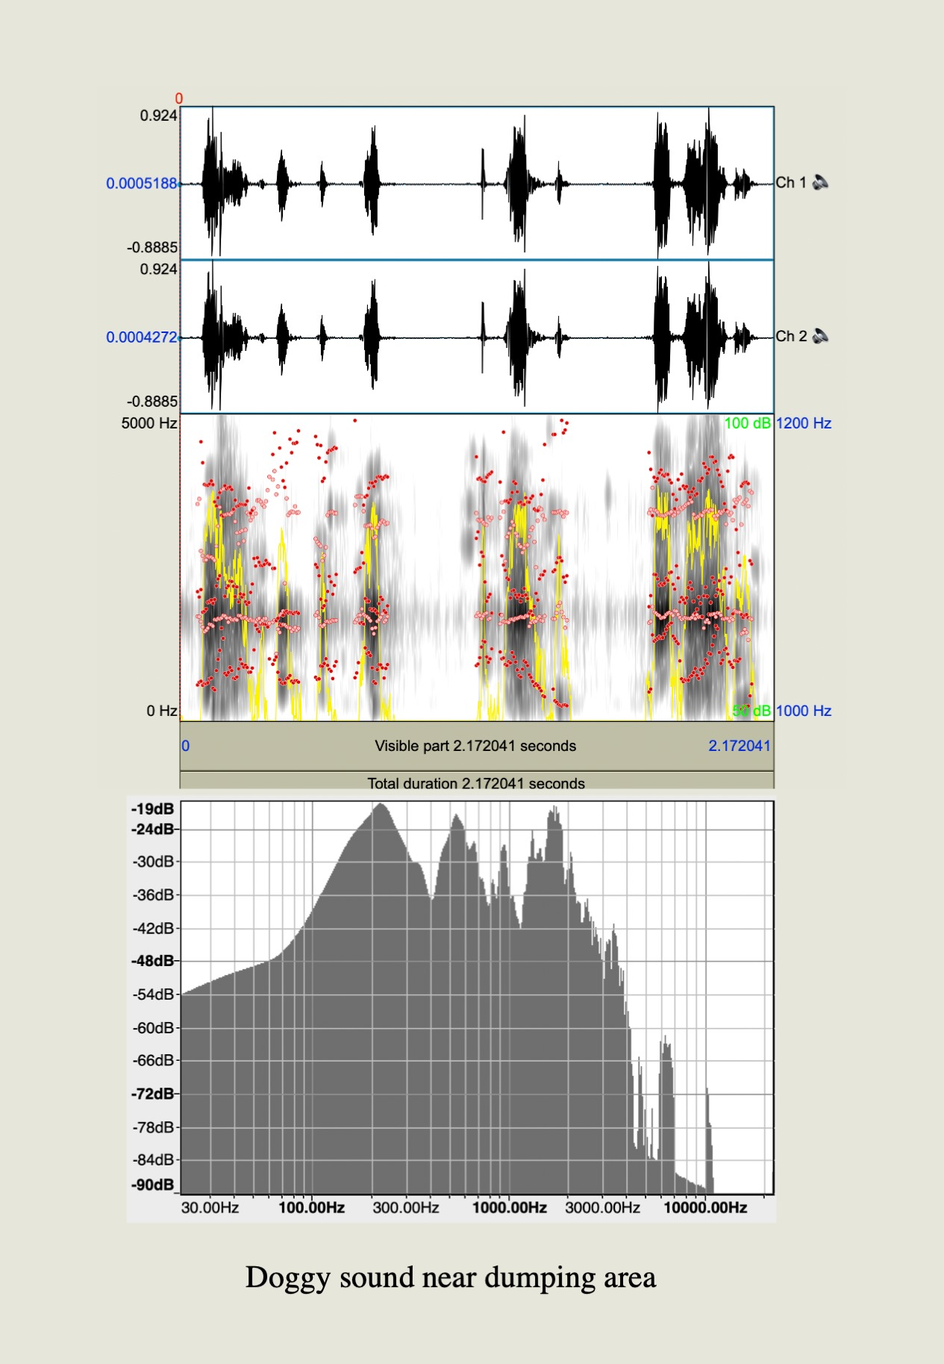
a
b
c
d
e
f
g
h
i
j
k

Extended Data 4. Characteristics of acoustic signals in Atta colombica. In each panel upper column: wave form, middle: spectrogram, bottom: spectrum plot. (a) pinching with forceps, and (b) burying with oats; whereas the recorded signals from independent conditions and locations were: (c) cutting Leguminosae leaves, (d) cutting Clusiaceae leaves, (e) cutting Heliconiaceae flowers, (f) vigilant sound near a fungus garden, (g) bark-like sound near a garbage dump, (h) bark-like sound near an entrance, (i) alarm sound on a trail, (j) larval care, and (k) a queen’s alarm sounds

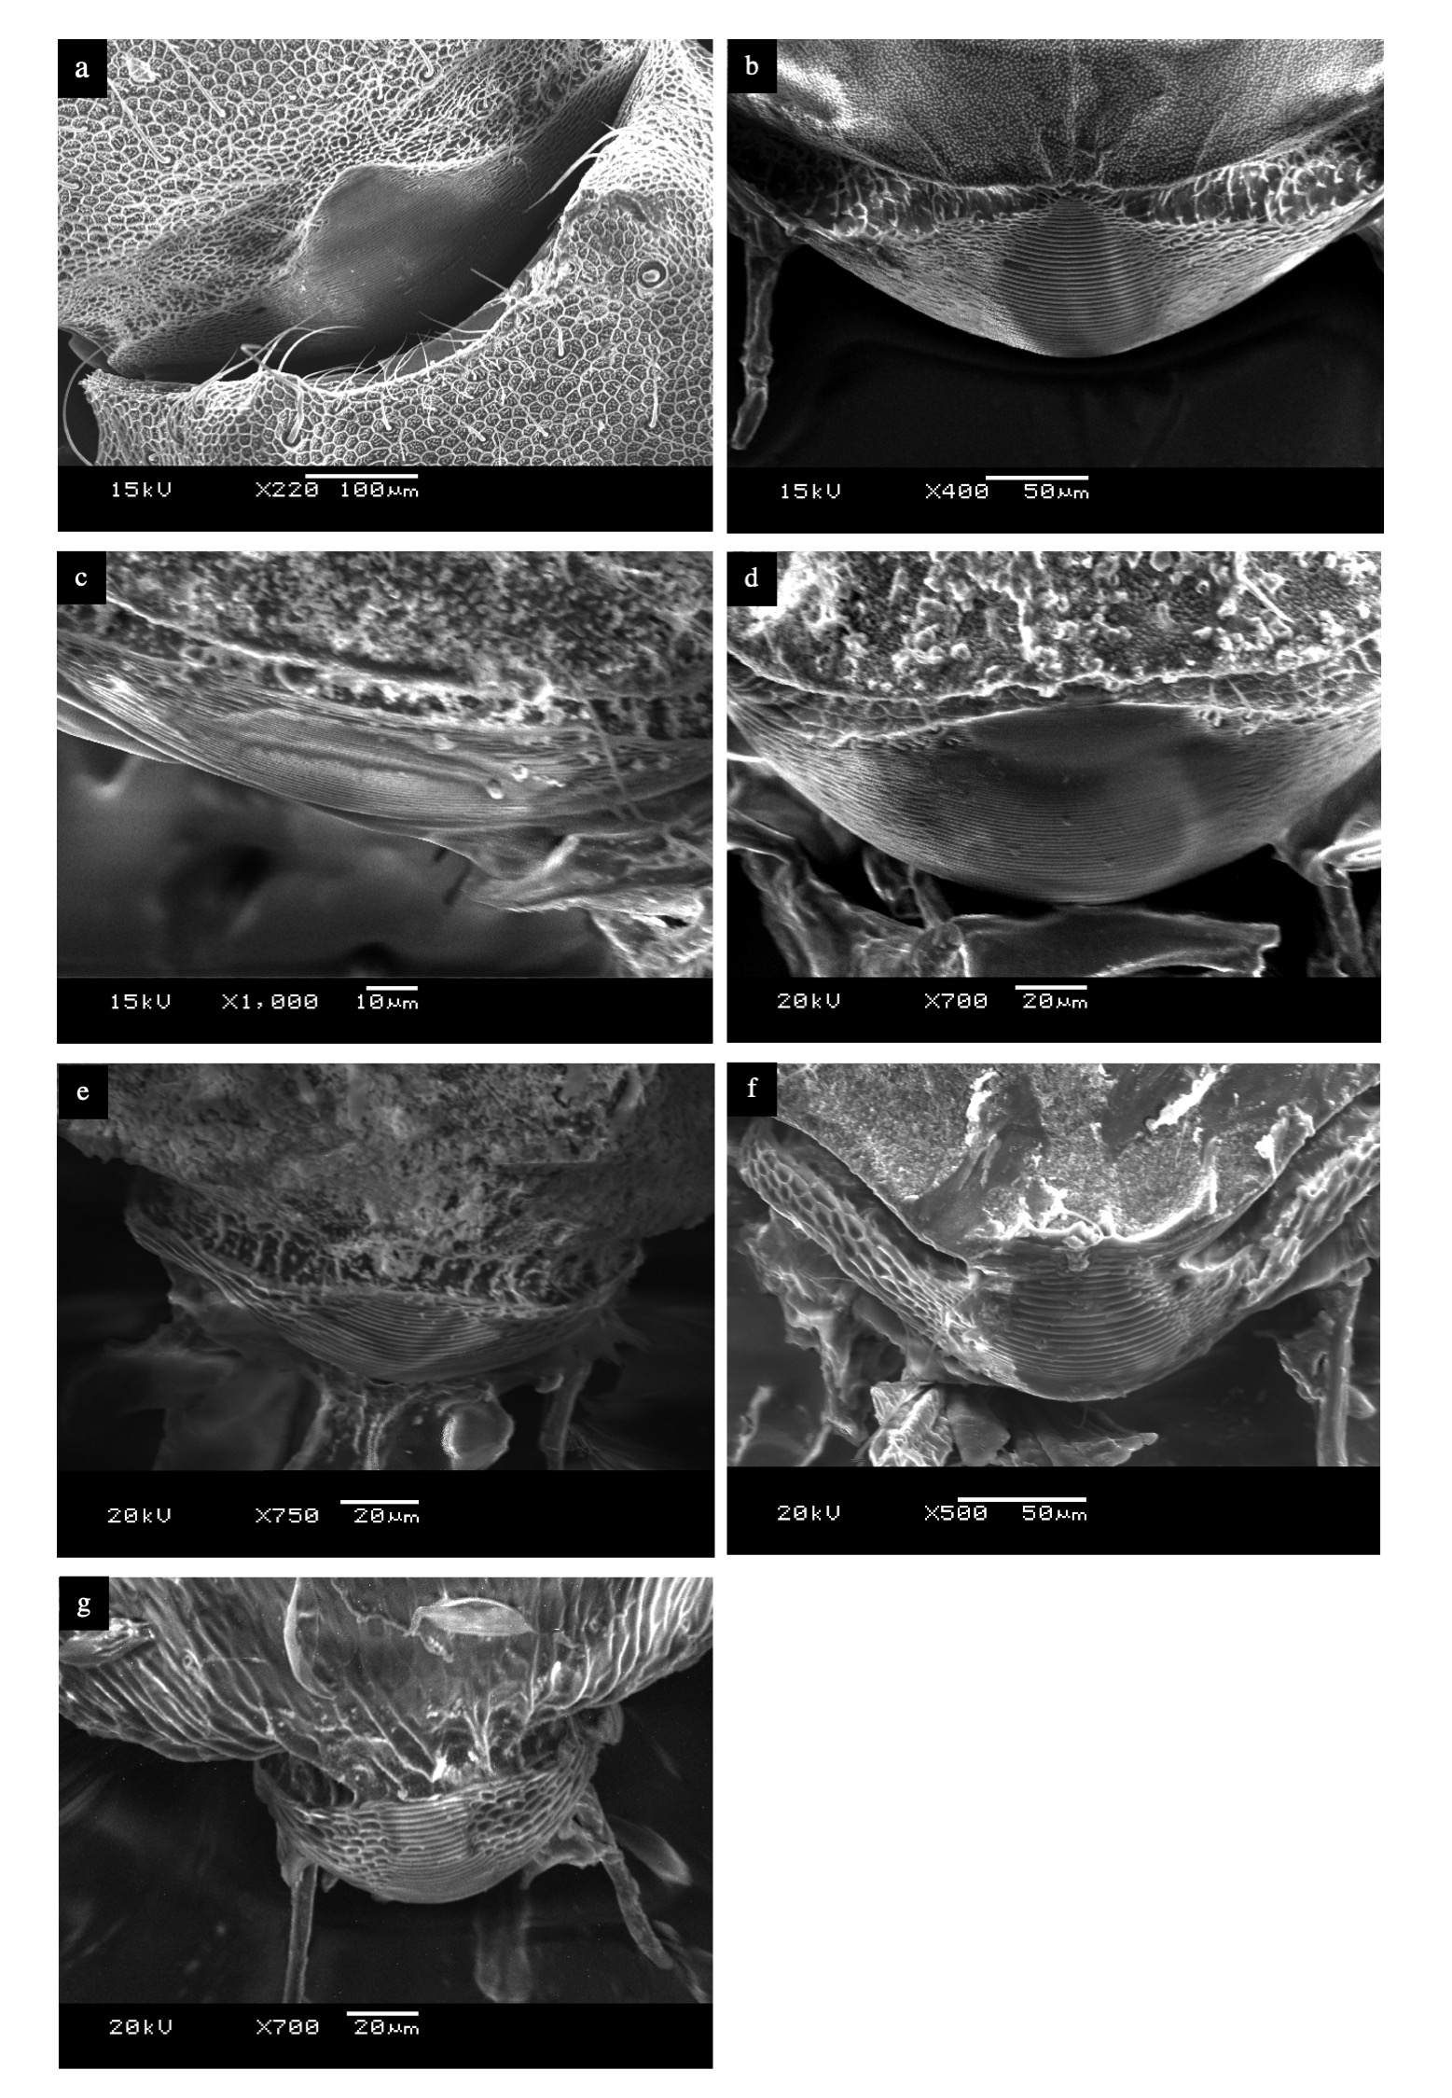
Extended Data 5. SEM images of the stridulatory organs of seven attine ants. a: Atta colombica, b: Acromyrmex octospinosus, c: Sericomyrmex amabilis, d: Trachymyrmex zeteki, e: Cyphomyrmex costatus, f: Apterostigma mayri, g: Myrmicocrypta ednaella

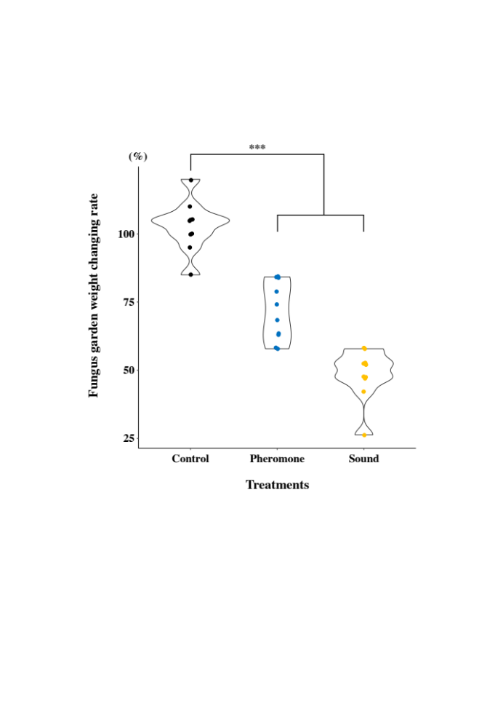
Extended Data 6. Sound and pheromone inhibition experiments. Ten sub-colonies, each with eight workers, were placed for 1 week near small pieces of fungus gardens, along with glued pheromone-producing organs, sound-producing organs, or upper part of the mesothorax (as a control) were placed with small pieces of fungus gardens for 1 week and post-experimental garden weights measured.


Supplementary information
(1) pinching with forceps
(2) burying with oats
(3) cutting Leguminosae leaves
(4) cutting Clusiaceae leaves
(5) cutting Heliconiaceae flowers
(6) vigilant sound near a fungus garden
(7) bark-like sound near a garbage dump
(8) bark-like sound near an entrance
(9) alarm sound on a trail

(10) larval care
(11) a queen’s alarm sounds

