Supplementary material of SRmdup: A new finer duplicate-read filter improves phylogenetic analyses of low-coverage ancient human DNA
We provide additional information, including a summary of filtering statistics, corresponding counts of major patterns in the Fig. 2, and comparisons of local phylogenetic relationships before and after filtering. Unless otherwise specified, duplicate determinations are based on corrected read coordinates defined in the main text, and terminal soft-clipped bases are included in the boundary calculations.
Table S1 summarizes the statistical results of the low-coverage Y-chromosome dataset after SRmdup filtering. The table lists the total number of input reads, the number of retained reads, the number of removed reads, the retention rate, and the number of removed reads corresponding to each major duplicate determination category. The counts are categorized according to the SRmdup sequential determination process to reflect the contribution of different rules to the total removal amount.
Table S2 provides the actual counts corresponding to the main enrichment patterns in Figure 2, supplementing the numerical information behind the heatmap color display and corresponding to the repeating determination rules used in SRmdup.
Figures S1 and S2 compare the changes in local phylogenetic relationships before and after SRmdup.

Supplementary Table S1. Summary of Read Retention and Removal for SRmdup

 | Input Reads | Retained Reads | Removed Reads | Retention Rate (%) | Same start and end | Same Start | Same End | Nearest ±1bp
FORWARD | 63,077 | 54,247 | 8,830 | 86.001 | 7 | 4,580 | 4,203 | 40
REVERSE | 63,235 | 54,205 | 9,030 | 85.720 | 13 | 3,399 | 5,566 | 52
ALL | 126,312 | 108,452 | 17,860 | 85.860 | 20 | 7,981 | 9,769 | 92

Supplementary Table S2. Counts for the heatmap in Figure 2
delta | 0 | 1 | 2 | 3 | 4 | 5 | 6 | 7 | 8 | 9 | 10 | 11 | 12 | 13 | 14 | 15 | 16 | 17 | 18 | 19 | 20 | >20
0 | 20 | 4,743 | 1,566 | 810 | 679 | 488 | 407 | 409 | 412 | 270 | 226 | 205 | 171 | 152 | 141 | 125 | 104 | 119 | 108 | 102 | 111 | 1,513
1 | 4,473 | 591 | 207 | 133 | 116 | 90 | 75 | 104 | 105 | 60 | 56 | 58 | 60 | 55 | 40 | 38 | 37 | 44 | 41 | 41 | 32 | 463
2 | 1,360 | 202 | 131 | 95 | 88 | 75 | 77 | 79 | 59 | 57 | 42 | 55 | 62 | 48 | 42 | 45 | 41 | 25 | 26 | 34 | 31 | 375
3 | 666 | 128 | 95 | 87 | 83 | 70 | 69 | 66 | 58 | 55 | 46 | 63 | 48 | 39 | 32 | 29 | 30 | 25 | 38 | 38 | 27 | 318
4 | 549 | 116 | 91 | 73 | 80 | 55 | 75 | 85 | 67 | 47 | 38 | 36 | 41 | 39 | 36 | 45 | 33 | 26 | 30 | 32 | 30 | 300
5 | 357 | 81 | 69 | 92 | 71 | 62 | 62 | 71 | 51 | 49 | 44 | 43 | 61 | 31 | 42 | 31 | 40 | 23 | 21 | 35 | 32 | 328
6 | 309 | 102 | 80 | 76 | 73 | 55 | 61 | 62 | 52 | 51 | 54 | 54 | 47 | 30 | 29 | 33 | 32 | 15 | 38 | 36 | 32 | 304
7 | 266 | 83 | 86 | 75 | 67 | 58 | 61 | 62 | 55 | 45 | 48 | 45 | 39 | 37 | 44 | 43 | 48 | 33 | 21 | 25 | 23 | 385
8 | 248 | 84 | 65 | 57 | 47 | 49 | 63 | 40 | 30 | 47 | 50 | 45 | 46 | 40 | 38 | 31 | 36 | 39 | 25 | 17 | 44 | 358
9 | 175 | 60 | 52 | 46 | 54 | 51 | 47 | 47 | 48 | 45 | 48 | 32 | 48 | 39 | 34 | 37 | 34 | 30 | 23 | 24 | 32 | 380
10 | 158 | 64 | 52 | 51 | 40 | 43 | 47 | 70 | 42 | 49 | 48 | 42 | 54 | 52 | 43 | 40 | 36 | 36 | 38 | 34 | 36 | 375
11 | 112 | 51 | 43 | 48 | 48 | 46 | 42 | 31 | 58 | 41 | 42 | 49 | 35 | 44 | 36 | 38 | 36 | 33 | 27 | 38 | 29 | 377
12 | 122 | 53 | 48 | 41 | 39 | 45 | 50 | 30 | 51 | 39 | 50 | 60 | 59 | 41 | 31 | 40 | 41 | 31 | 30 | 33 | 36 | 396
13 | 114 | 49 | 38 | 37 | 36 | 37 | 28 | 43 | 50 | 33 | 40 | 45 | 49 | 45 | 35 | 44 | 42 | 46 | 31 | 33 | 41 | 402
14 | 115 | 40 | 36 | 37 | 46 | 42 | 44 | 41 | 36 | 36 | 47 | 46 | 43 | 39 | 38 | 52 | 46 | 34 | 43 | 33 | 34 | 482
15 | 100 | 52 | 29 | 29 | 38 | 34 | 41 | 47 | 42 | 29 | 40 | 43 | 40 | 33 | 38 | 48 | 46 | 45 | 33 | 43 | 34 | 490
16 | 77 | 33 | 27 | 27 | 38 | 25 | 33 | 37 | 38 | 42 | 34 | 42 | 38 | 45 | 35 | 41 | 43 | 24 | 39 | 43 | 36 | 496
17 | 95 | 28 | 35 | 26 | 31 | 36 | 22 | 34 | 30 | 37 | 33 | 37 | 27 | 36 | 31 | 45 | 40 | 40 | 28 | 35 | 34 | 499
18 | 82 | 54 | 24 | 29 | 21 | 25 | 33 | 39 | 27 | 27 | 24 | 24 | 30 | 36 | 34 | 40 | 35 | 38 | 40 | 38 | 32 | 524
19 | 70 | 22 | 24 | 23 | 23 | 20 | 19 | 22 | 19 | 31 | 32 | 34 | 30 | 41 | 31 | 42 | 39 | 43 | 32 | 38 | 36 | 564
20 | 74 | 28 | 23 | 24 | 31 | 30 | 26 | 23 | 41 | 28 | 28 | 25 | 21 | 29 | 31 | 42 | 28 | 33 | 44 | 29 | 32 | 593
>20 | 1,085 | 416 | 371 | 360 | 353 | 342 | 316 | 354 | 372 | 331 | 365 | 357 | 415 | 425 | 452 | 485 | 518 | 524 | 586 | 594 | 656 | 168,457

Supplementary Figure S1. Median networks before and after SRmdup with original taxa set. A Before filtering, the network is the resolved tree (Spy 94a, (Mezmaiskaya 2, El Sidrón 1253)). B After SRmdup processing, two splits disappear, and the network is a star tree without pending edge incident with Mezmaiskaya 2.

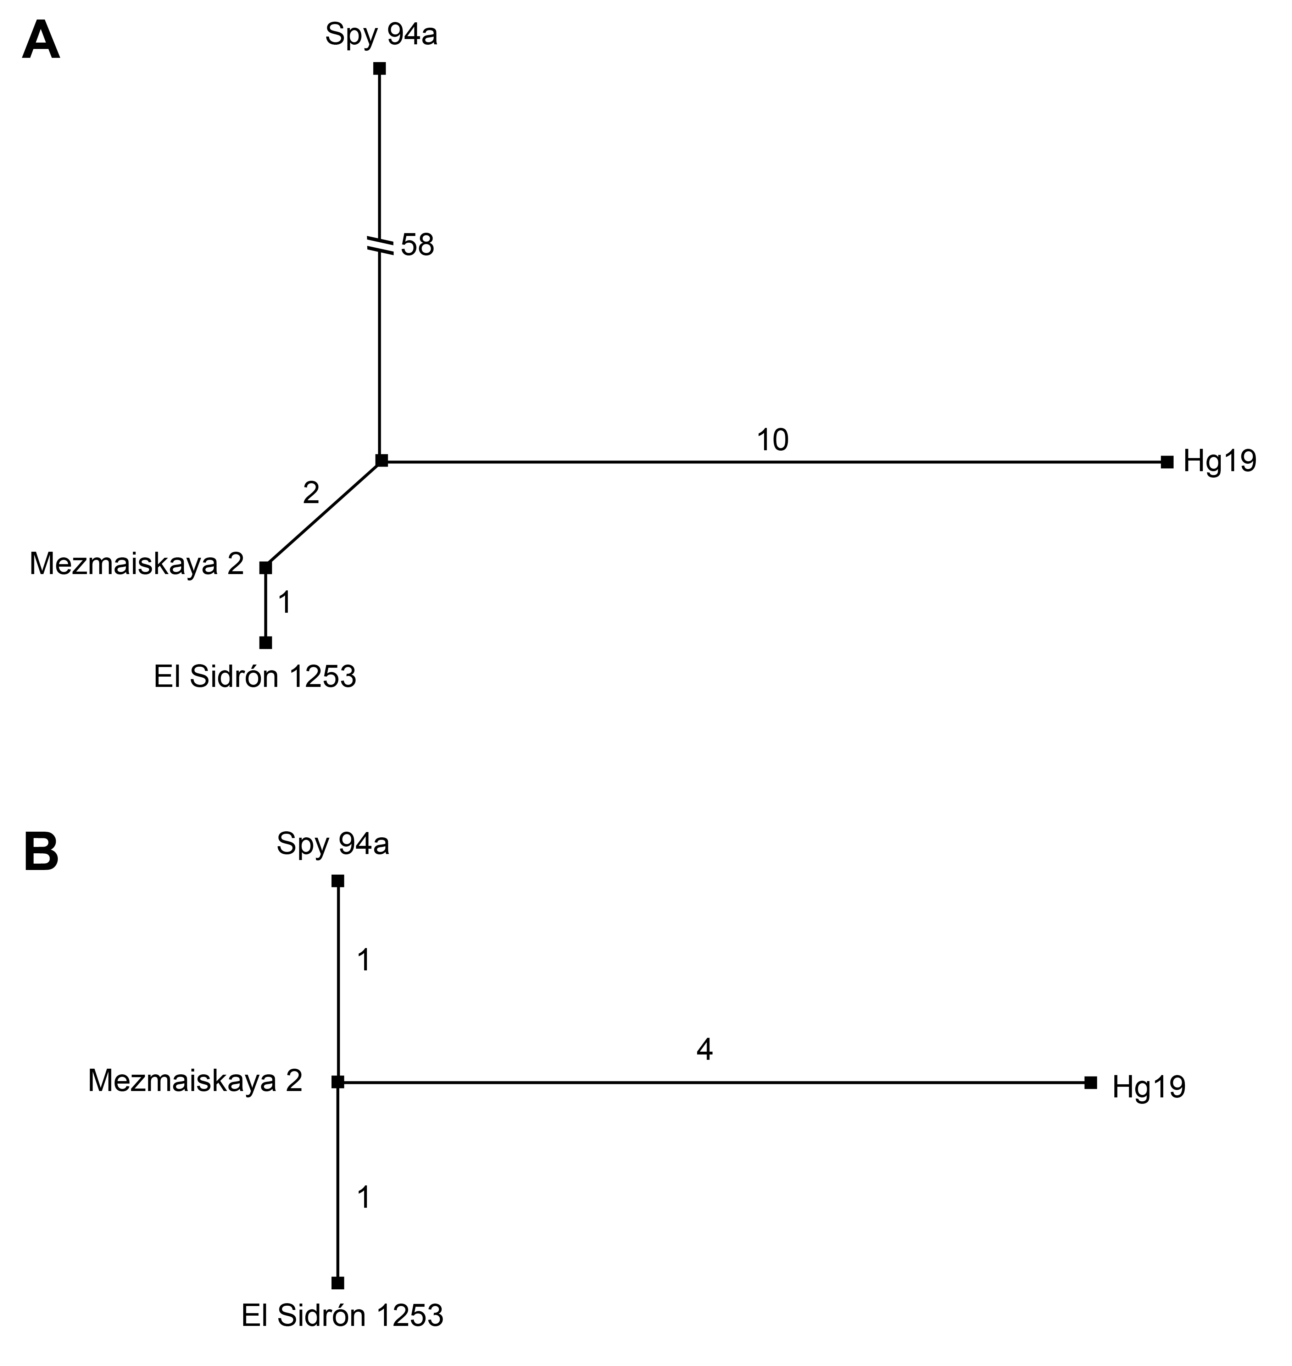

Supplementary Figure S2. Median networks before and after SRmdup with Spy 94a or El Sidrón 1253 excluded. A and B Spy 94a is excluded. The topologies are equal and the numbers of parsimony-informative sites are similar. C and D are El Sidrón 1253 is excluded. Before removing duplicates, the median network shows a reticulation and a much longer pending edge incident with Spy 94a. After removing duplicates, Spy 94a clusters with Mezmaiskaya 2, and only 9 sites separate it from the other taxa.

