Supporting information for

Multiplexed Complementary Signal Transmission for a Self-Regulating Artificial Nervous System

Young Jin Choi,^{1,†} Dong Gue Roe,^{2,†} Yoon Young Choi,¹ Seongchan Kim,³ Sae Byeok Jo,¹ Hwa Sung Lee,⁴ Do Hwan Kim,⁵ Jeong Ho Cho^{1,}*

¹Department of Chemical and Biomolecular Engineering, Yonsei University, Seoul 120-749, Republic of Korea.
²School of Electrical and Electronic Engineering, Yonsei University, Seoul 03722, Republic of Korea.
³SKKU Advanced Institute of Nanotechnology (SAINT), Sungkyunkwan University, Suwon 16419, Korea.
⁴Department of Materials Science and Chemical Engineering, Hanyang University, Ansan 15588, Republic of Korea.
⁵Department of Chemical Engineering, Hanyang University, Seoul 04763, Republic of Korea.

†These authors contributed Equally: Young Jin Choi, Dong Gue Roe.

*Corresponding author: J. H. Cho (jhcho94@yonsei.ac.kr)

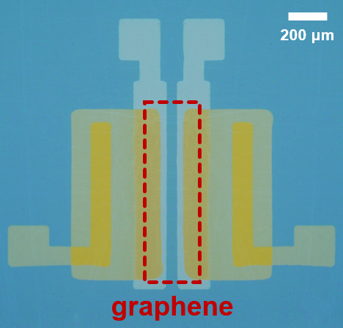
Figure S1. Optical microscopy image of the SIC.

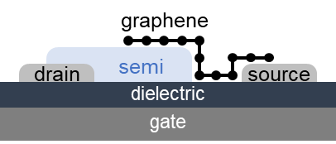
Figure S2. Schematic structure of graphene/n-type semiconductor heterojunction based SBT.

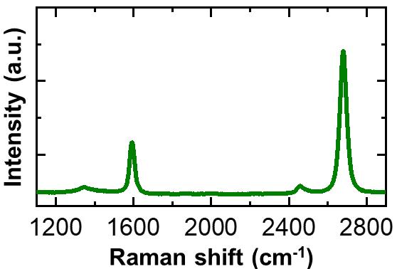
Figure S3. Raman spectrum of monolayer graphene, grown using the CVD method.

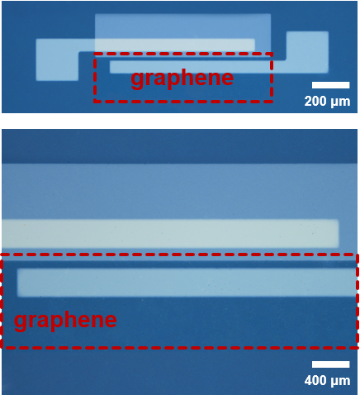
Figure S4. Optical microscopy image of graphene/IGZO based single SBT.

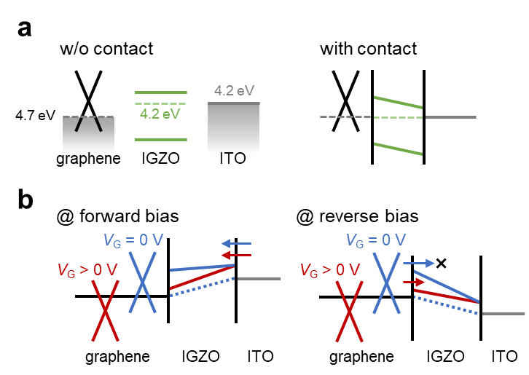
Figure S5. (a) Schematic band diagram of graphene, IGZO and ITO without and with contact. (b) Schematic band diagram of single SBT with V_{G} at forward and reverse bias conditions.

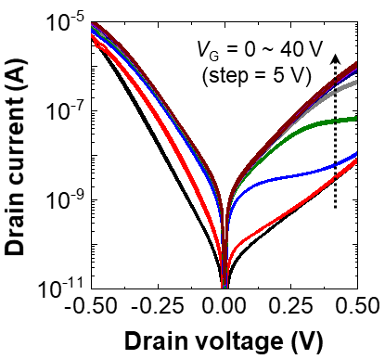
Figure S6. Output characteristic of single SBT under various V_{G} conditions.

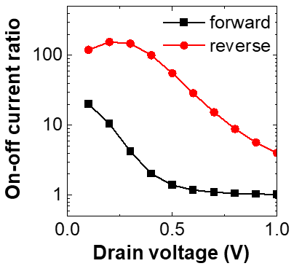
Figure S7. On-off current ratio versus V_{D} plots of forward and reverse bias conditions.

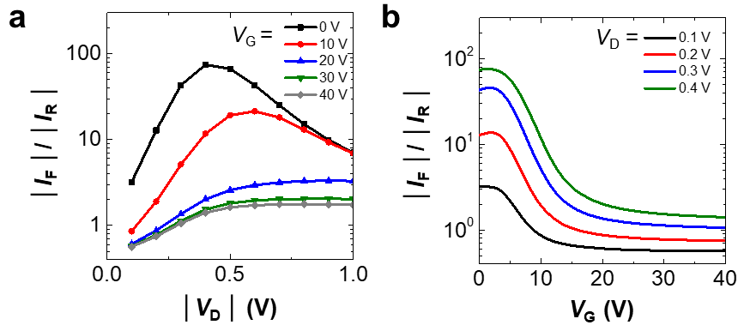
Figure S8. Change in the (a) | V_{D} | and (b) V_{G} dependent rectification ratio under different various bias conditions.

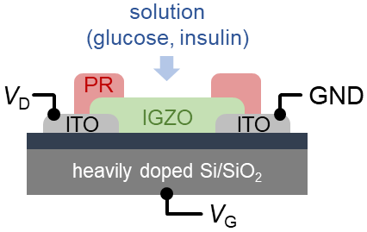
Figure S9. Schematic structure of IGZO based glucose/insulin transistor-type sensor.

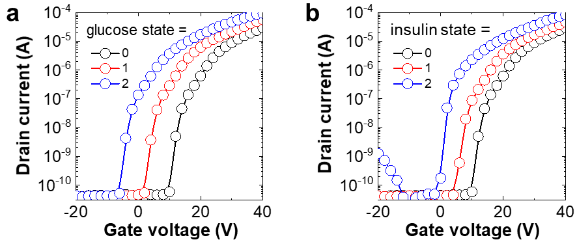
Figure S10. Transfer characteristics of IGZO based sensor under various (a) glucose and (b) insulin states.

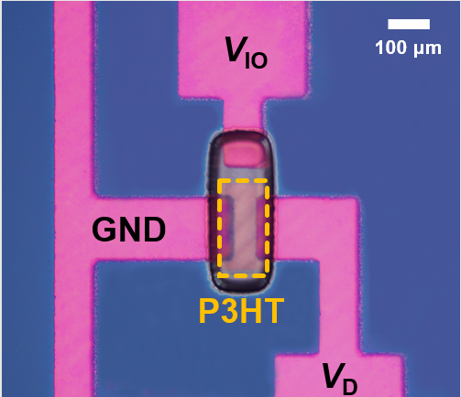
Figure S11. Optical microscopy image of P3HT/ion-gel based AS.

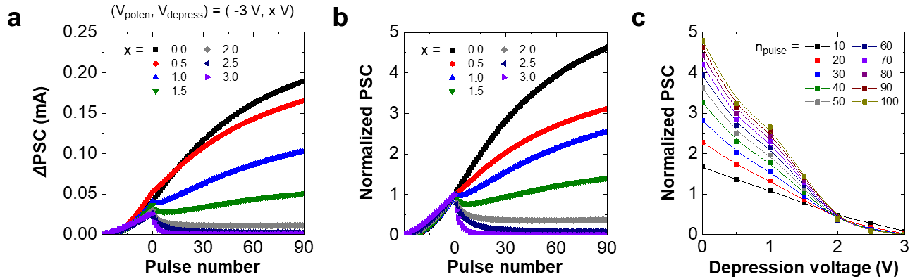
Figure S12. (a) ΔPSC and (b) Normalized PSC versus pulse number plots under an integrated pulse input with various depression voltage values. (c) Normalized PSC versus depression voltage curves for various pulse numbers under integrated pulse application.

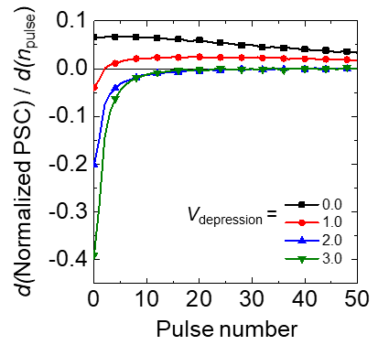
Figure S13. Derivative of normalized PSC under various depression voltages.

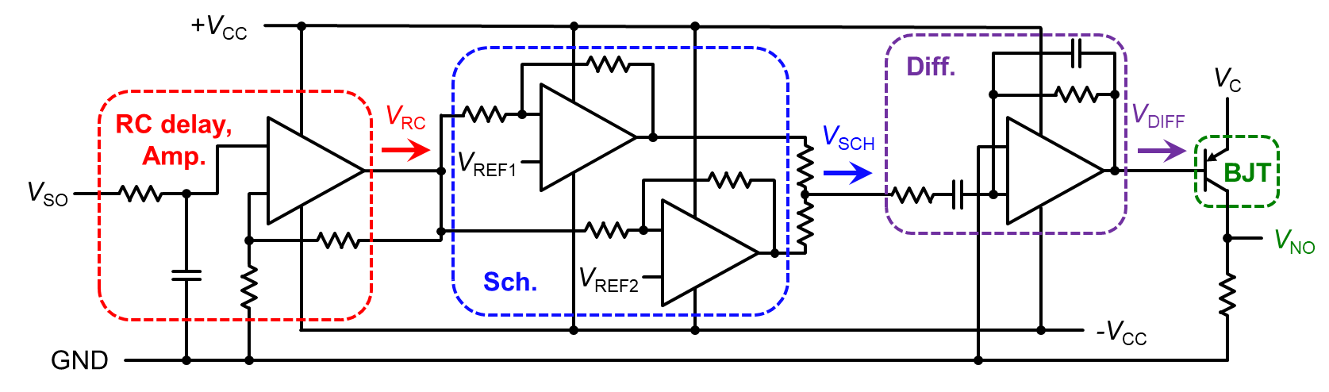
Figure S14. Circuit diagram of double-negative spike generation ANC.

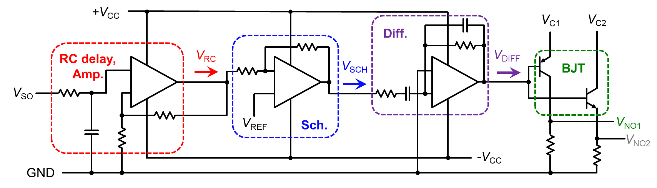
Figure S15. Circuit diagram of complementary spike generation ANC.

