SUPPLEMENTARY MATERIALS
Table of Contents
Supplementary Table 1: Search strategy 2
Supplementary Appendix 1. The modified Quality Assessment of Diagnostic Accuracy Studies-2 (QUADAS-2) checklist used for risk of bias assessment and applicability concern 5
Supplementary Appendix 2. QUADAS 2 and QUADAS-C individual study results 10
Supplementary Figure 1. Forest plot of sensitivity and specificity of PSMA-PET/MRI and mpMRI for the detection of EPE 13
Supplementary Figure 2. Forest plot of sensitivity and specificity of PSMA-PET/MRI and mpMRI for the detection of SVI 14
Supplementary Figure 3. Forest plot of sensitivity and specificity of PSMA-PET and CT for the detection of pelvic lymph node metastasis 15
Supplementary Figure 4. SROC plot of PSMA-PET versus CTAP for the detection of pelvic lymph node metastasis 16
Supplementary Figure 5. Forest plot of sensitivity and specificity of PSMA-PET and BS for the detection of bone metastasis 17
Supplementary Figure 6. SROC plot of PSMA-PET versus BS for the detection of bone metastasis 18
Supplementary Tables 2-4：Heterogeneity analysis 19
Supplementary Tables 5-6：Sensitivity analyses 23

Supplementary Table 1: Search strategy
Pubmed 2304 articles
( "Prostatic Neoplasms"[Mesh] OR "prostate cancer"[Title/Abstract] OR "prostatic cancer"[Title/Abstract] OR "prostate carcinoma"[Title/Abstract] OR "prostatic carcinoma"[Title/Abstract] )
AND
( "Glutamate Carboxypeptidase II"[Mesh] OR "PSMA"[Title/Abstract] OR "prostate specific membrane antigen"[Title/Abstract] OR "prostate-specific membrane antigen"[Title/Abstract] OR "68Ga-PSMA"[Title/Abstract] OR "18F-PSMA"[Title/Abstract] OR "DCFPyL"[Title/Abstract] OR "PSMA-1007"[Title/Abstract] )
AND
( "Positron-Emission Tomography"[Mesh] OR "PET"[Title/Abstract] OR "PET-CT"[Title/Abstract] OR "PET/MRI"[Title/Abstract] OR "positron emission tomography"[Title/Abstract] OR "PSMA-PET"[Title/Abstract] )
AND
( "Neoplasm Staging"[Mesh] OR "stage"[Title/Abstract] OR "staging"[Title/Abstract] OR "lymph node"[Title/Abstract] OR "metastasis"[Title/Abstract] OR "primary staging"[Title/Abstract] )

Embase 2127 articles
(
'prostate tumor'/exp OR 'prostate cancer':ti,ab OR 'prostatic cancer':ti,ab OR 'prostate carcinoma':ti,ab OR 'prostatic carcinoma':ti,ab
)
AND
(
'glutamate carboxypeptidase ii'/exp OR 'psma':ti,ab OR 'prostate specific membrane antigen':ti,ab OR 'prostate-specific membrane antigen':ti,ab OR '68ga-psma':ti,ab OR '18f-psma':ti,ab OR 'dcfpyl':ti,ab OR 'psma-1007':ti,ab
)
AND
(
'positron emission tomography'/exp OR 'pet':ti,ab OR 'pet-ct':ti,ab OR 'pet/mri':ti,ab OR 'positron emission tomography':ti,ab OR 'psma-pet':ti,ab
)
AND
(
'cancer staging'/exp OR 'stage':ti,ab OR 'staging':ti,ab OR 'lymph node':ti,ab OR 'metastasis':ti,ab OR 'primary staging':ti,ab
)

Web of Science
742 articles
TS=("psma-pet" OR "psma pet") AND TS=("prostate cancer" AND (staging OR metastasis) AND (comparative OR accuracy OR "diagnostic performance"))

scopus 1415 articles
TITLE-ABS-KEY ( "psma-pet" OR "psma pet" ) AND TITLE-ABS-KEY ( "prostate cancer" AND (staging OR metastasis) AND (comparative OR accuracy) )
)
Total 6588 articles

Supplementary Appendix 1. The modified Quality Assessment of Diagnostic Accuracy Studies-2 (QUADAS-2) checklist used for risk of bias assessment and applicability concern
Domain 1: Participant Selection
A. RISK OF BIAS: Could selection of patients have introduced bias?
Describe the methods of patient selection briefly:
Signalling Question (SQ)1: Was a consecutive or random sample of patients enrolled? | Yes / No / Unclear
SQ2: Was a case-control/matched cohort design avoided?  Yes: If the study is a paired study (each patient undergoes both tests) or an RCT, please answer “Yes”.  No: If it was clear that a case-control design was adopted (ie. selection for PSMA-PET or conventional imaging was not determined by the study team) but rather subjects are observed and followed up, please answer “No”.  Unclear: If the patient selection procedure was unclear or not reported. | Yes / No / Unclear
SQ3: Did the study avoid inappropriate exclusions?  Inappropriate exclusions would be exclusion of patients who are more or less likely to have disease which may influence the diagnostic accuracy of the test.  Examples of inappropriate exclusions include 1) excluding patients with intermediate to high-risk prostate cancer, 2) patients that underwent radical prostatectomy and pelvic lymph node dissection with histopathological confirmation of cancer, 3) both PSMA-PET and conventional imaging were performed within the same patient population.  Yes: If a high proportion of eligible patients was included without clear selection.  No: If a significant proportion of eligible patients was excluded with clear exclusion criteria or providing a reason.  Unclear: If the inclusion/exclusion criteria was not clearly defined. | Yes/No/Unclear
SUMMARY:  Risk of bias for participant selection:  High risk if ‘No’ for at least one SQ  Low risk if ‘Yes’ for all SQs.  Unclear risk if “Unclear” for at least one SQ | Low risk / High risk / Unclear risk
B. CONCERNS FOR APPLICABILITY OF PATIENT SELECTION DOMAIN

Are there concerns that the included patients and setting do not match the review question?  This is a pragmatic review hence the inclusion criteria are wide. If the study includes patients that fulfil the criteria above, this is “Low concern”. If it does not, this is “High concern”. If insufficient data are reported to make a decision then this is “Unclear concern”. | Low concern / High concern / Unclear concern

Domain 2: Index Test
A. RISK OF BIAS: Could the conduct or interpretation of the index test have introduced bias?
Describe briefly the nature of the PSMA-PET scan/conventional imaging modality (CIM: MRI/CT/Bone Scan), how it was conducted and results interpreted:
SQ1: Was the PSMA-PET scan/CIM performed without knowledge of the results of histopathological results from radical prostatectomy (RP) and pelvic lymph node dissection (PLND), or a composite reference standard (CRS) based on clinical parameters, imaging findings or histopathological evidence available on follow-up?  If both scans were done in the same setting (within 6 months’ interval) and interpreted within a pre-determined time period from the operation, the results from the reference standard are usually masked from the interpreter. In which case, the answer is “Yes”. | Yes / No / Unclear
SQ2: Was the PSMA-PET scan conducted independently of the conduct of histopathological diagnosis?  To answer this question consider both of the following:  - For example, did all patients undergo both PSMA-PET/CIM and histopathological confirmation or CRS, regardless of the circumstances surrounding the performance of the index test? If so, then the answer “Yes”. Otherwise, the answer is “No”.  - Was the PSMA-PET scan interpreter blinded to the results of the reference standard (histopathological diagnosis/CRS)? If not, answer “No”. If not stated, say “Unclear”  If 1) or 2) is “No”, this overrules “Unclear”. | Yes / No / Unclear
B. CONCERNS FOR APPLICABILITY
SUMMARY:  Risk of bias for index test:  Could the conduct or interpretation of the index test have introduced bias?  High risk if ‘No’ for at least one applicable SQ  Low risk if ‘Yes’ for all applicable SQs.  Unclear risk if “Unclear” for at least one applicable SQ. | Low risk / High risk / Unclear risk

Are there concerns that the index test, its conduct, or interpretation differ from the review question?  Given the varying components of CIM (MRI/CT/Bone Scan), each has its own unique acquisition technique and sequence as specified by the authors. If not stated, this is “High Concern”. If all imaging results were interpreted by board-certified radiological expertise in a randomized, blinded fashion with standardized protocol, this is “Low Concern”. If the evaluation setting, equipment technicalities and personnel were not detailed, this is “Unclear Concern”.  All PSMA-PET scan acquisition and readings were obtained with clear delineation of type and dosage of PSMA radiotracer, as well as time elapsed post-radiotracer administration. Board-certified radiological expertise for interpretation with randomized and blinding is also part of the standardized protocol. If this was not detailed, the answer is “High Concern”. If this is stated, the answer is “Low Concern”. If there was no information regarding PSMA-PET scan interpretation, this answer is “Unclear Concern”. | Low concern / High concern / Unclear concern
Domain 3: Reference Standard
A. RISK OF BIAS: Could the conduct or interpretation of the reference standard have introduced bias?
Describe briefly the nature of the reference standard (histopathological results from radical prostatectomy (RP) and pelvic lymph node dissection (PLND), or a composite reference standard (CRS) based on clinical parameters, imaging findings or histopathological evidence available on follow-up), how it was conducted and results interpreted:
SQ1: Was histopathological results or CRS interpreted without knowledge of the results of the PSMA-PET/CIM findings?  If either index tests were done in the same setting (within 6 months’ interval) and interpreted within a pre-determined time period from the operation, the results from the reference standard are usually masked from the interpreter. In which case, the answer is “Yes”. | Yes / No / Unclear
SQ2: Was histopathological confirmation/CRS conducted independently of the conduct of the PSMA-PET scan?  For example, did all patients undergo both index and reference modalities regardless of the circumstances surrounding the performance of the index test? If so, then the answer “Yes”. | Yes / No / Unclear
SUMMARY:  Risk of bias for reference test:  High risk if ‘No’ for at least one applicable SQ  Low risk if ‘Yes’ for all applicable SQs.  Unclear risk if “Unclear” for at least one applicable SQ. (Though “No” for one SQ supersedes “Unclear” if both results present). | Low risk / High risk / Unclear risk
B. CONCERNS FOR APPLICABILITY
Are there concerns that the comparator test, its conduct, or interpretation differ from the review question? | Low concern / High concern / Unclear concern
Domain 4: Flow and Timing
A. RISK OF BIAS: - Could the patient flow have introduced bias?
Describe any patients who did not receive the index or reference test, or who were excluded from the analysis. Describe the interval and any interventions between the index and reference tests.
SQ1: Was the time interval between any of the following combinations of tests less than 6 months?  - PSMA-PET and CT  - PSMA-PET and mpMRI  - PSMA-PET and Bone Scan  - PSMA-PET and Bone Scan + SPECT | Yes / No / Unclear
SQ2: Did all patients receive the same reference test?  Yes: if all participants received at least one of the relevant reference standard (CIM).  No: if only (part of) the index test positives or index test negatives received the complete reference standard.  Unclear: if it was not reported | Yes / No / Unclear
SQ3: Were all patients who underwent testing included in the analysis?  Studies with patients lost to follow-up or patient withdrawal within each, the answer is “No”. | Yes / No / Unclear
SUMMARY:  Risk of bias for flow and timing:  Could the participant flow have introduced bias?  High risk if ‘No’ for at least one SQ  Low risk if ‘Yes’ for all SQs.  Unclear risk if “Unclear” for at least one SQ. (Though “No” for one SQ supersedes “Unclear” if both results present). | Low risk / High risk / Unclear risk

Supplementary Appendix 2. QUADAS 2 and QUADAS-C individual study results
 | Risk of Bias (QUADAS-2) |  |  |  |  | Applicability Concerns (QUADAS-2) |  |  |  | Risk of Bias (QUADAS-C)
 | P | I |  | R | FT | P | I |  | R | P | I | R | FT
 | P | PSMA-PET | mp  MRI/CT/BS | R | FT | P | PSMA-PET | mpMRI/CT/BS
Studies of PSMA-PET versus mpMRI for tumour and nodal staging
Arslan 2020
Celen 2020
Chen 2020
Koseoglu 2020
Skawran 2022
Berger 2018
Pallavi 2020
Van Leeuwen 2019
Park 2018
Malaspina 2021
Kroenke 2019
Szigeti [28]
Petersen 2019
Van Damme 2021
Lebriz 2025
Josefine 2025
Urs 2019
Darshan 2024
Leonie 2023
Erland 2025
Mehmet 2025
Ida 2022
Burcak 2019
Bastiaan 2021
Camila 2023
Jordan 2025
Omar 2023
Trinh 2022
Ziyun 2024
Qing 2017
Frumer 2020
Kulkarni 2020
Anthony 2021
Studies of PSMA-PET versus CT for nodal staging
Hofman 2020
Pienta 2021
Malaspina 2021
Park 2018
Kroenke 2019
Maurer 2016
Studies of PSMA-PET versus BS for bone metastasis staging
Hofman 2020
Zacho 2020
Simsek 2020
Thabo 2018
Janssen 2018
Pyka 2016
Zenus 2023
Duygu 2020
Mikael 2021
Xiongjian 2023

P = patient selection, I = index test, R = reference standard, FT = flow and timing

Low risk of bias/ low concern
High risk of bias/ high concern
Unclear risk of bias/ unclear concern

Supplementary Figure 1. Forest plot of sensitivity and specificity of PSMA-PET/MRI and mpMRI for the detection of EPE
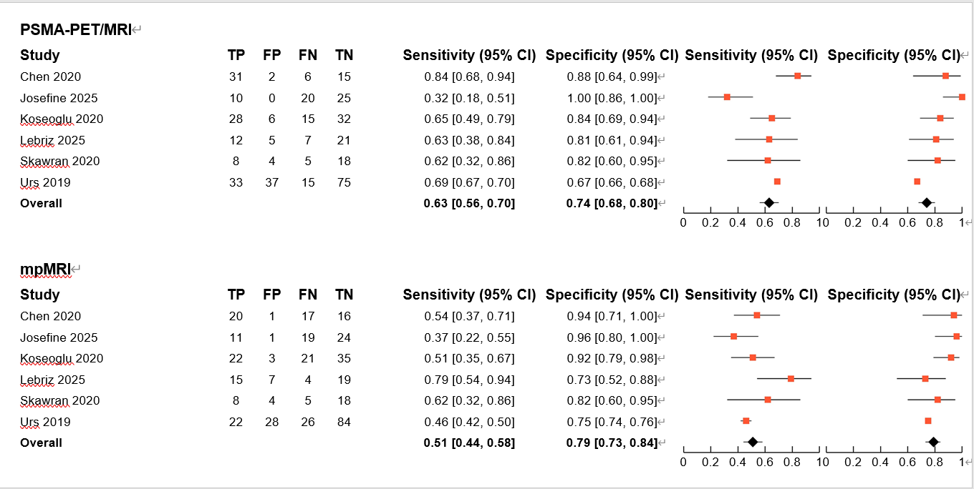

Supplementary Figure 2. Forest plot of sensitivity and specificity of PSMA-PET/MRI and mpMRI for the detection of SVI
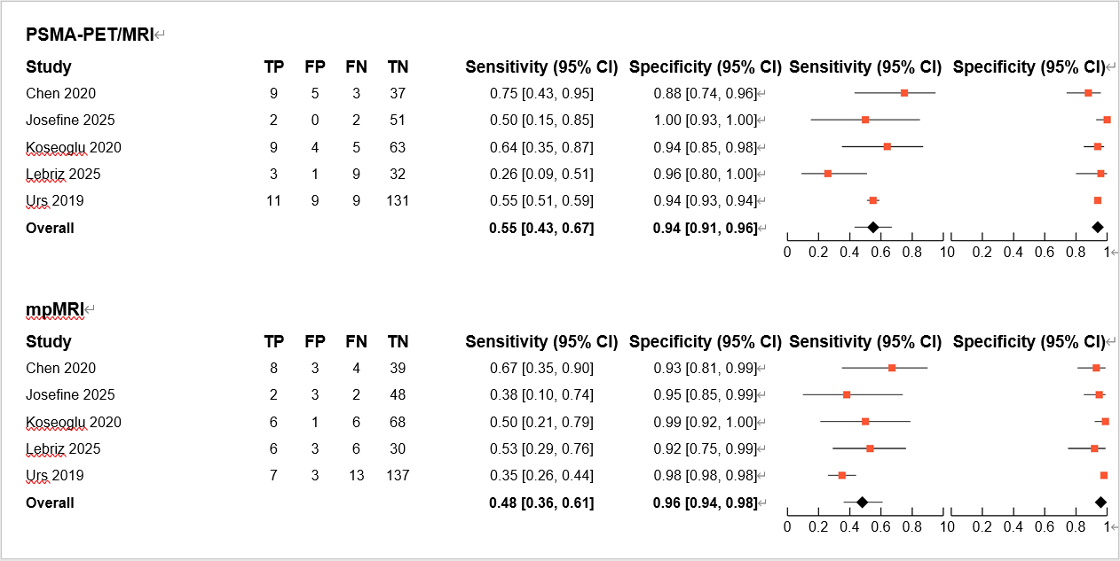

Supplementary Figure 3. Forest plot of sensitivity and specificity of PSMA-PET/MRI and CTAP for the detection of pelvic lymph node metastasis
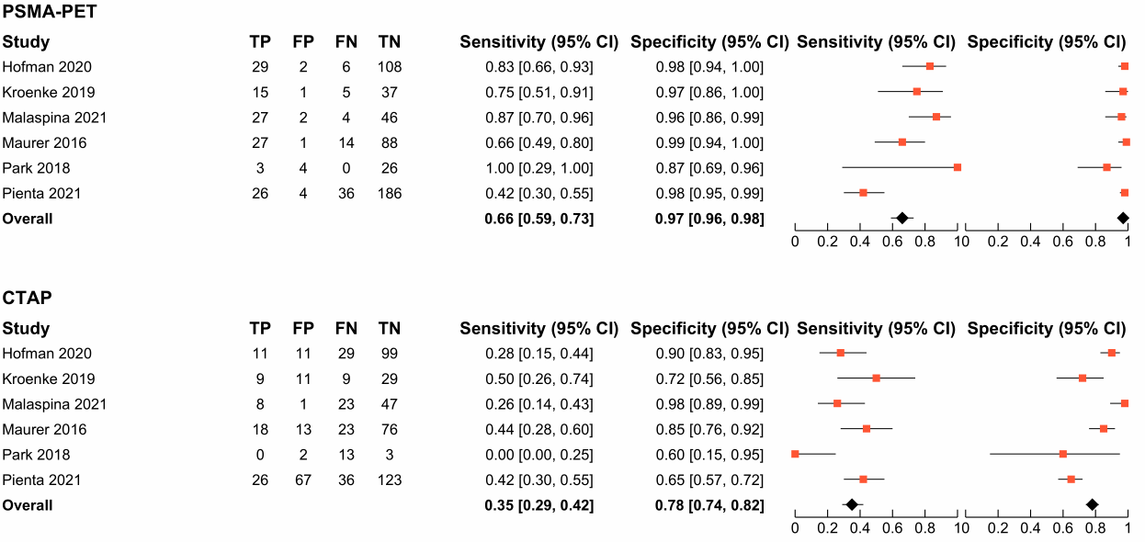

Supplementary Figure 4. Patient-level comparative assessment of pelvic lymph node metastasis detection: Summary receiver operating characteristic (SROC) analysis of prostate-specific membrane antigen positron emission tomography (PSMA-PET) versus computed tomography (CT)
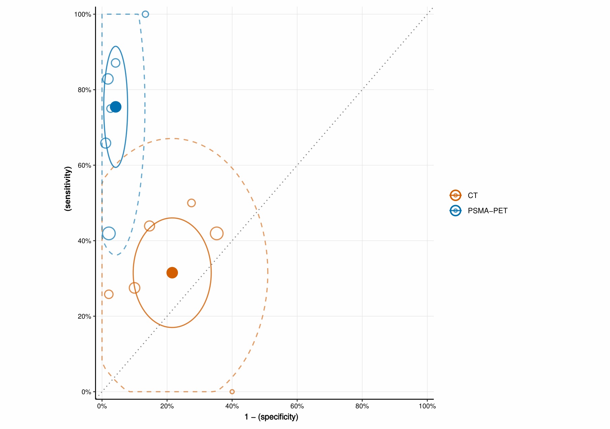
*Based on patient-level analysis, this figure compares the diagnostic accuracy of prostate-specific membrane antigen positron emission tomography (PSMA-PET, blue circles) versus computed tomography (CT, orange circles) for pelvic lymph node metastasis detection. The 95% confidence regions (solid lines) and 95% prediction regions (dashed lines) are displayed. Hollow circles represent individual study estimates of sensitivity and specificity, sized proportionally to study sample size to reflect estimation precision. Solid circles denote pooled estimates (summary points). The 95% confidence regions (solid lines) surrounding each summary point illustrate uncertainty in the pooled estimates, while the 95% prediction regions (dashed lines) indicate the range within which future study results are expected to fall with 95% probability, demonstrating the extent of between-study heterogeneity.

Supplementary Figure 5. Forest plot of sensitivity and specificity of PSMA-PET and bone scintigraphy (BS) for the detection of bone metastasis.
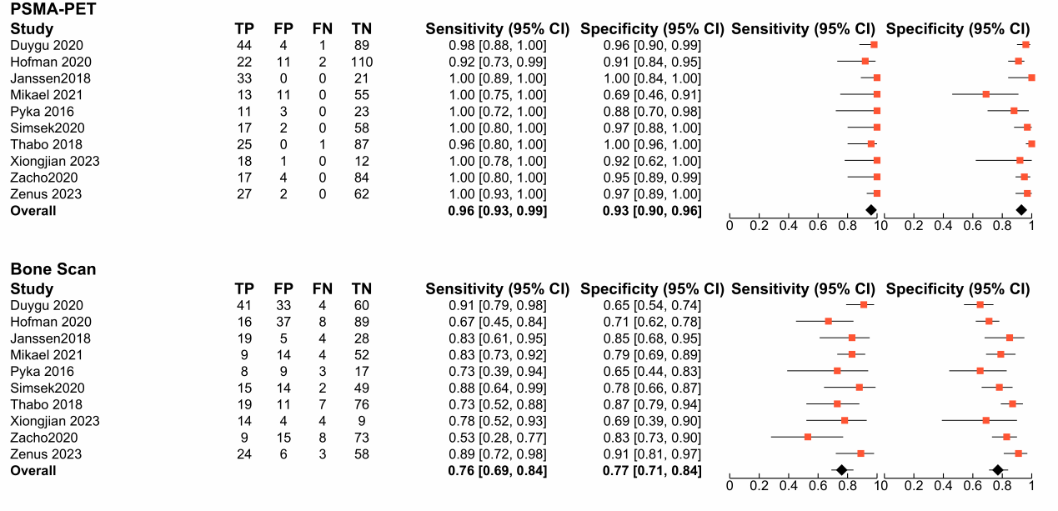

Supplementary Figure 6. Patient-level comparative assessment of bone metastasis detection: Summary receiver operating characteristic (SROC) analysis of prostate-specific membrane antigen positron emission tomography (PSMA-PET) versus bone scintigraphy (BS).
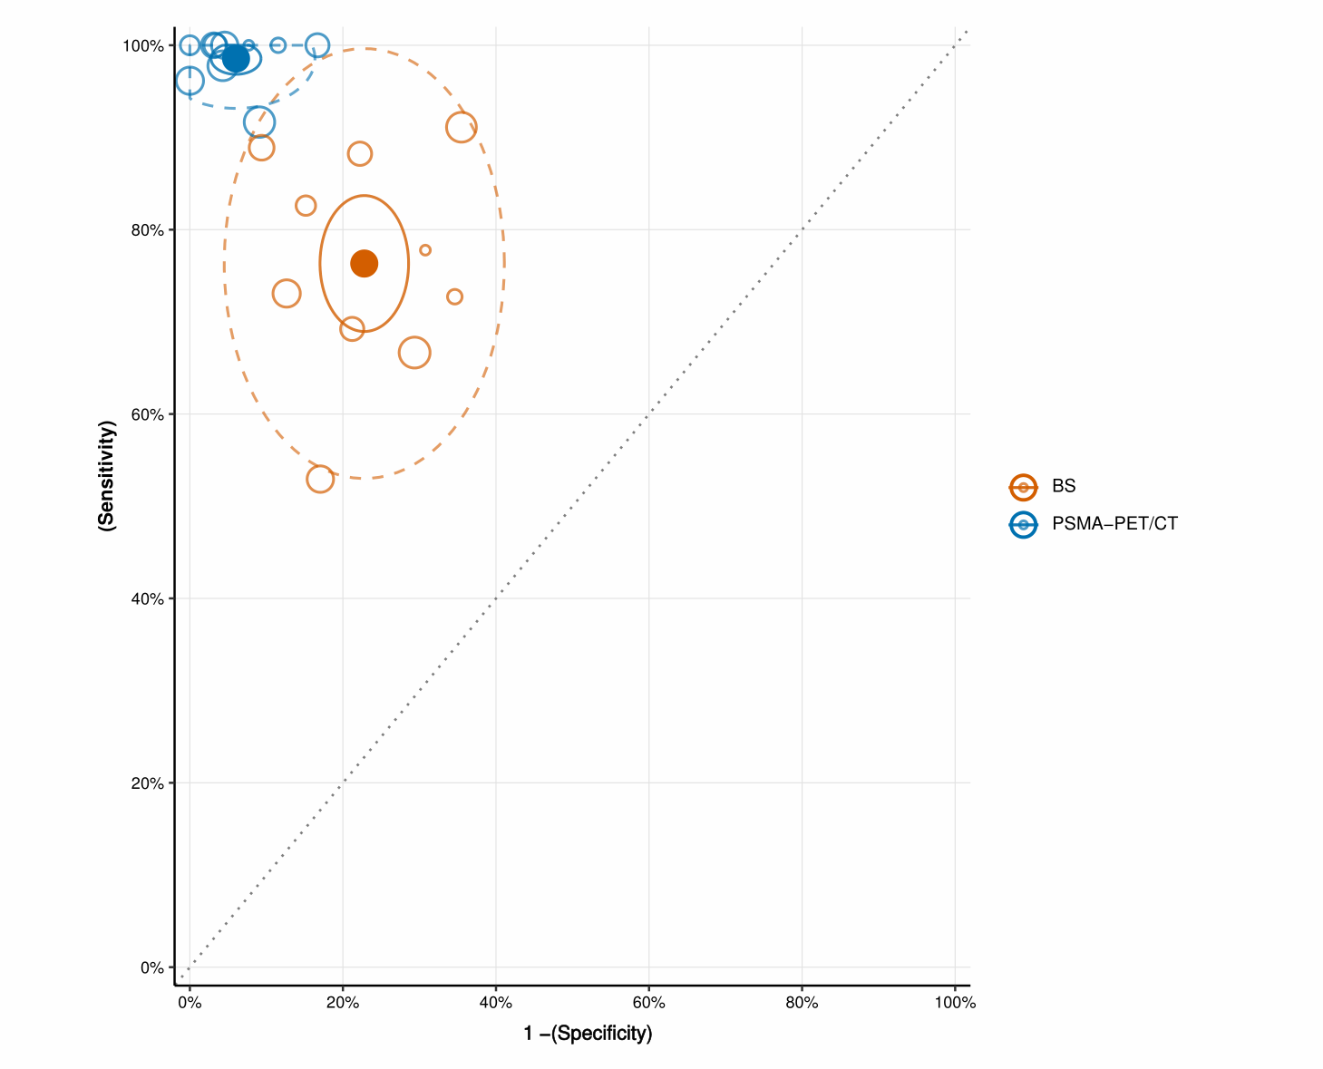

*Based on patient-level analysis, this figure compares the diagnostic accuracy of prostate-specific membrane antigen positron emission tomography (PSMA-PET, blue circles) versus bone scintigraphy (BS, orange circles) for bone metastasis detection. Solid lines represent 95% confidence regions and dashed lines indicate 95% prediction regions. Hollow circles depict individual study estimates of sensitivity and specificity, with sizes proportional to sample size to reflect estimation precision. Solid circles indicate pooled estimates. The 95% confidence regions surrounding each summary point represent uncertainty in pooled estimates, whereas 95% prediction regions illustrate the expected range for future studies with 95% probability, demonstrating between-study heterogeneity.

Supplementary Table 2：Heterogeneity: The Impact of PSMA-PET Scanner Type on the Sensitivity and Specificity of PSMA-PET
Covariate | No. studies | PSMA-PET sensitivity,% (95% CI) | PSMA-PET specificity,% (95% CI)
Tumour staging: patient-level comparison of PSMA-PET v. mpMRI for ECE detection
PSMA-PET/CT | 11 | 51.6 (38.3, 64.9) | 69.1 (58.3, 80.0)
PSMA-PET/MRI | 6 | 63.1 (55.7, 69.9) | 74.1 (67.8, 79.5)
Test for difference by PSMA-PET scanner |  | p<0.01 | p=0.9
Tumour staging: patient-level comparison of PSMA-PET v. mpMRI for SVI detection
PSMA-PET/CT | 10 | 53.6 (41.4, 65.8) | 87.2 (80.6, 93.7)
PSMA-PET/MRI | 5 | 54.8 (42.5, 66.6) | 94.3 (91.3, 96.3)
Test for difference by PSMA-PET scanner |  | p=0.9 | P=0.05
* P values were obtained from likelihood ratio tests

Supplementary Table 3：Heterogeneity: The Impact of Time Interval Between Imaging Modalities on the Sensitivity and Specificity of PSMA-PET and mpMRI
Covariate | No. studies | PSMA-PET sensitivity,% (95% CI) | mpMRI sensitivity,%  (95% CI) | PSMA-PET specificity,% (95% CI) | mpMRI specificity,% (95% CI)
Nodal staging: patient-level comparison of PSMA-PET v. mpMRI
Time interval ≤ 1 month | 6 | 70.8  (56.6, 85.0) | 43.7  (27.8, 59.5) | 92.8(86.3，99.3) | 91.5  (83.3, 99.7)
Absolute difference (95% CI), P value * |  | 27.1 (12.0, 42.2), p<0.001 |  | 1.3 (-5.4, 8.1) p=0.7
Time interval > 1 month | 9 | 66.6 (49.7, 83.6) | 31.8 (15.6, 48.0) | 89.1 (80.1, 98.0) | 89.1 (80.2, 97.9)
Absolute difference (95% CI), P value * |  | 34.8 (22.4, 47.2), p<0.001 |  | 0.00 (-4.7, 4.8), p=1
Test for difference by time interval |  | p=0.08 | p=0.02 | P=0.03 | p=0.25
* P values were obtained from likelihood ratio tests

Supplementary Figure 7. Patient-level comparative assessment of pelvic lymph node metastasis detection in studies with imaging intervals ≤1 month: Summary receiver operating characteristic (SROC) analysis of prostate-specific membrane antigen positron emission tomography (PSMA-PET) versus multiparametric magnetic resonance imaging (mpMRI).

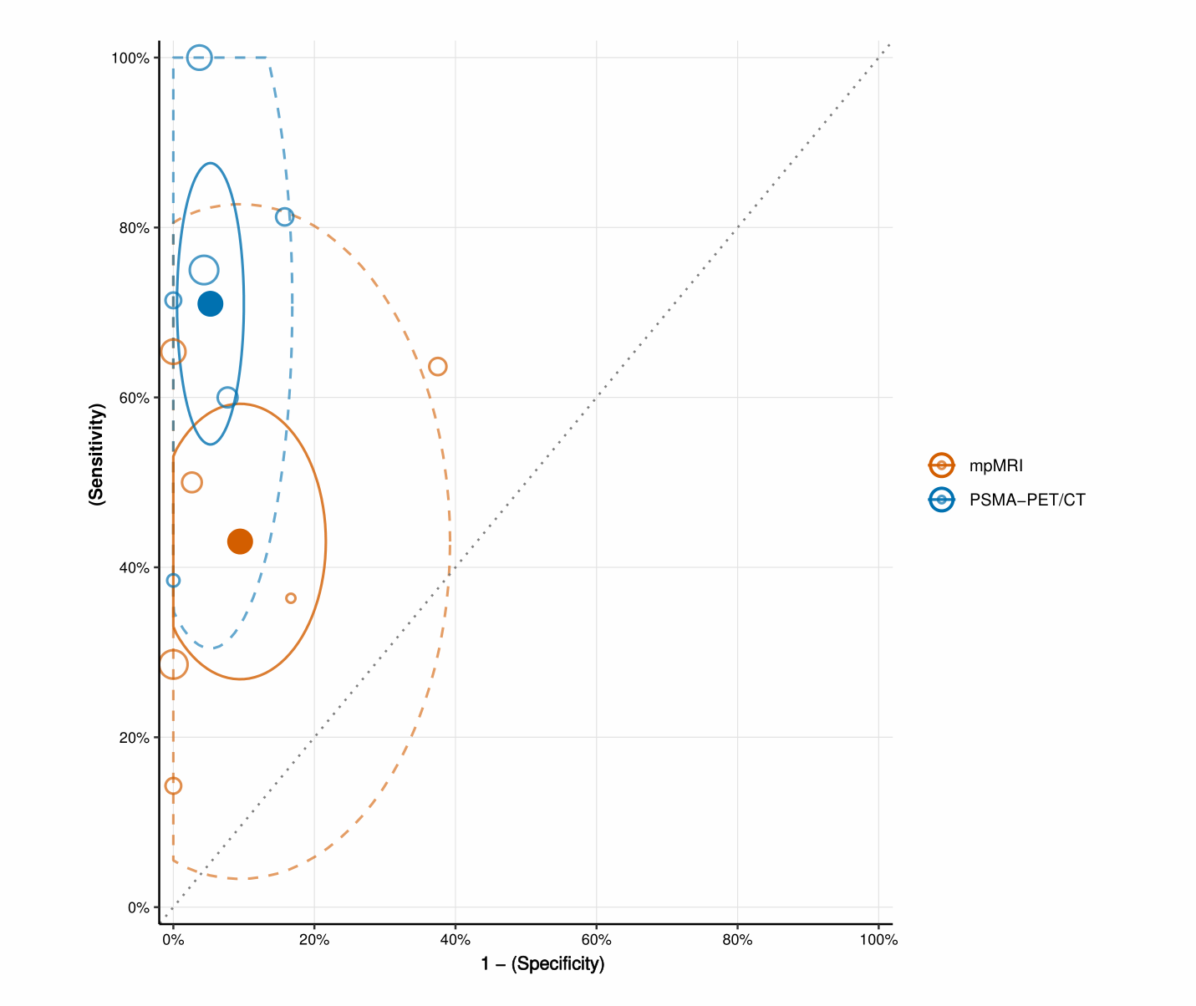
*Based on patient-level analysis, this figure compares the diagnostic accuracy of prostate-specific membrane antigen positron emission tomography (PSMA-PET, blue circles) versus multiparametric magnetic resonance imaging (mpMRI, orange circles) for pelvic lymph node metastasis detection. Hollow circles represent individual study estimates of sensitivity and specificity, scaled by sample size to reflect estimation precision. Solid circles denote pooled estimates (summary points). The 95% confidence regions (solid lines) surrounding each summary point illustrate uncertainty in the pooled estimates, while the 95% prediction regions (dashed lines) indicate the range within which future study results are expected to fall with 95% probability, demonstrating the extent of between-study heterogeneity.

Supplementary Table 4：Heterogeneity: The Impact of Study Design on the Sensitivity and Specificity of PSMA-PET and mpMRI
Covariate | No. studies | PSMA-PET sensitivity,% (95% CI) | CIM sensitivity,%  (95% CI) | PSMA-PET specificity,% (95% CI) | CIM specificity,% (95% CI)
Nodal staging: patient-level comparison of PSMA-PET v. mpMRI
Prospective study | 8 | 68.5 (58.9, 78.2) | 40.4 (30.3, 50.6) | 89.9 (81.9, 97.9) | 86.2 (75.7, 96.8)
Absolute difference (95% CI), P value * |  | 28.1 (15.3, 40.9), p<0.001 |  | 3.7 (-2.8, 10.2), p=0.3
Retrospective study | 10 | 75.2 (59.7, 90.7) | 40.8 (21.1, 60.4) | 91.5 (85.8, 97.2) | 88.3 (80.9, 95.7)
Absolute difference (95% CI), P value * |  | 34.4 (21.7, 47.1), p<0.001 |  | 3.2 (-2.4, 8.8), p=0.3
Test for difference by study design |  | p=0.9 | p=0.9 | p=0.8 | p=0.8
* P values were obtained from likelihood ratio tests

Supplementary Table 5：Diagnostic accuracy of PSMA-PET and mpMRI in studies using 3.0-Tesla MRI only
 | Imaging modality | Studies  ** | Sensitivity,% (95%CI) | Absolute difference in sensitivity  (95% CI), P value * | Specificity,% (95%CI) | Absolute difference in specificity  (95% CI), P value *
Tumour staging: patient-level comparison of PSMA-PET/CT v. mpMRI for EPE detection
All studies | PSMA-PET/CT | 11 | 51.6 (38.3,64.9) | -7.6  (-16.1, 0.9)  p=0.08 | 69.1  (58.3,80.0) | -7.0  (-14.7, 0.8)  p=0.08
All studies | mpMRI | 11 | 59.2  (46.3, 72.1) | -7.6  (-16.1, 0.9)  p=0.08 | 76.1  (67.1, 85.1) | -7.0  (-14.7, 0.8)  p=0.08
3T multiparametric MRI only | PSMA-PET/CT | 8 | 52.3  (36.8, 67.9) | -4.8  (-14.6, 4.9)  p=0.3 | 72.3  (59.3, 85.3) | -8.4  (-17.9, 1.0)  p=0.08
3T multiparametric MRI only | mpMRI | 8 | 57.2  (41.9, 72.5) | -4.8  (-14.6, 4.9)  p=0.3 | 80.8  (70.7, 90.8) | -8.4  (-17.9, 1.0)  p=0.08
Tumour staging: patient-level comparison of PSMA-PET/CT v. mpMRI for SVI detection
All studies | PSMA-PET/CT | 10 | 53.6  (41.4, 65.8) | 2.2  (-8.5, 12.9)  p=0.7 | 87.2  (80.6, 93.7) | -4.0  (-8.3, 0.4), p=0.07
All studies | mpMRI | 10 | 51.4  (39.0, 63.8) | 2.2  (-8.5, 12.9)  p=0.7 | 91.1  (86.5, 95.8) | -4.0  (-8.3, 0.4), p=0.07
3T multiparametric MRI only | PSMA-PET/CT | 6 | 61.5  (48.3, 74.6) | 1.7  (-13.9, 17.2)  P=0.8 | 82.1  (71.3, 92.9) | -6.3  (-13.4, 0.8)  P=0.08
3T multiparametric MRI only | mpMRI | 6 | 59.8  (45.3, 74.4) | 1.7  (-13.9, 17.2)  P=0.8 | 88.4  (80.5, 96.2) | -6.3  (-13.4, 0.8)  P=0.08
Nodal staging: patient-level comparison of PSMA-PET v. mpMRI
All studies | PSMA-PET | 19 | 69.9  (60.3, 79.5) | 30.5  (22.5, 38.6)  p<0.001 | 90.4  (85.8, 94.9) | 1.9  (-1.7, 5.5)  P=0.3
All studies | mpMRI | 19 | 39.4  (28.7, 50.1) | 30.5  (22.5, 38.6)  p<0.001 | 88.5  (83.1, 93.8) | 1.9  (-1.7, 5.5)  P=0.3
3T multiparametric MRI only | PSMA-PET | 11 | 68.8  (54.5, 83.1) | 24.3  (12.1, 36.6)  P<0.001 | 90.3  (84.7, 96.0) | 1.0  (-3.7, 5.6)  P=0.7
3T multiparametric MRI only | mpMRI | 11 | 44.4  (28.0,60.9) | 24.3  (12.1, 36.6)  P<0.001 | 89.4  (83.3,95.4) | 1.0  (-3.7, 5.6)  P=0.7
*P values obtained from likelihood ratio tests
** Refers to number of (a) studies utilising 3T field strength mpMRI only

Supplementary Table 6：Sensitivity Analyses – diagnostic accuracy of PSMA-PET and CIM from studies using 68Ga- or 18F-approved radioligands only
PSMA tracer | Imaging modality | Studies  ** | Sensitivity,% (95%CI) | Absolute difference in sensitivity  (95% CI), P value * | Specificity,% (95%CI) | Absolute difference in specificity  (95% CI), P value *
Tumour staging: patient-level comparison of PSMA-PET/CT v. mpMRI for EPE detection
68Ga*** | PSMA-PET/CT | 7 | 60.0 (40.2,70.1) | -2.9 (-24.2, 18.4)  p=0.8 | 73.1 (45.0, 90.0) | -0.9 (-24.4, 22.6)  p=0.9
68Ga*** | mpMRI | 7 | 62.9 (51.6, 73.0) | -2.9 (-24.2, 18.4)  p=0.8 | 74.0 (66.6, 80.2) | -0.9 (-24.4, 22.6)  p=0.9
18F**** | PSMA-PET/CT | 3 | 52.7 (36.0, 68.8) | -20.7 (-45.1, 3.8)  p=0.1 | 72.9 (47.5, 88.8) | -2.9 (-31.5, 25.7)  p=0.8
18F**** | mpMRI | 3 | 73.4 (51.5, 87.7) | -20.7 (-45.1, 3.8)  p=0.1 | 75.8 (50.8, 90.4) | -2.9 (-31.5, 25.7)  p=0.8
Tumour staging: patient-level comparison of PSMA-PET/CT v. mpMRI for SVI detection
68Ga*** | PSMA-PET/CT | 7 | 52.3 (40.9, 63.5) | -4.3 (-28.4, 19.7)  p=0.7 | 86.3 (73.0, 93.7) | -4.1 (-16.1, 7.9), p=0.5
68Ga*** | mpMRI | 7 | 56.7 (34.2, 76.7) | -4.3 (-28.4, 19.7)  p=0.7 | 90.4 (82.7, 94.9) | -4.1 (-16.1, 7.9), p=0.5
18F**** | PSMA-PET/CT | 3 | 45.6 (15.3, 79.5) | 1.3 (-34.0, 36.6)  P=0.9 | 94.5 (74.1, 99.0) | 2.5 (-10.8, 15.9)  P=0.7
18F**** | mpMRI | 3 | 44.3 (30.0, 59.5) | 1.3 (-34.0, 36.6)  P=0.9 | 92.0 (85.9, 95.6) | 2.5 (-10.8, 15.9)  P=0.7
Nodal staging: patient-level comparison of PSMA-PET v. mpMRI
68Ga*** | PSMA-PET | 15 | 61.0 (49.9, 71.1) | 21.5 (3.0, 40.0)  p<0.001 | 88.7 (82.8, 94.6) | 1.2 (-3.0, 5.4)  P=0.6
68Ga*** | mpMRI | 15 | 39.5 (25.3, 55.6) | 21.5 (3.0, 40.0)  p<0.001 | 87.5 (81.1, 93.9) | 1.2 (-3.0, 5.4)  P=0.6
18F**** | PSMA-PET | 4 | 81.4 (68.9, 89.6) | 36.3 (22.1, 50.5)  P<0.001 | 95.6 (91.8, 97.7) | 0.9 (-12.3, 14.0)  P=0.9
18F**** | mpMRI | 4 | 45.1 (35.5, 55.1) | 36.3 (22.1, 50.5)  P<0.001 | 94.7 (73.6, 99.1) | 0.9 (-12.3, 14.0)  P=0.9
* P values obtained from likelihood ratio tests
** Refers to number of (a) studies utilising 68Ga or 18F
***⁶⁸Ga-PSMA-11 mainly
****¹⁸F-PSMA-1007 mainly

