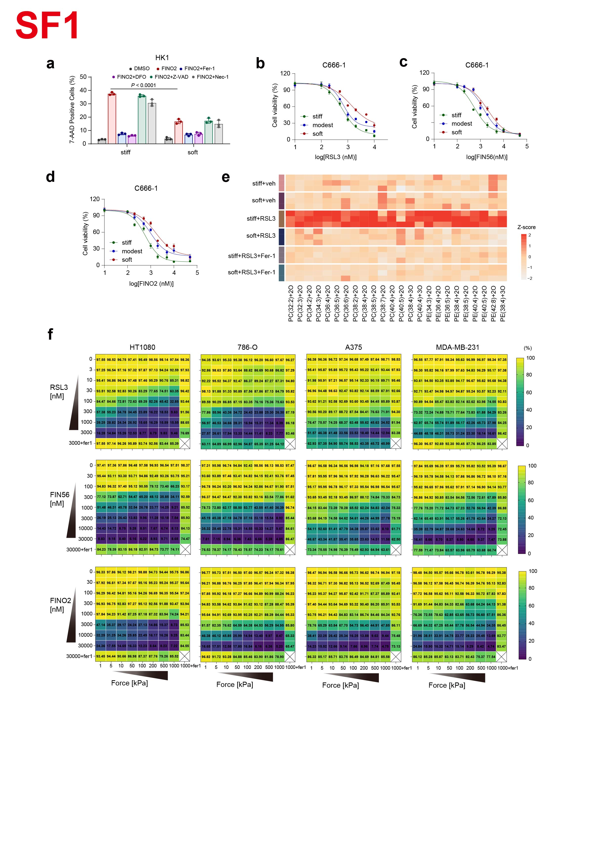Extended Fig.1 Matrix stiffening enhances radiosensitivity by promoting ferroptosis.
a, HK1 cells were cultured on stiff or soft matrices and pretreated with DMSO, Fer-1, DFO, Z-VAD-FMK or necrostatin-1 (Nec-1) before treatment with RSL3 or FIN56. The percentage of dead cells was measured.
b-d, Dose-dependent cell death induced by the ferroptosis inducers RSL3 (b), FIN56 (c) or FINO2 (d) in C666-1 cells cultured on stiff, modest or soft matrices.
e, Heatmap showing LC-MS analysis of the relative changes in RSL3-induced oxygenated PC and PE molecular species in HK1 cells cultured on stiff or soft matrices, with or without Fer-1treatment. Row z-scores were calculated from the averaged abundance of each lipid species.
f, Percentage of dead cells in HT1080, 786-O, A375, and MDA-MB-231 under the indicated treatments. Ferroptosis was induced by RSL3, FIN56 or FINO2 at the indicated concentrations in cells cultured on matrices of different stiffness.

Data are shown as mean ± SD and are representative of at least three independent experiments, two-way ANOVA (a).

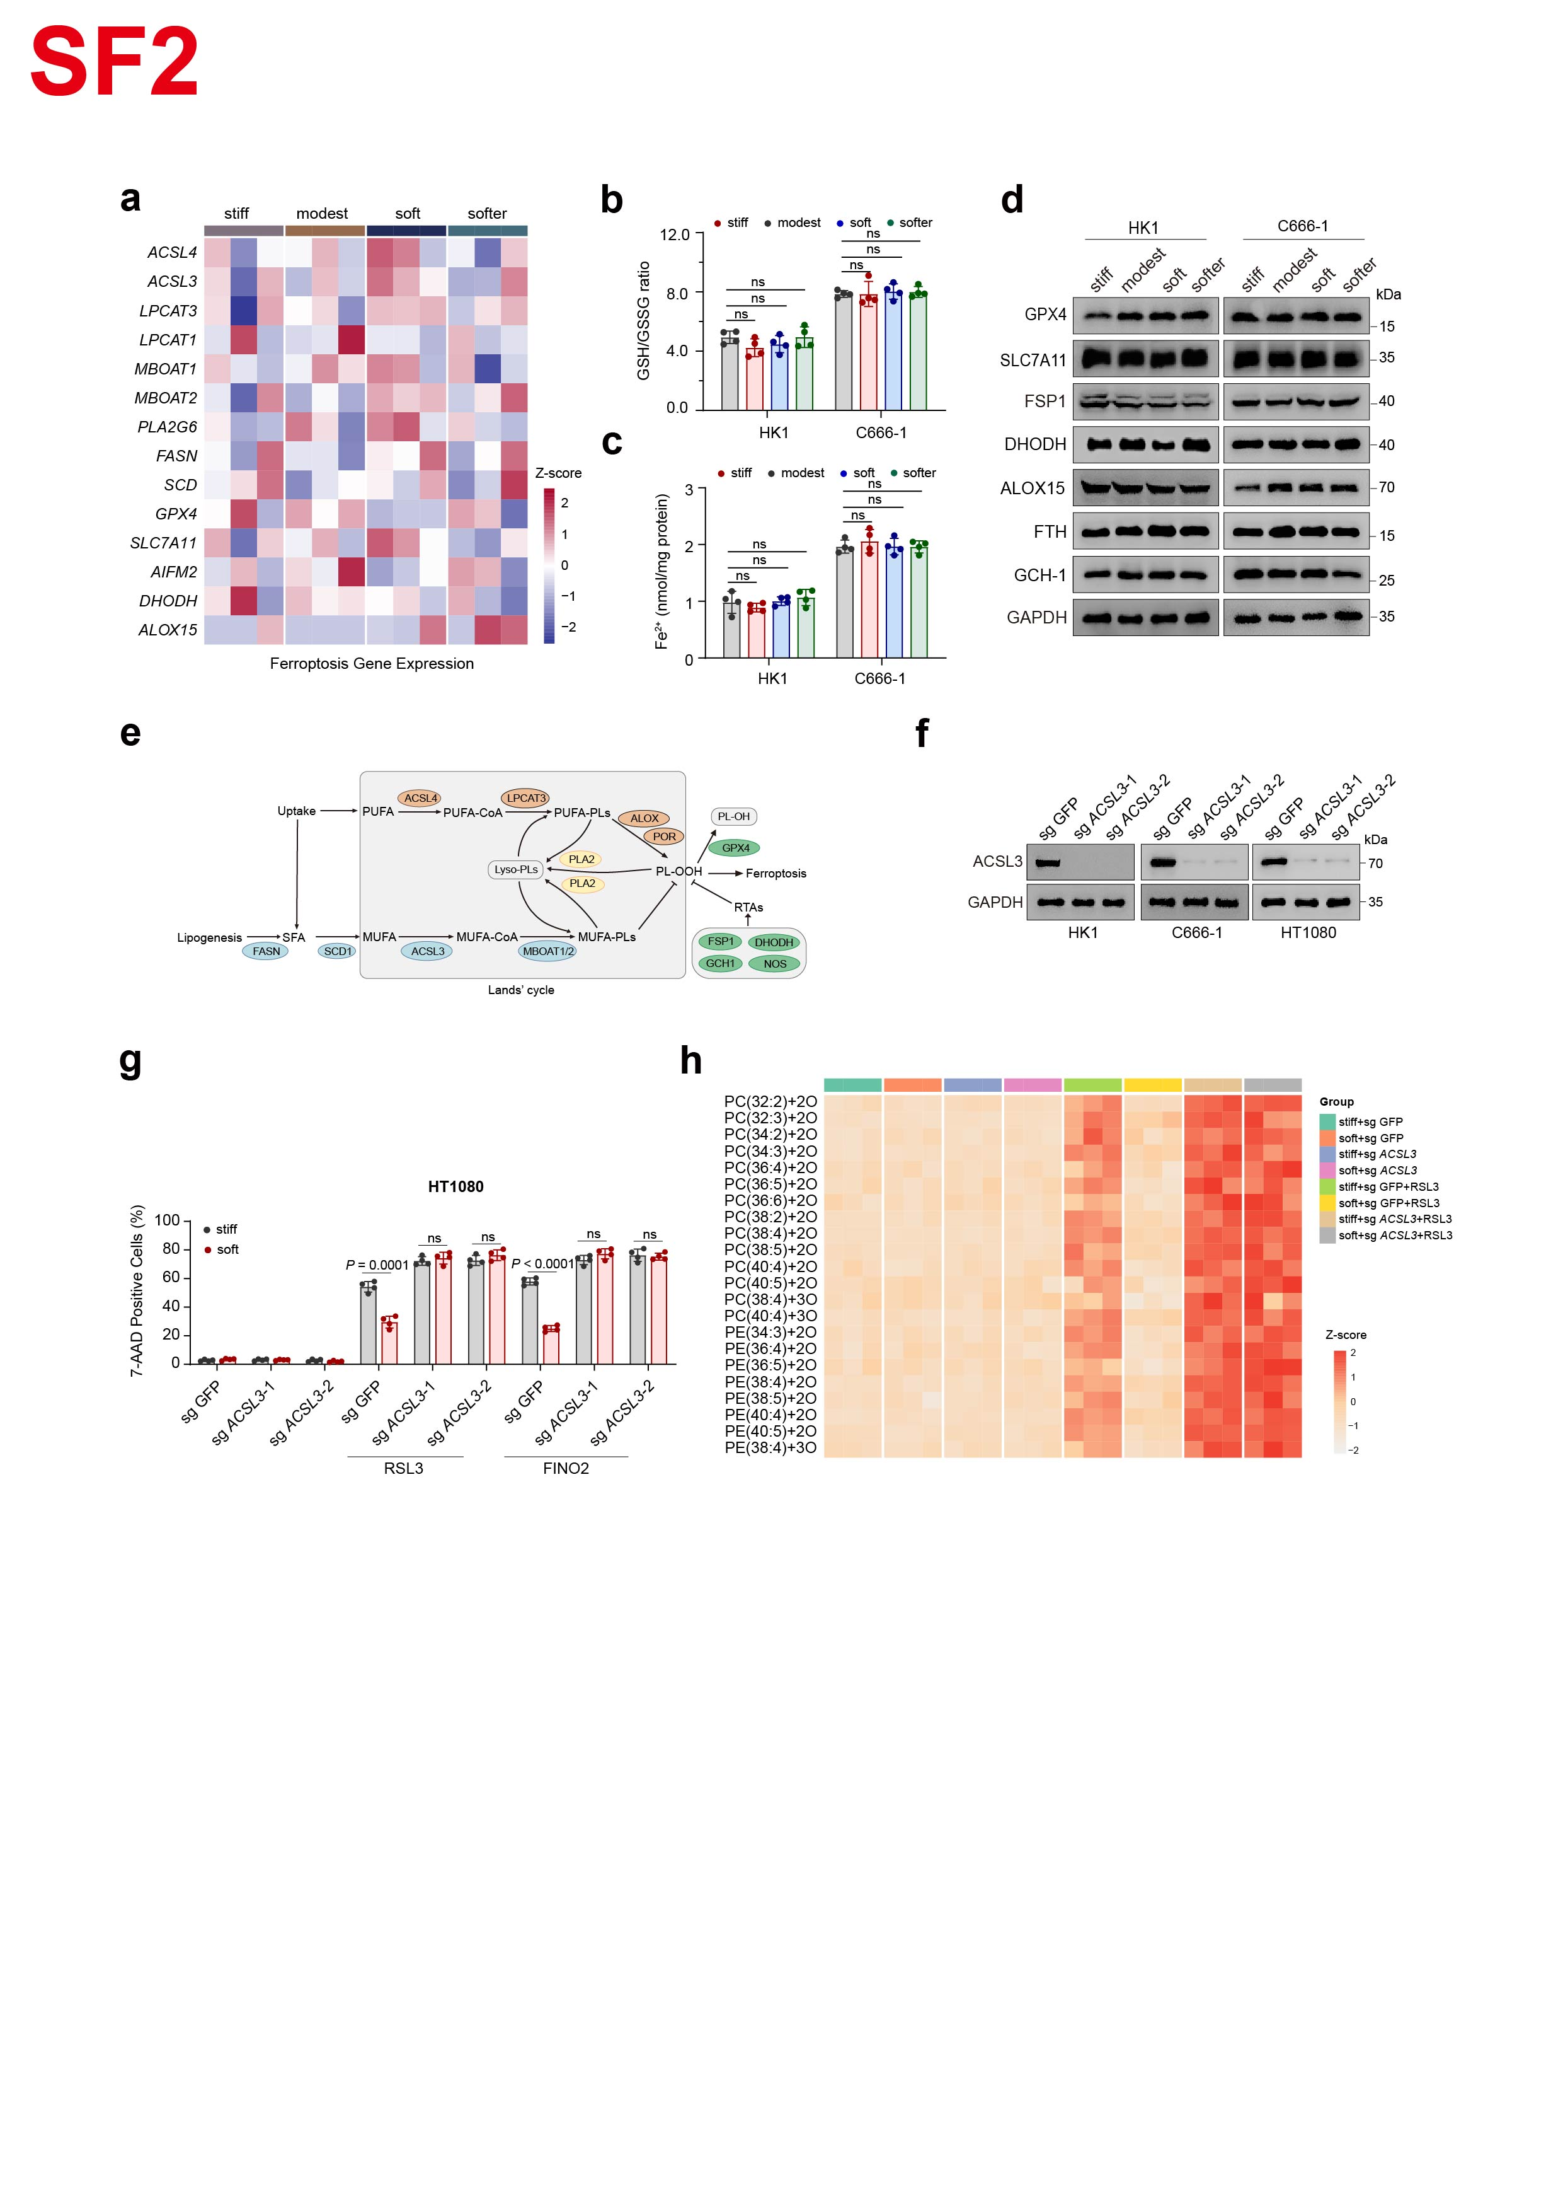Extended Fig.2 Matrix stiffness reshapes tumor cell lipid composition.
a, Heatmap showing the expression of ferroptosis-related genes in HK1 cells cultured on matrices of different stiffness. Row z-scores were calculated from the averaged expression of each gene.
b, GSH/GSSG ratios in HK1 cells cultured on matrices of different stiffness.
c, Cellular ferrous iron levels in HK1 cells cultured on matrices of different stiffness.
d, Immunoblots analysis of GPX4, SLC7A11, FSP1, DHODH, ALOX15, FTH and GCH1 in HK1 and C666-1 cells cultured on matrices of different stiffness.
e, Schematic illustration of the role of ACSL3 in ferroptosis and phospholipid remodeling.
f, Immunoblots analysis confirming ACSL3 knockout efficiency in HK1, C666-1 and HT1080 cells.
g, ACSL3-knockout HT1080 cells and parental cells were cultured on stiff or soft matrices and treated with RSL3 or FINO2. The percentage of dead cells was measured.
h, Heatmap showing LC-MS analysis of the relative abundance of RSL3-induced oxygenated PC and PE molecular species in parental and ACSL3-knockout HK1 cells cultured on stiff or soft matrices. Row z-scores were calculated from the averaged abundance of each lipid species.

Data are shown as mean ± SD and are representative of at least three independent experiments, unpaired two-tailed t-test (g) or one-way ANOVA (b-c). ns, not significant.

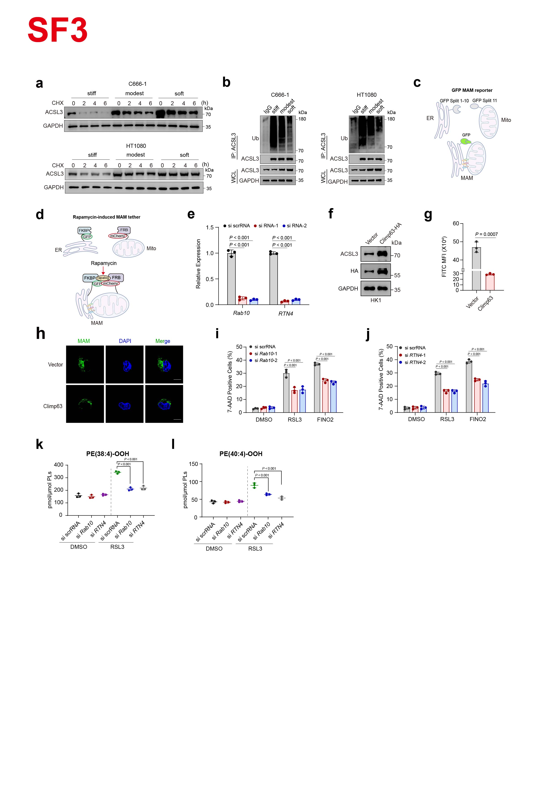Extended Fig.3 MMF regulates MAMs formation and ferroptosis through ER sheet-to-tubule remodeling.
a, Immunoblots analysis of ACSL3 in C666-1 and HT1080 cells cultured on matrices of different stiffness and treated with CHX for the indicated times.
b, C666-1 and HT1080 cells cultured on soft or stiff matrices were subjected to immunoprecipitation with anti-ACSL3 antibody, followed by immunoblotting with anti-Ub antibody.
c, Schematic illustration of the MAM reporter, in which GFP fluorescence is generated upon ER-mitochondria contact formation.
d, Schematic illustration of rapamycin-induced MAMs tethering through FKBP-FRB interaction in chemically inducible MAMs-forming cells.
e, RT-qPCR analysis of Rab10 and RTN4 mRNA expression following the indicated siRNA-mediated silencing.
f, Immunoblots analysis of ACSL3 and climp63 in CLIMP63-HA overexpressing HK1 cells.
g, Flow-cytometric quantification of the GFP-MAM reporter in CLIMP63-HA overexpressing HK1 cells and parental cells.
h, Immunofluorescence images of GFP-MAMs signal in CLIMP63-HA overexpressing HK1 cells and parental cells. Scale bar, 10 μm.
i-j, HK1 cells were subjected to Rab10, or RTN4 silencing before treatment with RSL3 or FINO2. The percentage of dead cells was measured.
k-l, HK1 cells treated with DMSO or RSL3, with or without prior silencing of Rab10 or RTN4. The levels of ferroptosis-associated phospholipid species, including PE (38:4)-OOH and PE (40:4)-OOH, was measured.

Data are shown as mean ± SD and are representative of at least three independent experiments, unpaired two-tailed t-test (g) or one-way ANOVA (e, i-l).

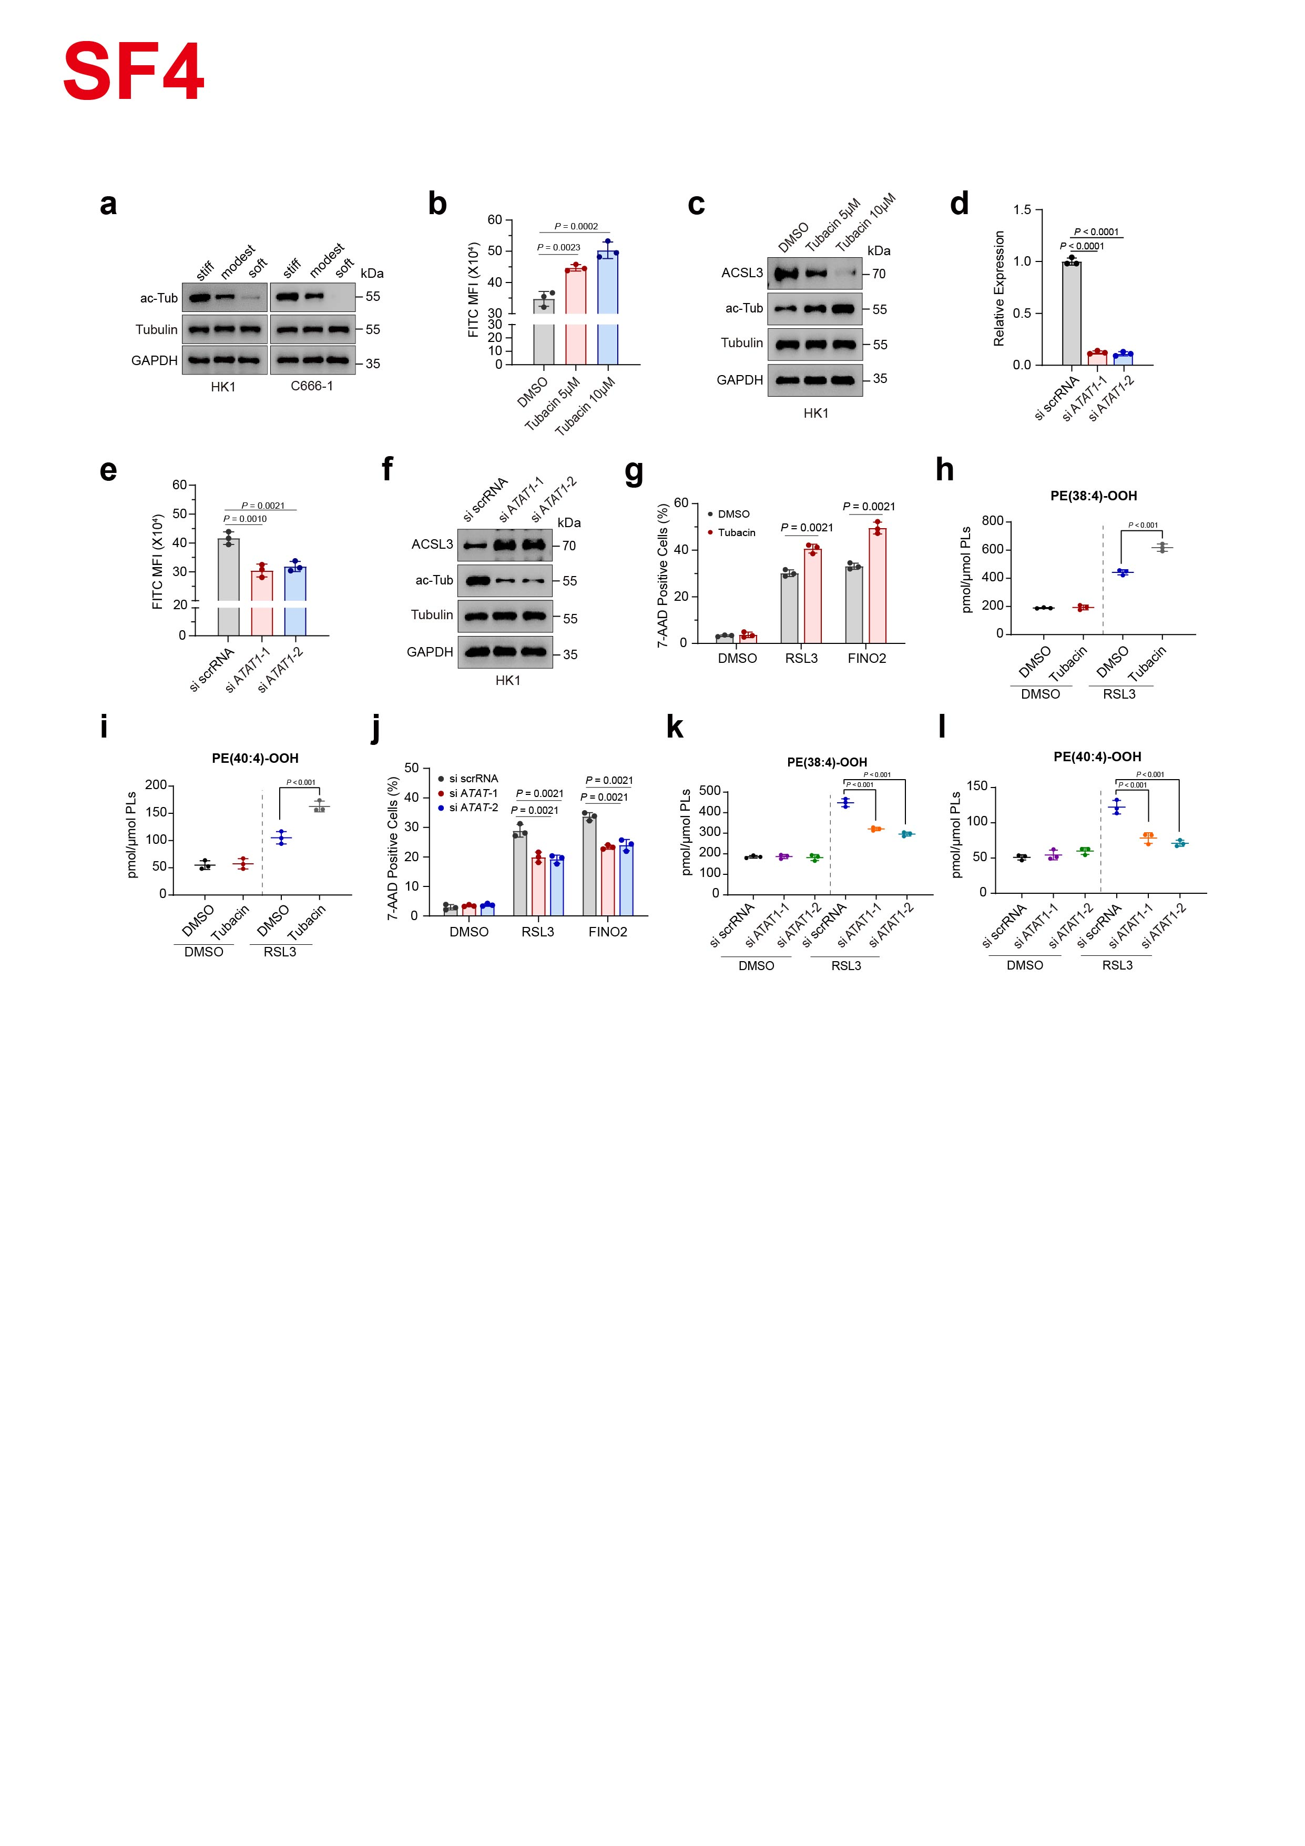Extended Fig.4 Microtubule acetylation regulates MAMs formation and ferroptosis.
a, Immunoblots analysis of tubulin and acetylated tubulin in HK1 and C666-1 cells cultured on matrices of different stiffness.
b, Flow-cytometric quantification of the GFP-MAM reporter in HK1 cells treated with DMSO or tubacin.
c, Immunoblot analysis of tubulin, acetylated tubulin and ACSL3 in HK1 cells treated with DMSO or tubacin.
d, RT-qPCR analysis of ATAT1 mRNA expression following the indicated siRNA-mediated silencing.
e, Flow-cytometric quantification of the GFP-MAM reporter in HK1 cells subjected to ATAT1 silencing.
f, Immunoblot analysis of tubulin, acetylated tubulin and ACSL3 in HK1 cells cultured on stiff matrices following ATAT1 silencing.
g, HK1 cells were pretreated with vehicle or tubacin before exposure to RSL3 or FINO2. The percentage of dead cells was measured.
h-i, Levels of the ferroptosis-associated phospholipid species PE (38:4)-OOH (h) and PE (40:4)-OOH (i) in HK1 cells treated with DMSO or RSL3, with or without prior tubacin treatment.
j, HK1 cells were subjected to ATAT1 silencing before exposure to RSL3 or FINO2. The percentage of dead cells was measured.
k-l, Levels of the ferroptosis-associated phospholipid species PE (38:4)-OOH (k) and PE (40:4)-OOH (l) in HK1 cells treated with DMSO or RSL3, with or without prior ATAT1 silencing.

Data are shown as mean ± SD and are representative of at least three independent experiments, unpaired two-tailed t-test (g) or one-way ANOVA (b, d-e, h-l).

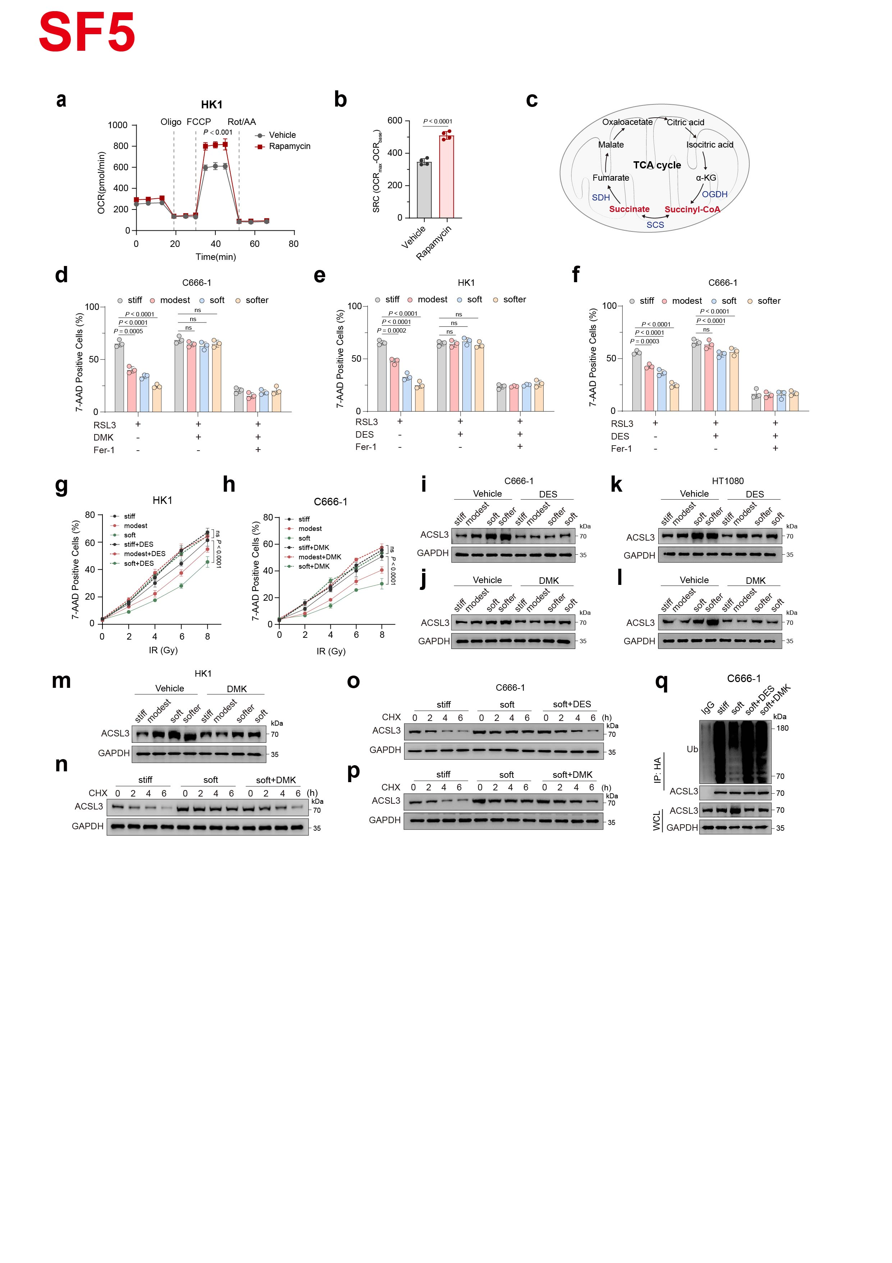Extended Fig.5 Mitochondrial succinate accumulation regulates ferroptosis by promoting ACSL3 degradation.
a, Oxygen consumption rate (OCR) of HK1 cells treated with vehicle or rapamycin. Oligo (oligomycin), FCCP and Rot/AA (rotenone and antimycin A) were used to determine the basal respiration, ATP-coupled respiration, maximal respiratory capacity and non-mitochondrial oxygen consumption. n = 4.
b, Spare respiratory capacity (SRC) of HK1 cells treated with vehicle or rapamycin.
c, Schematic illustration of the tricarboxylic acid (TCA) cycle.
d, C666-1 cells were cultured on matrices of different stiffness and treated with RSL3 alone, RSL3 plus DMK, or RSL3 plus DMK and Fer-1. The percentage of dead cells was measured.
e-f, HK1 cells (e) or C666-1 cells (f) were cultured on matrices of different stiffness and treated with RSL3 alone, RSL3 plus DES, or RSL3 plus DES and Fer-1. The percentage of dead cells was measured.
g-h, HK1 cells (g) or C666-1 cells (h) were cultured on matrices of different stiffness, treated with or without DES, and exposed to the indicated doses of irradiation. The percentage of dead cells was measured.
i-j, Immunoblots analysis of ACSL3 in C666-1 cells cultured on matrices of different stiffness and treated with DES (i), DMK (j) or vehicle.
k-l, Immunoblots analysis of ACSL3 in HT1080 cells cultured on matrices of different stiffness and treated with DES (k), DMK (l) or vehicle.
m, Immunoblots analysis of ACSL3 in HK1 cells cultured on matrices of different stiffness and treated with DMK or vehicle.
n, Immunoblots analysis of ACSL3 in HK1 cells cultured on stiff or soft matrices, with or without DMK supplementation, and treated with CHX for the indicated times.
o-p, Immunoblots analysis of ACSL3 in C666-1 cells cultured on stiff or soft matrices, with or without DES (o) or DMK (p), and treated with CHX for the indicated times.
q, Cell lysates from HA-ACSL3-WT-overexpressing C666-1 cells cultured on stiff or soft matrices, with or without DES or DMK supplementation, were subjected to immunoprecipitation with anti-HA antibody, followed by immunoblotting with anti-Ub antibody.

Data are shown as mean ± SD and are representative of at least three independent experiments, unpaired two-tailed t-test (a-b), one-way ANOVA (d-f) or two-way ANOVA (g-h).

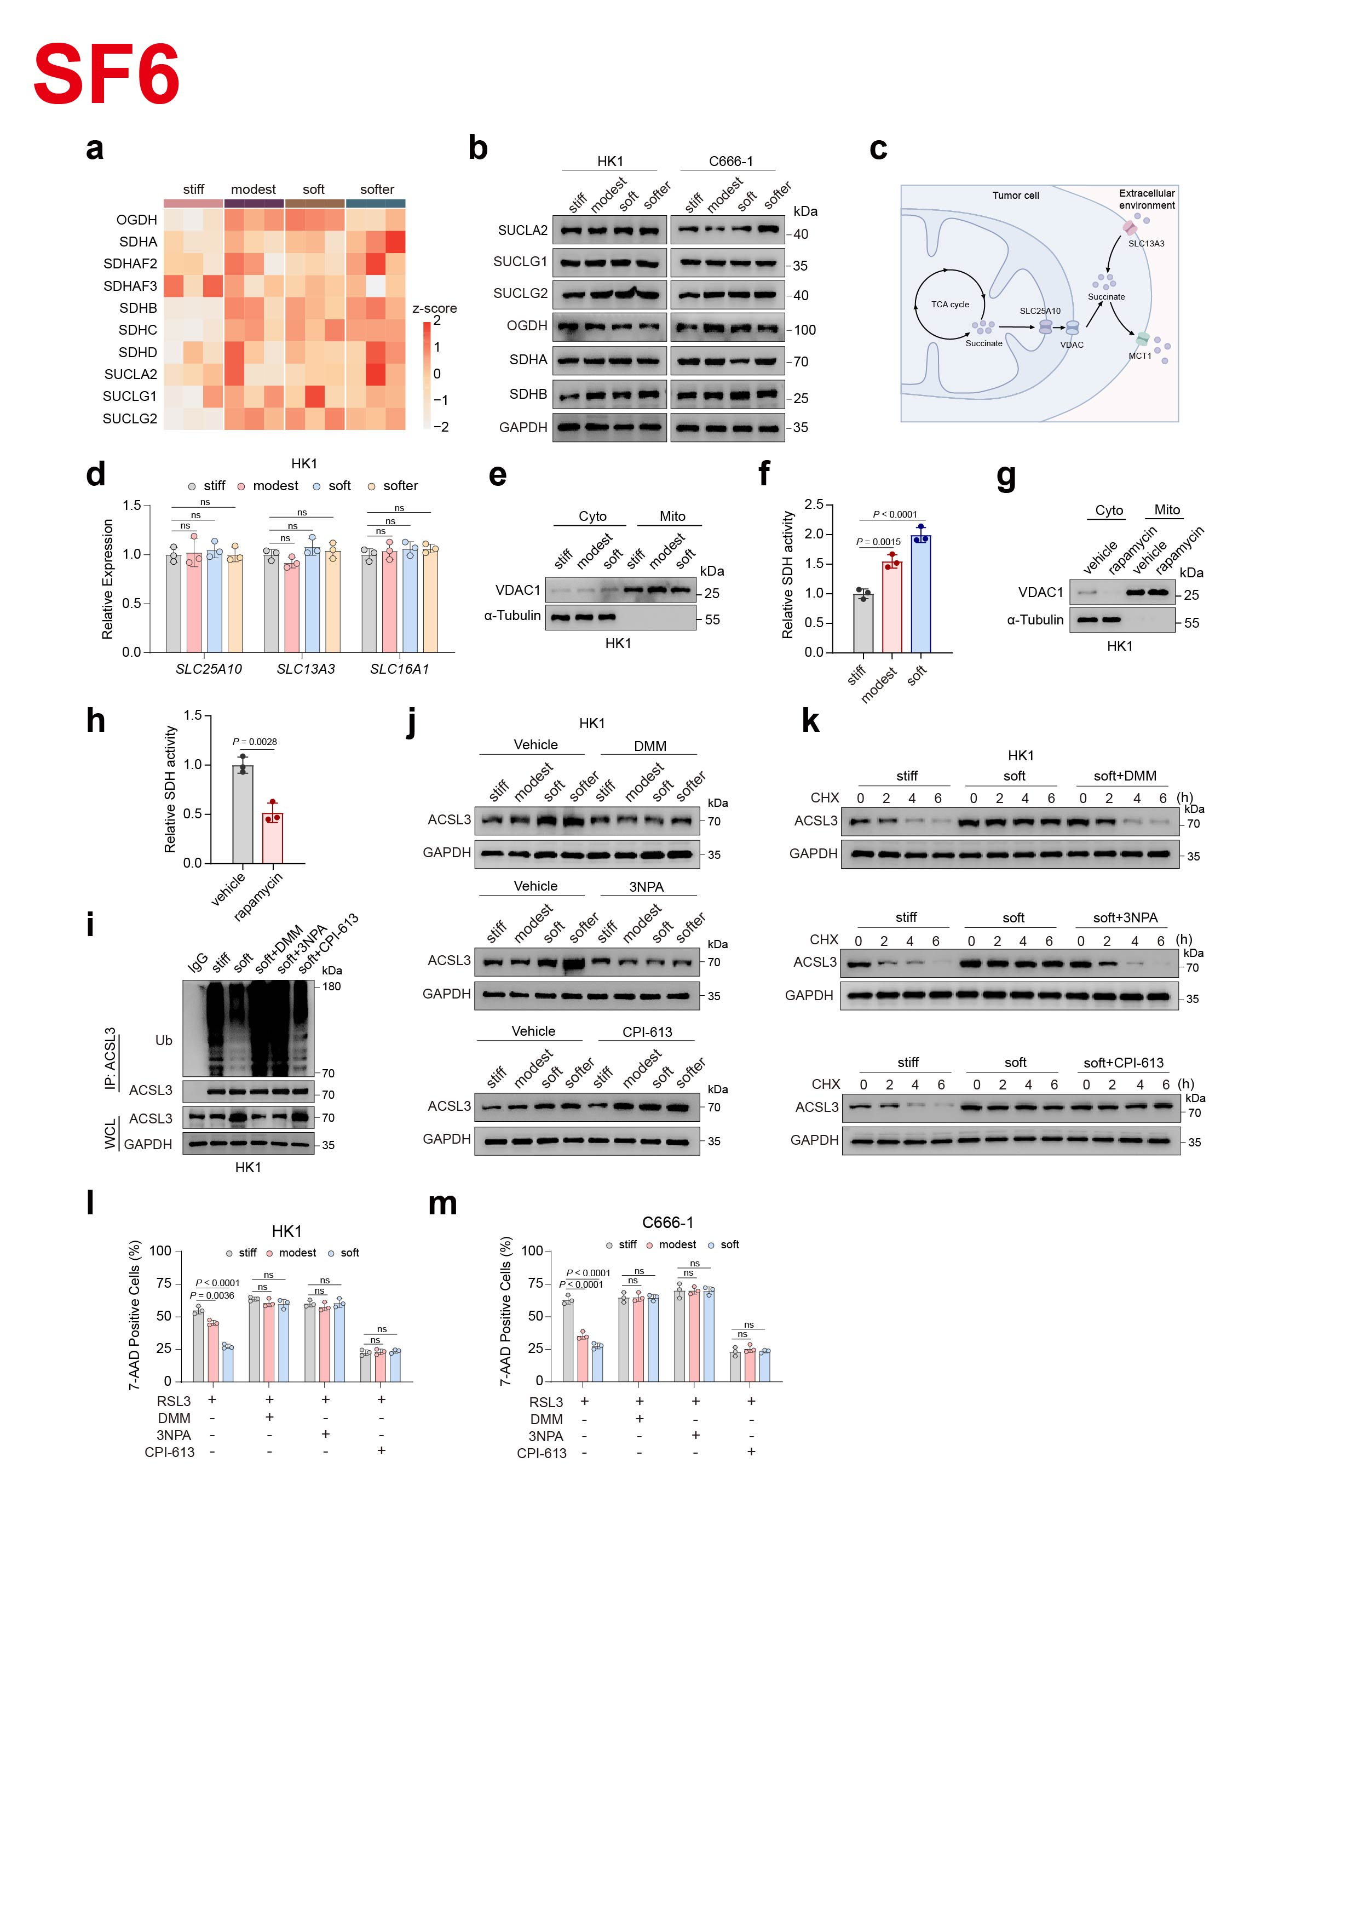Extended Fig.6 MMF regulates mitochondrial succinate metabolism by impairing SDH activity.
a, Proteomic profiling of succinate-associated metabolic enzymes in HK1 cells cultured on matrices of different stiffness. Row z-scores were calculated from the averaged abundance of each protein.
b, Immunoblot analysis of succinate-associated metabolic enzymes in HK1 and C666-1 cells cultured on matrices of different stiffness.
c, Schematic illustration of cellular succinate metabolism.
d, RT-qPCR analysis of SLC25A10, SLC13A3 and SLC16A1 (encoding MCT1 protein) mRNA expression in HK1 cells cultured on matrices of different stiffness.
e, Immunoblot analysis of VDAC1 in mitochondrial and cytoplasmic fractions from HK1 cells cultured on matrices of different stiffness.
f, Relative SDH activity in HK1 cells cultured on matrices of different stiffness.
g, Immunoblot analysis of VDAC1 in mitochondrial and cytoplasmic fractions from HK1 cells treated with vehicle or rapamycin.
h, Relative SDH activity in HK1 cells treated with vehicle or rapamycin.
i, Cell lysates from HK1 cells cultured on stiff or soft matrices, with or without DMM, 3-NPA or CPI-613 supplementation, were subjected to immunoprecipitation with anti-ACSL3 antibody, followed by immunoblotting with anti-Ub antibody.
j, Immunoblot analysis of ACSL3 in HK1 cells cultured on matrices of different stiffness and treated with DMM, 3-NPA, CPI-613 or vehicle.
k, Immunoblot analysis of ACSL3 in HK1 cells cultured on stiff or soft matrices, with or without DMM, 3-NPA or CPI-613, and treated with CHX for the indicated times.
l-m, HK1 cells (l) or C666-1 cells (m) were cultured on matrices of different stiffness and treated with RSL3 alone, RSL3 plus DMM, RSL3 plus 3-NPA, or RSL3 plus CPI-613.The percentage of dead cells was measured.

Data are shown as mean ± SD and are representative of at least three independent experiments, unpaired two-tailed t-test (h) or one-way ANOVA (d, f, l-m). ns, not significant.

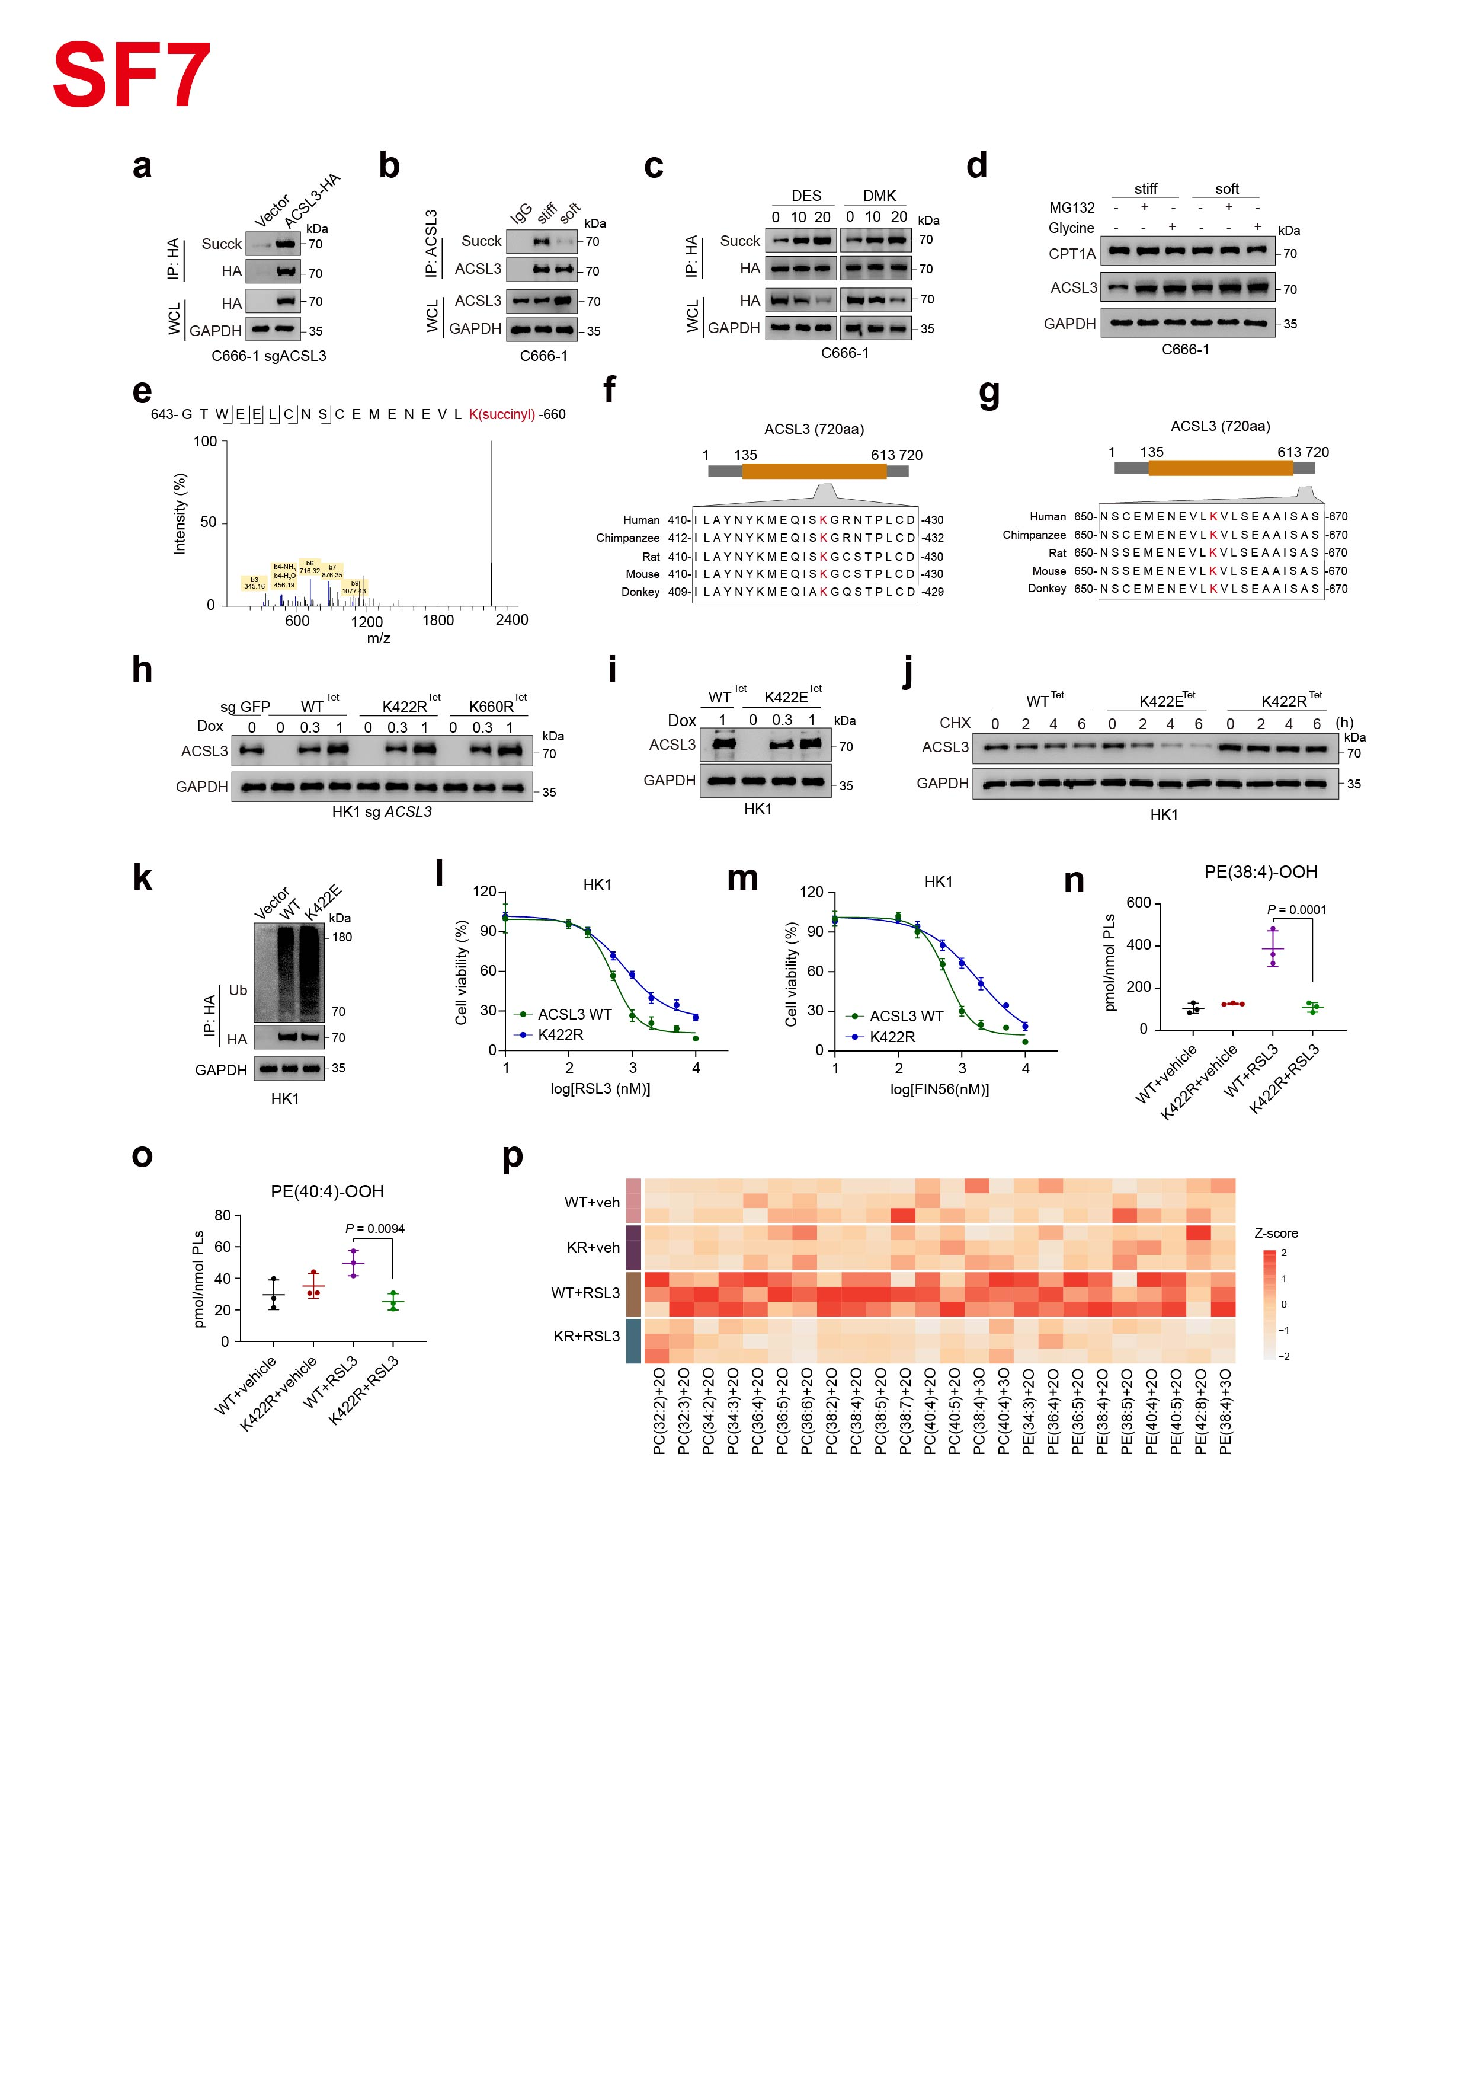Extended Fig.7 ACSL3 K422 succinylation promotes its degradation and mediates ferroptosis resistance.
a, Immunoprecipitation followed by immunoblotting showing lysine succinylation of ACSL3 in ACSL3-knockout C666-1 cells reconstituted with ACSL3-WT.
b, Immunoprecipitation followed by immunoblotting showing lysine succinylation of ACSL3 in C666-1 cells cultured on soft or stiff matrices.
c, Immunoprecipitation followed by immunoblotting showing lysine succinylation of ACSL3 in re-expressed ACSL3-WT-HA C666-1 cells treated with DES or DMK.
d, Immunoblots analysis of ACSL3 and CPT1A in C666-1 cells cultured on soft or stiff matrices and treated with MG132 or glycine.
e, Mass spectrometry analysis of the succinylation site in ACSL3 protein purified from HK1 cells.
f-g, Alignment of protein sequences surrounding ACSL3 K422 (f) and K660 (g) across different species.
h, Immunoblots analysis confirming doxycycline (Dox)-inducible expression of WT^{Tet} (ACSL3-WT^{Tet}), K422R^{Tet} (ACSL3-K422R^{Tet}) and K660R^{Tet} (ACSL3-K660R^{Tet}) in ACSL3-knockout HK1 cells in the absence or presence of Dox.
i, Immunoblots analysis confirming Dox-inducible expression of K422E (ACSL3-K422E^{Tet}) in ACSL3-knockout HK1 cells in the absence or presence of Dox.
j, Immunoblots analysis of ACSL3 in ACSL3-WT^{Tet}, ACSL3-K422E^{Tet} or ACSL3-K422R^{Tet} HK1 cells treated with CHX for the indicated times.
k, Cell lysates from ACSL3-WT^{Tet}, ACSL3-K422E^{Tet} or ACSL3-K422R^{Tet} HK1 cells were subjected to immunoprecipitation with anti-HA antibody, followed by immunoblotting with Ub antibody.
l-m, Dose-dependent cell death induced by the RSL3 (l) or FIN56 (m) in ACSL3-WT^{Tet} or ACSL3-K422R^{Tet} HK1 cells.
n-o, Levels of the ferroptosis-associated phospholipid species PE (38:4)-OOH (n) and PE (40:4)-OOH (o) in ACSL3-WT^{Tet} or ACSL3-K422R^{Tet} HK1 cells treated with vehicle or RSL3.
p, Heatmap showing LC-MS analysis of the relative abundance of RSL3-induced oxygenated PC and PE molecular species in ACSL3-WT^{Tet} or ACSL3-K422R^{Tet} HK1 cells treated with vehicle or RSL3. Row z-scores were calculated from the averaged abundance of each lipid species.

Data are shown as mean ± SD and are representative of at least three independent experiments, one-way ANOVA (n-o).

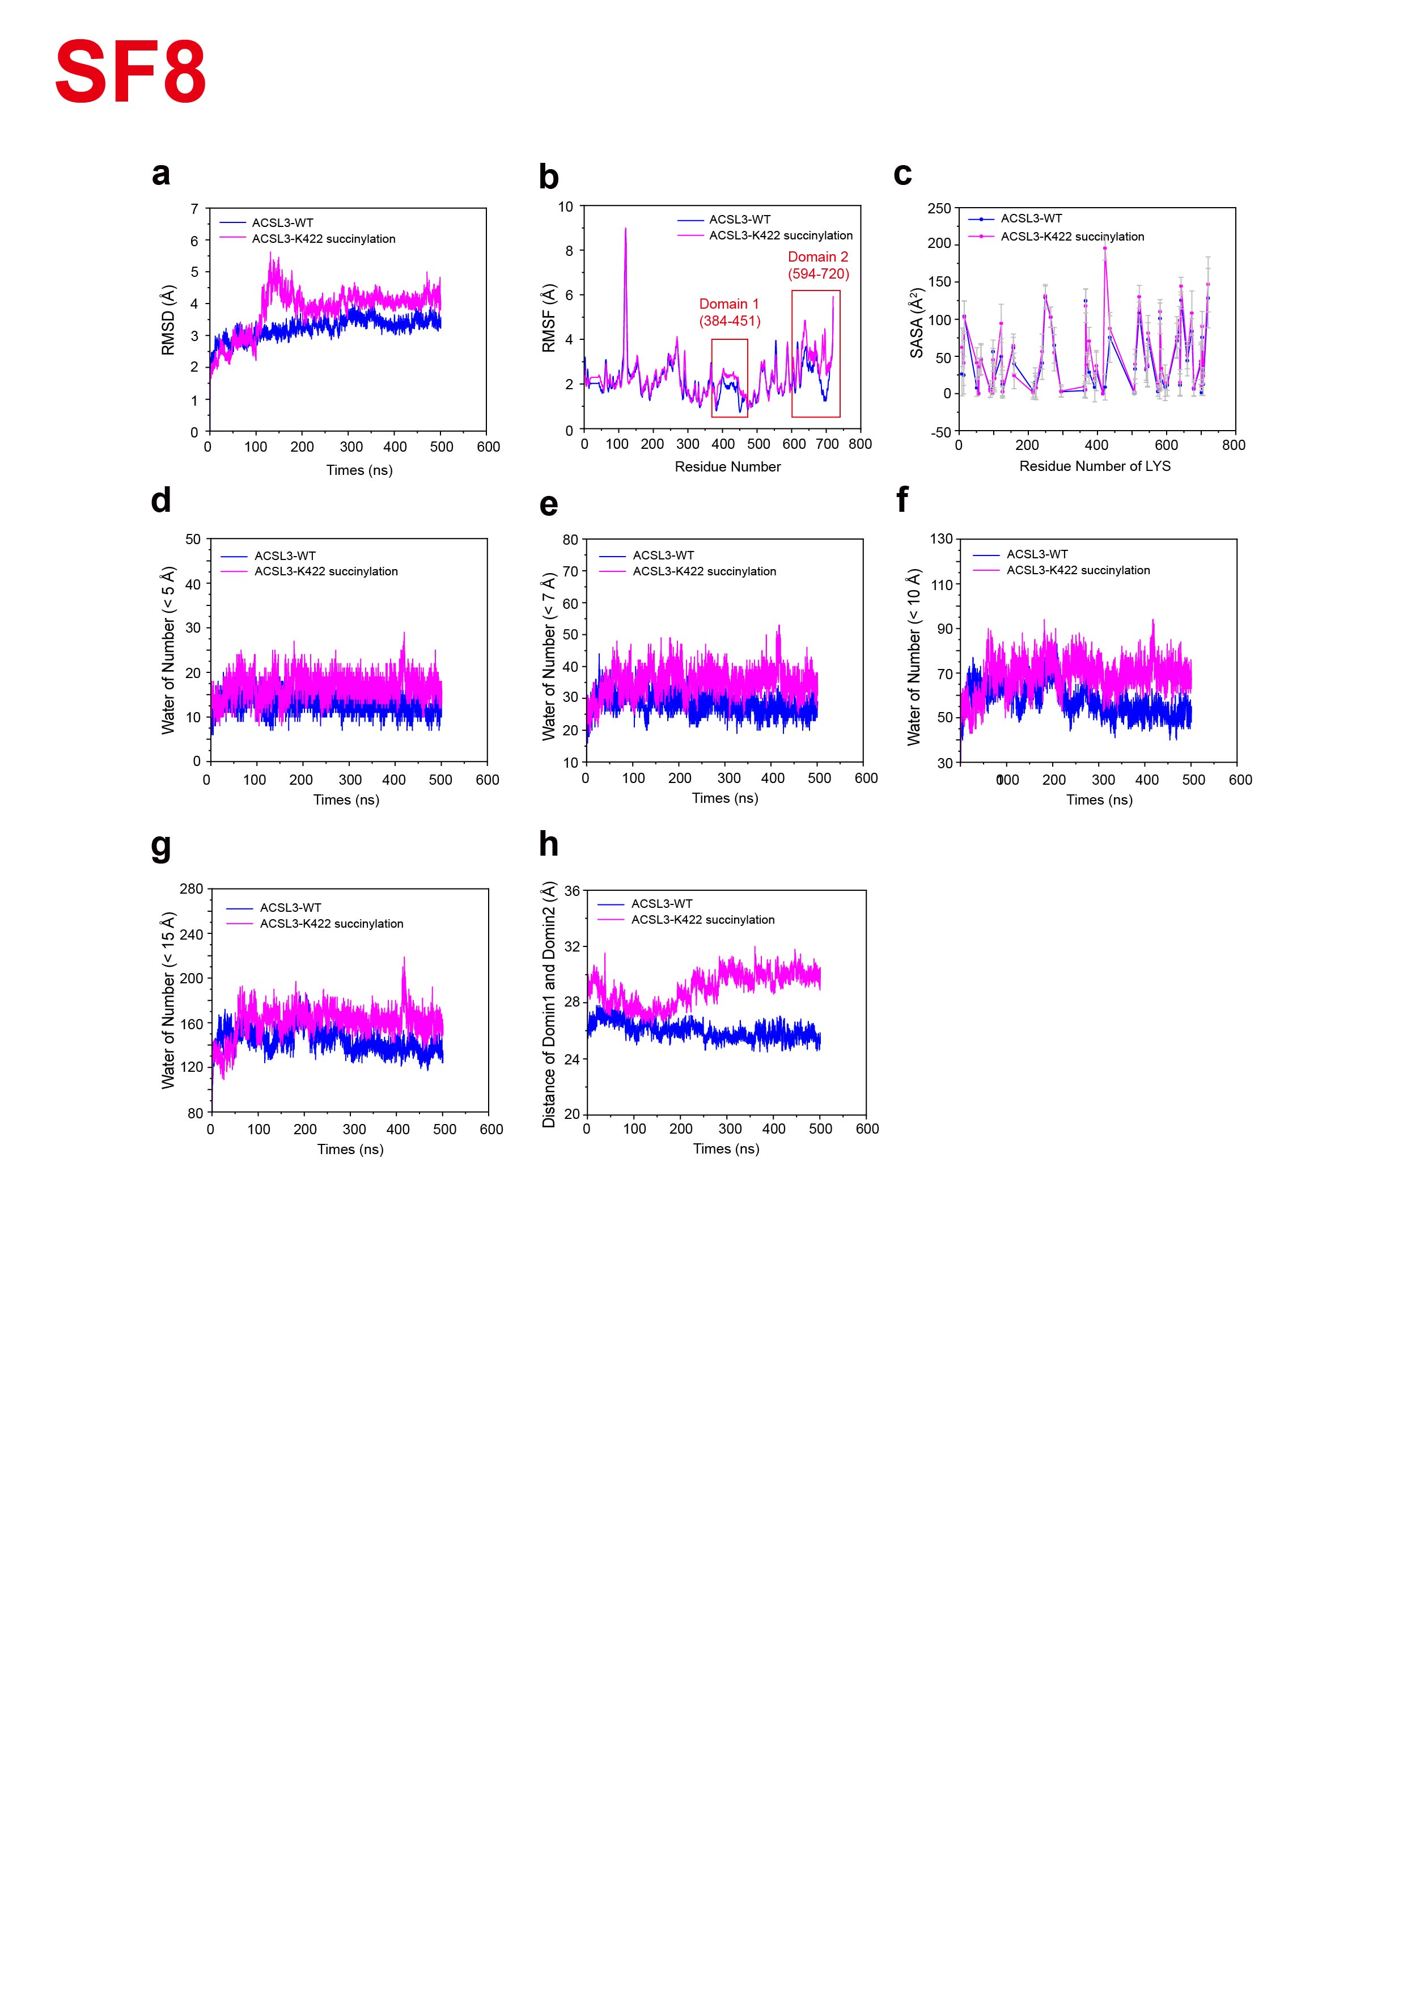Extended Fig.8 Molecular dynamics simulation for ACSL3 K422 succinylation.
a, Root-mean-square deviations (RMSD) of the heavy atoms in ACSL3 protein in ACSL3 WT model and ACSL3 K422 succinylation model.
b, Root-mean-square fluctuations (RMSF) of each residue in MD simulations in ACSL3 WT model and ACSL3 K422 succinylation model.
c, Solvent accessible surface area (SASA) of the LYS residues of ACSL3 proteins in ACSL3 WT model and ACSL3 K422 succinylation model.
d-g, Number of water molecules within 5 Å (d), 7 Å (e), 10 Å (f) and 15 Å (g) of the centroid of the ACSL3 proteins as a function of the simulation times in ACSL3 WT model and ACSL3 K422 succinylation model.
h, Distance changes between the centroid of the Domain 1 and the centroid of the Domain 2 in ACSL3 WT model and ACSL3 K422 succinylation model.

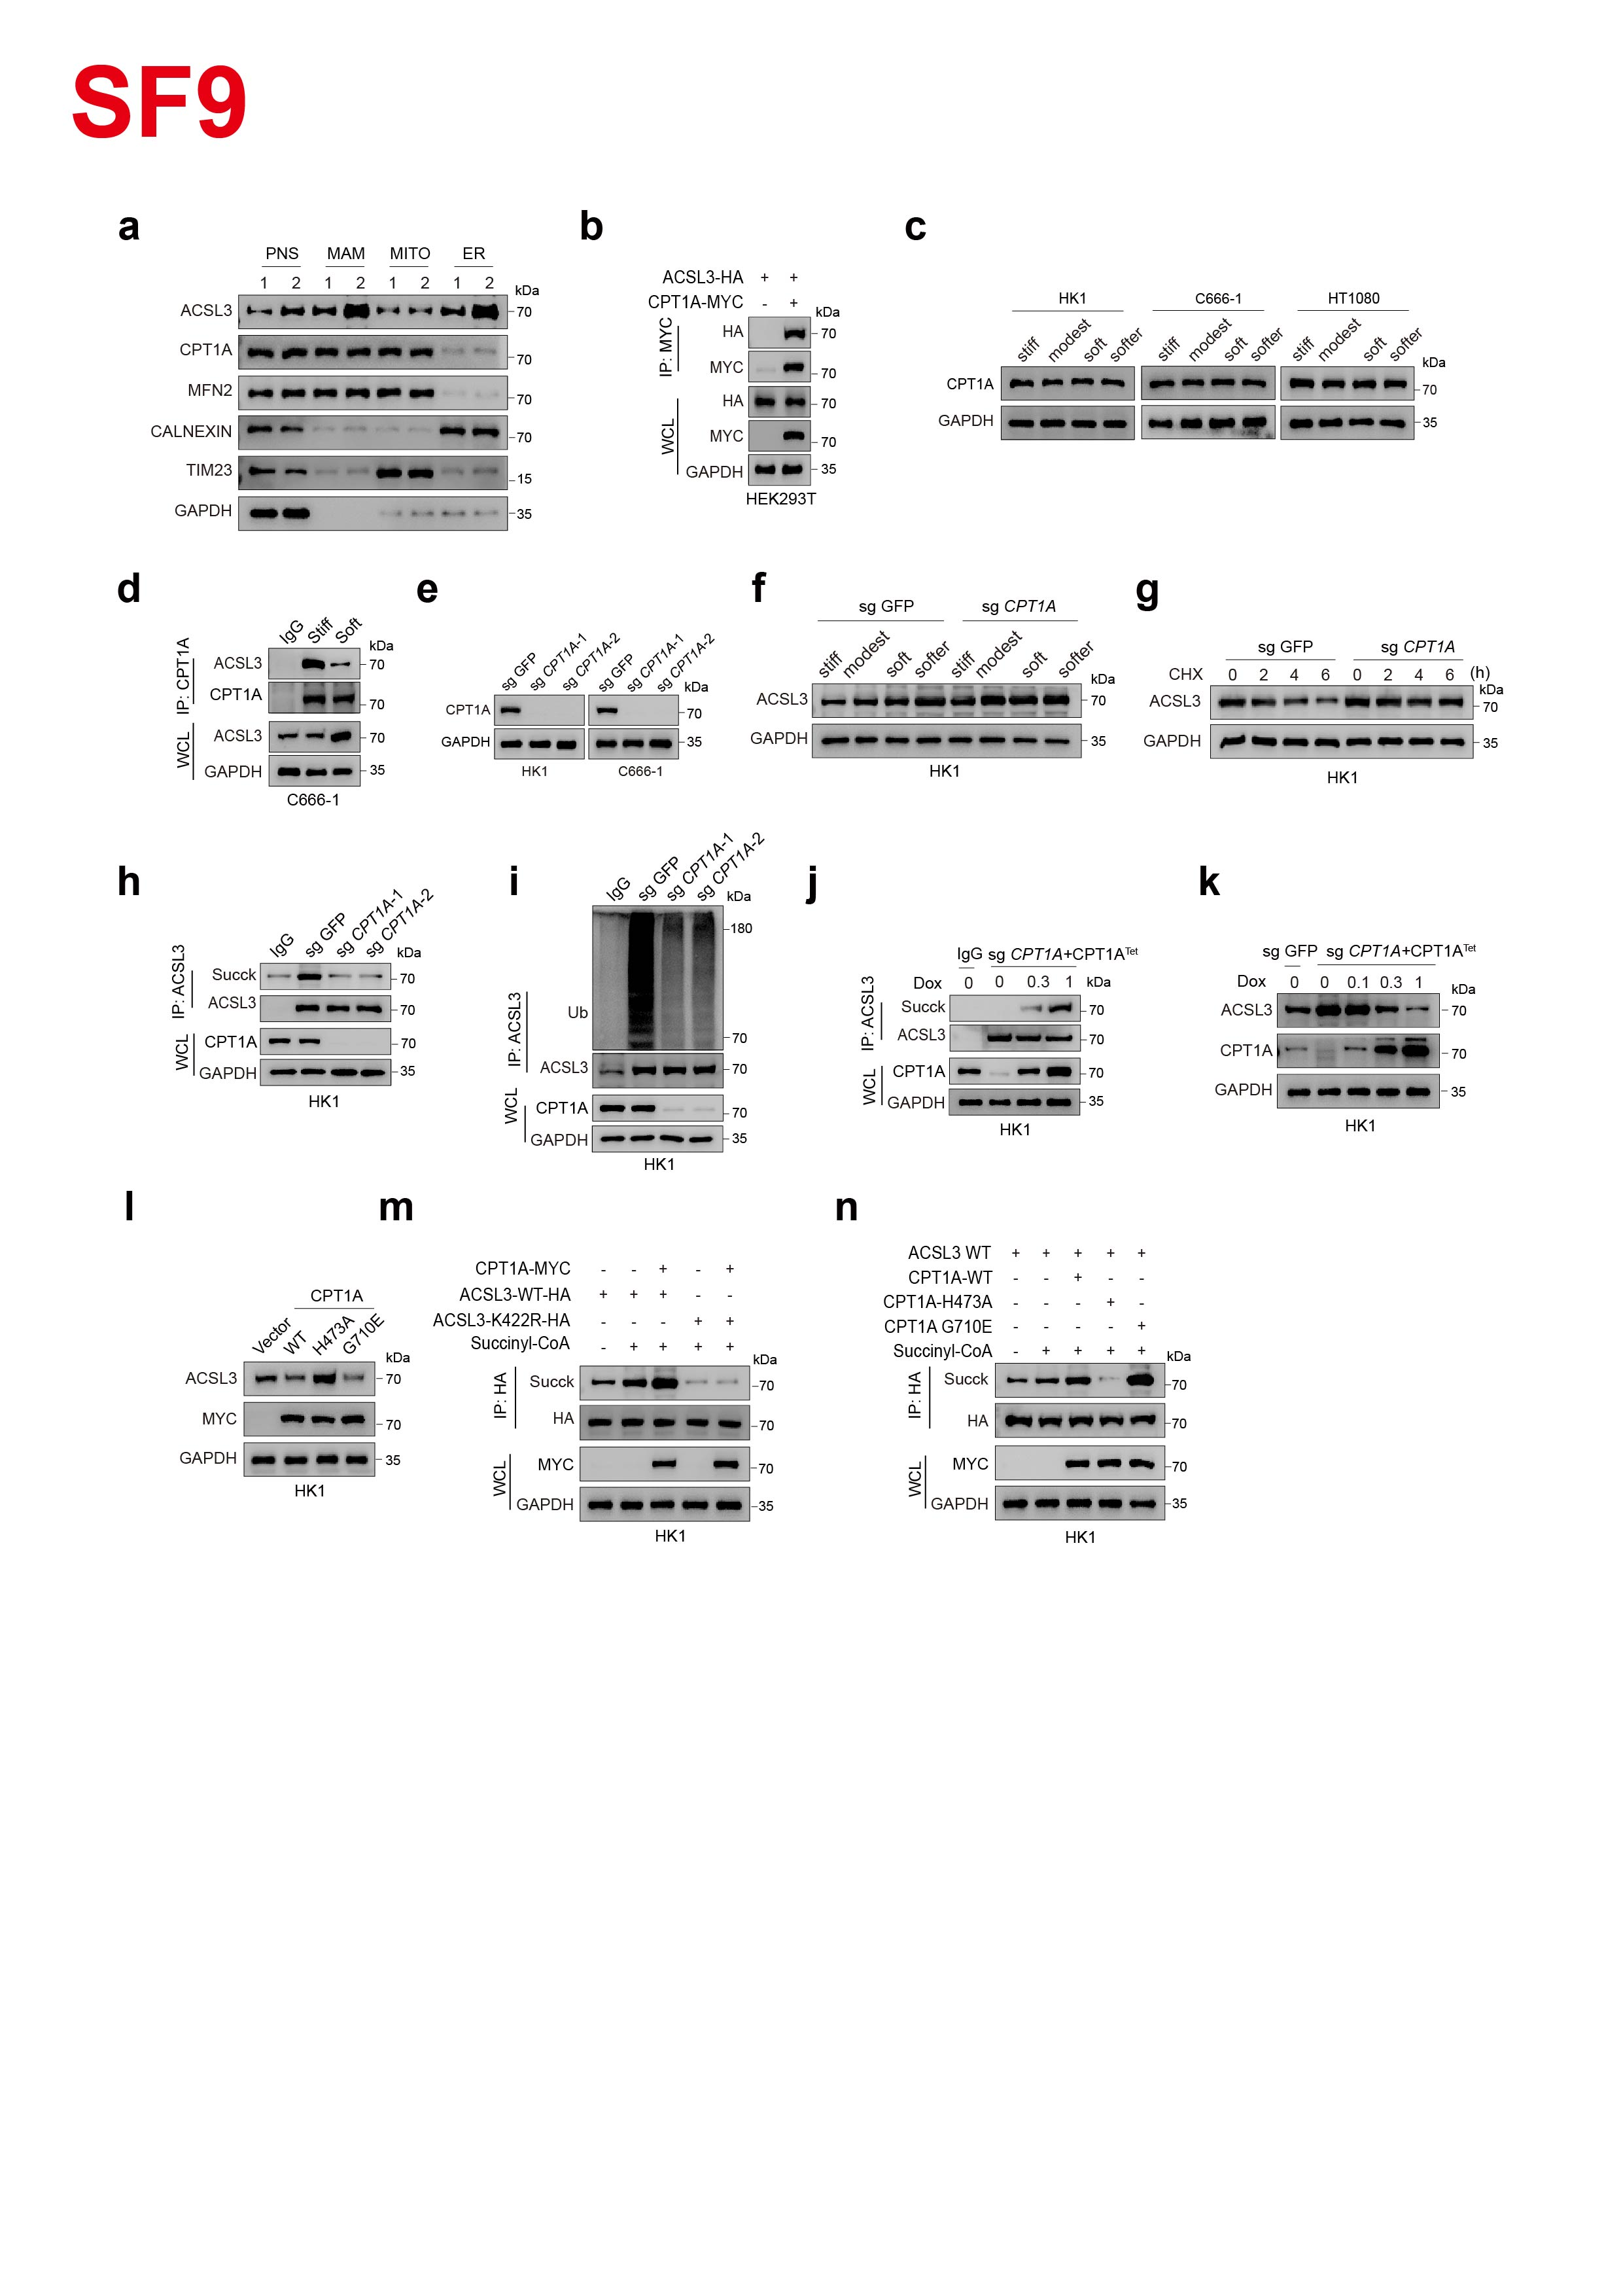Extended Fig.9 CPT1A mediates ACSL3 K422 succinylation and regulates its expression.
a, Immunoblots analysis of ACSL3, CPT1A, MFN2, CALNEXIN and TIM23 in subcellular fractions from HK1 cells. PNS, post-nuclear supernatant; MAM, mitochondria-associated membrane; MITO, mitochondria; ER, endoplasmic reticulum. TIM23, GAPDH, CALNEXIN and MFN2 serve as markers for mitochondria, cytosol, ER and MAM, respectively.
b, Immunoprecipitation followed by immunoblotting showing the interaction between CPT1A and ACSL3.
c, Immunoblots analysis of CPT1A in HK1, C666-1 and HT1080 cells cultured on matrices of different stiffness.
d, Immunoprecipitation followed by immunoblotting showing the interaction between CPT1A and ACSL3 in C666-1 cells cultured on soft or stiff matrices.
e, Immunoblots analysis confirming CPT1A knockout efficiency in HK1 and C666-1 cells.
f, Immunoblots analysis of ACSL3 in parental and CPT1A-knockout HK1 cells cultured on matrices of different stiffness.
g, Immunoblots analysis of ACSL3 in parental and CPT1A-knockout HK1 cells treated with CHX for the indicated times.
h, Immunoprecipitation followed by immunoblotting showing lysine succinylation of ACSL3 in CPT1A-knockout HK1 cells.
i, Cell lysates from parental and CPT1A-knockout HK1 cells were subjected to immunoprecipitation with anti-ACSL3 antibody, followed by immunoblotting with Ub antibody.
j, Immunoprecipitation followed by immunoblotting showing lysine succinylation of ACSL3 in HK1 cells with Dox-inducible CPT1A expression (CPT1A WT^{Tet}) in the absence or presence of Dox.
k, Immunoblots analysis of ACSL3 and CPT1A in CPT1A-WT^{Tet} HK1 cells in the absence or presence of Dox.
l, Immunoblots analysis of ACSL3 in CPT1A-WT^{Tet}, CPT1A-H473A^{Tet} or CPT1A-G710E^{Tet} overexpressing CPT1A-knockout HK1 cells.
m, Immunoprecipitation followed by immunoblotting showing lysine succinylation of ACSL3-WT^{Tet} or ACSL3-K422R^{Tet} HK1 cells in the absence or presence of CPT1A overexpression.
n, Immunoprecipitation followed by immunoblotting showing lysine succinylation of ACSL3 in CPT1A-WT^{Tet}, CPT1A-H473A^{Tet} or CPT1A-G710E^{Tet} overexpressing HK1 cells.

Data are representative of at least three independent experiments.

