Appendix
1、Dataset Description and Pre-processing

1.1 Dataset Construction and Assessment Tools
In this study, three clinical tabular datasets were constructed by integrating patient self-report questionnaires with formal clinical diagnoses. These datasets encompass basic demographic information and scores from various clinical assessment scales.
Dataset 1(D1) comprises 14 scales, including the Adolescent Non-Suicidal Self-Injury Assessment Questionnaire (ANSAQ), Hamilton Anxiety Rating Scale (HAMA), Hamilton Depression Rating Scale (HAMD), Delaware Bullying Victimization Scale-Student(DBVS-S), Rosenberg Self-Esteem Scale (RSES), Toronto Alexithymia Scale (TAS-20), Psychological Inventory of School Membership (PSSM), Emotion Regulation Questionnaire (ERQ-CRV), Connor-Davidson Resilience Scale (CD-RISC), Childhood Trauma Questionnaire-Short Form (CTQ-SF), Eysenck Personality Questionnaire (EPQ), Short-form Egna Minnen Beträffande Uppfostran (S-EMBU-C), Ruminative Responses Scale (RRS-CV), and Pittsburgh Sleep Quality Index (PSQI).
Dataset 2(D2) consists of 17 scales. In addition to the instruments mentioned above, it includes the Internet Addiction Test (IAT), Hypomania Symptom Check List (HCL-33), Scale for Suicide Ideation (SSI), and Snaith-Hamilton Pleasure Scale (SHAPS).
Dataset 3(D3) contains 13 scales, featuring the ANSAQ, Dysfunctional Beliefs and Attitudes about Sleep (DBAS), HAMA, HAMD, Insomnia Severity Index (ISI), S-EMBU-C, RRS-CV, RSES, TAS-20, CD-RISC, SSI, SHAPS, and Temporal Experience of Pleasure Scale (TEPS).

1.2 Data Refinement and Exclusion Criteria
For the CTQ-SF, EPQ, and S-EMBU-C, we utilized subscale-specific scores rather than total scores, as the multi-dimensional nature of these constructs renders the aggregate score less clinically informative. Specifically:
CTQ-SF was divided into emotional abuse, physical abuse, sexual abuse, emotional neglect, and physical neglect. EPQ was categorized into neuroticism, extraversion, psychoticism, and lie scales. S-EMBU-C was segmented into rejection, emotional warmth, and overprotection.
To ensure the robustness of the statistical analysis, certain variables with insufficient data volume were excluded. These included the IAT, HCL-33, SSI, and SHAPS in D2, as well as the SSI, SHAPS, and TEPS in D3.

1.3 Pre-processing and Data Integrity
During each fold of the cross-validation process, standardization and categorical encoding were performed on the training set. The transformation parameters derived from the training data were subsequently applied to the test set to prevent data leakage.

- Definition of Total Variance Difference (TVD) and Frobenius Norm Results
The Total Variance Difference (TVD) was employed to quantify the extent to which balancing strategies (e.g., SMOTE) alter the covariance structure of the minority class. Specifically, TVD measures the deviation of the synthetic samples' covariance matrix from the original minority class covariance matrix, capturing changes in both the total variance and the sum of variances across individual dimensions.
To further evaluate the magnitude of these structural discrepancies, we utilized the Frobenius norm as a complementary metric. This approach ensures that the synthetic data maintains the statistical integrity of the original clinical features while addressing class imbalance.
Table 1. TVD and Frobenius Norm Results for Minority Class Resampling Methods Across Three Datasets
Dataset | Method | Minority_Class | TVD_raw | TVD_PCA | Frobenius_norm_PCA
Total1 | SMOTE | 2 | -0.227944196 | -0.224660475 | 0.2140110048842
Total1 | Borderline-SMOTE | 2 | -0.173203734 | -0.160473589 | 0.1973818046054
Total1 | SMOTE-ENN | 2 | -0.299100687 | -0.298545546 | 0.3407884289415
Total1 | SMOTE-Tomek | 2 | -0.227944196 | -0.224660475 | 0.2140110048842
Total2 | SMOTE | 2 | -0.198964712 | -0.196021764 | 0.3264805960504
Total2 | Borderline-SMOTE | 2 | -0.163894056 | -0.155150637 | 0.3210459764149
Total2 | SMOTE-ENN | 2 | -0.279793905 | -0.281321526 | 0.4877974739180
Total2 | SMOTE-Tomek | 2 | -0.198964712 | -0.196021764 | 0.3264805960504
Total3 | SMOTE | 2 | -0.283397624 | -0.27951108 | 0.3572352597419
Total3 | Borderline-SMOTE | 2 | -0.134674576 | -0.118858286 | 0.6836390160273
Total3 | SMOTE-ENN | 2 | -0.292728591 | -0.287815837 | 0.3671042230829
Total3 | SMOTE-Tomek | 2 | -0.283397624 | -0.27951108 | 0.3572352597419
3、Methods of SHAP and TTT

3.1. Ensemble SHAP-Based Feature Ranking Strategy
When tabular data is treated as sequential input, the permutation order of features can significantly influence the learning efficacy of sequential models. To explore a more biologically and statistically meaningful feature sequence, we implemented an Ensemble SHAP Feature Ranking strategy. This approach aims to inject an inductive bias based on feature importance into the sequential deep learning models, thereby optimizing the input representation.
In this strategy, LightGBM and XGBoost were employed as surrogate models to evaluate the global importance of each clinical feature. We calculated the normalized mean absolute SHAP values for each feature to determine their respective contribution. Features were then ranked according to these importance scores, and the resulting ordered sequence was used as the input for the deep learning architecture. This ensures that the model prioritizes the most informative features during the sequential encoding process.

3.2. Implementation of Test-Time Training (TTT)
Test-Time Training (TTT) is an online adaptation strategy designed to enhance model robustness. Its core principle involves utilizing the information from unlabeled test samples during the inference phase to perform rapid, sample-specific fine-tuning of the pre-trained model. This process allows the model to adapt to potential distribution shifts in the test data, thereby improving predictive accuracy for individual cases.
In this study, the TTT strategy implemented for the Mamba-based models utilizes a self-supervised task: Masked Feature Reconstruction. Specifically, upon receiving a test sample and prior to the final classification, the model undergoes a brief adaptation phase:
(i): Masking: A portion of the embedded feature vector of the current sample is randomly masked (set to zero).
(ii): Reconstruction: The model is required to reconstruct the original masked features based on the remaining unmasked information.
(iii): Optimization: By minimizing the reconstruction loss (e.g., Mean Squared Error, MSE), the model parameters are updated via several gradient descent iterations.
This procedure forces the model to capture the internal feature dependencies specific to the current test sample. Following this self-adaptive fine-tuning, the model—now conditioned on the inherent structure of the sample—performs the final classification on the original, unmasked input.
4. Model Training and Experimental Framework

4.1. Hyperparameter Optimization and Parameter Settings
To achieve optimal performance, hyperparameter tuning for all models was conducted using the Optuna framework.
(i): Machine Learning Models: Most scikit-learn models were implemented with default parameters. However, to ensure convergence, max_iter was set to 1000 for Logistic Regression and 500 for the Multi-Layer Perceptron (MLP). Probability estimation was enabled for Support Vector Classification (SVC) (probability=True).
(ii): Keras-based Sequential Models: All models utilized the Adam optimizer and categorical_crossentropy loss function. We employed an EarlyStopping mechanism (monitoring validation accuracy) with a patience of 20 epochs to restore the best weights. Additionally, a ReduceLROnPlateau scheduler was used to halve the learning rate if the validation accuracy remained stagnant for 10 epochs.
(iii): Specialized Tabular Models: TabNet used an early stopping patience of 20 epochs. For TabPFNv2, we utilized the publicly available pre-trained weights for direct inference on the test sets without further fine-tuning. TabTransformer and FT-Transformer followed the same training protocol as the Keras sequential models.
(iv): Mamba Family and TTT: These models were optimized using AdamW with an initial learning rate of 1×10⁻³, incorporating the same learning rate scheduler and early stopping. For the TTT variants, an additional 10 rounds of masked feature reconstruction fine-tuning were performed before inference, using an Adam optimizer with a learning rate of 5×10⁻⁵.

4.2. Experimental Workflow
A rigorous experimental pipeline was followed to ensure robust performance evaluation:
(i): Cross-Validation: A 5-fold stratified cross-validation (StratifiedKFold) was applied to each dataset.
(ii): Data Pre-processing: Within each fold, training data were standardized using StandardScaler and underwent categorical encoding. These transformation parameters were then applied to the test set to maintain data integrity.
(iii): Training and Evaluation: Models were trained on the oversampled training set and evaluated on the unmodified original test set. Primary performance metrics included Accuracy, Macro-average AUC, and F1-score.

4.3. Input Transformation for Deep Learning Models
Input data were reformatted to meet the architectural requirements of specific deep learning models:
(i): Sequential Models: Feature vectors were treated as sequences, with the input tensor reshaped to (N_{samples}, N_{features}, 1).
(ii): TabNet & TabPFNv2: These models directly processed the encoded 2D tabular data or raw Pandas DataFrames/NumPy arrays.
(iii): Transformer and Mamba Architectures: These models required separate handling of numerical and categorical features. Numerical inputs and categorical embeddings were concatenated into a unified feature embedding sequence before being fed into the core layers of the architecture.
5. Model Performance with Data Strategy Optimization
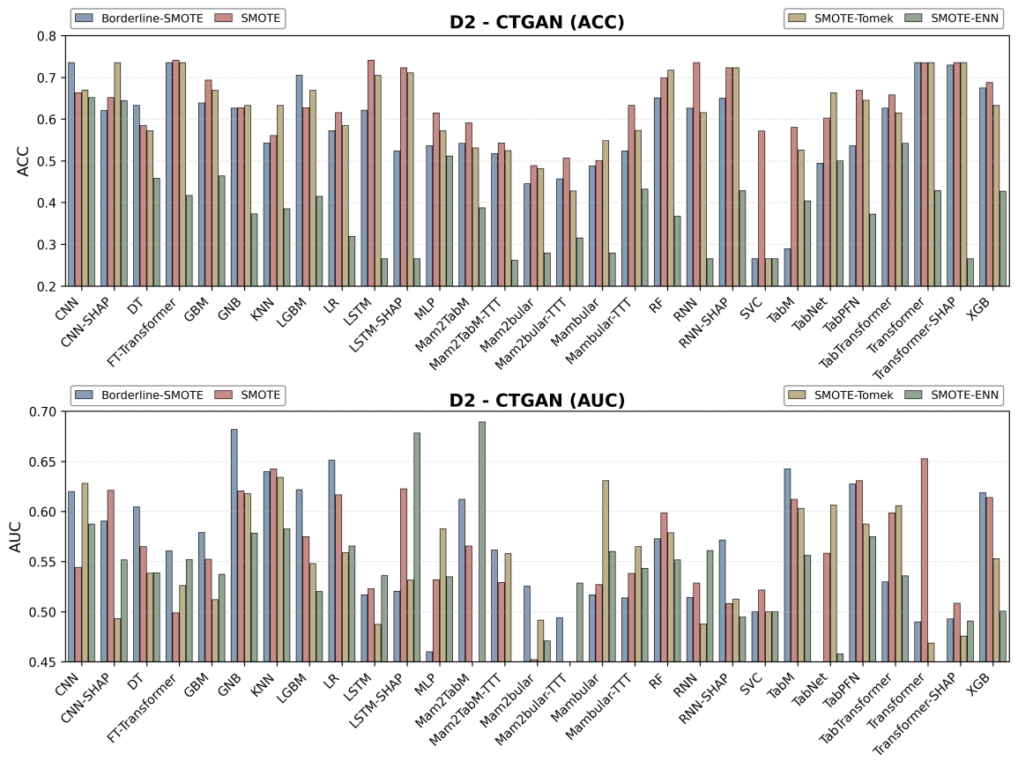
Fig 1. Performance Comparison of Models on CTGAN-Augmented D2 Under Different Balancing Strategies.
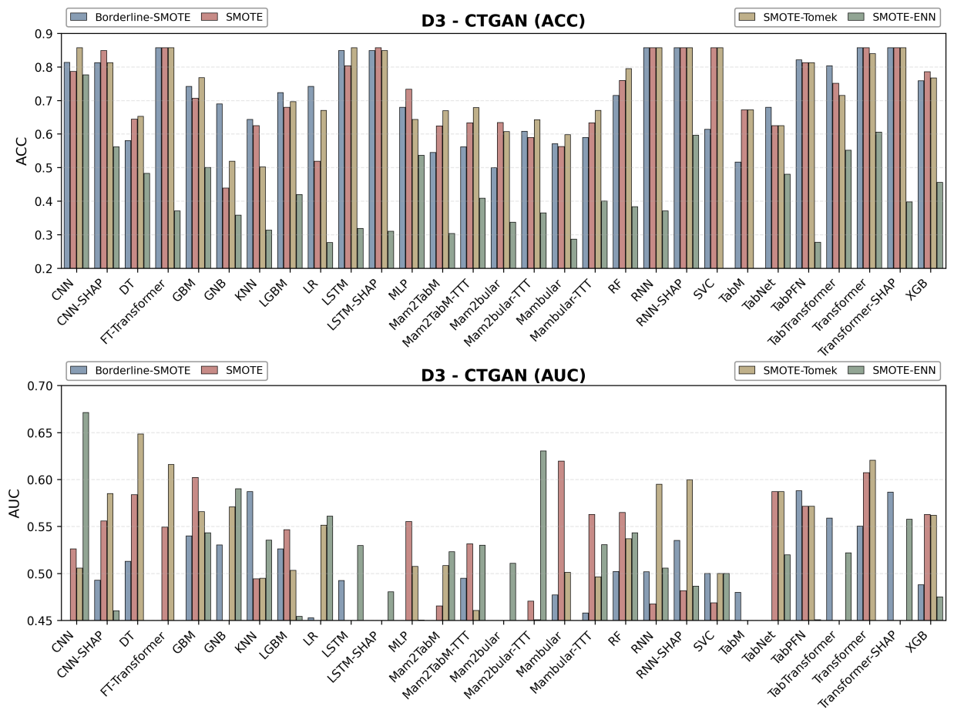
Fig 2. Performance Comparison of Models on CTGAN-Augmented D3 Under Different Balancing Strategies.

