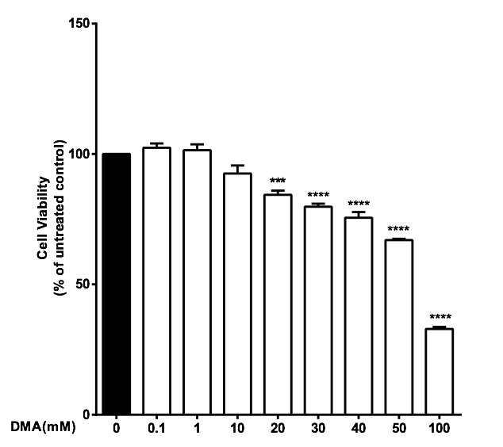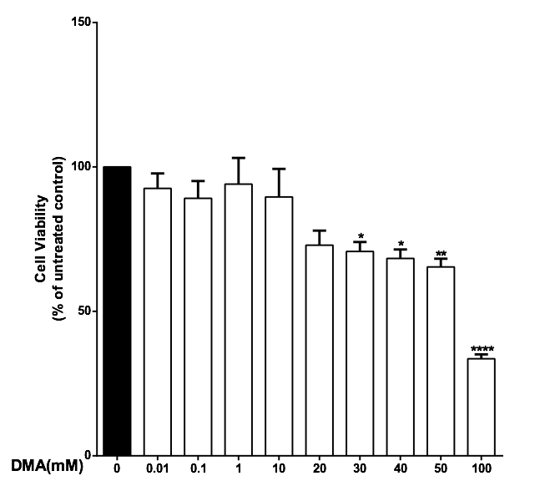
A B

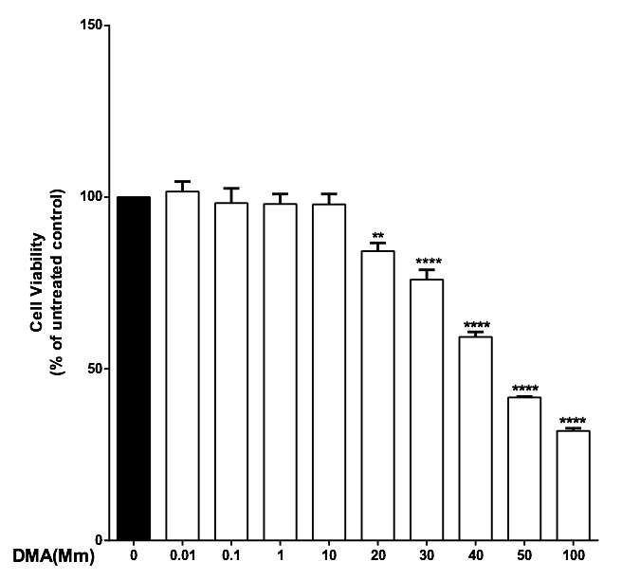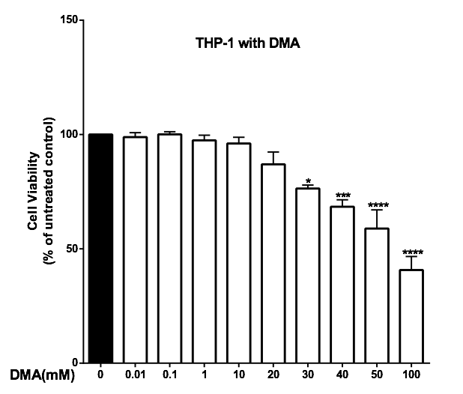

C D

Supplementary Figure 1. The effect of DMA on cell viability. Cell viability was determined by MTT assay in the absence or presence of increasing concentrations of DMA. A, HT-29 cells; B, HCT-116 cells; C, SW620 cells; D, THP-1 cells. *P<.05; **P<.01; ***P<.001; ****P<.0001.

