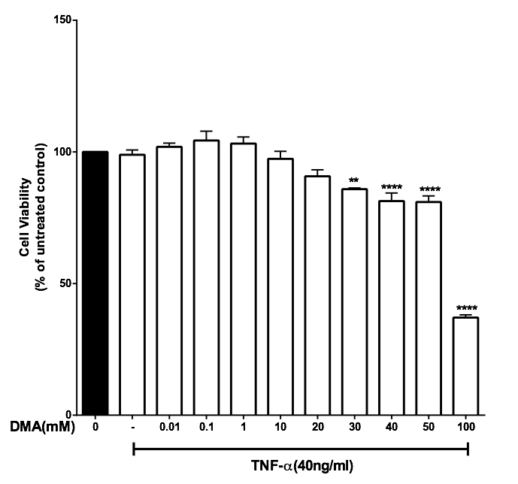

Supplementary Figure 3. The effect of DMA on cell viability in the presence of TNFα. Cell viability was determined by MTT assay in the absence or presence of increasing concentrations of DMA after stimulation with 40 ng mL⁻¹ TNFα. . A, HT-29 cells; B, HCT-116 cells; C, SW620 cells. *P<.05; **P<.01; ****P<.0001.

A

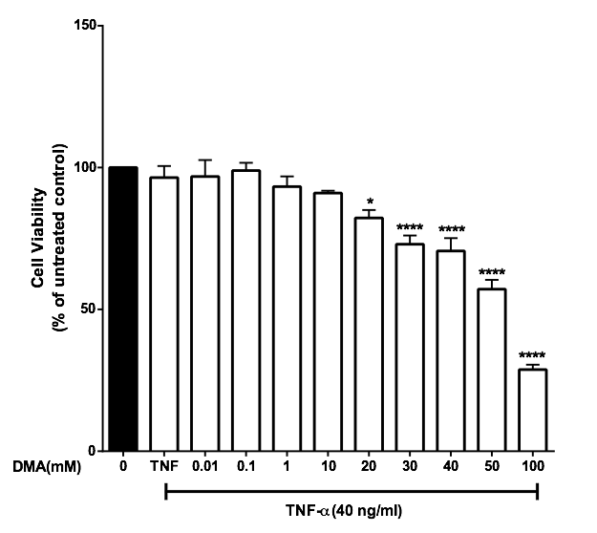

B

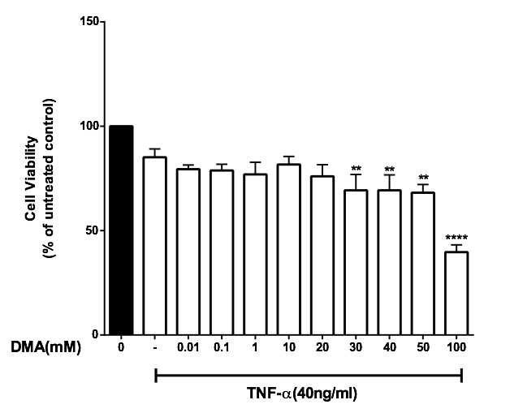

C

