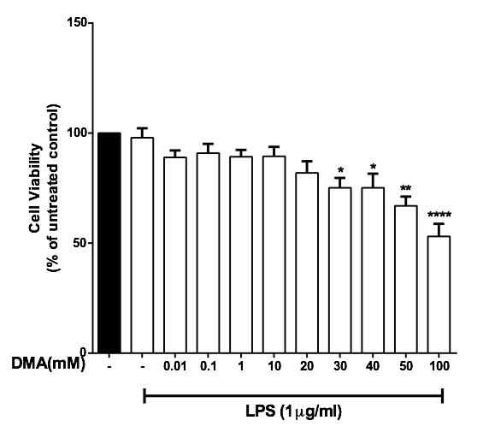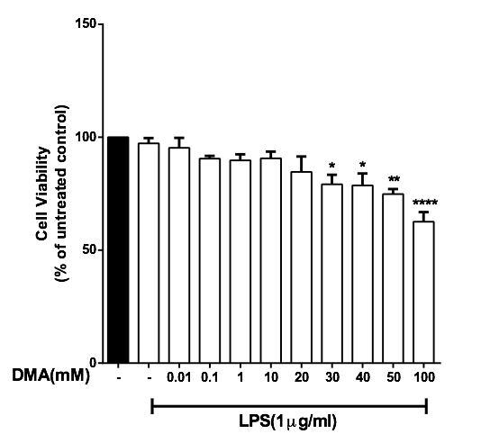
A B

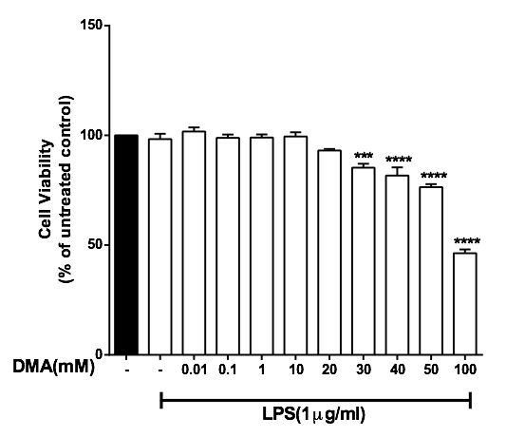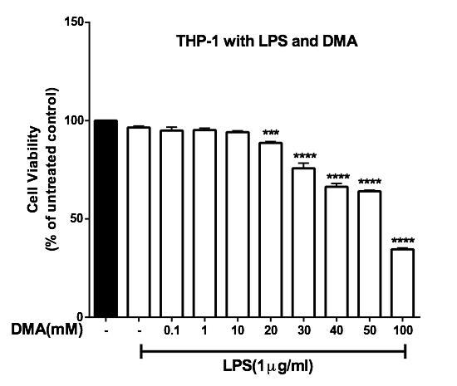
C D

Supplementary Figure 2. The effect of DMA on cell viability in the presence of LPS. Cell viability was determined by MTT assay in the absence or presence of increasing concentrations of DMA after stimulation with 1 μg ml⁻¹ LPS. A, HT-29 cells; B, HCT-116 cells; C, SW620 cells; D, THP-1 cells. *P<.05; **P<.01; ***P<.001; ****P<.0001.

