INPUT OUTPUT
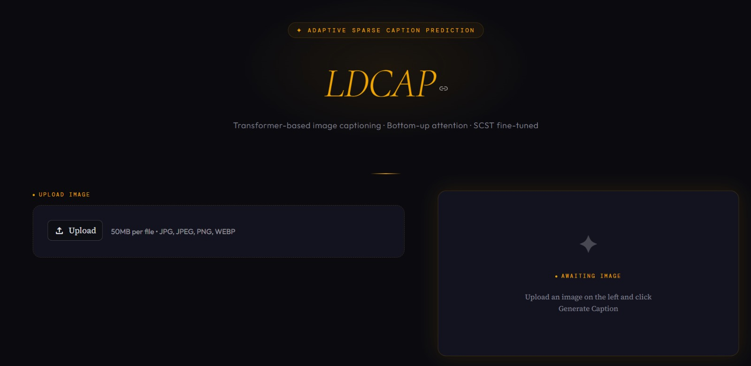

Figure 1: LDCAP interface illustrating image upload and caption generation through latent compression (RIN encoder) and dynamically conditioned decoding (FiLM), enabling robust performance under d

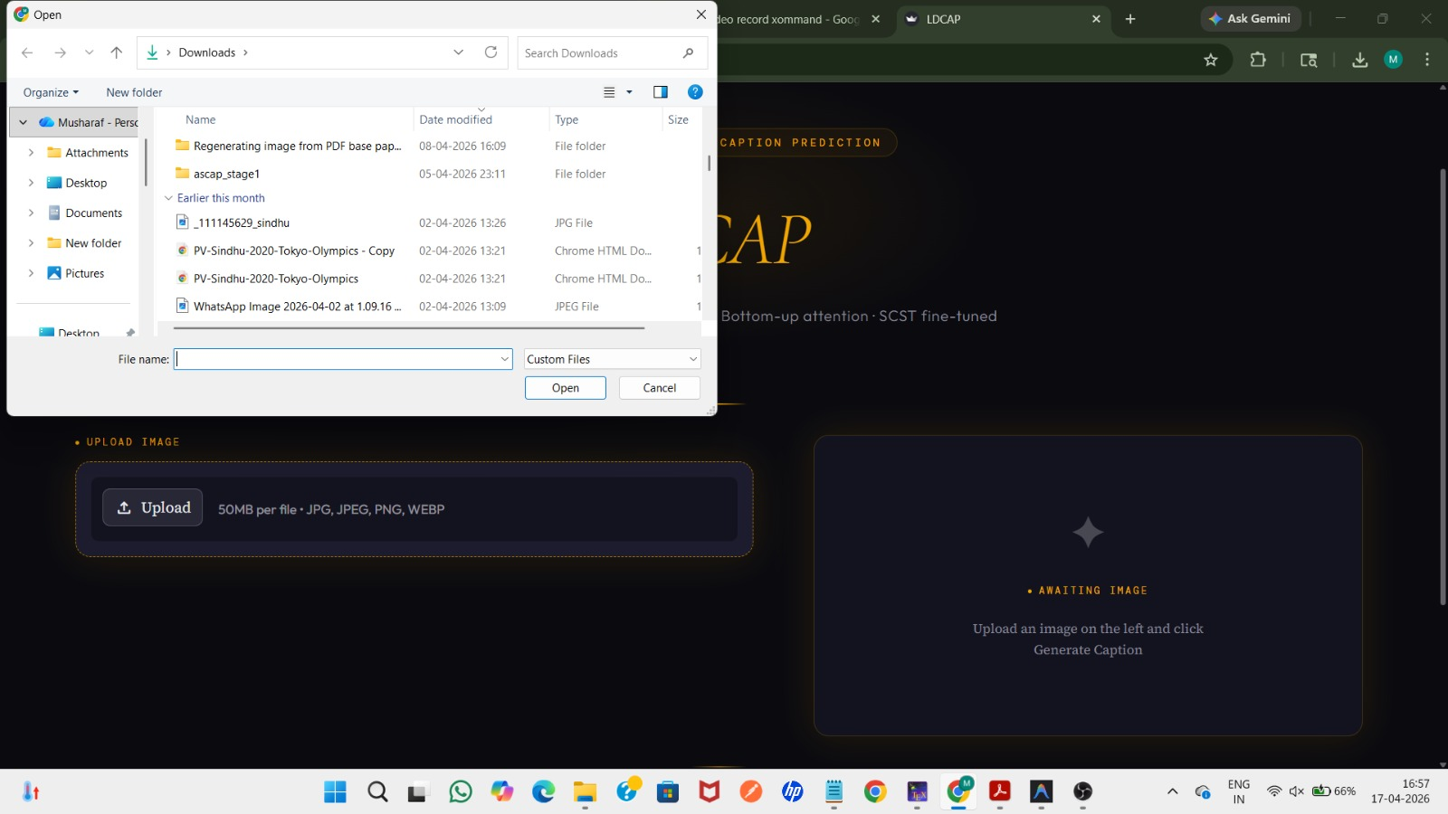
Figure 2: LDCAP interface showing the image upload stage, where a user selects an input image from the local system to initiate feature extraction and caption generation within the proposed pipeline.
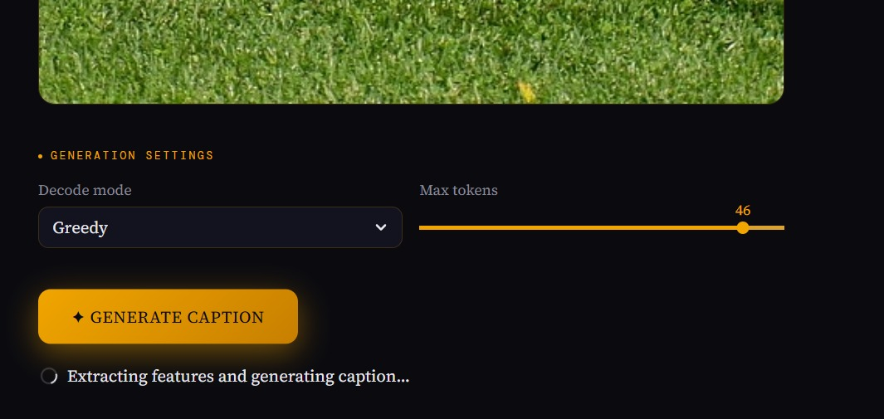

Figure 3: Caption generation stage in LDCAP showing user-defined decoding configuration and the execution of feature extraction and autoregressive caption prediction.

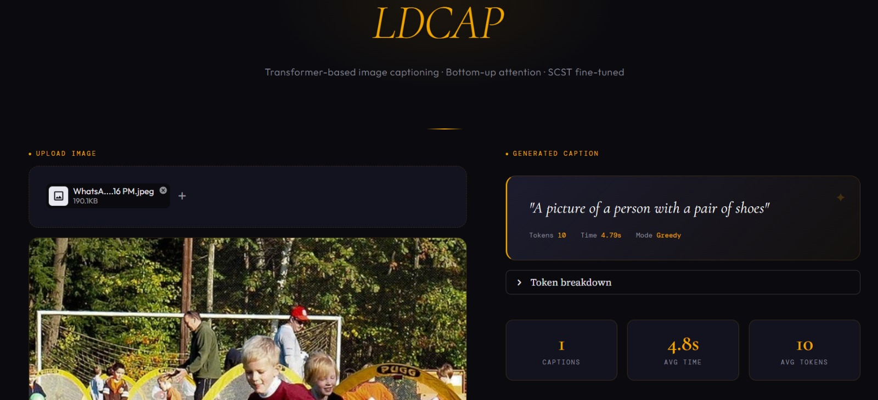

Figure 4: LDCAP output interface displaying the uploaded image and the generated caption, along with decoding details such as token count, inference time, and decoding mode, illustrating the end-to-end caption generation process.

