Supplementary Information
Flexible Ultrasensitive PtSe₂ Photodetector Array with GHz Bandwidth and Operation Temperature from -150 °C to 400 °C
Zhiyong Zhu ¹, Hon Ki Tsang², Yi Wang², Sheng Wang³，Haoyu Zhang³, Hui Wang³, Dehui Li⁴, Chenchen Ma⁴, Jiashu Wang¹, Rui You*⁵, Peng Li* ¹
¹ School of Mechanical Science and Engineering, Huazhong University of Science and Technology, Wuhan 430074, China.
² Department of Electronic Engineering, The Chinese University of Hong Kong, Shatin, New Territories, Hong Kong.
³Key Laboratory for the Physics and Chemistry of Nanodevices and Center for Carbon-Based Electronics, School of Electronics, Peking University, Beijing 100871, China.
⁴ School of Optical and Electronic Information, Huazhong University of Science and Technology, Wuhan 430074, China.
⁵Laboratory of the Intelligent Microsystem, Beijing Information Science and Technology University, Beijing, 100192, PR China.
*Correspondence to: lipeng2023@hust.edu.cn；yourui@bistu.edu.cn

Contents:
Supplementary Figure 1. Structural and spectroscopic characterization of PtSe₂ film.
Supplementary Figure 2. Transfer characteristic curve of the device.
Supplementary Figure 3. Analysis of Internal Electric Field and Photocurrent Distribution.
Supplementary Figure 4. Long-term stability test results.
Supplementary Figure 5. Photocurrent of devices under extreme temperatures.
Supplementary Figure 6. Flexible Optoelectronic Devices for Extreme Environments: Integration, Testing, and Application Prospects.
Supplementary Note 1. Structural and Physical Characterization of PtSe₂ Films.
Supplementary Note 2. Analysis of Device Transfer Characteristics.
Supplementary Note 3. Spatial Response Characteristics and Mechanism Analysis.
Supplementary Note 4. Evaluation of the Long‑Term Stability.
Supplementary Note 5. Robust Photoresponse of PtSe₂ Devices Across an Ultra‑Broad Temperature Range (‑150 °C to 400 °C).
Supplementary Note 6. Integration and Application Prospects of Flexible PtSe₂ Photodetector Arrays for Extreme Environments.

Supplementary Figures
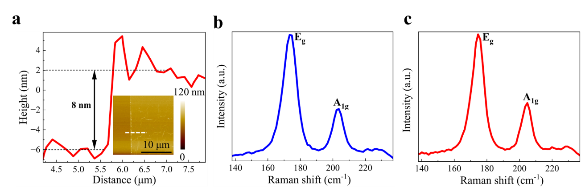
Supplementary Figure 1 | Structural and spectroscopic characterization of PtSe₂ film. (a) Atomic force microscopy height map of the PtSe₂ film. (b) Raman spectrum of PtSe₂ before the high-low temperature test (-150°C to 400°C). (c) Raman spectrum of PtSe₂ after the high-low temperature test (-150°C to 400°C).

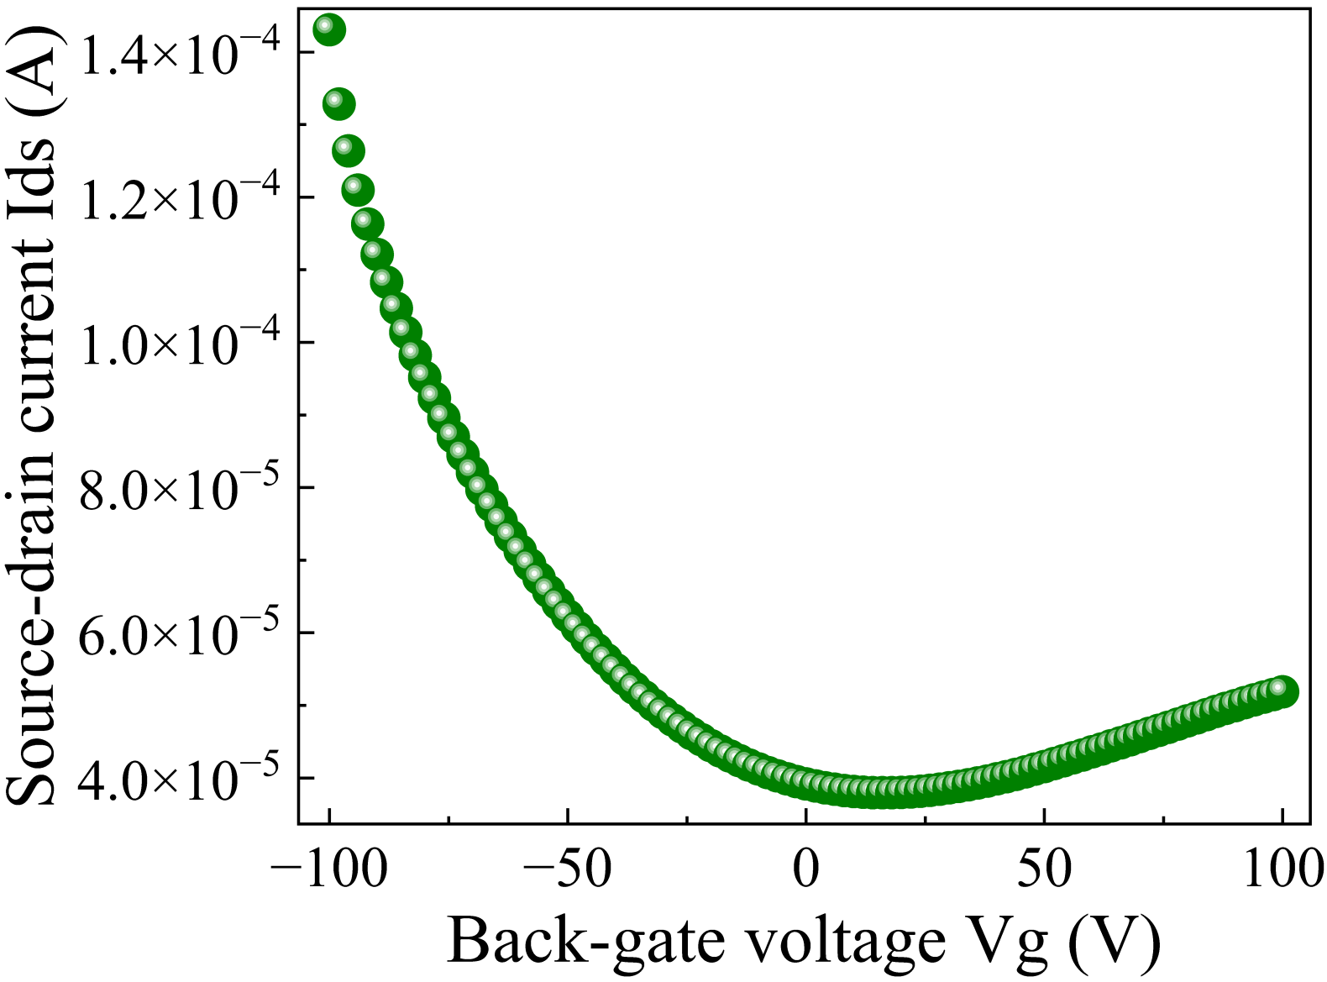
Supplementary Figure 2 | Transfer characteristic curve of the device.
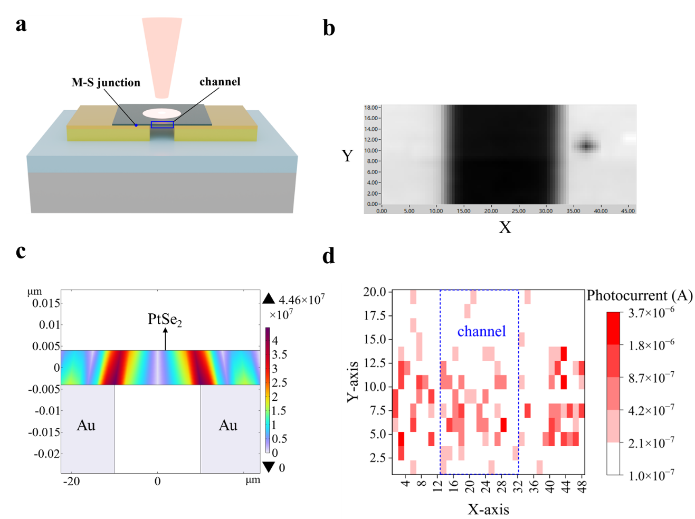
Supplementary Figure 3 | Analysis of Internal Electric Field and Photocurrent Distribution. (a) 3D schematic of the device under illumination, indicating the metal-semiconductor junction and the channel region. (b) Schematic of the device area covered by the photocurrent mapping measurement under 200 μW optical power, 5 V bias, and 940 nm wavelength. (c) The internal electric field distribution obtained through COMSOL simulation. (d) Spatial distribution map of photocurrent, with the X- and Y-axes representing the scan position coordinates and the color gradient indicating photocurrent intensity.

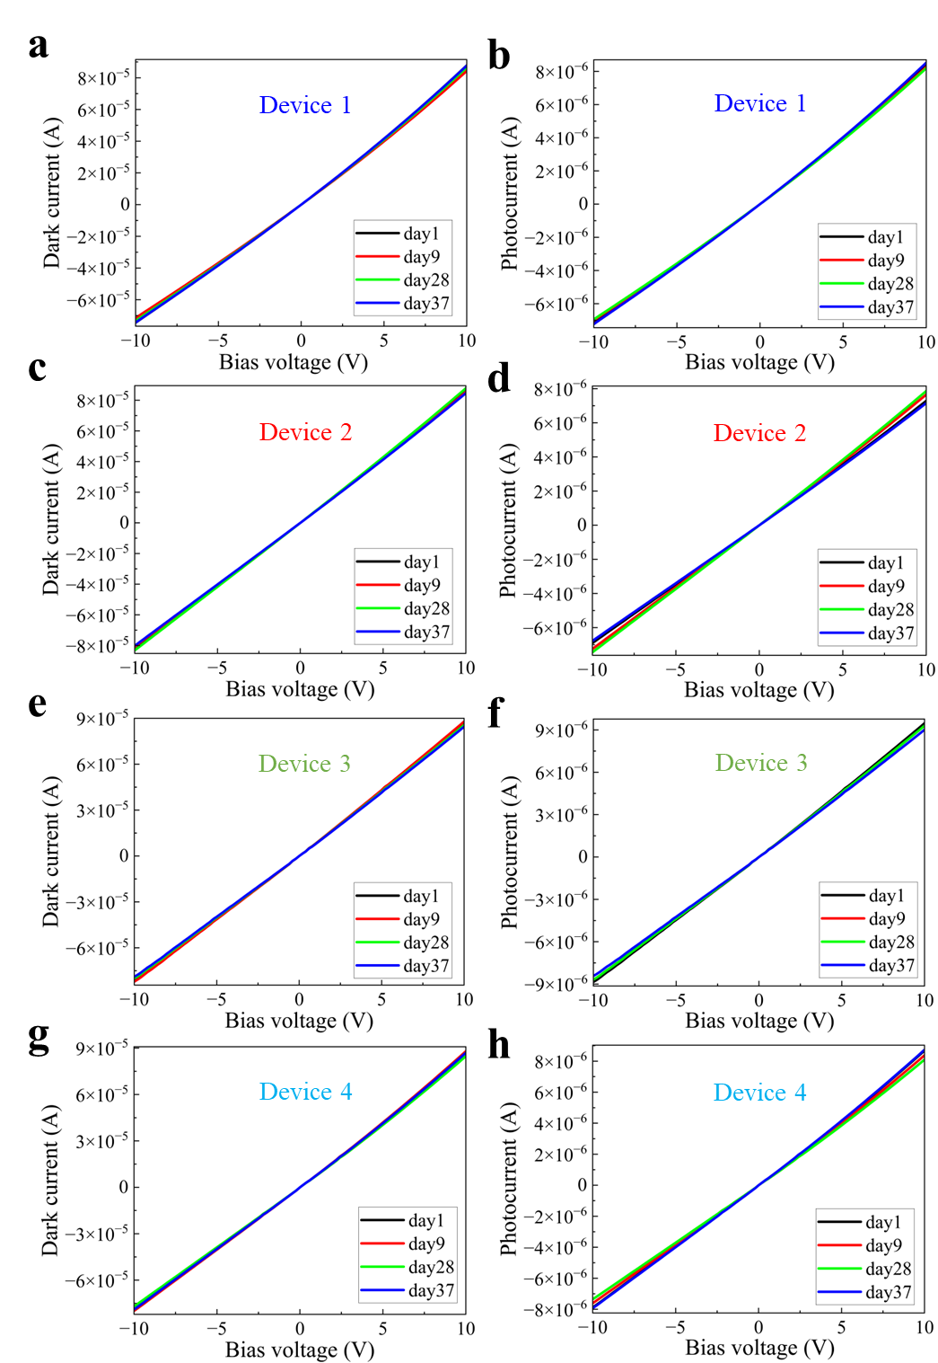
Supplementary Figure 4 | Long-term stability test results. Figures a, c, e, and g show the dark current versus bias voltage curves for devices 1 to 4, respectively, with each subfigure containing four curves measured on days 1, 9, 28, and 37. Figures b, d, f, and h present the corresponding photocurrent versus bias voltage curves for the same four devices under 980 nm illumination (optical power density ≈ 3.5 W/cm²) at the same four time points.
Supplementary Figure 5 | Photocurrent of devices under extreme temperatures. The photocurrent response of the device across a temperature range of -150 °C to 400 °C. The measurement was performed under 940 nm illumination at an optical power density of approximately 3 W/m².
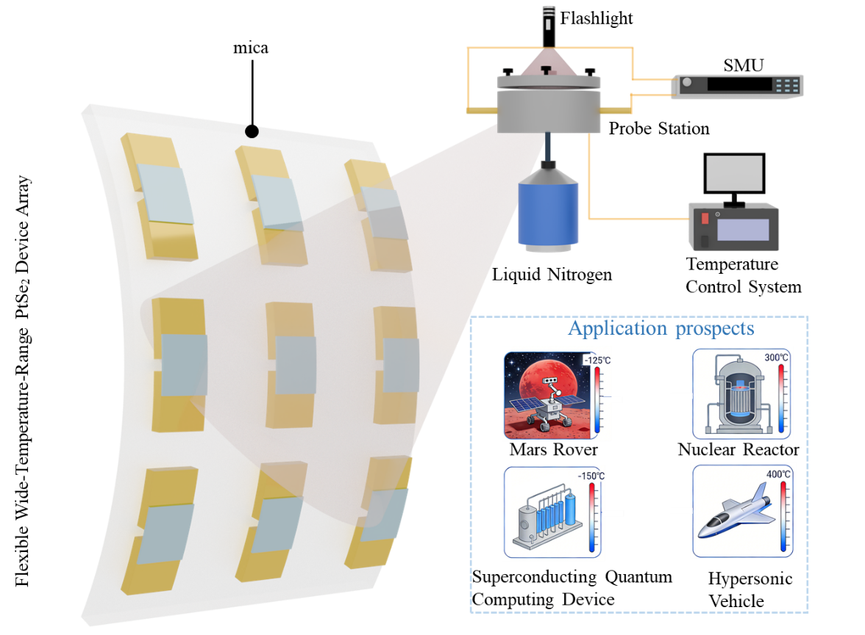
Supplementary Figure 6 | Flexible Optoelectronic Devices for Extreme Environments: Integration, Testing, and Application Prospects. The left side shows a photoelectric device array on a flexible mica substrate. The upper right part illustrates a high-low temperature testing system, while the lower right part presents a conceptual diagram envisioning its application prospects in extreme environments.
Supplementary Note 1: Structural and Physical Characterization of PtSe₂ Films
Supplementary Fig. 1 presents the thickness and spectroscopic characterization of the PtSe₂ thin film. The atomic force microscopy (AFM) height map (Supplementary Fig. 1a) shows that the film thickness is uniform, measured to be approximately 8 nm. The crystalline quality and phase purity of the material are further examined by Raman spectroscopy (Supplementary Fig. 1b). Two distinct characteristic peaks are observed at approximately 173 cm⁻¹ and 203 cm⁻¹¹, which are assigned to the E_{g} and A_{1g} vibrational modes of 1T-phase PtSe₂², respectively. The peaks are sharp and symmetric, and no impurity peaks are detected, indicating high crystallinity and good phase purity of the film.
To evaluate the thermal stability of the material, the Raman spectra of the PtSe₂ photodetector are compared before and after testing over a wide temperature range from -150 °C to 400 °C (Supplementary Fig. 1b and Supplementary Fig. 1c). No significant changes are observed in the positions or shapes of the characteristic peaks, demonstrating that the PtSe₂ film remains structurally stable across this broad temperature range without phase transformation or degradation.
Supplementary Note 2: Analysis of Device Transfer Characteristics
Transfer characteristic measurements were performed on a PtSe₂ device. With a fixed source-drain bias voltage of V_{ds} = 5 V, the transfer characteristic curve (I_{ds}-V_{g}) shown in Supplementary Fig. 2 was obtained by sweeping the back-gate voltage V_{g} from -100 V to 100 V.
The curve shows that I_{ds} first decreases and then increases with increasing V_{g}, reaching a minimum at V_{g} = 16 V. This point corresponds to the charge neutrality point, indicating the lowest carrier concentration in the channel. It is notable that the charge neutrality point is significantly shifted toward the positive gate voltage direction. This directly demonstrates that the fabricated PtSe₂ film exhibits p-type doping characteristics, which may originate from factors such as selenium vacancies formed during growth or environmental adsorption.
Further observation reveals a pronounced asymmetry in the curve between the positive and negative gate voltage regions. In the negative gate voltage region, the slope of I_{ds} versus V_{g} is significantly steeper than that in the positive gate voltage region (V_{g} > 16 V), indicating a stronger regulatory capability of negative gate voltage on the channel conductance. This behavior is generally attributed to a higher hole mobility than electron mobility in the channel, which is a typical characteristic of p-type semiconductors and is consistent with the aforementioned conclusion of the right-shifted charge neutrality point.
Supplementary Note 3: Spatial Response Characteristics and Mechanism Analysis
To study the spatial response characteristics of the device under illumination, we investigated its electric field and photocurrent distributions. The experiments were conducted under 940 nm wavelength illumination with an optical power of 200 μW (the spot diameter is approximately 1.5 μm.) and a bias voltage of 5 V. Supplementary Fig. 3a shows a three-dimensional schematic of the device, indicating the metal-semiconductor junction region and the channel region; Supplementary Fig. 3b illustrates the measurement area; Supplementary Figs. 3c and 3d present the electric field distribution and the spatial photocurrent distribution of the device, respectively. It should be noted that, due to the photoconductive gain effect caused by trap states^{3–7} in PtSe₂, the device can generate a relatively large microampere-level photocurrent at multiple measured points under illumination, though its spatial distribution is not uniform.
The specific features are as follows: As shown in Supplementary Fig. 3c, a strong electric field exists in the metal-semiconductor junction region, which efficiently separates photogenerated carriers. These carriers are then rapidly extracted by electrodes through fast drift motion, resulting in a significantly enhanced photocurrent in this region (Supplementary Fig. 3d). This also provides a key condition for the high-speed response of the device. In contrast, the electric field in the channel region is relatively weak, leading to lower efficiency in the separation and extraction of photogenerated carriers. Therefore, the photocurrent signal contributed by this region is markedly weaker than that from the junction region (Supplementary Fig. 3d).
Supplementary Note 4: Evaluation of the Long‑Term Stability
Excellent long-term stability of the four PtSe₂ photodetectors was demonstrated over a 37‑day test period. As shown in Supplementary Fig. 4a–h, the dark current and photocurrent curves measured on days 1, 9, 28, and 37 are nearly overlapping, with no obvious decay observed. These results indicate that the photoelectrical performance of the devices remains highly consistent over an extended time, confirming their good environmental stability.
Supplementary Note 5: Robust Photoresponse of PtSe₂ Devices Across an Ultra‑Broad Temperature Range (‑150 °C to 400 °C)
Supplementary Fig. 5 illustrates the variation trend of the device photocurrent over a temperature range from ‑150 °C to 400 °C. As shown, as the temperature is increased stepwise from ‑150 °C to 400 °C, a significant and continuous rise in photocurrent is observed, with recorded values of 0.578 μA, 0.713 μA, 0.961 μA, 1.35 μA, 2.42 μA, and 2.55 μA, respectively. Notably, the increase in photocurrent becomes more pronounced above 300 °C, indicating that the device maintains an active photoresponse even under high-temperature conditions.
This behavior can be explained from both carrier dynamics and the intrinsic material properties. First, elevated temperature leads to a marked enhancement in the concentration of thermally excited charge carriers and an improvement in carrier mobility, thereby promoting the separation and transport efficiency of photogenerated electron‑hole pairs^{8,9}. Second, as a narrow‑bandgap¹⁰ two‑dimensional material, the electrical conductivity of PtSe₂ is inherently sensitive to temperature; under high‑temperature conditions, its semiconducting behavior may become more prominent, and the contribution from thermal carrier injection may also be involved, collectively resulting in the enhanced photocurrent¹¹. These results demonstrate the promising potential of PtSe₂ for high‑temperature photodetection or sensing applications in extreme environments, and the correlation between photocurrent and temperature provides valuable insight for subsequent device optimization and thermal management design.
Supplementary Note 6: Integration and Application Prospects of Flexible PtSe₂ Photodetector Arrays for Extreme Environments
This study successfully fabricated an array of PtSe₂ photodetectors on a flexible mica substrate and systematically investigated their potential for applications in extreme environments. The device integration schematic (Supplementary Fig. 6) on the left illustrates the distribution of the array on the flexible substrate, which exhibits high integration density and good structural integrity. The depiction of its bent state (controlled during actual testing by conforming to a cylindrical surface of specific dimensions to define the bending radius) further demonstrates the excellent mechanical flexibility of the overall device, laying the foundation for its use in non-planar or deformable systems.
The upper right section provides a schematic of the high-low temperature testing system used to evaluate the environmental stability of the devices. This platform enables systematic characterization of the photoelectric performance and reliability of the devices under simulated extreme temperature conditions, thereby providing key data for assessing their practical environmental tolerance.
The conceptual diagram in the lower right section envisions the application prospects of such flexible optoelectronic devices. Leveraging their flexibility and potential environmental stability, this type of device is expected to be applied in multiple complex and demanding scenarios, such as deep-space exploration, operational condition monitoring in quantum computing equipment, and real-time detection in extreme industrial environments^{12–15}.

References
1. Wang, Z., Li, Q., Besenbacher, F. & Dong, M. Facile Synthesis of Single Crystal PtSe₂ Nanosheets for Nanoscale Electronics. Advanced Materials 28, 10224–10229 (2016).
2. Raczyński, J. et al. Studies of temperature-dependent Raman spectra of thin PtSe₂ layers on Al₂O₃ substrate. Materials Science and Engineering: B 297, 116728 (2023).
3. Yang, Y. et al. High-responsivity PtSe₂ photodetector enhanced by photogating effect. Applied Physics Letters 118, 013103 (2021).
4. Wu, J. et al. Dielectric‐Free MoS₂/VO₂ Junction Field‐Effect Transistor with Sensitive and Ultrafast Photoresponse for Light Encrypted Communication. Advanced Materials 37, 2503294 (2025).
5. Liao, F. et al. Bioinspired in-sensor visual adaptation for accurate perception. Nat Electron 5, 84–91 (2022).
6. Dodda, A. et al. Active pixel sensor matrix based on monolayer MoS₂ phototransistor array. Nat. Mater. 21, 1379–1387 (2022).
7. Chen, J. et al. Optoelectronic graded neurons for bioinspired in-sensor motion perception. Nat. Nanotechnol. 18, 882–888 (2023).
8. Wei, Y. et al. Grain Boundaries Engineering to Achieve Hot‐Carrier Photothermoelectric Infrared Detector. Laser & Photonics Reviews 20, e01839 (2026).
9. Kim, Y. R. et al. Unveiling the Hot Carrier Distribution in Vertical Graphene/h-BN/Au van der Waals Heterostructures for High-Performance Photodetector. ACS Appl. Mater. Interfaces 12, 10772–10780 (2020).
10. Zhao, Y. et al. High‐Electron‐Mobility and Air‐Stable 2D Layered PtSe₂ FETs. Advanced Materials 29, 1604230 (2017).
11. Zhu, Y., Xu, H., Yu, P. & Wang, Z. Engineering plasmonic hot carrier dynamics toward efficient photodetection. Applied Physics Reviews 8, 021305 (2021).
12. Zhong, Z. et al. Ionic-electronic photodetector for vision assistance with in-sensor image processing. Nat Commun 16, 7096 (2025).
13. Nguyen, B.-S., Lin, J.-F. & Perng, D.-C. Microstructural, Electrical, and Mechanical Properties of Graphene Films on Flexible Substrate Determined by Cyclic Bending Test. ACS Appl. Mater. Interfaces 6, 19566–19573 (2014).
14. Choi, K. K., Jhabvala, M. D., Forrai, D. P., Sun, J. & Endres, D. C-QWIPs for space exploration. Infrared Physics & Technology 54, 170–176 (2011).
15. Guan, R., Xu, H., Lou, Z., Zhao, Z. & Wang, L. Design and Development of Metasurface Materials for Enhancing Photodetector Properties. Advanced Science 11, 2402530 (2024).

