Compassion in Daily Life: Investigating Bidirectional Compassion-Affect Dynamics with Ecological Momentary Assessment

Supplementary Material

S1 Statystical analyses

Network Models
The mlVAR model (Epskamp et al., 2020) allows the estimation and visualization of three complementary network models, each capturing relationships among variables at a different temporal level (Epskamp et al., 2018):
1) Temporal network model. It captures the lagged associations between nodes from one measurement point (lag-1) to the next (lag). It yields a directed network where arrowheads indicate the predictive direction of one variable on another at the next time point, after controlling for all other variables at the previous measurement point. This model thus, reflect whether a deviation from one person's mean predicts a deviation from that person's mean on another variable at the next measurement occasion (Bringmann et al., 2016; Epskamp et al., 2018).
2) Contemporaneous network model. It provides information on the association between variables within the same time window, corresponding to a multilevel partial correlation network, after controlling for temporal associations. This network displays whether deviations from a person’s means on two variables predict one another at the same (i.e., same “beep”) measurement occasion (Epskamp et al., 2018; Greene et al., 2018).
3) A between-subjects network model. It shows regularized partial correlations between individuals' means during a specific time period (during 10 days in this case), after accounting for the other variables in the network (Epskamp et al.2012, 2018; Greene et al., 2018).
Node Selection
In line with the preregistration, five nodes were included in the models: three corresponding to the compassion flows (compassion toward oneself, compassion toward others, and compassion from others) and two representing affect (PA and NA). PA and NA scores were computed by averaging their respective EMA items (PA: happy, relaxed, energetic, satisfied; NA: stressed, anxious, irritated, sad).
Intraclass Correlation Coefficient
Following prior studies (Contreras et al., 2024), we calculated the Intraclass Correlation Coefficient (ICC) for each EMA item to examine within-person variability. The ICC represents the proportion of total variance attributable to between-person differences; lower ICC values therefore indicate greater within-person variability. For example, an ICC of .40 indicates that 40% of variance is between-person and 60% is within-person, suggesting substantial state-like fluctuation in the measured construct across assessments.
Assumption Testing
The mlVAR framework requires two statistical assumptions to be met: normality and stationarity.
Normality was assessed using Kolmogorov-Smirnov tests for each variable. To assess normality, we used Kolmogorov for each variable. Regarding stationarity, the VAR framework also assumes that the mean and variance of a variable do not change as a function of time (Bringmann et al., 2016; Aalbers et al., 2019). To test it, we used the Kwiatkowski-Phillips-Schmidt-Shin unit root test (KPSS Test for Stationarity) for each variable of each participant, as implemented in tseries R package (Trapletti & Hornik, 2019).
Assumption testing results
Kolmogorov–Smirnov tests indicated that none of the variables were normally distributed (all p values < 0.001). However, there is limited guidance on how to best handle non-normality in multilevel VAR models (Blanchard et al., 2023). Additionally, some authors argue that the normality assumption may not be critical or that violations primarily affect specific results (McNeish & Hamaker, 2020; Veenman et al., 2024). Considering these points, and following previous research (e.g., Contreras et al., 2024, Kirkorian et al., 2025), we proceeded with the analysis without adjusting for non-normality, given that the primary focus was on capturing temporal variability. Finally, KPSS unit root tests indicated stationarity for all variables across all participants.

S2 Results
Figure S1
Contemporaneous, Temporal, and Between-Subjects Networks of Compassion Flows and Affect With Partial Correlation Values
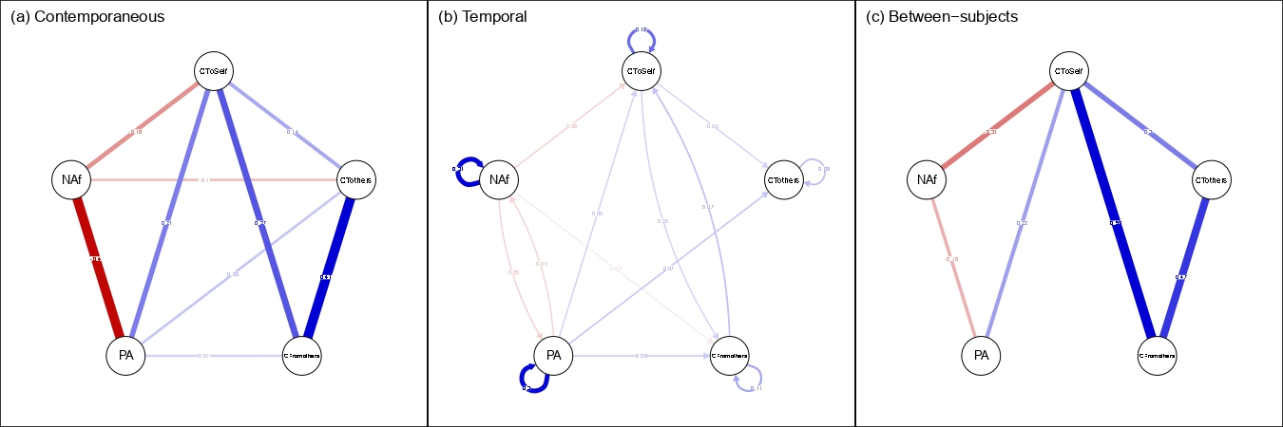
Note. This figure reproduces Figure 2 with the addition of partial correlation values displayed on each edge. Blue edges indicate positive partial correlations and red edges indicate negative partial correlations; edge width is proportional to the magnitude of the partial correlation. In the temporal network (panel b), directed arrows indicate lagged effects from time t−1 to time t, and self-loops represent autoregressive effects. NAf = negative affect; PA = positive affect; CToSelf = compassion to self; CTothers = compassion to others; CFromothers = compassion from others.
Table S1
Within-Person Contemporaneous Network Partial Correlations
Variable 1 | Variable 2 | r
Compassion to Others | Compassion to Self | 0.140
Compassion from Others | Compassion to Self | 0.273
Positive Affect | Compassion to Self | 0.209
Negative Affect | Compassion to Self | −0.175
Compassion from Others | Compassion to Others | 0.410
Positive Affect | Compassion to Others | 0.090
Negative Affect | Compassion to Others | −0.097
Positive Affect | Compassion from Others | 0.071
Negative Affect | Positive Affect | −0.403
Note. . r = partial correlations. Partial correlations represent associations between variables assessed at the same measurement occasion. Negative values indicate inverse associations.

Table S2
Within-Person Temporal Network Partial Correlations
Variable 1 | Variable 2 | r
Compassion to Self | Compassion to Self | 0.178
Compassion from Others | Compassion to Self | 0.074
Positive Affect | Compassion to Self | 0.055
Negative Affect | Compassion to Self | −0.055
Compassion to Self | Compassion to Others | 0.053
Compassion to Others | Compassion to Others | 0.078
Positive Affect | Compassion to Others | 0.067
Compassion to Self | Compassion from Others | 0.053
Compassion from Others | Compassion from Others | 0.109
Positive Affect | Compassion from Others | 0.064
Negative Affect | Compassion from Others | −0.029
Positive Affect | Positive Affect | 0.299
Negative Affect | Positive Affect | −0.053
Positive Affect | Negative Affect | −0.052
Negative Affect | Negative Affect | 0.307
Note. r = partial correlations Partial correlations represent lagged associations between variables across consecutive measurement occasions (t−1 → t). Diagonal entries reflect autoregressive effects. Negative values indicate inverse associations.
Table S3
Between-Person Network Partial Correlations
Variable 1 | Variable 2 | r
Compassion to Others | Compassion to Self | 0.300
Compassion from Others | Compassion to Self | 0.591
Positive Affect | Compassion to Self | 0.222
Negative Affect | Compassion to Self | −0.309
Compassion from Others | Compassion to Others | 0.467
Positive Affect | Compassion to Others | 0.158
Positive Affect | Compassion from Others | −0.135
Negative Affect | Positive Affect | −0.179
Note. r = partial correlations. Negative values indicate inverse associations.

References:
Aalbers, G., van der Lek, R., Jansen, B., van der Ploeg, M., & Fried, E. I. (2019). Social media and depression symptoms: A network perspective. Journal of Experimental Psychology: General, 148(8), 1454–1462. https://doi.org/10.1037/xge0000374
Blanchard, M. A., Contreras, A., Kalkan, R. B., & Heeren, A. (2023). Auditing the research practices and statistical analyses of the group-level temporal network approach to psychological constructs: A systematic scoping review. Behavior research methods, 55(2), 767-787. https://doi.org/10.3758/s13428-022-01839-y
Bringmann, L. F., Pe, M. L., Vissers, N., Ceulemans, E., Borsboom, D., Vanpaemel, W., Tuerlinckx, F., & Kuppens, P. (2016). Assessing temporal emotion dynamics using networks. Assessment, 23(4), 425–435. https://doi.org/10.1177/1073191116645909
Contreras, A., Blanchard, M. A., Mouguiama-Daouda, C., & Heeren, A. (2024). When eco-anger (but not eco-anxiety nor eco-sadness) makes you change! A temporal network approach to the emotional experience of climate change. Journal of anxiety disorders, 102, 102822. https://doi.org/10.1016/j.janxdis.2023.102822
Epskamp, S., Cramer, A. O. J., Waldorp, L. J., Schmittmann, V. D., & Borsboom, D. (2012). qgraph: Network visualizations of relationships in psychometric data. Journal of Statistical Software, 48, 1-18. 10.18637/jss.v048.i04
Epskamp, S., Deserno, M. K., Bringmann, L. F. (2020). mlvar: Multi-level vector autoregression [Computer software manual]. Retrieved from https://cran.r-project.org/web/packages/mlVAR/index.html
Epskamp, S., Waldorp, L. J., Mõttus, R., & Borsboom, D. (2018). The Gaussian Graphical Model in Cross-Sectional and Time-Series Data. Multivariate Behavioral Research, 53(4), 453–480. https://doi.org/10.1080/00273171.2018.1454823
Greene, T., Gelkopf, M., Epskamp, S., & Fried, E. I. (2018). Dynamic networks of PTSD symptoms during conflict. Psychological Medicine, 48(14), 2409–2417. https://doi.org/10.1017/S0033291718000351
Kirkorian, H., Barr, R., Suh, B., Booth, M., Blanchard, M. A., Piper, D. J., Li, J., & Kerr, M. L. (2026). Temporal associations between parents’ daily reports of media motivations, infant affect, and parenting behavior. Developmental psychology. https://doi.org/10.1037/dev0002133
McNeish, D., & Hamaker, E. L. (2020). A primer on two-level dynamic structural equation models for intensive longitudinal data in Mplus. Psychological Methods, 25(5), 610–635.
Trapletti, A., & Hornik, K. (2019). tseries: Time Series Analysis and Computational Finance. R package version 0.10-47. https://CRAN.R-project.org/package=tseries
Veenman, M., Janssen, L. H. C., van Houtum, L. A. E. M., Wever, M. C. M., Verkuil, B., Epskamp, S., Fried, E. I., & Elzinga, B. M. (2024). A Network Study of Family Affect Systems in Daily Life. Multivariate Behavioral Research, 59(2), 371–405. https://doi.org/10.1080/00273171.2023.2283632

