Research on forecast of global COVID-19 development trend
Yunyun Cheng¹, Yanping Bai^{2*}, Ting Xu², Rong Cheng², Hongping Hu²
¹ Department of Mathematics, School of Science, North University of China, Taiyuan 030051, China.
² Department of Mathematics, School of Science, North University of China, Taiyuan 030051, China.
* Corresponding author

E-mail: baiyp666@163.com

Supplementary Materials
Supplementary Figure 1
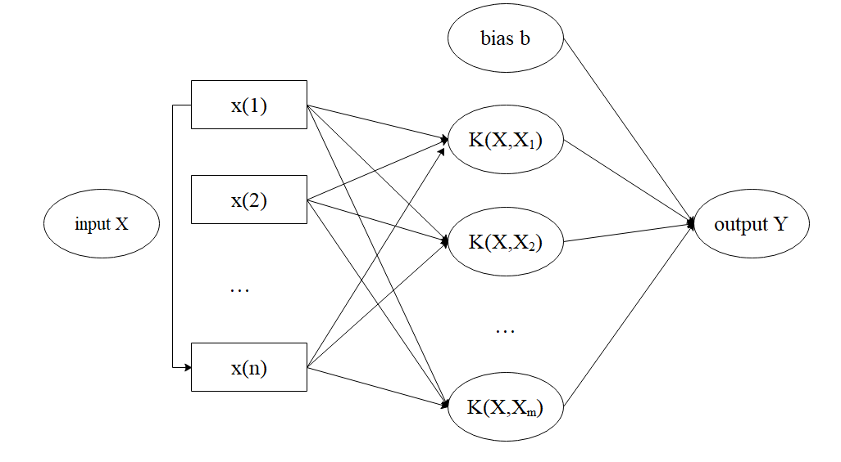
Supplementary Figure 1. SVM network structure diagram. K is the kernel function, which is the key of the SVM algorithm. It represents the inner product kernel between the support vector $x(i)$ and the vector $x$ extracted from the input space.

Supplementary Figure 2
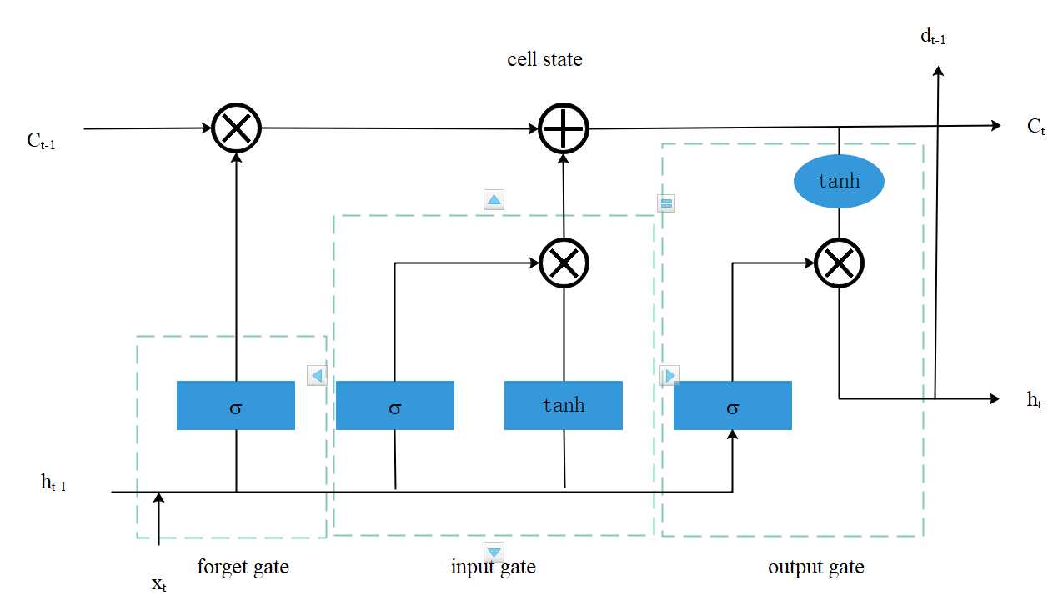
Supplementary Figure 2. LSTM network structure diagram. It is a simple loop in the structure of LSTM network, and has four interrelated fully connected feedforward neural networks, including forget gate, input gate, output gate and cell state. The gate consists of a sigmoid activation function network layer and a dot product operation. Three gates are used to control cell state information in LSTM.

