Supplementary Information
Multi-omics uncovers molecular targets for reef restoration from heat evolved strains of a host-generalist species of dinoflagellate (Cladocopium, Symbiodiniaceae)

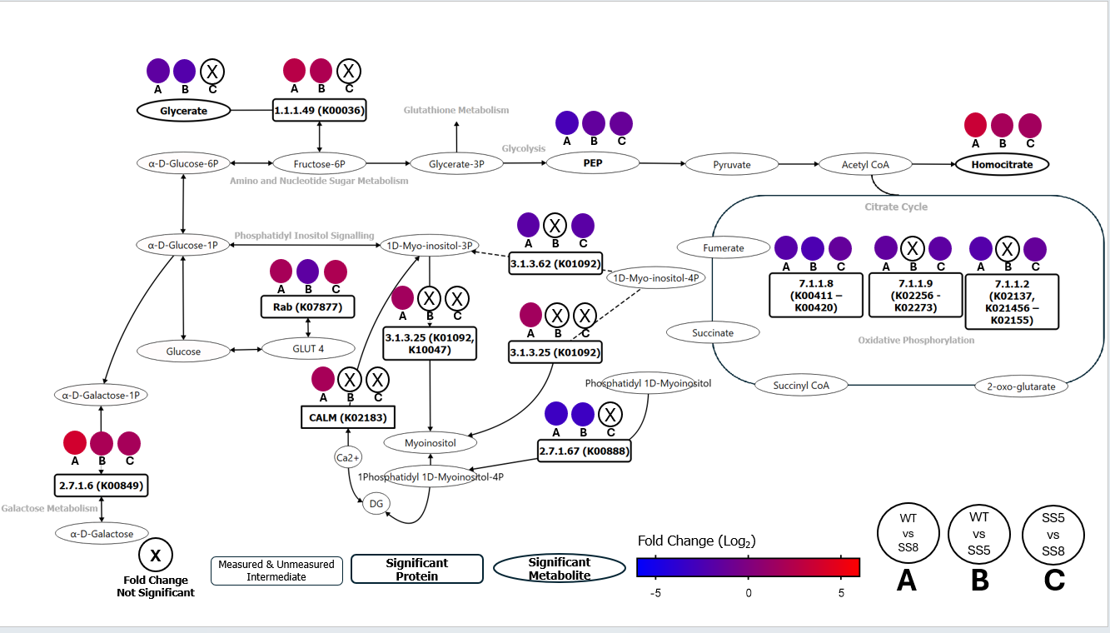
Fig S1 Carbon metabolism. Metabolite and protein fold change in E. diaphana hosts by KEGG pathway and select strain type comparison
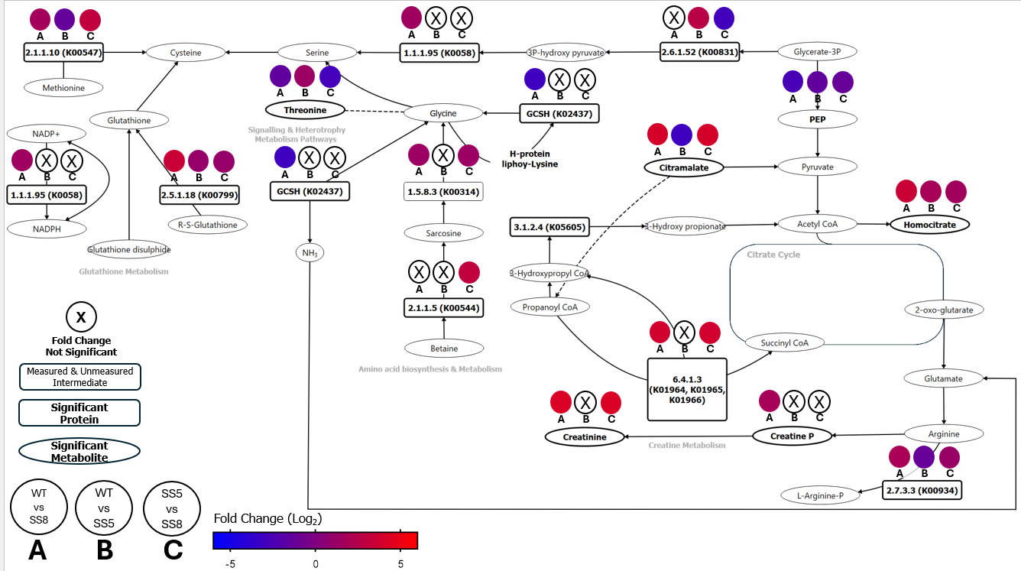
Fig S2 Glutathione metabolism. Metabolite and protein fold change in E. diaphana hosts by KEGG pathway and select strain type comparison

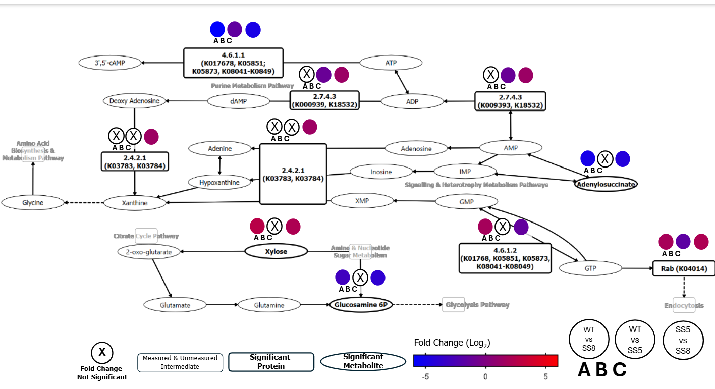
Fig S3 Nitrogen metabolism. Metabolite and protein fold change in E. diaphana hosts by KEGG pathway and select strain type comparison
Table S1 DIABLO outputs, dimension 1
Protein | Variable value | Lipids | Variable value | Metabolites | Variable value
Glutamine synthetase | -0.202 | DG(17:2(9Z,12Z)/18:3(9Z,12Z,15Z)/0:0)[iso2] | -0.489 | beta Nicotinamide adenine dinucleotide | -0.651
Glutathione S-transferase 4 isoform X1 | 0.008 | DG(19:1(9Z)/20:5(5Z,8Z,11Z,14Z,17Z)/0:0)[iso2] | -0.487 | Pterine | -0.512
Uncharacterised protein 164 | 0.015 | N-(3-(15-methyl-hexadecanoyloxy)-13-methyl-tetradecanoyl)-L-serine | -0.348 | Bambuterol | -0.383
Thioredoxin domain-containing protein 17 | 0.028 | PC(P-16:0/20:3(5Z,8Z,11Z)) | -0.317 | Guanosine | -0.379
Hydroxyacid-oxoacid transhydrogenase, mitochondrial | 0.037 | SQDG.14.0_16.0 | -0.307 | Azimsulfuron | -0.154
UPF0462 protein C4orf33 homolog | 0.041 | PS(13:0/18:3(6Z,9Z,12Z)) | -0.226 | L Cladinose | 0.011
Glutathione S-transferase | 0.048 | DG(17:1(9Z)/18:0/0:0)[iso2] | -0.163
UDP-N-acetylhexosamine pyrophosphorylase isoform X1 | 0.057 | Cer_NS d19:2_22:0 | -0.147
2,3-bisphosphoglycerate-independent phosphoglycerate mutase isoform X2 | 0.065 | LPC 20:4/0:0 | -0.146
Glyoxylate reductase/hydroxypyruvate reductase | 0.070 | DG(22:1(13Z)/22:3(10Z,13Z,16Z)/0:0)[iso2] | -0.138
Electron transfer flavoprotein subunit alpha, mitochondrial | 0.078 | PS(O-20:0/20:3(8Z,11Z,14Z)) | -0.120
Flavin-containing monooxygenase FMO GS-OX-like 8 | 0.079 | LysoPC(22:4(7Z,10Z,13Z,16Z)) | -0.119
Probable glutathione S-transferase 6 | 0.111 | EtherPE 16:1e_20:4 | -0.119
Uncharacterised protein 229 | 0.126 | Cer_NS d19:2_20:0 | -0.101
Glutathione S-transferase U19 | 0.146 | Rhodovibrin | -0.081
Uncharacterised protein 246 | 0.155 | Cer(d18:2/23:0) | -0.081
Acetyl-coenzyme A synthetase 2-like, mitochondrial | 0.162 | Cer(d18:2/22:0) | -0.032
3-hydroxyisobutyrate dehydrogenase, mitochondrial | 0.173 | PE(O-16:0/20:5(5Z,8Z,11Z,14Z,17Z)) | -0.024
GDP-L-fucose synthase | 0.190 | LysoPC(18:0) | -0.023
Dihydropteridine reductase | 0.213 | LysoPE(0:0/20:4(5Z,8Z,11Z,14Z)) | -0.012
Maleylacetoacetate isomerase | 0.221
Thimet oligopeptidas | 0.234
Kynurenine--oxoglutarate transaminase 3 | 0.249
Glutathione S-transferase | 0.258
S crystallin SL11 | 0.265
S.crystallin 4.1 | 0.271
3-hydroxyanthranilate 3,4-dioxygenase | 0.274
Prostaglandin reductase 2 | 0.281
Glutathione S-transferase Mu 5-like | 0.305
Phosphoglucomutase-1 | 0.308

Table S2 DIABLO outputs, dimension 2
Lipids | Variable value | Metabolites | Variable value | Proteins | Variable value
N,N-dimethyl-Safingol | -0.394 | Cynaroside A | 0.506 | NADH dehydrogenase [ubiquinone] flavoprotein 2, mitochondrial | -0.646
12alpha-Hydroxy-3-oxo-5beta-cholan-24-oic Acid | -0.280 | 3-(1,1-Dimethylallyl)scopoletin 7-glucoside | 0.460 | Low-density lipoprotein receptor-related protein 4 | -0.614
Zymosterol intermediate 1c | -0.246 | Lamioside | 0.426 | Glutamyl aminopeptidase isoform X1 | -0.411
8-oxo-3,7-Dimethyl-6E-octenyl acetate | -0.091 | Aeglin | 0.384 | Soma ferritin | -0.149
DG(16:0/17:0/0:0)[iso2] | -0.014 | Zingerone glucoside | 0.370 | Carbonic anhydrase 2 | -0.117
25-hydroxy-16,17,23,23,24,24-hexadehydrovitamin D3 / 25-hydroxy-16,17,23,23,24,24-hexadehydrocholecalciferol | -0.012 | Eremosulphoxinolide A | 0.254
LPC 0:0/18:1 | 0.004 | D-Sedoheptulose-7-phosphate | 0.036
TG(12:0/12:0/22:5(7Z,10Z,13Z,16Z,19Z))[iso3] | 0.005
GlcCer(d18:2/16:0) | 0.005
TG(12:0/14:0/18:3(9Z,12Z,15Z))[iso6] | 0.014
FAHFA 2:0_18:0 | 0.016
PC(16:1(9Z)/P-18:1(11Z)) | 0.018
TG(13:0/14:1(9Z)/18:2(9Z,12Z))[iso6] | 0.024
TG(14:1(9Z)/14:1(9Z)/14:1(9Z)) | 0.026
PA(P-20:0/22:6(4Z,7Z,10Z,13Z,16Z,19Z)) | 0.029
Prephytoene diphosphate | 0.034
TG(13:0/17:1(9Z)/22:5(7Z,10Z,13Z,16Z,19Z))[iso6] | 0.036
3alpha,7alpha,12alpha,26-tetrahydroxy-5alpha-cholestan-27-oic acid | 0.038
14:0(5Me[R],9Me[R],13Me) | 0.038
DG(22:5(7Z,10Z,13Z,16Z,19Z)/22:6(4Z,7Z,10Z,13Z,16Z,19Z)/0:0)[iso2] | 0.041
2-demethylmenaquinone-8 | 0.046
LPC 17:0/0:0 | 0.050
DGTS 4:0_13:0 | 0.056
C16 Sphinganine | 0.065
PC(O-1:0/O-16:0)[U] | 0.071
Phytyl diphosphate | 0.072
PA 2.0_16.3 | 0.075
Cer_AP t20:0_24:0 | 0.078
TG(12:0/13:0/20:5(5Z,8Z,11Z,14Z,17Z))[iso6] | 0.079
N-(26-hydroxyhexacosanyl)sphinganine | 0.080
DG(20:1(11Z)/22:3(10Z,13Z,16Z)/0:0)[iso2] | 0.080
Cucurbitaxanthin A | 0.081
TG(12:0/12:0/16:1(9Z))[iso3] | 0.092
16:0-Glc-Cholesterol | 0.107
Carboceric acid | 0.112
Persin | 0.112
PC(O-12:0/O-1:0) | 0.115
4-amino-4-deoxy-alpha-L-arabinopyranosyl undecaprenyl phosphate | 0.118
TG(15:1(9Z)/18:2(9Z,12Z)/22:6(4Z,7Z,10Z,13Z,16Z,19Z))[iso6] | 0.118
Hexacosanedioic acid | 0.125
PC(14:1(9Z)/24:1(15Z)) | 0.129
PC(P-20:0/12:0) | 0.143
Cer(t20:0/26:0(2OH)) | 0.165
Anhydrorhodovibrin | 0.203
3-Oxochola-1,4,6-trien-24-oic Acid | 0.204
SM(d18:2/14:0) | 0.218
Oleic acid(d2) | 0.237
PE-Cer(d14:2(4E,6E)/19:0) | 0.248
DG(17:2(9Z,12Z)/20:0/0:0)[iso2] | 0.284
PA(O-16:0/20:5(5Z,8Z,11Z,14Z,17Z)) | 0.364

