Functionally Calibrating Life Satisfaction:
The Case of Mating Motives and Self-Perceived Mate-value
Online Supplemental Material

An Alternative Mediation Model for Studies 2A and 2B
We propose a mediational model in which self-perceived short-term mate-value would calibrate life satisfaction as a means of facilitating short-term mating behavior. One could posit an alternative, however, in which self-perceived short-term mate-value would shape short-term mating behavior as a means of facilitating life satisfaction. We tested this alternative mediation model and, as with our focal model, found support for it from Studies 2 and 2B (Figure S1).
This is as one would expect, however. Because we measured self-perceived short-term mate-value, short-term unrestricted mating behavior, and life satisfaction contemporaneously, the current data structure cannot be used to infer causal relationships among these three variables. If the correlational relationships enable statistical mediation for one of these models, they are highly likely to do the same for the other. Thus, both models remain empirically plausible, although we believe that other research (Luhmann, Lucas, Eid, & Diener, 2013; Lyubomirsky, King, & Diener, 2005) lends credence to the model proposed here. Regardless, differentiating these alternatives would be valuable, requiring designs in which short-term mating behavior and life satisfaction are successfully manipulated experimentally.
Self-perceived
short-term mate value
Life satisfaction
Short-term
mating behavior
Total Effect
β_{2A} =.36, p < .001, β_{2B} =.41, p < .001
β_{2A} = .47, p < .001
β_{2B} = .47, p < .001
β_{2A} = .17, p = .021
β_{2B} = .28, p = .001
Bootstrap Estimate of Indirect Effect
β_{2A} = .08, 95% CI_{2A} [.01, .16]
β_{2B} = .13, 95% CI_{2B} [.05, .24]
Bootstrap Estimate of Direct Effect
β_{2A} = .28, 95% CI_{2A} [.13, .44]
β_{2B} = .28, 95% CI_{2B} [.08, .47]
Figure S1. Mediation model from Studies 2A and Study 2B showing that the predictive effect of self-perceived mate-value on life satisfaction is partially statistically mediated by short-term mating behavior for uncommitted men.

Sex Differences on Variability of Life Satisfaction
Based on previous research findings that men are more variable in mating success than are women (Clutton-Brock, Albon, & Guinness, 1981; Leimar, 1996), we assessed sex differences in life satisfaction variability, as a post-hoc consideration, using a modified signed-likelihood ratio test (M-SLR test) implemented in the “cvequality” package for R (Krishnamoorthy & Lee, 2014; Marwick & Krishnamoorthy, 2016).
We found no general sex differences in life satisfaction variability, M-SLRT = 1.72, p = .19 (Figure S2A). However, in light of a nuanced sex difference in the association between self-perceived mate-value and life satisfaction for those not in committed relationships, we tested and found that the life satisfaction variability of uncommitted men is marginally greater than the life satisfaction variability of uncommitted women, M-SLRT = 3.34, p = 0.067 (Figure S2B). In contrast, we found an opposite pattern for those in committed relationships: the life satisfaction variability of committed women is marginally greater than the life satisfaction variability of committed men, M-SLT = 3.15, p = 0.076 (Figure S2C).
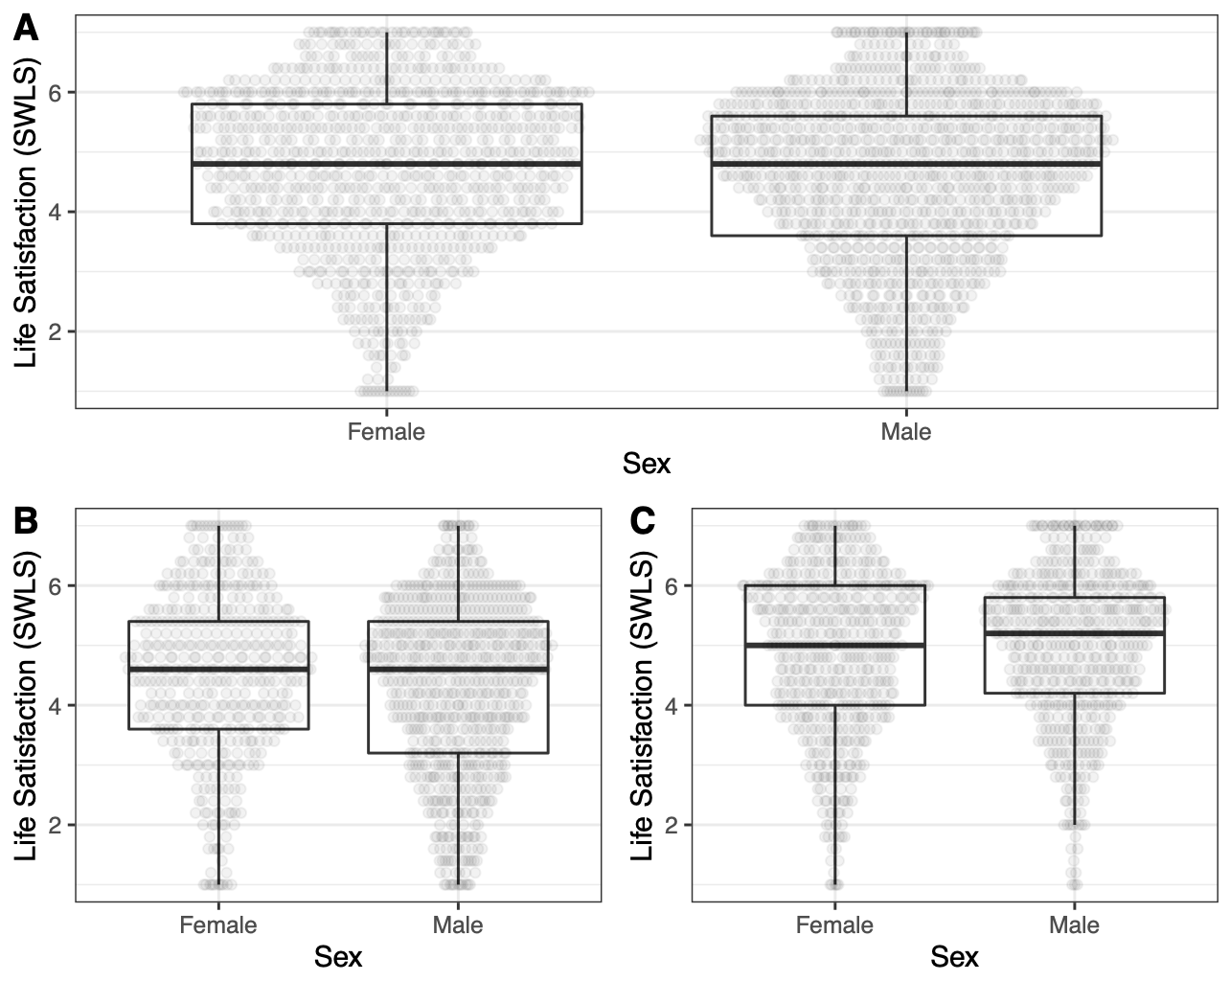
Figure S2. Boxplot of life satisfaction. Panel A (top) for men and women, Panel B (bottom left) for those in uncommitted relationships, and Panel C (bottom right) for those in committed relationships

Measures
Self-perceived mate-value: Studies 1, 2A, 2B, and 3

Items adapted from Haselton (2003)

1 = Not at all attractive, 9 = Extremely attractive

[Self-perceived long-term mate-value]
- Compared with other men [women] you know who are about your age, how desirable do women [men] find you as a long-term mate or marriage partner?
[Self-perceived short-term mate-value]
- Compared with other men [women] you know who are about your age, how desirable do women [men] find you as a short-term mate or casual-sex partner?

Life satisfaction: Studies 1, 2A 2B, and 3

Items from Diener, Emmons, Larsen, & Griffin (1985)

Below are five statements that you may agree or disagree with. Using the 1 - 7 scale below, indicate your agreement with each item by placing the appropriate number on the line preceding that item. Please be open and honest in your responding.

1 = Strongly disagree, 7 = Strongly agree

- In most ways my life is close to my ideal.
- The conditions of my life are excellent.
- I am satisfied with my life.
- So far, I have gotten the important things I want in life.
- If I could live my life over, I would change almost nothing.

Short-term mating motivation: Studies 2A and 2B

Item from Hill, Rodeheffer, Griskevicius, Durante, & White (2012)

1 = Strongly disagree, 7 = Strongly agree

- I am currently motivated to have a short-term (e.g., brief affair) or casual-sex relationship.

Short-term (unrestricted) mating behavior: Studies 2A and 2B

Items from Simpson & Gangestad (1991)
- With how many different partners have you had sex (sexual intercourse) within the past year? (0, 1, 2, 3, 4, 5, 6, 7, 8, 9+)
- How many different partners do you foresee yourself having sex with during the next five years? (0, 1, 2, 3, 4, 5-6, 7-8, 9-10, 10-14, 15+)
- With how many different partners have you had sex on one and only one occasion? (0, 1, 2, 3, 4, 5-6, 7-8, 9-10, 10-14, 15+)

Self-desirability: Study 2A

1 = Not at all attractive, 9 = Extremely attractive

- Compared with other men [women] you know who are about your age, how desirable do women [men] find you as a friend?

- Compared with other men [women] you know who are about your age, how desirable do women [men] find you as a sibling?

- Compared with other men [women] you know who are about your age, how desirable do women [men] find you as a coworker?

Self-esteem: Study 2B

Items from Rosenberg (1965)

1 = Strongly disagree, 7 = Strongly agree

- On the whole, I am satisfied with myself
- I take a positive attitude toward myself

Manipulations
Implicit social comparison manipulation used in Study 2A
<Instruction>
Online dating has become one of the most common ways of meeting people. In dating apps, it is important for users to be able to accurately assess how the opposite sex will view them. In this study, we are interested in how well people guess the opposite sex's preferences.

Based on the zip code you provided and GPS information, a computer program will now show you 20 randomly chosen same-sex profile pictures of people who live within 50 miles from you. While the program is collecting the data, please answer the following questions.

<Manipulation Instruction>
You will now view 20 pictures of same-sex profiles. Using the following scale, please estimate as accurately as possible how members of the opposite sex would perceive those profiles.
To men [women], how sexually desirable is this woman [man]?
MEN [WOMEN] would see this woman [man] as ___________

Not at all sexually desirable 1 2 3 4 5 6 7 8 9 Extremely sexually desirable

Direct feedback manipulation used in Study 2B
<Instruction>
The original WSPI is ended. Shortly after 10-15 seconds, the next button will automatically appear. As a reminder, we will ask additional questions, as part of our goal of improving the WSPI's reliability, validity, and predictability. Please answer all questions as truthfully and accurately as you can.

As we mentioned earlier, many people find it interesting to learn about their personal profiles. For this reason, we will now provide you with your individual social profile, as well as how it relates to profiles created from over 10,000 participants already studied in the United States.

<Questionnaires as a part of manipulation>

What is your highest level of education?
- Some high school, no diploma
- High school graduate, diploma or the equivalent (e.g., GED)
- Some college credit, no degree
- Trade/technical/vocational training
- Associate degree (e.g., AA, AS)
- Bachelor's degree (e.g., BA, BS)
- Master's degree (e.g., MA, MS, MEd)
- Professional degree (e.g., MD, DDS, DVM)
- Doctorate degree (e.g., PhD, EdD)

What is your current annual income?
- Less than $10,000
- $10,000 - $19,999
- $20,000 - $29,999
- $30,000 - $39,999
- $40,000 - $49,999
- $50,000 - $59,999
- $60,000 - $69,999
- $70,000 - $79,999
- $80,000 - $89,999
- $90,000 - $99,999
- $100,000 - $149,999
- More than $150,000

What is your expected annual income in 5 years?
- Less than $10,000
- $10,000 - $19,999
- $20,000 - $29,999
- $30,000 - $39,999
- $40,000 - $49,999
- $50,000 - $59,999
- $60,000 - $69,999
- $70,000 - $79,999
- $80,000 - $89,999
- $90,000 - $99,999
- $100,000 - $149,999
- More than $150,000

Here are a number of personality traits. To what extent do they apply to you? Please choose a number to indicate the extent to which the trait is characteristic of you.
You should rate the extent to which the pair of traits applies to you, even if one characteristic applies more strongly than the other.

1 = Strongly disagree, 7 = Strongly agree

- Extraverted, enthusiastic
- Critical, quarrelsome
- Dependable, self-disciplined
- Anxious, easily upset
- Open to new experiences, complex
- Reserved, quiet
- Sympathetic, warm
- Disorganized, careless
- Calm, emotionally stable
- Conventional, uncreative

How tall are you in feet and inches?
- Feet ________________________________________________
- Inches ________________________________________________

What is your weight in pounds?
- Pounds ________________________________________________

What is your waist size in inches? [male only]
- less than 28
- 28 - 29
- 30 - 31
- 32 - 33
- 34 - 35
- 37 - 38
- 38 - 39
- 40 - 41
- 42 - 43
- 44 - 45
- 46 - 47
- more than 47

What is your waist size in inches? [female only]
- less than 25
- 25 - 26
- 27 - 28
- 29 - 30
- 31 - 32
- 33 - 34
- 35 - 36
- 37 - 38
- 39 - 40
- more than 40

What is your hip size in inches (pants size)? [female only]
- less than 33
- 33 - 34 (size 000 - 00)
- 35 - 36 (size 0 - 2)
- 37 - 38 (size 4 - 6)
- 39 - 40 (size 8 - 10)
- 41 - 44 (size 12 - 14)
- 45 - 47 (size 16 - 18)
- 48 - 50 (size 20 - 22)
- more than 50

What is your chest size (shirt size)? [male only]
- size XS
- size S
- size M
- size L
- size XL
- size XXL
- size XXXL

What is your bra size in inches? [female only]
- 30
- 32
- 34
- 36
- 38
- 40
- 42
- 44
- 46

What is your bra size in cups? [female only]
- AA
- A
- B
- C
- D
- DD
- E/DDD
- F

What color is your natural hair?
- Light Ash Blond
- Light Blond
- Light Golden Blonde
- Beeline Honey
- Medium Champagne
- Butterscotch
- Light Cool Brown
- Light Brown
- Light Golden Brown
- Chocolate Brown
- Dark Golden Brown
- Medium Ash Brown
- Reddish Blonde
- Light Auburn
- Medium Anburn
- Red Hot Cinnamon
- Espresso
- Jet Black

What is your eye color?
- Gray
- Blue
- Violet
- Blue-green
- Green
- Amber
- Hazel
- Brown
- Black
- Other

How well do you feel that these attributes apply to you currently?
1 = Strongly disagree, 7 = Strongly agree
- Ambitious
- Attractive face
- Attractive body
- Desire children
- Enthusiastic about sex
- Faithful to partners
- Financially secure
- Generous
- Good sense of humor
- Healthy
- Independent
- Intelligent
- Kind and understanding
- Loyal
- Responsible
- Religious
- Shares my values
- Shares my interests
- Sociable
- Emotionally stable

How often do you fantasize about having sex with someone other than your current dating partner?
- never
- very seldom
- about once every two or three months
- about once a month
- about once every two weeks
- about once a week
- several times per week
- nearly every day
- at least once a day

Please respond honestly to the following questions:
1 = Strongly disagree, 7 =Strongly agree

- Sex without love is OK
- I can easily imagine myself being comfortable and enjoying "casual" sex with different partners.
- I would have to be closely attached to someone (both emotionally and psychologically) before I could feel comfortable and fully enjoy having sex with him or her.
- I am interested in maintaining a long-term romantic relationship with someone special.

Which of these two would you prefer?
1 = Definitely option 1, 9 = Definitely option 2

- Option 1 : Have one romantic/sexual partner and invest a lot in the relationship
Option 2 : Have many romantic/sexual partners and invest less in each relationship
- Option 1 : Have one child and invest all your time and resources into that one child
Option 2 : Have multiple children and split your time and resources across all of them
- Option 1 : Work on a job that pays you now
Option 2 : Spend time/money to learn new skills (e.g., education) now, but get a job that pays more in the future

<Positive Feedback; High mate-value condition>
Participant,
Based on your sex and age, we estimated your relative, comparative standing as a member of each of the following social relationships.
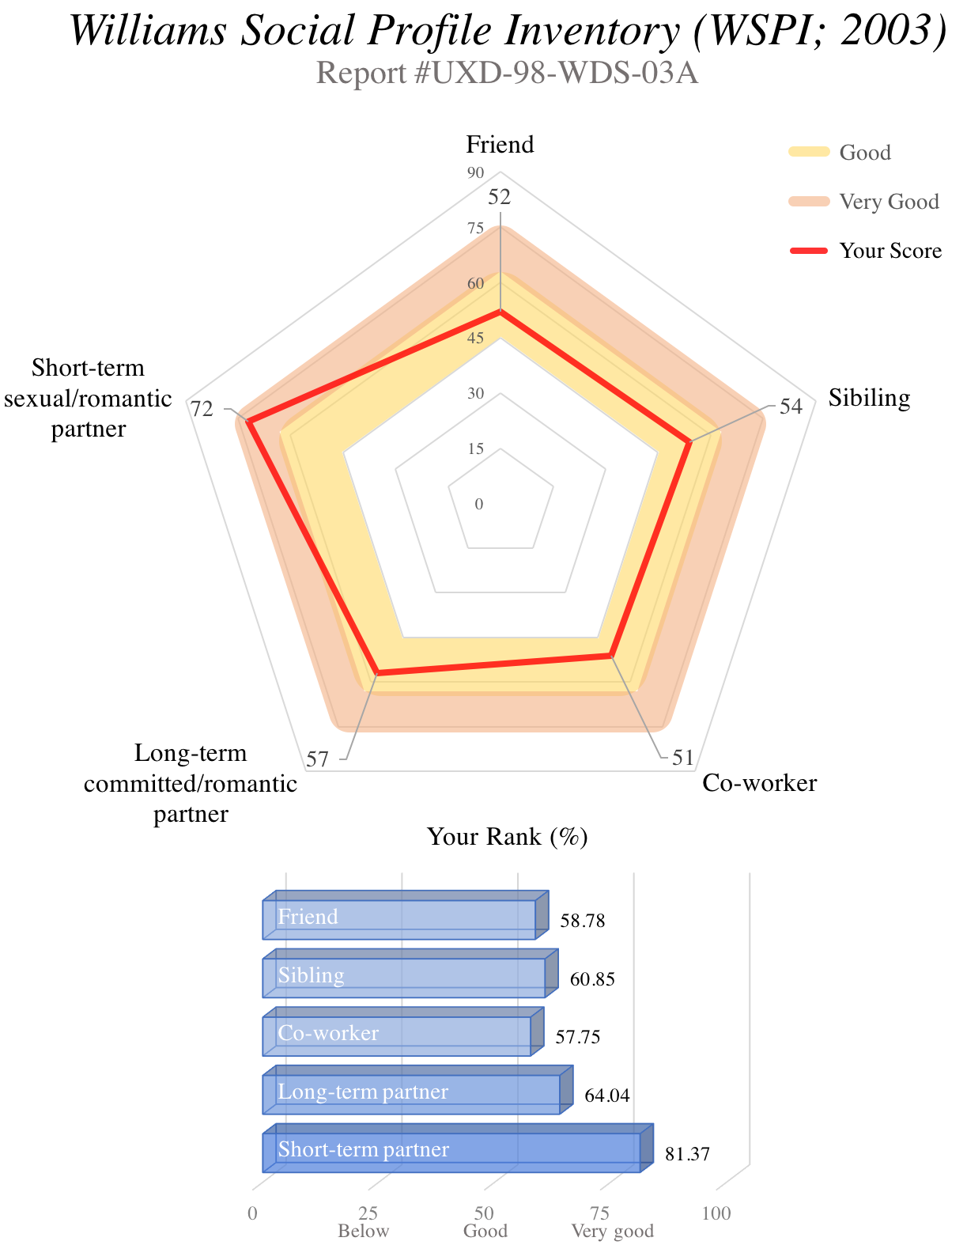
- Friend:
  - Score: 52
  - Higher than 58.78% of population
  - This means that you are likely to be a good friend.
- Sibling:
  - Score: 54
  - Higher than 60.85% of population
  - This means that you are likely to be a good sibling.
- Co-worker:
  - Score 51
  - Higher than 57.75% of population
  - This means that you are likely to be a good co-worker.
- Long-term committed/romantic partner:
  - Score 57
  - Higher than 64.04% of population
  - This means that you are likely to be a good long-term committed/romantic partner.
- Short-term sexual/romantic partner:
  - Score 72
  - Higher than 81.37% of population
  - This means that you are likely to be a very good short-term sexual/romantic partner.

<Negative Feedback: Low mate-value condition>
Participant,
Based on your sex and age, we estimated your relative, comparative standing as a member of each of the following social relationships.
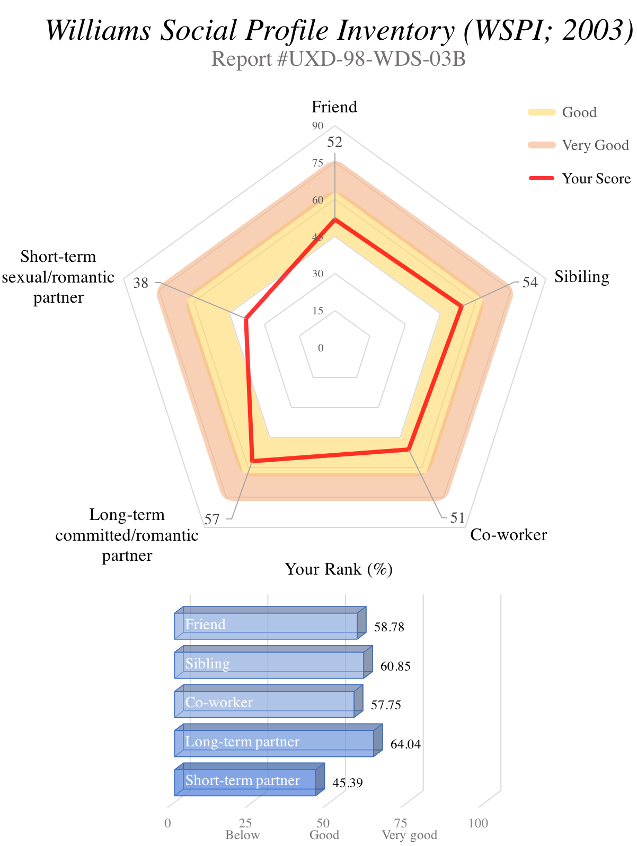
- Friend:
  - Score: 52
  - Higher than 58.78% of population
  - This means that you are likely to be a good friend.
- Sibling:
  - Score: 54
  - Higher than 60.85% of population
  - This means that you are likely to be a good sibling.
- Co-worker:
  - Score 51
  - Higher than 57.75% of population
  - This means that you are likely to be a good co-worker.
- Long-term committed/romantic partner:
  - Score 57
  - Higher than 64.04% of population
  - This means that you are likely to be a good long-term committed/romantic partner.
- Short-term sexual/romantic partner:
  - Score 38
  - Higher than 45.39% of population
  - This means that you are likely to be a below average short-term sexual/romantic partner.

Short-term mating motivation prime used in Study 3
< Mating Condition (Ainsworth & Maner, 2012)>
In the space provided, please briefly describe below 4-5 times that you have felt sexual desire or arousal from afar—that is, without having interacted with the person yet.
- 1 ________________________________________________
- 2 ________________________________________________
- 3 ________________________________________________
- 4 ________________________________________________
- 5 ________________________________________________

In the space provided below, please describe in detail one situation that makes you, or has made you, feel a great amount of sexual desire for another person. Please be detailed enough so that someone reading what you write might be able to picture him- or herself in that situation.

< Control Condition>
In the space provided, please briefly describe below 4-5 things that make you feel loved and being cared for by your family.
- 1 ________________________________________________
- 2 ________________________________________________
- 3 ________________________________________________
- 4 ________________________________________________
- 5 ________________________________________________

In the space provided below, please describe in detail one situation that makes you, or has made you feel the most loved and cared for by your family. Please be detailed enough so that someone reading what you write might be able to picture him- or herself in that situation.

References
Clutton-Brock, T. H., Albon, S. D., & Guinness, F. E. (1981). Parental investment in male and female offspring in polygynous mammals. Nature, 487–489.
Diener, E., Emmons, R., Larsen, J., & Griffin, S. (1985). The satisfaction with life scale. Journal of Personality Assessmemt, 49, 71–75.
Haselton, M. G. (2003). The sexual overperception bias: Evidence of a systematic bias in men from a survey of naturally occurring events. Journal of Research in Personality, 37, 34–47.
Hill, S. E., Rodeheffer, C. D., Griskevicius, V., Durante, K. M., & White, A. E. (2012). Boosting beauty in an economic decline: Mating, spending, and the lipstick effect. Journal of Personality and Social Psychology, 103, 275–291.
Krishnamoorthy, K., & Lee, M. (2014). Improved tests for the equality of normal coefficients of variation. Computational Statistics, 29, 215–232.
Leimar, O. (1996). Life-history analysis of the Trivers and Willard sex-ratio problem. Behavioral Ecology, 7, 316–325.
Luhmann, M., Lucas, R. E., Eid, M., & Diener, E. (2013). The prospective effect of life satisfaction on life events. Social Psychological and Personality Science, 4, 39–45.
Lyubomirsky, S., King, L., & Diener, E. (2005). The benefits of frequent positive affect: Does happiness lead to success? Psychological Bulletin, 131, 803–855.
Marwick, & Krishnamoorthy. (2016). cvequality: tests for the equality of coefficients of variation from multiple groups.
Rosenberg, M. (1965). Society and the adolescent self-image. Princeton, NJ: Princeton University Press.
Simpson, J. A., & Gangestad, S. W. (1991). Individual differences in sociosexuality: Evidence for convergent and discriminant validity. Journal of Personality and Social Psychology, 60, 870–883.

