Supplementary Table S1. p-values from pairwise comparison of stability and viability between constructed centromeres.
CEN Construct #1 | CEN Construct #2 | Viability  p-value | Stability  p-value
Minimal | CDEI^{L75} | 0.097 | 0.76
Minimal | CDEIII^{R19} | 6.6E-6*** | 0.069
Minimal | CDEIII^{R56} | 3.2E-6*** | 0.039*
Minimal | CDEIII^{R113} | 8.8E-4*** | 0.025*
Minimal | Full | 3.5E-6*** | 0.082
CDEIII^{L75} | CDEIII^{R19} | 0.0012** | 0.11
CDEIII^{L75} | CDEIII^{R56} | 0.0016** | 0.25
CDEIII^{L75} | CDEIII^{R113} | 1.6E-4*** | 0.81
CDEIII^{L75} | Full | 0.0022** | 0.90
CDEIII^{R19} | CDEIII^{R56} | 0.37 | 0.26
CDEIII^{R19} | CDEIII^{R113} | 0.42 | 0.81
CDEIII^{R19} | Full | 0.036* | 0.90
CDEIII^{R56} | CDEIII^{R113} | 0.24 | 0.19
CDEIII^{R56} | Full | 0.072 | 0.31
CDEIII^{R113} | Full | 0.097 | 0.72

Supplementary Table S2. List of yeast strains used
Strain Name | Genotype | References
BY4741 | MATa his3∆1 leu2∆0 met15∆0 ura3∆0 | Zhang H, Roberts DN, Cairns BR (2005)
WYYY410 | MATa his3∆1 leu2∆0 met15∆0 ura3∆0 [CEN8 on all chromosomes] | Ling YH, Yuen KWY (2019)
WYYY428 | BY4741, ade2∆::MET15 ade3∆::LEU2 trp1-∆63 | Ling YH, Yuen KWY (2019)
WYYY429 | WYYY428, ade2∆::MET15 ade3∆::LEU2 trp1-∆63 [CEN8 on all chromosomes] | Ling YH, Yuen KWY (2019)
DCY1495.1 | WYYY429 + galcen8:ura (40kb) | This study
DCY1500.1 | (WYYY410)+p1SDM (galcen8:ura) | This study
DCY1501.1 | (WYYY410)+p2SDM (galcen8:ura) | This study
DCY1502.1 | (WYYY410)+p2p1SDM (galcen8-300:ura) | This study
DCY1503.1 | (WYYY410)+p3SDM (galcen8:ura) Isolate #1 | This study
DCY1504.1 | (WYYY410)+p4SDM (galcen8:ura) Isolate #1 | This study
AKY1.1 | (WYYY429 with pTA-1SDM-cen8) Trp+, #1 | This study
AKY2.1 | (WYYY429 with pTA-2SDM-cen8) Trp+, #1 | This study
AKY3.1 | (WYYY429 with pTA-3SDM-cen8) Trp+, #1 | This study
AKY4.1 | (WYYY429 with pTA-4SDM-cen8) Trp+, #1 | This study
AKY5.1 | (WYYY429 with pTA-2p1SDM-cen8) Trp+, #1 | This study
AKY6.1 | (WYYY429 with pTA-3p1SDM-cen8) Trp+, #1 | This study
AKY7.1 | (WYYY429 with pTA-cen118-cen8) #1 | This study
AKY8.1 | (WYYY429 with YeCEN330) #1 | This study
AKY9.1 | (WYYY429 with YeCEN330CA) #1 | This study
AKY12.1 | (YEF473a + mini-AKB9 [~2.5 kb] isolate 1) | This study
AKY13.1 | (J1781D + 2p1SDM Isolate 1) | This study
AKY14.1 | (YEF473a + mini-AKB13 [~2.5 kb] isolate 2 | This study
AKY15.1 | (J1781D + 1SDM Isolate 4) | This study
AKY18.1 | (DCY1504.1, yta7∆, Kan resistant, Ura+) | This study
AKY19.1 | (DCY1502.1, yta7∆, Kan resistant, Ura+) | This study

Supplementary Table S3. Primers table
Primer Name | Sequence
Galp_EagI_rev new | TCAGAACGGCCGCAAAAAATTGTTAATATACCTCTATAC
GC1 | TCGACTACGCGATCATGGCG
GC2 | CACGATGCGGTCGTCCGGGCGTAGA
His4PopoutUp | TAGTATAAGATTCCTCTGGAGCGTC
4080 | CTACCGTTAATTGATGATCTGG
eC1 | TCAATAGCTTGCAGCGTAGCTAA
eC2 | GGGTGGGAAACTGAAGAAATC
qPCR-GAL-f1 | AATATACCTCTATACTTTAACGTCAAGGAG
qPCR-GAL-r2 | ATGCGTCCGGCGTAGA
3050 Reverse | CGCCATGATCGCGTAGTCGA
Yta75 KO | GAAGTTACCACGGTCTATTTCTCTCTTCTCGCTATTTATTCACAATTGGTGCAGAAAGAACCAGCTGAAGCTTCGTACGC
Yta73 KO | GCACATTCATGTATATGAACTAACTACATTTAAGAATTATATAAACATTATGGACTCCTGCGCATAGGCCACTAGTGGATCTG
Yta7_CHKUP | GGAACTGCGTAGGGTCTTAAA
Yta7_CHKDN | ATTCTCGGTCATTACCCGAAACG
Q5SDM_upZERO_75_F | GTGTAATTGTTGGAGTTCTTCTTATCTACTTTTTAACTTCTCCTTGACGTTAAAGTATAG
Q5SDM_upZERO_75_R | ATCCACAAAACGATTTAGTATAATAAGTAGGATGGTAATCACATGACTAATAATTCTTTTAATTTTAATTAAT
Q5SDM_dsFULL_F | AAACATCAATAATCATTTTTTTATTTTTCGCGTTTTTAAGATAATGTCTTAACCAATTTTCTAAGTTCGGAACAC
Q5SDM_dsFULL_R | ATTTCACAAGCACTAAGGGAGAGTTTTGTCAACAAAGAATTTTATCGCTTCCTCAA AGTTGGTAAAGCAACTTAAC
Q5SDM_dsMED_56_F | CGCGTTTTTAAGATAATGTCTTAACCAATTTTCTAAGTTCGGAACAC
Q5SDM_dsMED_56_R | AAAAATAAAAAAATGATTATTGATGTTTGTTGGTAAAGCAACTTAAC
Q5SDM_dsLOW_20_F | CTTAACCAATTTTCTAAGTTCGGAACAC
Q5SDM_dsLOW_20_R | ACATTATCTTGTTGGTAAAGCAACTTAAC

Supplementary Table S4. Viability results of pat1Δ mutants
 | CFUs  Glucose (YPD) | CFUs  Galactose (YPG) | Viability (%)
Replicate 1 | 2 | 796 | 0.25
Replicate 2 | 4 | 784 | 0.51
Replicate 3 | 5 | 810 | 0.62
Average Viability: | 0.46 | Standard Deviation: | 0.19

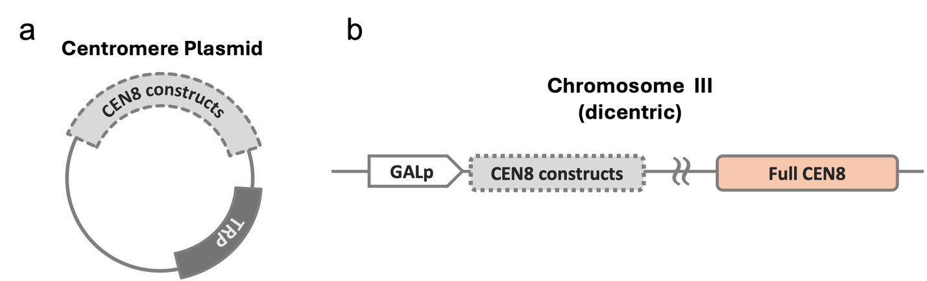

Supplementary Figure S1 Centromere plasmid and dicentric constructs schematic. Panels (a) and (b) represent the centromere plasmids and dicentric chromosome construction used in two assays.

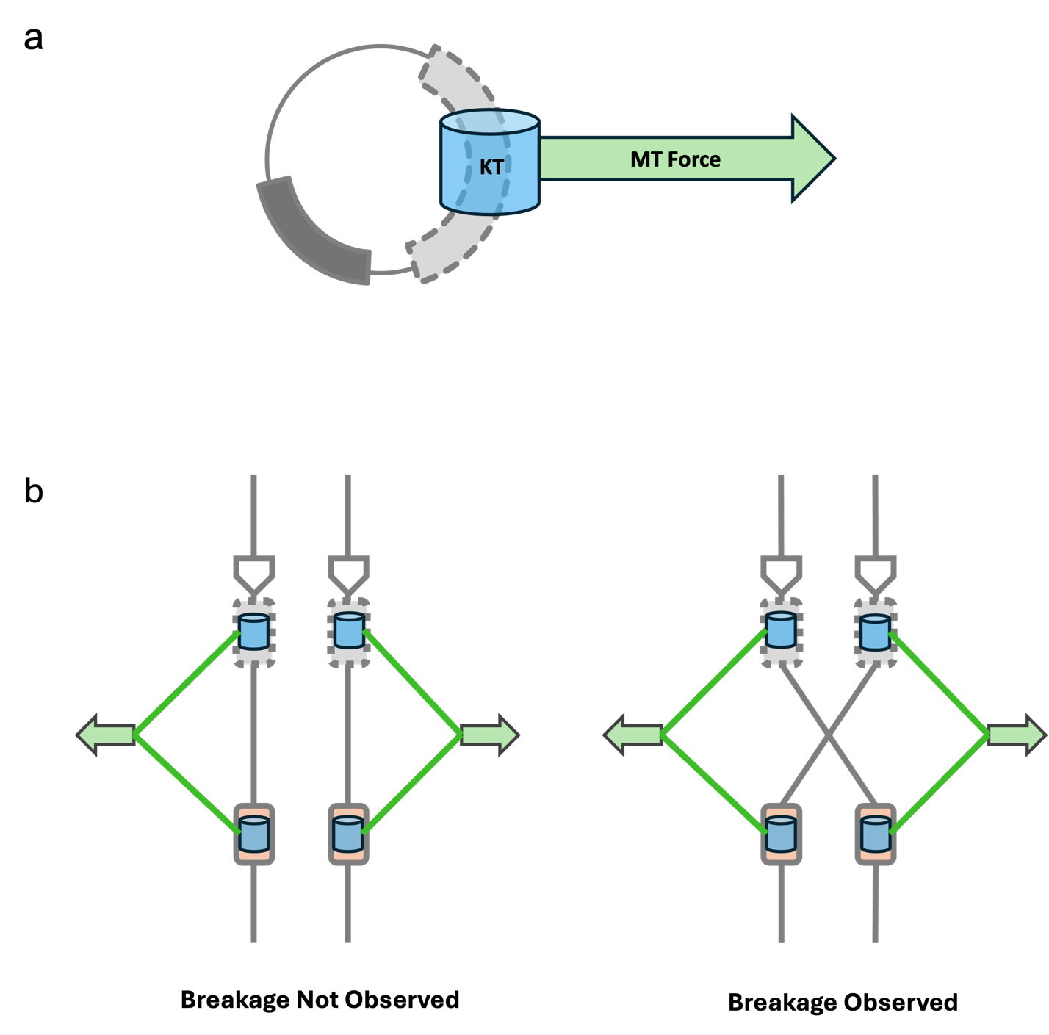
Supplementary Figure S2 Centromere functionality can be extrapolated from plasmid stability and dicentric viability. (a) Functional centromeres attached on to plasmids are more likely to form kinetochore attachment, which leads to MT attachment during mitosis, followed by segregation into daughter cells. (b) Functional centromeres allow for kinetochore and then microtubule attachment, which results in a 50:50 breakage chance. Increasing CEN function is associated with decreasing viability.

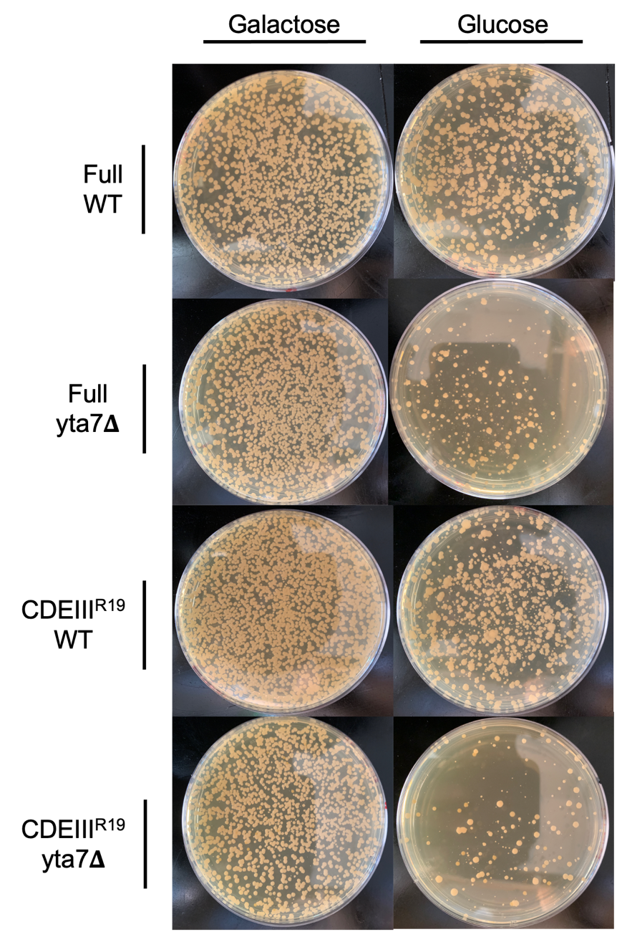

Supplementary Figure S3 Removal of Yta7 decreases viability and increases heterogeneity of cell morphology. Representative plates showing growth of dicentric strains carrying either a full-length centromere or the CDEIII^{R19} centromere in WT and yta7Δ backgrounds under dicentric-activating conditions (on glucose) or non-activating conditions (on galactose).
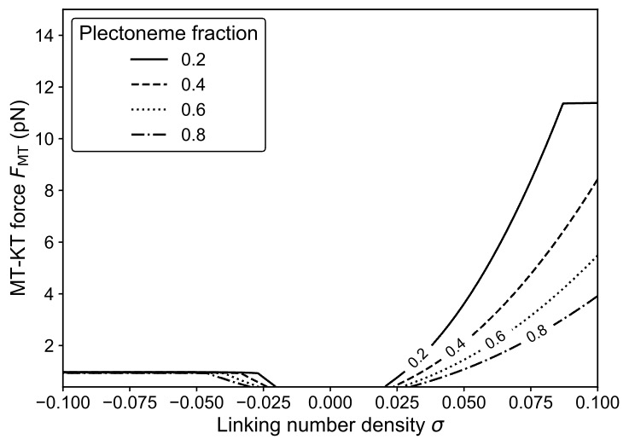
Supplementary Figure S4 Predicted plectoneme fraction depends on superhelical density and
MT–KT force. Contour of the plectoneme length fraction per DNA arm Supercoiling mechanics are computed using the stretched-DNA coexistence framework of (Marko 2007), in which the plectoneme fraction is zero below the coexistence threshold (σ=σ_{s}(F)) and increases linearly with σ inside the extended–plectoneme coexistence region. Asymmetry between negative and positive supercoiling reflects force-dependent competition with torque-melted (denatured) states under negative σ, which can preempt plectoneme formation at forces approximately ≥1 pN in the Marko model.

