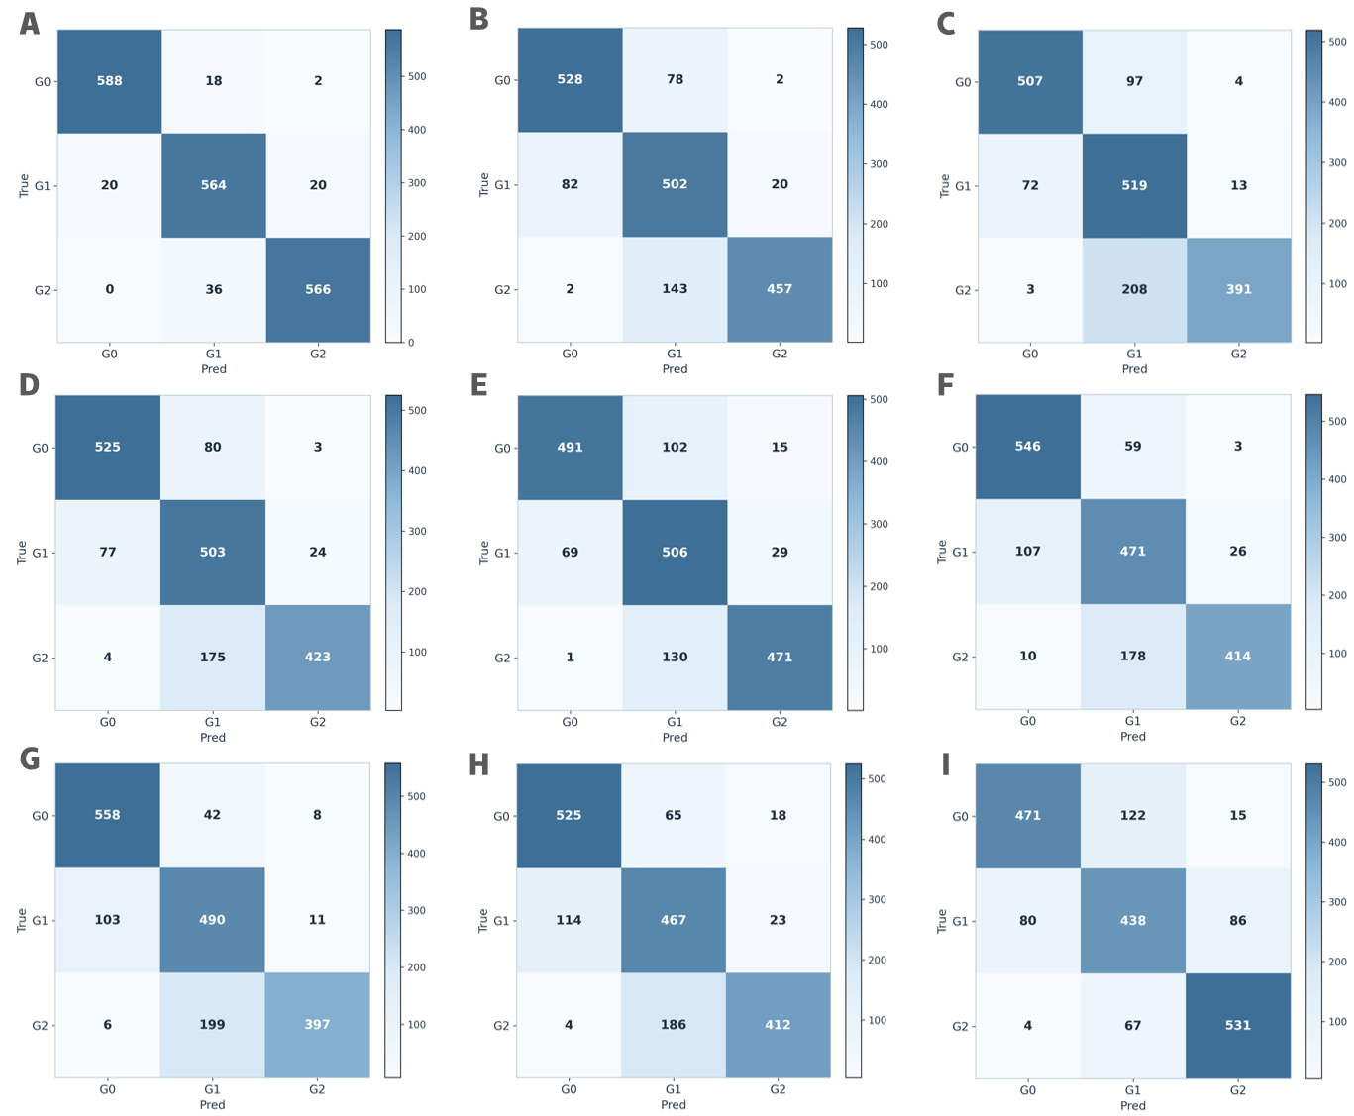
Figure S1. Confusion matrices for the proposed model and comparator models in the internal validation cohort. (A) Proposed model. (B) DenseNet121. (C) DenseNet169. (D) DenseNet201. (E) DenseNet264. (F) ResNet18. (G) ResNet34. (H) ResNet50. (I) ResNet101.

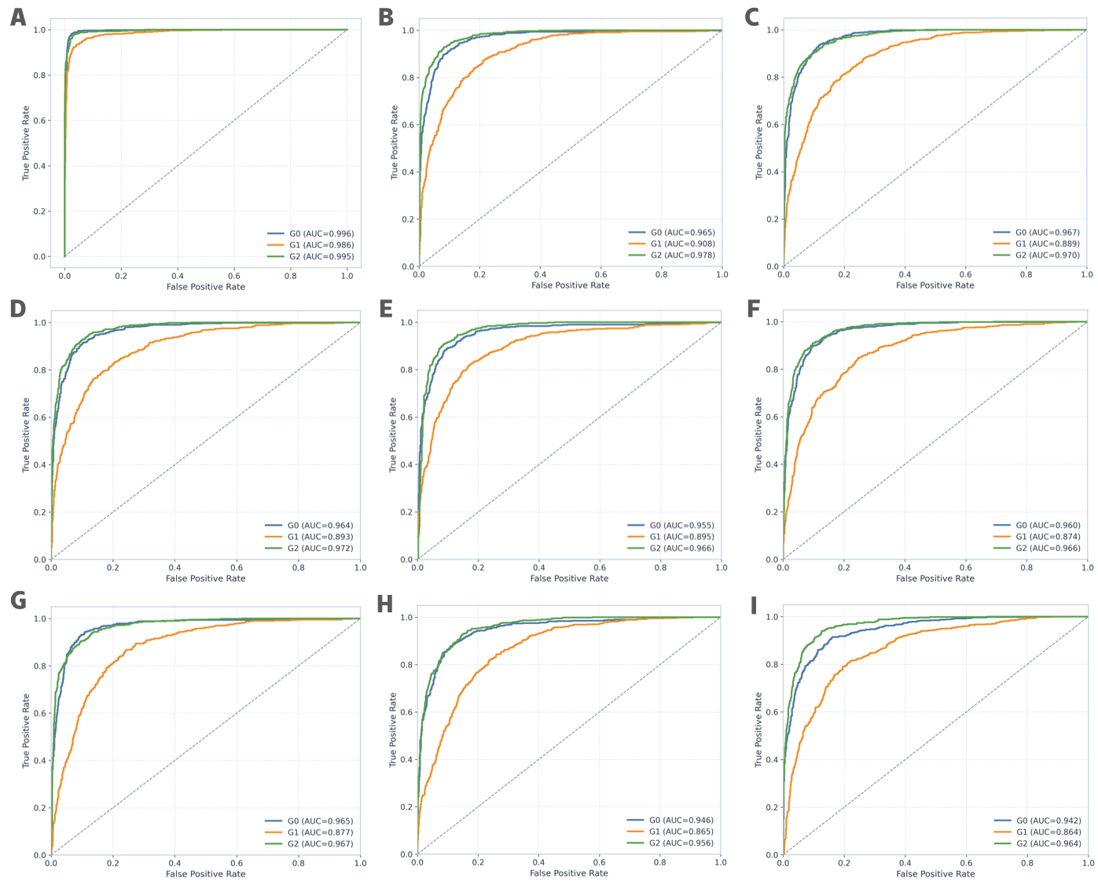
Figure S2. One-versus-rest ROC curves for the proposed model and comparator models in the internal validation cohort. (A) Proposed model. (B) DenseNet121. (C) DenseNet169. (D) DenseNet201. (E) DenseNet264. (F) ResNet18. (G) ResNet34. (H) ResNet50. (I) ResNet101.

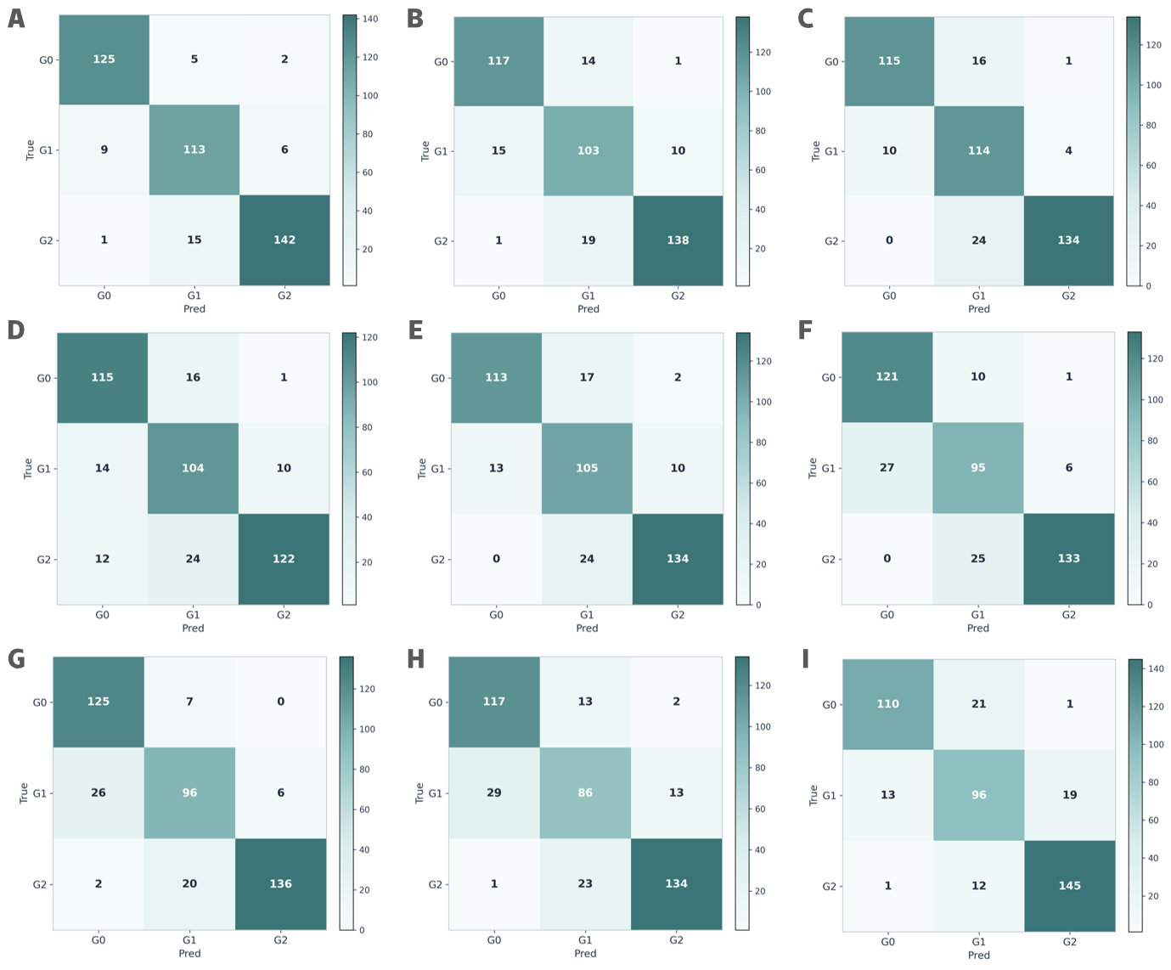
Figure S3. Confusion matrices for the proposed model and comparator models in the independent external validation cohort. (A) Proposed model. (B) DenseNet121. (C) DenseNet169. (D) DenseNet201. (E) DenseNet264. (F) ResNet18. (G) ResNet34. (H) ResNet50. (I) ResNet101.

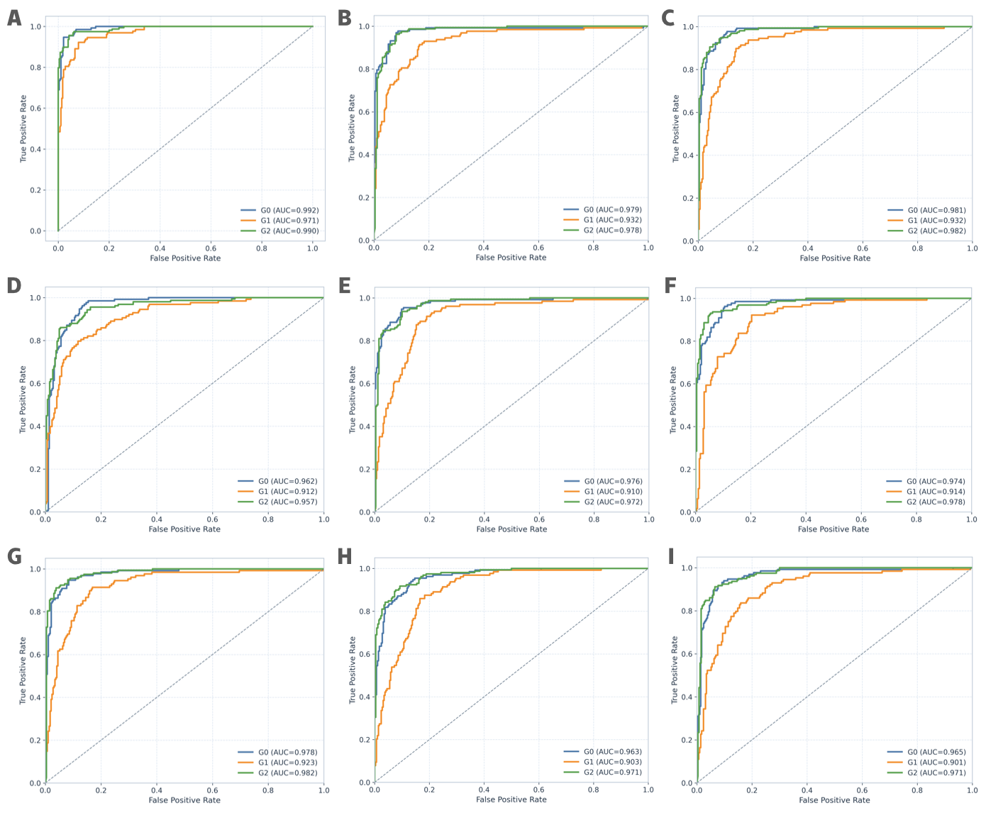
Figure S4. One-versus-rest ROC curves for the proposed model and comparator models in the independent external validation cohort. (A) Proposed model. (B) DenseNet121. (C) DenseNet169. (D) DenseNet201. (E) DenseNet264. (F) ResNet18. (G) ResNet34. (H) ResNet50. (I) ResNet101.

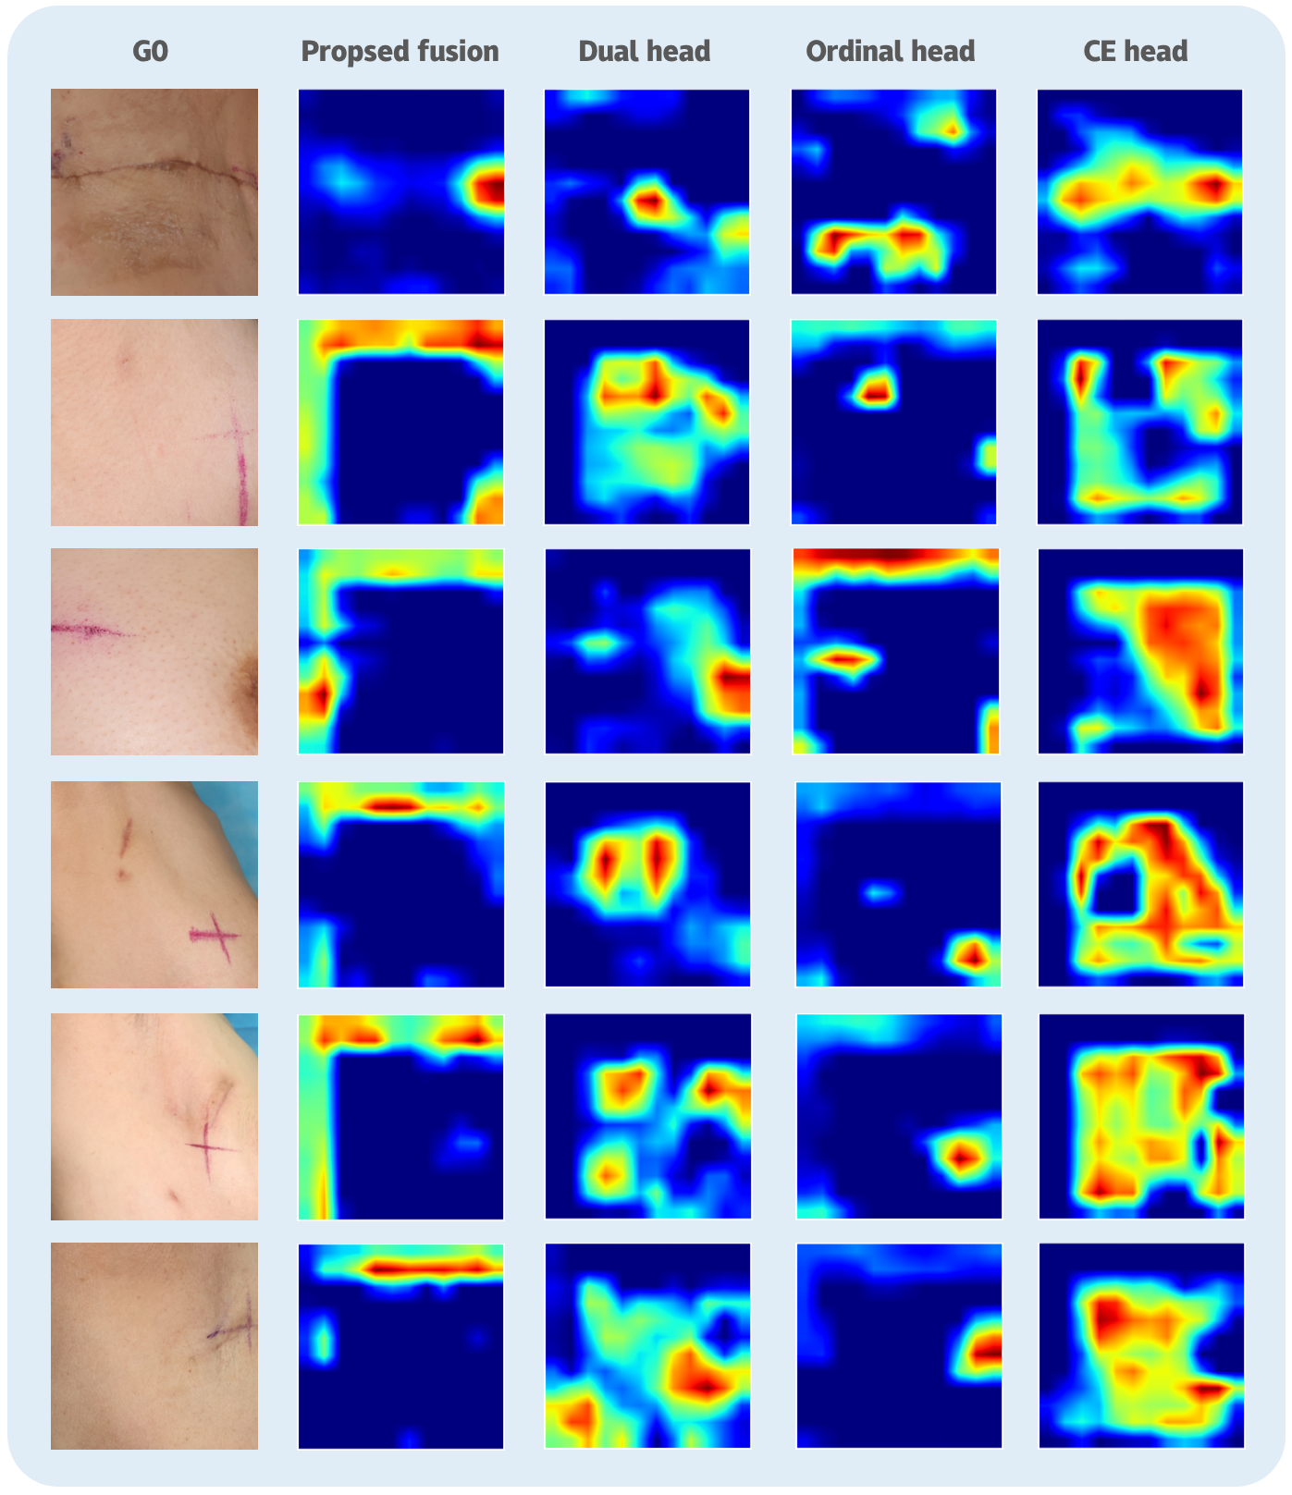
Figure S5. Representative activation maps for grade 0 cases across the proposed model and ablation variants.

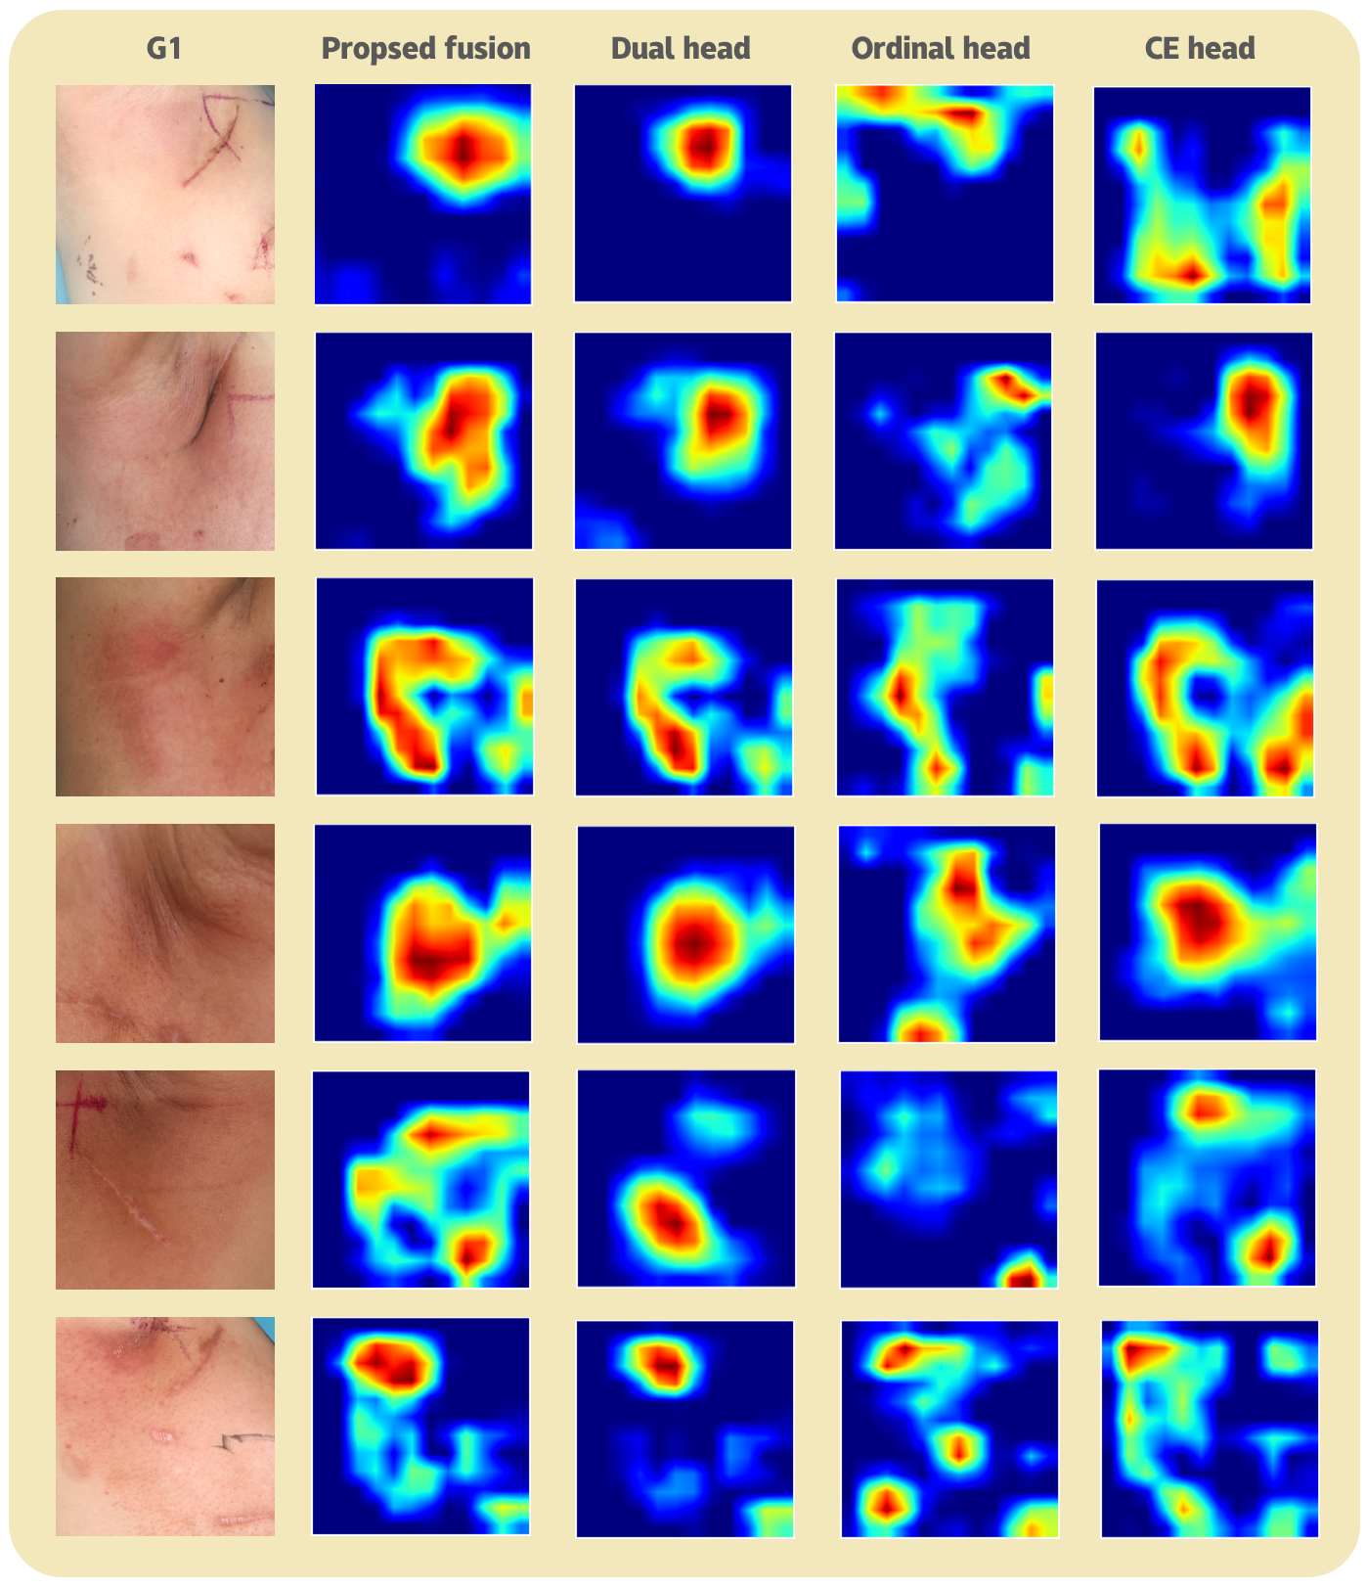
Figure S6. Representative activation maps for grade 1 cases across the proposed model and ablation variants.

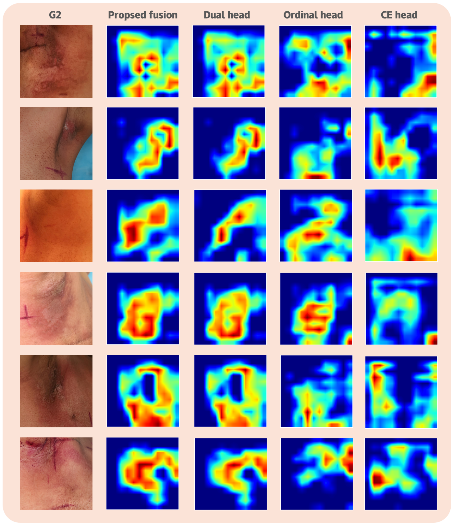
Figure S7. Representative activation maps for grade 2 cases across the proposed model and ablation variants.

