Tying Molecular $8_{5}$ and $5_{1}$ Knots via Aza-Indolyl Motif
Yan Zou^{a,+}, Haitong Tang^{a,+}, and Guo-Xin Jin^{a,b,*}
ªShanghai Key Laboratory of Molecular Catalysis and Innovative Materials, State Key Laboratory of Molecular Engineering of Polymers, Department of Chemistry, Fudan University, Shanghai 200433, P. R. China
⁺These authors contributed equally to this work
*E-mail: gxjin@fudan.edu.cn.
^{b}State Key Laboratory of Coordination Chemistry, School of Chemistry and Chemical Engineering, Nanjing University, Nanjing, 210093, P. R. China
*E-mail: gxjin@fudan.edu.cn

Content
1. General Experimental Section 2
2. Synthesis of the ligand and assemblies 2
2.1 Synthesis of ligand L 2
2.2 Synthesis of assemblies 1 and 2-M (M = Rh, Ir) 3
3. Characterisation data of the ligand and assemblies 6
3.1. Characterisation data of ligand L 6
3.2. Characterisation data of all assemblies 1, 2-M (M = Rh, Ir) 8
4. Variable concentration NMR experiments 19
5. Molecular structures of assemblies 21
6. The IGM analysis of assembly 24
7. Structural size simulated procedure based on ¹H DOSY NMR test for 1, 2-Rh, and 2-Ir 26
8. X-ray Crystallography Details 29
9. References 33

1. General Experimental Section
All reagents and solvents were obtained from commercial companies and used without any further purification unless otherwise stated. Binuclear blocks E1-Rh and E2-M (M = Rh, Ir) were synthesized according to the previously published procedure.^{S1,S2} Anhydrous N,N-dimethylformamide (DMF) used in the Ullmann coupling reaction was dried over molecular sieves and degassed by purging with nitrogen for 0.5h. NMR spectra were performed on a Bruker AVANCE III HD 400 MHz spectrometer at 298.15K. Chemical shifts are reported in parts per million (ppm) from low to high frequency and referenced to the residual solvent resonances^{S3} (δ H = 3.31 ppm for CD₃OD, δ H =7.26 ppm for CDCl₃). The multiplicity of ¹H signals is indicated as: s = singlet; d = doublet; t = triplet; q = quartet; m = multiplet; or combinations of thereof. Coupling constants (J) are quoted in Hz and reported to the nearest 0.1 Hz. Elemental analyses were performed on an Elemental Vario EL III analyzer. ESI-TOF/MS spectra were recorded on a Water G2-XS TOF mass spectrometer.

2. Synthesis of the ligand and assemblies

2.1 Synthesis of ligand L

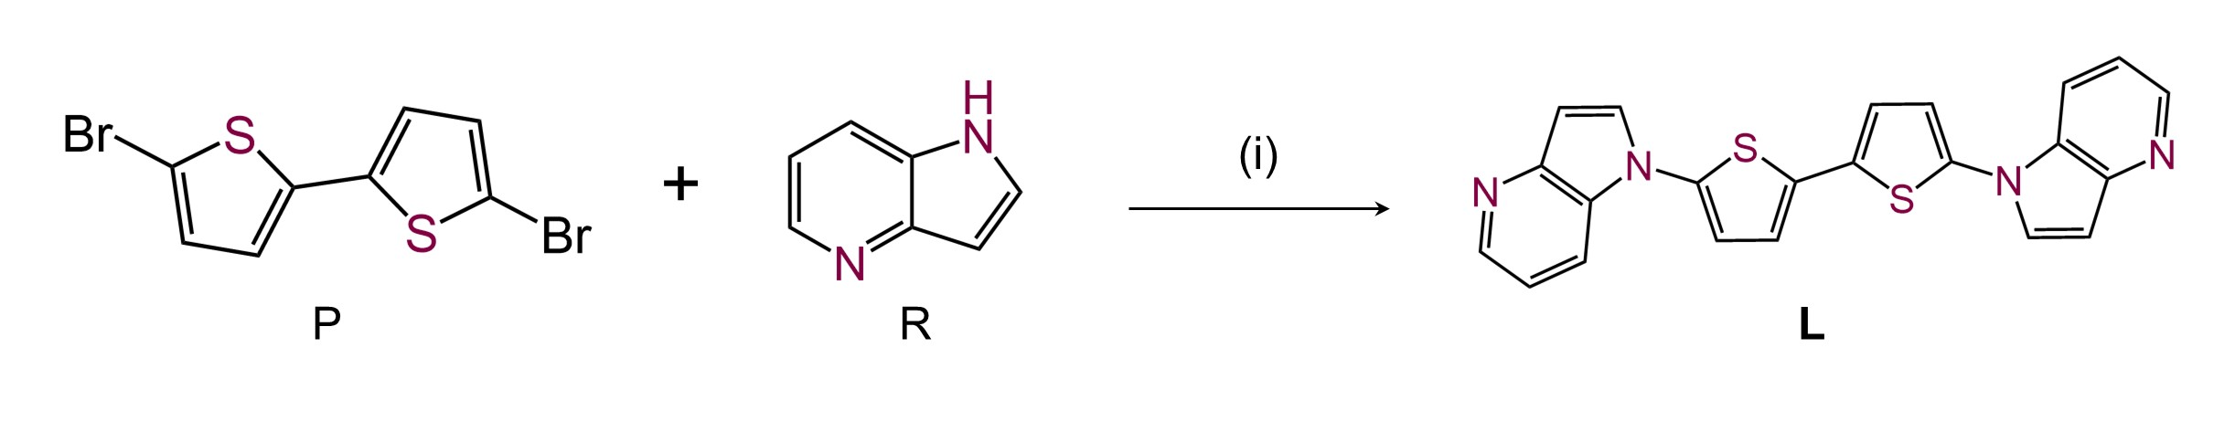
Supplementary Fig. 1. Synthesis steps of the ligand L. Reagents and conditions: (i) (a) CuI, 1,10-phenanthroline, K₂CO₃, anhydrous DMF, 160°C, 72h. (b) H₂O, 0°C.
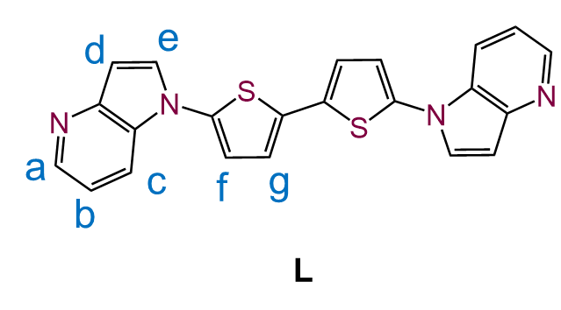
Synthesis: Under an atmosphere of nitrogen, the following reagents were added successively to a dry 250 mL Schlenk flask: 5,5′-dibromo-2,2′-bithiophene (324.06 mg, 1.0 mmol), 4-azaindole (260 mg, 2.2 mmol), CuI (19 mg, 0.1 mmol), 1,10-phenanthroline (36 mg, 0.2 mmol), and potassium carbonate (552 mg, 4.0 mmol). The solids were ensured to be well mixed. Anhydrous DMF (10 mL) was added slowly via syringe to rinse the flask walls and submerge all solid materials. The reaction mixture was then placed in a preheated oil bath at 160°C and stirred vigorously (approximately 600 rpm) under refluxing conditions in a nitrogen atmosphere. The reaction was allowed to proceed for about 72h. After completion, the reaction mixture was cooled to room temperature and slowly poured into an ice-water mixture (100 mL), resulting in the precipitation of a light-yellow solid. The solid was collected by filtration and washed with saturated sodium chloride solution (2 × 30 mL) to remove residual DMF and salts. The crude product was subsequently washed sequentially with petroleum ether, diethyl ether, and a small amount of ice-cold ethanol. The solid was dried under vacuum to afford ligand L as a light-yellow solid (298.5 mg, 0.75 mmol, 75 %).
Characterization: Anal. calcd. for C₂₂H₁₄N₄S₂: C, 66.30; H, 3.54; N, 14.05. Found: C, 66.33; H, 3.52; N, 14.04. ¹H NMR (400 MHz, Chloroform-d) δ 8.55 (s, 1H, H_{a}), 7.93 (d, J = 8.1 Hz, 1H, H_{c}), 7.56 (d, J = 3.3 Hz, 1H, H_{e}), 7.24 – 7.18 (m, 1H, H_{b}), 7.15 (d, J = 3.9 Hz, 1H, H_{g}), 7.09 – 6.99 (m, 1H, H_{f}), 6.91 (s, 1H, H_{d}). ESI-TOF/MS: m/z 399.0659 [L + H]⁺ requires 399.0732.

2.2 Synthesis of assemblies 1 and 2-M (M = Rh, Ir)

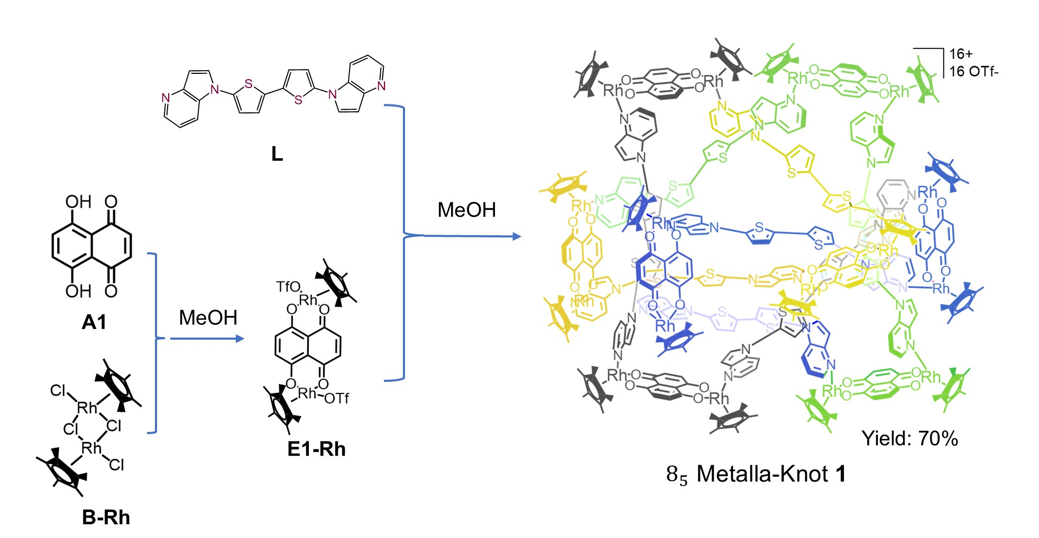
Supplementary Fig. 2. Synthesis steps of the assembly 1.

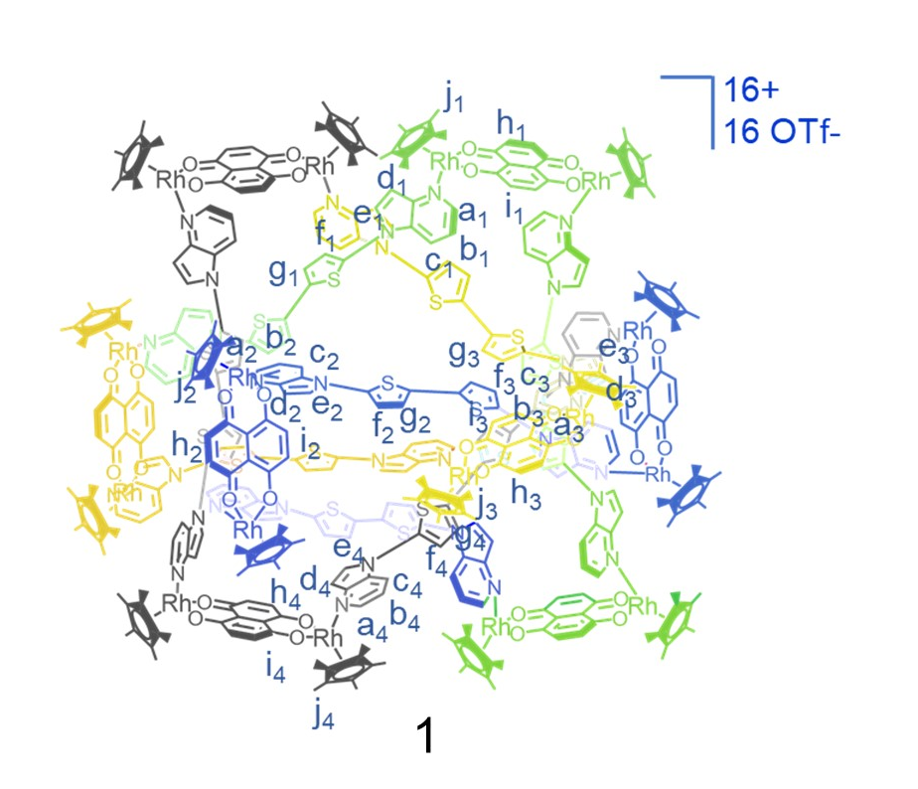
Synthesis: Starting material B-Rh (0.04 mmol, 24.72 mg) was dissolved in 8 mL of anhydrous methanol. AgOTf (4.0 equiv. 40.96 mg) was added, and the mixture was stirred in the dark for 12h at 25°C. The white precipitate was removed by centrifugation, yielding a yellow supernatant for subsequent use. Separately, 5,8-dihydroxynaphthalene-1,4-dione A1 (0.04 mmol, 7.60 mg) was dissolved in 1.0 mL methanol, followed by the addition of 0.8 mL sodium hydroxide solution (0.1 M in methanol). After stirring for 12h, the pre‑prepared yellow supernatant was introduced to afford a dark green methanolic solution of E1-Rh. The mixture was stirred at room temperature for a further 12h before ligand L (0.04 mmol, 16.0 mg) was added, resulting in a dark green solution. The product was then precipitated by the slow diffusion of excess diethyl ether (10 mL). The dark green crystalline solid was collected by centrifugation and washed with fresh diethyl ether (3 × 10 mL). The crude product was redissolved in a minimal amount of methanol (5 mL). This solution was placed in a small tube, which was slowly filled with diethyl ether. Dark green block-shaped crystals suitable for X-ray diffraction analysis were obtained via liquid-phase diffusion at 25°C over one week (38.12 mg, 3.5 × 10⁻³ mmol, 70%).
Characterization: Anal. calcd. for C₄₃₂H₃₈₄O₈₀S₃₂N₃₂Rh₁₆F₄₈: C, 47.65; H, 3.55; N, 4.11. Found: C, 47.66; H, 3.56; N, 4.13. ¹H NMR (400 MHz, Methanol-d₄) δ 8.50 (dd, J = 8.6, 4.9 Hz, 2H, H_{a1}), 8.40 (dd, J = 12.8, 6.9 Hz, 2H, H_{a2}), 8.29 (d, J = 6.1 Hz, 1H, H_{a3}), 8.23 (dd, J = 11.6, 5.0 Hz, 2H, H_{c2}), 8.01 (dd, J = 8.4, 5.1 Hz, 2H, H_{g1}), 7.98 (d, J = 5.6 Hz, 1H, H_{a3}), 7.94 (q, J = 5.0, 4.3 Hz, 2H, H_{h3}), 7.89 – 7.81 (m, 4H, H_{g2+h1}), 7.81 – 7.76 (m, 3H, H_{g3+g4}), 7.75 – 7.70 (m, 2H, H_{c1}), 7.68 (d, J = 3.5 Hz, 1H, H_{a4}), 7.64 (d, J = 8.3 Hz, 1H, H_{e4}), 7.61 – 7.56 (m, 2H, H_{e2}), 7.54 (d, J = 7.0 Hz, 2H, H_{e3}), 7.51 (s, 1H, H_{c4}), 7.49 (d, J = 4.7 Hz, 1H, H_{h4}), 7.47 (d, J = 4.9 Hz, 2H, H_{h2}), 7.44 (d, J = 5.1 Hz, 2H, H_{e1}), 7.41 (d, J = 3.3 Hz, 2H, H_{h1}), 7.39 (s, 2H, H_{i1}), 7.37 (d, J = 2.7 Hz, 1H, H_{f4}), 7.30 (s, 1H, H_{i4}), 7.26 (t, J = 4.6 Hz, 2H, H_{f1}), 7.20 – 7.15 (m, 2H, H_{i3}), 7.12 (d, J = 3.4 Hz, 2H, H_{b2}), 7.11 – 7.08 (m, 2H, H_{f3}), 7.03 (s, 2H, H_{b1}), 7.02 (d, J = 2.2 Hz, 2H, H_{c3}), 6.98 (dd, J = 8.6, 3.3 Hz, 2H, H_{f2}), 6.84 (d, J = 4.3 Hz, 2H, H_{b3}), 6.73 (dd, J = 8.5, 5.4 Hz, 1H, H_{b4}), 6.69 – 6.64 (m, 2H, H_{i2}), 6.60 (d, J = 3.9 Hz, 1H, H_{d4}), 6.33 (d, J = 4.2 Hz, 0.5H, H_{d3}), 6.27 (d, J = 4.2 Hz, 0.5H, H_{d3}), 6.16 (t, J = 4.2 Hz, 2H, H_{d1}), 6.09 (d, J = 3.8 Hz, 0.5H, H_{d2}), 6.00 (d, J = 9.8 Hz, 0.5H, H_{d2}), 5.85 (d, J = 9.7 Hz, 0.5H, H_{d3}), 5.71 (d, J = 3.9 Hz, 0.5H, H_{d2}), 5.36 (d, J = 9.8 Hz, 0.5H, H_{d2}). 1.82 (s, 20H, H_{j1+j2+j3+j4}), 1.72 (s, 15H, H_{j1+j2+j3+j4}), 1.67 (d, J = 6.3 Hz, 40H, H_{j1+j2+j3+j4}), 1.46 (d, J = 13.2 Hz, 30H, H_{j1+j2+j3+j4}). ESI-TOF/MS: m/z 2028.4919 [1 – 5OTf⁻]⁵⁺ requires 2028.4924; m/z 2572.8611 [1 – 4OTf⁻]⁴⁺ requires 2572.8536.

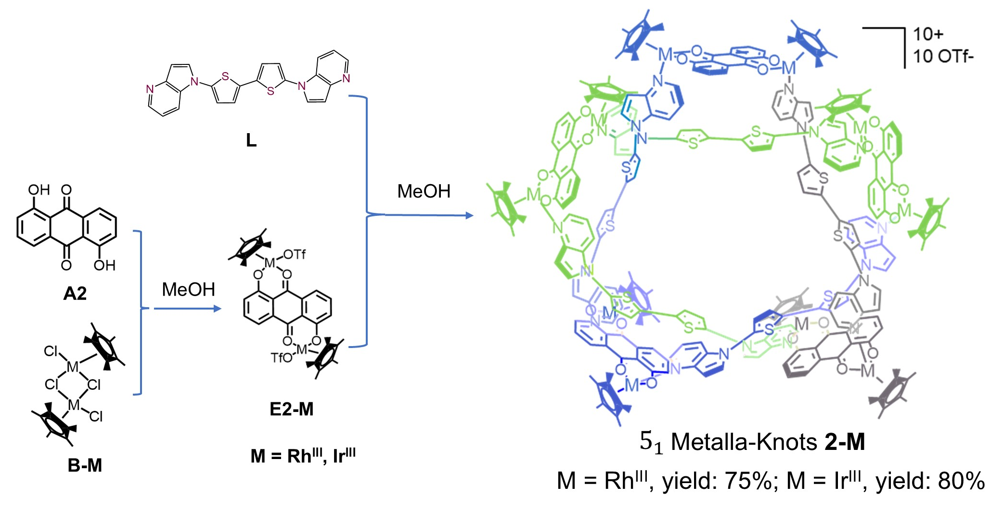
Supplementary Fig. 3. Synthesis steps of the assembly 2-M.

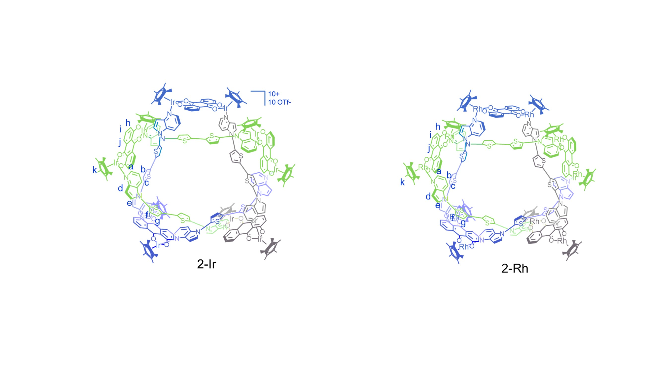
Synthesis: Starting material B-Rh (0.04 mmol, 24.72 mg) was dissolved in 8 mL of anhydrous methanol. AgOTf (4.0 equiv. 40.96 mg) was added, and the mixture was stirred in the dark for 12h at 25°C. The white precipitate was removed by centrifugation, yielding a yellow supernatant for subsequent use. Separately, 1,5-dihydroxyanthracene-9,10-dione A2 (0.04 mmol, 9.60 mg) was dissolved in 1.0 mL methanol, followed by the addition of 0.8 mL sodium hydroxide solution (0.1 M in methanol). After stirring for 12h, the pre‑prepared yellow supernatant was introduced to afford a dark purple methanolic solution of E2-Rh. The mixture was stirred at room temperature for a further 12h before ligand L (0.04 mmol, 16.0 mg) was added, resulting in a dark purple solution. The product was then obtained by the slow diffusion of excess diethyl ether (10 mL). The dark purple crystalline solid was collected by centrifugation and washed with fresh diethyl ether (3 × 10 mL). The crude product was redissolved in a minimal amount of methanol (4 mL). This solution was placed in a small tube, which was slowly filled with diethyl ether. Dark purple block-shaped crystals suitable for X-ray diffraction analysis were obtained via liquid-phase diffusion at 25°C over one week (43.4 mg, 6.0 × 10⁻³ mmol, 75%).
Characterization: Anal. calcd. for C₂₉₀H₂₅₀O₅₀S₂₀N₂₀Rh₁₀F₃₀: C, 49.36; H, 3.57; N, 3.97. Found: C, 49.34; H, 3.56; N, 3.95. ¹H NMR (400 MHz, Methanol-d₄) δ 8.67 (d, J = 5.3 Hz, 1H, H_{a}), 8.11 (d, J = 6.5 Hz, 1H, H_{c}), 7.98 (s, 1H, H_{g}), 7.86 (s, 1H, H_{f}), 7.79 (d, J = 8.4 Hz, 1H, H_{j}), 7.57 (d, J = 7.4 Hz, 2H, H_{b+i}), 7.01 (d, J = 8.7 Hz, 1H, H_{h}), 6.21 (s, 1H, H_{d}), 3.15 (s, 1H, H_{e}), 1.71 (s, 15H, H_{k}). ESI-TOF/MS: m/z 2202.4701 [2-Rh – 3OTf⁻]³⁺ requires 2202.4538; m/z 1614.6074 [2-Rh – 4OTf⁻]⁴⁺ requires 1614.6023.

Synthesis: Compound 2-Ir was prepared via a procedure analogous to that described for 2-Rh, except that starting material B-Ir (32.0 mg, 0.04 mmol) was employed instead of B-Rh, yielding dark blue block-shaped crystals suitable for single-crystal X-ray diffraction (50.87 mg, 6.4 × 10⁻³ mmol, 80%).
Characterization: Anal. calcd. for C₂₉₀H₂₅₀O₅₀S₂₀N₂₀Ir₁₀F₃₀I_{2.32}: C, 42.25; H, 3.05; N, 3.39. Found: C, 42.27; H, 3.06; N, 3.41. ¹H NMR (400 MHz, Methanol-d₄) δ 8.67 (d, J = 5.5 Hz, 1H, H_{a}), 8.10 (d, J = 7.2 Hz, 1H, H_{c}), 7.96 (d, J = 3.6 Hz, 1H, H_{g}), 7.85 (d, J = 8.4 Hz, 1H, H_{f}), 7.81 (s, 1H, H_{j}), 7.73 – 7.57 (m, 2H, H_{b+i}), 7.03 (d, J = 9.1 Hz, 1H, H_{h}), 6.33 (d, J = 4.0 Hz, 1H, H_{d}), 3.28 (s, 1H, H_{e}), 1.63 (s, 15H, H_{k}). ESI-TOF/MS: m/z 2500.3080 [2-Ir – 3OTf⁻]³⁺ requires 2500.3090; m/z 1837.9997 [2-Ir – 4OTf⁻]⁴⁺ requires 1837.9937.

3. Characterisation data of the ligand and assemblies

3.1. Characterisation data of ligand L
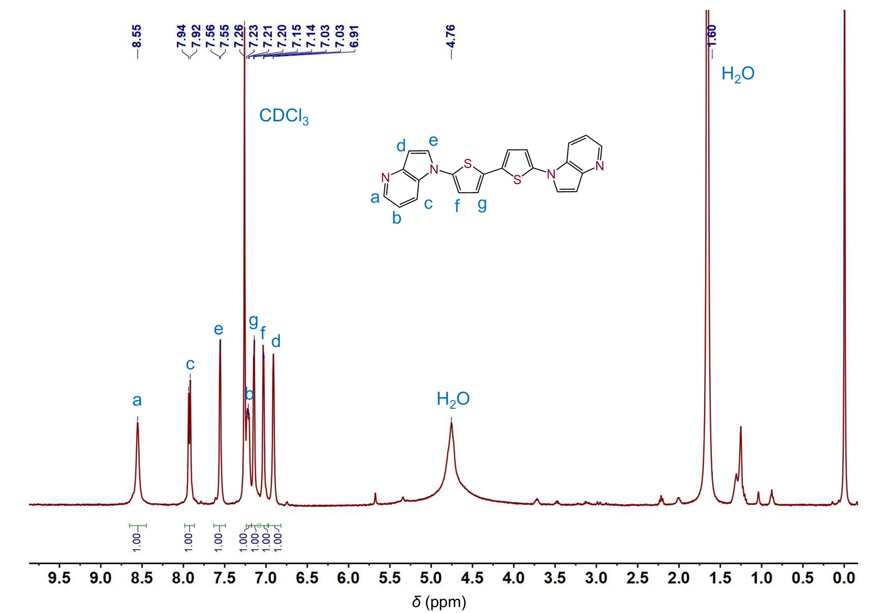
Supplementary Fig. 4. ¹H NMR (400 MHz, CDCl₃, c = 1.0 mM, 298.15K) spectrum of L.
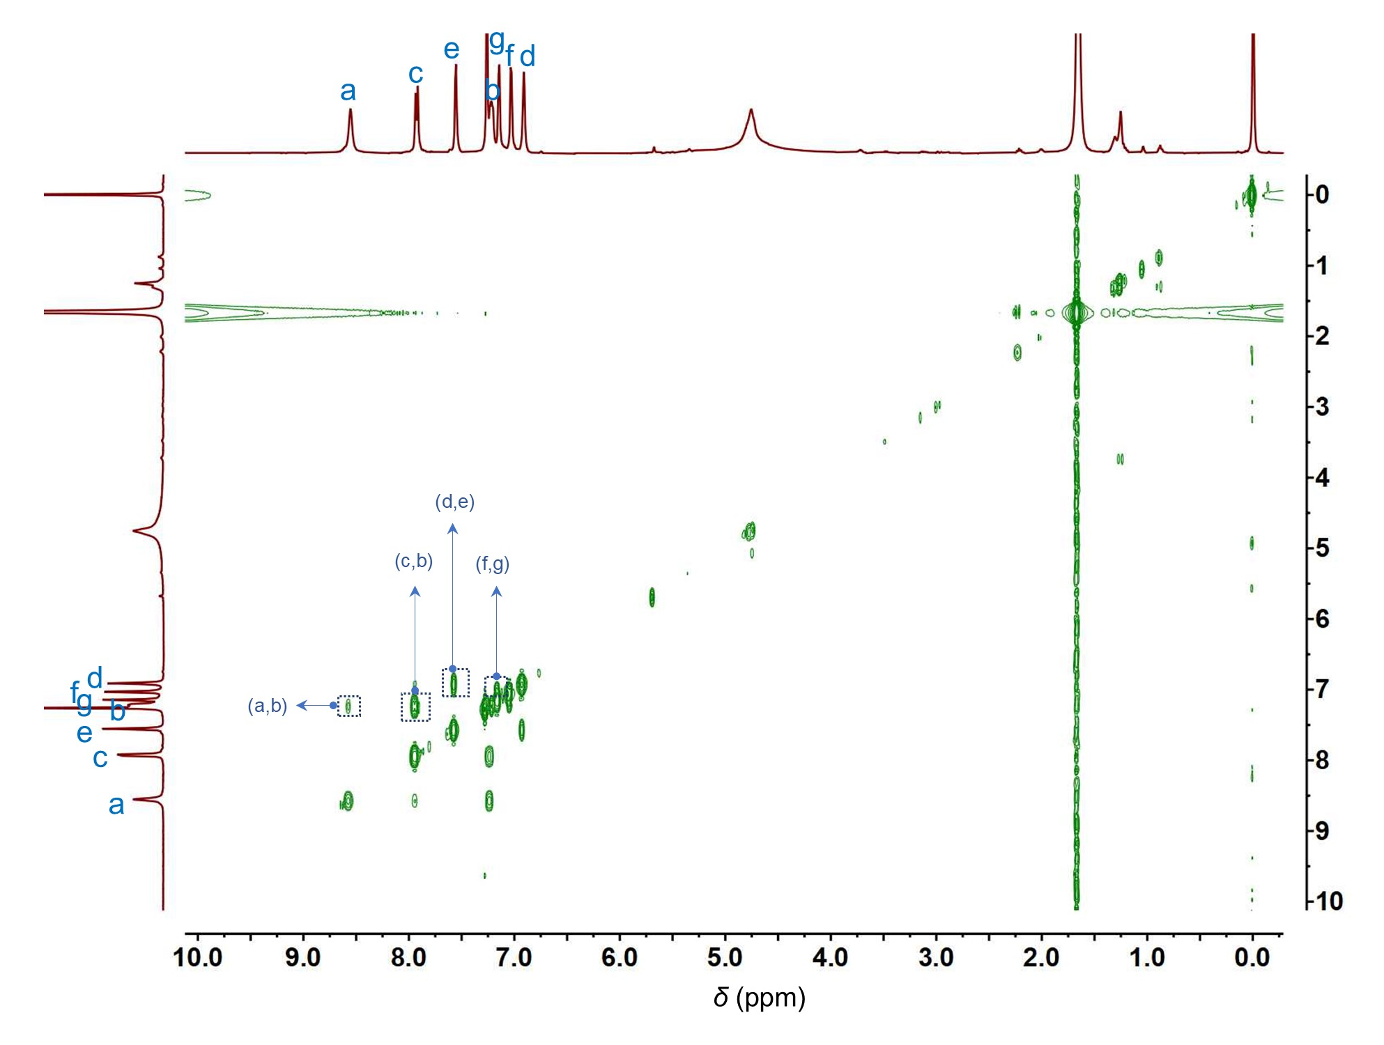
Supplementary Fig. 5. ¹H-¹H COSY NMR (400 MHz, CDCl₃, c = 1.0 mM, 298.15K) spectrum of L.

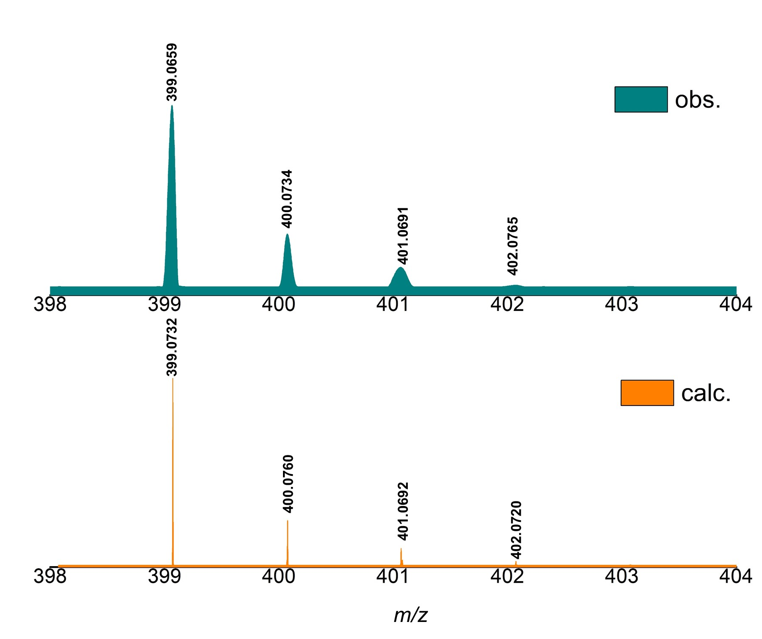
Supplementary Fig. 6. Experimental (top) and theoretical (bottom) ESI-TOF/MS of L.
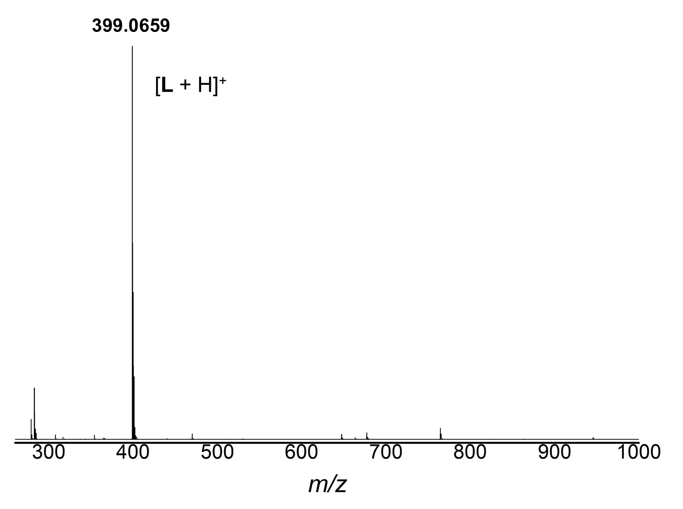
Supplementary Fig. 7. The full ESI-TOF/MS spectrum of L in CH₃OH.

3.2. Characterisation data of all assemblies 1, 2-M (M = Rh, Ir)
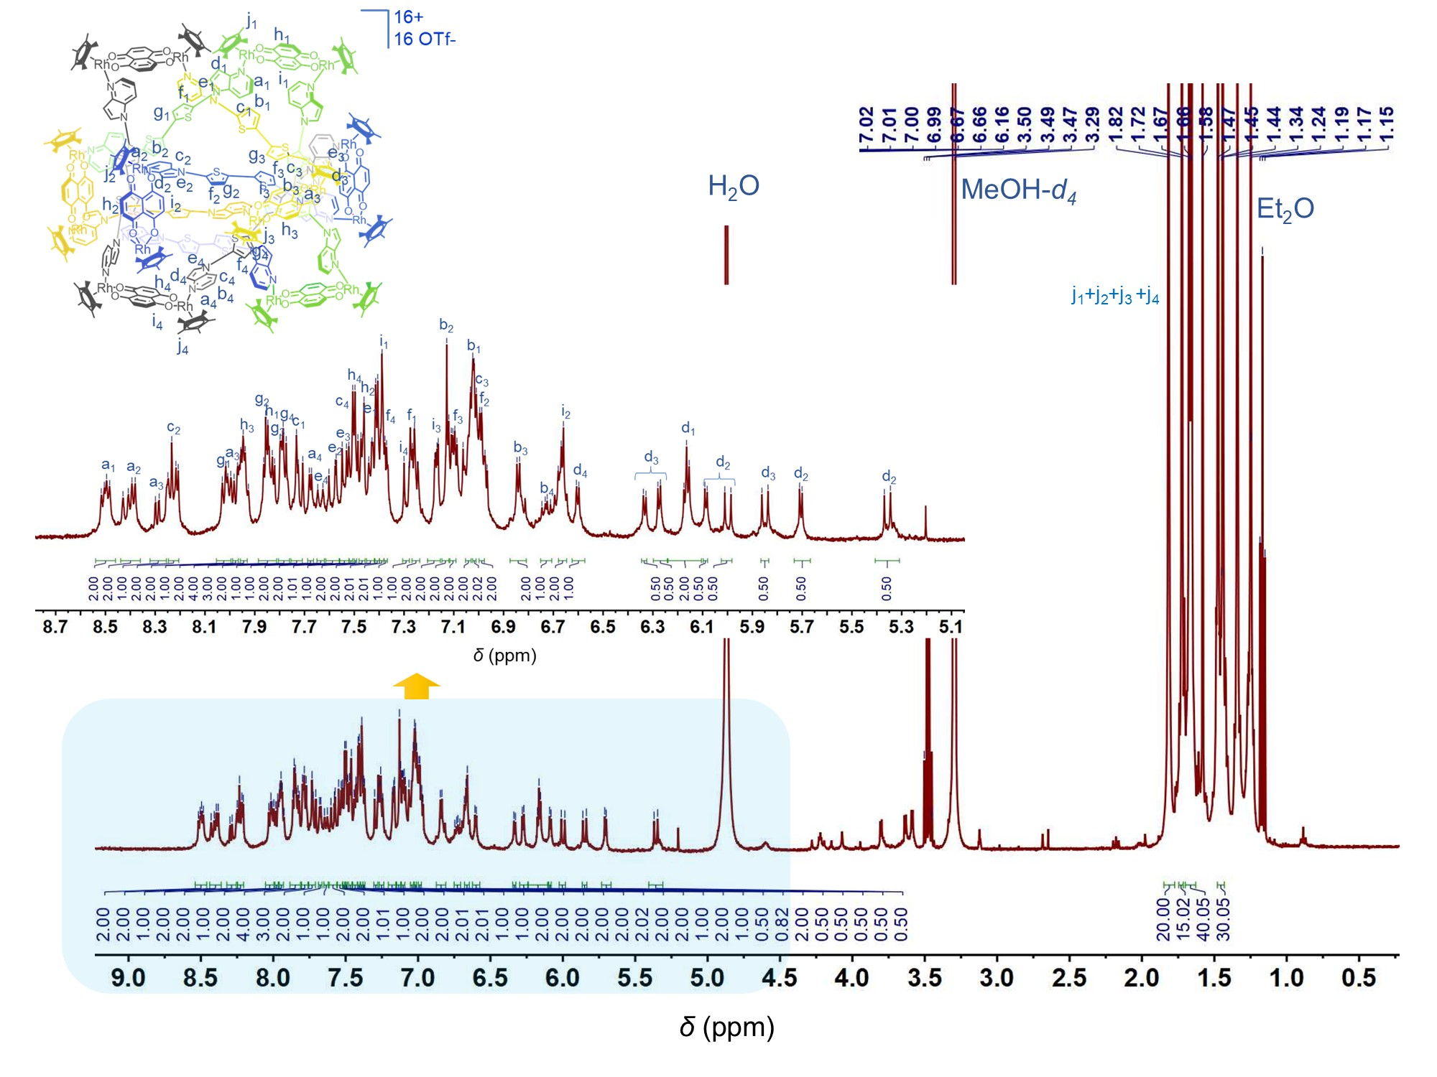
Supplementary Fig. 8. ¹H NMR (400 MHz, MeOH-d₄, c = 2.0 mM, 298.15K) spectrum of 1.
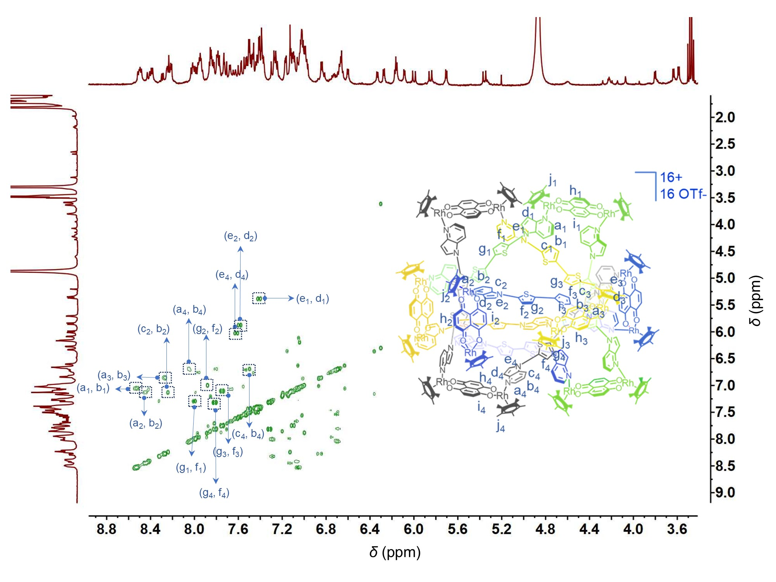
Supplementary Fig. 9. ¹H-¹H COSY NMR (400 MHz, MeOH-d₄, c = 2.0 mM, 298.15K) spectrum of 1.

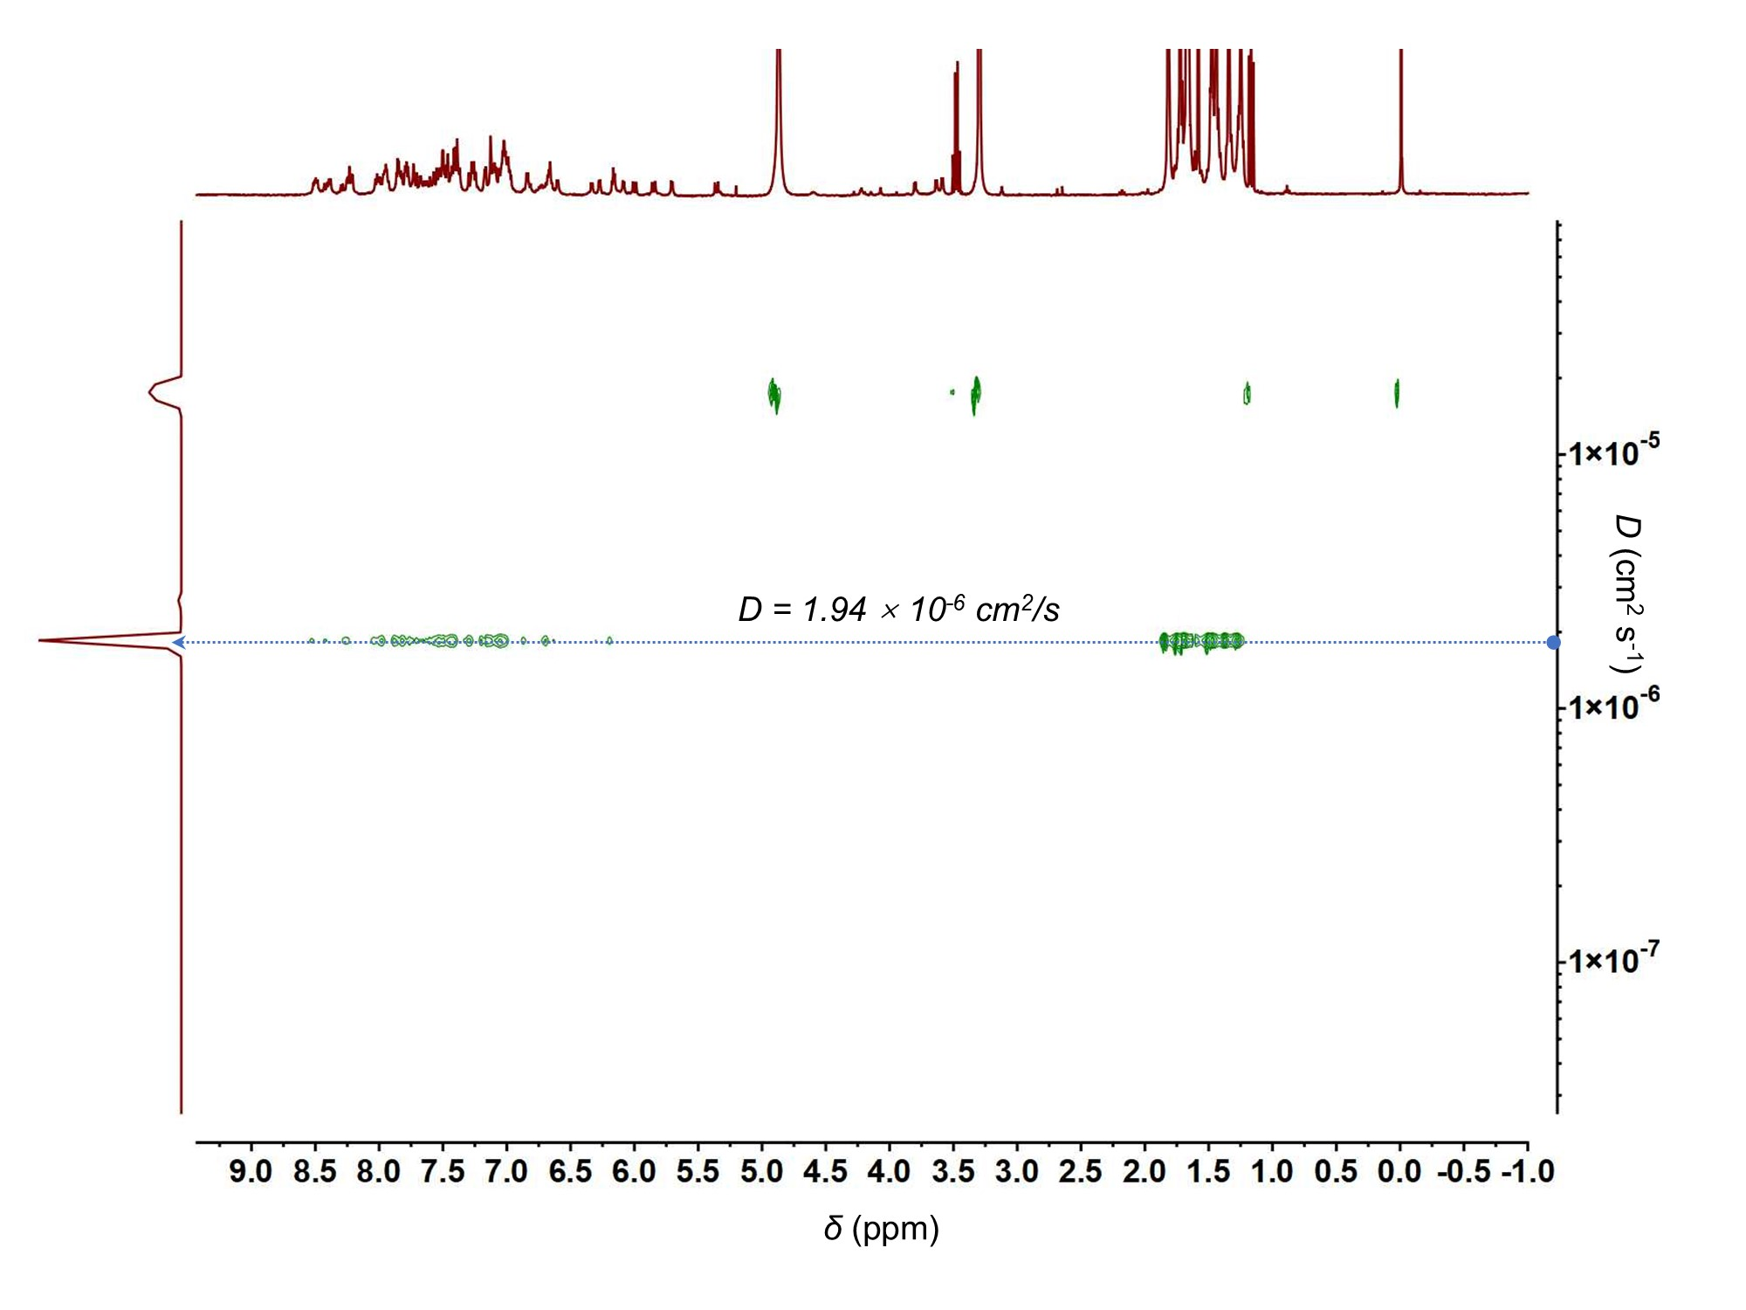
Supplementary Fig. 10. ¹H-¹H DOSY NMR (400 MHz, MeOH-d₄, c = 2.0 mM, 298.15K) spectrum of 1.
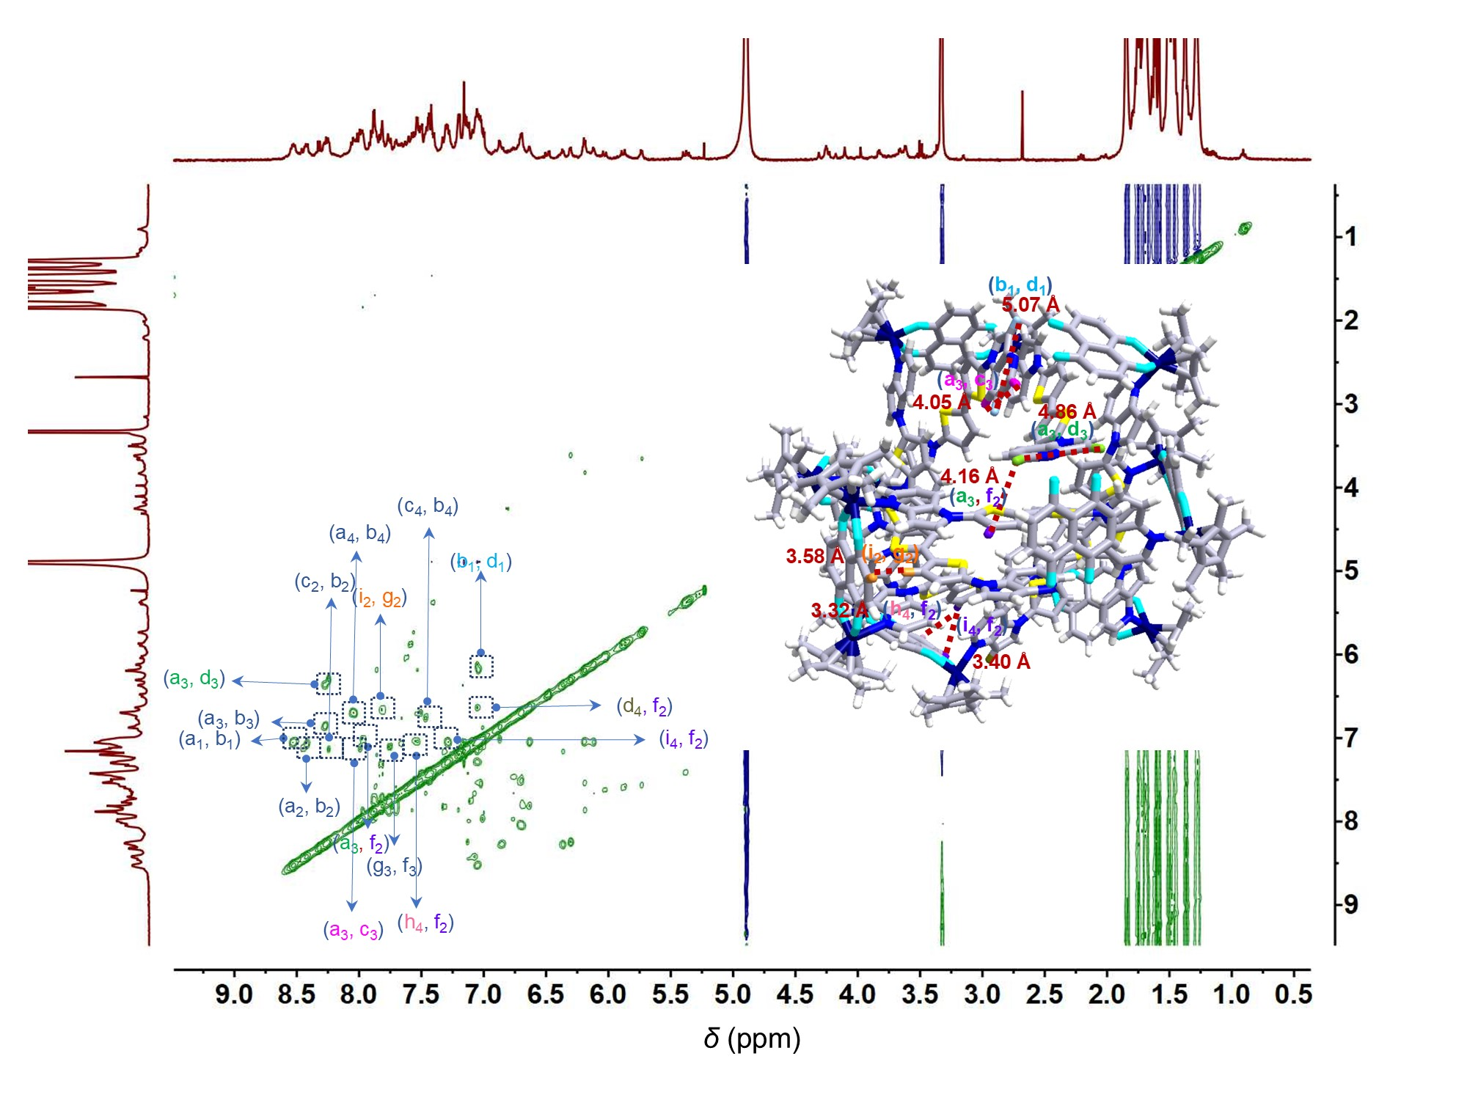
Supplementary Fig. 11. ¹H-¹H NOESY NMR spectrum of 1 (400 MHz, MeOH-d₄, c = 2.0 mM, 298.15K).

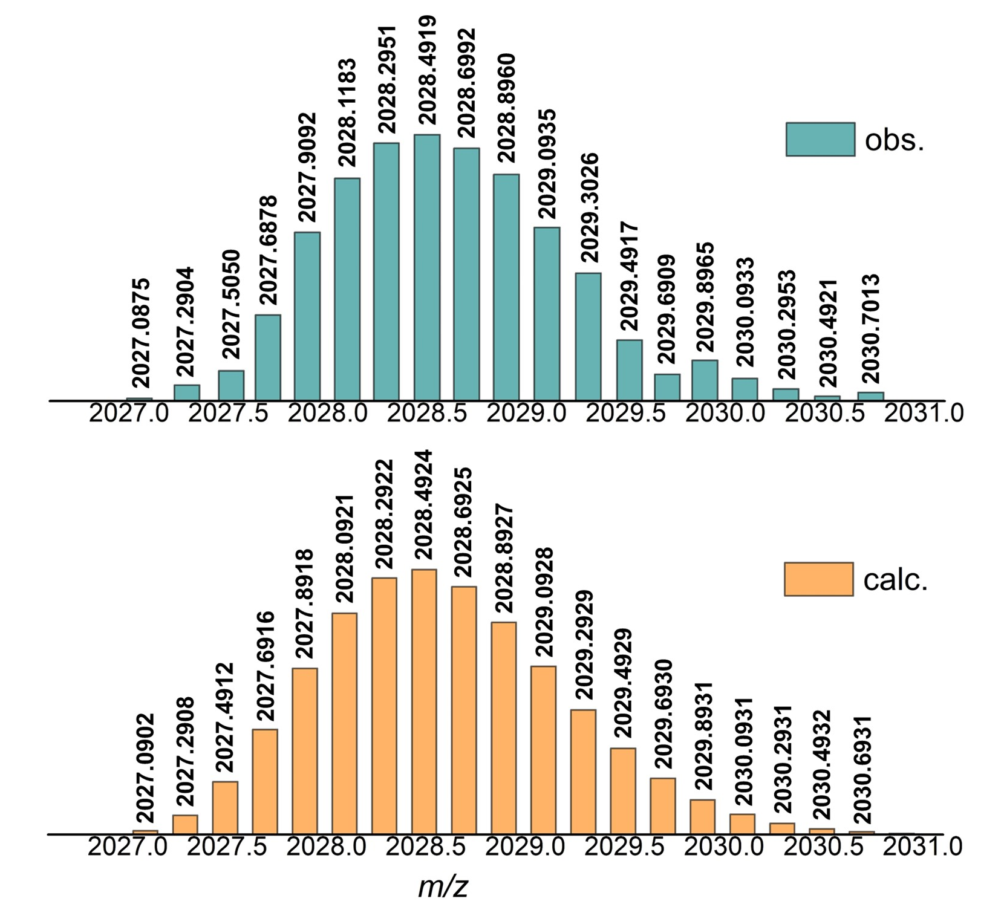
Supplementary Fig. 12. High-resolution ESI-TOF/MS of [1 – 5 OTf⁻]⁵⁺ in 1. Experimental spectrum (top) and calculated spectrum (bottom).
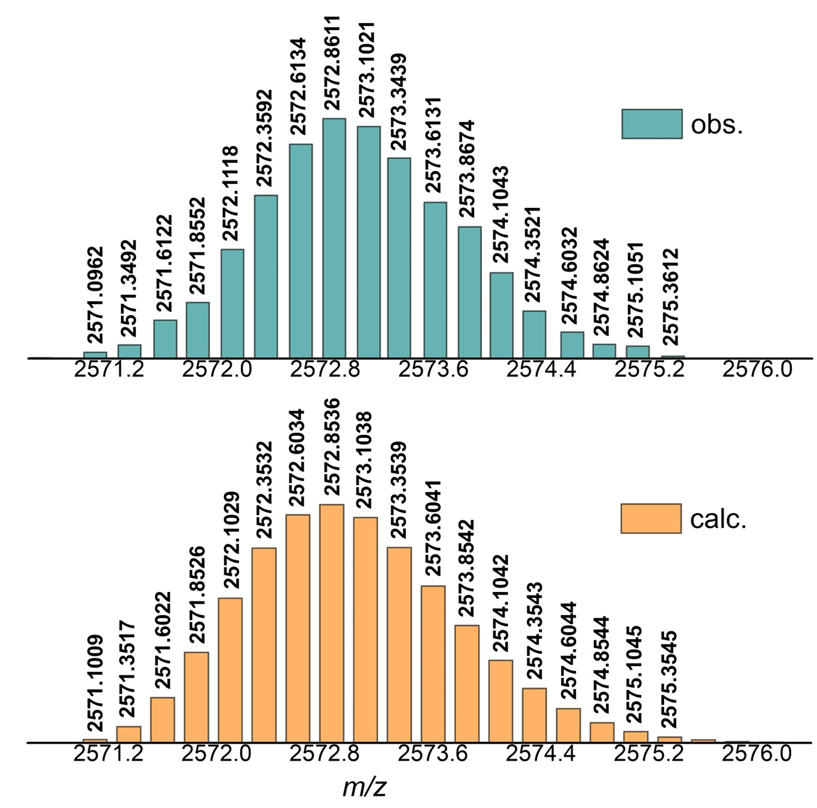
Supplementary Fig. 13. High-resolution ESI-TOF/MS of [1 – 4 OTf⁻]⁴⁺ in 1. Experimental spectrum (top) and calculated spectrum (bottom).
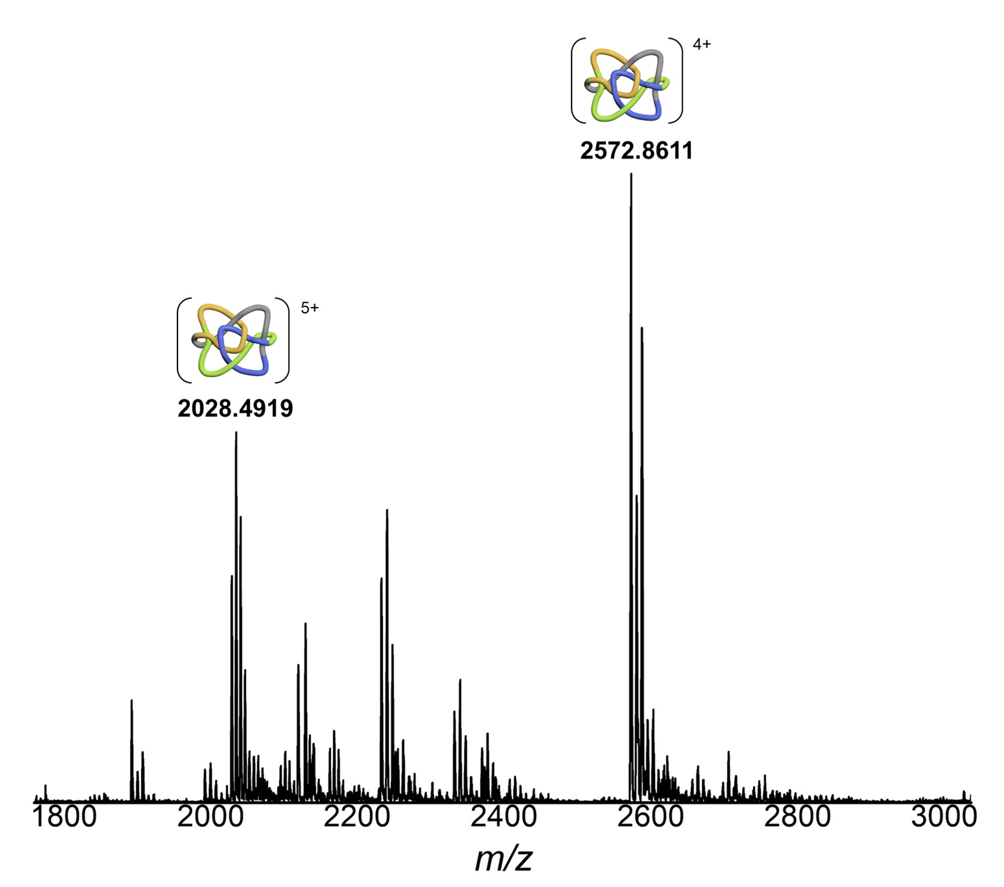
Supplementary Fig. 14. Low-resolution ESI-TOF/MS of [1 – 5 OTf⁻]⁵⁺ and [1 – 4 OTf⁻]⁴⁺ in 1.
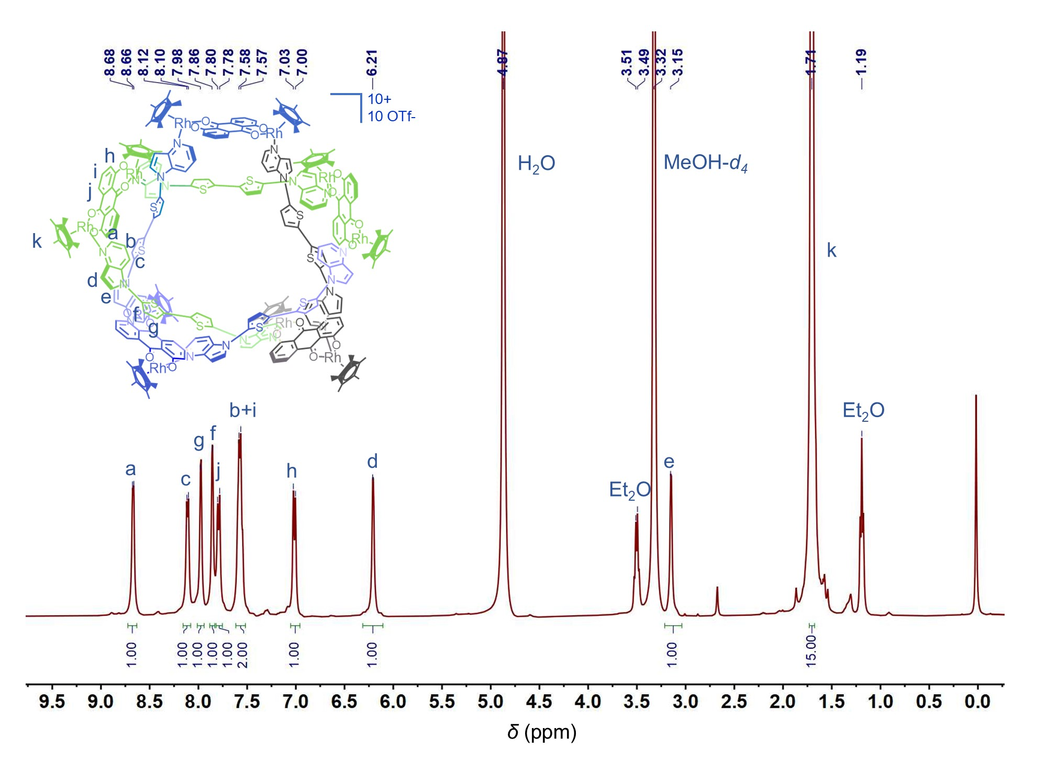
Supplementary Fig. 15. ¹H NMR (400 MHz, MeOH-d₄, c = 2.0 mM, 298.15K) spectrum of 2-Rh.

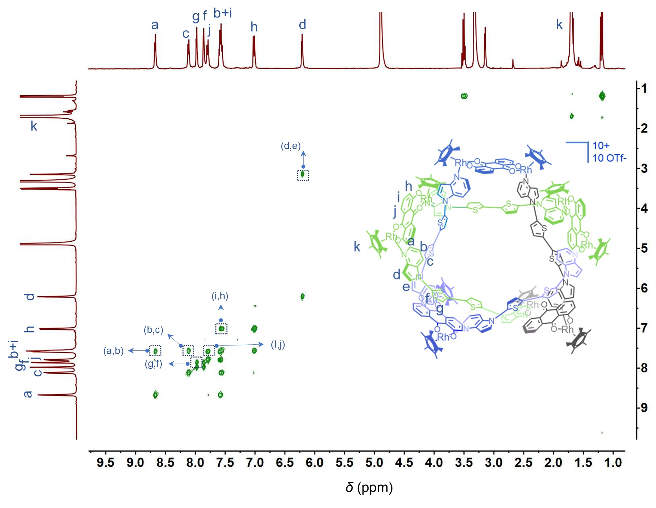
Supplementary Fig. 16. ¹H-¹H COSY NMR (400 MHz, MeOH-d₄, c = 2.0 mM, 298.15K) spectrum of 2-Rh.
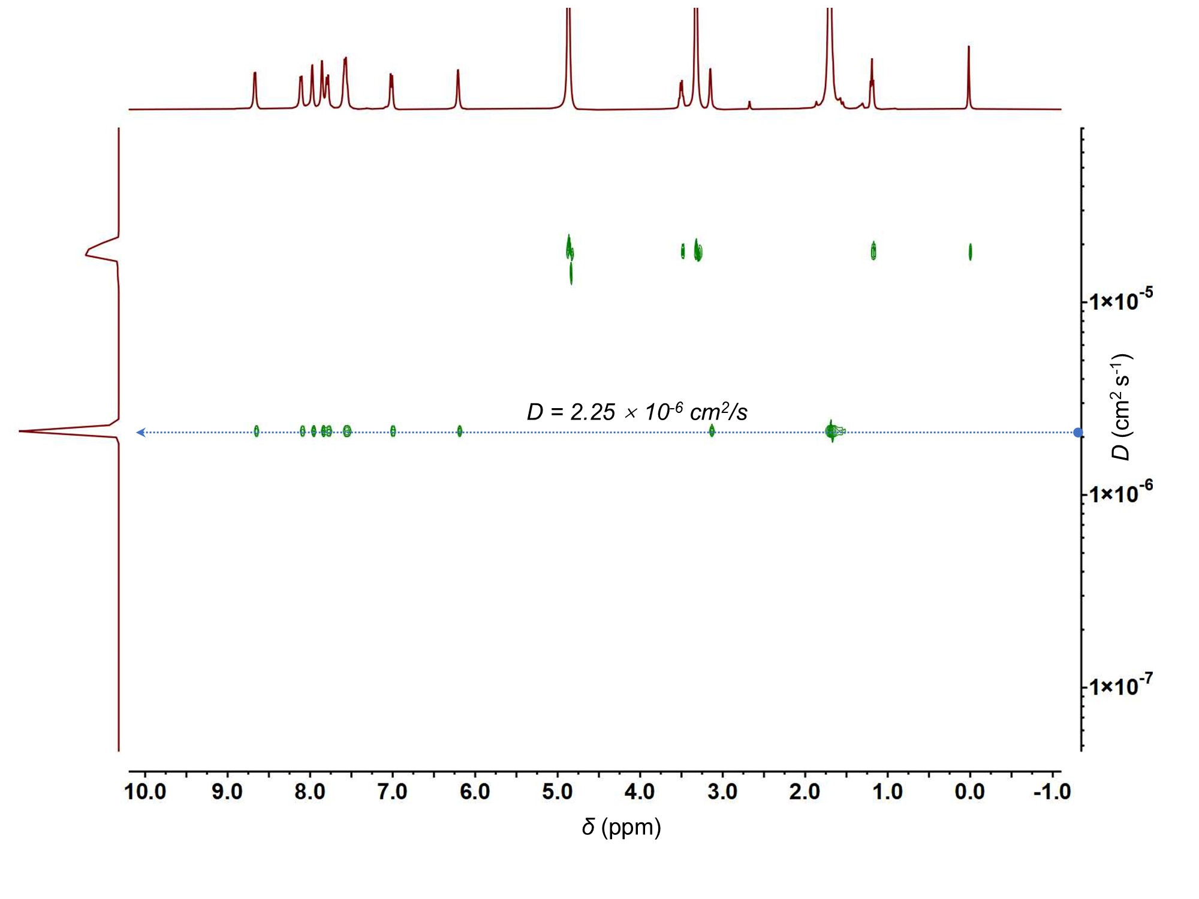
Supplementary Fig. 17. ¹H-¹H DOSY NMR (400 MHz, MeOH-d₄, c = 2.0 mM, 298.15K) spectrum of 2-Rh.

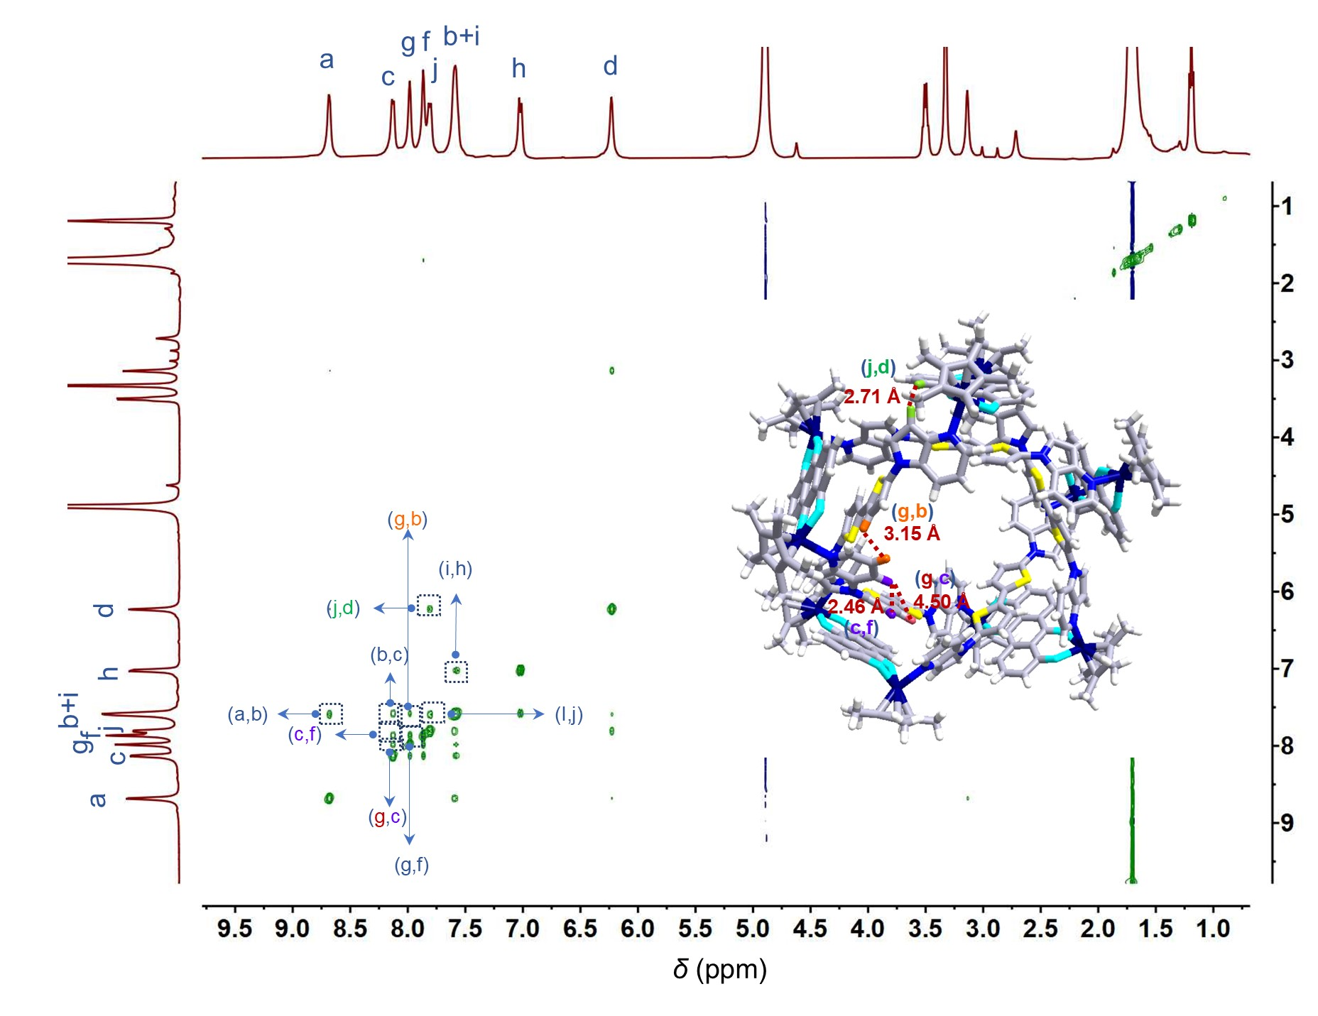
Supplementary Fig. 18. ¹H-¹H NOESY NMR spectrum of 2-Rh (400 MHz, MeOH-d₄, c = 2.0 mM, 298.15K).

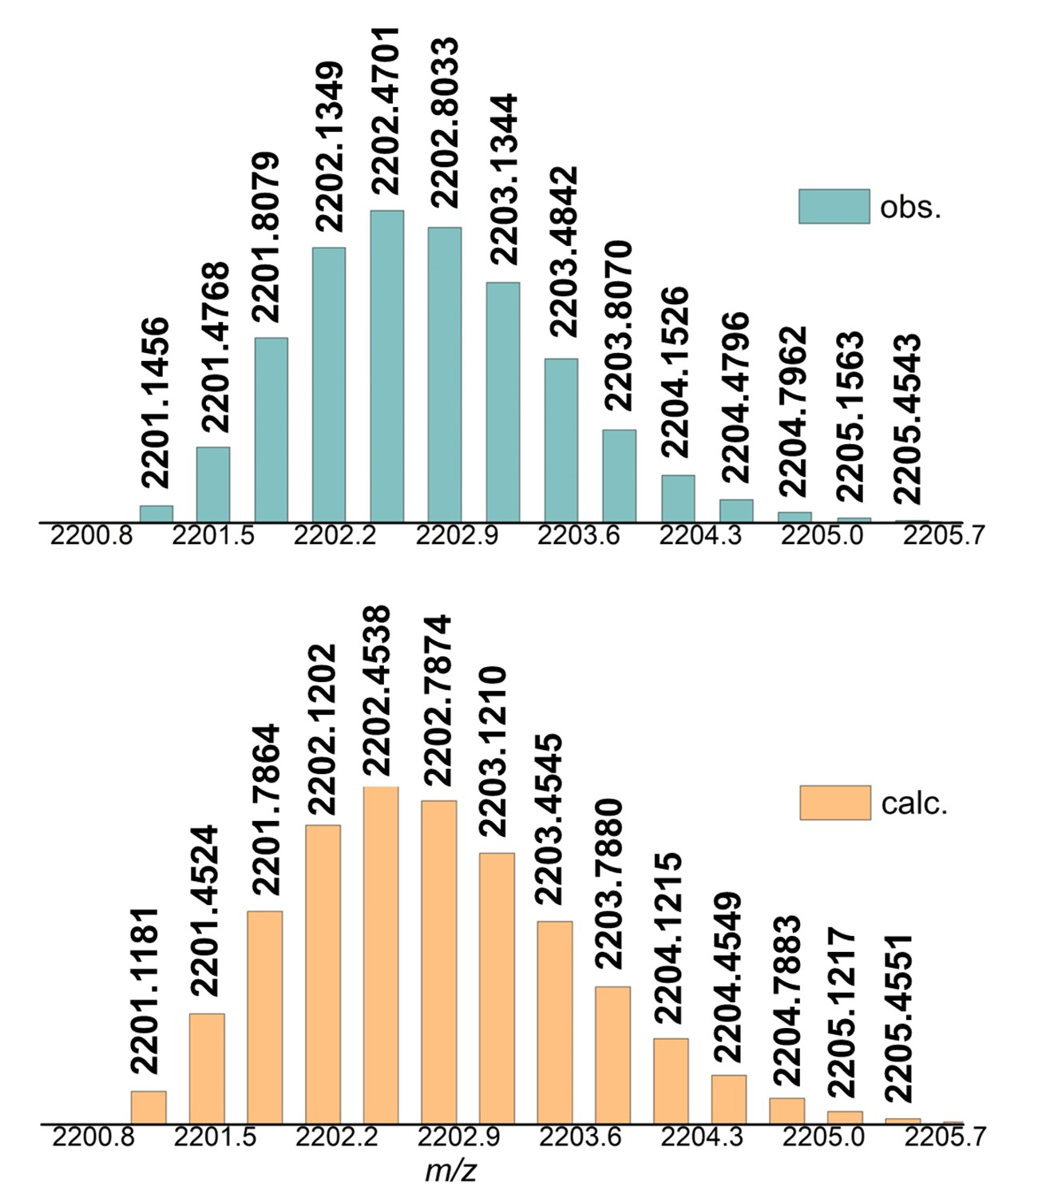
Supplementary Fig. 19. High-resolution ESI-TOF/MS of [2-Rh – 3 OTf⁻]³⁺ in 2-Rh. Experimental spectrum (top) and calculated spectrum (bottom).

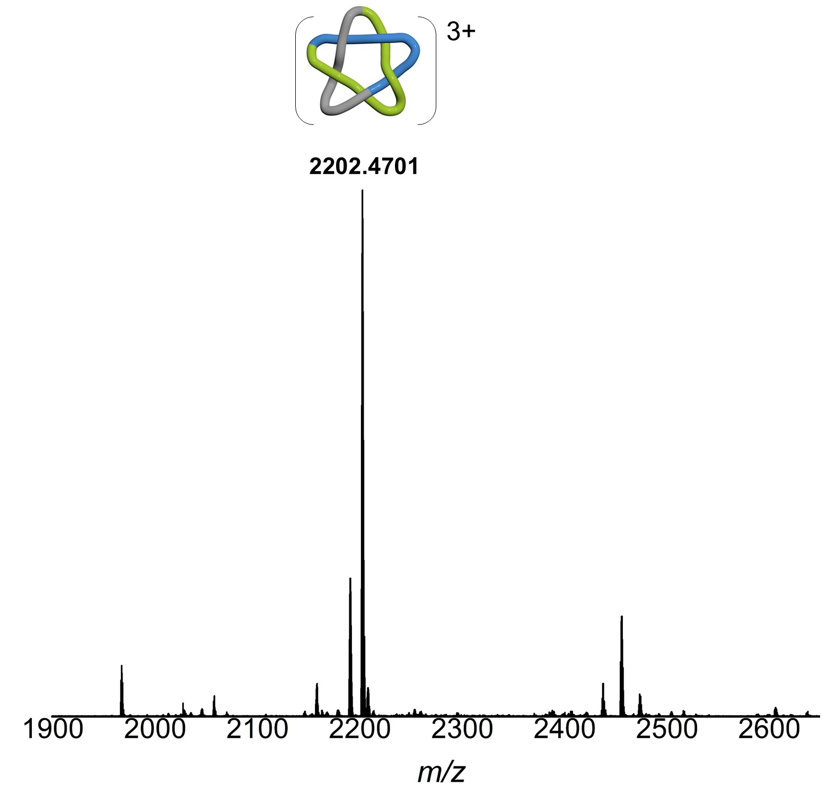
Supplementary Fig. 20. Low-resolution ESI-TOF/MS of [2-Rh – 3 OTf⁻]³⁺ in 2-Rh.
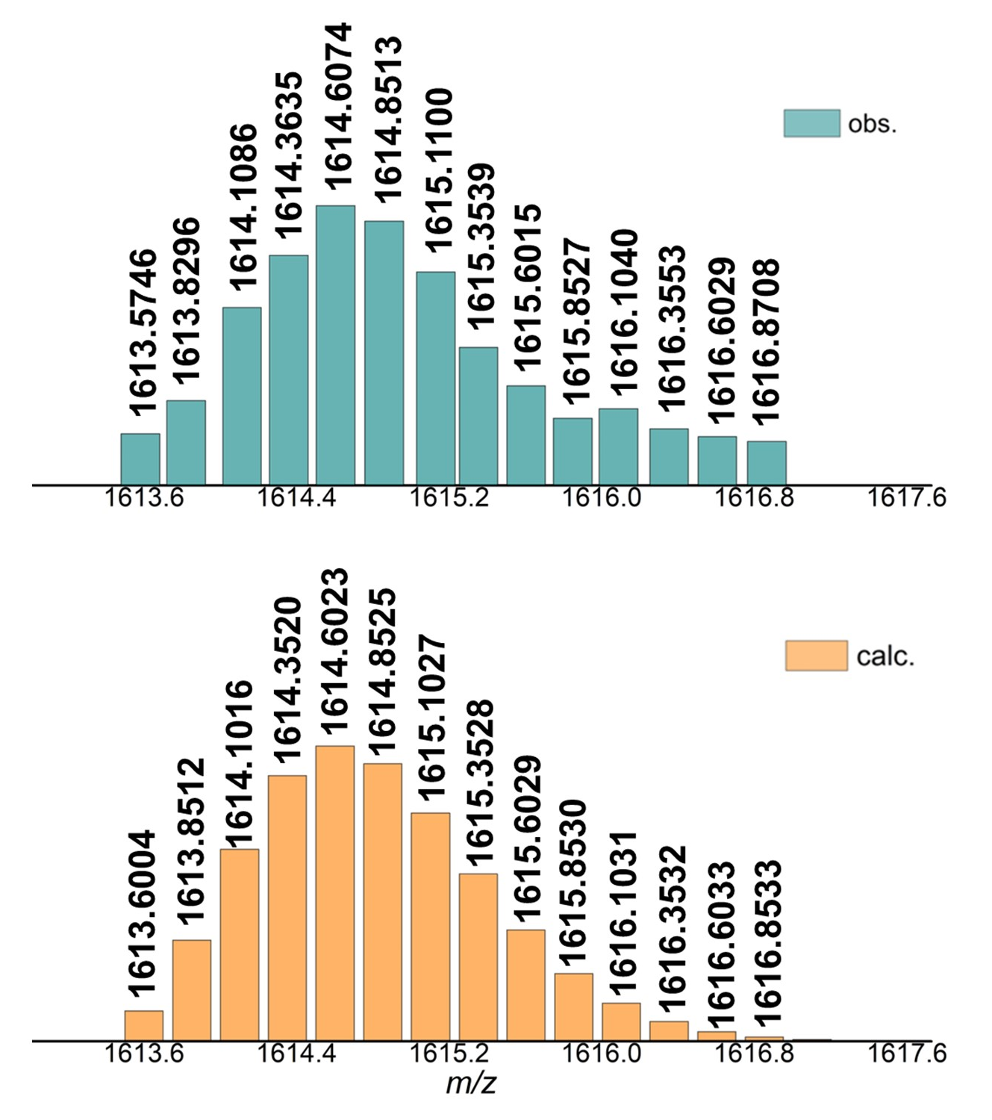
Supplementary Fig. 21. High-resolution ESI-TOF/MS of [2-Rh – 4 OTf⁻]⁴⁺ in 2-Rh. Experimental spectrum (top) and calculated spectrum (bottom).

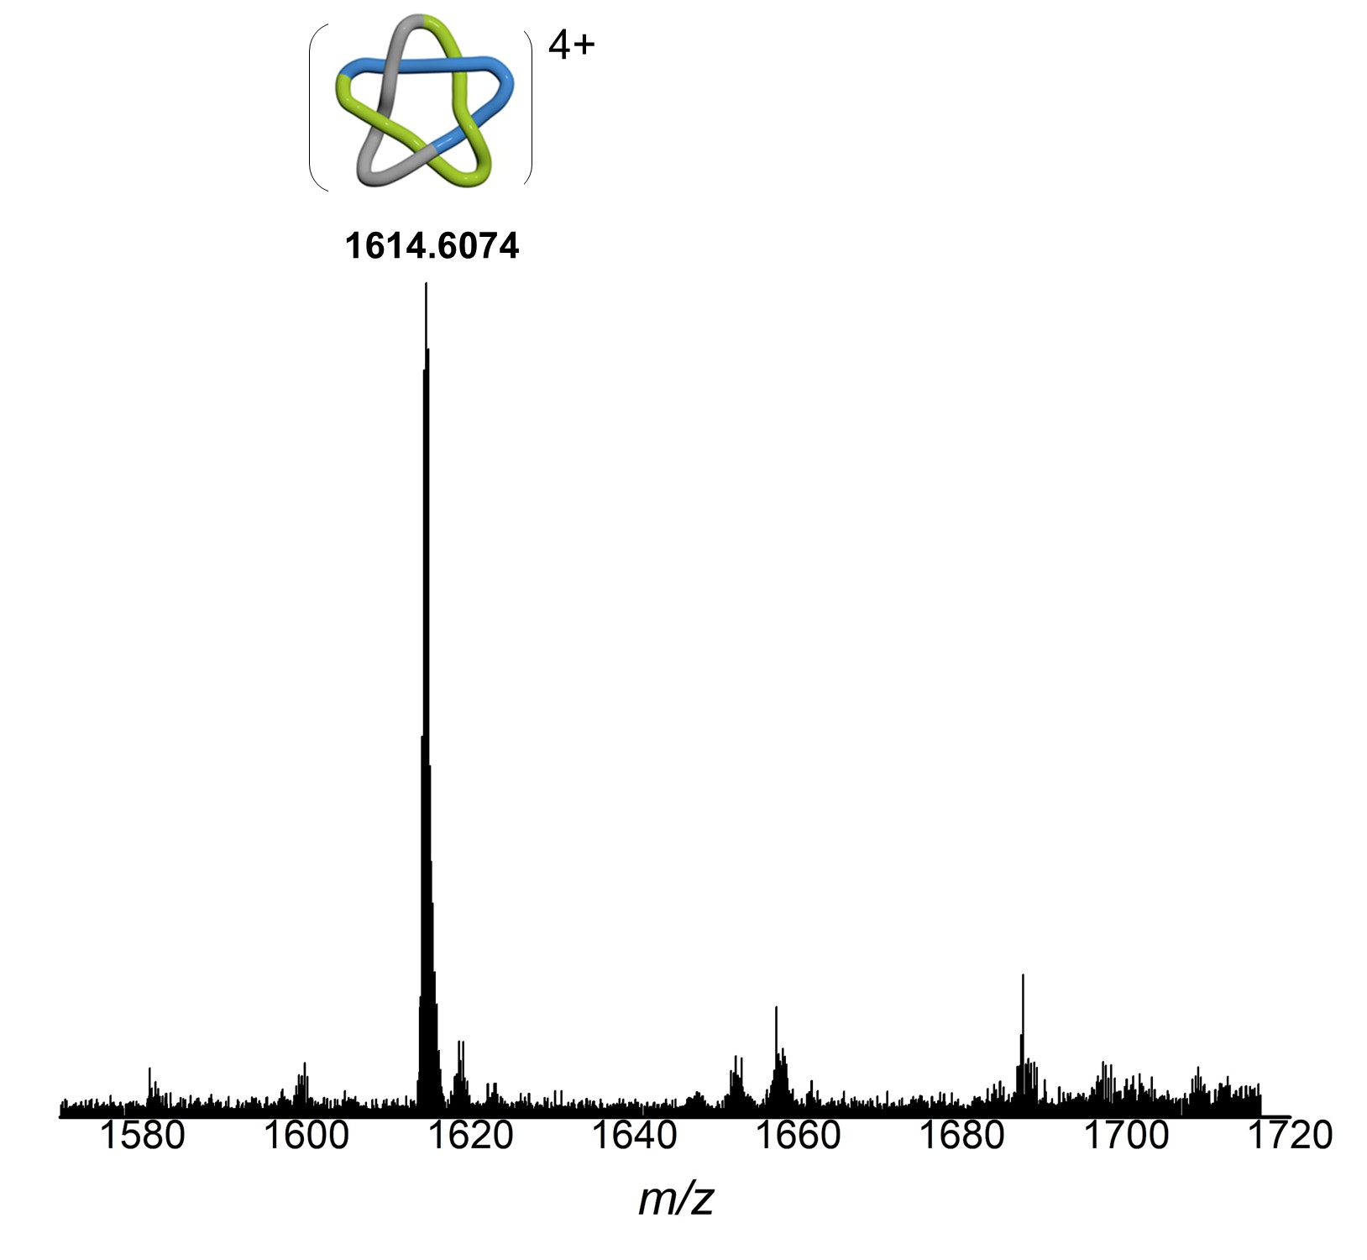
Supplementary Fig. 22. Low-resolution ESI-TOF/MS of [2-Rh – 4 OTf⁻]⁴⁺ in 2-Rh.
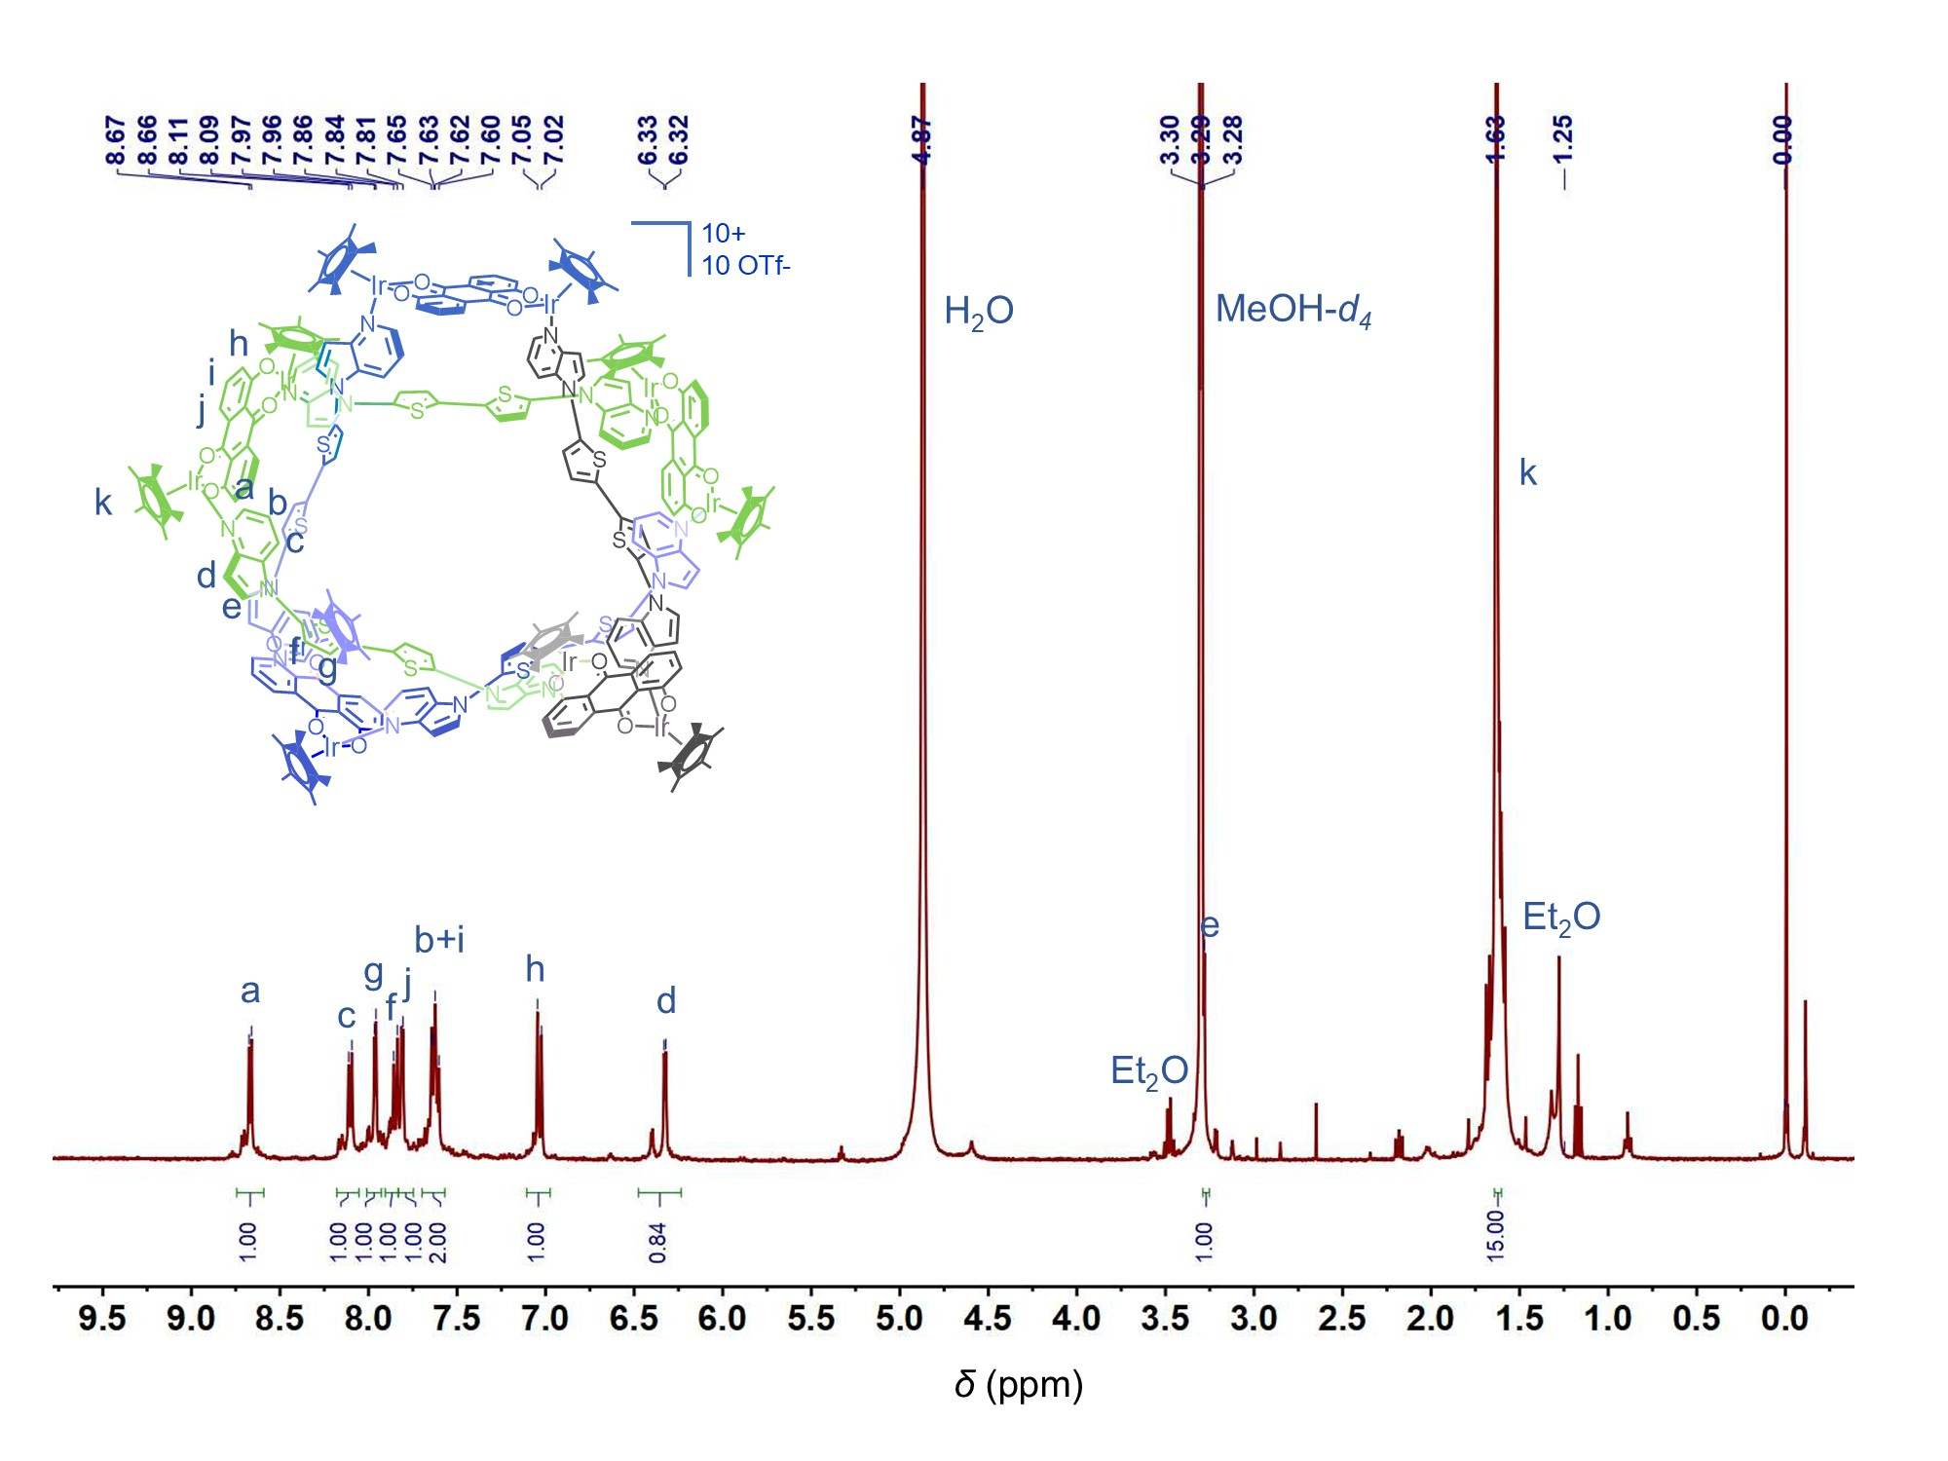
Supplementary Fig. 23. ¹H NMR (400 MHz, MeOH-d₄, c = 2.0 mM, 298.15K) spectrum of 2-Ir.

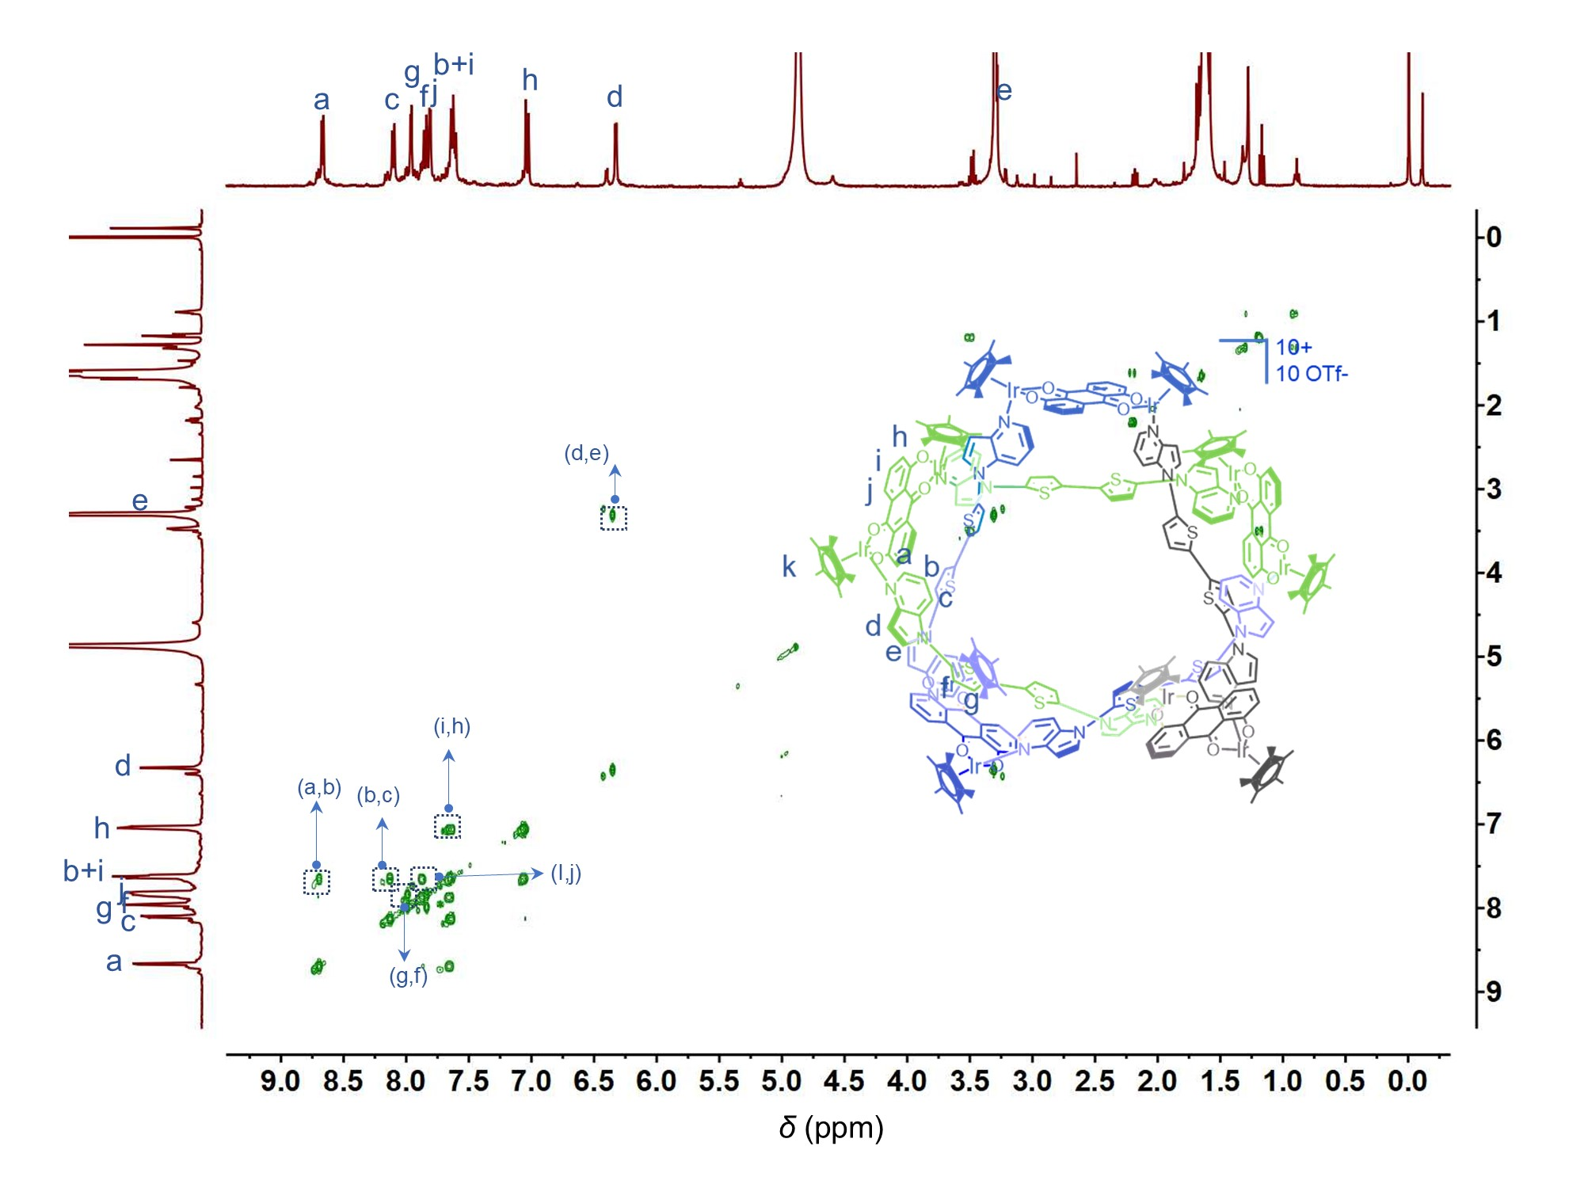
Supplementary Fig. 24. ¹H-¹H COSY NMR (400 MHz, MeOH-d₄, c = 2.0 mM, 298.15K) spectrum of 2-Ir.
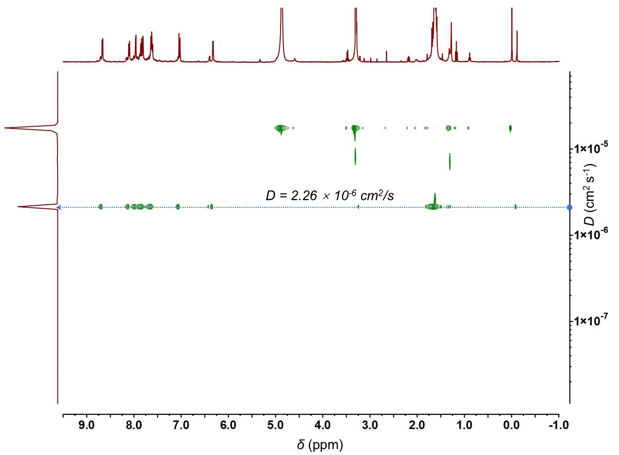
Supplementary Fig. 25. ¹H-¹H DOSY NMR (400 MHz, MeOH-d₄, c = 2.0 mM, 298.15K) spectrum of 2-Ir.

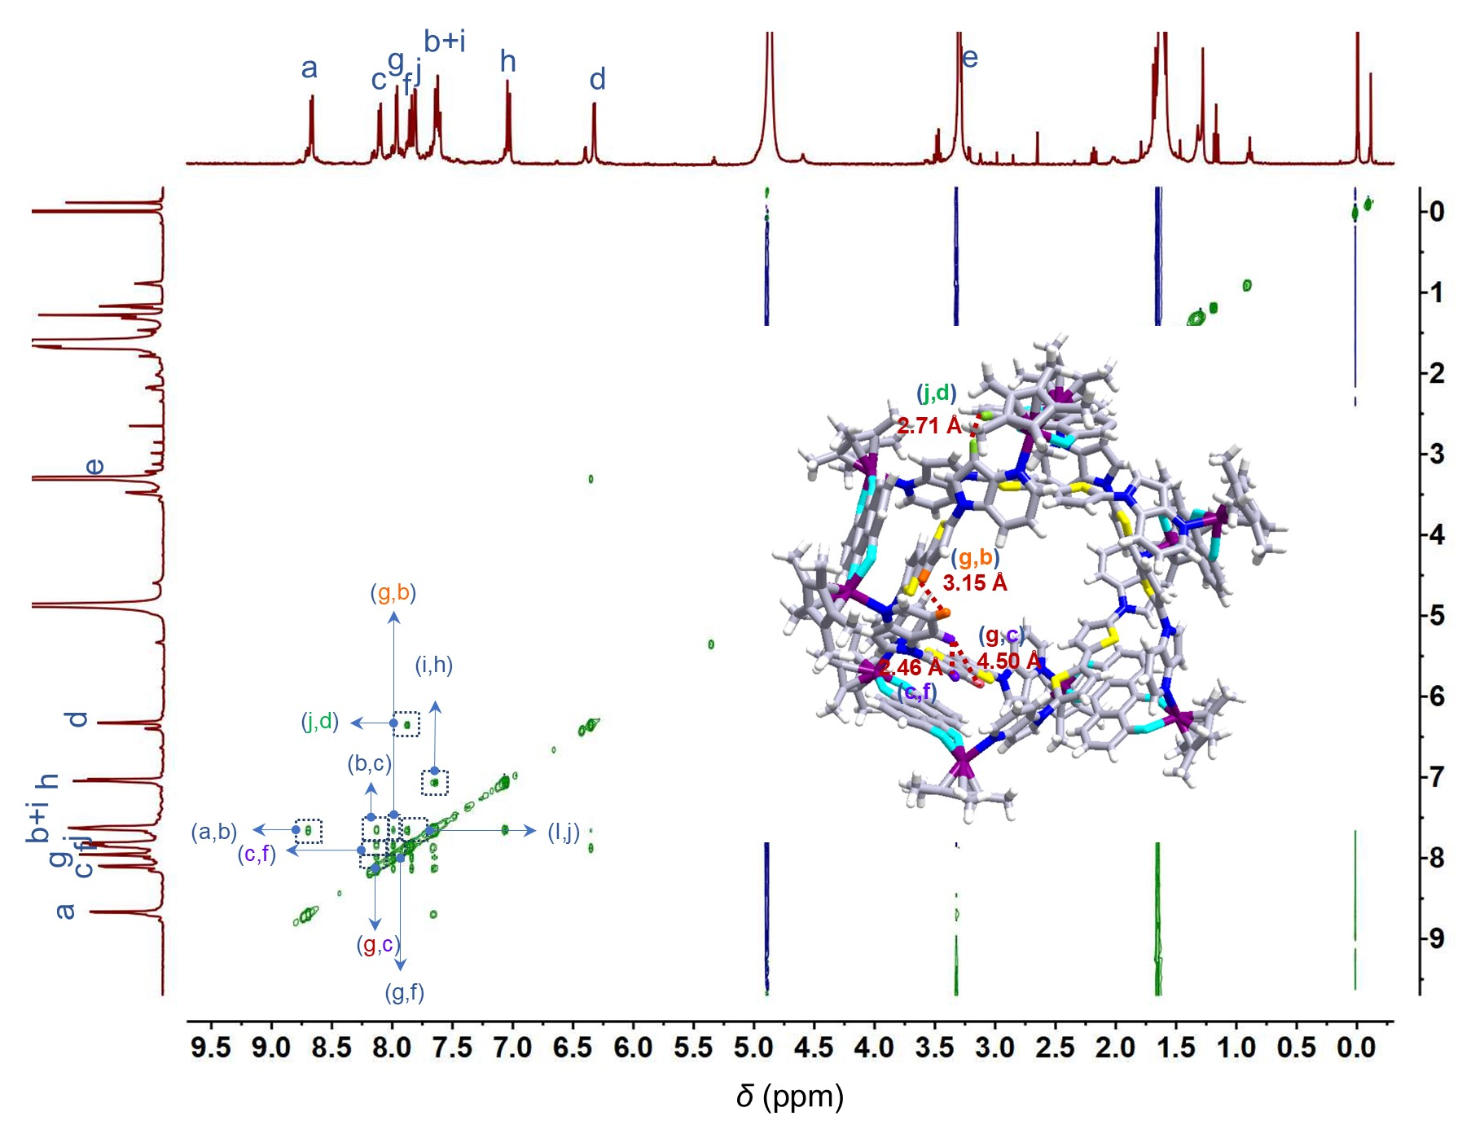
Supplementary Fig. 26. ¹H-¹H NOESY NMR spectrum of 2-Ir (400 MHz, MeOH-d₄, c = 2.0 mM, 298.15K).
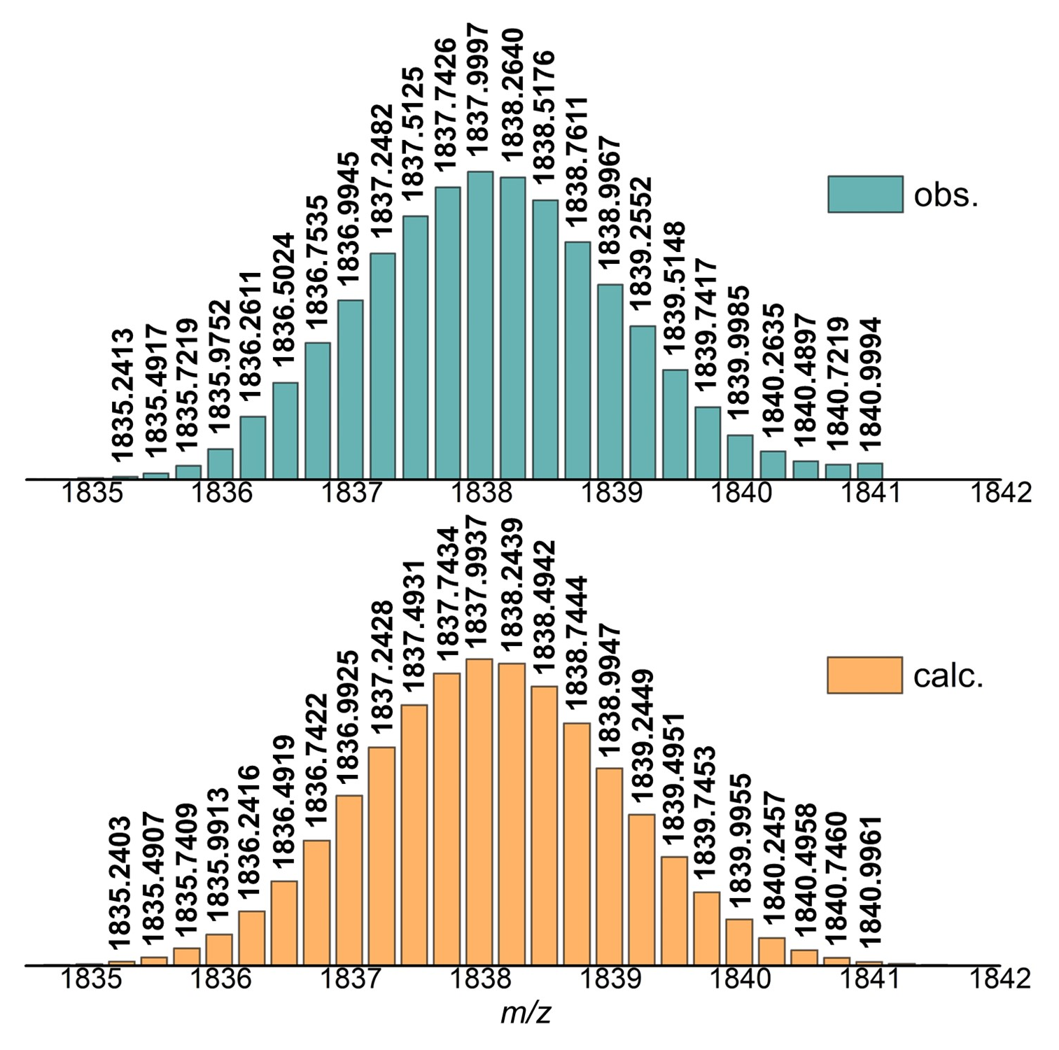
Supplementary Fig. 27. High-resolution ESI-TOF/MS of [2-Ir – 4 OTf⁻]⁴⁺ in 2-Ir. Experimental spectrum (top) and calculated spectrum (bottom).

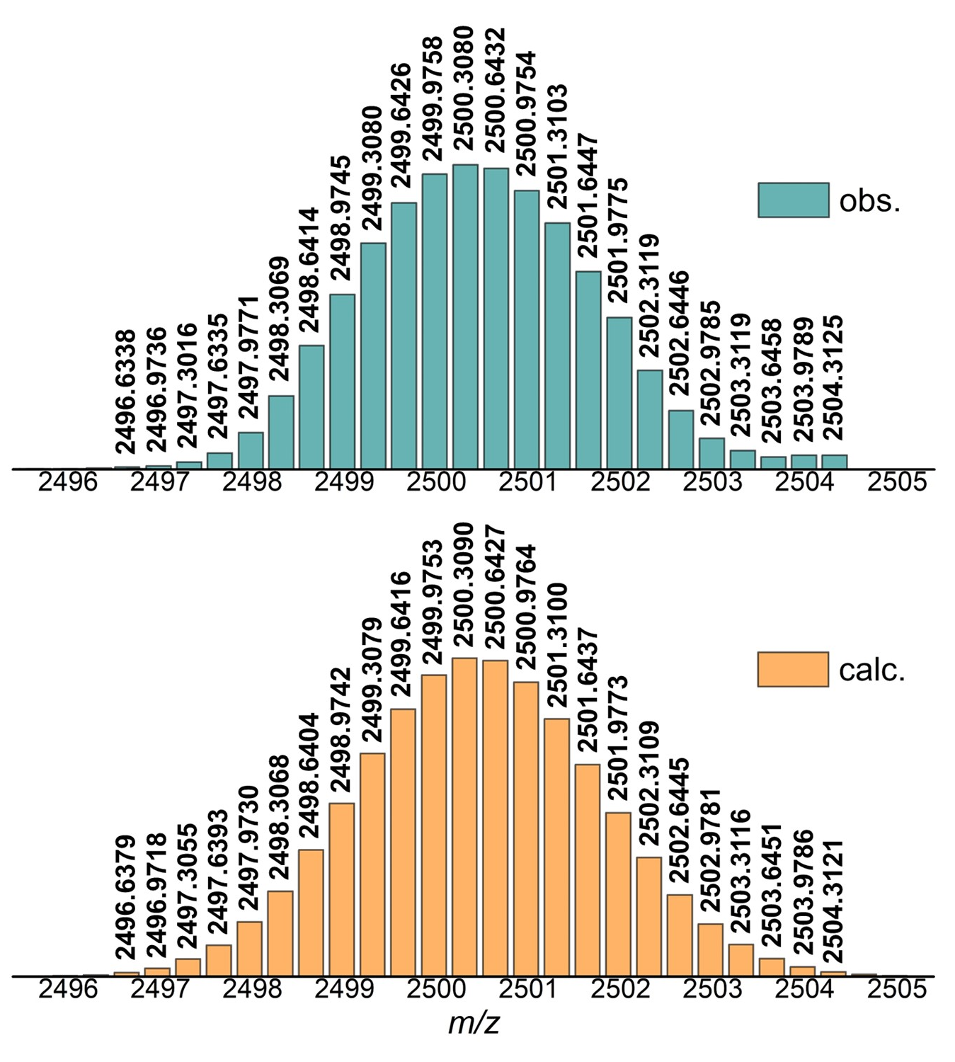
Supplementary Fig. 28. High-resolution ESI-TOF/MS of [2-Ir – 3 OTf⁻]³⁺ in 2-Ir. Experimental spectrum (top) and calculated spectrum (bottom).

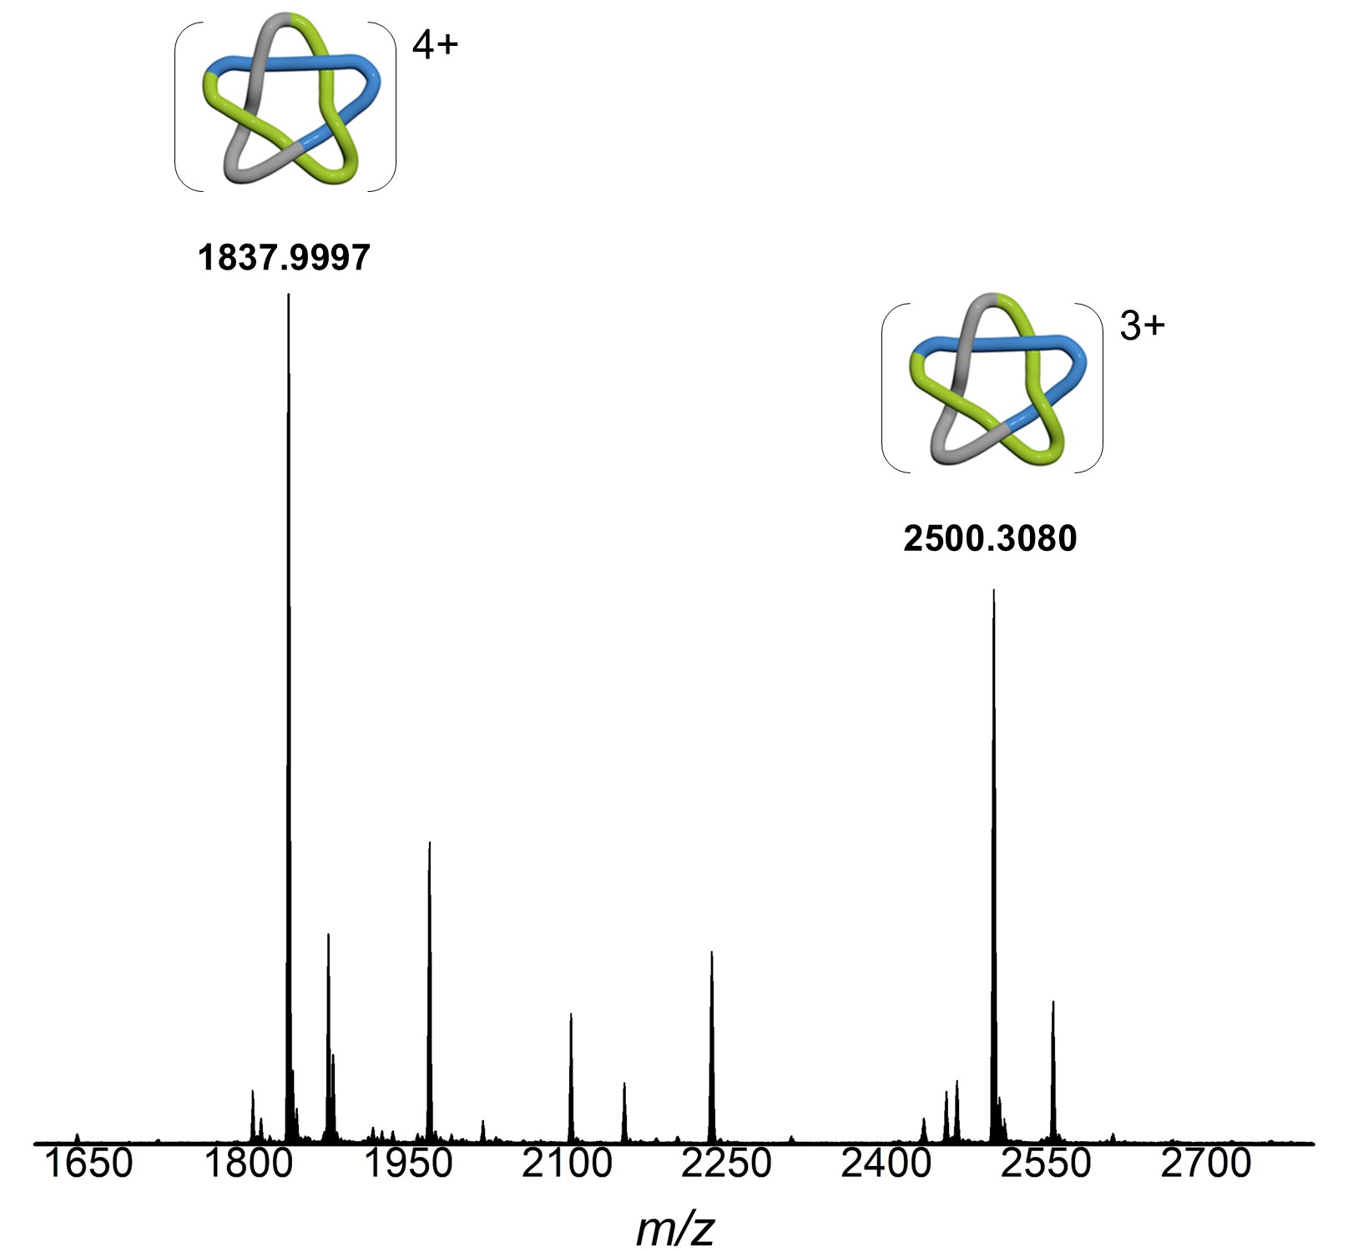
Supplementary Fig. 29. Low-resolution ESI-TOF/MS of [2-Ir – 4 OTf⁻]⁴⁺ and [2-Ir – 3 OTf⁻]³⁺ in 2-Ir.

4. Variable concentration NMR experiments

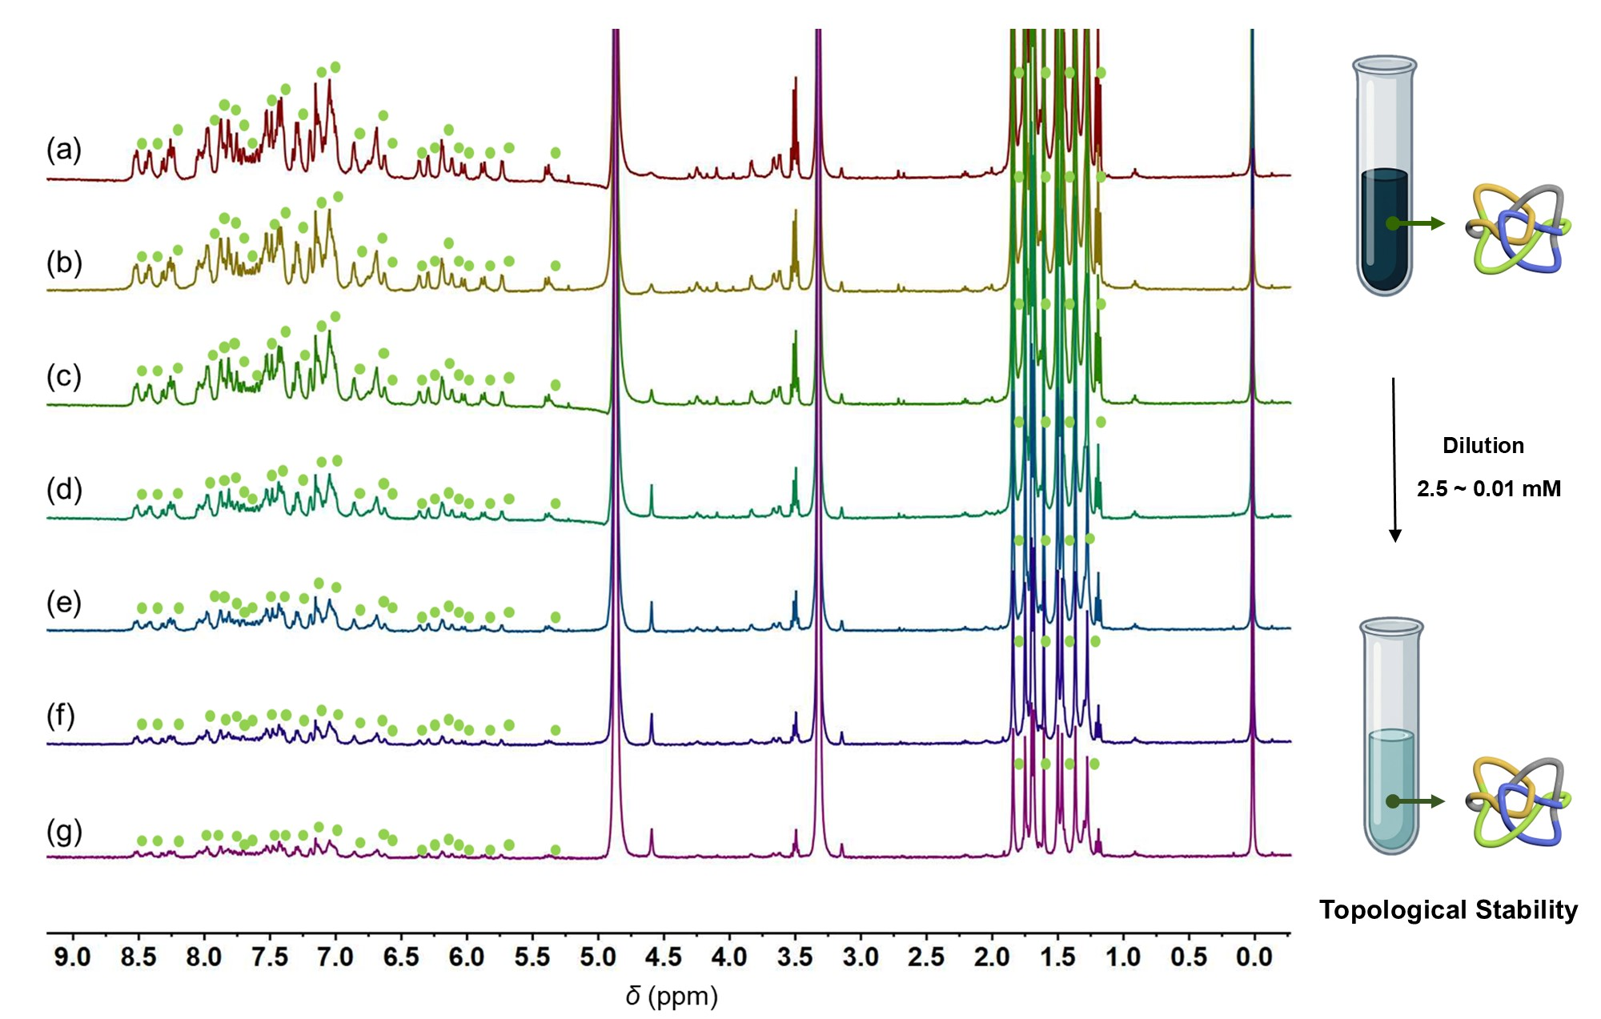Supplementary Fig. 30. Variable concentration ¹H NMR (400 MHz, MeOH-d₄, ppm) spectra for 1. (a) c = 2.5 mM. (b) c = 2.0 mM. (c) c = 1.0 mM. (d) c = 0.5 mM. (e) c = 0.1 mM. (f) c = 0.05 mM. (g) c = 0.01 mM.
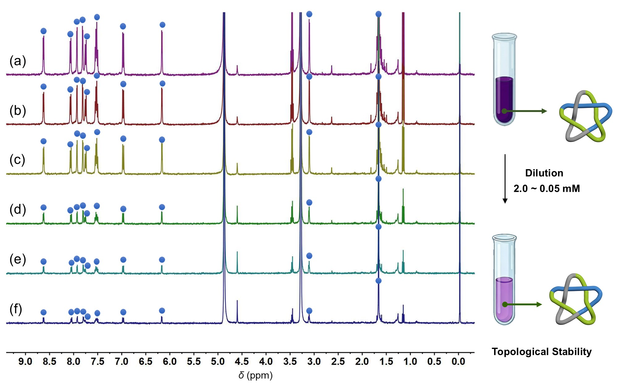
Supplementary Fig. 31. Variable concentration ¹H NMR (400 MHz, MeOH-d₄, ppm) spectra for 2-Rh. (a) c = 2.0 mM. (b) c = 1.0 mM. (c) c = 0.5 mM. (d) c = 0.2 mM. (e) c = 0.1 mM. (f) c = 0.05 mM.

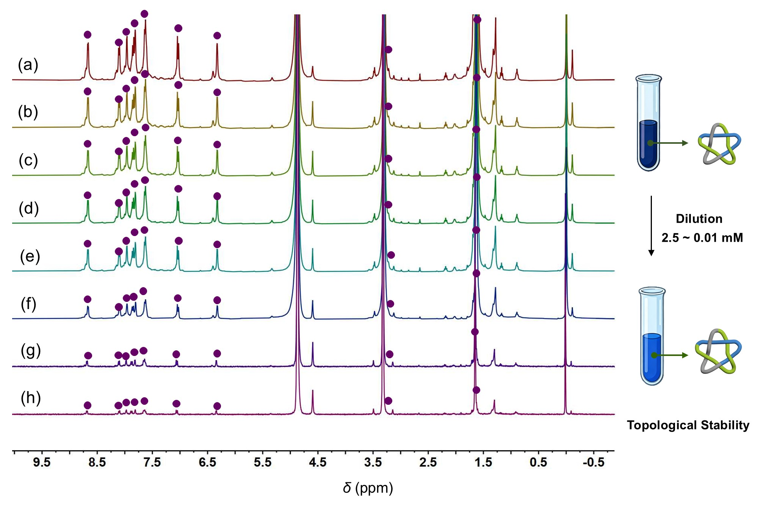
Supplementary Fig. 32. Variable concentration ¹H NMR (400 MHz, MeOH-d₄, ppm) spectra for 2-Ir. (a) c = 2.5 mM. (b) c = 2.0 mM. (c) c = 1.5 mM. (d) c = 1.0 mM. (e) c = 0.5 mM. (f) c = 0.2 mM. (g) c = 0.05 mM. (h) c = 0.01 mM.

5. Molecular structures of assemblies
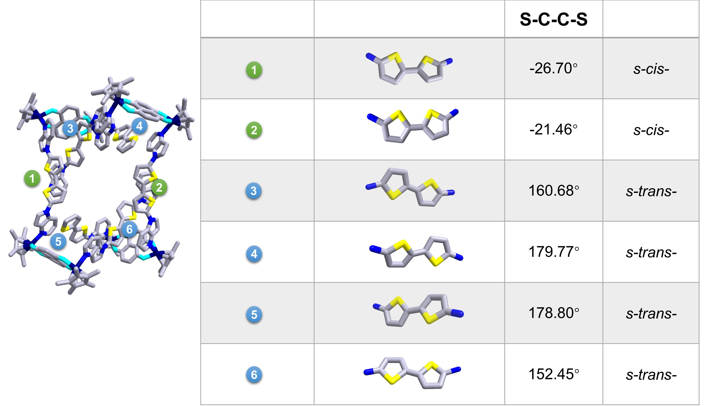
Supplementary Fig. 33. Vertically aligned ligand strands and the torsion angles (S–C–C–S) in 1. All triflate anions and solvent molecules were omitted for clarity. Color code: C, gray; N, navy blue; S, yellow; O, turquoise; Rh, blue.

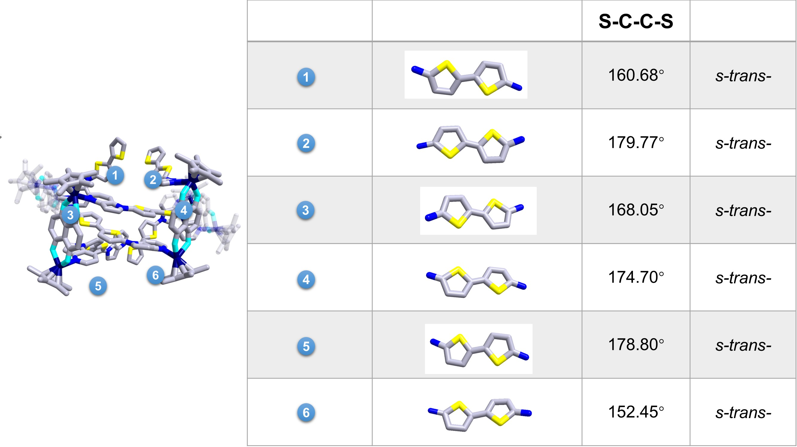
Supplementary Fig. 34. Horizontally aligned ligand strands and the torsion angles (S–C–C–S) in 1. All triflate anions and solvent molecules were omitted for clarity. Color code: C, gray; N, navy blue; S, yellow; O, turquoise; Rh, blue.
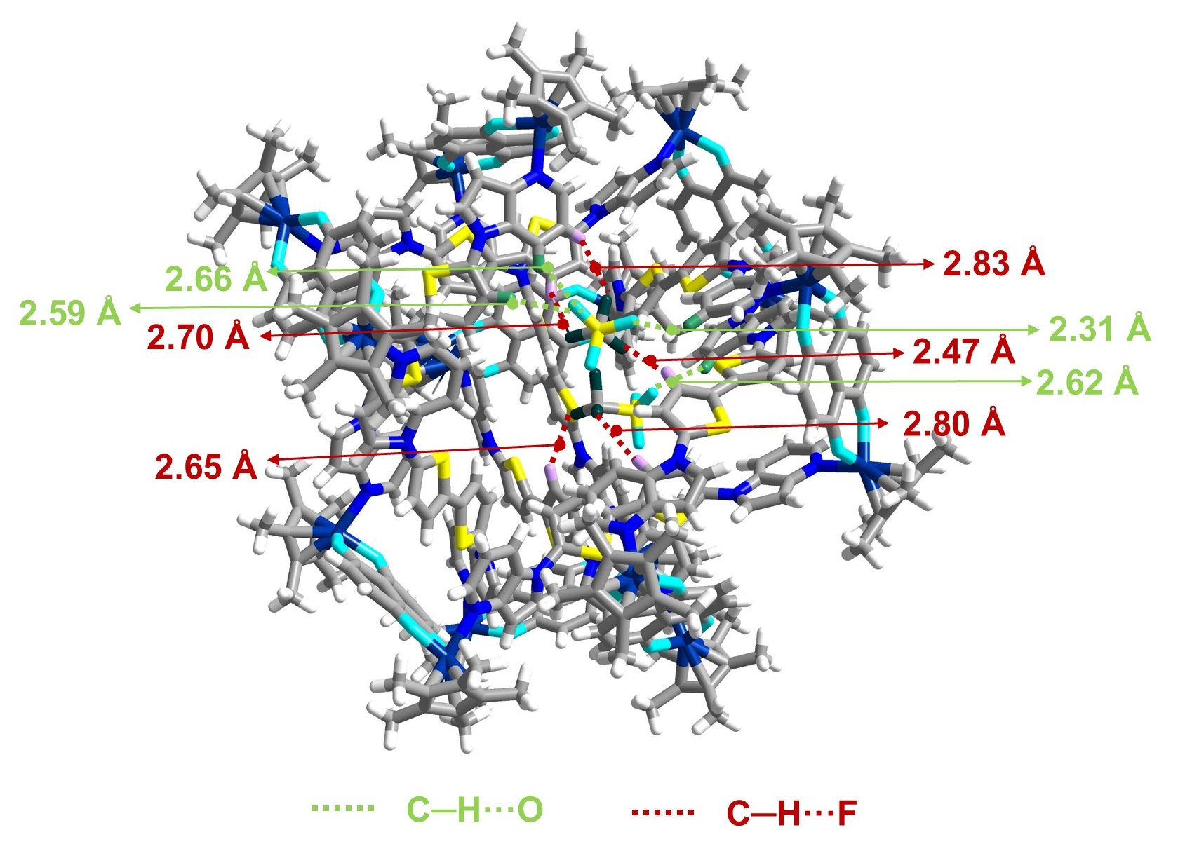
Supplementary Fig. 35. Partial structure highlighting inter-ring C–H···F and C–H···O interactions in 1. All solvent molecules were omitted for clarity. Color code: C, gray; N, navy blue; S, yellow; O, turquoise; H, white; Rh, blue.

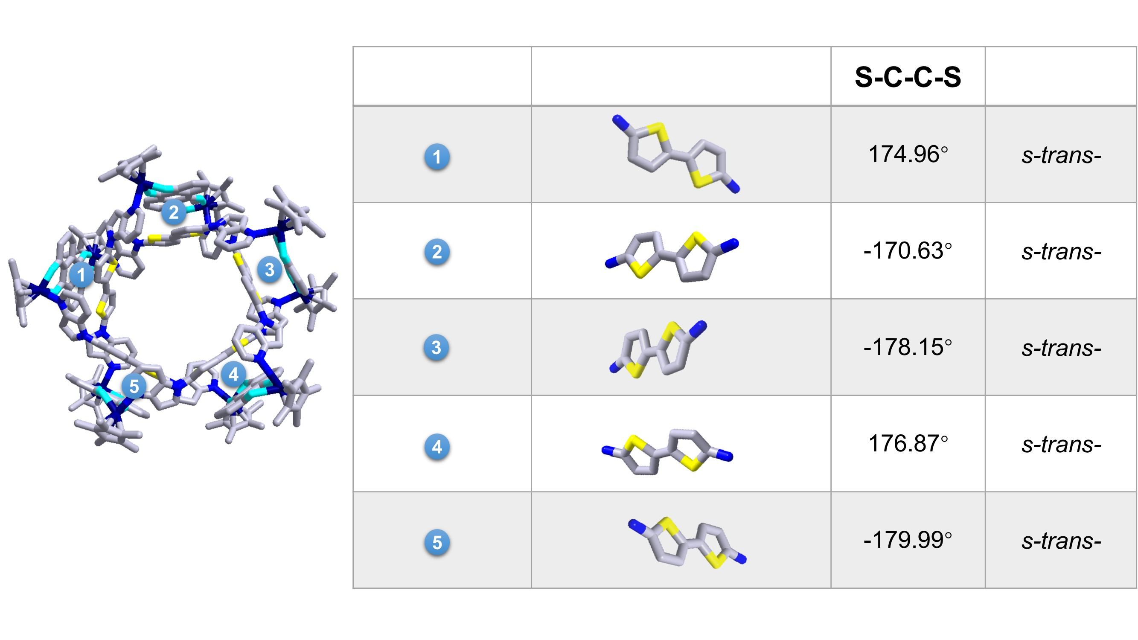
Supplementary Fig. 36. The torsion angles (S–C–C–S) in 2-Rh. All triflate anions and solvent molecules were omitted for clarity. Color code: C, gray; N, navy blue; S, yellow; O, turquoise; Rh, blue.
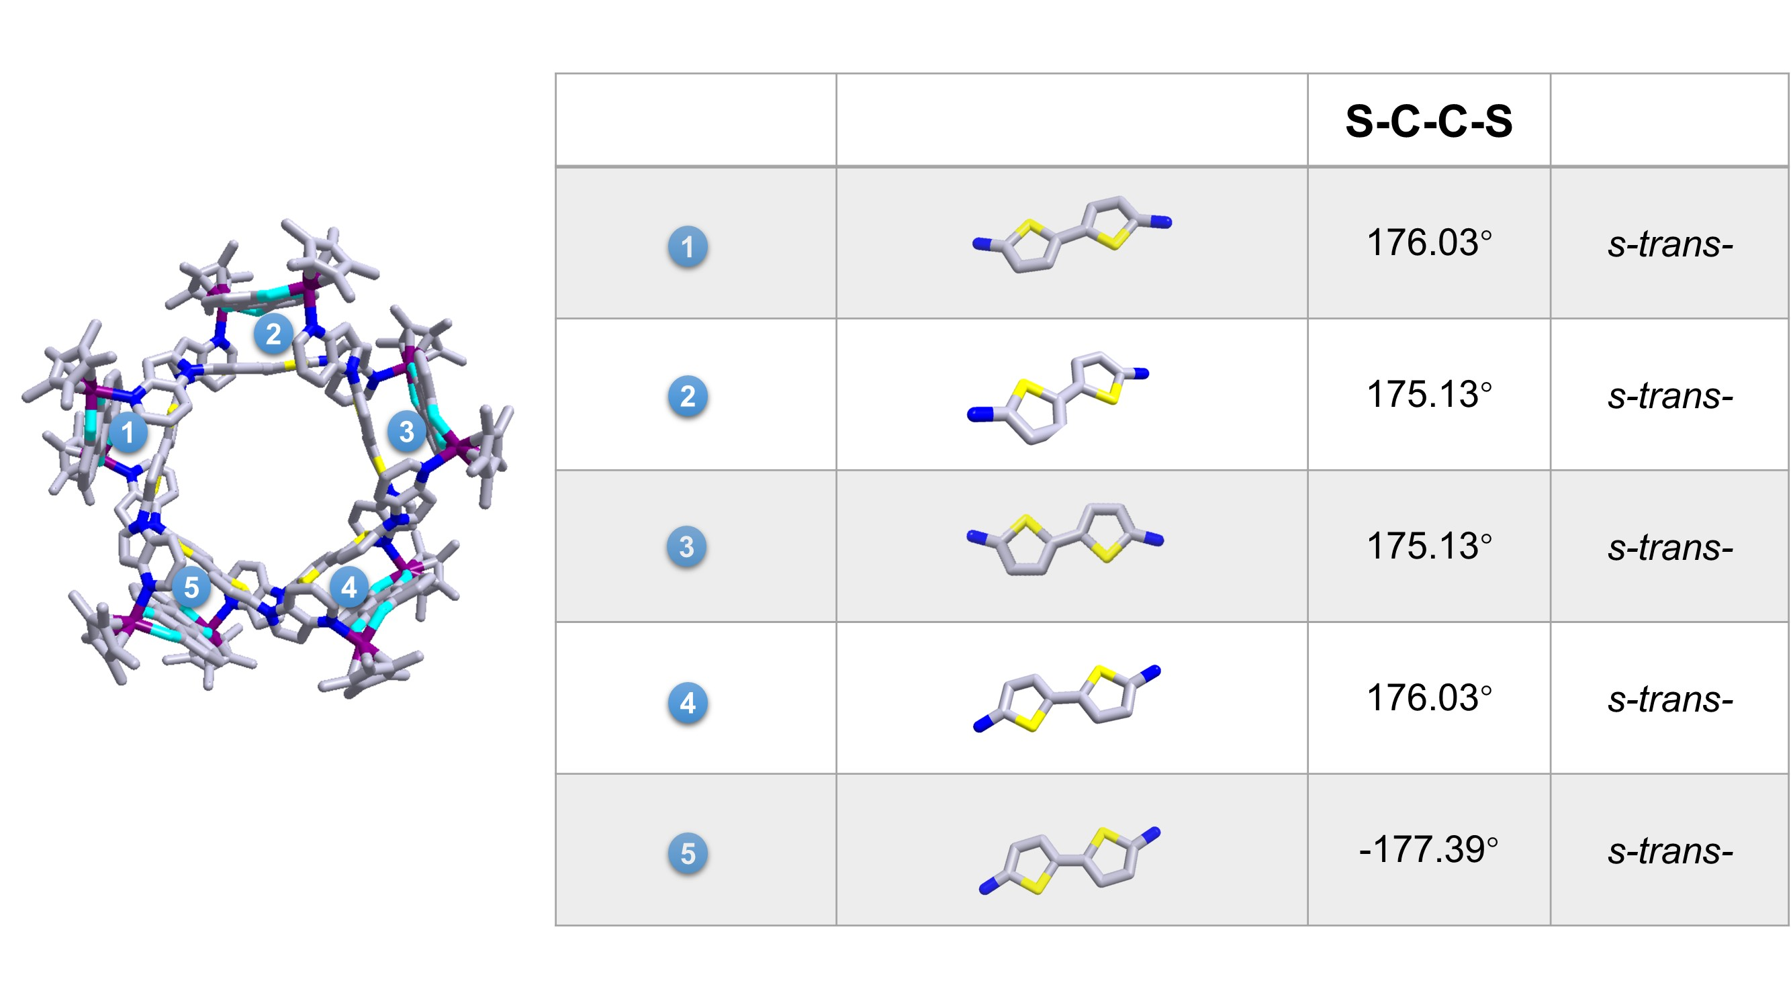
Supplementary Fig. 37. The torsion angles (S–C–C–S) in 2-Ir. All triflate anions and solvent molecules were omitted for clarity. Color code: C, gray; N, navy blue; S, yellow; O, turquoise; Ir, violet.

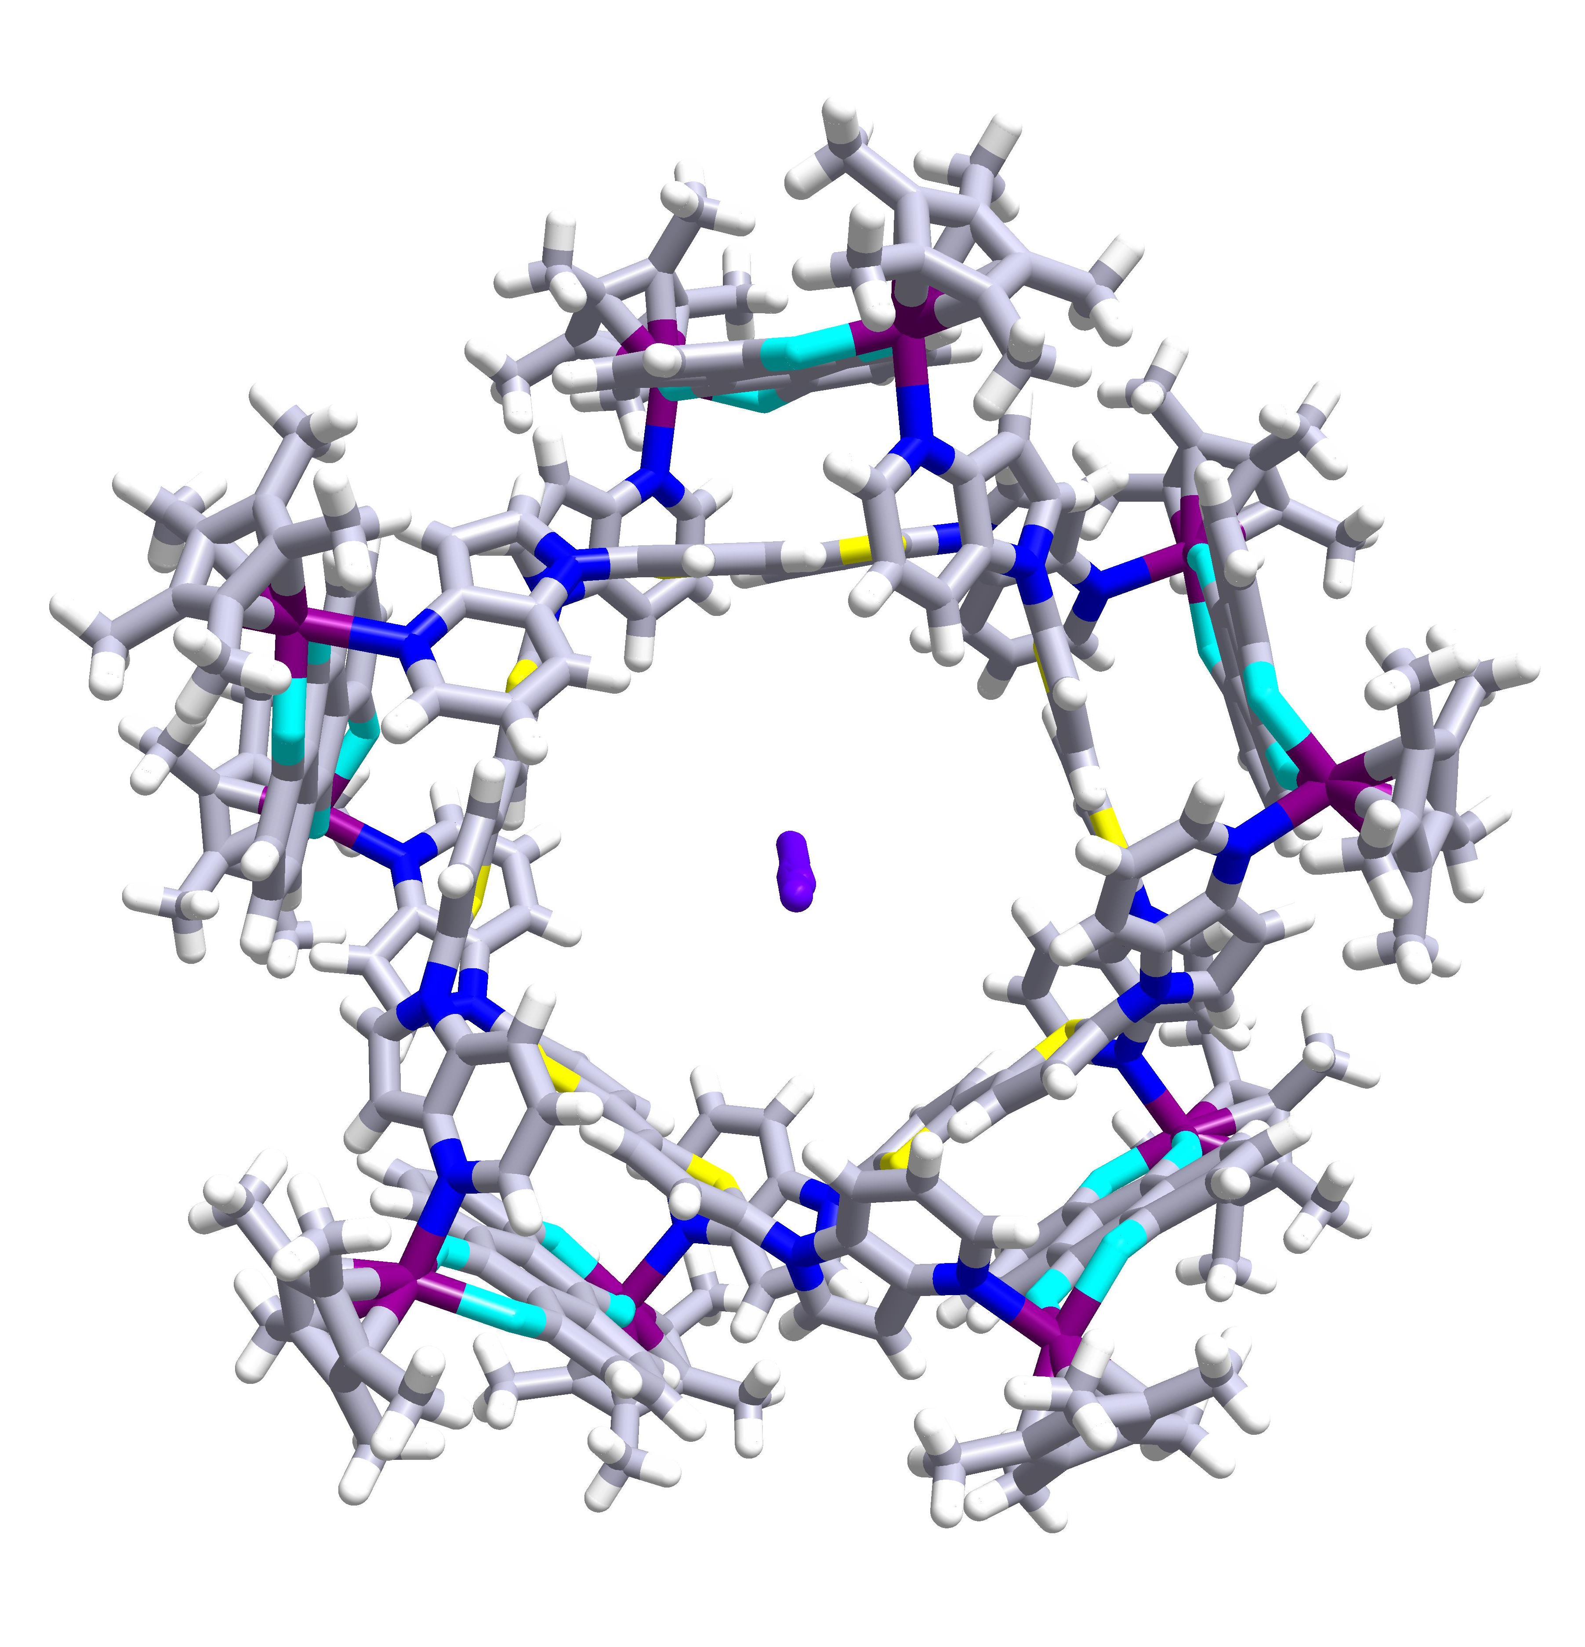
Supplementary Fig. 38. Single-crystal structure diagram of compound [2-Ir] + I⁻. All triflate anions and solvent molecules were omitted for clarity. Color code: C, gray; N, navy blue; S, yellow; O, turquoise; H, white; I, purple; Ir, violet. I⁻ ions originate from the use of CuI during the synthesis process of the ligand L.

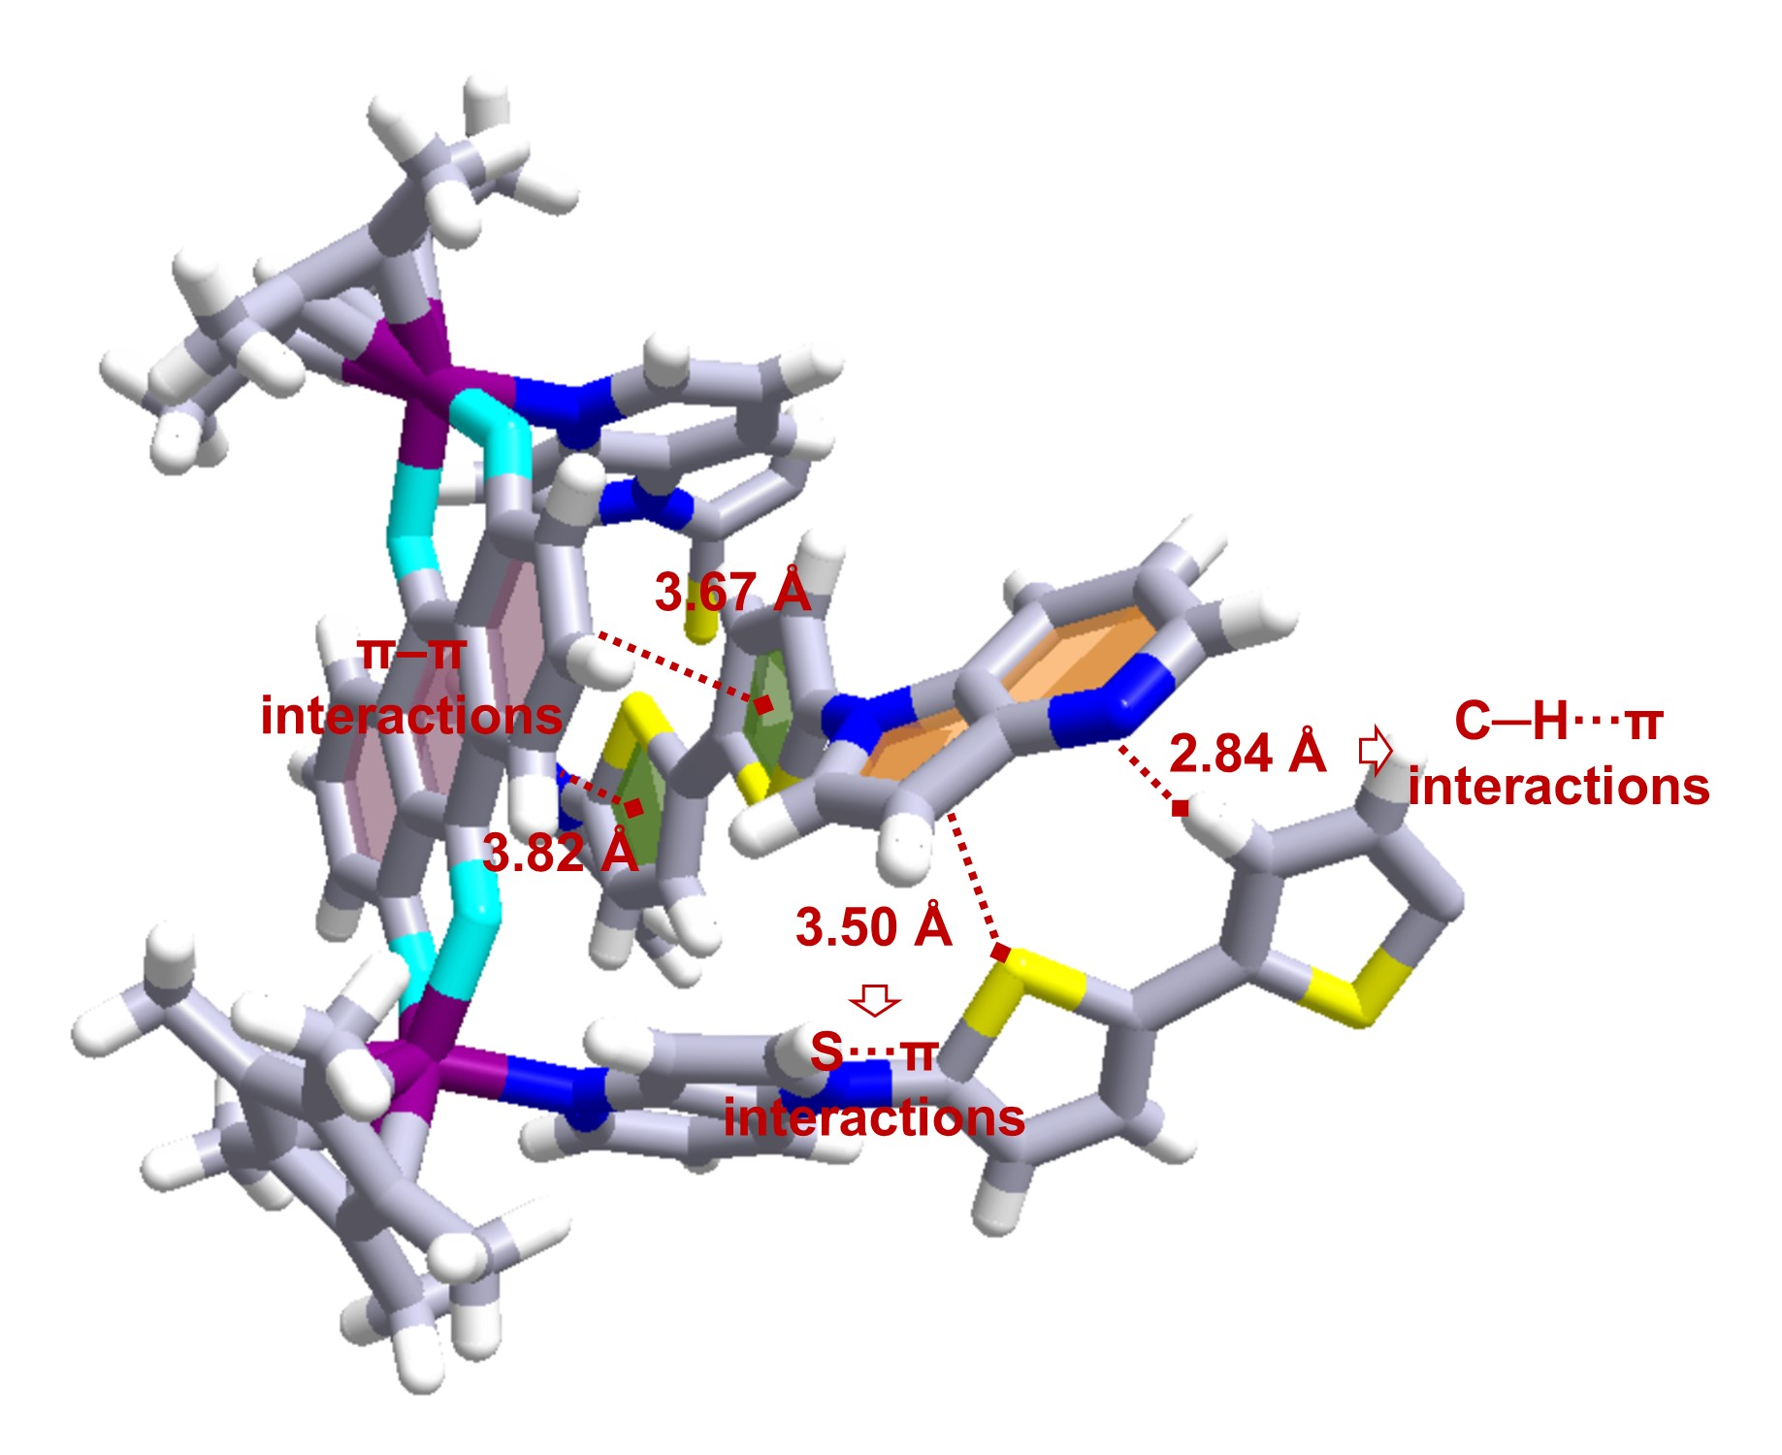
Supplementary Fig. 39. Partial non-covalent interactions in the structure of 2-Ir. All triflate anions and solvent molecules were omitted for clarity. Color code: C, gray; N, navy blue; S, yellow; O, turquoise; H, white; Ir, violet.

6. The IGM analysis of assembly

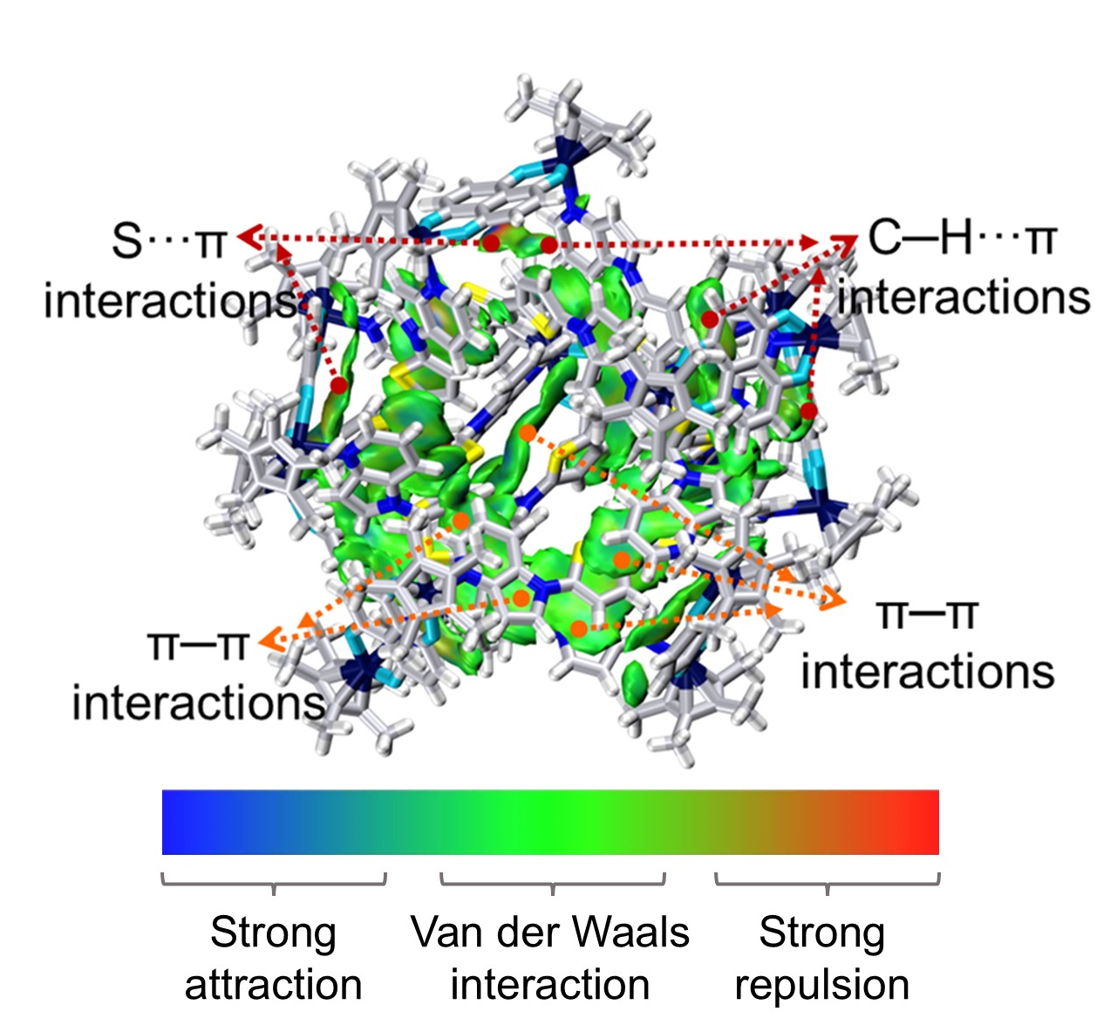
Supplementary Fig. 40. Intramolecular interaction visualizations of 1 by IGM analysis (isovalue = 0.003 a.u.). All triflate anions and solvent molecules were omitted for clarity. Color code: C, gray; N, navy blue; S, yellow; O, turquoise; H, white; Rh, blue.
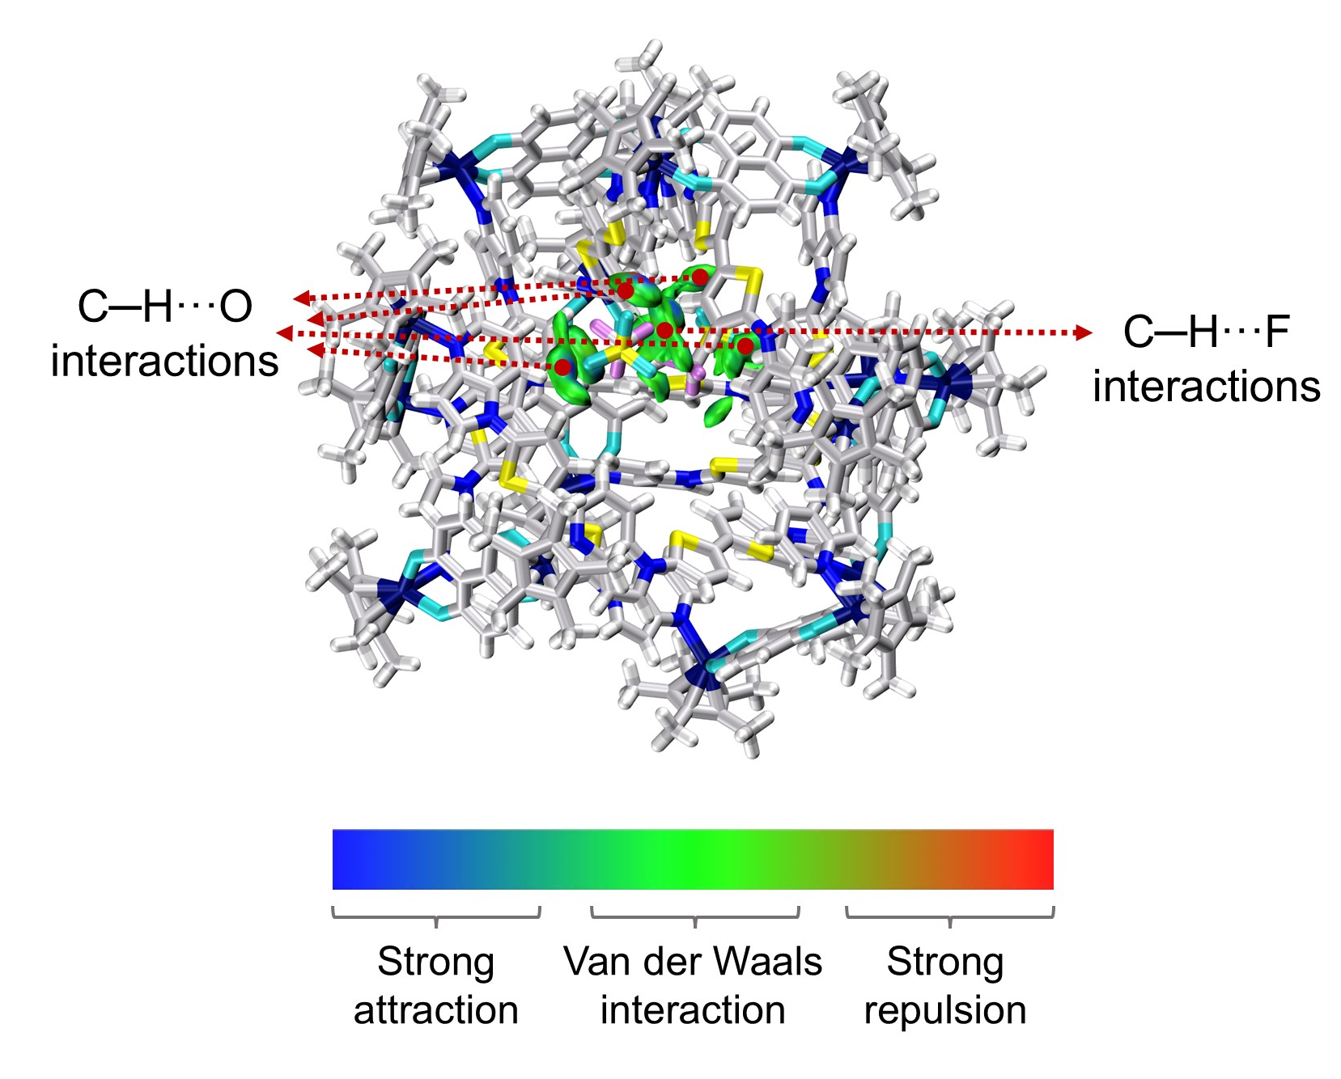
Supplementary Fig. 41. IGM analysis reveals the non-covalent interactions between 1¹⁶⁺ and OTf⁻ anions (isovalue = 0.003 a.u.). All solvent molecules were omitted for clarity. Color code: C, gray; N, navy blue; S, yellow; O, turquoise; H, white; Rh, blue.

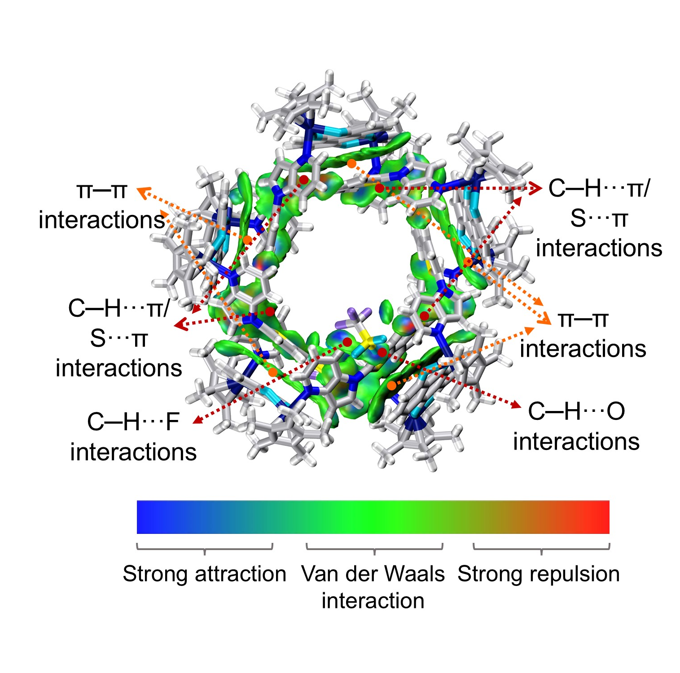
Supplementary Fig. 42. Intramolecular interaction visualizations of [2-Rh]¹⁰⁺ and OTf⁻ anions by IGM analysis (isovalue = 0.003 a.u.). All solvent molecules were omitted for clarity. Color code: C, gray; N, navy blue; S, yellow; O, turquoise; H, white; F, purple; Rh, blue.
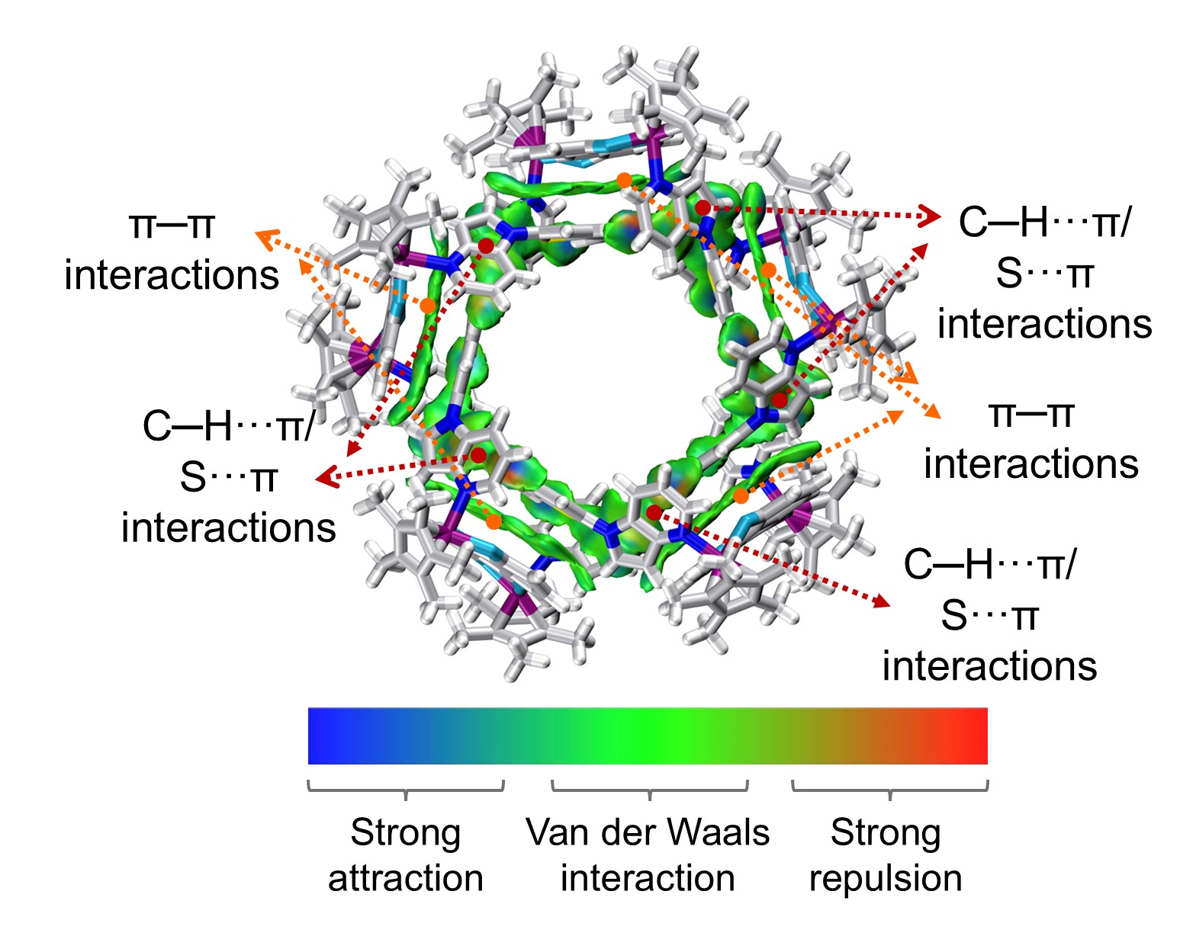
Supplementary Fig. 43. Intramolecular interaction visualizations of 2-Ir by IGM analysis (isovalue = 0.003 a.u.). All triflate anions and solvent molecules were omitted for clarity. Color code: C, gray; N, navy blue; S, yellow; O, turquoise; H, white; Ir, violet.

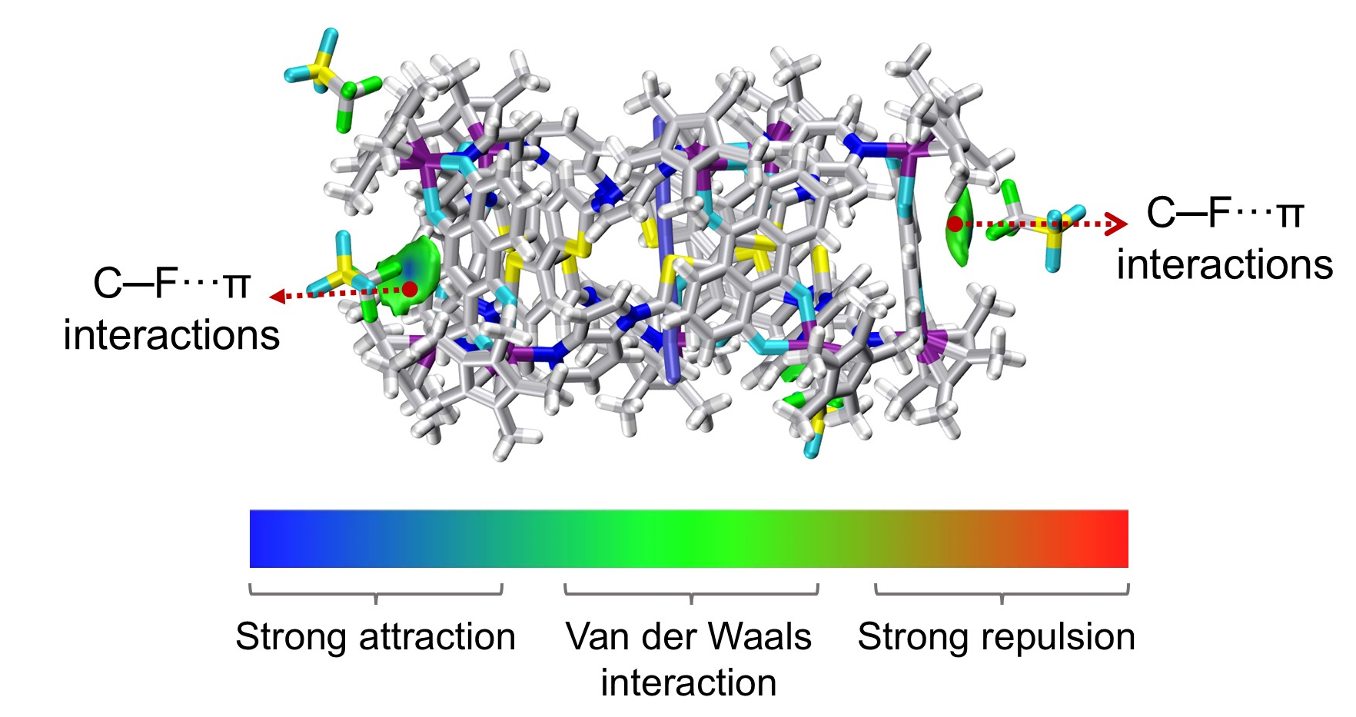
Supplementary Fig. 44. IGM analysis reveals the non-covalent interactions between [2-Ir] + I⁻ and OTf⁻ (isovalue = 0.001 a.u.). All solvent molecules were omitted for clarity. Color code: C, gray; N, navy blue; S, yellow; O, turquoise; H, white; F, green; I, purple; Ir, violet.

7. Structural size simulated procedure based on ¹H DOSY NMR test for 1, 2-Rh, and 2-Ir
For the sphere model, according to the Stokes-Einstein equation, the hydrodynamic radius (r_{h}) of particles has a relationship with diffusion coefficients (D)^{S4}:
Equation 1: $D=\frac{K_{b} T}{6πηr_{h}}$
For non-sphere situation, the relationship between D and r_{h} is modified^{S5}:
Equation 2: $D=\frac{K_{b} T}{cf_{s}πηr_{h}}$
c is a size-correction factor which can be obtained via equation 3^{S5} based on the equivalent sphere of the diffusing entity (r_{es}) and the equivalent sphere of the solvent (r_{solv}), as follows:
Equation 3: $c=\frac{6}{1+0.695({\frac{r_{solv}}{r_{es}})}^{2.234}}$
The volume V_{cyli} of a cylinder with the height (l) and the diameter (d) can be calculated in the following equation:
$V_{cyli}=π({\frac{d}{2})}^{2}l$
The volume V_{sphere} can be calculated in the following equation:
$$V_{shere}=\frac{4}{3}π{r_{es}}^{3}$$
where V_{sphere} = V_{cyli}, and then the equivalent sphere r_{es} can be calculated in the following equation:
$$r_{es}=({\frac{3}{16}d^{2}l)}^{\frac{1}{3}}$$
For solvent, if the van der Waals volume of solvent (V_{solv}) can be given, the equivalent sphere of the solvent (r_{solv}) can be calculated in the following equation:
$r_{solv}=({\frac{3}{4π}V_{solv})}^{\frac{1}{3}}$
And the f_{s} is a system-derived shape friction correction factor, which can be modelled in this work as a cylinder parameterized by length (l) and diameter (d) in the following equation^{S6}:
$f_{s}=1.0304+0.0193\left[\ln\left(\frac{l}{d}\right)\right]+0.06229{\left[\ln\left(\frac{l}{d}\right)\right]}^{2}+0.00476{\left[\ln\left(\frac{l}{d}\right)\right]}^{3}+0.00166{\left[\ln\left(\frac{l}{d}\right)\right]}^{4}+2.66×{10}^{-6}{\left[\ln\left(\frac{l}{d}\right)\right]}^{7}$
The ratio (r_{h}/r_{es}) provides the data necessary to adjust l and d such that the volume generated by them matches the volume generated by r_{h}, and the ratio should be infinitely close to 1.

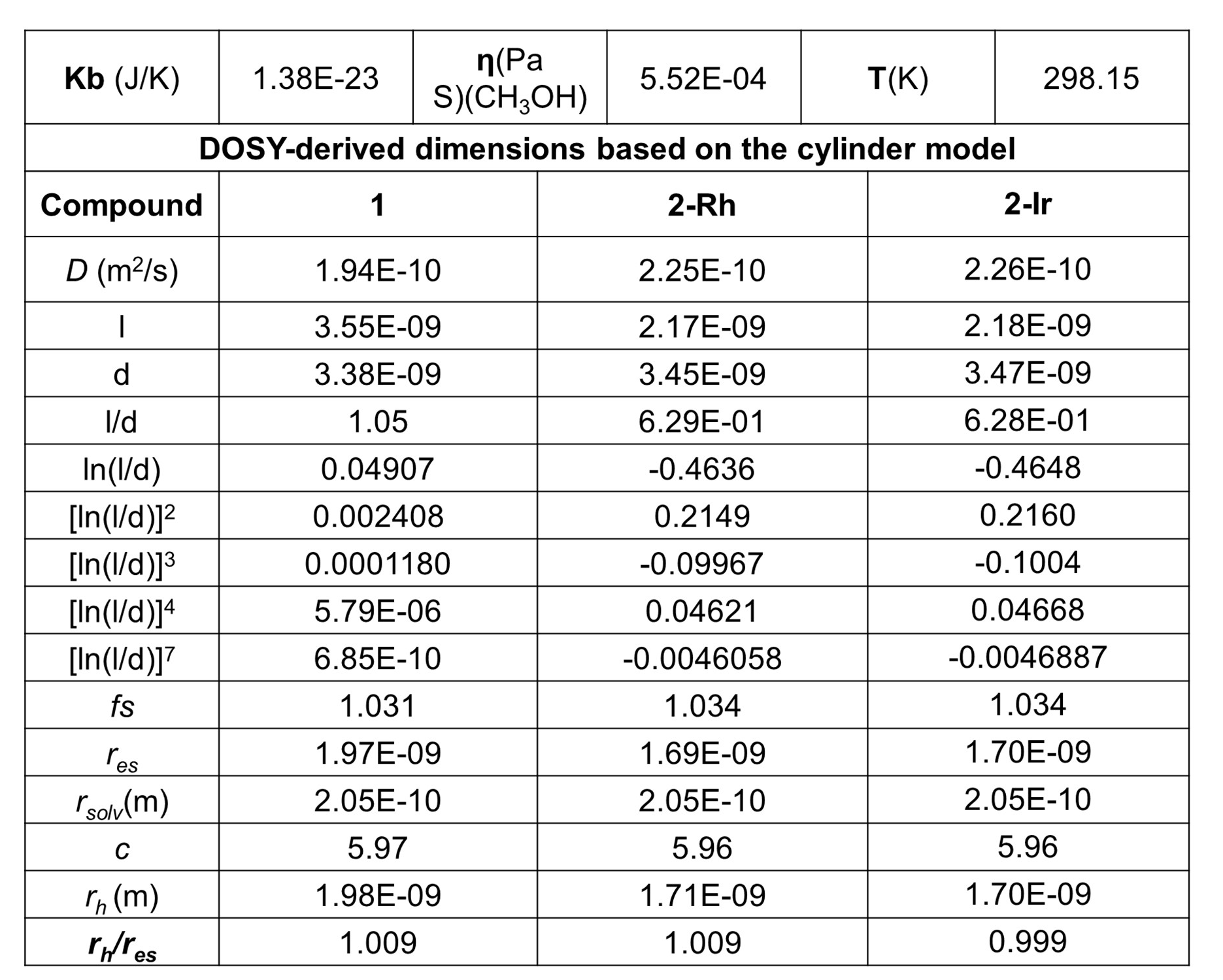
Supplementary Fig. 45. Screenshot of Microsoft Excel spreadsheet used to fit assemblies 1, 2-Rh, and 2-Ir using the modified Stokes-Einstein equation.

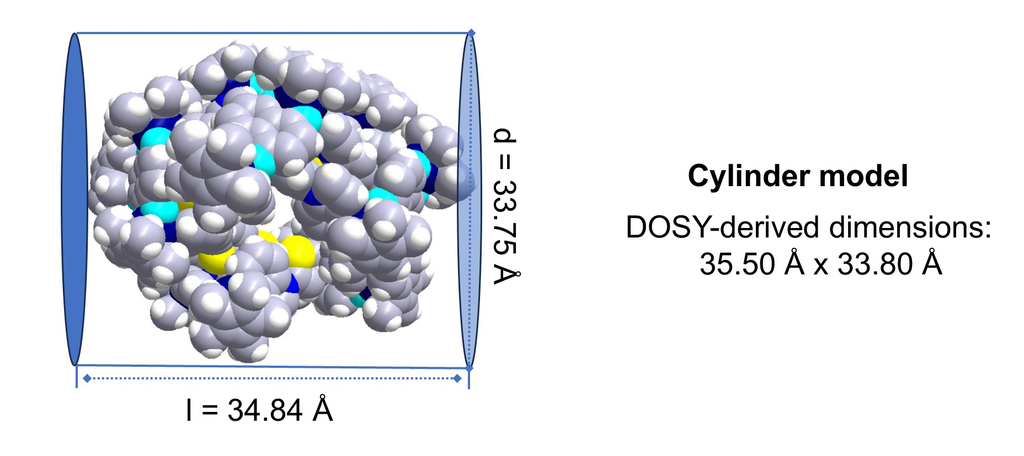
Supplementary Fig. 46. DOSY-derived dimensions of 1 (height: l = 35.50 Å, diameter: d = 33.80 Å) fitted using diffusion constant D = 1.94 × 10⁻¹⁰ m² s⁻¹ according to the cylinder model.
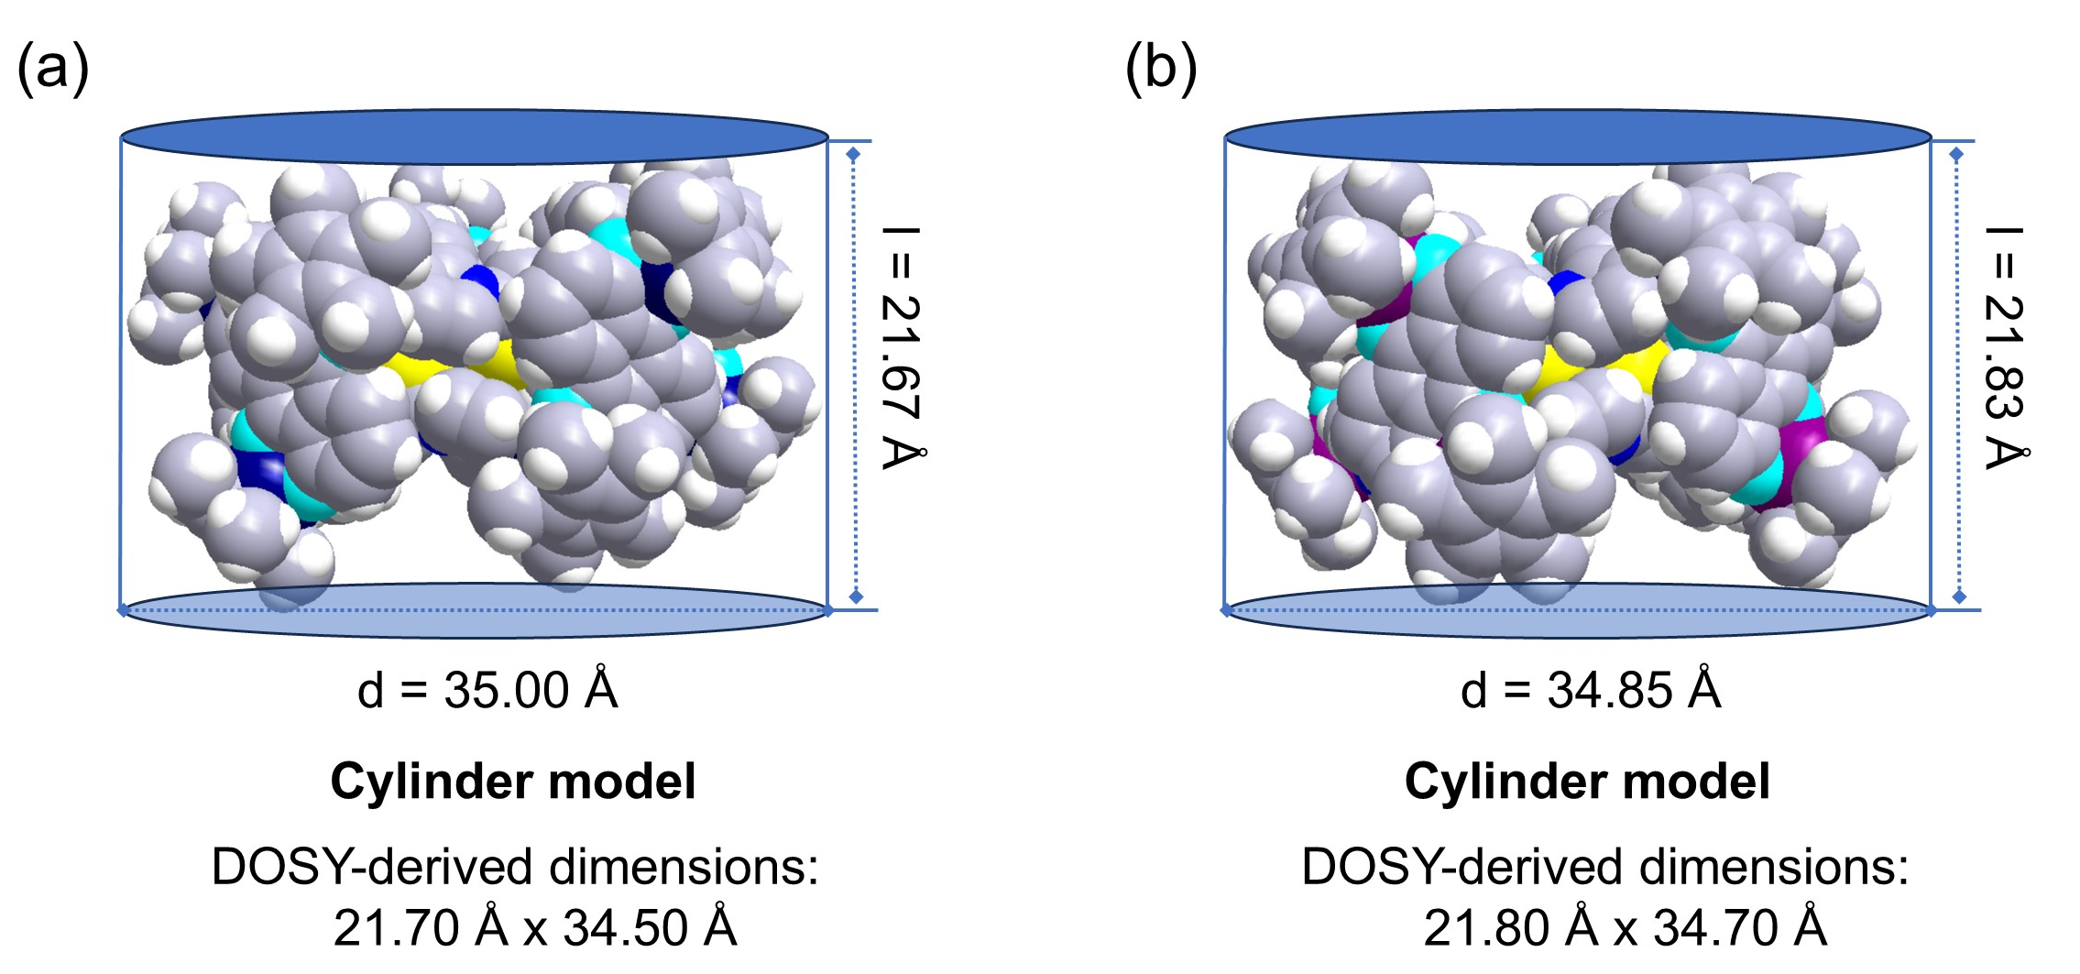
Supplementary Fig. 47. (a) DOSY-derived dimensions of 2-Rh (height: l = 21.70 Å, diameter: d = 34.50 Å) fitted using diffusion constant D = 2.25 × 10⁻¹⁰ m² s⁻¹ according to the cylinder model. (b) DOSY-derived dimensions of 2-Ir (height: l = 21.80 Å, diameter: d = 34.70 Å) fitted using diffusion constant D = 2.26 × 10⁻¹⁰ m² s⁻¹ according to the cylinder model.

8. X-ray Crystallography Details
Single-crystal X-ray diffraction data of 1, 2-Rh, and [2-Ir] + I⁻ were collected at 173.0 K on a Bruker D8 VENTURE METALJET liquid metal X-ray source system equipped with a Ga Kα radiation (λ = 1.34139 Å). The indexing of diffraction data was accomplished via the difference vector method using the Bruker APEX 4 software^{S7}, ensuring accurate identification of crystal lattice parameters. Data integration and reduction were performed with SAINT v8.34A^{S8}, while absorption correction was applied via the multi-scan method implemented in the SADABS 2014/5 routines; no additional corrections were applied for extinction effects or crystal decay processes.^{S9} The crystal structure was solved by direct methods, and full-matrix least-squares refinement was conducted based on Fₒ² values using the SHELX program^{S10} suite integrated with the OLEX2 interface^{S11}. To ensure structural rationality, appropriate restraints, constraints, and rigid body models were applied to regulate the molecular geometry and atomic displacement parameters of compound 1, 2-Rh, and [2-Ir] + I⁻. Hydrogen atoms were positioned geometrically and treated as riding atoms during the refinement process. The disordered solvent molecules that could not be restrained properly were removed using the SQUEEZE method. Details of the X-ray crystallographic refinement of 1, 2-Rh, and [2-Ir] + I⁻ can be found in Tables S1, S2, and S3.
Table S1. Summary of crystal data and structure refinement parameters for 1.
Identification code | 1
Empirical formula | C₈₃₉H₇₆₈F₂₁N₆₄O₈₅Rh₃₂S₃₉
Formula weight | 18049.59
Temperature/K | 173.0
Crystal system | triclinic
Space group | P-1
a/Å | 30.597(3)
b/Å | 43.115(5)
c/Å | 49.102(5)
α/deg | 64.586(3)
β/deg | 85.851(2)
α/deg | 78.992(3)
V/Å³ | 57427(10)
ρ_{calc} Mg/m³ | 1.044
Absorption coefficient/mm⁻¹ | 3.123
F(000) | 18366
Crystal size/mm³ | 0.25 х 0.20 х 0.15
Radiation | GaKα (λ = 1.34139)
Theta range for data collection/° | 2.357 to 42.318
Index ranges | -30<=h<=30, -43<=k<=43, -49<=l<=49
Reflections collected | 675821
Independent reflections | 46234 [R(int) = 0.1444, R(sigma) = 0.1134]
Absorption correction | multi-scan
Refinement method | Full-matrix least-squares on F²
Data/restraints/parameters | 120662/8872/9696
Goodness-of-fit on F² | 1.271
Final R indices [I>2sigma(I)] | R₁ = 0.1373, wR₂ = 0.3834
R indices (all data) | R₁ = 0.2116, wR₂ = 0.4411
Largest diff. peak and hole, e/Å³ | 1.336/-0.861
R₁ = Σ||F₀|-|F_{c}|| (based on reflections with F₀²>2σF²). wR₂ = [Σ[w(F₀²-F_{c}²)²]/Σ[w(F₀²)²]]^{1/2}; w = 1/[σ²(F₀²)+(0.095P)²]; P = [max(F₀², 0)+2F_{c}²]/3(also with F₀²>2σF²)
Table S2. Summary of crystal data and structure refinement parameters for 2-Rh.
Identification code | 2-Rh
Empirical formula | C₂₈₆H₂₅₀F₁₈N₂₀O₃₈Rh₁₀S₁₆
Formula weight | 6459.11
Temperature/K | 173.0
Crystal system | triclinic
Space group | P-1
a/Å | 19.4495(16)
b/Å | 27.334(2)
c/Å | 36.537(3)
α/deg | 84.456(3)
β/deg | 80.875(3)
α/deg | 74.312(3)
V/Å³ | 18435(3)
ρ_{calc} Mg/m³ | 1.164
Absorption coefficient/mm⁻¹ | 3.253
F(000) | 6556
Crystal size/mm³ | 0.25 х 0.20 х 0.15
Radiation | GaKα (λ = 1.34139)
Theta range for data collection/° | 2.459 to 48.555
Index ranges | -21<=h<=21, -30<=k<=30, -40<=l<=40
Reflections collected | 268863
Independent reflections | 27530 [R(int) = 0.0921, R(sigma) = 0.0635]
Absorption correction | multi-scan
Refinement method | Full-matrix least-squares on F²
Data/restraints/parameters | 53086/2776/3543
Goodness-of-fit on F² | 1.581
Final R indices [I>2sigma(I)] | R₁ = 0.1466, wR₂ = 0.4237
R indices (all data) | R₁ = 0.1953, wR₂ = 0.4595
Largest diff. peak and hole, e/Å³ | 2.604/-1.360
R₁ = Σ||F₀|-|F_{c}|| (based on reflections with F₀²>2σF²). wR₂ = [Σ[w(F₀²-F_{c}²)²]/Σ[w(F₀²)²]]^{1/2}; w = 1/[σ²(F₀²)+(0.095P)²]; P = [max(F₀², 0)+2F_{c}²]/3(also with F₀²>2σF²)
Table S3. Summary of crystal data and structure refinement parameters for [2-Ir] + I⁻.
Identification code | [2-Ir] + I⁻
Empirical formula | C₂₈₄H₂₅₀F₁₂I_{2.32}Ir₁₀N₂₀O₃₂S₁₄
Formula weight | 7347.64
Temperature/K | 173.0
Crystal system | monoclinic
Space group | C2/c
a/Å | 16.0635(8)
b/Å | 56.281(3)
c/Å | 44.321(3)
α/deg | 90
β/deg | 92.849(2)
α/deg | 90
V/Å³ | 40020(4)
ρ_{calc} Mg/m³ | 1.219
Absorption coefficient/mm⁻¹ | 6.024
F(000) | 14299
Crystal size/mm³ | 0.30 х 0.20 х 0.15
Radiation | GaKα (λ = 1.34139)
Theta range for data collection/° | 2.677 to 48.279
Index ranges | -17<=h<=17, -62<=k<=58, -32<=l<=49
Reflections collected | 104439
Independent reflections | 12903 [R(int) = 0.0941, R(sigma) = 0.0931]
Absorption correction | multi-scan
Refinement method | Full-matrix least-squares on F²
Data/restraints/parameters | 28720/1343/1735
Goodness-of-fit on F² | 1.135
Final R indices [I>2sigma(I)] | R₁ = 0.1143, wR₂ = 0.3360
R indices (all data) | R₁ = 0.1723, wR₂ = 0.3828
Largest diff. peak and hole, e/Å³ | 1.748/-1.495
R₁ = Σ||F₀|-|F_{c}|| (based on reflections with F₀²>2σF²). wR₂ = [Σ[w(F₀²-F_{c}²)²]/Σ[w(F₀²)²]]^{1/2}; w = 1/[σ²(F₀²)+(0.095P)²]; P = [max(F₀², 0)+2F_{c}²]/3(also with F₀²>2σF²)

9. References
S1. Bao, S.-J., Zou, Y., Zhang, H.-N. & Jin, G.-X. The codriven assembly of molecular metalla-links (613, 623) and metalla-knots (41, 31) via coordination and noncovalent interactions. Proc. Natl. Acad. Sci. U.S.A. 121 e2407570121 (2024).
S2. Gao, X., Cui, Z., Shen, Y.-R., Liu, D., Lin, Y.-J. & Jin, G.-X. Synthesis and Near-Infrared Photothermal Conversion of Discrete Supramolecular Topologies Featuring Half-Sandwich [Cp*Rh] Units. J. Am. Chem. Soc. 143, 17833–17842 (2021).
S3. Fulmer, G. R., Miller, A. J. M., Sherden, N. H., Gottlieb, H. E., Nudelman, A., Stoltz, B. M., Bercaw, J. E. & Goldberg, K. I. NMR Chemical Shifts of Trace Impurities: Common Laboratory Solvents, Organics, and Gases in Deuterated Solvents Relevant to the Organometallic Chemist. Organometallics 29, 2176–2179 (2010).
S4. Edward, J. T. Molecular volumes and the Stokes-Einstein equation. J. Chem. Educ. 47, 261 (1970).
S5. Chen, H. C. & Chen, S. H. Diffusion of crown ethers in alcohols. J. Chem. Phys. 88, 5118 (1984).
S6. Hansen, S. Translational friction coefficients for cylinders of arbitrary axial ratios estimated by Monte Carlo simulation. J. Chem. Phys. 121, 9111 (2004).
S7. Bruker APEX2, v2014.5-0; Bruker AXS, Inc.: Madison, WI, 2007.
S8. SAINT, v8.34A; Bruker AXS, Inc: Madison, WI, 2013.
S9. SADABS, Bruker AXS, Inc.: Madison, WI, 2014.
S10. Sheldrick, G. M. Crystal Structure Refinement with SHELXL. Acta Cryst. C. 71, 3–8 (2015).
S11. Dolomanov, O. V., Bourhis, L. J., Gildea, R. J., Howard, J. A. K. & Puschmann, H. OLEX2: a Complete Structure Solution, Refinement and Analysis Program. J. Appl. Cryst. 42, 339–341 (2009).

