Supplementary Information
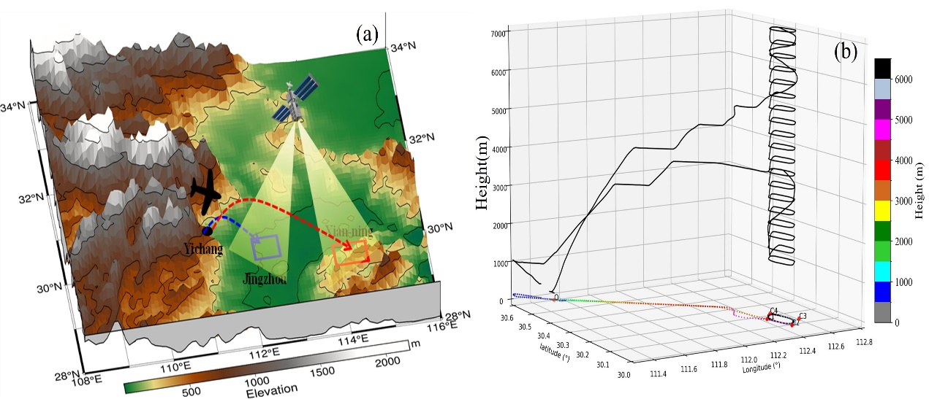
Fig. S1. Schematic map of aircraft and satellite observations. (a) Terrain map overlaid with the overall aircraft flight overview. (b) Detailed flight tracks of the aircraft within the operational area.
Table S1. Summary of the flights used in this study.
Flight | Date | Time range  (UTC) | Maximum altitude(m) | Weather
F1 | 20180629 | 01:48-04:08 | 4722 | Cloudy
F2 | 20200618 | 02:40-04:40 | 7335 | Rainy
F3 | 20200704 | 02:50-04:05 | 7339 | Rainy
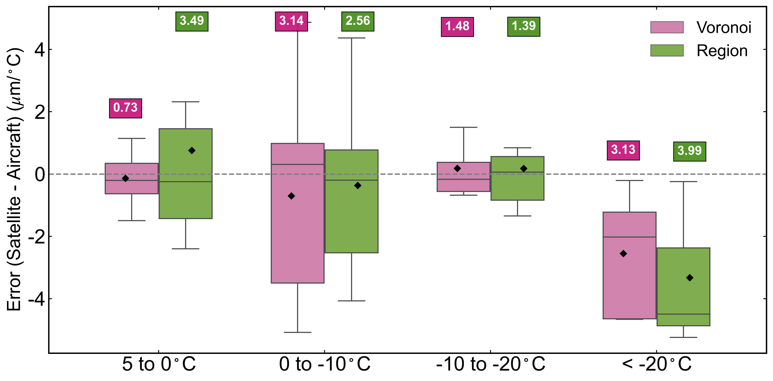
Fig.S2 Distribution of CER vertical-gradient errors from the Voronoi and conventional Region retrievals relative to aircraft in situ observations for four temperature intervals: 0 to 5 °C, -10 to 0 °C, -20 to -10 °C, and < -20 °C. Errors are calculated as satellite minus aircraft CER gradients (μm °C⁻¹). Boxes show the interquartile range, center lines mark the median, and whiskers extend to 1.5 × IQR. Colored diamonds represent the mean error. Colored square annotations show the RMSE value for each method in each temperature interval.
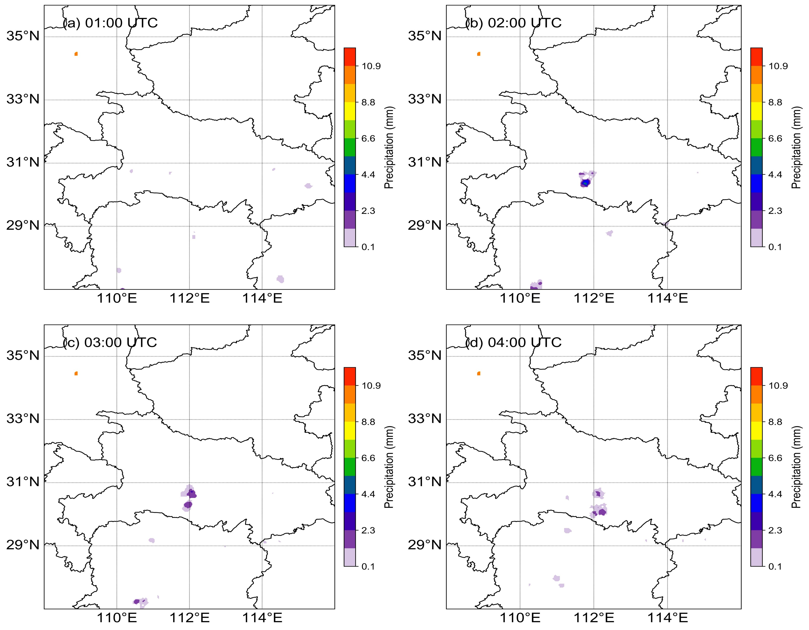
Fig S3. Spatial distribution of surface precipitation rate (mm h⁻¹) for the case study on 1 June 2022 at (a) 01:00, (b) 02:00, (c) 03:00, and (d) 04:00 UTC, derived from quality-controlled automatic weather station observations resampled to a 0.04° grid using radial basis function interpolation. Black contours delineate the cloud cluster boundary (10.8 μm brightness temperature < 280 K). The intensification of surface precipitation from panel (a) to (d) is consistent with the stage-dependent CER evolution described in the text.
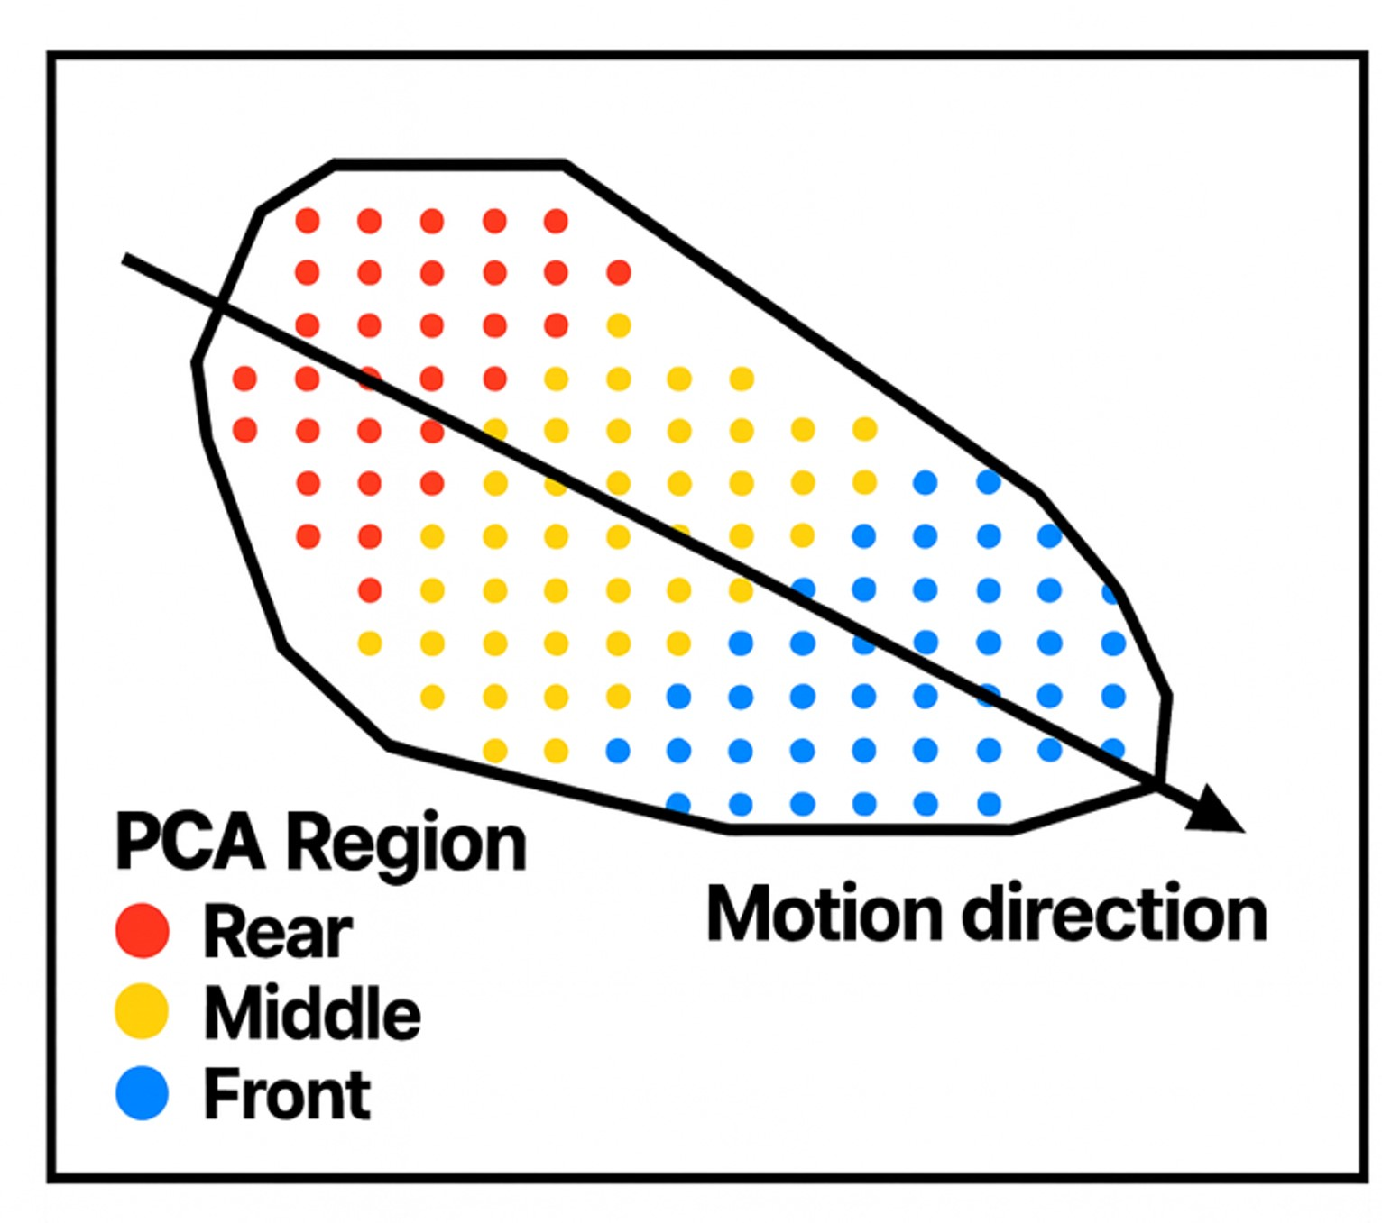
Fig S4 Principal component analysis (PCA) for sector partitioning.
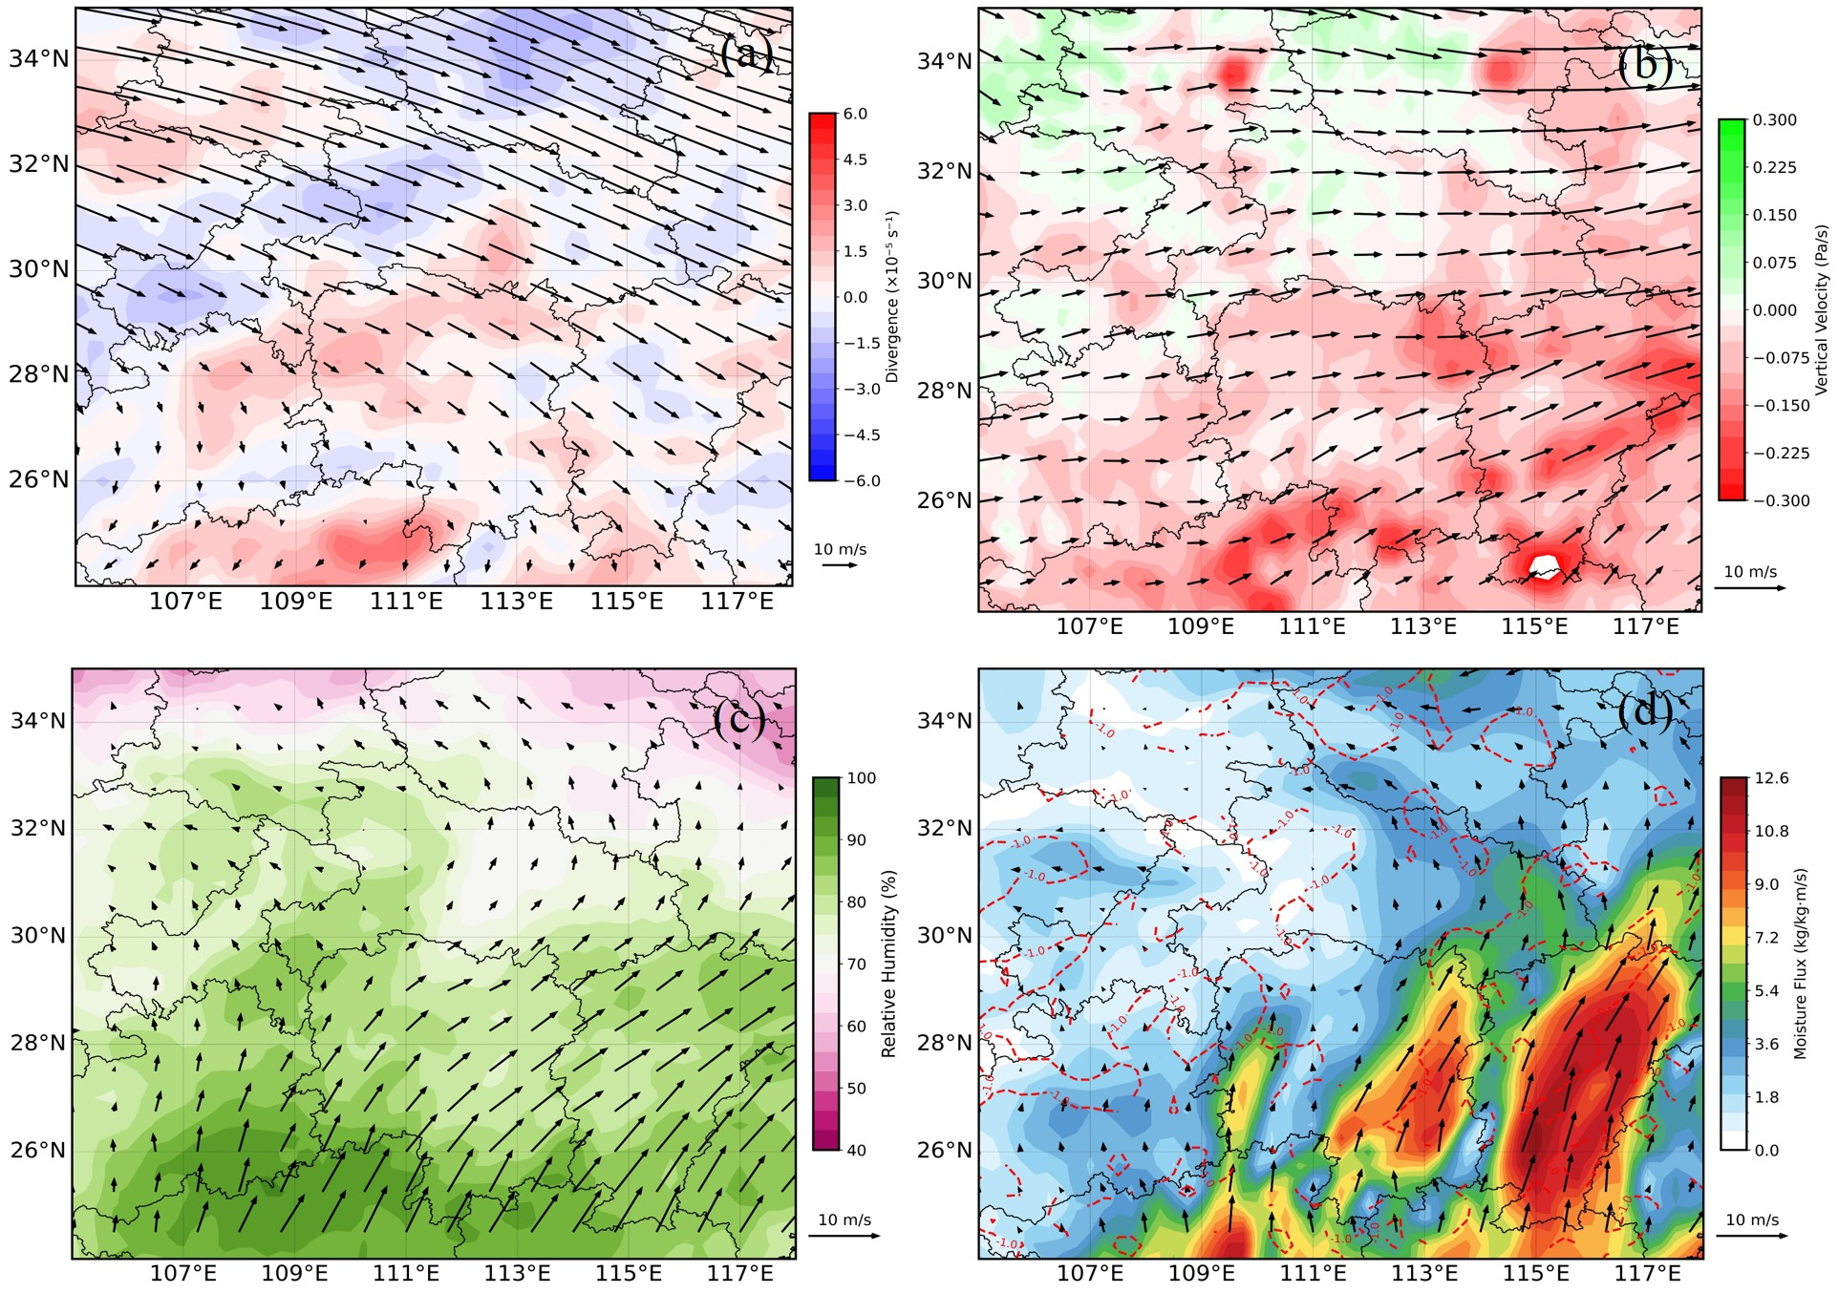
Fig S5. ERA5 composite dynamical and thermodynamic fields for 162 propagating convective systems (EPCSs). (a) 200 hPa wind vectors overlaid with divergence (s⁻¹). (b) 500 hPa wind vectors overlaid with vertical velocity (Pa s⁻¹), with upward motion (negative values) shaded in blue. (c) 850 hPa wind vectors overlaid with relative humidity (%). (d) 925 hPa wind vectors overlaid with water vapor flux (kg kg⁻¹ m s⁻¹); the red dashed contour denotes the 1.0 kg kg⁻¹ m s⁻¹ isoline.
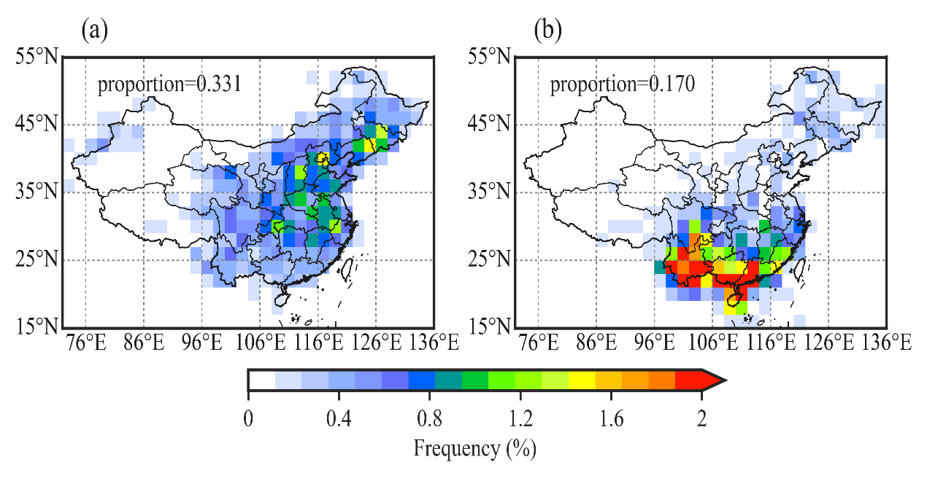
Fig S6 Frequency distributions of eastward (a) and westward (b) convective cloud clusters over China.
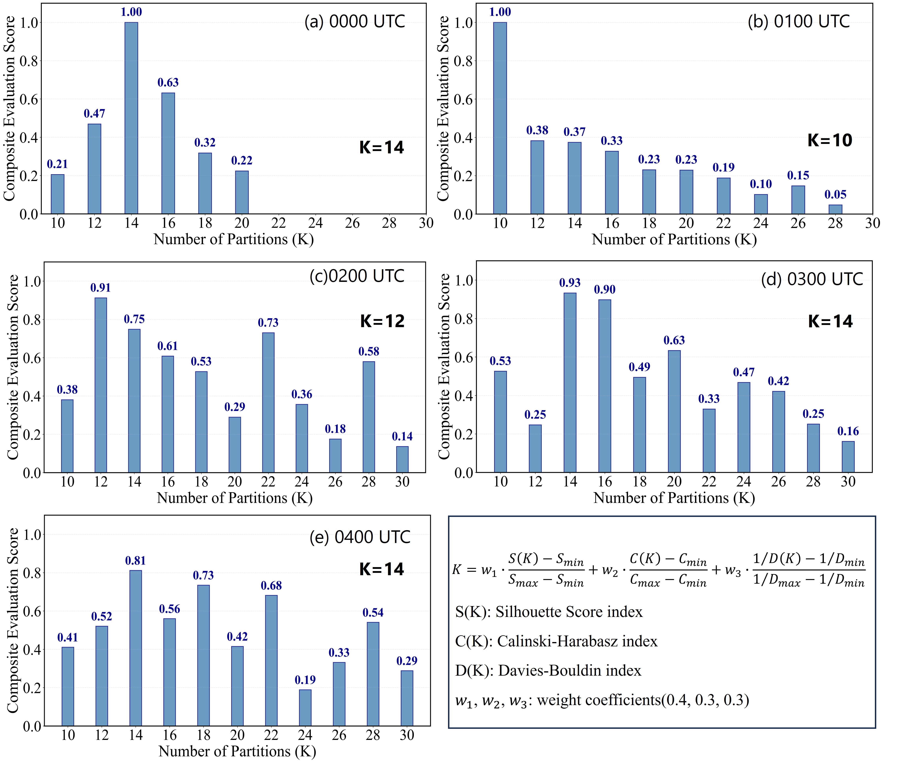
Fig S7. Determination of optimal Voronoi partition number K for the case study on 1 June 2022. Composite index scores (combining Silhouette, Calinski–Harabasz, and Davies–Bouldin metrics) as a function of candidate cluster number K at five successive times: (a) 00:00 UTC (optimal K = 14), (b) 01:00 UTC (K = 10), (c) 02:00 UTC (K = 12), (d) 03:00 UTC (K = 14), (e) 04:00 UTC (K = 14). The optimal K (marked by a red asterisk) is selected as the value maximising the composite index score. Higher composite scores indicate more distinct and coherent Voronoi sub-regions.

