Table S1. Characteristics of participants (n = 500)
 | n=500 | Frequency | Percentage (%)
EMS providers | EMR  Frontline rescuer  EMT BLS provider  EMT Intermediate  Advanced EMT Paramedic  ENP  Head of ERs | 124  63  41  45  70  140  17 | 24.8  12.6  8.2  9.0  14.0  28.0  3.4
Age | Mature working age 55-64 years Prime working age 25-54  Early working age 15-24 | 23  404  73 | 4.6  80.8  14.6
Sex | Male  Female | 206  294 | 41.2  58.8
Income | ≤600 USD (20,000 TBH)  >600 USD (20,000 TBH) | 235  265 | 47.0  53.0
Education level | Elementary/ high school  Undergraduate degree  Postgraduate degree  Vocational certificate | 127  277  29  67 | 25.4  55.4  5.8  13.4
Training level | First responders  Basic level  Intermediate level  Advanced level  Other related training | 77  137  7  265  14 | 15.4  27.4  1.4  53.0  2.8
Work experience in years | 1 year  1-2 years  3-5 years  5-10 years  >10 years | 19  85  125  89  182 | 3.8  17.0  25.0  17.8  36.4
Expected years | <5 year  5-10 years  10-15 years  15-20 years  Until retirement | 102  126  42  31  199 | 20.4  25.2  8.4  6.2  39.8
Work hours as EMS provider | < 10 hours  10–20 hours  21–30 hours  31–39 hours  ≥40 hours | 106  91  50  66  187 | 21.2  18.2  10.0  13.2  37.4
Work load after pandemic | Yes, prolonged  Yes, reduced  No changes | 289  26  185 | 57.8  5.2  37.0

The sociodemographic characteristics of EMS providers included age, marital status, sex, education level, monthly income, insurance coverage, job role within the EMS workforce, years
of experience in Thai EMS, expected duration of employment in EMS, training level, weekly working hours, and post–COVID-19 workload.

Table S2. Table. Exploratory Factor Analysis (EFA) of Behavioral Health
KMO and Bartlett's Test
Kaiser-Meyer-Olkin Measure of Sampling Adequacy |  | 0.957
Bartlett's Test of Sphericity | Approx. Chi-Square | 7807.848
Bartlett's Test of Sphericity | df | 300
Bartlett's Test of Sphericity | Sig. | .000

For the preliminary analysis Kaiser-Meyer-Olkin measure was used. From the KMO and Bartlett’s test it measures how suited is the data from the survey for conducting the factor analysis. It measures the sample adequacy for each variable in the model. As the value is more than 0.8 and less than 1 which is 0.95 so the sampling is adequate for the factor analysis.

Table S3. Component matrix in terms of Behavioral Health, Safety Attitude, Teamwork Climate and Wellness (redefined components)
Item-1Self Efficacy |  | Factor loadings
16 | I can find something to smile | 0.69
18 | I am emergency rely person for my friends | 0.77
24 | I've enough energy to do all things | 0.79
25 | It’s ok if someone don’t prefer me as friends | 0.72
Item-2 Personal Competence
4 | Keeping interested is important | 0.71
9 | Is determined | 0.75
10 | Seldom wonder what the point of it all is | 0.71
11 | Take things one day at a time | 0.77
12 | Have self- discipline | 0.76
13 | Keeping interested in things | 0.80
14 | Can get through difficult times as have previous experiences | 0.73
Item-3 Self Confidence
15 | I believe I can handle many things at a time | 0.69
20 | I can make myself do important things whether I like or not | 0.63
- Behavioral Health construct

Note: total 12 item were removed from the primary RS-25 item Behavioral Health construct

Item |  | Factor loadings
11 | Satisfaction with efficient service delivery provision for proper response works | 0.71
13 | Working like a family with all EMS team and units | 0.64
14 | High moral and ethics in the EMS response and operation team | 0.65
15 | Satisfaction with EMS support team and personnel in all aspects | 0.72
- Wellness construct

- Teamwork Climate construct
Item |  | Factor loadings
7 | Regular updates of rules and guidelines in EMS units | 0.72
8 | Provision of training new EMS workforce | 0.73
9 | Coordination between ED doctors and prehospital team during response | 0.74
10 | Culture of learning and appropriate feedbacks | 0.65

Item |  | Factor loadings
1 | Sufficient information received about events and unexpected incidents | 0.64
2 | Adequate safety measures to frontline workers | 0.70
3 | Routine availability of clinical decisions to service providers | 0.80
- Safety Attitude construct

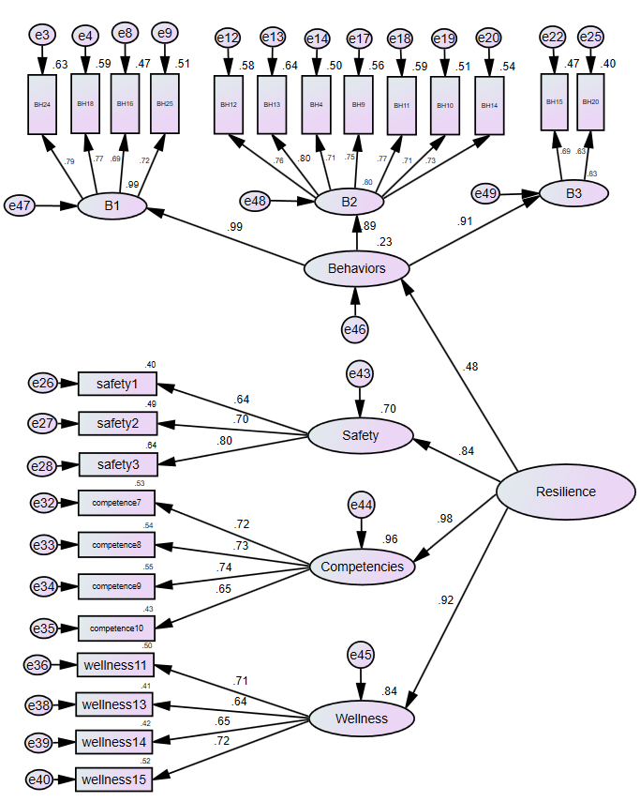
Figure S1. Adjusted model- CFA from SPSS-AMOS

CFA using SPSS-AMOS 23 with components generated after EFA.

