Supporting Information

Synergistic Hydrogen Bonding and Coulomb Force Enhance Electron Transport for Ultrasensitive Ammonia Sensing
Pei-Dong Bao,^{[a,b,c]} Peng Lin,^{[a]} Ke-Feng Li,^{[a]} Jiang-Feng Lu,^{[a]} Xiao-Qing Yu,^{[a]} De-Kai Cai,^{[a,b,c]} Gang Xu*^{[a]} and Guan-E Wang*^{[a]}
[a] State Key Laboratory of Structural Chemistry, Fujian Provincial Key Laboratory of Materials and Techniques toward Hydrogen Energy, Fujian Institute of Research on the Structure of Matter, Chinese Academy of Sciences (CAS), Fuzhou, 350002, China.
[b] Fujian Provincial Key Laboratory of Polymer Materials, College of Chemistry and Materials Science, Fujian Normal University, Fuzhou, 350007, China.
[c] Fujian College, University of Chinese Academy of Sciences, Fuzhou, 350002, China.

Table of Contents
S1 Experimental Procedures 3
S1.1 Time-resolved in-situ DRIFTS spectra collection 3
S1.2 Density functional theory (DFT) calculations 3
S2 Supporting Figures 4
Figure S1. Morphology images of SnATP-NH₃⁺. SEM image of SnATP-NH₃⁺ nanosheets. 4
Figure S2. Element distribution (EDS) analysis of SnATP-NH₃⁺. EDS images of SnATP-NH₃⁺ nanosheets. 5
Figure S3. X-ray photoelectron spectroscopy (XPS) spectra of N 1s for SnATP-NH₃⁺. 6
Figure S4. PXRD patterns of SnATP-NH₃⁺ after immersion in diﬀerent organic solvents for 7 days. 6
Figure S5. Band structure diagram of SnATP-NH₃⁺. 7
Figure S6. Arrhenius plots of conductivity for SnATP-NH₃⁺ under dry air. 7
Figure S7. Fabrication process of the SnATP-NH₃⁺ based sensor. 8
Figure S8. Gas sensing test system. Diagram of the homemade gas sensing test system. 8
Figure S9. Scanning Electron Microscopy (SEM) of SnATP-NH₂. 9
Figure S10. Powder X-ray diffraction (PXRD) pattern of SnATP-NH₂. 9
Figure S11. Element distribution (EDS) analysis of SnATP-NH₂. EDS images of SnATP-NH₂. 10
Figure S12. Infrared characterization. Fourier-transform Infrared (FTIR) spectra of SnATP-NH₂ and 4-Aminothiophenol. 11
Figure S13. Thermogravimetric analysis (TG) of SnATP-NH₂. TG curve of SnATP-NH₂. 11
Figure S14. PXRD patterns of SnATP-NH₂ after immersion in diﬀerent organic solvents for 7 days. 12
Figure S15. Fabrication process of the SnATP-NH₂ based sensor. 12
Figure S16. Cross-sensitivities of SnATP-NH₂ molecular-based material towards 13 types of gases. 13
Figure S17. DFT calculation of NH₃ adsorption on the zero-dimensional molecular material SnATP-NH₃⁺. 14
S3 Supporting Tables 15
Table S1. Crystallographic data for SnATP-NH₃⁺. 15
Table S2. Crystallographic data for SnATP-NH₂ 16
Table S3. Sensing performance of the no-light irradiation material-based RT chemiresistive NH₃ sensors. 17

S1 Experimental Procedures

S1.1 Time-resolved in-situ DRIFTS spectra collection
DRIFTS spectra were collected on a Nicolet 6700 FT-IR spectrometer with MCT/A detector cooled by liquid nitrogen. The spectra were displayed in absorbance units and acquired with a resolution of 4 cm⁻¹ using 128 scans. To monitor the real test condition, all the spectra were collected under synthetic air (79% nitrogen, 21% oxygen). Data collection was performed on OMNIC software. The powder of SnATP-NH₃⁺ nanosheets was heated to 85 °C under the high-purity Ar flow at a rate of 200 mL/min for 2 h. Then a spectrum of the pristine sample was collected using the aforementioned KBr background. Then under the lifted temperature synthetic air was introduced at a rate of 100 mL/min. Difference spectra were collected every 15 min continuously for 150 min. All spectra were obtained by 128 scans with a resolution of 4 cm⁻¹ from 650 to 4000 cm⁻¹

S1.2 Density functional theory (DFT) calculations
DFT calculations were carried out to investigate the adsorption interaction between NH₃ molecules and SnATP-NH₃⁺ nanosheets, employing the VASP. The GGA parameterized with the PBE exchange-correlation function were used for all geometry optimizations and electron density difference calculations. A plane-wave cutoff energy of 400 eV was set. Geometry optimizations were considered converged when the energy and force thresholds reached 1 × 10⁻⁴ eV per atom and 0.03 eV Å^{–1}, respectively. A 1×4×3 k-point mesh was used for Brillouin zone sampling.
The crystal structure of SnATP-NH₃⁺ was optimized prior to constructing the adsorption model. Based on the optimized crystal structure, a surface slab model was created by cleaving along the (100) crystal plane. To eliminate spurious interactions between periodic images, a vacuum spacing of 15 Å was applied along the surface normal direction. The surface of the slab is decorated with both amino (-NH₂) and ammonium chloride (-NH₃⁺/Cl⁻) functional groups, with the latter originating from the partial protonation of the former. The SnATP-NH₃⁺ nanosheet model underwent full relaxation through additional geometry optimization. The adsorption energy of NH₃ on the surface of the SnATP-NH₃⁺ slab model and the electron density difference after adsorption were calculated. To visualize the electron transfer following gas adsorption, electron density difference calculations were performed on two atom sets: one representing the SnATP-NH₃⁺ and the other representing the gas molecule. The number of electrons transferred from SnATP-NH₃⁺ to gas molecule was obtained by Bader charge calculation. The adsorption energies were calculated by the following formula:
E_{ads} = E_{ab} – (E_{a} + E_{b})
E_{ab} the total energy of the slab model with the adsorbed gas molecule, E_{a} is the energy of the pristine slab model, and E_{b} is the energy of the isolated gas molecule.

S2 Supporting Figures
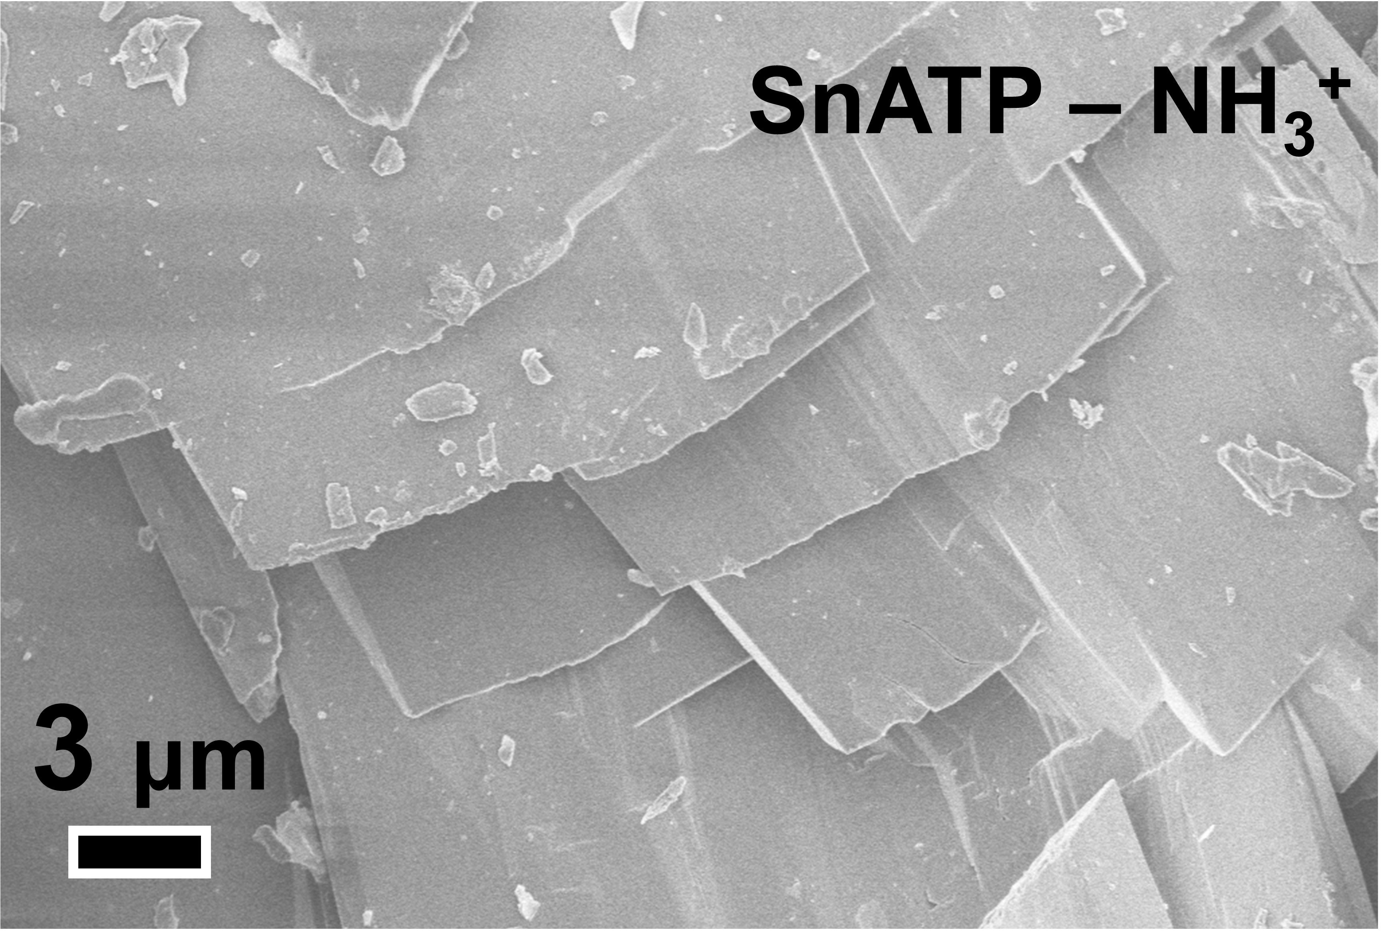

Figure S1. Morphology images of SnATP-NH₃⁺. SEM image of SnATP-NH₃⁺ nanosheets.

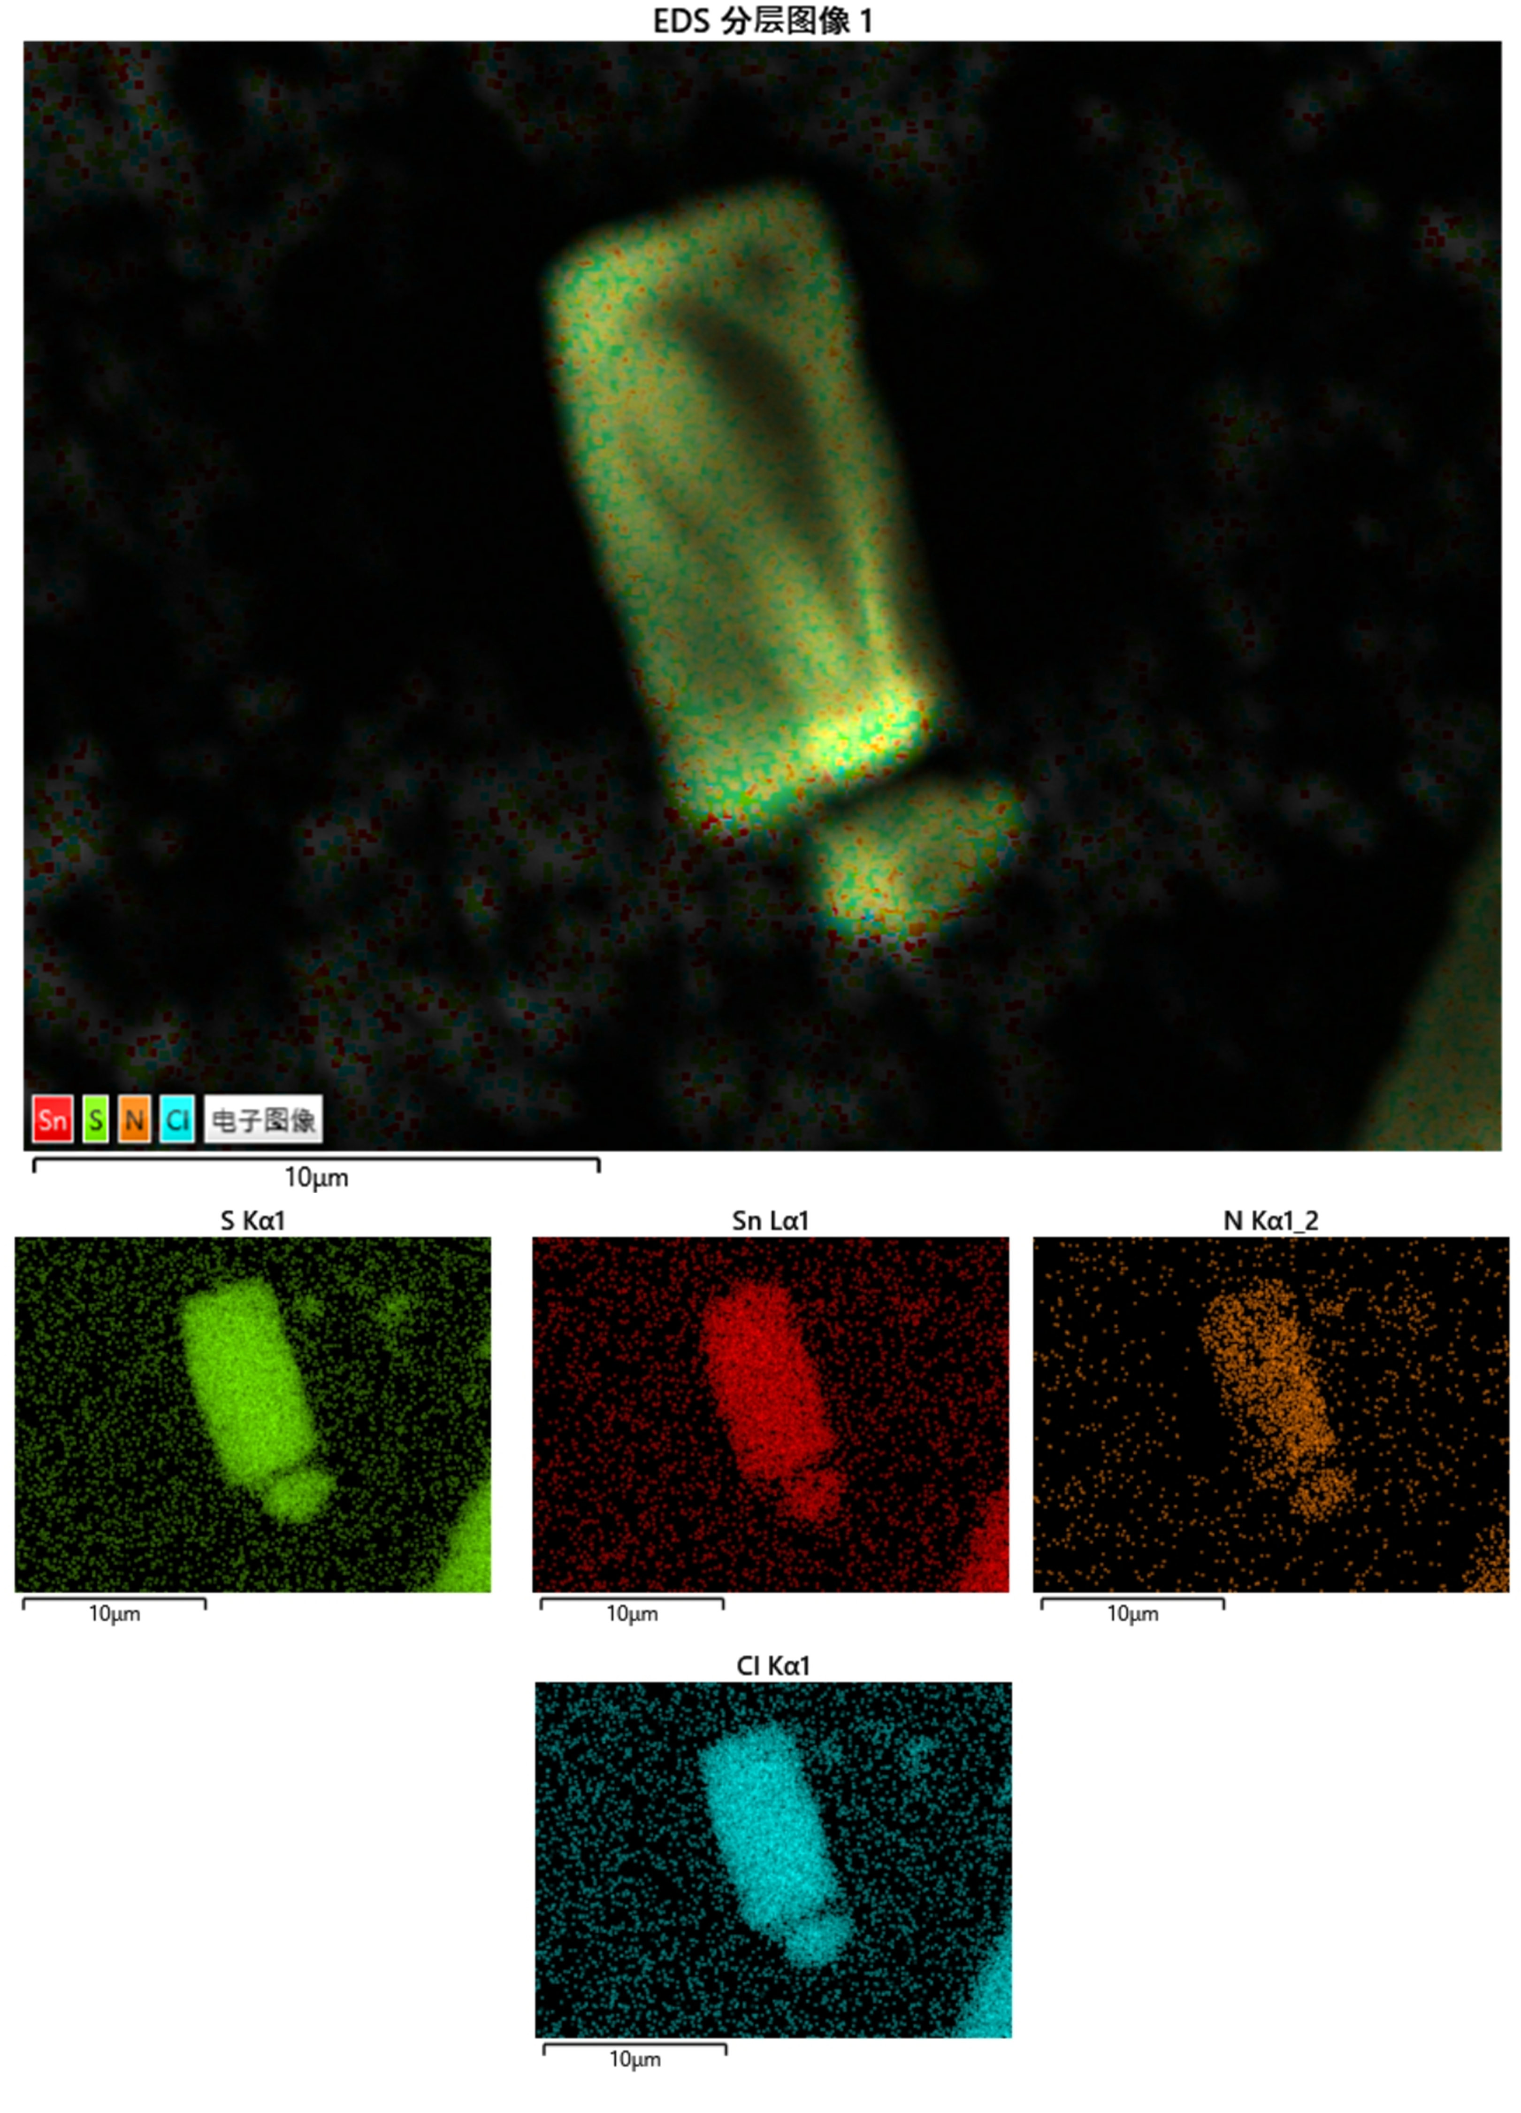

Figure S2. Element distribution (EDS) analysis of SnATP-NH₃⁺. EDS images of SnATP-NH₃⁺ nanosheets.

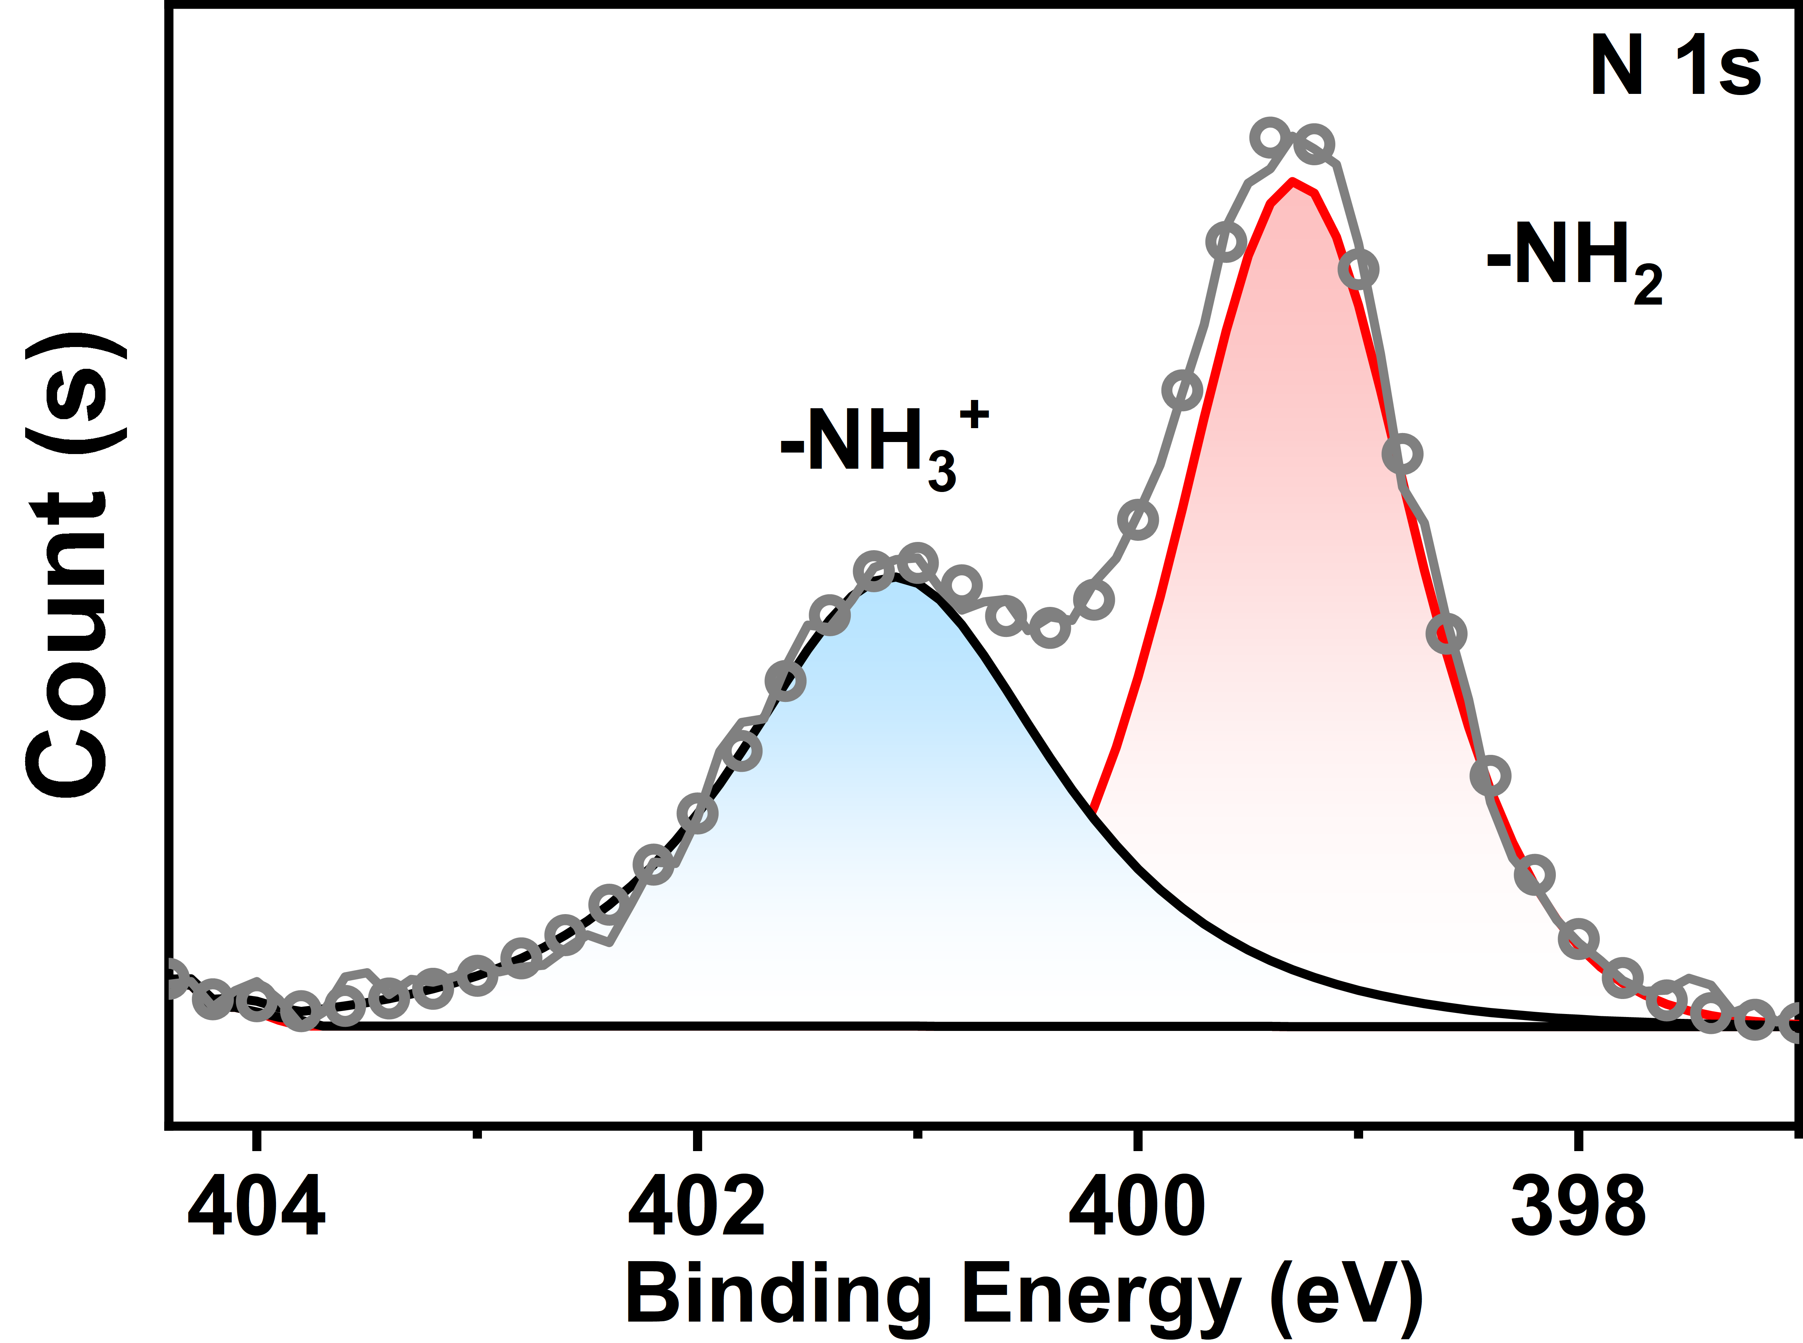

Figure S3. X-ray photoelectron spectroscopy (XPS) spectra of N 1s for SnATP-NH₃⁺.

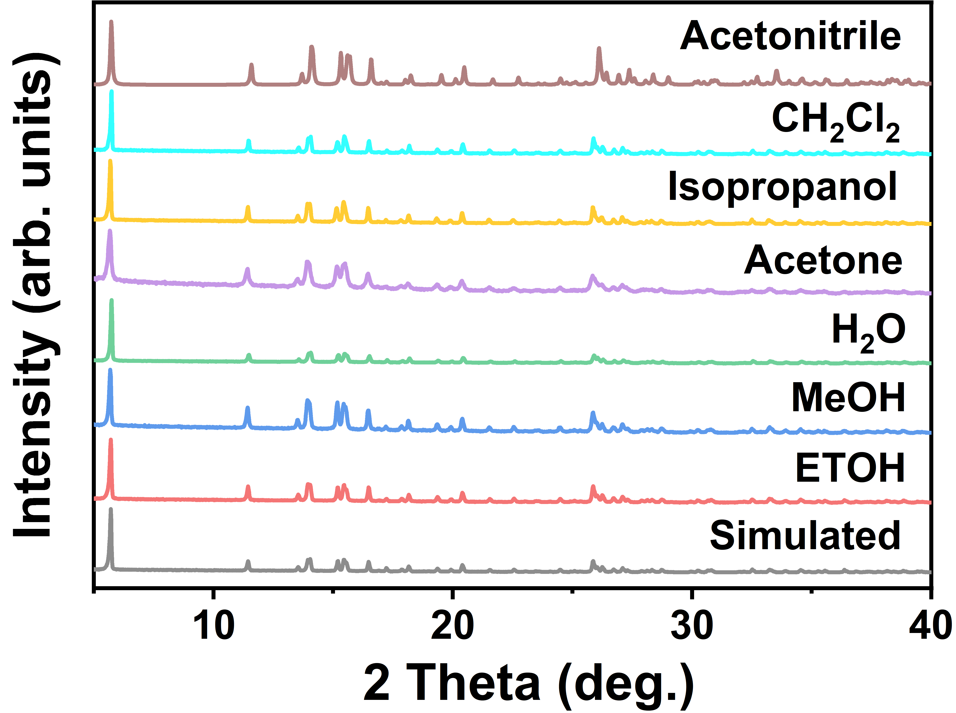

Figure S4. PXRD patterns of SnATP-NH₃⁺ after immersion in diﬀerent organic solvents for 7 days.

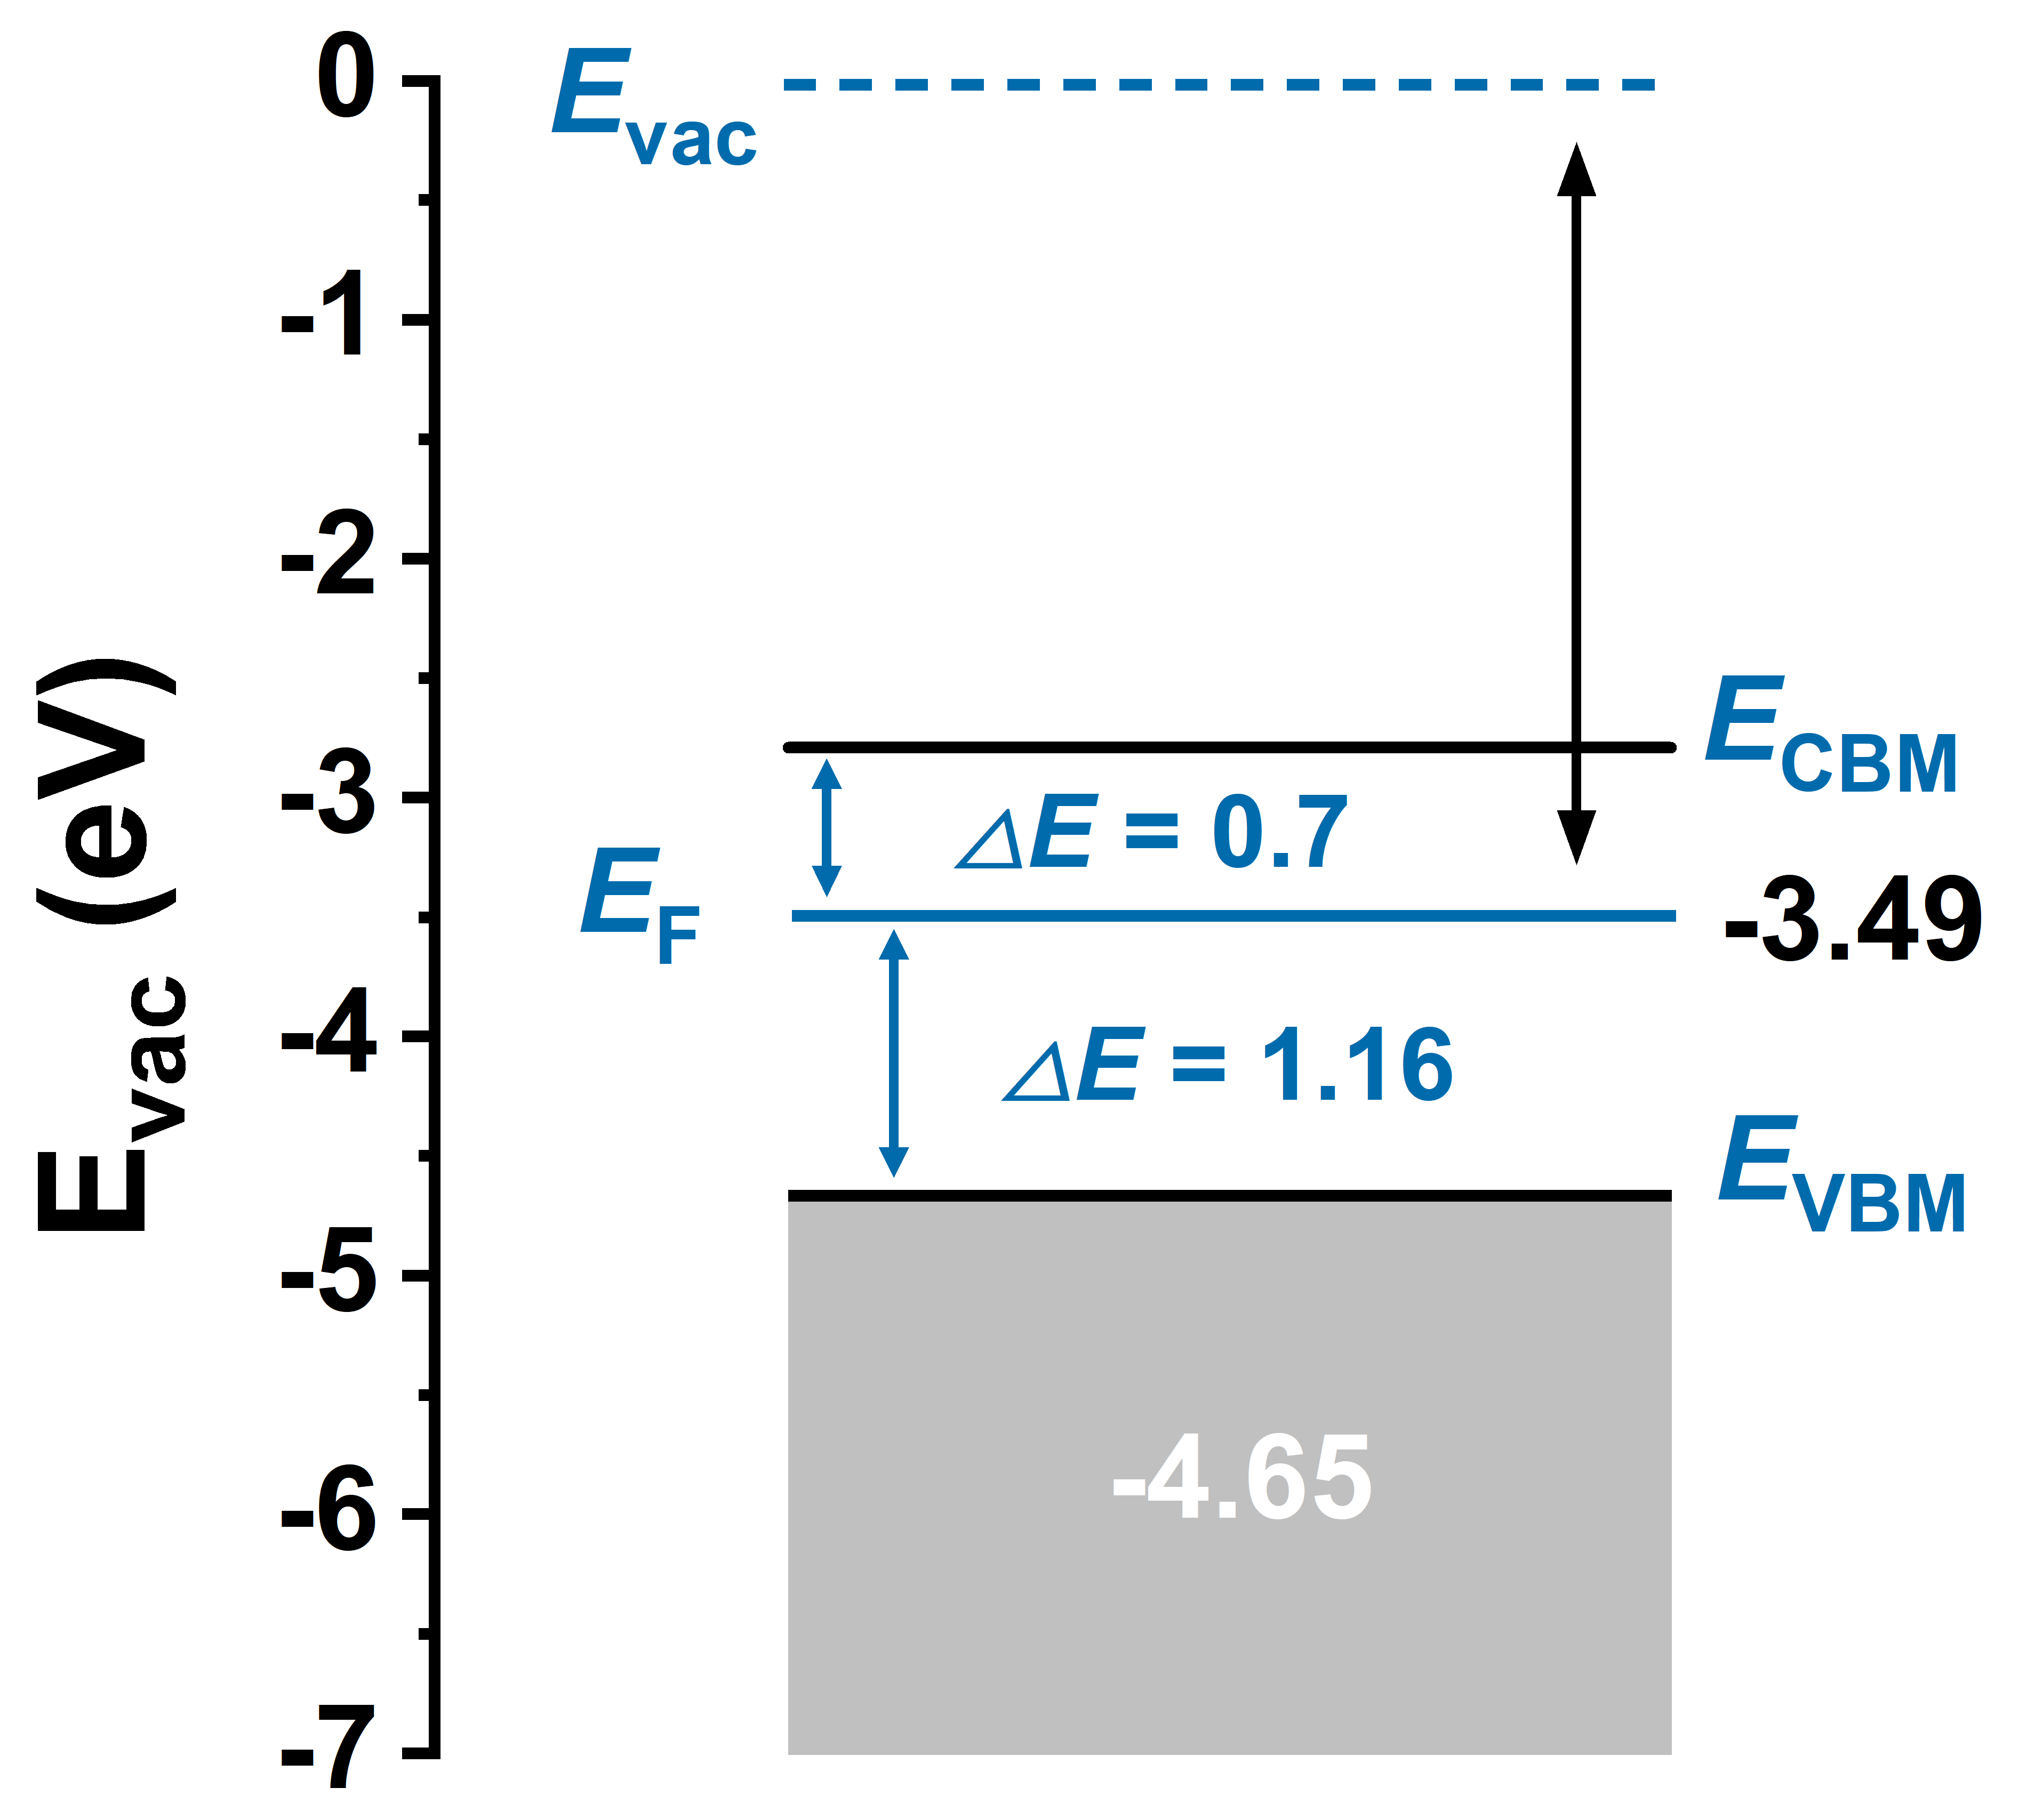

Figure S5. Band structure diagram of SnATP-NH₃⁺.

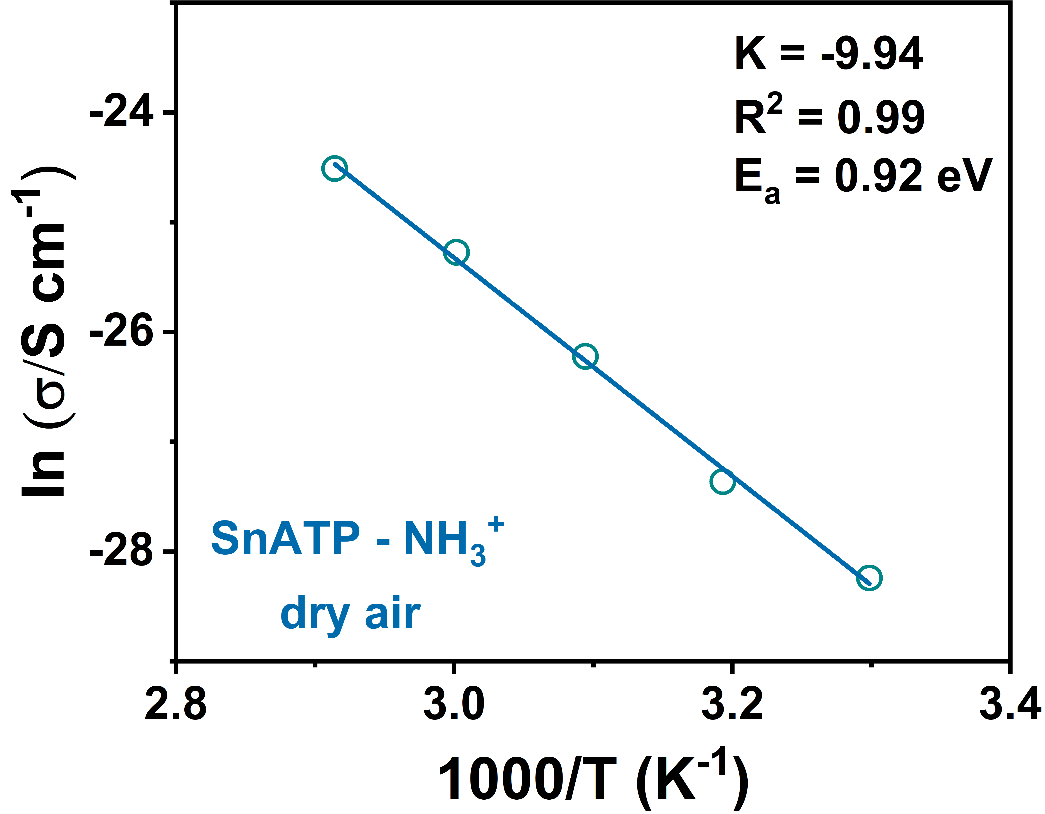

Figure S6. Arrhenius plots of conductivity for SnATP-NH₃⁺ under dry air.

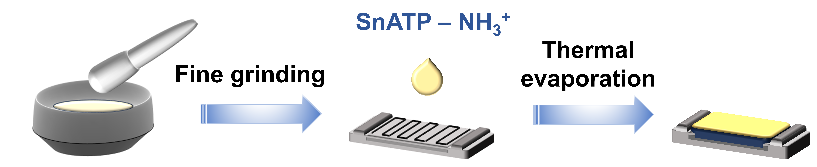

Figure S7. Fabrication process of the SnATP-NH₃⁺ based sensor.

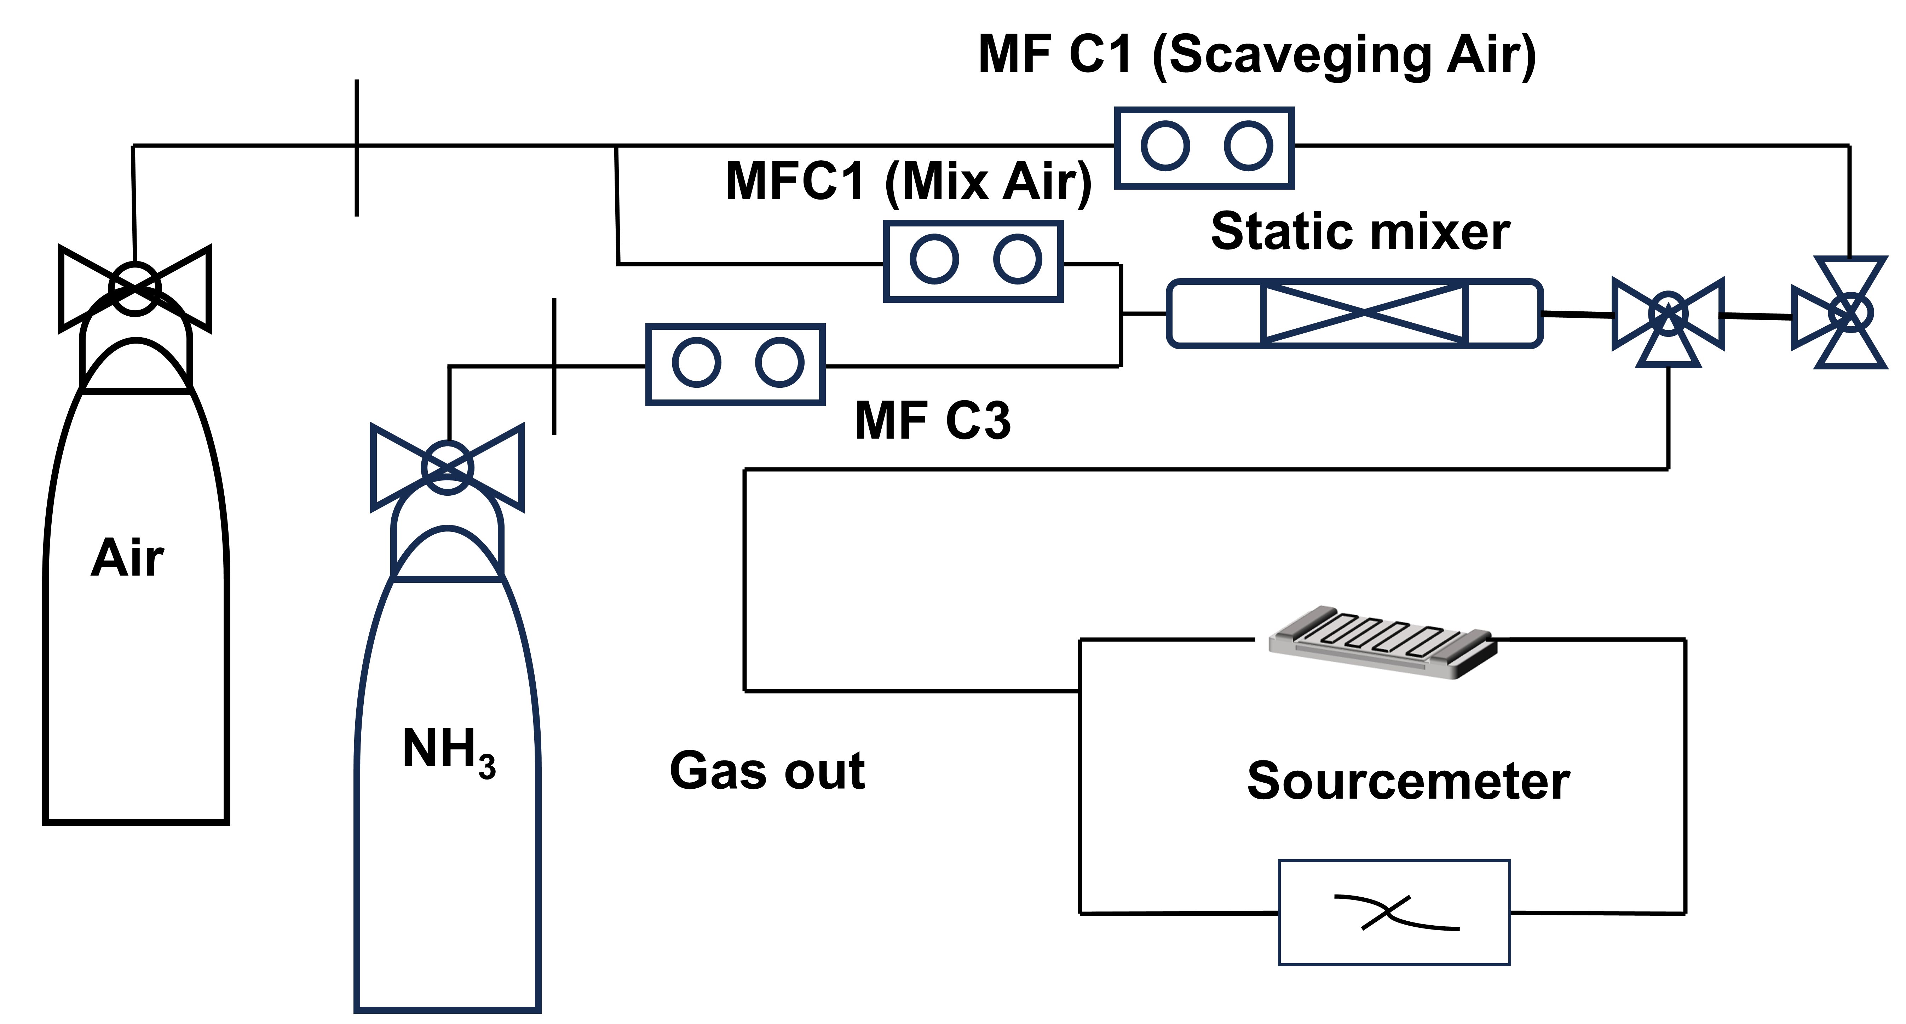

Figure S8. Gas sensing test system. Diagram of the homemade gas sensing test system.

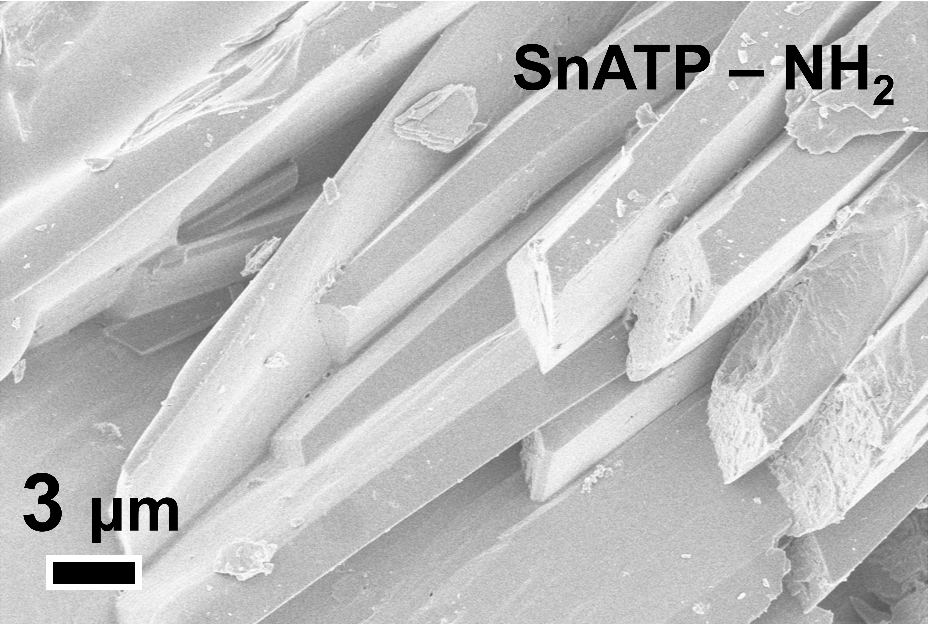

Figure S9. Scanning Electron Microscopy (SEM) of SnATP-NH₂.

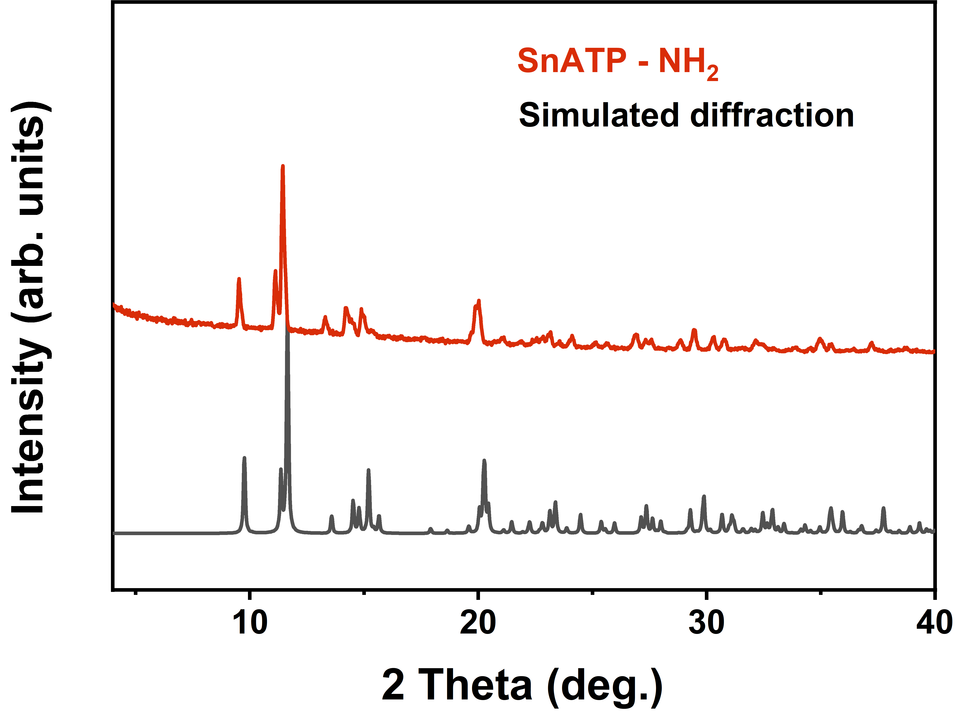

Figure S10. Powder X-ray diffraction (PXRD) pattern of SnATP-NH₂.
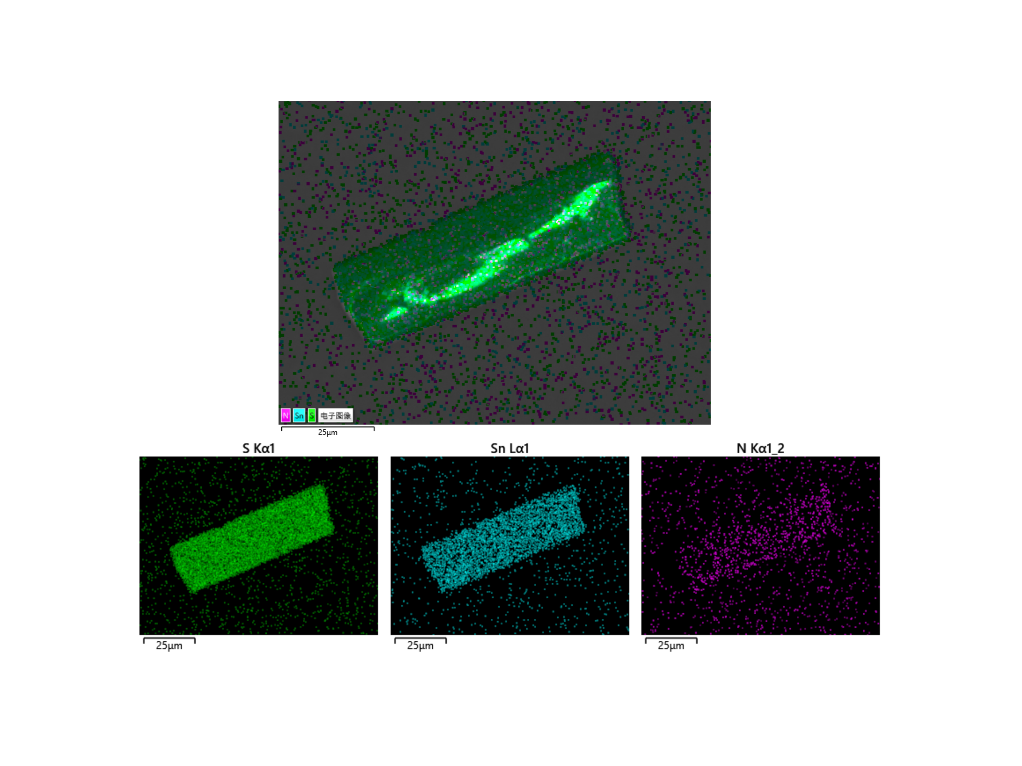

Figure S11. Element distribution (EDS) analysis of SnATP-NH₂. EDS images of SnATP-NH₂.

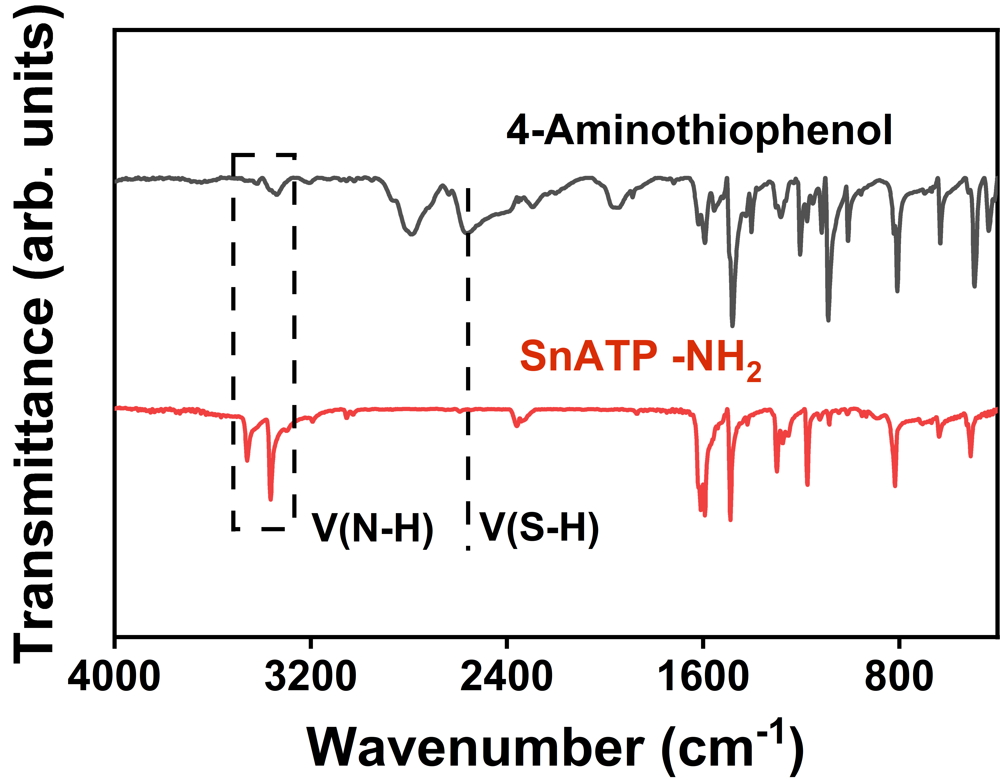

Figure S12. Infrared characterization. Fourier-transform Infrared (FTIR) spectra of SnATP-NH₂ and 4-Aminothiophenol.

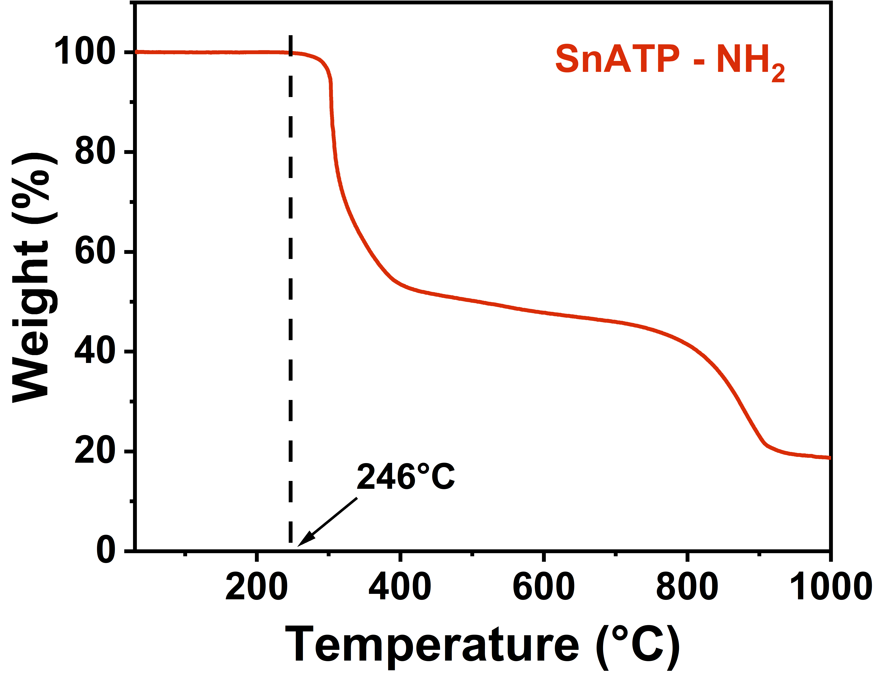

Figure S13. Thermogravimetric analysis (TG) of SnATP-NH₂. TG curve of SnATP-NH₂.

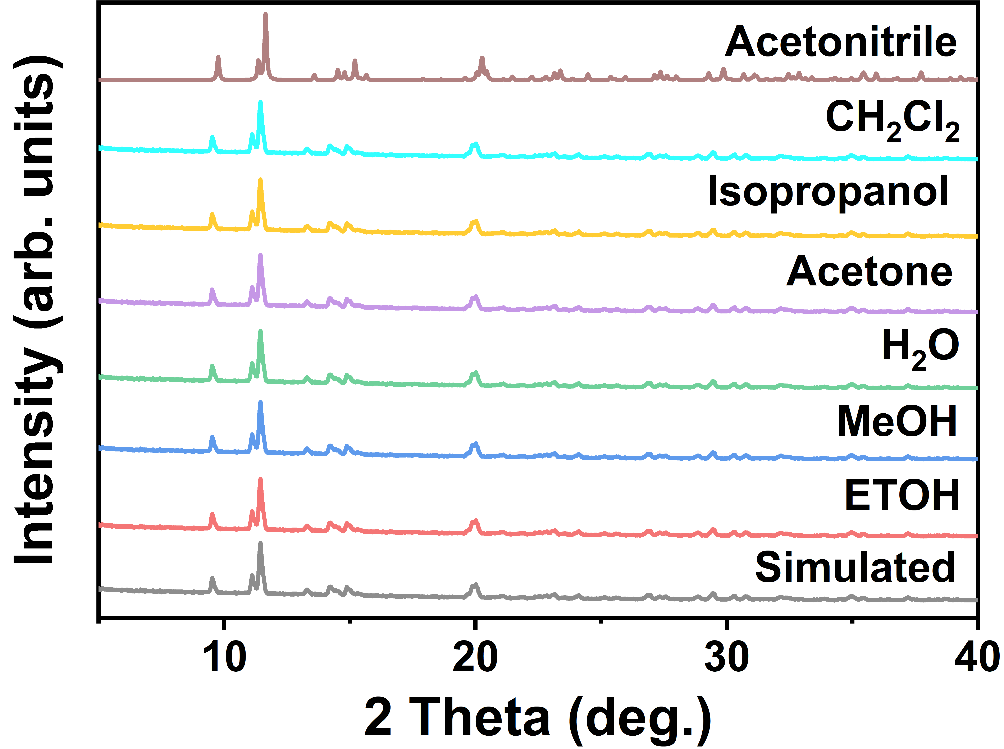

Figure S14. PXRD patterns of SnATP-NH₂ after immersion in diﬀerent organic solvents for 7 days.

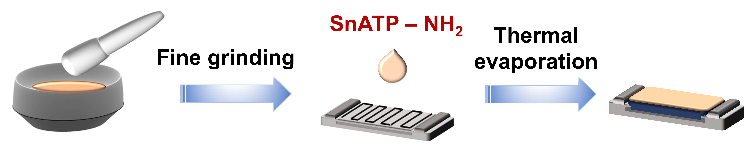

Figure S15. Fabrication process of the SnATP-NH₂ based sensor.

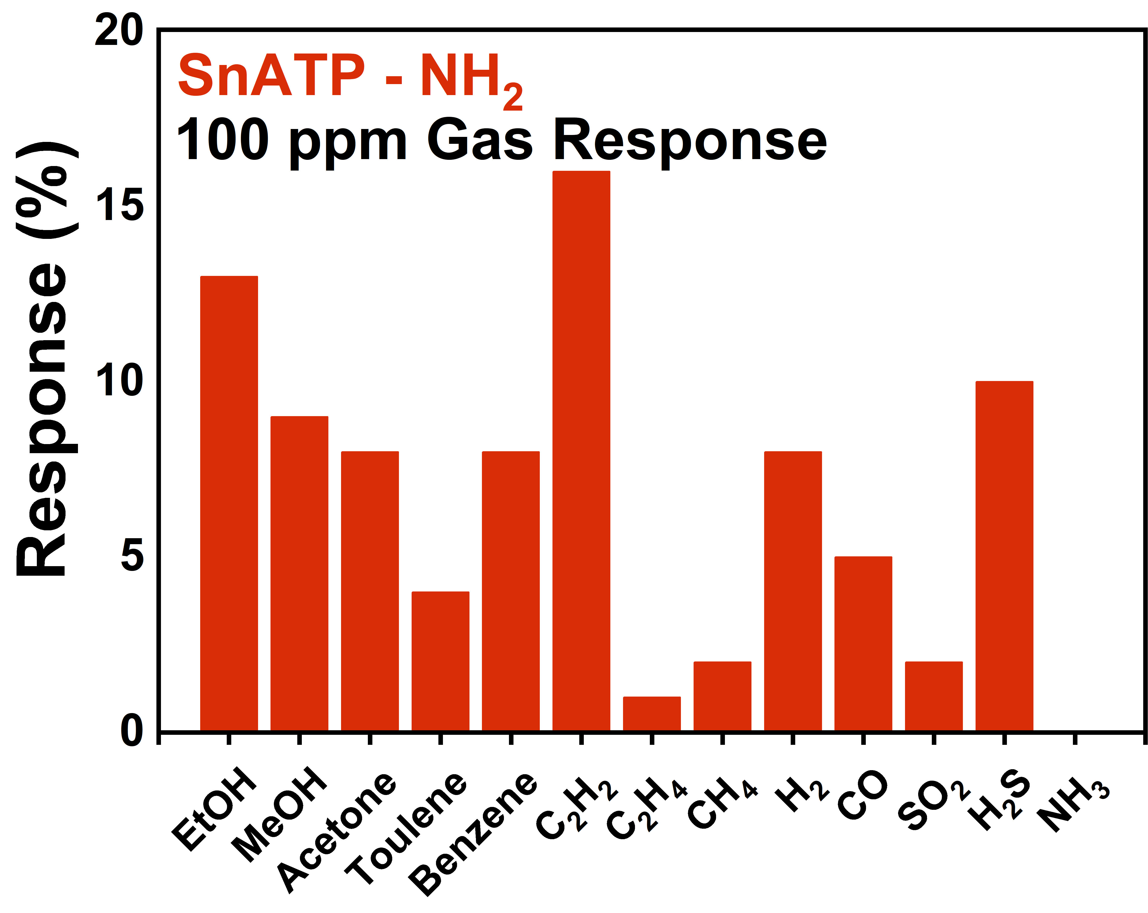

Figure S16. Cross-sensitivities of SnATP-NH₂ molecular-based material towards 13 types of gases.

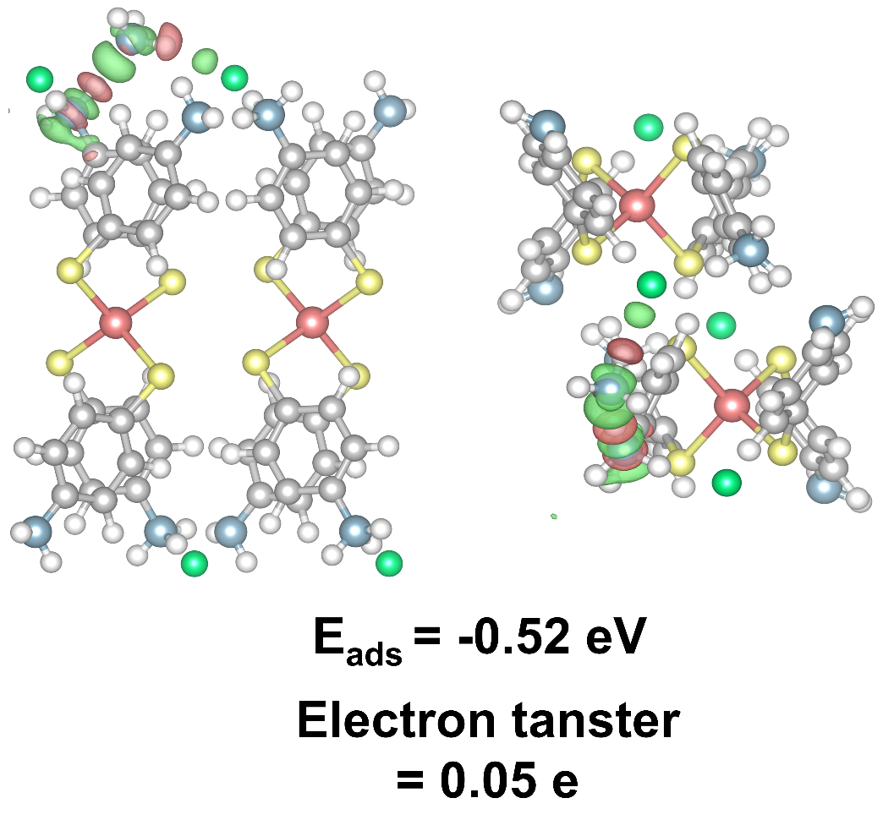

Figure S17. DFT calculation of NH₃ adsorption on the zero-dimensional molecular material SnATP-NH₃⁺.

S3 Supporting Tables

Table S1. Crystallographic data for SnATP-NH₃⁺.
Chemical formula | SnC₂₄H₂₆Cl₂N₄S₄
Formula weight | 686.32
Temperature | 100 K
Crystal system | Monoclinic
Space group | C_{2/c}
Cell parameters | a = 31.07 Å, b = 7.88 Å, c = 11.64 Å
Cell volume | α = 90°, β = 96.94°, γ = 90°, V = 2831.12 Å³
ρcalc | 0.555 g cm⁻³
F (000) | 1384
Z | 4
Index ranges | –38 ≤ h ≤ 38, –9 ≤ k ≤ 19, –14 ≤ l ≤ 14
Reflections collected | 8829
Independent reflections | 2804
Completeness | 99.93%
Solution method | Superflip
Refinement method | Full-matrix least-square on F² in Jana2020
GOF on F² | 1.115
Final R indexes [I>=2σ (I)] | R₁ = 0.0235, wR₂ = 0.0700
Final R indexes [all data] | R₁ = 0.0236, wR₂ = 0.0701
aR₁ = Σ||F₀ |–|F_{c}|| / Σ |F₀ |;^{b} wR₂ = [Σw(F₀²–F_{c}²)² / Σw(F₀²)²]^{1/2}

Table S2. Crystallographic data for SnATP-NH₂
Chemical formula | SnC₂₄H₂₄N₄S₄
Formula weight | 615.46
Temperature | 100 K
Crystal system | Monoclinic
Space group | P2₁/m
Cell parameters | a = 8.77 Å, b = 15.21 Å, c = 9.08 Å
Cell volume | α = 90°, β = 93.82°, γ = 90° V = 1208.78Å³
ρcalc | 2.835 g cm⁻³
F (000) | 620
Z | 2
Index ranges | –7 ≤ h ≤ 10, –18 ≤ k ≤ 18, –11 ≤ l ≤ 10
Reflections collected | 2509
Independent reflections | 2371
Completeness | 99.56%
Solution method | Superflip
Refinement method | Full-matrix least-square on F² in Jana2020
GOF on F² | 1.180
Final R indexes [I>=2σ (I)] | R₁ = 0.0526, wR₂ = 0.1449
Final R indexes [all data] | R₁ = 0.0538, wR₂ = 0.1454
aR₁ = Σ||F₀ |–|F_{c}|| / Σ |F₀ |;^{b} wR₂ = [Σw(F₀²–F_{c}²)² / Σw(F₀²)²]^{1/2}

Table S3. Sensing performance of the no-light irradiation material-based RT chemiresistive NH₃ sensors.
 | Sensinng material | LOD(ppm) | Response  (10 ppm) | Response time. | Ref. in main text
CPs  Materials | SnATP-NH₃⁺ | 0.042 | 5416% | 174 s @ 10 ppm | This work
CPs  Materials | MTCP | 0.25 | 100% | 600 s @ 10 ppm | 12
CPs  Materials | Cu-HHTP 2D  thin film | 0.5 | 75% | 96 s @ 100 ppm | 13
CPs  Materials | Cu₃(HHTP)₂ | 0.5 | 70 | 90s @ 100 ppm | 14
CPs  Materials | Cu-HHTP 3D  thin film | 8.7×10⁻⁵ | 60.5% | 35 s @ 100 ppm | 13
CPs  Materials | BiHHTP | n.d. | 46% | 900 @ 10 ppm | 15
CPs  Materials | ZnTDA | 1 | 41% | 133 @ 10 ppm | 16
CPs  Materials | NiPc-Ni | 0.05 | 23% | 1800 s @ 10 ppm | 17
CPs  Materials | NiPc-Cu | 0.16 | 13% | 1800 s @ 10 ppm | 17
CPs  Materials | CoTDA | 1 | 10% | 34 @ 10 ppm | 16
CPs  Materials | CuTz1 | 0.23 | 5% | 30 s @ 10 ppm | 18
CPs  Materials | Cu₃(HHTP)-THQ | 0.35 | 4.5% | 180 s @ 10 ppm | 19
CPs  Materials | Cu-BHT | 0.21 | 4 | 58 s @ 20 ppm | 20
CPs  Materials | RE-fcu-MOF | 0.23 | 4% | 50 @ 20 ppm | 21
CPs  Materials | Cu₃(HITP)₂ | 0.5 | 2.5% | n.d. | 22
CPs  Materials | CuTCNQF₄ | 10 | 0.2% | 300 s @ 10 ppm | 23
Sulfide Materials | In₂S₃ | 10 | 15% | 84 s @ 10 ppm | 24
Sulfide Materials | MnPS₃ | 0.05 | 11% | n.d. | 25
Sulfide Materials | MoS₂ film | 0.12 | 10% | 54 s @ 0.5 ppm | 26
Oxide Materials | Coral-shaped Dy₂O₃ | 0.1 | 200% | 17.4 s @ 50 ppm | 27
Oxide Materials | MnO₂ nanofibers | 1 | 4% | 150 s @ 60 ppm | 28
Polymer Materials | COF-5  nanosheets | 0.2 | 246% | n.d. | 29
Polymer Materials | Polyaniline | 1 | 227% | 120 s @ 10 ppm | 30
Polymer Materials | pDPPBu-BT | 0.01 | 47% | n.d. | 31
Polymer Materials | PEDOT  nanorods | 10 | 6% | 10 s @ 10 ppm | 32
Polymer Materials | PEDOT film | 10 | 4% | 10 s @ 10 ppm | 32
Polymer Materials | q2D PANI | 0.03 | 2.5% | n.d. | 33
Carbon based Materials | Modified SWCNT | 0.1 | 18% | 300 s @ 10 ppm | 34
Carbon based Materials | Graphene nanomesh | 0.16 | 11% | 300 s @ 10 ppm | 35
Carbon based Materials | Activated carbons | 10 | 7% | 2700 s @ 10 ppm | 36

